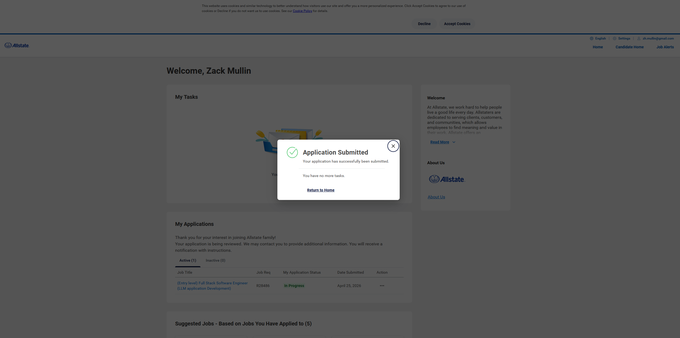
Allstate Software Engineer – Remote – Entry level https://www.allstate.jobs/job/23265315/-entry-level-full-stack-software-engineer-llm-application-development-remote-il/?source=IndeedOrganicJB&src=JB-10760


Software Developer at FortyAU Nashville TN https://www.indeed.com/viewjob?jk=135f58e8ef5a9e74&from=shareddesktop_copy


Python Developer at SANS Consulting Nashville TN https://www.indeed.com/viewjob?jk=1394696e915c8dc3&from=shareddesktop_copy

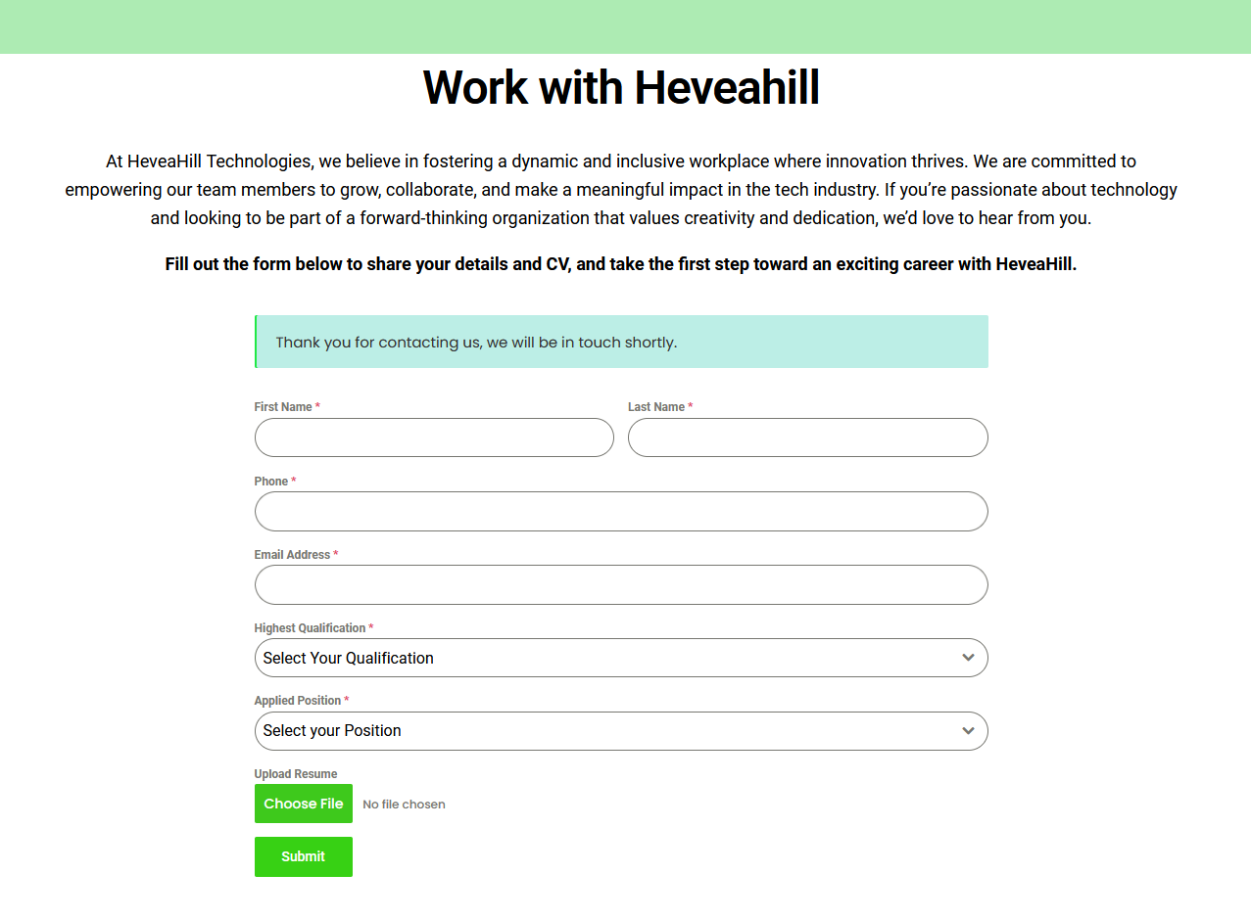
Software Engineer Heaveahill Technologies Nashville TN
https://www.indeed.com/viewjob?jk=77984340d2dbd28b&from=shareddesktop_copy

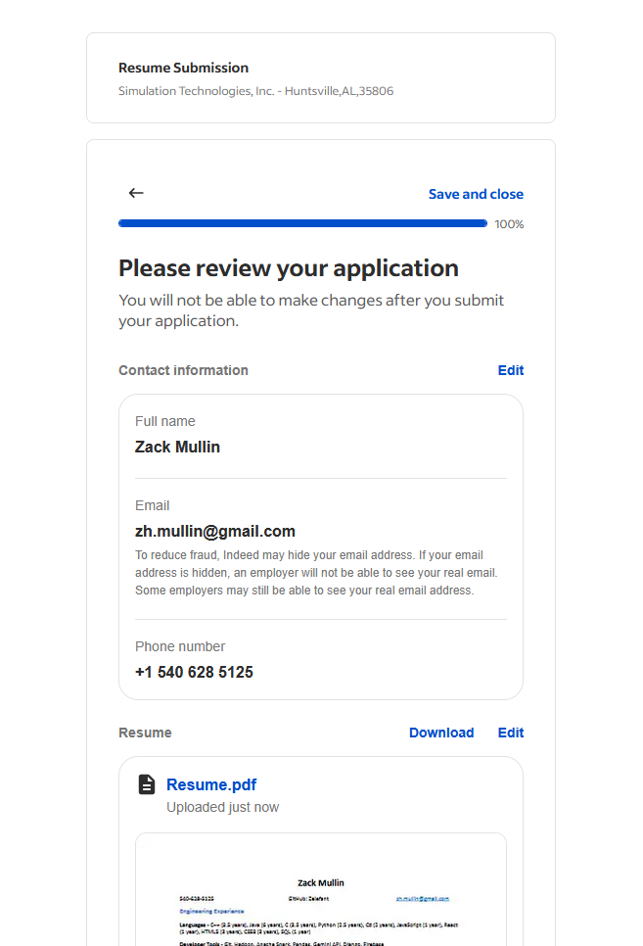
Simulation Technologies Huntsville AL
https://www.indeed.com/viewjob?jk=db2a98c4588138e1&from=shareddesktop_copy

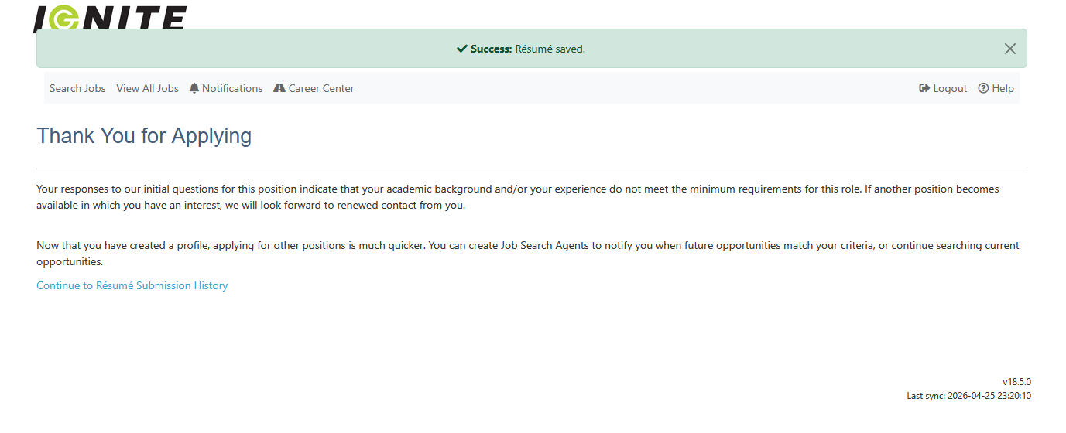
AI/ML Software Engineer Ignite Fueling
https://www.indeed.com/viewjob?jk=e0b091bcc292c324&from=shareddesktop_copy

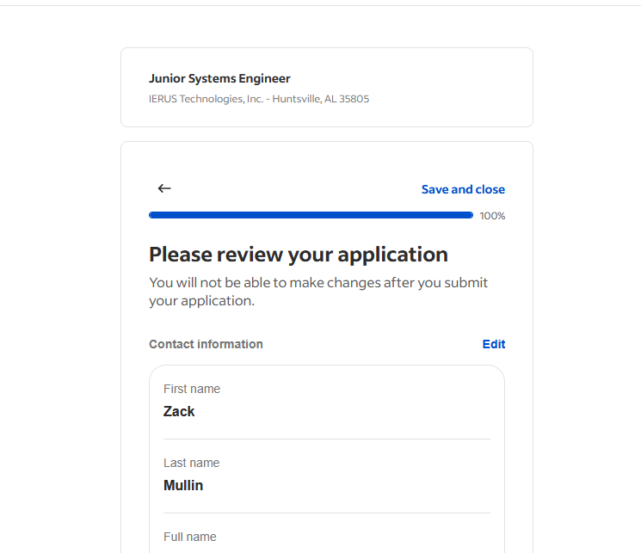
https://www.indeed.com/viewjob?jk=9f3ef2f854561a6b&from=shareddesktop_copy
Junior Systems Engineer IERUS Tech

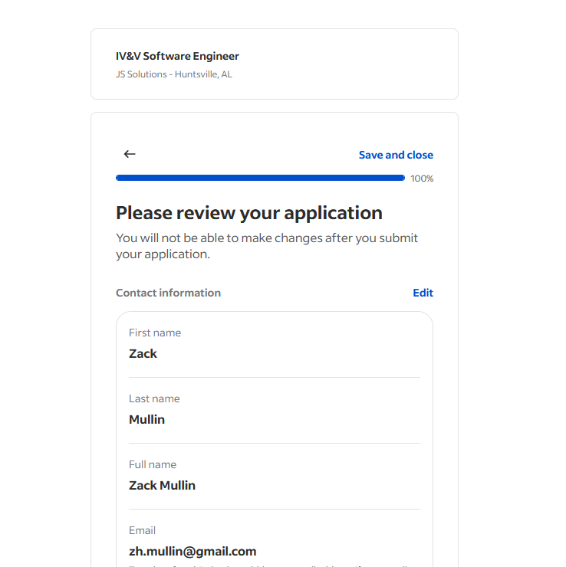

IV&V Software Engineer JS Solutions
https://www.indeed.com/viewjob?jk=10a6311494f8dfe2&from=shareddesktop_copy

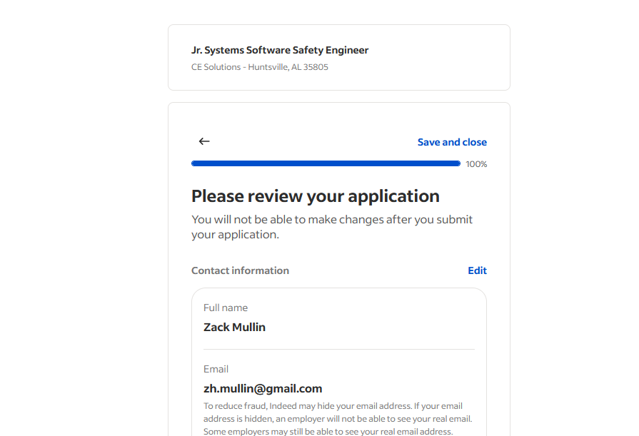
https://www.indeed.com/viewjob?jk=54e4f90386b03baf&from=shareddesktop_copy
JR systems software safety engineer at CE solutions

