

**Members:**

Avila, Leilen UTN FRRo – Studying system engineering

Bolzan, Ana Emilia UTN FRRo – Studying chemical engineering

Ladreyt, Alejandro Jesús UTN FRRo – Studying chemical engineering

Ladreyt, Pablo Oscar UTN FRRo – Studying system engineering

1. **The Challenge**

Our project aims to reduce uncertainty level of travelling informing passengers of various changes in flight plans generated by weather, this also creates a favorable outlook towards airlines, which saves money by not having to book a hotel for passengers who may be delayed at the airport and also preserve the prestige given by concern for them.

Situations like these that generate a great strain on both sides, they can be completely avoided

.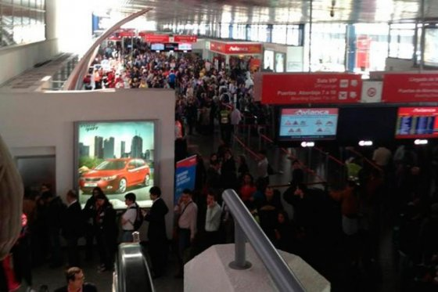

While, as previously described, these situations can be solved for by the payment of a stay, time lost is irretrievable, plus a travel fatigue and frustration of being unable to reach their destination on time due to force majeure.



**2. La Propuesta (Conceptos en Anexo)**

An application for compatible mobile operating systems effective, simple and easy to use is proposed. Where, with the data available on the airline ticket, the future passenger can confirm the status of your flight.

Only 3 data are required:

* The flight number, unique.
* The IACO Code airline a 3-letter code that identifies the company.
* Takeoff date

Internally, the program checks a set of climatic parameters in determining the conditions of takeoff aircraft model with forecast for the date and time of the flight, indicating the possible flight status.

By having the screen in portrait mode, the application acts in compact mode, only indicating flight status. By putting the screen in landscape mode you can view a more complete information based on the same data, seeing the intervening airports on the trip and times of departure and arrival of the flight giving a better user experience.

Additionally it offers a tracking service for those who want to periodically check the status of the selected flights and alerting to any change with a popup message.

**3. Impact and prospectives**

The application will decongest airports thanks to the information provided to passengers about how climate change will affect their flight plans. On the other hand, travelers will feel content because the system will send a notification and be deprived of any unforeseen at the airport. They will also have more time to book a hotel if the delay is prolonged and what could have been a tense situation will become fully surmountable and easy to fix.

In turn, the concern will also decreased airlines, which would reduce potential passenger insurance payments and stay. It is an innovative application that serves the two sides of the coin.

In the future, to improve the accuracy of the application, you can also link it to airports, which will report on strikes, bomb threats or other causes of human nature that result in the delay or cancellation of a particular flight. It may even be extended to other means of transport of passengers or freight as trains, trucks or collective long distance.

**Attached images**

Portrait

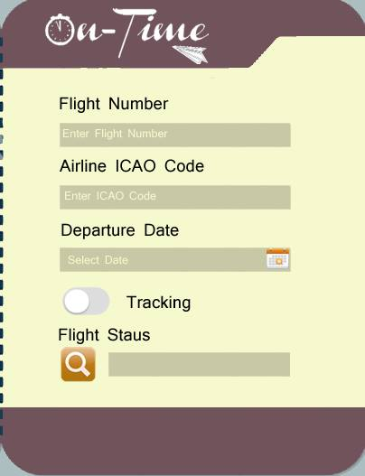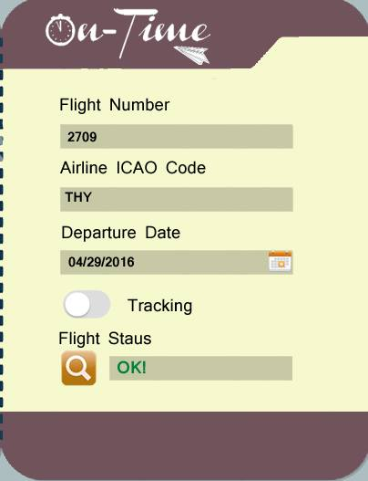

Landscape

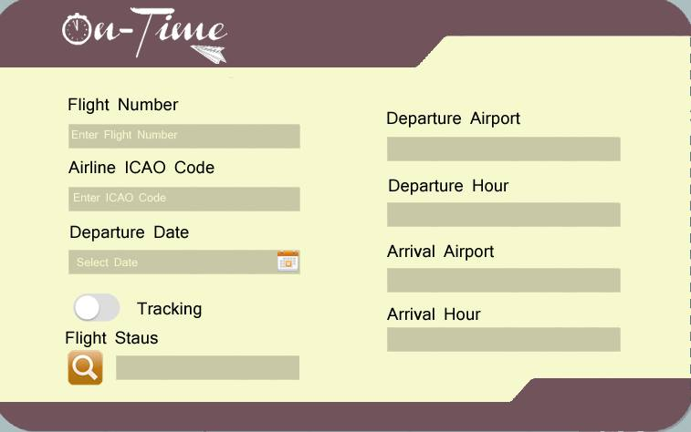

Tracking service activated

