**Club Membership Application**

A sample template to use as a club membership application form,

for test and demonstration purposes.

Workflow of this example/ usage scenario:

**1** – The aspiring club applicant goes to the website of this club where he enters the data requested:

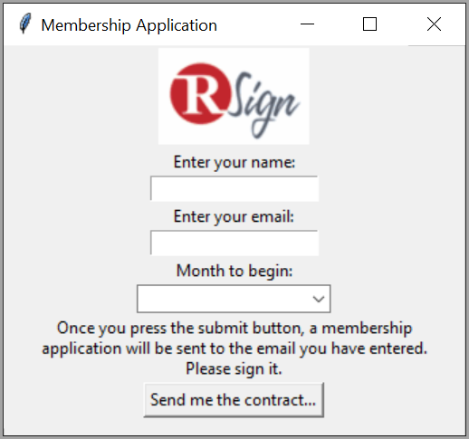

**2** – Once done he presses on “**Send me the contract**” which is this document.

**3** – This document is sent by RSign to the email address indicated above, which should be that of the applicant.

**4** – Once signed the document is forwarded to an “Applicant Qualifier” for approval. The qualifier is requested to sign as well.

|  |  |  |
| --- | --- | --- |
| *Club Applicant Signature* |  | *Club Administration* |
|  |  |  |
| *Date (dd / mm / yyyy)* |  | *Date (dd / mm / yyyy)* |
|  |  |  |