Component Definition Document
(CDD)
For the
Weather
Example
Component Assembly

Rev. -

June 27, 2011

Prepared By:
Northrop Grumman Corporation
Electronic Systems
Baltimore, MD
Table of Contents
1 Introduction 3
1.1 Scope 3
2 Applicable Documents 3
2.1 Applicable Government Documents 3
2.2 Other Applicable Documents 3
3 Component Description 3
3.1 Overview 3
3.2 Operational Context 4
4 Component Interfaces 4
4.1 Service Ports 4
4.1.1 Weather Information Facet (internal) 4
4.2 Client Ports 5
4.2.1 Weather Information Receptacle (internal) 5
4.3 Publisher Ports 5
4.3.1 Temperature Reading Publisher (internal) 5
4.4 Subscriber Ports 5
4.4.1 Temperature Reading Subscriber (internal) 5
4.5 External Ports 5
5 Component Functionality 5
6 Configurable Parameters 5
7 Design Constraints 6
8 Component Test 6
9 Component Dependencies 6

Introduction

Scope
This document captures the specification and design for the Weather Example software component assembly. This example assembly is targeted for deployment on the Scalable Node Architecture (SNA) real-time component framework. As such, it must be compliant with SNA Component Based Architecture (CBA) design guidelines.

This specification defines the component assembly’s functional, interface and performance requirements, the context in which it must operate, and any design constraints it must adhere to. It provides criteria for verifying compliance, but it does not state methods for achieving results.

This is intended to be a relatively informal living document, to be included in same CM repository and package as the component source code. This CDD will initially be populated by a system engineer or software architect/lead to define component design constraints & guidelines. Over time, it will transition to enhance the “to be built” specification sections with “as built” design information documenting the final component product.

Applicable Documents

Applicable Government Documents

Document No. | Title

Other Applicable Documents

Document No. | Title
N/A | RTI DDS User’s Guide

Component Description

Overview
The Weather Example component assembly is one of the component source examples included in the SNA SDK for reference, testing and experimentation. This example illustrates the pattern for sharing state information between component executers and facet executers and the use of CCM attributes. In addition, this example also demonstrates the pattern for using a CCM receptacle / facet, using a timer, and using the DDS_State publish / subscribe ports.

There are three components in this example, Airplane_comp, TemperatureSensor_comp, and WeatherStation_comp. The TemperatureSensor_comp periodically publishes a TemperatureReading_msg which contains the latest temperature reading. The component has two attributes which allows it to be configured for the simulated average and standard deviation between readings. The WeatherStation_comp subscribes to the TemperatureSensor_msg and creates an average over the last 100 readings. The Airplane_comp uses a provided facet to query the WeatherStation_comp for the average and latest readings. This is shown in Figure 3-1.

Note: This example currently has only one TemperatureSensor_comp instance and thus one DDS instance. It should be noted that in real-life situations there would almost always be multiple instances when using this pattern. In addition, many DDS QoS settings such as history depth are actually per instance (not per topic). For example, if a subscriber had a history depth that was set to five samples and there were four instances (i.e., values of a key) on that topic, then there would be a total of 20 samples (four independent buffers of five samples) buffered for that subscriber.

Operational Context
Figure 3-1 – Weather Example Component Assembly
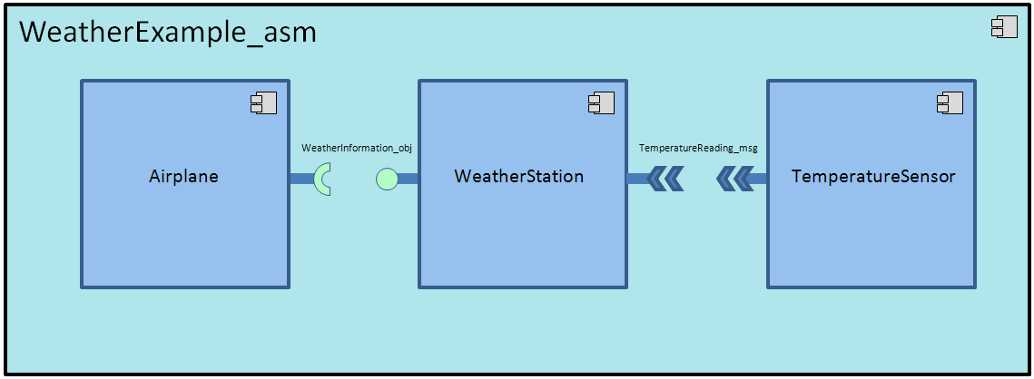
This simple assembly is completely self contained and has no external connections. It is designed to operate solely within the constraints of the SNA SDK development environment to allow a new user/developer to step through the SNA component based development (CBD) process of loading a component assembly into the SNA IDE, building/compiling it, and then executing it.

The example is provided with an appropriate set of SNA configuration files and a deployment plan to support its execution within a single-host SNA SDK “localhost” Virtual Machine (VM). Alternative variations on the default supplied design and deployment are possible via experimentation by a software developer.

Component Interfaces
The component assembly has an interface between the Airplane component and the Weather Station component. In addition, the Weather Station and Temperature Sensor interact with each other through a DDS message shown Figure 3-1.

Service Ports

Weather Information Facet (internal)
The Weather Information facet is provided by the Weather Station component. The facet interface provides one method called getWeatherInformation() which takes a WeatherInformation structure as an out parameter and returns a Boolean indicating the validity of the structure.

Client Ports

Weather Information Receptacle (internal)
The Weather Information receptacle is used by the Airplane component. The receptacle interface uses one method called getWeatherInformation ()which takes a WeatherInformation structure as an out parameter and returns a Boolean indicating the validity of the structure. The client port will periodically get called upon the expiration of an internal timer.

Publisher Ports

Temperature Reading Publisher (internal)
The Temperature Sensor component will periodically publish updates to a topic instance that contains the latest temperature reading. The topic instance is defined by a sensor ID value, unique to each component instance. This component publishes using a DDS_Update extended port that is typed by the TemperatureReading_msg structure.

Subscriber Ports

Temperature Reading Subscriber (internal)
The Weather Station component will subscribe to receive updates to the data published periodically by a Temperature Sensor component. This component subscribes using a DDS_StateListener extended port that is typed by the TemperatureReading_msg structure.

External Ports
There are no external ports for this assembly.

Component Functionality
At startup the Temperature Sensor component will set up an SNA timer (per the SNA Time Management API) to generate a timer event every 1 seconds. Upon timer expiration, the Temperature Sensor’s timer callback will publish an event with a simulated temperature reading.

The temperature reading event will be processed by the Weather Station component and an average of the last 100 readings will be made available for query. The Airplane component will use the provided facet and query for the average and last temperature readings every 1 second. The readings will be displayed on the console.

Once started, this scenario will execute indefinitely, or until the deployment is halted manually.

The DDS_State connector is used for DDS publishing and subscribing by using the DDS_Update and DDS_StateListen extended ports. The topic has a key consisting of a long corresponding to a unique sensor ID.

Configurable Parameters
The temperature sensor can be configured to publish an average temperature and variance via CCM attributes reflected in the deployment plan.

Design Constraints
- A Temperature Sensor will periodically publish a DDS message with the latest simulated value.
- The DDS message will be published and subscribed to using a DDS_State connector.
- A Weather Station will subscribe the temperature readings to create an average temperature reading for the last 100 values.
- An Airplane component will periodically query the Weather Station for the latest and last 100 readings.
- The Weather Example component assembly will follow established naming conventions and code organization guidance defined in the SNA SDK documentation, such that new SNA software developers can use it as a design reference.
- A full set of SNA compliant configuration and deployment files will be provided with this example in order to support run-time execution in a default single-host target deployment.
- This example will utilize the standard SNA APIs to perform all functions.

Component Test
This 3-component assembly must be executable on a single “localhost” development computer, to include the SNA SDK x86-64 VM at a minimum. Users can experiment with the deployment plan to redeploy to an alternative 2-host target environment if desired.

Component Dependencies
The Weather Example assembly is self contained and has no dependencies on any other application components. Its only dependency is on the SNA SDK’s run time execution environment.

