[Company Address]

Toby McClean

[Type the abstract of the document here. The abstract is typically a short summary of the contents of the document.]

08

**Fall**

Exercise Book

# Plug-in Exercises

What this exercise is about

In this exercise you will extend the Workbench

At the end of this exercise you should be able to

* Create Eclipse Plug-in Projects
* Add menus to the Workbench

## Create a new project

The first step in creating our plug-in is to create a plug-in project using the Eclipse New Project wizard. We will create an empty Eclipse Plug-in project that contributes to the Workbench UI.

From the File menu New 🡪 Project…

Select Plug-in Project from the list of possible projects to create in the New Project wizard.

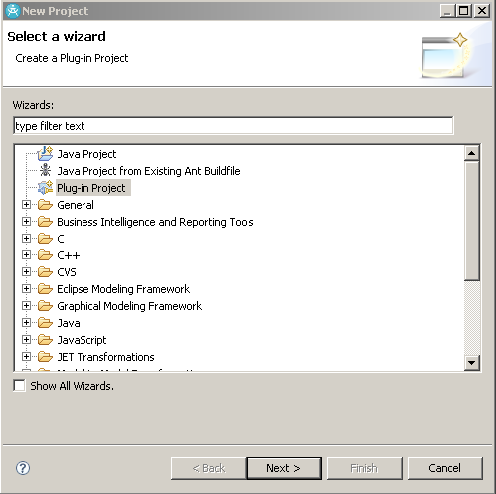

Click the Next button.

Enter the name of the project; com.eett.exercises.plugins. Keep Use default location and Create a Java project checked. Retain the defaults for the other properties. Click on Next >.

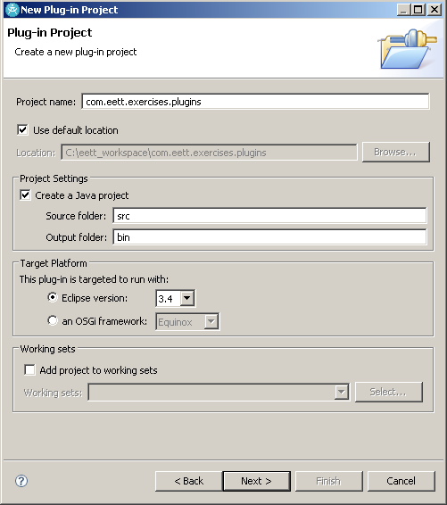

Specify the Plug-in Content. Keep the Plug-in ID, Plug-in Version, Plug-in Provider and Execution Environment defaults. Change the Plug-in Name to EETT Plug-in Exercises. Uncheck Generate an activator and make sure that This plug-in will make contributions to the UI is checked. Click the Next > button.

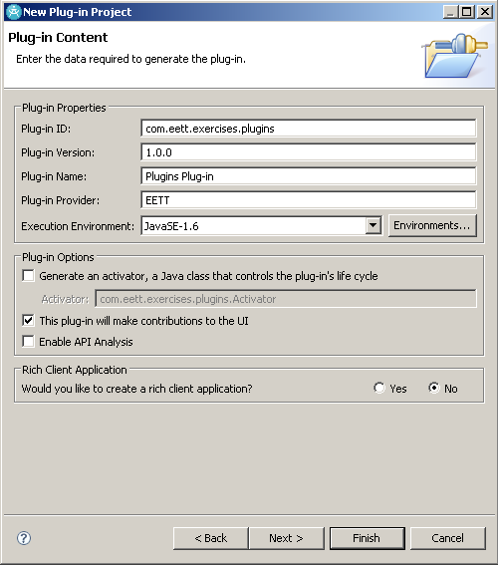

On the Templates page check the ‘Create a plug-in using one of the templates’ and select the ‘Hello, World’ option. Click Next >.

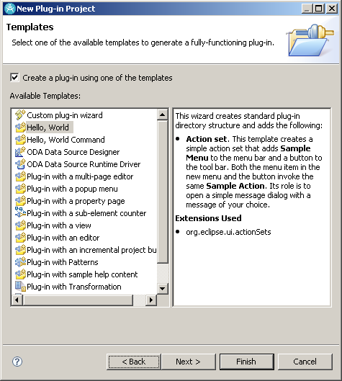

By using a Template most of the code necessary to create a menu and an Action to handle selecting the menu is generated for you. In the Sample Action Set page you can configure the code that will be generated. Change the Action Class Name to HelloWorldAction and the Message Box Text to Welcome to the transformation training. Click Finish.

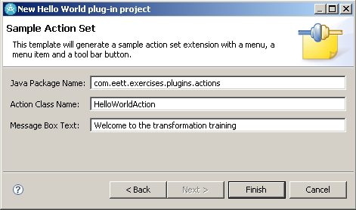

When prompted to switch to the Plug-in Development perspective click Yes.

## Test the plug-in

At this point we can launch a Runtime Workbench and see our plug-in in action. To view the default that is generated select Run As 🡪 Eclipse Application from the project’s context menu.

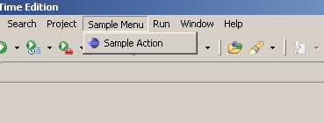

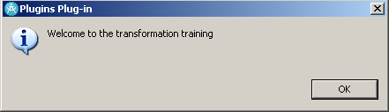

This is an Eclipse version of the classic Hello World application. We will explore in more detail and augment the default that was created for us.

## Define the plug-in manifest files

The project wizard that we used in the previous steps created the plug-in manifest files for us. The plugin.xml contains our extensions to the Eclipse workbench and META-INF/MANIFEST.MF describes the plug-in and its dependencies.

Open the MANIFEST.MF file in the Plug-in Manifest Editor and explore the values using the Overview, Dependencies and Runtime pages.

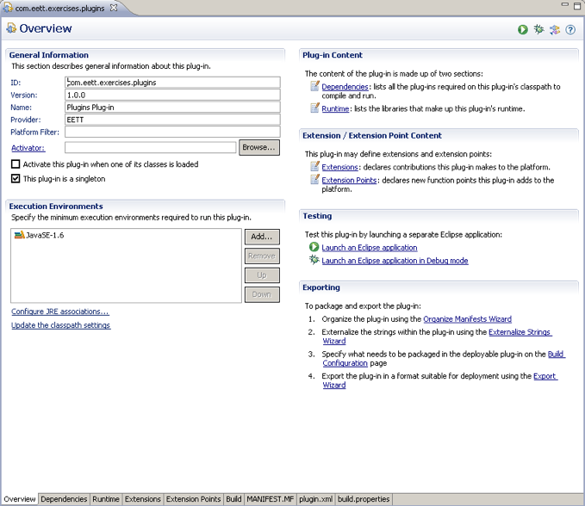

You can also change the MANIFEST.MF manually using the MANIFEST.MF page in the editor. We do not need to change this file at this point.

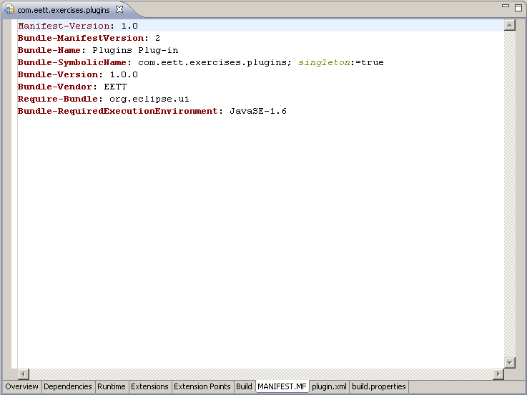

Open the plugin.xml using the Plug-in Manifest Editor. The current file should look like the following. We will change some of these values in order to customize the defaults that were generated by the wizard.

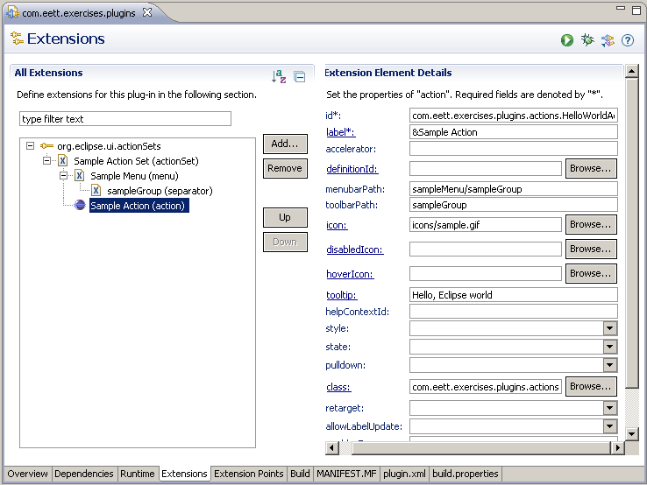

|  |
| --- |
| <plugin>  <extension  point="org.eclipse.ui.actionSets">  <actionSet  label="Sample Action Set"  visible="true"  id="com.eett.exercises.plugins.actionSet">  <menu  label="Sample &amp;Menu"  id="sampleMenu">  <separator  name="sampleGroup">  </separator>  </menu>  <action  label="&amp;Sample Action"  icon="icons/sample.gif"  class="com.eett.exercises.plugins.actions.HelloWorldAction"  tooltip="Hello, Eclipse world"  menubarPath="sampleMenu/sampleGroup"  toolbarPath="sampleGroup"  id="com.eett.exercises.plugins.actions.HelloWorldAction">  </action>  </actionSet>  </extension>  </plugin> |

When we ran the plug-in that was generated the menu item names were not very descriptive or customized. We will change the names of the menus from Sample… to something more specific to our exercises. We will reuse the main menu item that is contributed to the workbench so we need to ensure that its name is applicable and that its id is intuitive.

Start by changing the label of the actionSet to **EETT Action Set**, which is the label used by the Workbench to represent this action set to the user. We will also set the description field to ‘**Actions contributed during the Eclipse transformation training**’. This change will show up in the perspective configuration where you can show and hide action sets.

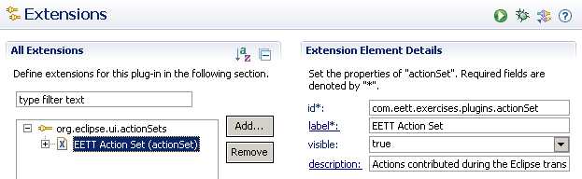

Change the menu label to **EETT**, which will be the label used in the main menu of the workbench. Also, change the id of the menu to **com.eett.eettMenu**, this id is used to refer to the menu to add actions.

Change the menu’s separator to have the name **additions** rather than **sampleGroup**. This separator is used as part of the path to add actions to the EETT menu.

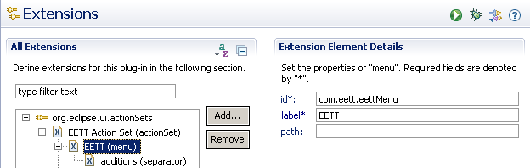

We can now update the action to reflect the changes we have made to the menu and action set. We will start by changing the label to **Welcome** to better reflect what the action does. In the previous steps we changed the id of the menu and the name of its seperator so we have to update the path menubarPath to reflect this; change it to **com.eett.eettMenu/additions**. We can also change the tooltip to **EETT Welcome**.

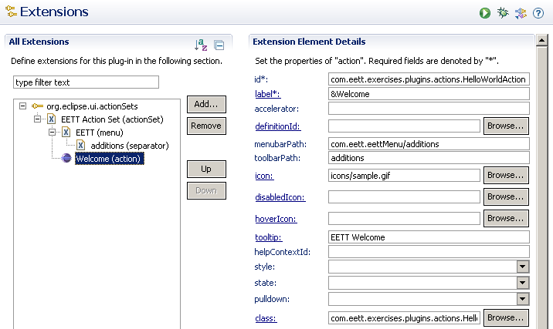

The plugin.xml file should now resemble

|  |
| --- |
| <plugin>  <extension  point="org.eclipse.ui.actionSets">  <actionSet  label="EETT Action Set"  visible="true"  id="com.eett.exercises.plugins.actionSet">  <menu  label="EETT"  id="com.eett.eettMenu">  <separator  name="additions">  </separator>  </menu>  <action  label="&amp;Welcome"  icon="icons/sample.gif"  class="com.eett.exercises.plugins.actions.HelloWorldAction"  tooltip="EETT Welcome"  menubarPath="com.eett.eettMenu/additions"  toolbarPath="additions"  id="com.eett.exercises.plugins.actions.HelloWorldAction">  </action>  </actionSet>  </extension>  </plugin> |

We can launch a Runtime Workbench and see our plug-in changes in action.

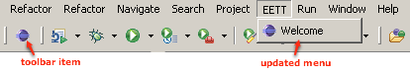

To view our action set name changes we can open the Customize Perspective dialog; Window 🡪 Customize Perspective… This is also a good place to look if the menu does not show up in your runtime workbench.

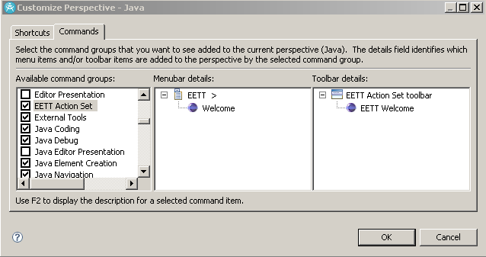

## Implement the action delegate

This part of the exercise will modify the default action delegate that was generated by the wizard. Switch to the Java perspective and open the **HelloWorldAction.java** file. The code is documented take a few minutes to familiarize yourself with it.

We are going to the change the title for the dialog box. In the run method change the second parameter of MessageDialog.openInformation to “EETT”. *Note that it is best practice to externalize strings such as this one so that they can be localized.* Your run method should now resemble.

|  |
| --- |
| **public** **void** run(IAction action) {  MessageDialog.*openInformation*(  window.getShell(),  "EETT",  "Welcome to the transformation training");  } |

Save your changes and launch the runtime workbench to ensure that your changes were made. It should now look like.

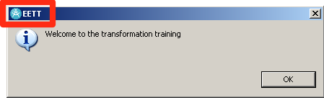

## Publish the plug-in

We now have a plug-in and we can publish it to our installation so that it is available without running the workbench.

Open the Plug-in Manifest Editor for our plug-in and switch to the Overview page. In the top right-hand corner is a button to export the plug-in. Click on the button.

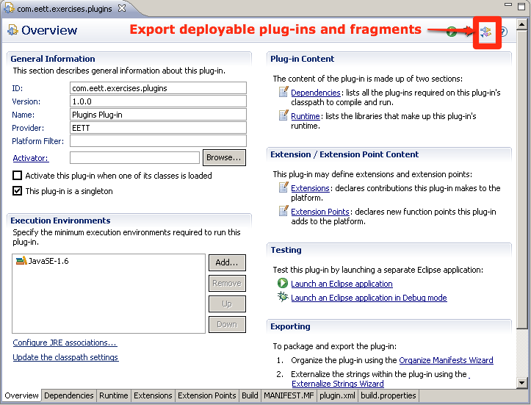

In the dialog make sure your plug-in is selected in the list of Available Plug-ins and specify Destination Directory as the plug-ins directory of your Eclipse install. With RSA-RTE this will likely be SDPShared directory of your install. Leave the other settings to their defaults.

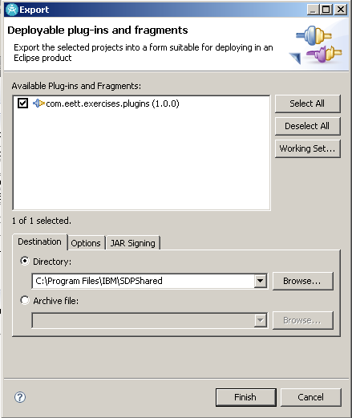

Click the Finish button and restart your workbench. When the workbench restarts it will have the EETT menu just like in the runtime workbench. Test to make sure that it behaves the same.

Through out the course we will add additional actions to the EETT menu.

# Eclipse Modeling Framework Exercises

In this exercise a metamodel for the structural part of ROOM will be developed in order to gain a better understanding of EMF. The exercise will start by creating an Ecore model of the ROOM language. This model is used to create dynamic instances and to generate the code for the metamodel and a default tree based editor. There will be activities show how to work with the generated code in order to implement the derived attributes, implement operations and override code that is generated by EMF.

The last two activities of the exercise will practice working with transactions and querying a model.

## Building an Ecore Model

Create a new project basic project.

From the main menu select File 🡪 New 🡪 Project…

In the New Project Wizard select Project under the General group, and click the Next > button.

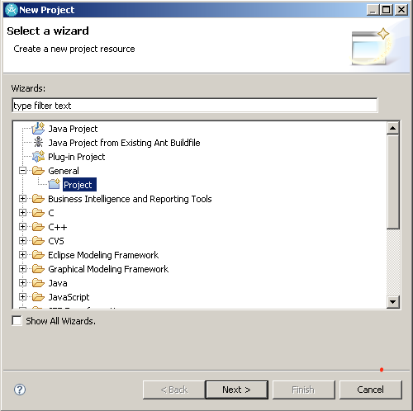

Provide a Project Name, com.eett.exercises.emf and click the Finish button

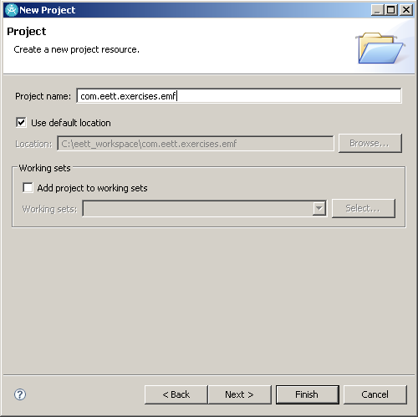

Create a new EMF model.

Add a models folder to the com.eett.exercises.emf project, to store our model artifacts

Select the models folder and choose File 🡪 New 🡪 Other…

In the New wizard select Ecore Diagram from Other (you may have to check Show All Wizards) and click the Next > button

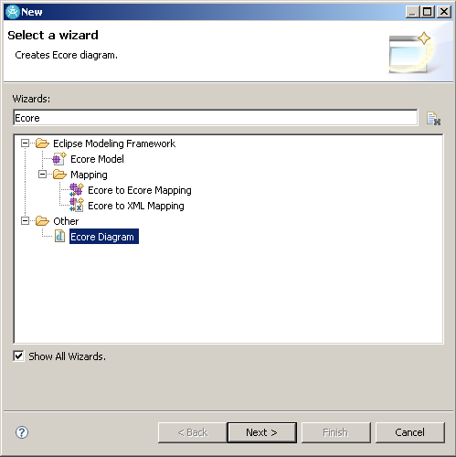

Set the name of the Ecore Diagram to room.ecore_diagram and click the Next > button

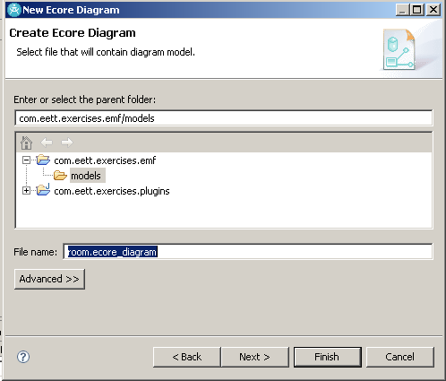

Set the name of the Ecore model to room.ecore and click the Finish button

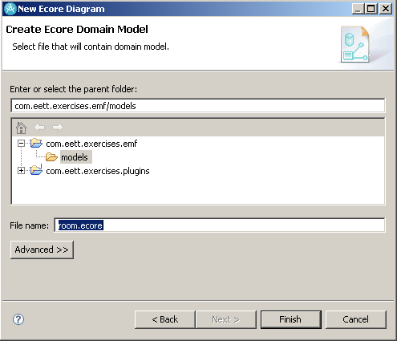

Your project should now look like

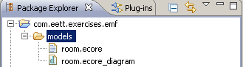

Open the Ecore diagram and set the properties in the property grid to the following, which configures the properties of the root ePackage. To access the properties right-click in the diagram editor and select Show Properties View.

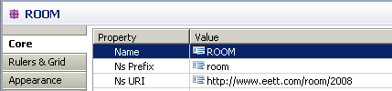

In the diagram editor build a model that looks like the following

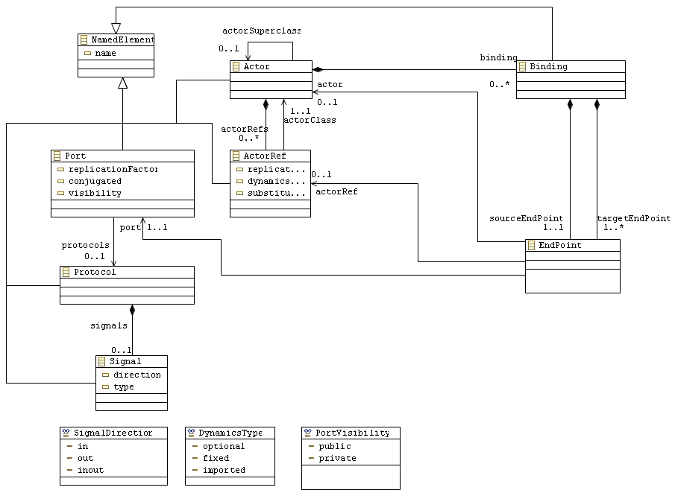

NamedElement (Abstract EClass)

|  |  |  |  |
| --- | --- | --- | --- |
| **Name** | **Type** | **Lower bound** | **Upper bound** |
| name | EString | 0 | 1 |

|  |  |  |  |  |  |
| --- | --- | --- | --- | --- | --- |
| Name | Type | Containment | Opposite | Lower bound | Upper bound |
|  |  |  |  |  |  |

Actor (EClass)

extends NamedElement

|  |  |  |  |
| --- | --- | --- | --- |
| **Name** | **Type** | **Lower bound** | **Upper bound** |
|  |  |  |  |

|  |  |  |  |  |  |
| --- | --- | --- | --- | --- | --- |
| Name | Type | Containment | Opposite | Lower bound | Upper bound |
| actorSuperClass | Actor | false |  | 0 | 1 |
| bindings | Binding | true | actor | 0 | -1 |
| actorRefs | ActorRef | true | container | 0 | -1 |
| ports | Port | true |  | 0 | -1 |

ActorRef (EClass)

|  |  |  |  |  |
| --- | --- | --- | --- | --- |
| **Name** | **Type** | **Lower bound** | **Upper bound** | **Default** |
| replicationFactor | EInt | 0 | 1 |  |
| dynamicsType | DynamicsType | 0 | 1 | fixed |
| substitutable | EBoolean | 0 | 1 | false |

|  |  |  |  |  |  |
| --- | --- | --- | --- | --- | --- |
| Name | Type | Containment | Opposite | Lower bound | Upper bound |
| actorClass | Actor | false |  | 1 | 1 |
| container | Actor | false | actorRefs | 1 | 1 |

Port (EClass)

|  |  |  |  |  |
| --- | --- | --- | --- | --- |
| **Name** | **Type** | **Lower bound** | **Upper bound** | **Default** |
| replicationFactor | EInt | 0 | 1 | 1 |
| conjugated | EBoolean | 0 | 1 | false |
| visibility | PortVisibility | 0 | 1 | public |

|  |  |  |  |  |  |
| --- | --- | --- | --- | --- | --- |
| Name | Type | Containment | Opposite | Lower bound | Upper bound |
| protocol | Protocol | false |  | 0 | 1 |

Protocol (EClass)

|  |  |  |  |
| --- | --- | --- | --- |
| **Name** | **Type** | **Lower bound** | **Upper bound** |
|  |  |  |  |

|  |  |  |  |  |  |
| --- | --- | --- | --- | --- | --- |
| Name | Type | Containment | Opposite | Lower bound | Upper bound |
| signals | Signal | true |  | 0 | -1 |

Signal (EClass)

|  |  |  |  |  |
| --- | --- | --- | --- | --- |
| **Name** | **Type** | **Lower bound** | **Upper bound** | **Default** |
| direction | SignalDirection | 0 | 1 | in |
| type | EString | 0 | 1 |  |

|  |  |  |  |  |  |
| --- | --- | --- | --- | --- | --- |
| Name | Type | Containment | Opposite | Lower bound | Upper bound |
|  |  |  |  |  |  |

SignalDirection (EEnum)

|  |  |
| --- | --- |
| **Name** | **Value** |
| IN | 0 |
| OUT | 1 |
| INOUT | 2 |

DynamicsType (EEnum)

|  |  |
| --- | --- |
| **Name** | **Type** |
| optional | 0 |
| fixed | 1 |
| imported | 2 |

PortVisibility(EEnum)

|  |  |
| --- | --- |
| **Name** | **Type** |
| public | 0 |
| private | 1 |

When finished creating the model validate it to ensure that there are no errors. To validate select the root package and Sample Ecore Editor 🡪 Validate from the main menu.

We have built a metamodel for a subset of the ROOM language, we can now look at creating the generator model and creating models using the metamodel.

Publish the Model so that it can be used dynamically

We will first convert our com.eett.exercises.emf project to a plugin project. Select the project and choose PDE Tools 🡪 Convert Projects to Plug-in Projects… Make sure that com.eett.exercises.emf is checked and click Finish.

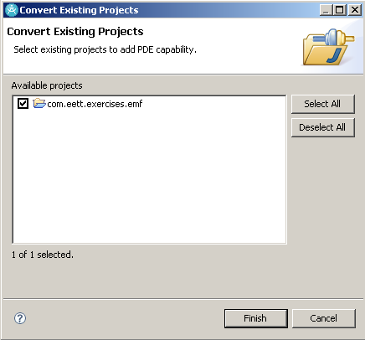

Open the META-INF/MANIFEST.MF in the Plug-in Manifest Editor and change the Name of the plug-in to be EETT EMF Models and the provider to EETT. Save your changes and switch to the Extensions page of the editor.

On the Extensions page click the Add… button. In the Extension Point Selection dialog make sure that Show only extension points from the required plug-ins is unchecked. Then select the com.eclipse.emf.ecore.dynamic_package extension point. Click the Finish button.

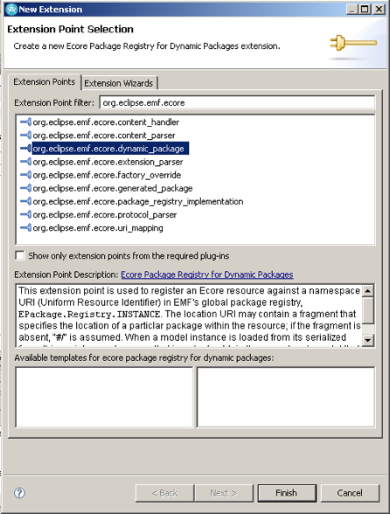

Set the extension points URI field to be the NS URI of the room.ecore model and the location to the location of the room.ecore model. Save your changes.

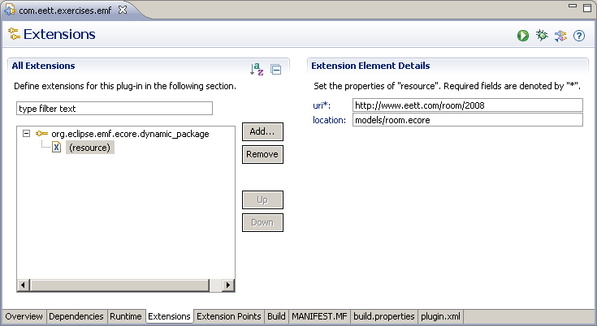

## Creating a Dynamic Instance

Once the metamodel has been created it is possible to create instances of the ROOM metamodel that was defined in the previous exercises. The reflective API of EMF allows a generic editor to be provided to create what are called dynamic instances of the model. This is as opposed to generating the implementation of the metamodel and using either the generated editor or building a custom editor.

In the EMF Ecore editor select the Actor element, and select Create Dynamic Instance from the context menu.

Open the Run Configuration dialog (Run 🡪 Run Configurations…). Create a new Eclipse Application configuration, EMF Exercises, and switch to the Plug-ins page. Change the Launch with field to ‘plug-ins selected below only’.

In the list of plug-ins uncheck com.ibm.ccl.help.preferenceharvester, and click Apply followed by Run.

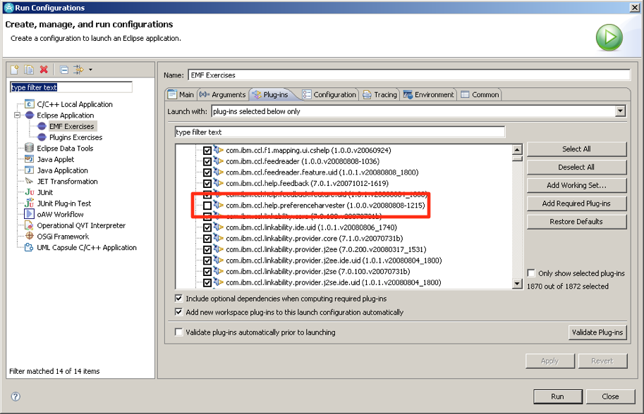

This should launch a runtime workbench, which we will use to programmatically work with our ROOM metamodel. To do this we will use Pluglets, which are an IBM Modeling Platform specific technology for extending the workbench. A pluglet provides script like capabilities, to perform tasks without having to build full plug-ins.

In the runtime workbench create a new Pluglets project, named com.eett.exercises.emf.pluglets. Don’t worry about the other settings in the project wizard.

The project will contain a pluglet.xml file which is used to capture dependencies on plug-ins. We going to use EMF in this exercise, therefore we need to add a dependency on org.eclipse.emf.ecore. Open pluglet.xml with a text editor and modify it to look like the following and save the file

|  |
| --- |
| <?xml version="1.0" encoding="UTF-8"?>  <pluglets>  <require>  <import plugin="com.ibm.xtools.pluglets"/>  <import plugin="org.eclipse.emf.ecore"/>  </require>  </pluglets> |

The Pluglets Plug-in Dependencies should now include org.eclipse.emf.ecore and org.eclipse.emf.common.

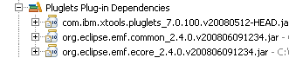

Now create a new Pluglet (File 🡪 New 🡪 Pluglet) in the project. Select the Simple 🡪 Pluglet template. Click the Next > button. Set the name of the Pluglet to DynamicROOMModel and click Finish.

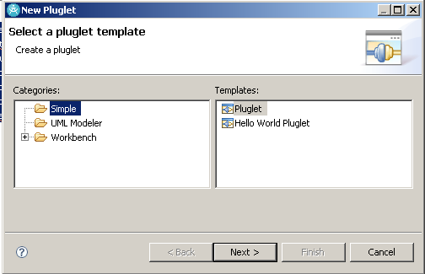

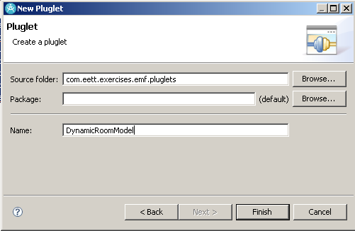

Open the DynamicRoomModel.java file and enter the code described below. This code creates two Actor objects, AbstractDyeingController and DyeingController. They are stored in separate resources, abstractDyeingController.xmi and dyeingController.xmi respectively. We then set the actorSuperclass of DyeingController to be AbstractDyeingController.

|  |
| --- |
| **import** java.io.IOException;  **import** org.eclipse.emf.common.util.URI;  **import** org.eclipse.emf.ecore.EClass;  **import** org.eclipse.emf.ecore.EObject;  **import** org.eclipse.emf.ecore.EPackage;  **import** org.eclipse.emf.ecore.EStructuralFeature;  **import** org.eclipse.emf.ecore.resource.Resource;  **import** org.eclipse.emf.ecore.resource.ResourceSet;  **import** org.eclipse.emf.ecore.resource.impl.ResourceSetImpl;  **import** com.ibm.xtools.pluglets.Pluglet;  **public** **class** DynamicRoomModel **extends** Pluglet {  **private** **static** **final** String *MODELS_FOLDER*  = "platform:/resource/com.eett.exercises.emf.pluglets/models/";    **public** **void** plugletmain(String[] args) {    // Retrieved the EPackage for the Room metamodel that we registered  // It is retrieved using the string we specified as the URI when we  // registered it in the dynamic_package extension point  EPackage room  = EPackage.Registry.*INSTANCE*  .getEPackage("http://www.eett.com/room/2008");    **if**(room != **null**) {  // Create a ResourceSet so that we can create Resources  // to store the model elements we create in  ResourceSet resourceSet = **new** ResourceSetImpl();    // Create the Resources to store the objects that we create in  Resource controllerResource  = resourceSet.createResource(URI.*createURI*(  *MODELS_FOLDER* + "dyeingController.xmi"));  Resource abstractControllerResource  = resourceSet.createResource(URI.*createURI*(  *MODELS_FOLDER* + "abstractDyeingController.xmi"));    // In order to be able to create an Actor object we need  // have its EClass which we can get from the EPackage  EClass actorEClass = (EClass) room.getEClassifier("Actor");    // Similarly, to set the features of an Actor we  // need the EStructuralFeature objects for them which we  // can get from the EClass  EStructuralFeature actorNameAttribute  = actorEClass.getEStructuralFeature("name");  EStructuralFeature actorSuperclass  = actorEClass.getEStructuralFeature("actorSuperclass");    // Create the AbstractDyeingController Actor and add it  // to the Resource we created for it  EObject abstractController =  room.getEFactoryInstance().create(actorEClass);  abstractController  .eSet(actorNameAttribute, "AbstractDyeingController");  abstractControllerResource.getContents()  .add(abstractController);    // Create the DyeingController Actor and add it  // to the Resource we created for it  EObject controller =  room.getEFactoryInstance().create(actorEClass);  controller  .eSet(actorNameAttribute, "DyeingController");  controllerResource.getContents().add(controller);    // Set the actorSuperclass feature of the dyeingController  // to be the abstractController  controller.eSet(actorSuperclass, abstractController);    // Save and unload the Resources we created and added  // contents to  **try** {  abstractControllerResource.save(**null**);  controllerResource.save(**null**);  abstractControllerResource.unload();  controllerResource.unload();  } **catch** (IOException e) {  out.println("Could not save the resources.");  }    }  **else** {  out.println("Could not get the room EPackage");  }  }  } |

Run the Pluglet by selecting Run 🡪 Internal Tools 🡪 DynamicRoomModel or from the toolbar as shown below.

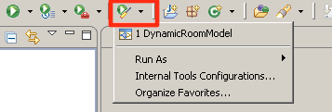

Running the Pluglet should create a new folder models in your project with two files. Open the dyeingController.xmi file with the Generic Editor. Notice how it also loaded the abstractDyeingController.xmi because there is a cross-reference to it (actorSuperclass of DyeingController).

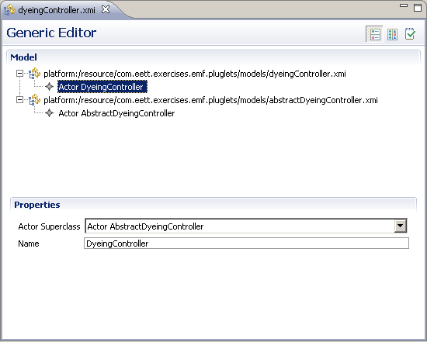

## Generating code for the Ecore Model

The Ecore model created in the previous exercise specifies the concepts, relationships and capabilities within our ROOM domain. In order to be able to generate code for this model we need to create a generator model that decorates the metamodel you defined with additional information to help with generation.

On the models folder in the com.eett.exercises.emf project right-click and select New 🡪 Other…

In the New wizard select EMF Model under the Eclipse Modeling Framework folder and click Next >

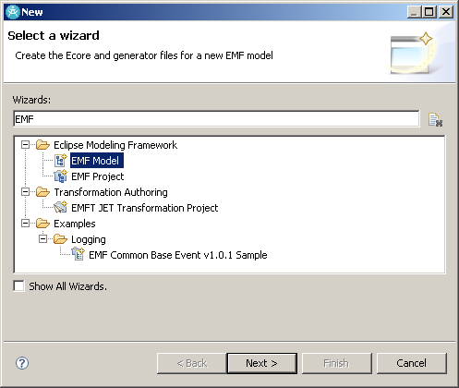

Set the file name to room.genmodel and click the Next > button

A Model Importer must be selected to create our generator model, select the Ecore Model option and click Next >

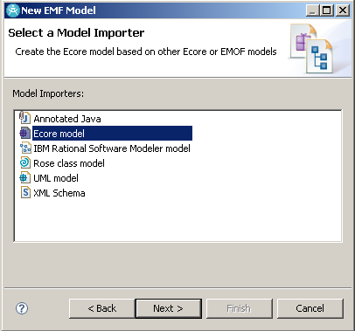

On the Ecore Import page use the Browse Workspace to locate and select the room.ecore model and click the Load button and then Next >

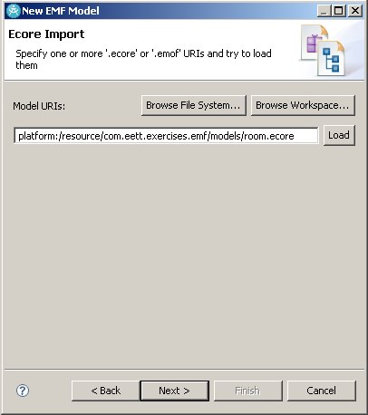

The following dialog should appear select the Finish button

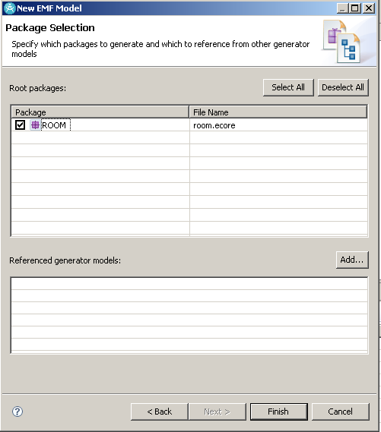

Open the new room.genmodel with the EMF Generator editor,

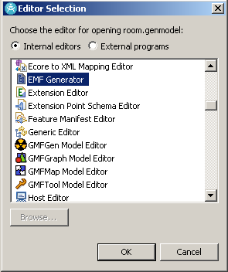

The model should look like the following

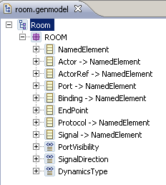

Explore the generator model observing the additional properties that have been added to the elements from our Ecore model. At this point the only property that we need to change is Base Package on the root EPackage ROOM. Change this property to com.eett.exercises.emf, this is the package that the generated code will be generated into.

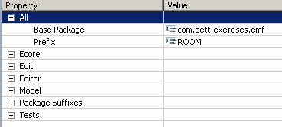

With the generator model open right-click on the root package element and select Generate All, this will generate three new plug-ins (com.eett.exercises.emf.edit, com.eett.exercises.emf.editor, and com.eett.exercises.emf.test) and add source to the com.eett.exercises.emf project that the model is in. It will also modify the com.eett.exercises.emf project adding the plug-in and Java nature to the project.

The com.eett.exercises.emf project should now resemble

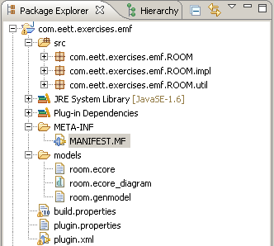

If there are errors in the three other projects we need to update the plug-in manifest for the com.eett.exercises.emf. Open the MANIFEST.MF file in the Plug-in Editor and change to the Runtime page. We need to export the com.eett.exercises.emf.ROOM and com.eett.exercises.emf.ROOM.util packages that were generated because the .edit, .editor and .test plug-ins are dependent on them.

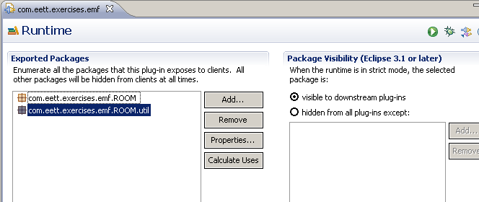

|  |
| --- |
| Manifest-Version: 1.0  **Bundle-ManifestVersion**: 2  **Bundle-Name**: Emf  **Bundle-SymbolicName**: com.eett.exercises.emf;*singleton*:=true  **Bundle-Version**: 1.0.0  **Require-Bundle**: org.eclipse.emf.ecore  **Export-Package**: com.eett.exercises.emf.ROOM,  com.eett.exercises.emf.ROOM.util  **Bundle-RequiredExecutionEnvironment**: JavaSE-1.6 |

We need to change the registration of the metamodel to point to the generated package. Comment out the org.eclipse.emf.ecore.dynamic_package extension in plugin.xml and add a new extension org.eclipse.emf.ecore.generated_package. Set the URI to be <http://www.eett.com/room/2008> and the class to com.eett.exercises.emf.ROOM.ROOMPackage.

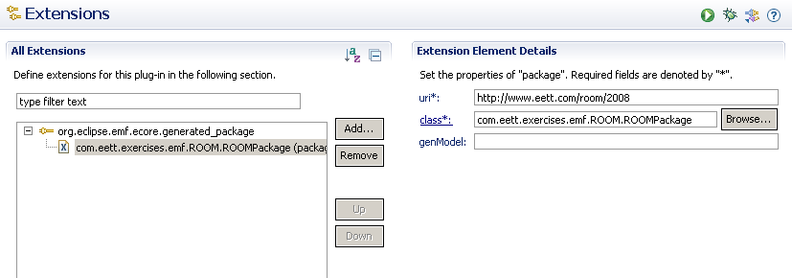

For now we won’t worry about the code that was generated, instead we will create a model using the generated model editor.

Switch to the Java perpective and open the Run Configurations dialog by selecting Run 🡪 Run Configurations… from the main menu or by using the toolbar.

Java - com

Select EMF Exercises Run Configuration by selecting the Eclipse Application entry on the left and make sure that our new plug-ins are included.

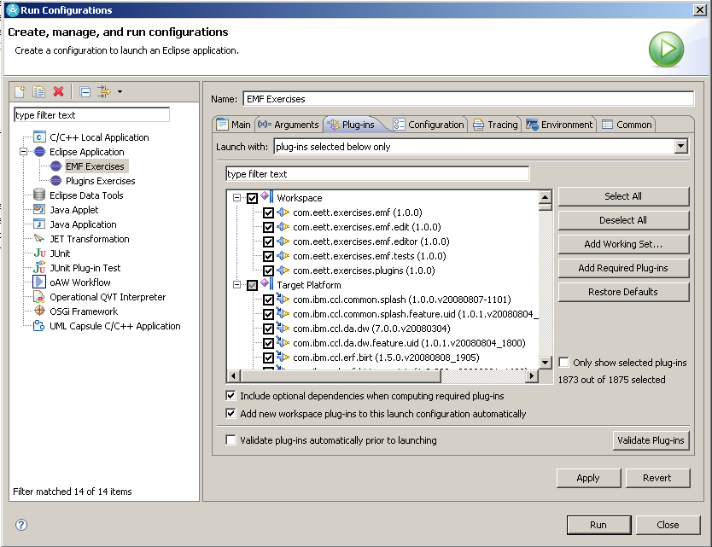

Now click on the Apply button followed by the Run button, this should launch a Runtime Workbench that will enable you to use the editor that was generated for the ROOM metamodel.

To create a ROOM model select the models folder in our com.eett.exercises.emf.pluglets project and File 🡪 New 🡪 Other… In the New wizard select the ROOM Model wizard and click Next >.

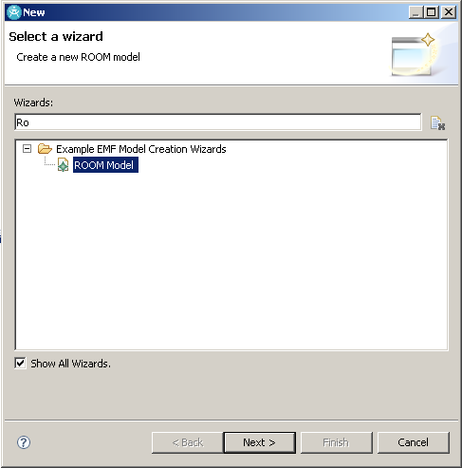

Set the name of the model to DyeingController.room and click Next >. In the ROOM Model wizard set the Model Object to Actor and click Finish.

This will create a new resource with an Actor object in it and open it in the ROOM Editor, which is customized to the ROOM metamodel. Notice that the shortcoming of our current metamodel is that we have no top container element allowing us to create other elements of our model in the same resource.

Exit the runtime workbench and modify the metamodel to include a Model EClass that can contain Actors and Protocols. Reload the generator model (in the EMF Generator editor, Generator 🡪 Reload… from the main menu.) Regenerate the model and re-launch the runtime workbench to be able to create a ROOM Model with Model as the Model Object.

Possible improvements

* Change the Wizard category of the ROOM Model in the wizard
* By changing the _UI_Wizard_category property in the plugin.properties file
* Add a perspective where the ROOM Model is listed in the New Menu with having to go through the Select a wizard

## Implement a derived attribute and operation

In this exercise we will add a derived attribute and an operation into our model and then provide the logic for them. An Actor has a reference to Port and a port has different attributes, one of which is visibility. We will consider all public Ports to be interface ports, so we can derive the list of interface ports from the ‘ports’ existing ports reference. Similarly, we may want to have an operation on an Actor for creating an interface port, given a name.

Open the room.ecore model in the Sample Ecore Model Editor and modify the Actor EClass adding

## Working with transactions

## Querying our model

In this exercise will create a plug-in that extends the ROOM Model Editor with a query that will find all Actor’s that do not have a actorSuperclass. In order to do this we will add an action to the model editor that invokes the query we will write.

Start by creating a new plug-in project with

|  |  |
| --- | --- |
| ID | com.eett.exercises.emf.query, |
| Name | EETT EMF Query Exercise |
| Provider | EETT |
| Version | 1.0.0 |
| This plug-in is a singleton | ☑ |

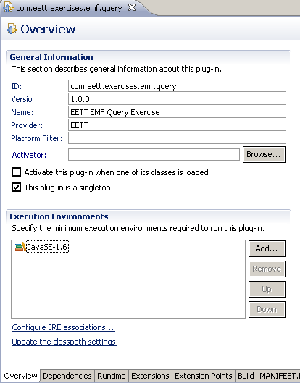

Switch to the Dependencies page of the Plug-in Editor and add the following dependencies

* org.eclipse.ui
* org.eclipse.core.runtime
* org.eclipse.emf.ecore
* org.eclipse.emf.query
* com.eett.exercises.emf
* com.eett.exercises.emf.editor

In order for the query to accessible from the ROOM Editor we need to add an extension to the editor. Switch to the Extensions page of the Plug-in Editor and click the Add… button in the All Extensions section.

From the Extension Point Selection dialog select the org.eclipse.ui.editorActions extension point (you may have to uncheck the ‘Show only extension points from the required plug-ins’ option if you haven’t all the dependencies listed above.)

If an editorContribution isn’t automatically added for you, select the extension point and New 🡪 editorContribution from its context menu. Set the details for the editorContribution to:

|  |  |
| --- | --- |
| **id** | com.eett.exercises.emf.query.editorContribution |
| **targetID** | com.eett.exercises.emf.ROOM.presentation.ROOMEditorID |

The targetID field specifies the identifier that was generated for the ROOM editor, this is necessary for the workbench to know the specific editor that we are contributing to. A list of available editors can be found by clicking the Browse… button beside the field.

Add a menu to the editorContribution through its context menu and set its details as shown in the following table. The path field identifies the menu that we are contributing to in the ROOM editor, this id is defined in the ROOM editor plug-in that was generated from the ROOM EMF model. Add a separator to this menu called additions.

|  |  |
| --- | --- |
| **id** | com.eett.exercises.emf.queryMenuID |
| **label** | &Query |
| **path** | com.eett.exercises.emf.ROOMMenuID/addtions |

Add an action to the editorContribution through its context menu and set its details as shown in the following table. We are adding this action to the menu that we defined in the previous step, as referenced in the menubarPath. In the next step we will create the class we have defined in the class field.

|  |  |
| --- | --- |
| **id** | com.eett.exercises.emf.query. NoSuperclassQuery |
| **label** | Actors with No Superclass |
| **class** | com.eett.exercises.emf.query.actions.NoSuperclassQuery |
| **menubarPath** | com.eett.exercises.emf.ROOMMenuID/ com.eett.exercises.emf.queryMenuID/additions |

We do not want the action to be enabled for anything so we will add an enablement to our action to control when it can be invoked. Add an enablement with an objectClass through the action’s context menu and set the name to org.eclipse.emf.ecore.EObject which will restrict the enablement to only objects of type EObject.

The plugin.xml page should now resemble:

|  |
| --- |
| <?xml version="1.0" encoding="UTF-8"?>  <?eclipse version="3.2"?>  <plugin>  <extension  point="org.eclipse.ui.editorActions">  <editorContribution  id="com.eett.exercises.emf.query.editorContribution"  targetID="com.eett.exercises.emf.ROOM.presentation.ROOMEditorID">  <menu  id="com.eett.exercises.emf.queryMenuID"  label="&amp;Query"  path="com.eett.exercises.emf.ROOMMenuID/additions">  <separator name="additions" />  </menu>  <action  class="com.eett.exercises.emf.query.actions.NoSuperclassQuery"  id="com.eett.exercises.emf.query.NoSuperclassQuery"  label="Actors with No Superclass"  menubarPath="com.eett.exercises.emf.ROOMMenuID/ com.eett.exercises.emf.queryMenuID/additions"  style="push">  <enablement>  <objectClass name="org.eclipse.emf.ecore.EObject"></objectClass>  </enablement>  </action>  </editorContribution>  </extension> </extension> |

We will now create the handler for our query action in the src folder of the plugin add a Class using the wizard (New 🡪 Class). Set the name to NoSuperclassQuery and the package to com.eett.exercises.emf.query.actions. The handler must implement the IEditorActionDelegate.

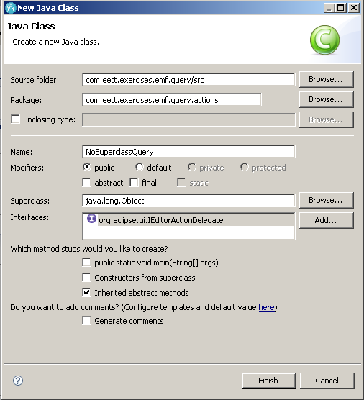

In the newly created class there are two methods that were are interested implementing setActiveEditor and run, we will also add an additional operation to perform the actually query.

The setActiveEditor will allow us to capture the current editor and to access the selected model element to use as the source for our query. To support the method add an editor field to the class of type ROOMEditor. The behavior of setActiveEditor follows.

|  |
| --- |
| @Override  **public** **void** setActiveEditor(IAction action, IEditorPart targetEditor) {  if(editor instancoeof ROOMEditor) {  editor = (ROOMEditor) targetEditor;  } } |

The run action will invoke the query that we will write and then select the objects returned by the query in the editor. The behavior of run follows.

|  |
| --- |
| @Override  **public** **void** run(IAction action) {  Collection<EObject> selectedObjects  = **new** ArrayList<EObject>();    // get the selected object from the editor  **if**(editor !- null  && editor.getSelection() **instanceof** IStructuredSelection){    IStructuredSelection structuredSelection =   (IStructuredSelection) editor.getSelection();  **for**(Object next : structuredSelection.toList()){  **if**(next **instanceof** EObject){  selectedObjects.add((EObject) next);  }  }  }  // execute the query  Collection<EObject> result = performQuery(selectedObjects);    // select the query results in the editor  **if**(!result.isEmpty()){  editor.setSelectionToViewer(result);  }  } |

Finally, we write a query that takes the selected element in the editor and find all the Actors that do not have the actorSuperclass reference set.

|  |
| --- |
| **private** Collection<EObject> performQuery  (Collection<EObject> selectedObjects) {  // create a condition that tests whether an Actor’s  // actorSuperclass feature to see if it is null  EObjectCondition condition = **new** EObjectReferenceValueCondition(  ROOMPackage.*eINSTANCE*.getActor_ActorSuperclass(),  EObjectInstanceCondition.*IS_NULL*);  SELECT query = **new** SELECT(  **new** FROM(selectedObjects),  **new** WHERE(condition));    **return** query.execute();  } |

This completes the creation of the plug-in that will perform the query. It needs to be tested in a runtime workbench. Create a runtime workbench including this plug-in and the ones that it requires. Open an existing ROOM model or create a new one using the ROOM Editor, ensure that the ROOM Editor menu contains a query sub-menu.

# UML Module Exercises

## UML Model Exercise

What this exercise is about

In this exercise, you will create a UML model of a dyeing system. The system that consists of a dye tank that has a fill valve and a drain valve, the tank has a high sensor to determine when it is filled to its maximum and low sensor to determine when it is getting low on dye. A controller receives signals from the sensors in order to open and close the appropriate valves.

At the end of this exercise, you should be able to:

* Create a UML model using the UML Model Editor, and
* Programmatically create UML model elements

Exercise Instructions

Start by creating a project that will contain the models that we create in this exercise and others.

1. Create a new basic Eclipse project
2. Select File 🡪 New 🡪 Project… 🡪 Project
3. Set the Project name to com.eett.exercises.uml.models
4. Keep Use default location checked
5. Click Finish >

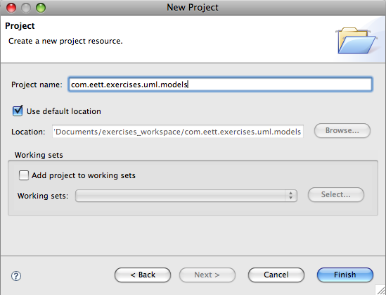

You should now have an empty project in your workspace

1. Use the project context menu we will add a folder to store our models in.
2. Select the project and New 🡪 Folder from its context menu.
3. Set the Folder name to **models** and click Finish
4. We will now create a UML model in our project and populate it with our dyeing system model
5. Select the models folder and New 🡪 Other… from its context menu.
6. In the New wizard select UML Model in the Example EMF Model Creation Wizards group.

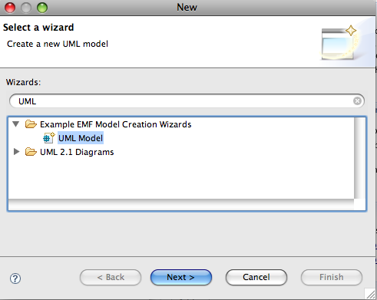

1. Set the File Name to dyeingSystem.uml and click Next >
2. Set the Model Object field to Model and leave the XML Encoding field to the default value and click Finish

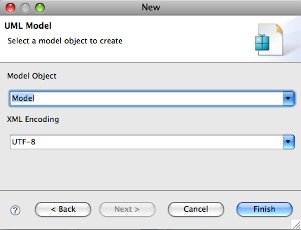

The project in your workspace should now contain a dyeingSystem.uml file, the you can open using the UML Model Editor.

## UML Keywords Exercise

What this exercise is about

In this exercise, you will create a UML model using the UML Model Editor and tag the elements in the model using key words. You will also extend the UML model editor with actions to automatically add specific keywords to model elements.

At the end of this exercise, you should be able to:

* Set key words in a UML model using the UML Model Editor
* Add actions to the UML Model Editor to tag elements with key words

Exercise Instructions

Start by creating a project with the name **com.zeligsoft.transformation.uml**.**keywords** in the workspace.

1. Switch to the Plug-in Development perspective, if not already there.
2. Select Window 🡪 Open Perspective 🡪 Other… 🡪 Plug-in Development
3. Create a new Plug-in project as we will be adding actions to an editor
4. Select File 🡪 New 🡪 Project… 🡪 Plug-in Project
5. Set the Project name to com.zeligsoft.transformation.uml.keywords
6. Keep Use default checked
7. Keep Create a Java project checked
8. Make sure that the Eclipse version is set to 3.4
9. Click Next >

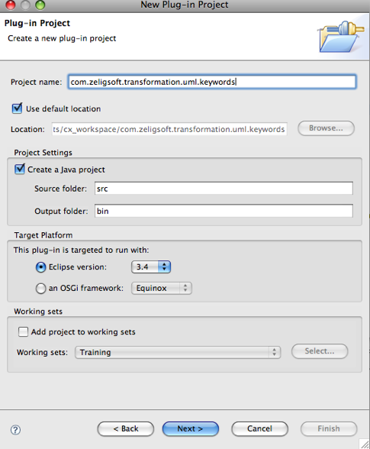

1. Configure the Plug-in Content dialog
2. Keep the defaults for Plug-in ID and Plug-in Version
3. Set the Plug-in Name to UML Keywords Example
4. Set the Plug-in Provider to Ericsson Transformation Training
5. Make sure that “This plug-in will make contributions to the UI” is the only Plug-in Option checked
6. Make sure that Would you like to create a rich client application? Is set to No
7. Click Finish

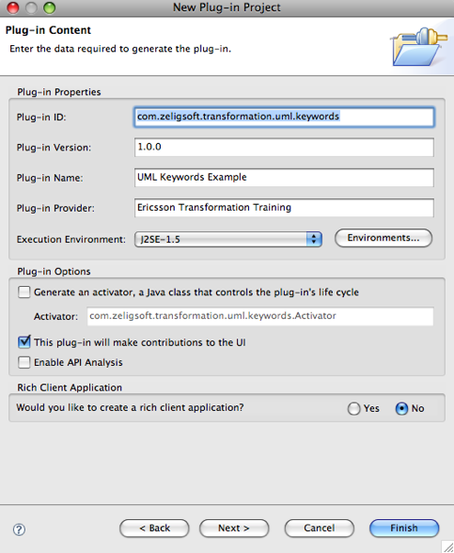

1. Create a UML model named dyeingSystem.uml in which we will build a UML model of a Dyeing system that consists of a dye tank that has a fill valve and a drain valve, the tank has a high sensor to determine when it is filled to its maximum and low sensor to determine when it is getting low on dye. A controller receives signals from the sensors in order to open and close the appropriate valves.
2. Select the project created in the last step and **New 🡪 Folder** from the context menu
3. Change the name of the folder to models
4. Select the models folder and **File 🡪 New 🡪 Other… 🡪 UML** Model and click **Next >**



1. Set the File Name to dyeingSystem.uml and click **Next >**
2. Set the Model Object field to Model and leave the XML Encoding field to the default value and click **Finish**



## UML Profiles Exercise

What this exercise is about

In this exercise, you will create a Profile defining a ROOM like model. It will allow use to define, in UML models, models that use the ROOM concepts. This includes for example identifying classes as ROOMActors and ports as ROOMPorts.

What you should be able to do

At the end of this exercise, you should be able to:

* Define a UML profile using the UML Model Editor
* Register and publish the profile to make it available at run-time
* Apply and use the profile in a UML model
* Add actions to the UML Model Editor to create elements with the stereotypes applied

1. Select the **com.zeligsoft.training.exercises.uml** project and then choose File | New | Other…
2. Select UML Model in the Example EMF Model Creation Wizards folder and click the Next > button
3. Enter UMLRT.profile.uml as the file name and click the Next > button
4. Select Profile as the Model Object and click the Finish button
5. Open the new model file with the UML Model Editor an change the name of the Profile element to UMLRT
6. Load Resource, pathmap://UML_METAMODELS/UML.metamodel.uml
7. Add a Package Import and set Imported Package to uml

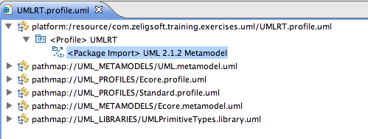

1. In the Profile create Stereotypes
   1. UMLRT_Capsule
   2. UMLRT_Port
   3. UMLRT_Protocol
2. For each of the Stereotypes add a metaclass extension, select the Stereotype and select UML Editor | Stereotype | Create Extension … from the main menu and select the appropriate metaclass
   1. UMLRT_Capsule – uml::Class
   2. UMLRT_Protocol – uml::Class
   3. UMLRT_Port – uml::Port

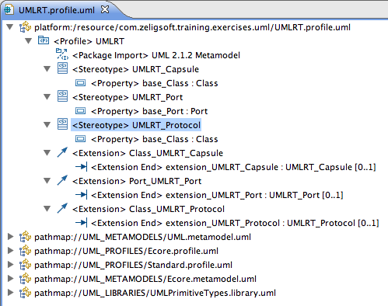

1. Make sure the UMLRT Profile element is selected in the model and then select UML Editor | Profile | Define, keeping the default options click the Ok button

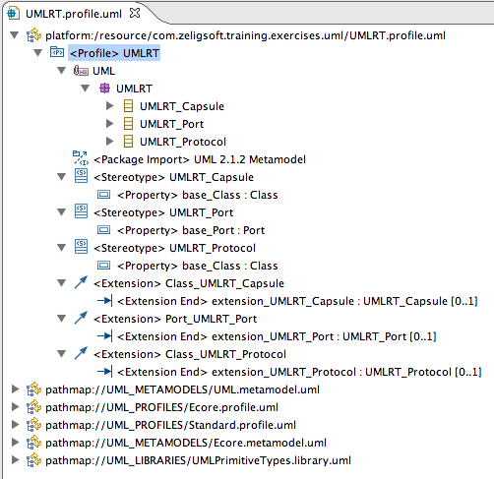

## Applying the Profile to a Model

1. Open the DyeingSystem.uml model with the UML Editor
2. Select UML Editor | Load Resource from the main menu
3. Enter UMLRT.profile.uml as the resource location and click the Ok button
4. Select the UMLRT Model element in the editor and UML Editor | Package | Apply Profile …

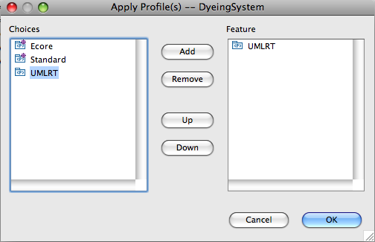

1. Select Valve Class in the model and UML Editor | Element | Apply Stereotype … and choose the UMLRT_Capsule Stereotype
   1. Repeat for DyeingSystemController
   2. Repeat for DyeingSystem
2. Select the Ports on each of the elements and apply the UMLRT_Port stereotype
3. Select the ValveControl Class and apply the UMLRT_Protocol stereotype

# Transformation Exercises

## M2M Setup

In order execute transformations from the ROOM Editor we need to add an extension to the editor. Create a new Plug-in project.

|  |  |
| --- | --- |
| **ID** | com.eett.exercises.m2m.ui |
| **Version** | 1.0.0 |
| **Name** | EETT Transformations UI Exercise |
| **Provider** | EETT |

Add the following dependencies.

* org.eclipse.core.runtime
* org.eclipse.ui
* com.eett.exercises.emf
* com.eett.exercises.emf.editor

Switch to the Extensions page of the Plug-in Editor and click the Add… button in the All Extensions section.

From the Extension Point Selection dialog select the org.eclipse.ui.editorActions extension point (you may have to uncheck the ‘Show only extension points from the required plug-ins’ option if you haven’t all the dependencies listed above.)

If an editorContribution isn’t automatically added for you, select the extension point and New 🡪 editorContribution from its context menu. Set the details for the editorContribution to:

|  |  |
| --- | --- |
| **id** | com.eett.exercises.emf.query.editorContribution |
| **targetID** | com.eett.exercises.emf.ROOM.presentation.ROOMEditorID |

The targetID field specifies the identifier that was generated for the ROOM editor, this is necessary for the workbench to know the specific editor that we are contributing to. A list of available editors can be found by clicking the Browse… button beside the field.

Add a menu to the editorContribution through its context menu and set its details as shown in the following table. The path field identifies the menu that we are contributing to in the ROOM editor, this id is defined in the ROOM editor plug-in that was generated from the ROOM EMF model. Add a separator to this menu called additions.

|  |  |
| --- | --- |
| **id** | com.eett.exercises.transformations.MenuID |
| **label** | &Transform |
| **path** | com.eett.exercises.emf.ROOMMenuID/addtions |

The plugin.xml page should now resemble:

|  |
| --- |
| <?xml version="1.0" encoding="UTF-8"?>  <?eclipse version="3.2"?>  <plugin>  <extension point="org.eclipse.ui.editorActions">  <editorContribution  id="com.eett.exercises.transformation.editorContribution"  targetID="com.eett.exercises.emf.ROOM.presentation.ROOMEditorID">  <menu  id="com.eett.exercises.transformation.MenuID"  label="&amp;Query"  path="com.eett.exercises.emf.ROOMMenuID/additions">  <separator name="additions" />  </menu>  </editorContribution>  </extension> </plugin> |

We will now create an abstract handler for our transformation actions in the src folder of the plugin add an abstract Class using the wizard (New 🡪 Class). Set the name to AbstractTransformationAction and the package to com.eett.exercises. transformations.actions. The handler must implement the IEditorActionDelegate.

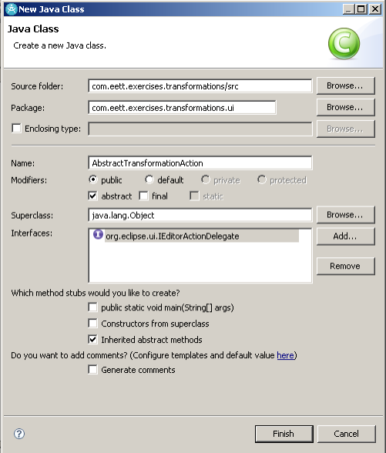

The setActiveEditor method will allow us to capture the current editor and to access the selected model element to use as the source for our transformation. To support the method add an editor field to the class of type ROOMEditor. The behavior of setActiveEditor follows.

|  |
| --- |
| @Override  **public** **void** setActiveEditor(IAction action, IEditorPart targetEditor) {  if(editor instancoeof ROOMEditor) {  editor = (ROOMEditor) targetEditor;  } } |

We will add an additional method to the class to return the selected object. If there is more than one object selected it will pick the first one in the list.

|  |
| --- |
| // Return the object that is currently selected in the active editor  // if more than one is selected return the first one  **protected** EObject getSelectedObject() {  **if**(editor != **null**  && editor.getSelection() **instanceof** IStructuredSelection) {  IStructuredSelection structuredSelection =  (IStructuredSelection) editor.getSelection();  **for**(Object next : structuredSelection.toList()){  **if**(next **instanceof** EObject){  **return** (EObject) next;  }  }  }  **return** **null**;  } |

## M2M with Java

In this exercise we will create a model-to-model mapping from our ROOM model to a simplified model of the Java programming language. This requires the java.ecore modeled that will be provided. Before doing the exercises generate and register the model. The remainder of the exercise assumes that you have done this.

Create a new Plug-in Project.

|  |  |
| --- | --- |
| ID | com.eett.exercises.m2m.java |
| Version | 1.0.0 |
| Name | EETT M2M Java Exercise |
| Provider | EETT |

Dependencies

org.eclipse.emf.java

com.eett.exercises.emf

Add an action to the ROOM Editor in the com.eett.exercises.transformations plug-in. Add an action to the editorContribution through its context menu and set its details as shown in the following table. We are adding this action to the menu that we defined in the previous step, as referenced in the menubarPath. In the next step we will create the class we have defined in the class field.

|  |  |
| --- | --- |
| **id** | com.eett.exercises.transformation.java.transform |
| **label** | Java Transform |
| **class** | com.eett.exercises.transformations.ui.actions.ROOM2JavaAction |
| **menubarPath** | com.eett.exercises.emf.ROOMMenuID/ com.eett.exercises.transformation.MenuID /additions |

We do not want the action to be enabled for anything so we will add an enablement to our action to control when it can be invoked. Add an enablement with an objectClass through the action’s context menu and set the name to com.eett.exercises.emf.ROOM.Model, which will restrict the enablement to only objects of type Model. Add a new handler for this action that specializes the AbstractTransformationAction we created in the previous exercise.

In the com.eett.exercises.m2m.java plug-in create a class ROOM2JavaTransformation in the com.eett.exercises.m2m.java package. This is the class we will use as the entry point for our transformation. This class will have a protected constructor and a single method for now, transform that takes a ROOM Model and creates Java JModel.

|  |
| --- |
| /**  * A class that is the entry point of a M2M transformation  * written in Java. Its purpose is to transform a  * com.eett.exercises.emf.ROOM.Model into a  * org.eclipse.emf.java.JModel.  *  * **@author** Zeligsoft  *  */  **public** **class** ROOM2JavaTransform {  /**  * We only want one of these transform entry point classes  * created so we manage the creation of the instance and  * make it accessible through this static field.  */  **public** **static** **final** ROOM2JavaTransform *INSTANCE* =  **new** ROOM2JavaTransform();    /**  * Constructor is protected since we do not  * allow others to create instances.  */  **protected** ROOM2JavaTransform() {    }    /**  * A transformation written in Java that takes as input  * a ROOM model and transforms it into a Java model.  */  **public** JModel transform(Model roomModel) {  JModel target = JavaFactory.*eINSTANCE*.createJModel();    target.setName(roomModel.getName());    **return** target;  }  } |

The package containing this class must be exported, in order for you to access it.

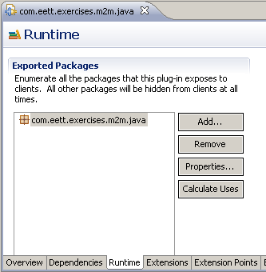

We now need to invoke this transformation from the action we have created. This means that the com.eett.exercises.transforms plug-in needs a dependency on the Java M2M plug-in. Then we modify the run method in the action to be the following.

|  |
| --- |
| @Override  **public** **void** run(IAction action) {  // get the selected object in the active editor  EObject eobject =  getSelectedObject();    // this should be a ROOM model since we restricted  // action to it but we will test it any way  **if**(eobject **instanceof** Model){  Model roomModel = (Model) eobject;    // run the transformation and store the result  JModel jModel = ROOM2JavaTransform  .*INSTANCE*.transform(roomModel);    // persist the model to a resource that has  // the same name as the source ROOM model and in  // the same folder  **if**(roomModel.eResource()!= **null**  && roomModel.eResource().getURI() != **null**){  // create the new URI and resource for the target  // model by removing the source file extension and  // add the model.java file extension  URI jModelURI = roomModel.eResource()  .getURI().trimFileExtension();  jModelURI = jModelURI.  appendFileExtension("model.java");    Resource jModelResource =  roomModel.eResource().getResourceSet()  .createResource(jModelURI);  // add the result to the new model  jModelResource.getContents().add(jModel);  **try** {  jModelResource.save(**null**);  } **catch** (IOException e) {  e.printStackTrace();  **throw** **new** RuntimeException("Trying to transform an element and an exception was thrown:\n" + e.getMessage());  }    // unload and remove the resource from the  // source models resource set  jModelResource.unload();  roomModel.eResource().getResourceSet().  getResources().remove(jModelResource);  }  **else** {  **throw** **new** RuntimeException("Trying to transform an element that is not in a resource.");  }  }  } |

Load a runtime workbench and tryout your transformation. Once you are sure that the action is working. Add rules to your m2m.java project that transform an Actor to a JCompilationUnit and a JClass within it. Add a JField to the JClass for each port on the Actor. The JCompilationUnit rule will be called by the transformation we have already created.

## M2M with QVT

Before beginning this exercise it is best to export the projects for the metamodels as plug-ins and restart the Workbench. This requires using File 🡪 Export… and exporting them to a folder called dropins in the %RSA_INSTALL%/SDP directory.

In this section we will create a model-to-model transformation using QVT. Start by creating a QVT project com.eett.exercises.m2m.qvt. Add depedencies to the ROOM and Java model projects just as we did in the previous exercise.

Create a transformation ROOM2Java.qvto within the project. The first thing that needs to be done is to define the metamodels that will be used.

|  |
| --- |
| **modeltype** roomMM "strict" **uses** "http://www.eett.com/room/2008";  **modeltype** javaMM "strict" **uses** "http://www.eclipse.org/emf/2002/Java"; |

Now define the transformation that has an in parameter of type roomMM and and out parameter of type javaMM.

|  |
| --- |
| **transformation** Room2Java(**in** room:roomMM, **out** javaM:javaMM); |

Now we must define the entry point for the transformation, which will accept a Model element from ROOM and transform it into a target of type JModel. Set the name of the JModel to be the name of the ROOM model.

|  |
| --- |
| **mapping** **main**(**in** rModel:roomMM::Model, **out** jModel:javaMM::JModel) {  **init** {  jModel := **object** JModel{name:= rModel.name};  }  } |

Add a rule to the file that maps an Actor or Protocol to a JCompilation and a JClass as a member of the JCompilationUnit. The difference being that a Protocl ends up being an interface.

|  |
| --- |
| **mapping** PackageableElement::roomElement2JCompilationUnit()  : JCompilationUnit  **disjuncts** Actor::actor2JCompilationUnit,  Protocol::protocol2JCompilationUnit {  }  **mapping** Actor::actor2JCompilationUnit() : JCompilationUnit {  name := **self**.name;  type += **self**->**map** actor2JClass();  }  **mapping** Protocol::protocol2JCompilationUnit() : JCompilationUnit {  name := **self**.name;  types += **self**->**map** protocol2JClass();  }  **mapping** Protocol::protocol2JClass() : JClass {  name := **self**.name;  interface := **true**;  }  **mapping** Actor::actor2JClass() : JClass {  name := **self**.name;  } |

Modify the entry point to iterate through the members of the ROOM model and map. This will use the roomElement2JCompilationUnit rule we wrote.

|  |
| --- |
| **mapping** **main**(**in** rModel:roomMM::Model, **out** jModel:javaMM::JModel) {  **init** {  jModel := **object** JModel{name:= rModel.name};  elements += rModel.elements->**map**  roomElement2JCompilationUnit();  }  } |

To test the transformation create or use an existing ROOM model using the editor. Now create a Run Configuration to test the mapping, Run 🡪 Run Configurations… and create a new Operational QVT Interpreter, ROOM2Java. Set the Transformation Module to be the transformation we just developed and make sure that the Generate trace file is checked. Finally, specify the target of the transformation.

Now click on the Run button and examine the model that is created and the generated trace file.

Now extend the transformation to consider the ports on Actors and the signals on Protocols.

### For the adventurous

Create a similar QVTO transformation that works on RSA-RTE models and thus against profile used by RSA-RTE.

## M2T with xPand

In this exercise we will map a JModel into Java source. To do this we will use xPand and a workflow. Start by creating a new openArchitectureWare Project, com.eett.exercises.m2t.xpand. Make sure that the Create a sample is checked.

Now modify the MANIFEST.MF to have a dependency on org.eclipse.emf.java.

We won’t need the files in src/metamodel so they can be deleted. The xPand template should also be renamed to GenerateJava.xpt and an import for the Java metamodel. Which will allow us to build an M2T for our Java models.

|  |
| --- |
| «IMPORT java» |

We now need to define the transformation entry point, which is defined for a JModel.

|  |
| --- |
| «DEFINE main FOR JModel»  «ENDDEFINE» |

Add a rule for writing each JCompilationUnit to a file with the .java extension.

|  |
| --- |
| «DEFINE writeJCompilationUnit FOR JCompilationUnit»  «IF this.name != null»  «FILE this.name + ".java"»    «ENDFILE»  «ENDIF»  «ENDDEFINE» |

Modify the workflow file that was generated. So that it is named generateJava.oaw and that it works with our models and metamodels.

Change the model property to be the model you will test with. Note that you can also define these properties in a separate file.

|  |
| --- |
| <property name='baseDir' value='./'/>  <property file='${baseDir}/my.properties'/> |

Change <component class=”org.openarchitectureware.xpand2.Generator”> element to be as shown below. This points to our Java metamodel and the transformation file that we renamed. The last part is a post-processing step that makes the generated Java look good.

|  |
| --- |
| <!-- generate code -->  <component class="org.openarchitectureware.xpand2.Generator">  <metaModel id="javaMM" class="oaw.type.emf.EmfMetaModel">  <metaModelPackage  value="org.eclipse.emf.java.JavaPackage" />  </metaModel>  <expand  value="template::GenerateJava::main FOR model" />  <outlet path="${src-gen}" >  <postprocessor class="org.openarchitectureware.xpand2.output.JavaBeautifier" />  </outlet>  </component> |

You can now create an oaw Workflow Run Configuration to execute the transformation. Select the workflow that we modified in the previous step as your initial Workflow File using the Search… button. Apply and run the workflow.

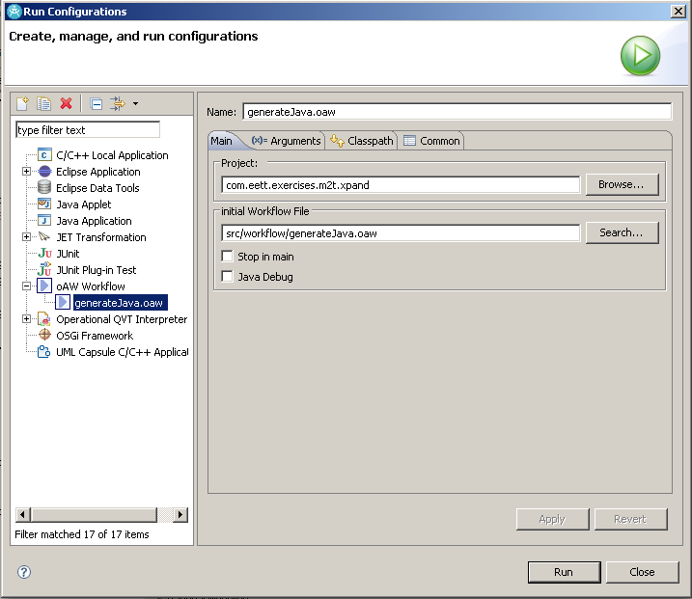

There should be a src-gen folder in your project with the generated files in it.

Augment the transformation to include generating the types contained in the JCompilationUnit, which should be JClass. This can be done by adding a new rule to the transformation and calling it with the EXPAND FOREACH expression.

Re-run the transformation and observe the impact of your new rules.

**For the adventurous**

* Extend the tranformation even further to include JField and JOperation for a JClass.

## M2T with JET

In this exercise we will map a JModel into Java source. To do this we will use JET. Start by creating a new EMFT JET Transformation Project, com.eett.exercises.m2t.jet. Keep the default values for the other fields in the project wizard.

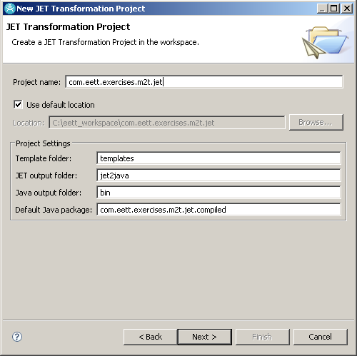

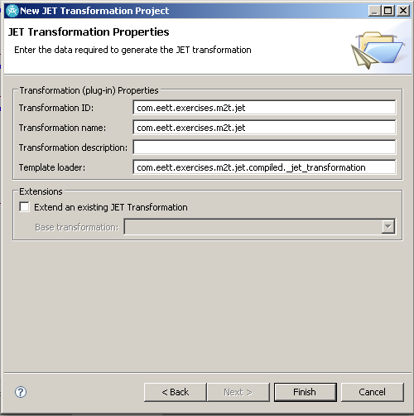

Now modify the MANIFEST.MF to have a dependency on org.eclipse.emf.java.

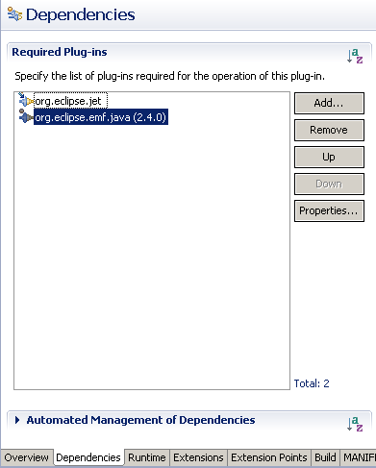

We also need to modify the org.eclipse.jet.transform extension to specify an EMF model loader. Change to the Extensions page of the Plug-in Editor and select the (transform) element of the extension. Change its modelLoader field to be org.eclipse.jet.emf.

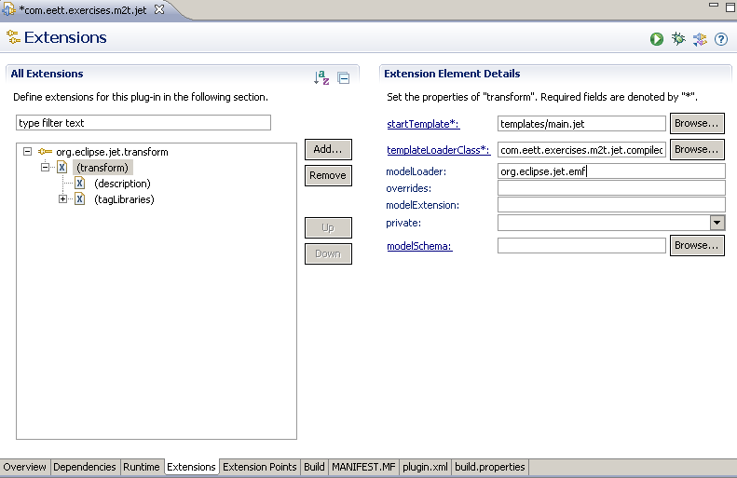

The JET template is named main.jet and can be found in the templates folder. We will modify it to use our metamodel. At the same time define the entry point, which sets a variable jModel, to be the root of the JModel passed in.

|  |
| --- |
| <%@jet imports="org.eclipse.emf.java.*" %>  <%@taglib prefix="ws" id="org.eclipse.jet.workspaceTags" %>  <%-- Main entry point for com.eett.exercises.m2t.jet --%>  <%-- Define variables the root element in the model --%>  <c:setVariable select="/*" var="jModel"/> |

Now we will add a iterator over the JCompilationUnits (the elements attribute) in the model and write them to a file in a src-gen directory in the com.eett.exercises.m2t.jet (Note this could be a parameter to the template).

|  |
| --- |
| <c:iterate select="$jModel/elements" var="jCompilationUnit">  <ws:project name="com.eett.exercises.m2t.jet">  <ws:folder path="src-gen">  <java:package name="com.eett.exercises.emf.m2t.jet">  <java:class name="{$jCompilationUnit/@name}"  template="templates/JCompilationUnit.java.jet"/>  </java:package>  </ws:folder>  </ws:project>  </c:iterate> |

Notice that this calls another template JCompilationUnit.java.jet that we have not created yet. So add a new JET transformation, JCompilationUnit.java.jet to the templates folder. Set the contents of the file to be the following.

|  |
| --- |
| <%@taglib prefix="ws" id="org.eclipse.jet.workspaceTags" %>  <%@taglib prefix="c" id="org.eclipse.jet.controlTags" %>  <c:iterate select="$jCompilationUnit/types" var="jClass">  public class <c:get select="$jClass/@name"/> {  }  </c:iterate> |

You can now create a JET Transformation Run Configuration to execute the transformation. But before doing so create a new src folder called src-gen in the project. Select the transformation we just created in the ID field. Also select a Java model to test our transformation as the Transformation Input. Apply and run the transformation. The files should be generated to the src-gen folder.

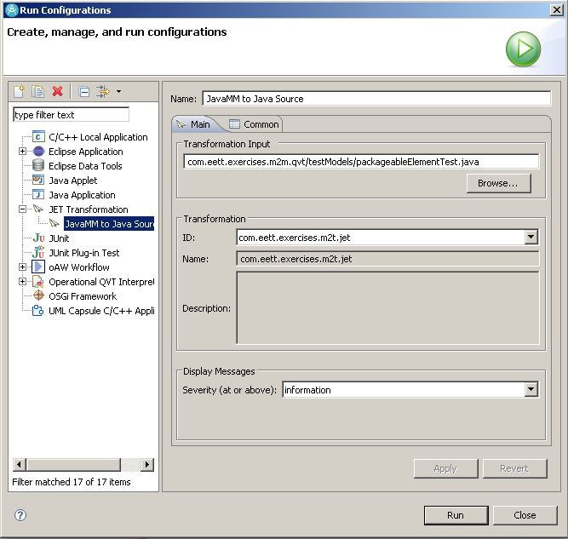

Augment the transformation to include generating the types contained in the JCompilationUnit, which should be JClass. Remember that a JClass has a field that indicates whether it is an interface. Hint use the c:if tag.

Re-run the transformation and observe the impact of your new rules.

**For the adventurous**

* Extend the tranformation even further to include JField and JOperation for a JClass.

## Workflows

In this part we will create a workflow that takes a ROOM model and writes out code. In order to do this we need to create a new component that can work with QVT models.

# Validation Exercises

## Working with Validation Framework

This exercise will perform model validation on our ROOM metamodel using the EMF validation framework. More specifically, it will create an EValidator implementation that delegates to the validation framework, to provide user-demand “batch mode” validation from an EMF editor.

## Constructing a Batch Model Constraint

A model constraint is a subclass of the AbstractModelConstraint that overrides the validate() method. The validate method has the task of taking the input from the validation context returning either a ctx.createSuccessStatus() or ctx.createFailureStatus().

Create a new Class NonEmptyNamesConstraint that specializes AbstractModelConstraint, in the com.eett.exercises.validation package.

Override the validate method and add the following logic to it.

|  |
| --- |
| public IStatus validate(IValidationContext ctx) {  EObject eObj = ctx.getTarget();  EMFEventType eType = ctx.getEventType();    // In the case of batch mode and not live mode.  if (eType == EMFEventType.NULL) {  String name = null;  if (eObj instanceof NamedElement) {  name = ((NamedElement)eObj).getName();  }  if (name == null || name.length() == 0) {  return ctx.  createFailureStatus(new Object[]   {eObj.eClass().getName()});  }  }  return ctx.createSuccessStatus();  } |

We now need to add the constraint provider extension to our Plug-in Manifest. Open the plug-in editor and add an org.eclipse.emf.validation.constraintProviders extension.

Add a category to the extension and set its properties to.

|  |  |
| --- | --- |
| **name** | ROOM Constraints |
| **id** | com.eett.exercises.validation.constraints |

Add a constraintProvider to the extension setting the package element that was created to http://www.eett.com/room/2008.

Add a constraints element to the constraintProvider and set its categories to com.eett.exercises.validation.constraints. Now add a constraint element and set its properties to.

|  |  |
| --- | --- |
| **id** | com.eett.exercises.validation.NonEmptyNamesConstraint |
| **name** | Non-empty names |
| **mode** | Batch |
| **severity** | ERROR |
| **lang** | Java |
| **class** | com.eett.exercises.validation.NonEmptyNamesConstraint |
| **statusCode** | 1 |

Modify the message element to have the following:

|  |
| --- |
| A {0} has been found to have no name specified. |

Add three target elements to the constraint for NamedElement classes. These classes are qualified by the EPackage we specified in the package element previously.

We now need to add a context in which our constraint will execute. The primary reason for doing this is avoid constraints from different vendors being executed in the wrong context. Start by adding another extension for org.eclipse.emf.validation.constraintBindings. and add a clientContext element to it. Setting its id to com.eett.exercises.validation.roomContext and default to false.

Add a selector element to the clientContext setting its class to be com.eett.exercises.validation.ValidationDelegateClientSelector. Then create a new class in the com.eett.exercises.validation package called ValidationDelegateClientSelector and add the following to the file.

|  |
| --- |
| //NOTE: This is _NOT_ a recommended approach to writing a client selector.  //Suggested approaches:  // -Check the resource of the EObject either by identity or by URI  // as long as this resource is somehow unique to this application  // -Check the identity of the resource set to ensure that it is some  // private object  // -Check the identity of the EObject itself to see if it belongs to  // some private collection  // -Check the EClass of the EObject but only if the metamodel is private  // to this application and will not be used by other contexts  **public** **class** ValidationDelegateClientSelector  **implements** IClientSelector {  **public** **static** **boolean** *running* = **false**;    **public** **boolean** selects(Object object) {  **return** *running*;  }  } |

Finally add a binding element to the constraintBindings extension settings its id to be com.eett.exercises.validation.roomContext the id of the context we defined in the previous step, and the category to com.eett.exercises.validation.constraints, which we defined on the constrainProviders extension.

Your plugin.xml file should now look like the following.

|  |
| --- |
| <?xml version="1.0" encoding="UTF-8"?>  <?eclipse version="3.2"?>  <plugin>  <extension  point="org.eclipse.emf.validation.constraintProviders">  <category  id="com.eett.exercises.validation.constraints"  name="ROOM Constraints">  </category>  <constraintProvider  cache="true">  <package  namespaceUri="http://www.eett.com/room/2008">  </package>  <constraints>  <constraint  id="com.eett.exercises.validation.NonEmptyNamesConstraint"  lang="Java"  mode="Batch"  name="Non-empty names"  severity="ERROR"  statusCode="1">  <message>  message body text  </message>  <target  class="NamedElement">  </target>  </constraint>  </constraints>  </constraintProvider>  </extension>  <extension  point="org.eclipse.emf.validation.constraintBindings">  <clientContext  default="false"  id="com.eett.exercises.validation.roomContext">  <selector  class="com.eett.exercises.validation.ValidationDelegateClientSelector">  </selector>  </clientContext>  <binding  category="com.eett.exercises.validation.constraints"  context="com.eett.exercises.validation.roomContext">  </binding>  </extension>  </plugin> |

## Executing the constraint

To be able to execute the constraint add an action to the ROOM Editor to invoke constraints. Refer to the Query and Transformation for guidance on doing this. The code to execute the is the following:

|  |
| --- |
| ValidationDelegateClientSelector.running = true;  IBatchValidator validator = (IBatchValidator)ModelValidationService.getInstance()  .newValidator(EvaluationMode.BATCH);  validator.setIncludeLiveConstraints(true);  IStatus status = validator.validate(selectedEObjects);  ValidationDelegateClientSelector.running = false; |

The first part of this code snippet enables the latch so that the validation service will determine that the provided EObjects belong to our client context. We requested a batch validation and asked that the batch validator include live validation constraints because live validation constraints are often written to handle the batch validation case. Finally, we validate the selected EObjects and are given back the status of the validation.