Complementary products
- How to -

Customer: Jeremias

Project Name:
Jeremias website

Implementation:
Upgrade

(Draft version)

Belgrade, July 9th 2018



Document properties

Document history

Date | Version | Description | Author
09.07.2018. | 0.1 | Complementary products  - How to - | Vladimir Terescenko

Document authorization

 | Name | Date
Written by | Vladimir Terescenko | 17.07.2018.
Reviewed by
Approved by

Reference documents

Document | Title

Contents
1 Complementary produts – How to - 4
1.1 Adding / removing complementary products 4

Complementary products
– How to -

Adding / removing complementary products
- Head over to backend.
- Go to Items → Overview.
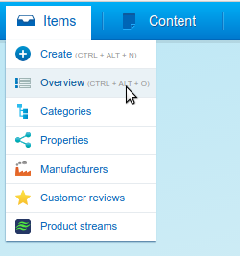

- New window should appear with title “Item overview”.
- In the upper right corner in the “search” box enter name or product number of the product that you want to edit.

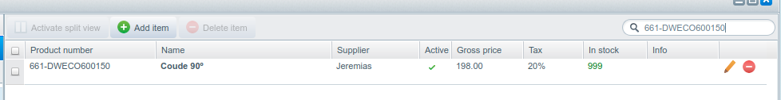

- from the list above choose product and click on “pencil” icon in the end of the with product data row.

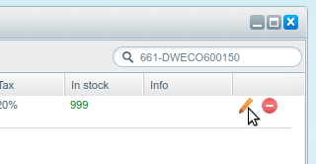

- New window should appear with product details.
- Click on tab “Cross-selling”.

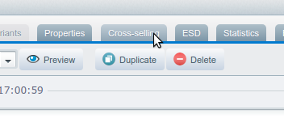

- In the upper left corner there should be section called “Similar items”.

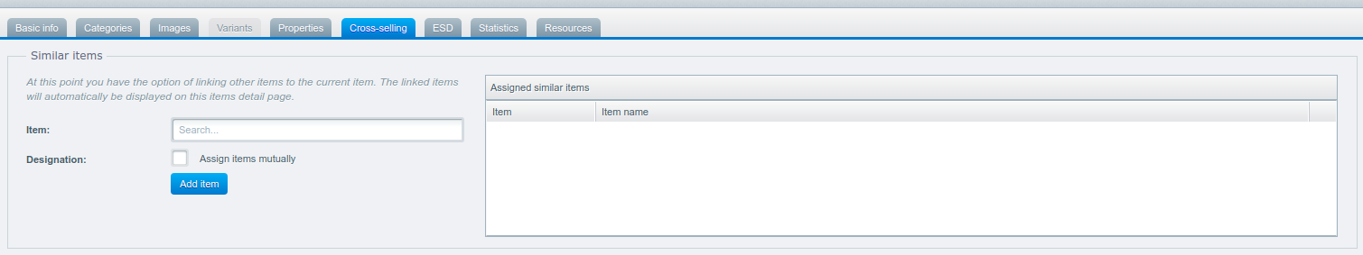
- In the search box labeled “Item” insert name or the product number of the product that you want to add as complementary product.
- From the list below choose item that you want to add.
- Click on the item from the list.

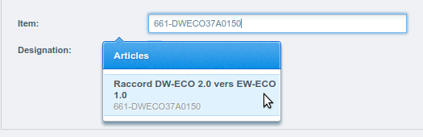

- Item name should appear in the “Item” box.
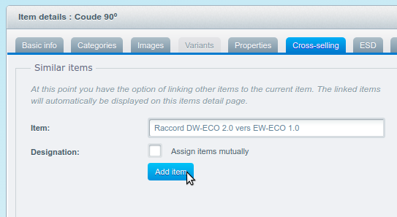

- Click on “Add Item” button to add product as complementary products.
- In the right section of the “Similar items” there is a list of all assigned items. Item that you have assigned should be in the list.
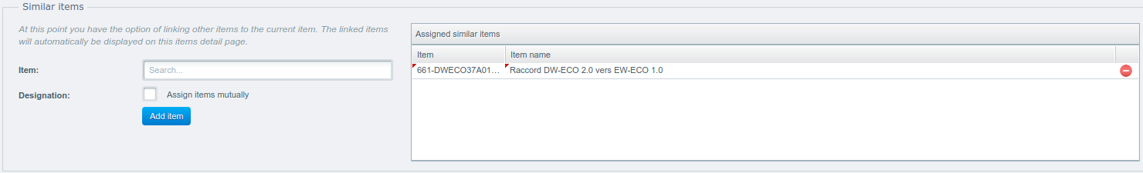
- By checking box “Assign items mutually” product that you are modifying will be automatically added as complementary product to the product that you had selected from the list.
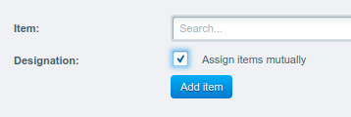

- After adding complementary products click on “Save item” button to save changes.

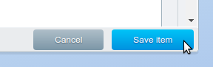

- If you go to the detail page of the product that you have edited, in the bottom of the page, under the section “GAMMES COMPLÉMENTAIRES” you will be able to see complementary products that you have added.
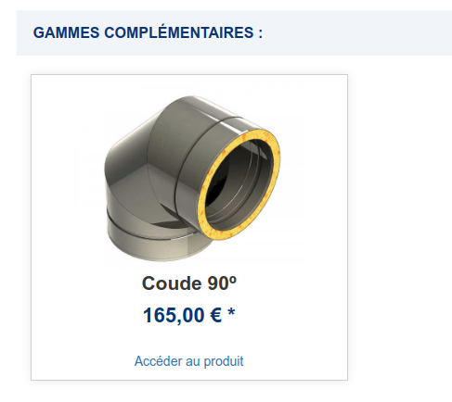

- If you want to remove complementary product from the product of your choice, simply click on “red circle” icon in the list of the complementary products, click on “Save item” button, and association with that product will be removed.

