**Vasileios-Filippos Zembilas**

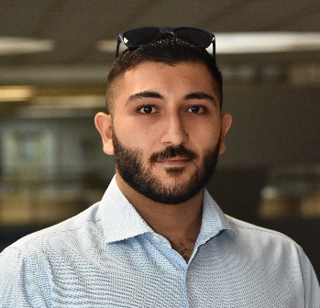

City: *Thessaloniki*

Phone Number: *6946424932*

E-mail: *vasilisfzembilas@gmail.com*

GitHub URL: *github.com/Zembi*

LinkedIn: *Vasileios-Filippos Zembilas*

Born on the 21th of October 1998

# EDUCATION

**2016 - 2022** Graduated with 7.53 from the Department of **Applied Informatics** at the **University of Macedonia** (teaching proficiency).

**University Projects:**

* **Java** – java tourism app(JavaHotel) with few actions for the user and the admin

(*github.com/Zembi/JAVAHOTEL*)

* **Web Development** – informative website about a famous athlete (*github.com/Zembi/GiannisAnteWeb or hosted at https://jannis34.eu/*)
* **C** – first contact with software development and gaining the logic of development through it (*Java too*)
* **SQL** – commands, structure and exercises in real databases
* **3dsMaxMinion** – created a minion(graphics and modelling) and record the process in stages files **(**drive.google.com/file/d/1cYGwFwBq1KFTKNbNP2aVUbaJDmmyQ-cg/view?usp=sharing)
* **Adobe** – editing programs as photoshop, premier pro and audition (drive.google.com/file/d/19vYP1_rQl8xLKQr5SLf_w8742syzod_l/view?usp=sharing)
* **Research** – crowdfunding topic, on business productivity and innovation (*drive.google.com/drive/folders/1jE5uQEhNMtHTSYJ6oYDX_F4qfRu1CE8i?usp=sharing*)
* **Stocks & cryptos** – observed and learned about indexes and digital portfolios with Finance Yahoo and Naftemporiki (non-profitable)

# PROFESSIONAL EXPERIENCE

* *Freelance 2019-present*, Web development (Junior Front-end, Back-end)
* *July 2015-September 2015*, Salesman, Department Store, Paralia Katerini

# SKILLS

**PROGRAMMING EXPERIENCE**

* **Java**(software development for apps, backend for web)
* **Javascript**(web development)
* **Php**(backend for web – prefer it instead of Java)
* **SQL**(database contact and exchange data with web)
* **Html, Css**
* **C#, Blender**(Unity Projects, modelling and understand how Game Engines work)
* **Python**(simple introductive apps)

**FOREIGN LANGUAGES**

* English **B2** (*Michigan*)

**SOFT SKILLS**

* Creativity, work ethic, dedication, adaptability, communication, teamwork, problem-solving, attention to detail

# MILITARY SERVICE

* **Fulfilled**, November 2021 – August 2022 Armored (ELDYK)

# DRIVING LICENCE

* **B** category
* **A2** category