**FNB Business Value Adds**

**Functional Requirements Specification**

**Version: 0.1**

**Status: Draft**

**Date: 2017/11/21**

*Instant Payroll Compliance*

|  |  |
| --- | --- |
| **Project Number** | TBC |
| **Project Sponsor(s)** | Sanjeev Orie |
| **Project Manager** | Kabelo Tlhabane |
| **Author(s)** | Lebogang Machaba |
| **Document Title** | Instant Payroll Compliance March Release |
| **Date created** | 21 November 2017 |

Document References

|  |  |  |
| --- | --- | --- |
| **#** | **Document Name** | **Location (SharePoint link)** |
|  | Instant Payroll- Compliance |  |

Document Version Control

|  |  |  |  |  |
| --- | --- | --- | --- | --- |
| **Version** | **Status** | **Author** | **Date** | **Comments** |
| 0.1 | Draft | Lebogang Machaba | 11/12/2017 | Document Creation |
| 0.2 | Final | Lebogang Machaba |  | Final Document |

Sign off

|  |  |  |  |
| --- | --- | --- | --- |
| **Name** | **Designation** | **Signature** | **Date** |
| Novin Govender | Business Owner |  |  |
| Carminda Santos | IT Risk Manager |  |  |
| Mo Karolia | Solutions Architect |  |  |
| Ashley Damons | First Rand Group Tax |  |  |
| Lofti Opperman | Axiomatic consultant –Tax expert |  |  |
| Florence Nxumalo | Axiomatic consultant –Tax expert |  |  |

Distribution List (For Information)

|  |  |
| --- | --- |
| **Name** | **Business Area** |
| Sanjeev Orie | **Project Sponsor** |
| Novin Govender | **Business Owner** |
| Carminda Santos | **IT Risk Manager** |
| Yuvendran Chetty | **Product Analyst** |
| Shaakira Bulbulia | **FNB Business Value Adds PMO** |
| Shereen Docrat | **FNB Business Value Adds PMO** |
| Kabelo Tlhabane | **FNB Business Value Adds PMO** |
| Mo Karolia | **Solutions Architect** |
| Kgang Moloke | **FNB Business Value Adds** |
| Nathi Mfeka | **FNB Business Value Adds** |
| Neeharika Ravi | **FNB Business Value Adds** |
| Nadine Ontong | **First Rand Tax** |
| Ashley Dasmond | **FNB Business Finance** |
| Dirk Potgieter | **FNB Business Legal** |
| Pedro Fortuna | **FNB Business IT Risk** |
| Nicole Van Den Heever | **FNB Business Operations Integrate** |
| Chantal Lund | **FNB Business Operations** |

TABLE OF CONTENTS

1 Introduction 5

1.1 Acronyms and Abbreviations 5

2 Project Background 6

2.1 Project Overview 6

2.2 Project Objectives 6

2.3 Scope 6

2.4 Assumptions 6

2.5 Critical Success Factors 7

2.6 Dependencies 7

2.7 As is Process 7

2.8 To be Process 7

3 Business requirements 8

4 NON-FUNCTIONAL Requirements 10

4.1 Usability Requirements 10

4.2 Performance Requirements 10

4.3 Security and Access Requirements 10

4.4 Testing Requirements 10

5 Functional Requirements: Graphical Depiction 11

5.1 Re-Instatement (Discharge & Re-engagement) 11

5.2 IRP5 Start Date 11

5.3 Display calculations on system 12

5.4 Weekly Year-To-Date 15

5.5 Reporting 19

# Introduction

The purpose of this Functional Requirements Specification is to document the requirements of the Instant Payroll Compliance solution for the common understanding of all business stakeholders and to support the development and implementation of the solution.

## Acronyms and Abbreviations

|  |  |
| --- | --- |
| **Term** | **Definition** |
| IP | Instant Payroll |
| YTD | Year-to-Date |
| FNB | First National Bank |

# Project Background

Instant Payroll is a web-based application which allows the customer to perform payroll processing functions this includes generating payslips, running reports e.g. EMP201, emp501, IRP5 etc.

Currently the system is developed with basic functionality and it is required that we enhance the existing functionality so that the FNB Payroll system can completely comply with SARS rules and regulations.

The system should apply the weekly YTD calculations based on the current financial year.

## Project Overview

Business has identified the need to modify the system and perform weekly YTD calculations to prevent incorrect taxation and also to enhance the system to be SARS compliance.

## Project Objectives

The business objectives for the project are as follows:

* System to perform YTD Weekly Calculations
* System should allow the client to Re-instate discharged employees *(Engagement and Discharge)*
* System to display the Tax calculations and formulas
* System should provide clients with correct IRP5 using the IRP5 Start date
* Comply with weekly Easy filing
* System should provide the client with correct Reporting

## Scope

* Application of the functionality in the following countries
* Segments FNB Business
* South Africa (C0. 15)
* Systems
* Instant Payroll
* Roles
* Instant Payroll Client

## Assumptions

* Instant Solutions Dev will develop the required functionality based on the requirements as recorded in the BRS.
* For the Tax year 2017/2018 there will be no weekly EasyFile submissions

## Critical Success Factors

* System should perform the YTD Weekly calculations using the 52/53 weeks
* System should allow clients to Re-in state employees who have been discharged
* System should allow the clients to view how their Tax is being calculated
* System should allow the client to generate EasyFile for weekly
* System should allow the client to run EMP201 reports

## Dependencies

* Final approval from Business and Risk.

## As is Process

* The system is currently calculating Weekly payroll using the Monthly snap shoot

## To be Process

* Enable Instant Payroll to have YTD weekly calculations and comply to SARS standards

# Business requirements

|  |  |  |  |
| --- | --- | --- | --- |
| **ID** | **Name** | **Description** | **Priority** |
| REQ01 | Re-Instatement  (Discharge & Re-engagement) | System should have the functionality for Discharged and re-instated employees.  Problem:  Currently the system is using employee ID as a unique Identifier and this hinders the client from re-instating the employee as they information already exist  Resolution and Rules:   * Create a different unique Identifier e.g. DB_empID# * This unique Identifier should allow the system to generate separate tax certificates with records of employment period within the same financial year * Certificate should only tax the employee on the period they were employed * When client tries to re-capture the details of an existing employee, * System should prompt the client that the employee already exist * And check if employee has been discharged if so then advise client to Re-instate the employee * Once the Discharge field is captured then system should show Re-instate checkbox and a Re-engagement date field otherwise it should be hidden * Create new employee numbers for re-instated employees | M |
| REQ02 | IRP5 Start Date | Create IRP5 start date, which will be used for tax calculations.  Problem:  Currently the system is using the employees engagement date or the first payrun period start date to perform tax calculations but this becomes incorrect if the employee gets discharged and re-instated.  Resolution and Rules:   * Create IRP5 Start Date * IRP5 Start date will be used for tax calculations instead of engagement date * For a new employee, system will use the first payslip date and going forward default to the Financial tax year start date * For an employee who has been discharged and re-instated, system will use the re-instated/ re-engagement date as IRP5 start date for tax calculations * This IRP5 Start date will be used on the back-end and will not be displayed for client’s view. (show it)? * Audit trail for employment history | M |
| REQ03 | Weekly Year-To-Date calculations (uif, sdl, paye, med,pen, prov, etc) | System to provide YTD Weekly calculations  Problem:  Weekly payrolls are generated using snapshots.  Resolution and Rules:   * Implement a function that will allow the client to select/enter parameters that will determine the number of weeks for that tax year ( 52 or 53 weeks) * Parameter for client to select: * Pay day (Monday – Sunday) as a ddl * After selecting the Pay-day, system should determine if the tax year is a 52/53 weeks then client should select dates and confirm the Tax year dates by proving consent /disclaimer *(to ensure the client is aware that the information selected will be applied for that Financial Tax year and it cannot be changed)* * For the tax year that has 53 weeks the client can selects dates that are either 7 days before the new tax year OR 7 days after/into the new tax year. * System should then redirect the client to Payslip creation page *(Remove the Payrun Creation page)* * Once the payslip is created and then payrun is closed system should automatically create the next payrun      * For payments/contributions made to the 3rd party, system should alert/inform the client to enter the full monthly amount * Then the system should take the full amount paid on monthly bases and divide it by the number of weeks (either 52 or 53) depending on that particular month * The limits for Payment/Con Pension, SDL, UIF should * System should apply the annual limits for all the Payments/ Contributions (Pension, UIF and SDL) * On the Payslip creation page and report, the system should then display a portion of amount to be paid to the 3rd party on that particular week | M |
| REQ04 | Display calculations on system | Client should be provided with explanation for tax calculations on the system.  Problem:  System does not provide tax calculations or explanation to clients and therefore Support team get a high volume of queries.  Resolution and Rules:   * Tax calc * PAYE * SDL * UIF * Pension calc limitation | M |
| REQ06 | Reporting | System changes should reflect on the statutory reports   * Client should only run reports on past periods * For EMP201, system should only unlock the report on the last week of the month * Weekly portion paid toward the 3rd party, should reflect on the reports. | M |

# NON-FUNCTIONAL Requirements

## Usability Requirements

* Conform to the POPI Act.

## Performance Requirements

* Instant Payroll System must be available 24hours a day/7days a week, 365 days a year.

## Security and Access Requirements

* The following permissions must apply:
  + Primary user for ZOB
  + Administrator for ZBI

## Testing Requirements

* Testing INT and QA
* Testing access must be granted to Business:
  + Pre-Prod
* Sign-off for Pre-Prod testing must be achieved prior to being migrated into Production
* Business to test in Live
* Live test profiles to be requested for Business to test

# Functional Requirements: Graphical Depiction

## Re-Instatement (Discharge & Re-engagement)

Client to enter the **Discharge Date**

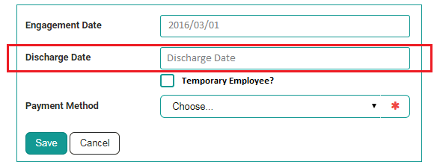

Once the Discharge Date is captured system should show the **“Re-instate/ Re-engagement Date”** field.

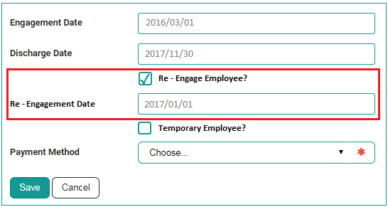

## IRP5 Start Date

IRP5 Start date will use the date of the first generated payslip or the first payslip generated after being Re-instated.

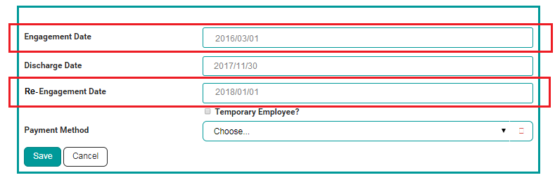

## Display calculations on system

Client can click **Tax Details** to view how the following were calculated

PAYE, SDL and UIF or they can click on the informative icon to view the calculations

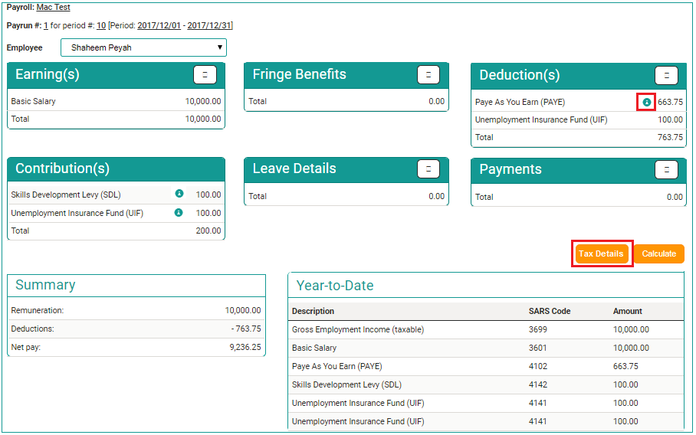

Client should be redirected to the below page when they click **informative icon** or **Tax details**

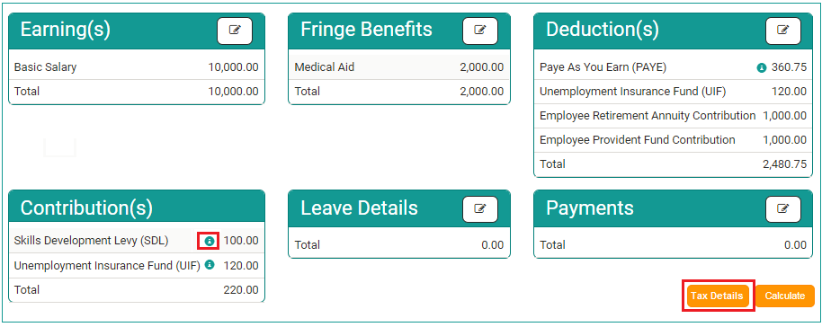

SDL

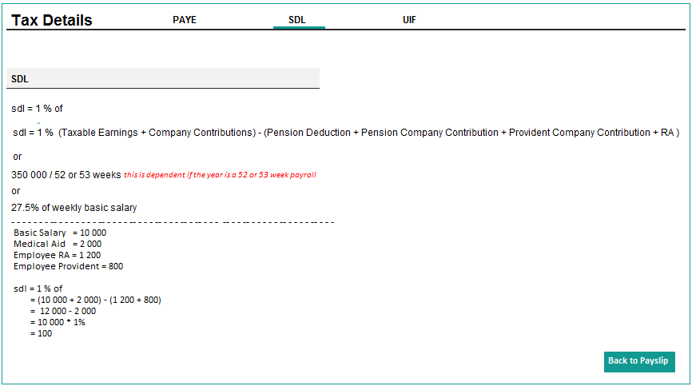

UIF

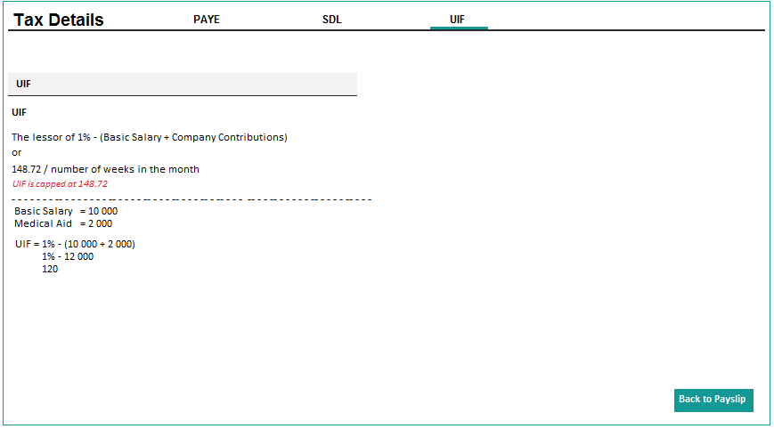

PAYE

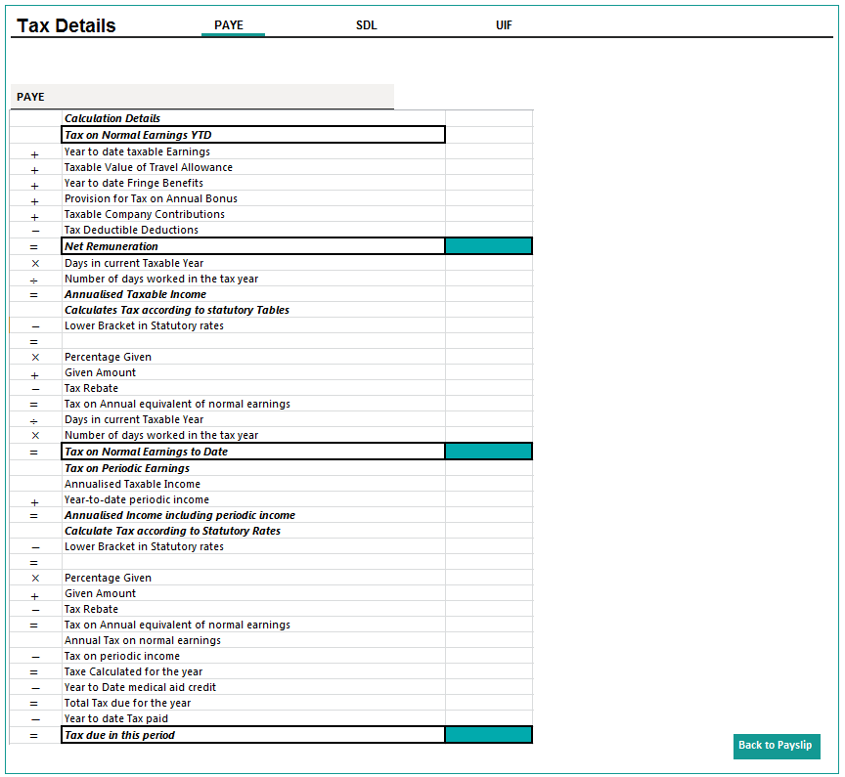

## Weekly Year-To-Date

Client to create the Payroll

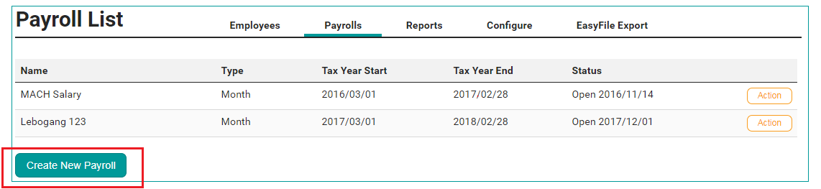

System should default the Payroll ‘Type’ to **Monthly**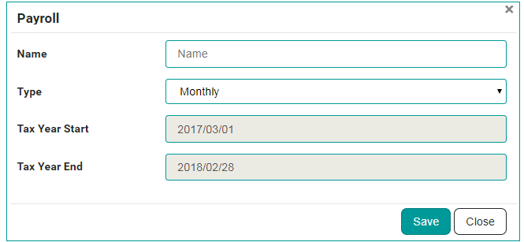

Once ‘Weekly’ is selected as payroll Type, system should display the below screen for clients to select **Pay Date**

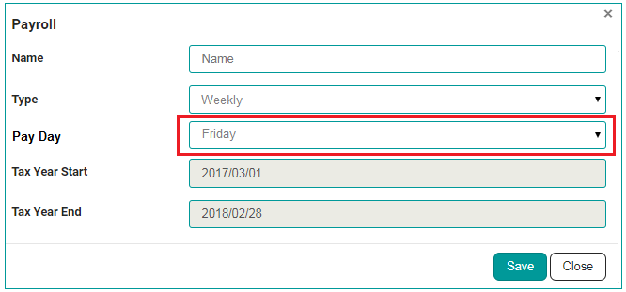

When client clicks the Save button to update selected parameters, system should prompt the below window for clients to sign the Tax year setup Disclaimer.

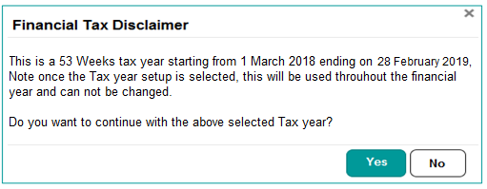

For the tax year that has 53 weeks the client can selects dates that are either 7 days before the new tax year OR 7 days after/into the new tax year.



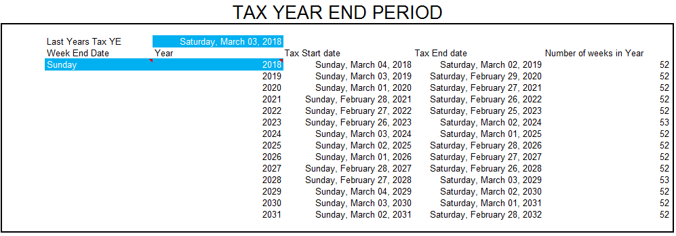

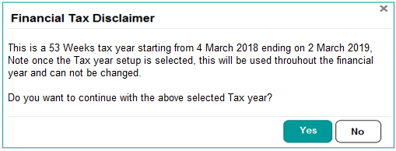

Once the client accepts Tax Disclaimer, system will redirect them to Payslip creation.

The next Payrun will be auto created once the current one is closed

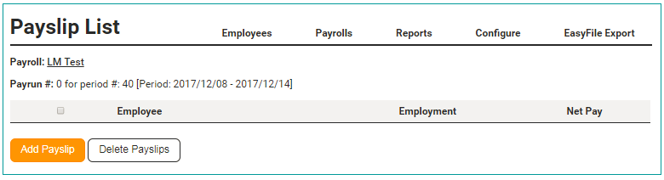

**Payments and Contributions to be paid to the 3rd Party.**

The client should capture the Monthly amount and then the system will divide it by either 4/5 weeks depending on the number of weeks for that particular month.

**Example:** This month has 4 weeks

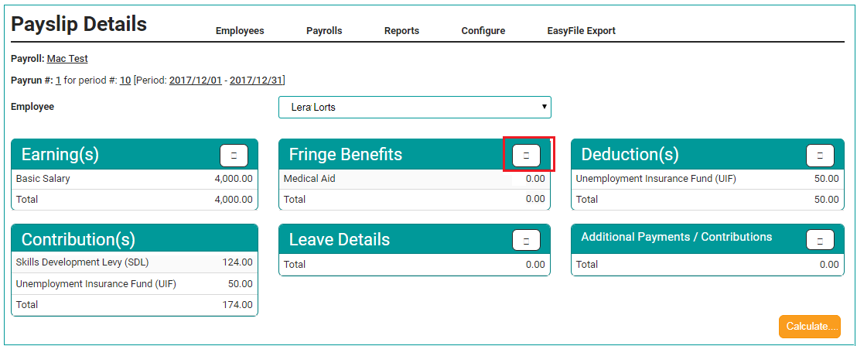

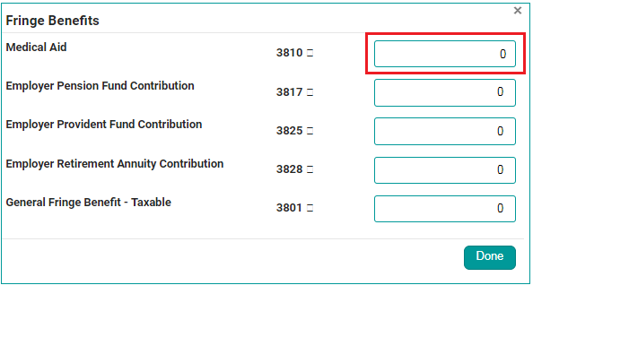

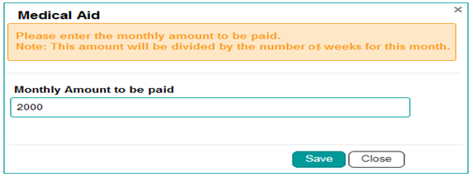

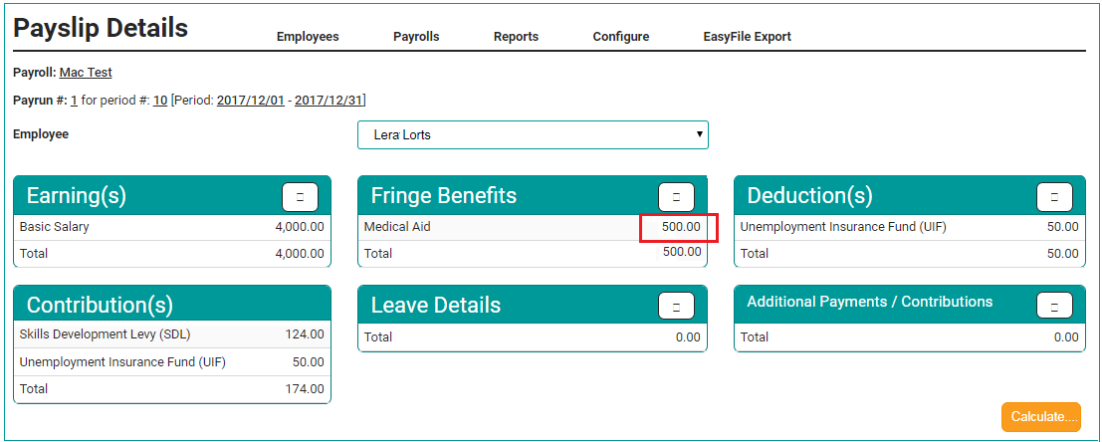

This will apply to the following codes:

Fringe Benefits

* 3810 Medical Aid
* 3817 Employer Pension Fund Contribution
* 3825 Employer Provident Fund Contribution
* 3828 Employer Retirement Annuity Contribution
* 3801 General Fringe Benefit – Taxable

Deductions

* 4005 Medical Aid
* 4006 Employer Retirement Annuity Contribution
* 4003 Employer Provident Fund Contribution
* 4001 Employer Pension Fund Contribution

Other Payments/ Contributions

* 4006 Employer Retirement Annuity Contribution (No Net Effect)
* 4003 Employer Provident Fund Contribution (No Net Effect)
* 4001 Employer Pension Fund Contribution (No Net Effect)

For the following codes, system should automatically display the divided value by the number of weeks

* 4141 Unemployment Insurance Fund (UIF)
* 4142 Skills Development Levy (SDL)

## Reporting

* For EMP201 and Provident / Pension Fund report , system should only unlock the report on the last week of the month
* Client should only run reports on past periods

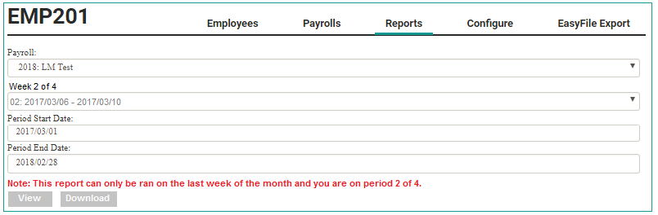

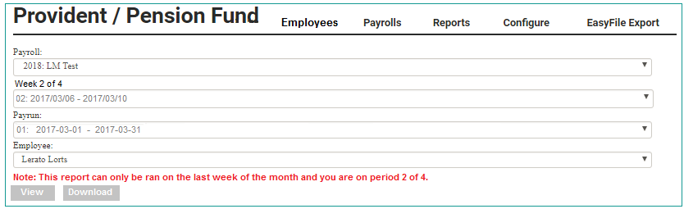

3rd Party limits for weekly are they changing or not?