Astana IT University
Front-End Development

Assignment #1. HTML & CSS Basics
Documentation Report

Project: EduSphere — Online Educational Platform

Team name: The Ethernet
Group: SE-2510

Team member | Role | Pages created
Ramil Zhunussov | Team lead / Front-end | index.html (Home), courses.html (Courses & Pricing)
Maxim Batyushkin | Content & layout | about.html (About Us), instructors.html (Instructors)
Azamat Mustafin | Tables & forms | schedule.html (Schedule), contact.html (Contact & Registration)

Astana, 2026

1. Objective
The goal of this assignment was to build a complete multi-page website using only hand-written HTML and CSS — no Bootstrap, no Tailwind and no external UI library of any kind — and to publish it online. Our team chose an educational platform as the topic, because it naturally requires every element listed in the task: a course catalogue (lists and images), a timetable (data tables), a registration page (forms) and team biographies (typography and circular profile pictures).
By completing the assignment we learned to:
- separate content (HTML) from presentation (CSS) and keep all styling in one external stylesheet;
- apply foundational HTML tags: headings, paragraphs, images, links, ordered and unordered lists, tables and forms;
- use all four core CSS selector types — element, class, ID and descendant;
- work with the box model, typography, a custom colour palette and flexbox based layouts;
- publish a static website to GitHub Pages and verify that all relative paths still work on the live URL.

2. Project overview
EduSphere is a fictional online learning platform. The website consists of six pages that share one header, one navigation bar, one footer and one external stylesheet, so the branding is identical everywhere.

2.1. Folder structure
edusphere/
|-- index.html (Home — Ramil)
|-- courses.html (Courses & Pricing — Ramil)
|-- about.html (About Us — Maxim)
|-- instructors.html (Instructors — Maxim)
|-- schedule.html (Schedule — Azamat)
|-- contact.html (Contact & Registration — Azamat)
|-- css/
| `-- style.css (the single shared stylesheet)
`-- images/ (21 SVG images: logo, banners, avatars, icons)
All assets are referenced with relative paths (css/style.css, images/logo.svg), which is why the site works identically from a local folder and from GitHub Pages.

2.2. Colour palette and typography
CSS variable | Value | Used for
--color-primary | #2f2a77 | Header, footer, headings, table headers
--color-primary-light | #5b54c9 | Links, nav hover background
--color-accent | #f2a33c | Buttons, active nav item, borders
--color-teal | #16a394 | Badges, check marks, secondary accents
--color-page | #f7f7fb | Page background
--color-surface | #ffffff | Card fill
--color-text | #1b1c3a | Body text
--color-text-muted | #5a5b78 | Secondary text and captions

Two font families are combined: a serif stack (Georgia) for all headings and a sans-serif stack (Segoe UI) for body text, with a monospace stack for inline code. Because frameworks and external libraries were forbidden, we deliberately used system font stacks instead of a web-font service.

3. Step-by-step description of the work

Part 1. HTML structure

Step 1. HTML boilerplate
We created six .html files in the project root. Every file contains the full boilerplate and a credit comment in the <head> that names the project, the team, the page and its author:
<!DOCTYPE html>
<html lang="en">
<head>
<!-- Project : EduSphere — Online Educational Platform
Team : The Ethernet (Group SE-2510)
Members : Ramil Zhunussov, Maxim Batyushkin, Azamat Mustafin
Page : index.html — Home
Author : Ramil Zhunussov -->
<meta charset="UTF-8">
<meta name="viewport" content="width=device-width, initial-scale=1.0">
<title>EduSphere — Learn Online, Build Real Projects</title>
<link rel="stylesheet" href="css/style.css">
</head>
Each page has its own descriptive <title>:
- index.html — “EduSphere — Learn Online, Build Real Projects”
- courses.html — “Courses & Pricing — EduSphere”
- instructors.html — “Our Instructors — EduSphere”
- schedule.html — “Class Schedule — EduSphere”
- about.html — “About Us — EduSphere”
- contact.html — “Contact & Registration — EduSphere”

Step 2. Structured content & typography
Every page starts with exactly one <h1> that names the page, uses <h2> for the main sections and <h3> for sub-sections and card titles, so the heading outline of each document is logical and can be read by a screen reader. Body text is written in <p> elements, with <strong> for emphasis and a .highlight class for short phrases we wanted to mark visually.
The required “About the Team Members” block lives in the #team section of about.html. It contains three profile cards — one per member — each with a circular photo, the person's role, a short biography, the list of pages that person created and a list of hobbies.

Step 3. Lists, images and links
- Ordered lists (<ol>) are used wherever sequence matters: “How learning works” on the home page, the company timeline on About Us, the enrolment steps on Courses, instructor qualifications, and “What happens after you send the form” on Contact.
- Unordered lists (<ul>) are used for sets where order is irrelevant: course syllabi, platform features, hobbies, timetable legend, attendance rules and the footer site map.
- Every page contains at least one image, and every <img> has a meaningful alt attribute — for example alt="Weekly calendar grid next to a clock showing live class times". All 21 images are hand-written SVG files, so they stay sharp at any zoom level and keep the repository small.
- The global navigation is one <nav class="nav-menu"> block with a <ul> of six links, copied identically into all six pages. The link of the current page carries class="active", so the visitor always knows where they are.

Step 4. Data tables
The site contains four tables, all wider than three columns:
- #pricing-table on courses.html — 5 columns (Plan, Price, Courses included, Mentor support, Certificate) and 4 data rows.
- #office-hours on instructors.html — 5 columns of consultation slots.
- #weekly-schedule on schedule.html — 7 columns (Time + Monday to Saturday) and 5 time rows; the first cell of every row is a <th scope="row">.
- A study-format comparison table on schedule.html — 3 columns.
Every table uses <thead>/<tbody>, header cells <th> with a scope attribute, data cells <td> and a <caption> that numbers the table. The tables are wrapped in a .table-wrap container with overflow-x: auto so that on a phone a wide table scrolls sideways instead of breaking the layout.

Step 5. HTML forms & buttons
contact.html contains the registration form #contact-form with method="post". It includes every input type required by the task and a few extras:
- text input — Full name (required, minlength="3");
- email input — Email address (required, validated by the browser);
- tel input — Phone number;
- dropdown <select> — the course the student is interested in;
- radio buttons — preferred study format (evening / weekend / intensive);
- colour selection <input type="color"> — accent colour of the student profile;
- checkbox — newsletter subscription;
- <textarea> — the message;
- two buttons — <button type="submit"> and <button type="reset">.
Every field is connected to its <label> through matching for and id attributes, so clicking a label focuses the field. Required fields are marked with * and the required attribute, which makes the browser refuse to submit an incomplete form.

Part 2. External styling with CSS

Step 7. CSS linking & global reset
All styling is concentrated in one file, css/style.css (about 1140 lines, divided into 15 commented sections). It is linked from the <head> of every page with a relative path, and no page contains a <style> block or an inline style attribute:
<link rel="stylesheet" href="css/style.css">
The stylesheet starts with a global reset:
* {
margin: 0;
padding: 0;
box-sizing: border-box;
}
box-sizing: border-box means padding and borders are counted inside the declared width, which makes every later box-model calculation predictable.

Step 8. CSS selectors
All four core selector types are used, each for the job it suits best:
Type | Examples from style.css | Purpose
Element | body, h1, h2, h3, p, a, img, ul, ol, table, th, td, blockquote | Global defaults: typography, colours, table borders
Class | .container, .card, .btn, .profile-img, .highlight, .badge, .step-list, .check-list, .team-card | Reusable components repeated across pages
ID | #main-header, #hero, #site-footer, #contact-form, #pricing-table, #weekly-schedule, #office-hours | Unique elements that appear once per page
Descendant | .nav-menu a, .card h3, table td, #contact-form label, .team-card ul li, #site-footer a | Precise targeting of nested elements without extra classes

We also used the pseudo-classes :hover, :focus, :focus-visible and nth-child(even) for striped table rows, and the pseudo-elements ::before to draw the numbered circles of .step-list and the green check marks of .check-list.

Step 9. Typography, palette & backgrounds
The palette is declared once as CSS custom properties in :root (see section 2.2) and reused everywhere through var(), which is why changing one line restyles the whole site. Headings use the serif stack at weight 700 with line-height 1.25; body text uses the sans-serif stack at 16px with line-height 1.7, and paragraphs are limited to max-width: 68ch for comfortable reading.
Links were restyled completely:
a {
color: var(--color-primary-light);
text-decoration: none; /* default underline removed */
font-weight: 600;
border-bottom: 2px solid transparent;
transition: color .25s ease, border-color .25s ease;
}
a:hover {
color: var(--color-accent-dark);
border-bottom-color: var(--color-accent); /* amber underline appears */
}

Step 10. Navigation bar styling
#main-header has the dark indigo background, a 4px amber bottom border and position: sticky, so the menu stays visible while scrolling. Inside it, display: flex with justify-content: space-between pushes the logo to the left and the menu to the right. The menu itself is a flex row:
.nav-menu ul { list-style: none; display: flex; flex-wrap: wrap; gap: .35rem; }
.nav-menu a { display: inline-block; padding: .55rem 1rem;
border-radius: 6px; color: #fff; }
.nav-menu a:hover { background: var(--color-primary-light);
border-bottom-color: var(--color-accent); }
.nav-menu a.active { background: var(--color-accent);
color: var(--color-primary); }
flex-wrap: wrap is what lets the same menu reflow into two centred rows on a phone without any JavaScript.

Step 11. Box model & layout sizing
Four different units are used deliberately:
- px — borders, small radii and fixed image sizes (border: 2px, width: 46px);
- rem — all padding and margins, so spacing scales with the root font size (.section { padding: 3.5rem 0 });
- % — fluid container width (.container { width: 92%; max-width: 1140px }) and full-width images;
- vh — the hero block (#hero { min-height: 72vh }) so the first screen fills most of the viewport.
Cards demonstrate the box model directly: .card has 1.6rem of padding, a 1px border, a 12px border-radius and a soft box-shadow that grows on hover, while the grid around them uses grid-template-columns: repeat(auto-fit, minmax(280px, 1fr)) so the number of columns adapts to the screen width.

Step 12. Media & image styling
No image carries width or height attributes in the HTML — every dimension comes from the stylesheet: .brand-logo is 46x46 px, .banner is 100% wide and 260px tall with object-fit: cover, .course-card .thumb is 180px tall, and .feature-card img is 88x88 px. The circular pictures required by the task are the profile photos:
.profile-img {
width: 150px;
height: 150px;
border-radius: 50%; /* square SVG becomes a circle */
object-fit: cover;
border: 5px solid var(--color-accent);
margin: 0 auto 1rem;
}
They are used for the three team members on about.html and, with the larger .profile-img-lg modifier, for the three instructors on instructors.html.

Step 13. Form & UI component styling
Inputs, selects and the textarea share one rule set: full width, 2px border, 6px radius, 0.7rem of padding and the page-coloured background. The focus state is the most important part — it makes the active field unmistakable:
input[type="text"]:focus, input[type="email"]:focus,
select:focus, textarea:focus {
outline: none;
background-color: #fff;
border-color: var(--color-primary-light);
box-shadow: 0 0 0 4px rgba(91, 84, 201, .18); /* soft focus ring */
}
Radio buttons are wrapped in pill-shaped labels that react to :hover, the colour picker is styled as a small swatch, and the two buttons use the shared .btn class with the .btn-primary and .btn-reset modifiers (rounded 999px, a lift on hover via transform: translateY(-2px)).
Tables are styled with a dark indigo <th> row, 1px cell borders, striped even rows through tbody tr:nth-child(even) and a teal row highlight on hover.

Part 3. Deployment & publishing

Step 15. Publishing on GitHub Pages
- Created a public GitHub repository named edusphere.
- Uploaded the whole project folder — the six .html files, the css folder and the images folder — keeping the structure unchanged.
- Opened Settings → Pages, selected “Deploy from a branch”, branch main and folder / (root), then pressed Save.
- Waited for the green deployment check and opened the published address.
- Verified on the live site that the stylesheet loads, all 21 images appear, and every link of the navigation bar opens the right page — relative paths such as css/style.css and images/logo.svg work unchanged online.
Live website URL: https://zemmeus.github.io/Assigment-1-WEB/
Repository: https://github.com/Zemmeus/Assigment-1-WEB
Verified after deployment: all six pages, the stylesheet and all 21 SVG images return HTTP 200 on the live URL, and the navigation links work from every page.

4. Screenshots of every page
All screenshots below are full-page captures taken in Google Chrome at a viewport width of 1440 px.
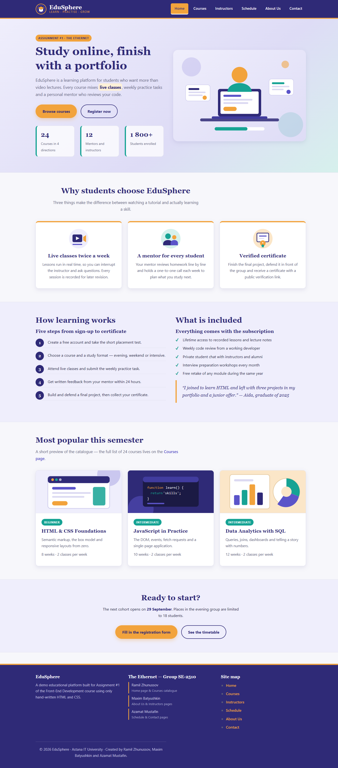
Figure 1. index.html — Home page: hero block, feature cards, “How learning works” ordered list and popular courses. (Ramil Zhunussov)
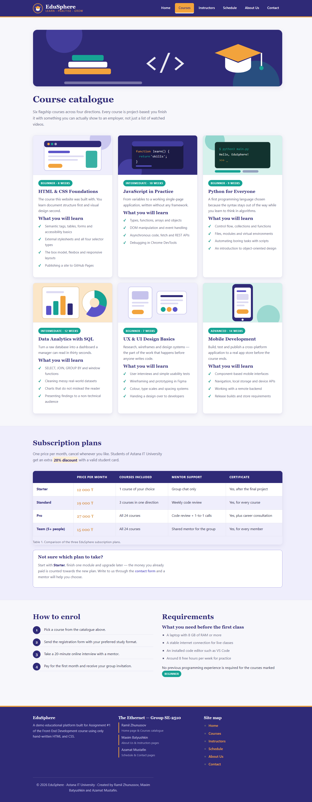
Figure 2. courses.html — Course catalogue with six course cards and the #pricing-table comparison table. (Ramil Zhunussov)
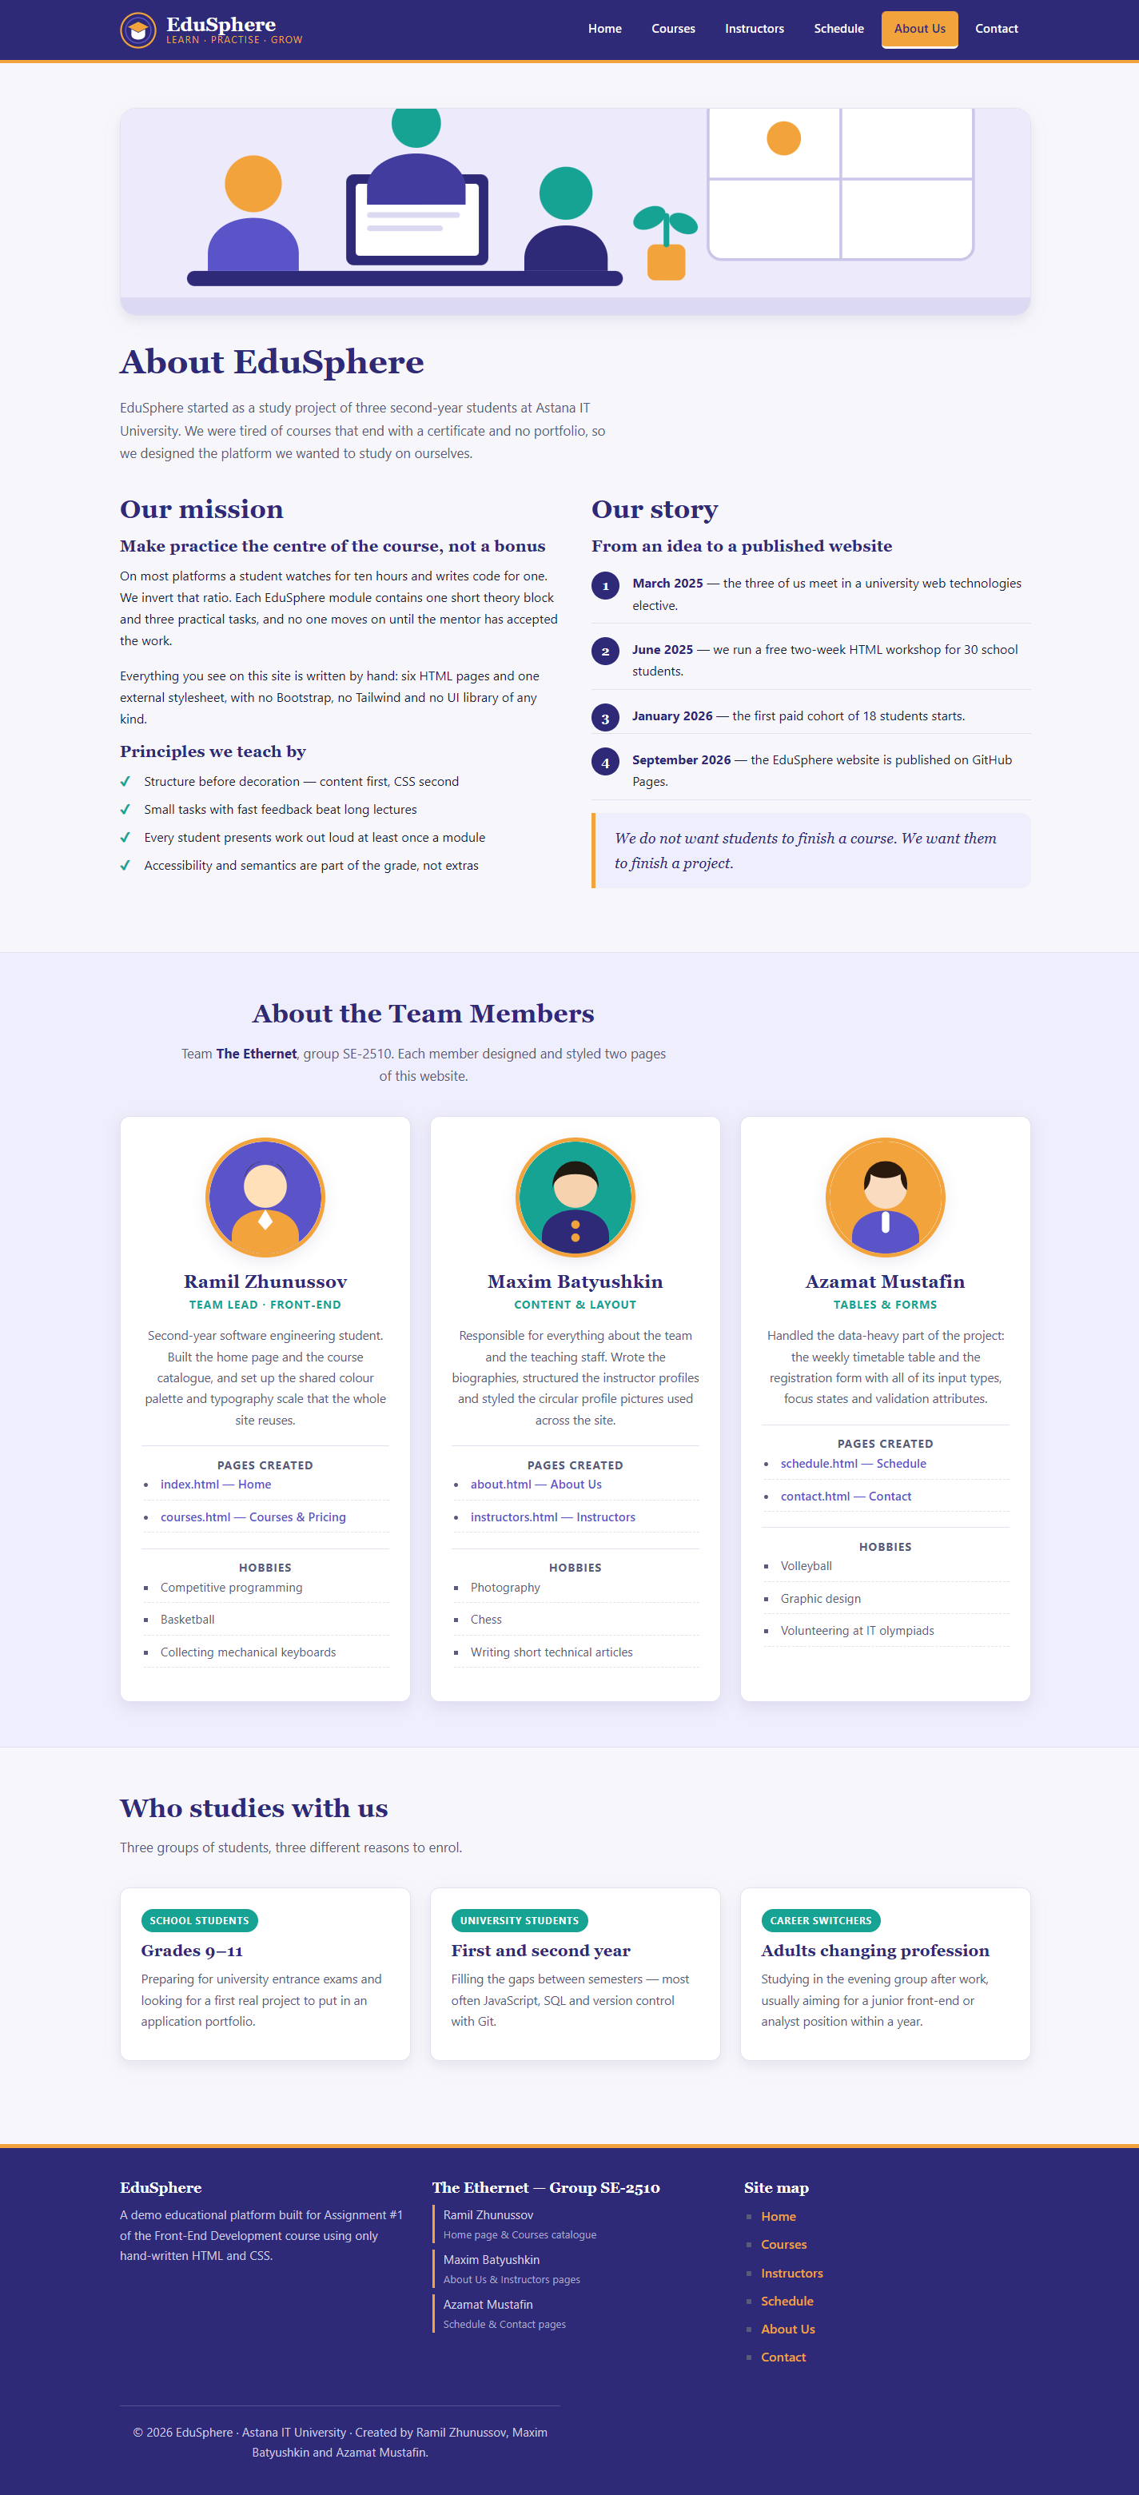
Figure 3. about.html — About the platform and the required “About the Team Members” section with circular photos. (Maxim Batyushkin)
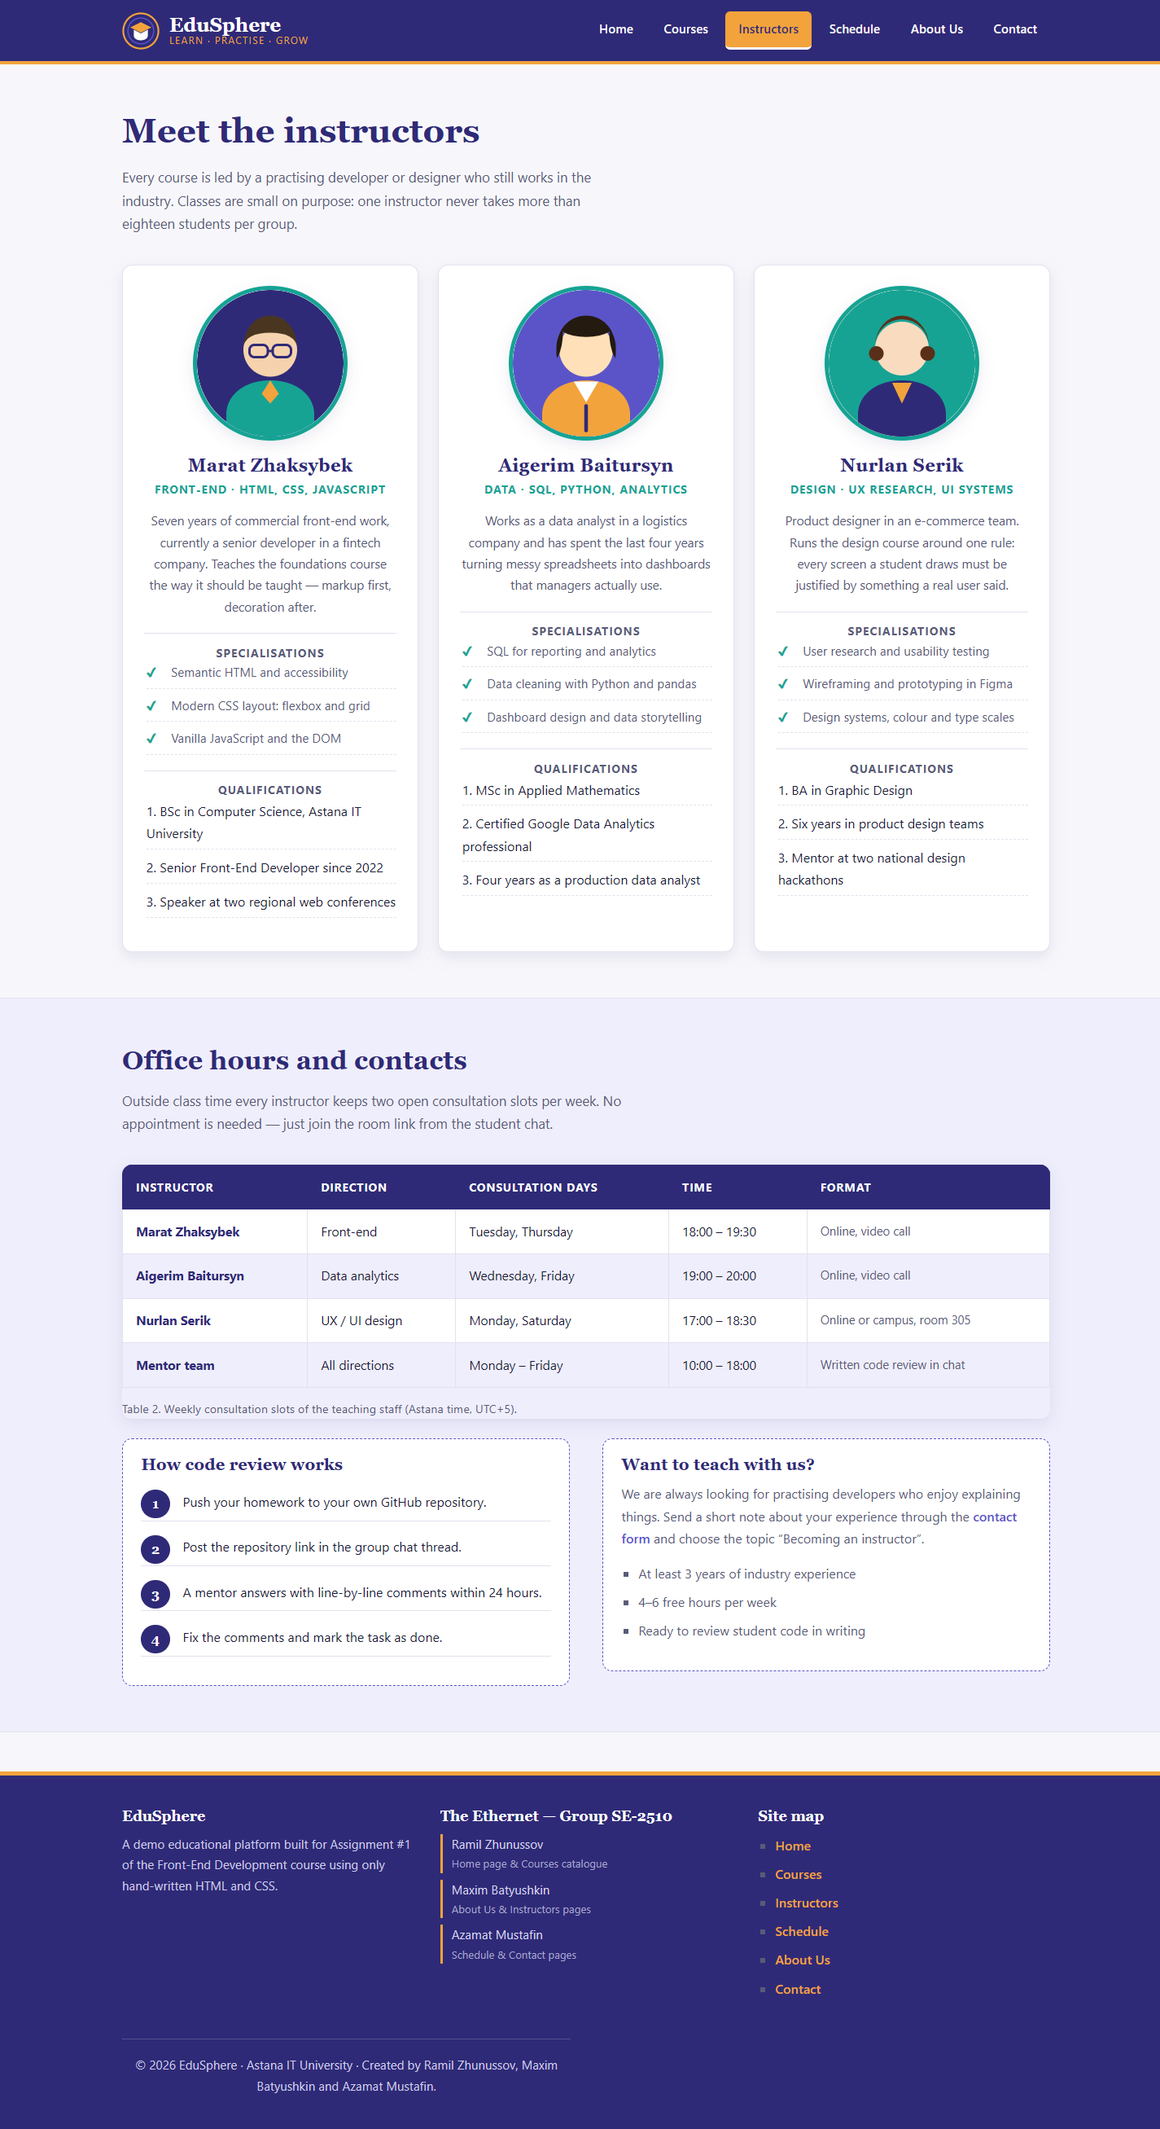
Figure 4. instructors.html — Instructor profiles with circular pictures and the #office-hours table. (Maxim Batyushkin)
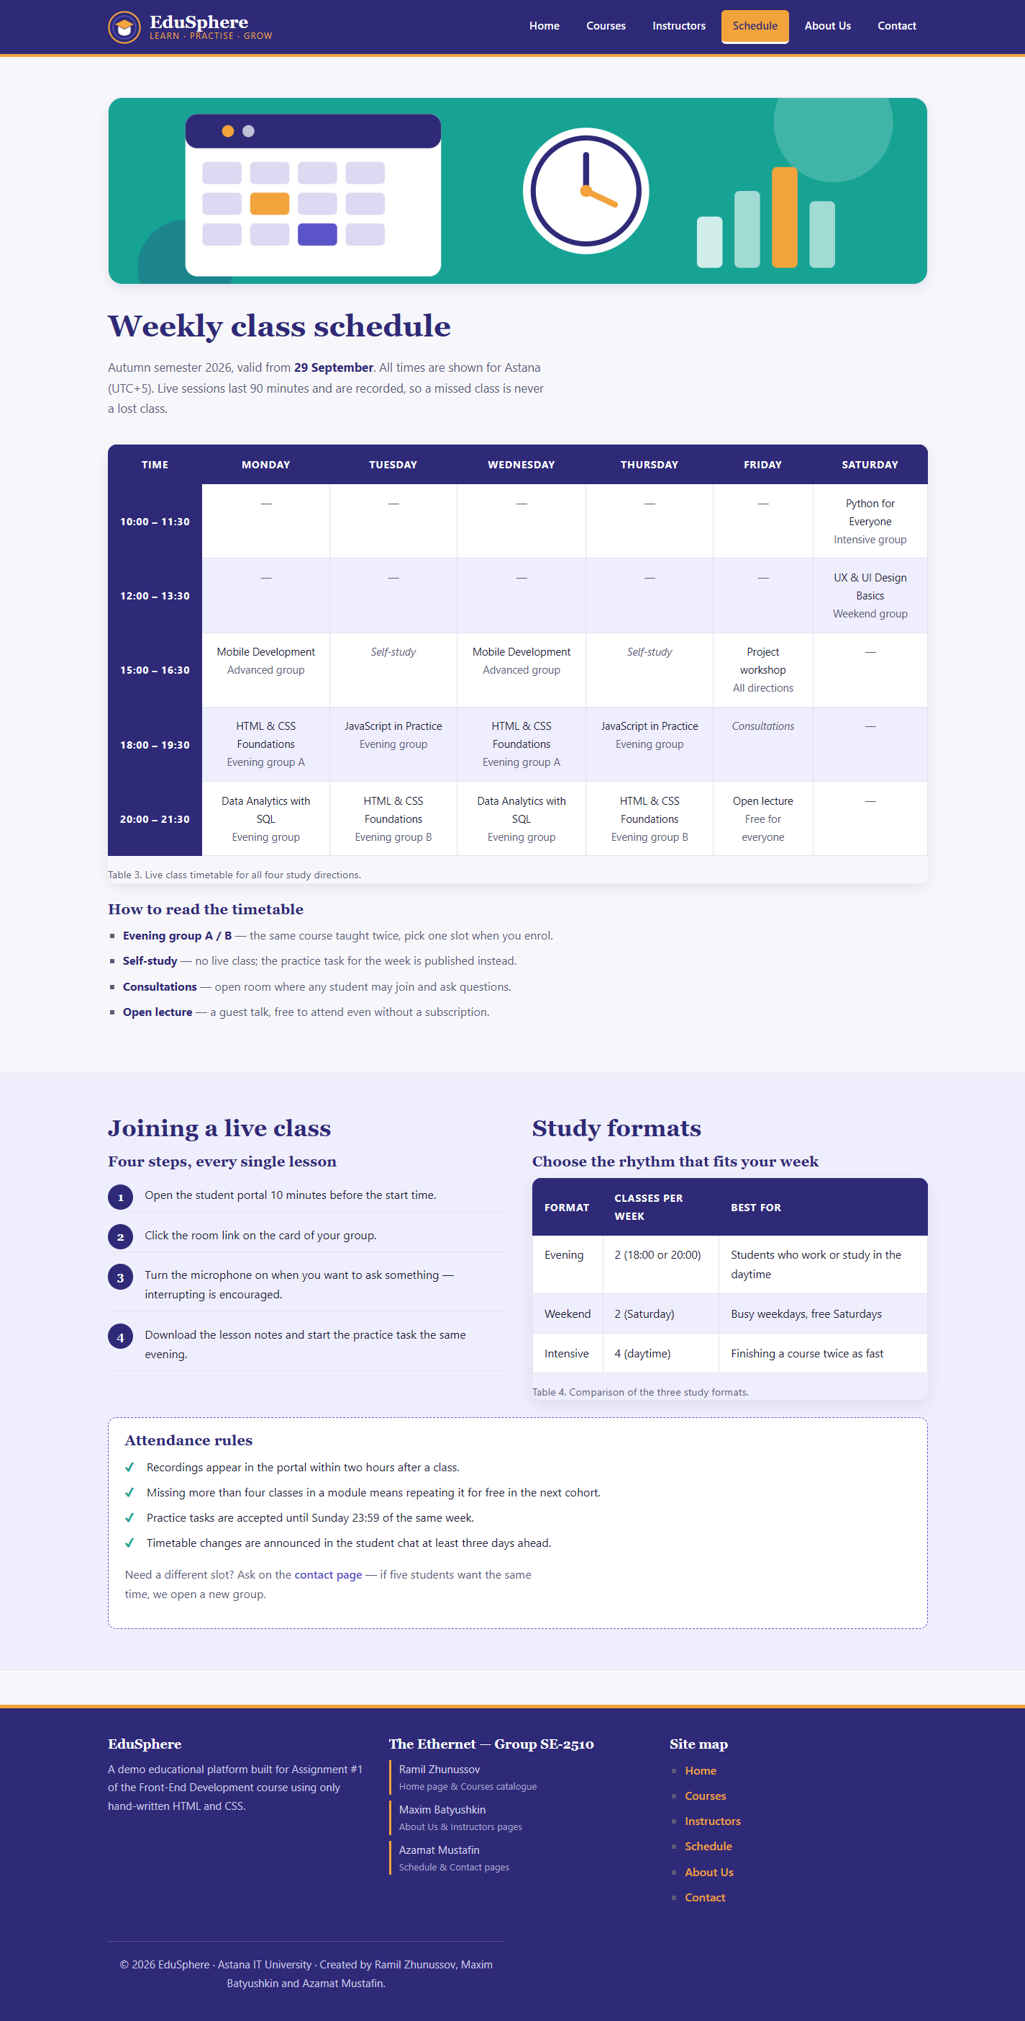
Figure 5. schedule.html — The #weekly-schedule timetable (7 columns) and the study-format comparison table. (Azamat Mustafin)
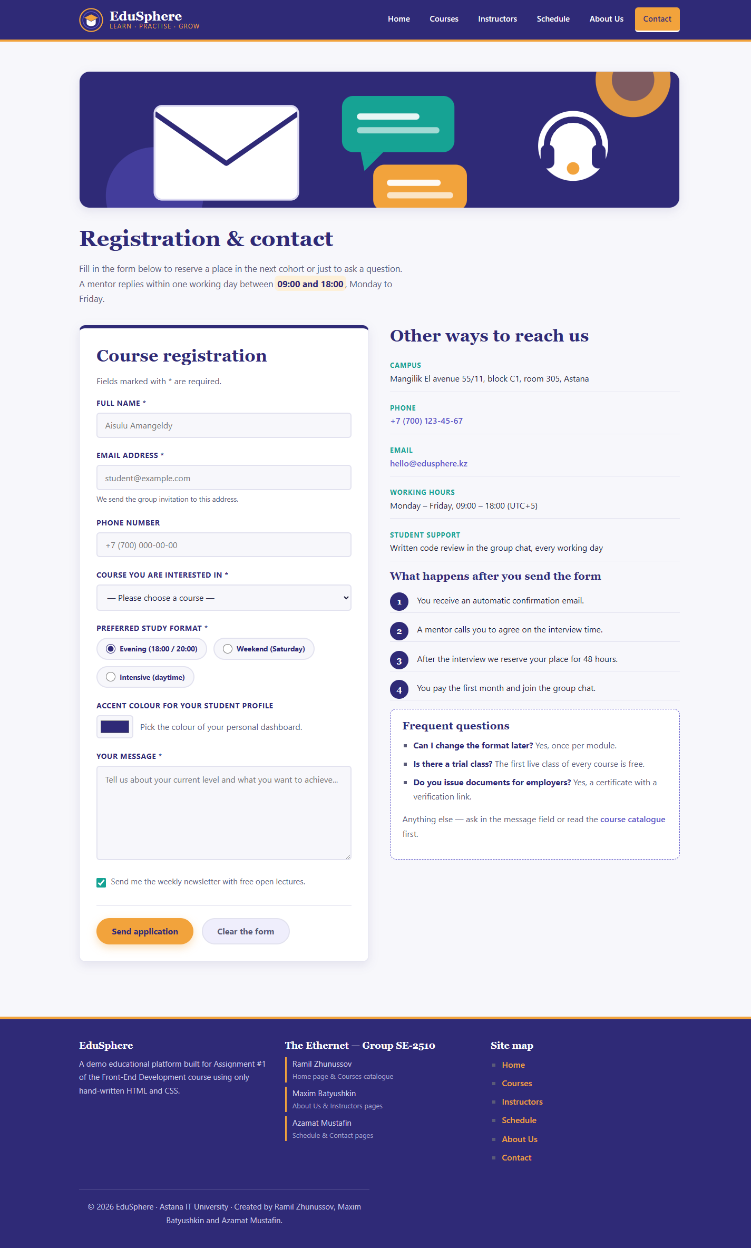
Figure 6. contact.html — The #contact-form registration form with text, email, tel, select, radio, colour, checkbox and textarea fields. (Azamat Mustafin)

5. Requirements checklist
Requirement | Where it is implemented | Done
6 pages for 3 team members | index, courses, about, instructors, schedule, contact | Yes
Full boilerplate on every page | All six .html files | Yes
Credit comment in <head> | All six .html files | Yes
Descriptive <title> per page | All six .html files | Yes
Semantic headings h1–h3 and <p> | All six pages | Yes
“About the Team Members” block | about.html, section #team | Yes
Ordered lists <ol> | index, courses, about, instructors, schedule, contact | Yes
Unordered lists <ul> | All six pages | Yes
At least one image per page with alt | 21 SVG images across all pages | Yes
Consistent global navigation | .nav-menu in all six pages | Yes
Table with <th>, <tr>, <td>, 3+ columns | 4 tables (5, 5, 7 and 3 columns) | Yes
Form: text, email, select/radio, colour, textarea, button | #contact-form | Yes
Shared external css/style.css linked everywhere | All six pages | Yes
Element / class / ID / descendant selectors | style.css sections 03, 08, 05 | Yes
Custom palette and typography | :root custom properties | Yes
Links without underline + :hover effect | style.css section 03 | Yes
Styled navigation bar with hover and active states | .nav-menu a, a.active | Yes
Box model: margin, padding, border, px/%/rem/vh | style.css sections 04, 08, 11 | Yes
Image sizes controlled from CSS | style.css section 10 | Yes
Circular image (border-radius: 50%) | .profile-img on about + instructors | Yes
Styled inputs, textarea, buttons with focus states | style.css section 12 | Yes
Footer with all team member names | #site-footer in all six pages | Yes
No frameworks or UI libraries | Hand-written CSS only | Yes
Published on GitHub Pages | See section 3, Step 15 | Yes

6. Final reflection
The part of the assignment that taught us the most was not writing the tags but deciding what belongs in HTML and what belongs in CSS. Our first draft had image sizes as width and height attributes and a few inline style attributes; moving all of it into style.css made the pages shorter, easier to read and much faster to restyle — after the palette became a set of :root variables, changing the whole site's accent colour took one line.
Three specific problems we had to solve:
- Specificity. Our pill-shaped radio labels stopped working because the more specific rule #contact-form label (one ID + one element) was overriding .radio-group label (one class + one element). We fixed it by qualifying the second rule with the same ID, and in the process finally understood how specificity is actually counted.
- Wide tables on small screens. The 7-column timetable destroyed the layout on a phone until we wrapped it in a .table-wrap container with overflow-x: auto, which lets the table scroll on its own instead of stretching the page.
- Keeping six pages consistent. Because the header, navigation and footer are repeated in every file, a change has to be made six times. This is exactly the problem that template engines and components solve later in the course — doing it by hand made the reason obvious.
If we continued the project, the next steps would be a responsive hamburger menu, real form submission to a backend, and replacing the repeated header and footer with an include mechanism. For a pure HTML and CSS assignment, however, the current version does everything it should: six consistent pages, one stylesheet, no frameworks and no broken links.

7. Resources used
- Abitova G.A. Web technologies Front-End Development. Part 1 (2022).
- W3Schools HTML tutorial — https://www.w3schools.com/html/html_basic.asp
- W3Schools CSS tutorial — https://www.w3schools.com/css/css_syntax.asp
- MDN Web Docs — HTML and CSS reference (developer.mozilla.org).
- Course video playlist provided in the assignment description.

