IST3134 Big Data Analytics — Group Assignment Plan
One-page memory for “what is this project and what does it produce?”

1. The one-sentence version
Analyse 10 years of US flight-delay data two ways — pandas on one laptop versus PySpark on AWS — and show that as the data grows, the big-data way keeps working while the laptop way slows down and eventually chokes. That contrast IS the assignment.

2. The question we answer
Main question: Over the ten-year period from 2015 to 2024, which airports, routes, carriers, and times of day experienced the worst flight delays, and how did the mix of delay causes shift over the course of the decade?
It splits into five sub-questions, each mapping to one output (see Section 5):
- Q1 (Carrier): Which airlines had the worst arrival delays over 2015–2024, measured by their average arrival delay and by the percentage of their flights that were delayed?
- Q2 (Airport): Which origin airports had the worst departure performance over 2015–2024, measured by the average delay and the percentage of delayed flights leaving each airport?
- Q3 (Route): Which origin-to-destination routes had the worst delays over 2015–2024, among routes with enough flights to be meaningful?
- Q4 (Time of day): How does a flight’s likelihood and length of delay vary with its scheduled departure hour, and which hours of the day are the worst to fly?
- Q5 (Cause mix over time): How has the share of total delay attributable to each of the five causes — carrier, weather, national airspace system, security, and late-arriving aircraft — changed from year to year across the decade?
Q1–Q4 are “who/what/when is worst” snapshots; Q5 is the trend. “Delayed” = arrival delay ≥ 15 minutes.

3. The dataset
Our data comes from the Airline On-Time Performance collection published by the United States Bureau of Transportation Statistics (BTS), available free and without any login at transtats.bts.gov. Every domestic flight operated by the major US airlines is reported to the government, and each one becomes a single row.
Each row is a detailed portrait of one flight. It tells you who flew it (the airline, aircraft, and flight number), where it went (origin and destination airports, their cities and states, and the distance between them), when it was meant to happen versus when it actually did (scheduled and actual departure/arrival times, and from the gap, exactly how many minutes early or late it was), and what happened to it (whether it operated normally, was cancelled, or was diverted).
What makes this dataset special for a delay study is that it records not just that a flight was late but why. When a flight arrives 15 minutes or more behind schedule, its lateness is split across five official causes: delay the airline itself caused, weather, congestion in the national airspace system, security, and late-arriving aircraft (the knock-on from the same plane running late earlier). This is what lets us ask what is actually driving delays and how it has changed.
For our analysis we lean on a focused set of these fields: the airline, the origin and destination airports, the scheduled and actual times, the arrival and departure delays, the cancellation flag, the distance, and the five delay-cause columns.

4. How we run it and what we compare

4a. The two implementations
The same analysis is run two different ways:
- Local (baseline): Python + pandas on a single machine (one laptop).
- Cloud (big data): PySpark on AWS (EMR cluster reading the data from S3).

4b. The durations we compile and experiment with
- 1 month (Jan 2024) — the small “match the numbers” test.
- 1 year (2024) — first real benchmark.
- 5 years (2020–2024).
- 10 years (2015–2024) — full scale.

4c. What we measure (beyond the analysis)
- Runtime — how long the whole run takes (seconds).
- Peak memory — the most memory the run used at once (GB).
- Whether it completes at all — pandas is expected to slow and eventually fail at the larger durations, while Spark should finish all four.

5. What each sub-question produces (table + chart)
Every run — pandas or Spark, at any duration — produces the same outputs. Each sub-question is answered by one result table and one chart. The charts below are illustrative mock-ups to show the intended shape of each output; they do not use real data.

Q1 — By carrier
A table of every airline with its average arrival delay and its percentage of delayed flights, shown as a horizontal bar chart ranking airlines from worst to best on-time performance. Reveals the most and least reliable carriers.
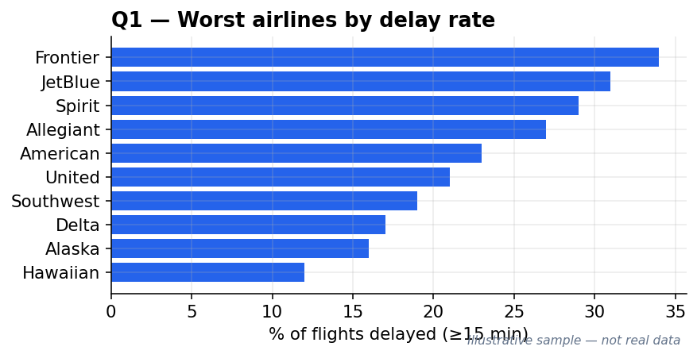

Q2 — By airport
A table of origin airports (those with at least 1,000 flights) with their average delay and percentage delayed, shown as a horizontal bar chart of the worst airports (optionally on a US map). Shows where travellers are most likely to be delayed leaving from.
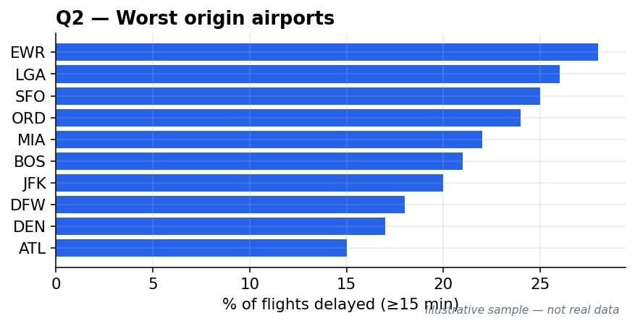

Q3 — By route
A table of origin-to-destination routes (those with at least 500 flights) ranked by delay, shown as a horizontal bar chart of the worst routes. Shows which specific city pairs are the most delay-prone.
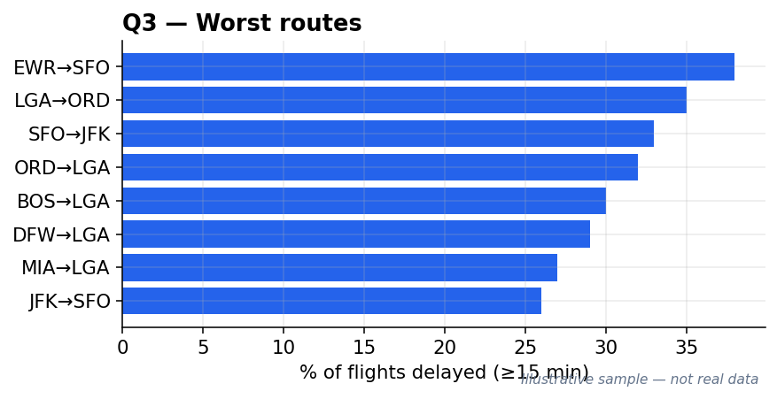

Q4 — By time of day
A table of the 24 scheduled departure hours with the average delay and percentage delayed for each, shown as a line chart of delay against hour of day (0–23). Shows how delays build up through the day and which hours are worst.
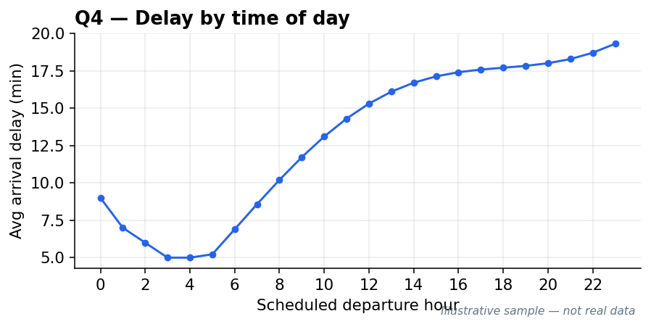

Q5 — Cause mix over time
A table of each year (2015–2024) with the share of total delay minutes contributed by each of the five causes, shown as a stacked area chart across the years. Shows how the balance between carrier, weather, airspace, security, and late-aircraft delays has shifted.
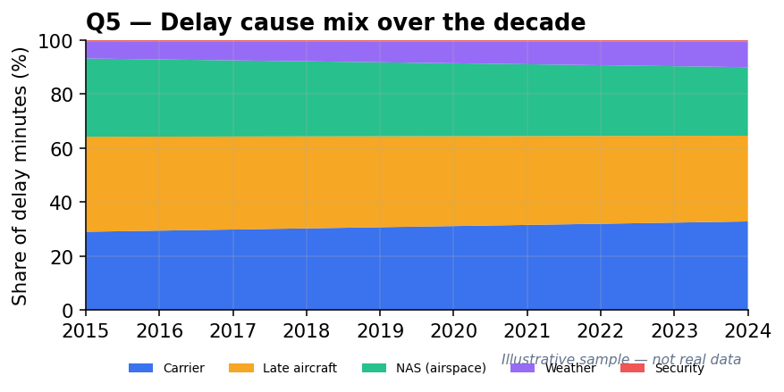

The comparison (the big-data point)
Separately from the five, every run prints a performance line — rows processed, runtime, and peak memory. Collecting these from pandas and Spark at 1, 5, and 10 years gives a runtime-versus-data-size chart (and a matching memory chart), each with one line for pandas and one for Spark. This is the output that demonstrates why big data tools are needed: the pandas line climbs steeply and eventually fails, while the Spark line stays flat.
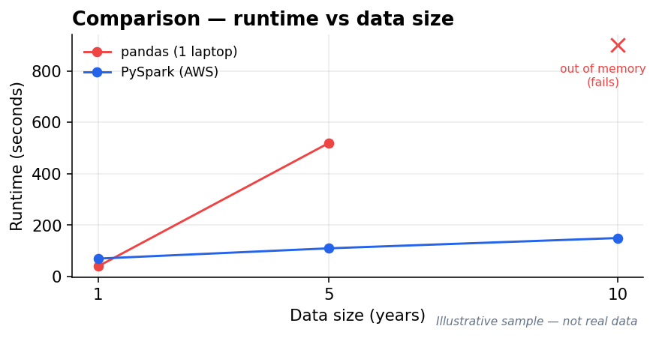

6. Deliverables (what we hand in)
- Report (Word or PDF) containing:
  - Brief introduction to the problem.
  - Brief introduction to the dataset (with the link).
  - Explanation of the Spark / big-data approach.
  - Analysis of the output with justifications.
  - An individual reflection from each team member.
- GitHub repository with all source code and the dataset link — the grader marks whatever is in the repo, so it must be self-contained and runnable.
- Zip file of any extra materials, submitted alongside the report.
Marking (20% total): problem intro 10% · dataset intro 10% · Spark approach 20% · output analysis 20% · reflection 20% · code quality 10% · implementation (the two-way comparison) 10%.

7. Key dates & milestones
- 24 July 2026 — Deadline to confirm our dataset with the lecturer. Show a working sample and get approval before building at full scale.
- ~3 August 2026 — Submission link opens on eLearn (about a week before the deadline).
- 10 August 2026 — Submission window opens.
- 13 August 2026, 11:59 pm — Final deadline: report + GitHub repo (+ any extras zipped) submitted.

