

FACULTY OF ENGINEERING AND TECHNOLOGY

IST3134 – Group Assignment
ACADEMIC SESSION: SEPTEMBER 2025

Group Members:
Teo Zen Ben (22120679)
Jeanette Tan En Jie (23035173)

Topic:
Analyzing a Decade of US Flight Delays
A Comparison of a Single Machine Approach (pandas) and a Cloud Big Data Approach (PySpark on AWS)
GitHub repository: https://github.com/ZenBen5173/IST3134-Flight-Delay-BigData
Dataset: US Bureau of Transportation Statistics, transtats.bts.gov

1. Introduction to the Problem
Flight delays are a common and costly problem in air travel which negatively impacts passengers, airlines and airports at the same time. When a flight arrives late, it causes missed connections, extra crew and fuel costs and a domino effect, where the aircraft not only starts its own next trip late but also holds up other flights using the same runway, gates and crew. Due to this, understanding where and when delays happen is incredibly useful for planning and for setting expectations.
In this assignment we studied ten years of United States domestic flight records, ranging from 2015 to 2024 and evaluated which airports, routes, airlines and times of day had the worst delays and how the reasons behind those delays changed over the decade.
The dataset for a full decade is incredibly large as it contains roughly 62 million flight records, with this size, it is deliberately too big to fit comfortably in the memory of a single laptop. This makes it a suitable problem for Big Data Analytics and allows us to effectively identify and compare two different methods of solving the same problem.
To do this, we built the same analysis twice, once using Python with the pandas library on a single machine which is the ordinary non Big Data approach, and another using Apache Spark (PySpark) running on an Amazon Web Services (AWS) cluster in the cloud which is the Big Data approach. By running both at increasing data sizes and measuring how long each took and how much memory each used, we were able to clearly show the importance of a distributed cloud tool and why it is needed once the data grows large.

2. Introduction to the Dataset
The data comes from the Airline On-Time Performance collection published by the United States Bureau of Transportation Statistics (BTS), which is free to download and does not require any login. The download page is at https://www.transtats.bts.gov under the section “Reporting Carrier On-Time Performance (1987-present)”. Every domestic flight operated by the major US reporting airlines is recorded and each flight becomes one row in the data.
The data is published one file per month, so the full ten year period from 2015 to 2024 is made up of 120 monthly files, which together contain about 62 million flight records after cancelled flights are removed. Each row has around 110 columns and it describes one flight in detail, indicating that it records various factors such as which airline flew it, where it departed from, where it was going, the scheduled and the actual departure and arrival times, the distance, whether the flight was cancelled or diverted and, when a flight was late, a breakdown of the reason for the delay. This breakdown splits the lateness across five official causes, which are carrier (a problem the airline itself caused such as crew, maintenance or baggage), weather, national airspace system (air traffic control, heavy traffic and airport conditions), security and late arriving aircraft (a knock-on delay from the same plane arriving late on its previous trip).
For our analysis we used a focused set of the columns rather than all 110, meaning we kept the airline, the origin and destination airports, the scheduled departure time, the arrival delay, the cancellation flag and the five delay cause columns. Throughout this report a flight is counted as delayed when its arrival delay is 15 minutes or more, which is the standard definition used by the US Department of Transportation. Table 1 lists the main columns that we used and what each one means.
Column | Meaning
Reporting_Airline | The airline that operated the flight
Origin, Dest | Departure and destination airport codes
CRSDepTime | Scheduled departure time, used to derive the hour of day
ArrDelay | Arrival delay in minutes (15 or more counts as delayed)
Cancelled | 1 if the flight was cancelled, otherwise 0
CarrierDelay, WeatherDelay, NASDelay, SecurityDelay, LateAircraftDelay | The five delay cause columns, in minutes
Table 1. The main columns used from the BTS On-Time Performance data.

3. Research Questions
The main question we set out to answer was, over the ten years from 2015 to 2024, which airports, routes, carriers and times of day had the worst flight delays and how the mix of delay causes shifted over the decade. We split this into five smaller questions so that each one maps cleanly to one result:
- Q1 (Carrier). Which airlines had the worst arrival delays, measured by the percentage of their flights that were delayed and their average arrival delay?
- Q2 (Airport). Which origin airports had the worst departure performance?
- Q3 (Route). Which origin to destination routes had the worst delays?
- Q4 (Time of day). How does the chance of a delay change with the scheduled departure hour and which hours are the worst to fly?
- Q5 (Cause mix over time). How has the share of total delay coming from each of the five causes changed from year to year across the decade?

4. Scope and Limitations
This project covers United States domestic flights recorded in the BTS On-Time Performance data over the ten years from 2015 to 2024 and within that data we look only at the five questions set out above, which are delays by carrier, airport, route and time of day together with the yearly mix of delay causes. A flight is treated as delayed when its arrival delay is 15 minutes or more. The Big Data goal is a fair comparison of two ways of running the same group by aggregation, so our focus is on how the runtime and the memory behave as the data grows rather than on building the fastest possible pipeline.
Several things are deliberately left outside our scope. We do not try to predict or model delays, so there is no machine learning, because the aim was the aggregation itself and the comparison of the two tools. We do not look at international flights, airfares, passenger numbers or the wider cost of delays. Cancelled flights are simply removed rather than studied on their own. We also do not tune either system for maximum speed and we did not resize the cluster or change the Spark settings, so the runtimes should be read as a like for like comparison on a standard setup rather than the best each tool could reach. Finally the cloud upload was slowed by the data source limiting our requests, which we note where it is relevant.

5. The Algorithm and How Spark Processes the Data
The algorithm we used is a group by aggregation, which is the same idea as the classic MapReduce pattern that Big Data platforms are built around. We developed the aggregation logic ourselves with assistance from AI tools and we wrote it using the ready made grouping functions that pandas and Spark already provide. The documentation for both libraries is listed in the references at the end of the report. In plain terms the algorithm answers each question by sorting the flights into groups, for example one group per airline and then summarizing each group.
Behind the scenes, Spark breaks the work into three stages. In the map stage each flight record is read once and turned into a key and a small set of values, for example the key is the airline and the values are a count of one, the arrival delay in minutes and a 1 or 0 flag for whether the flight was delayed. In the shuffle stage the platform gathers together all the values that share the same key, meaning all the records for the same airline are brought to the same place. In the reduce stage the values in each group are combined, meaning the counts are added up, the delay minutes are averaged and the delayed flags are averaged to give the percentage of delayed flights. The same three stage pattern is used for the airport, route, hour and yearly cause groupings, only the key changes.
The reason this suits Big Data is the way Spark carries out the work. pandas loads the entire dataset into the memory of one machine and then processes it, so the memory needed grows with the size of the data. Spark instead splits the data into many partitions, meaning smaller chunks and spreads them across the machines in a cluster so that many parts of the map and reduce work happen at the same time. When memory runs low Spark writes intermediate data to disk (this is called spilling) instead of failing, so it can process data that is far larger than the memory of any single machine (The pandas development team, n.d.-b; Zaharia, Chowdhury, Franklin, Shenker, & Stoica, 2010). This is why the same algorithm scales to the full decade on Spark while it strains the single machine version and it is the central point that this assignment is designed to demonstrate.

6. Implementation and Experimental Setup
We implemented the same analysis in two ways so that we could compare a non Big Data approach against a Big Data approach on identical work.

6.1 The single machine baseline (pandas)
The baseline was written in Python using the pandas library and it was run on one laptop. It reads the monthly files, removes cancelled flights, creates the delayed flag and the departure hour and then runs the five group by aggregations. This version keeps all of the data in memory, so it is simple and fast for small inputs but it is expected to strain as the number of years grows.

6.2 The Big Data approach (PySpark on AWS)
The Big Data version was written in PySpark, which is the Python interface to Apache Spark and it was run on a cluster on Amazon Web Services. We uploaded the data to Amazon S3, meaning cloud storage and we then created an Amazon EMR cluster, which is a managed Spark and Hadoop platform, made up of one primary node and two core nodes.
The Spark job reads the data directly from S3, runs the exact same five aggregations and writes the results back to S3. The cluster ran Spark 4.0.2 on the emr-spark-8.0.0 release and the screenshots of the running cluster, the completed job and the success log are included with our submission as evidence that the analysis was carried out in the cloud.
An important check is that the two implementations agree, because they run the same algorithm on the same data they should give the same answers and they did, meaning the result tables from pandas and from Spark matched to the decimal, for example American Airlines showed the same 29.29% of flights delayed for January 2024 in both. This shows that the comparison between the two is fair, because any difference in speed or memory comes from the tools and not from the calculation.
Check | pandas (local) | Spark (AWS)
Rows after removing cancellations | 526,882 | 526,882
Overall flights delayed (>=15 min) | 24.0% | 24.0%
American Airlines, % delayed | 29.29% | 29.29%
Table 2. A sample of the pandas and Spark results for January 2024, showing that the two engines produced identical numbers.
To measure how each approach scales we ran both of them over four increasing data sizes, which were one month (January 2024), one year (2024), five years (2020 to 2024) and ten years (2015 to 2024) and for each run we recorded the number of rows, the total runtime and, for pandas, the peak memory used.

7. Analysis of the Output
This section presents the findings for the full ten year period. Each result is shown as a chart together with a short table so that the numbers stated in the text can also be seen in the figures.

7.1 Q1 Worst airlines
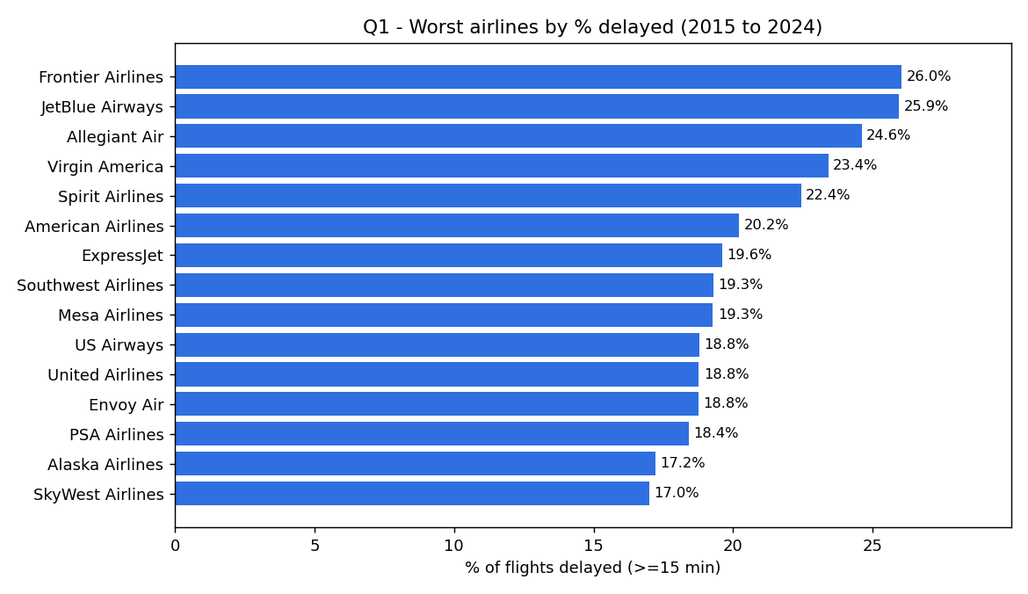
Figure 1. Airlines ranked by the percentage of flights delayed, 2015 to 2024.
The airlines with the worst delay records over the decade were the low cost carriers. Frontier Airlines was the worst with 26.0% of its flights delayed, followed by JetBlue at 25.9%, Allegiant at 24.6%, Virgin America at 23.4% and Spirit at 22.4%, as shown in Figure 1 and Table 3. The pattern in the chart is that the top of the ranking is filled almost entirely by budget carriers while the large network carriers such as Delta, Alaska and Hawaiian sit at the reliable end. A likely reason is the budget model itself, because these airlines keep their aircraft flying as much as possible with short turnarounds and little spare time in the schedule, so there is very little slack to absorb a delay and any early disruption is passed on to later flights. This link between scheduled slack and delay is well established, where re-allocating buffer time in a schedule has been shown to measurably reduce how far delays propagate (AhmadBeygi, Cohn, & Lapp, 2010).
Interpreting this a step further, the ranking looks less like a list of good and bad airlines and more like a business-model choice, because the budget carriers deliberately run their aircraft on very tight turnarounds to keep costs and fares low, which leaves little room to recover once something slips, so punctuality is effectively being traded for a lower ticket price. This reading assumes that the percentage delayed mainly reflects each carrier's own scheduling and turnaround choices rather than the particular airports and routes it happens to serve, which we did not separate out. Recent evidence supports the link, finding that low cost carriers set significantly shorter turnaround times than traditional carriers and that this choice directly shapes their on-time performance (Malighetti, Morlotti, Redondi, & Paleari, 2023).
Airline | Flights | Avg arrival delay (min) | % delayed
Frontier (F9) | 1,287,500 | 11.3 | 26.0
JetBlue (B6) | 2,528,111 | 10.9 | 25.9
Allegiant (G4) | 739,094 | 11.8 | 24.6
Virgin America (VX) | 217,006 | 7.4 | 23.4
Spirit (NK) | 1,837,073 | 8.0 | 22.4
Table 3. The five airlines with the highest percentage of delayed flights.

7.2 Q2 Worst airports
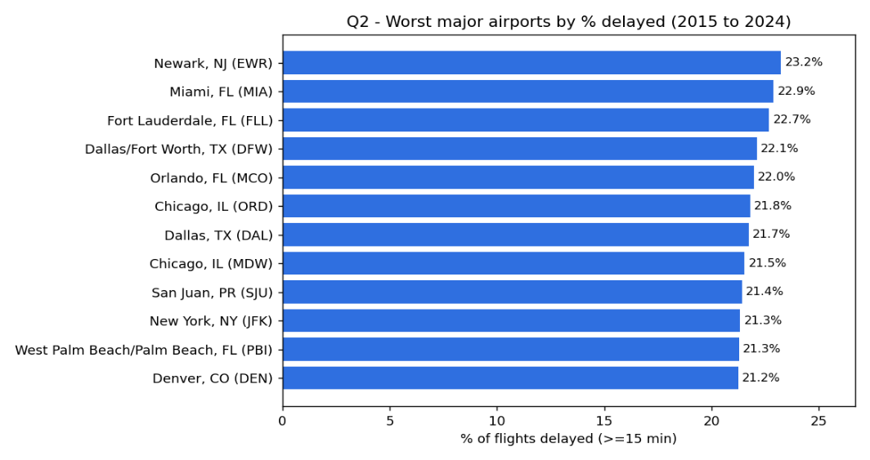

Figure 2. Worst major origin airports (at least 100,000 flights over the decade).
Among the busy airports, those with at least 100,000 departures over the decade so that the result is not distorted by tiny low traffic airports, Newark was the worst at 23.2% of flights delayed, followed by Miami at 22.9%, Fort Lauderdale at 22.7%, Dallas Fort Worth at 22.1% and Chicago O'Hare at 21.8%, as shown in Figure 2. The more telling pattern in the chart is that the worst airports are not scattered across the country, they cluster by city. Dallas appears twice with Fort Worth and Love Field, Chicago appears twice with O'Hare and Midway and four of the twelve are Florida airports. When both airports serving the same city land near the top, the delays look like a shared regional problem rather than one badly run airport. This matches the FAA idea of a metroplex, a metropolitan area where a large number of airports are concentrated and the air traffic becomes congested, and several of our worst airports including the Dallas Fort Worth area, the Florida airports and Denver fall in the exact metros the FAA singled out for congestion relief (U.S. Department of Transportation, Office of Inspector General, 2019).
This also lets us read the delays as a coupled regional system rather than a set of independent airports, which implies that a single airport has limited power to fix its own numbers because the improvement depends on shared airspace and traffic flow across the whole metro. Here we assume that filtering to airports with at least 100,000 departures gives a fair comparison of major airports and that an airport's origin delay rate reflects conditions at and around that airport rather than the destinations its flights are heading to. This regional coupling is backed by recent work showing that neighboring airports' delays move together, with the strongest and most stable coupling found among the busy north east airports (Wang, Li, Gopalakrishnan, & Liu, 2022), and by evidence that large hub airports are the most vulnerable to delay and the slowest to recover once it sets in (Yao & Zhang, 2023).
We chose 100,000 departures over the decade, which is about twenty seven flights a day, because an airport needs a reasonably large number of flights before its delay percentage is stable rather than swung by a handful of flights, and below that threshold the ranking fills up with tiny airports whose rates are noisy. The exact cut off is a judgment call, but the pattern is not sensitive to it, the same busy hubs stay at the top across a range of thresholds.

7.3 Q3 Worst routes
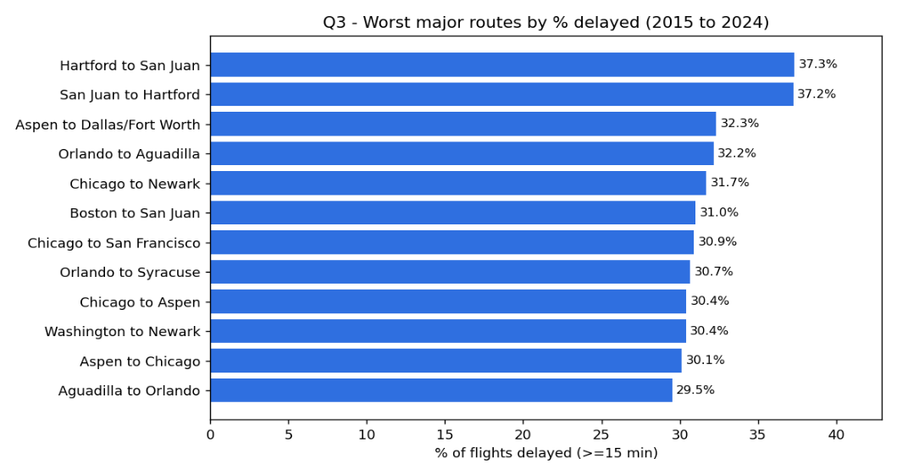
Figure 3. Worst major routes (at least 5,000 flights over the decade).
Looking at specific origin to destination routes with at least 5,000 flights over the decade, the worst were the connections between Hartford and San Juan in Puerto Rico, where about 37% of flights were delayed in each direction, followed by Aspen to Dallas Fort Worth at 32.3% and several routes out of Chicago Midway and Newark, as shown in Figure 3. The clearest pattern in the chart is that the worst routes appear as mirrored pairs, so Hartford to San Juan and San Juan to Hartford both sit at the top, as do Orlando to Aguadilla and Aguadilla to Orlando. This points to delay propagation on a single aircraft rotation, because the same plane usually flies out and straight back on these thin routes, so a late inbound leg forces the return leg to leave late as well. This connection driven propagation through shared aircraft is exactly what has been shown to spread delay across an airline network (AhmadBeygi, Cohn, Guan, & Belobaba, 2008). The routes are also mostly long leisure markets such as Puerto Rico and Aspen, which fits the airport results because Newark and the Florida and Puerto Rico markets appear again.
Reading the mirrored pairs a little further, they point to a fixable operational cause rather than a mysterious one, because if the delay is being handed from the inbound leg to the outbound leg of the same aircraft then adding a little more turnaround time on these specific rotations should absorb much of it. This assumes that the same aircraft really does fly the out and back on these thin routes, which is typical but which we did not confirm from individual tail numbers. The mechanism itself, where a delay travels forward along the sequence of flights flown by one aircraft, is exactly the tail-propagated delay described in recent airport network research (Wang et al., 2022).

7.4 Q4 Delay by time of day
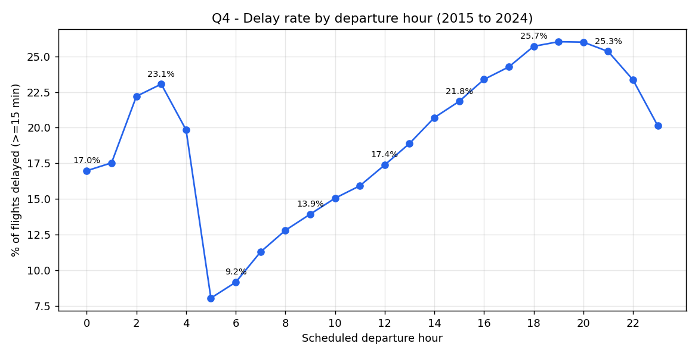
Figure 4. Percentage of flights delayed by scheduled departure hour, 2015 to 2024.
The time of day has a strong and very consistent effect. Early morning flights were the most reliable, so flights scheduled to leave between 5am and 7am actually arrived a few minutes early on average and only about 8% to 11% were delayed, and the delay rate then built up steadily through the day to a peak in the early evening, where flights leaving around 6pm to 7pm had the highest average delay and about 26% of them were delayed, as shown in Figure 4 and Table 4. The shape of this curve is the knock on effect made visible, because small delays early in the day accumulate as the same aircraft and crews are reused later. This is supported by how the delay is officially recorded, since the largest single reported cause is late arriving aircraft, which BTS defines as a previous flight with the same aircraft arriving late and causing the next one to leave late (Bureau of Transportation Statistics, n.d.-b). The practical advice that follows is simple, an early flight is much more likely to be on time than a late afternoon or evening one.
Interpreting the curve further, it suggests the network behaves like a queue that only fully resets overnight, because the delays picked up in the morning are rarely recovered within the same operating day, they instead build from one flight to the next, so the early evening peak is really the accumulated result of the whole day rather than an evening specific problem. This reading assumes that a flight's scheduled departure hour is a reasonable stand in for where its aircraft sits in the daily rotation, with early flights on fresh aircraft and later flights inheriting many earlier legs, and that demand and route difficulty are broadly similar across the day. Recent airport network research supports this, showing that delays are carried forward along an aircraft's sequence of flights as the day goes on (Wang et al., 2022).
Scheduled departure hour | Avg arrival delay (min) | % delayed
06:00 | -2.7 | 9.2
09:00 | 0.1 | 13.9
12:00 | 3.5 | 17.4
15:00 | 7.5 | 21.8
18:00 (worst) | 10.8 | 25.7
21:00 | 10.0 | 25.3
Table 4. Selected departure hours showing how delay rises through the day.

7.5 Q5 How the delay causes changed over the decade
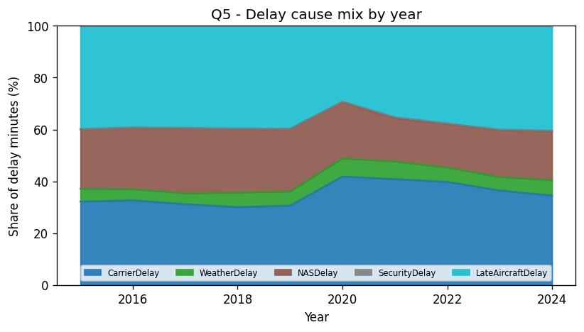
Figure 5. Share of total delay minutes by cause, each year from 2015 to 2024.
Across the whole decade the two largest causes of delay were late arriving aircraft and the carrier itself, which together made up roughly 70% of all delay minutes, while weather stayed small at around 4% to 7% and security was almost negligible at well under half a percent, as shown in Figure 5 and Table 5. The pattern is that delay is mostly an internal operational problem rather than an external one, because the two dominant categories both sit inside the airline and airspace system rather than being caused by weather or security. It is worth noting that this small weather share understates the true role of weather, because BTS records non extreme weather inside the airspace and late aircraft categories rather than as its own line (Bureau of Transportation Statistics, n.d.-b), which is one reason we did not try to attribute the airport pattern to weather. The clearest change happened in 2020, the first year of the COVID pandemic, when carrier caused delay jumped to 41.8% of the total and late aircraft delay fell to 29.2%, which fits the idea that with far fewer flights in the schedule there were fewer aircraft to pass delays down the chain. As flying returned to normal the mix moved back and by 2024 late aircraft was again the largest cause at 40.4%. The link to the pandemic is not only our own reading, an independent government review of the same period also found that airline controlled problems overtook late arriving aircraft as the leading cause of disruption during the pandemic (U.S. Government Accountability Office, 2023).
We can push the 2020 result a little further, because it suggests that late aircraft delay is not a fixed feature of the system but something that depends on how densely the schedule is packed. When the pandemic emptied the schedule there were far fewer connecting aircraft to pass a delay down the chain, so the late aircraft share fell and the airline's own carrier delays became the larger share, which is why the mix looks so different in that one year. This assumes that the five BTS cause categories were recorded in a consistent way across the whole decade, so that a change in the mix reflects real operations rather than a change in how causes are labelled. An independent government review of the same period reached the same conclusion from the other direction, finding that during the pandemic and its recovery airline-caused problems, not knock-on late aircraft, became the leading driver of disruption (U.S. Government Accountability Office, 2023).
Year | Carrier % | Weather % | NAS % | Security % | Late aircraft %
2015 | 32.2 | 4.9 | 22.9 | 0.1 | 39.8
2019 | 30.6 | 5.5 | 24.0 | 0.1 | 39.7
2020 | 41.8 | 7.0 | 21.7 | 0.2 | 29.2
2022 | 39.8 | 5.6 | 16.8 | 0.2 | 37.6
2024 | 34.5 | 6.0 | 18.9 | 0.2 | 40.4
Table 5. Delay cause mix for selected years, as a share of total delay minutes.

7.6 What the findings mean in practice
The patterns above are not only descriptive, they point to concrete actions for the organizations that manage flights. Because the worst airports cluster by metropolitan region rather than standing out one by one, the most useful response sits above the level of a single airport, in the shared airspace and traffic flow of the whole metro. This is exactly the aim of the FAA metroplex program, which redesigns arrival and departure procedures across all the airports in a congested metro at once (U.S. Department of Transportation, Office of Inspector General, 2019), so our results suggest that the north east and the Florida corridors are where that kind of regional investment would pay off most.
For the airlines the strongest lever is schedule design. The time of day curve and the mirrored worst routes both trace back to delays being handed from one flight to the next along a single aircraft, so building a little more turnaround buffer into the tightest rotations, especially the thin out and back leisure routes and the first wave of morning aircraft, would stop small delays snowballing through the day (Wang et al., 2022; AhmadBeygi, Cohn, & Lapp, 2010). This matters most for the budget carriers, whose very tight turnarounds put them at the top of the delay ranking (Malighetti et al., 2023), so a modest amount of extra slack on their busiest aircraft would likely move them down it.
For passengers the takeaway is the most concrete of all. Because the delay rate climbs steadily through the day, the single best thing a traveler can do is fly early. Flights scheduled to depart between about 5am and 7am were the most reliable in the whole decade, only around 8% to 11% were delayed and on average they arrived a few minutes early, while flights leaving in the early evening around 6pm to 7pm were delayed about 26% of the time, which is more than double the morning rate. The lowest risk itinerary is therefore an early morning departure that avoids the busiest north east and Florida hubs, while a late evening flight out of one of those hubs carries the highest risk. And because the cause breakdown shows that most delay is operational rather than weather driven, these are patterns a traveler can plan around rather than random bad luck.

8. Performance Comparison: Single Machine versus Cloud Big Data
The results above answer the flight delay question and they are the same no matter which tool produced them. The purpose of this section is different, meaning it compares how the two implementations behaved as the data grew, which is the core Big Data argument of the assignment. Table 6 lists the measured runtime for both approaches and the peak memory for the pandas baseline at each of the four data sizes.
Data size | Rows | pandas runtime | pandas peak memory | Spark on AWS runtime
1 month | 526,882 | 8 s | under 1 GB | 23.7 s
1 year | 6,982,746 | 41.3 s | 4.33 GB | 33.7 s
5 years | 30,590,198 | 227.4 s | 19.05 GB | 126.7 s
10 years | 61,839,886 | 479.0 s | 38.44 GB | 250.3 s
Table 6. Measured runtime and memory for both approaches at each data size.
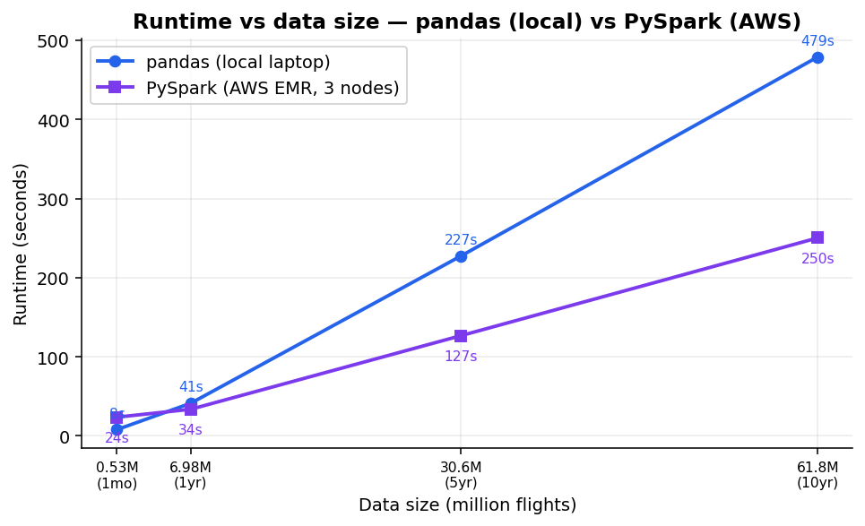
Figure 6. Runtime against data size for pandas (local) and PySpark (AWS).
The runtime comparison in Figure 6 shows a clear crossover. For the smallest data, one month, pandas was actually faster at 8 seconds against 23.7 seconds for Spark, because Spark has to start up a cluster, read from S3 and coordinate work across machines and this fixed overhead is not worth it for a tiny input. The two approaches met at around one year and beyond that Spark pulled ahead, so at ten years Spark finished in 250.3 seconds while pandas took 479.0 seconds, which is about 1.9 times faster. This is the expected behavior of a distributed framework, which carries a fixed cost to split the work, move the data and coordinate the machines and therefore only pays off once the data is large enough for that parallel work to outweigh the startup cost (Dean & Ghemawat, 2008).
It is worth unpacking why the two lines cross rather than one simply beating the other. At one month pandas wins because it runs in a single process on data that is already local, so it starts computing straight away, while Spark must first launch a cluster of Java processes, pull the compressed files across the network from S3 and split them into partitions, and that fixed setup of tens of seconds dwarfs the tiny amount of real work. As the data grows the picture inverts, because pandas does all the work sequentially on one core so its time rises in a roughly straight line with the number of rows, whereas Spark spreads the same work across many cores and nodes so its per-row cost is lower and its fixed startup becomes a smaller and smaller fraction of the total, which is why the gap widens rather than staying constant. The practical meaning is that the crossover point, near one year or about seven million rows for us, acts as a rough decision threshold for when a distributed tool is worth its overhead, though the exact point would shift with cluster size, file format and network speed, so it should be read as indicative rather than a fixed rule.
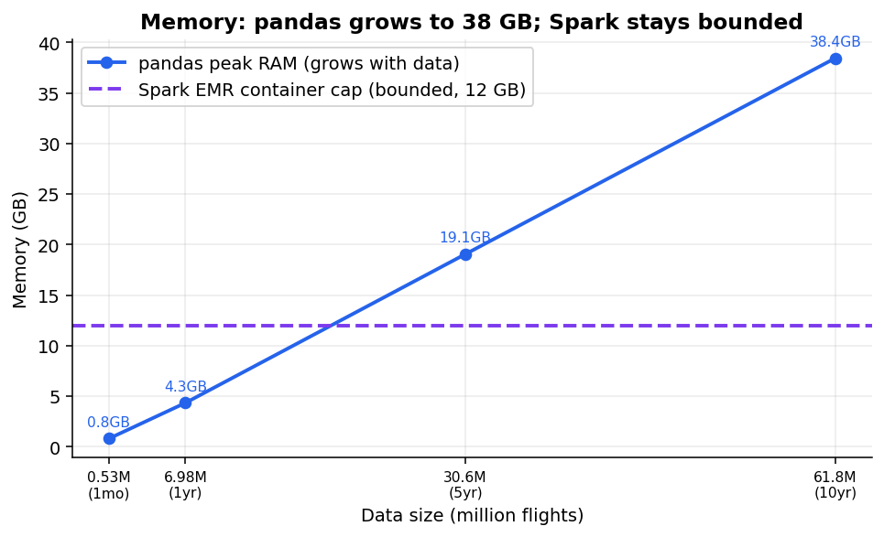
Figure 7. Peak memory: pandas grows with data size while Spark stays bounded.
The memory comparison in Figure 7 is even more important than the runtime. The 38.44 GB figure is the peak memory that pandas asked for, measured with Python's tracemalloc tool, which counts the memory blocks that Python allocates rather than the physical memory of the machine (Python Software Foundation, n.d.). Most of that memory comes from the text columns, because pandas keeps everything in memory and stores text such as the airline, origin, destination and route as tens of millions of separate Python objects that each carry a large overhead, and the pandas documentation itself notes that text columns are far heavier than numeric ones (The pandas development team, n.d.-b). This peak is much larger than the 16 GB of physical memory in our laptop, so at the five year and ten year sizes the data could not fit in memory at once. The run still finished because Windows moves memory that does not fit in RAM onto a page file on the disk, a mechanism called virtual memory, so the job completed by spilling onto the solid state drive rather than staying in RAM (Microsoft, n.d.). That spill is slow and it is not guaranteed, a machine with less free disk or a smaller page file would simply have run out of memory and stopped. This is the real limitation of the single machine approach, it is not only that it becomes slower but that it cannot hold very large data in memory at all, which is exactly the limitation a Big Data platform is built to remove.
The shape of the memory lines matters as much as their height. Pandas rises in almost a straight line because it loads the whole dataset, plus temporary copies made during the group by, into memory at once, so its peak tracks the size of the data directly and reaches 38.44 GB at ten years. Spark stays flat because it never holds the whole dataset at one time, it streams the data through in partitions and spills to disk when memory runs short, so its peak is set by the size of a partition and the executor rather than by the total volume. The key point is that this is a difference in kind and not only in degree, because the pandas line is heading towards a hard ceiling, which is the physical memory of the machine, and once the data crosses that ceiling the job does not merely slow down, it fails with an out of memory error. Our 64 GB laptop hid this wall, but reading the line against a normal 8 to 16 GB laptop shows it would have been hit at around the five year mark, which is exactly the failure that a distributed platform is designed to remove. We assume here that the measured peak reflects the true working set and that a typical laptop's usable memory is the relevant ceiling, while the roughly 12 GB Spark cap is a configuration choice rather than a limit forced by the data.
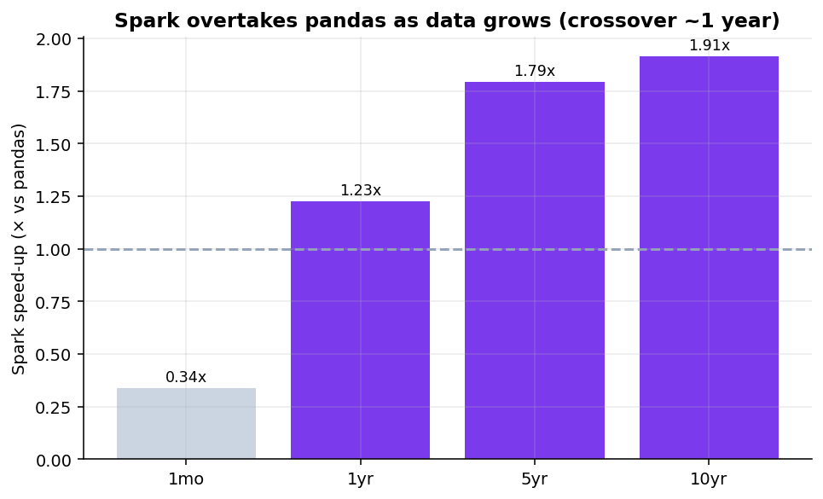
Figure 8. How many times faster Spark is than pandas at each data size.
Figure 8 summarizes the speed up, the pandas runtime divided by the Spark runtime, and it makes the trend easy to see, since Spark starts below 1 and is slower than pandas at one month then rises to about 1.9 times faster at ten years. The speed up is real but modest, which is expected, because the overall gain from parallel processing is always held back by the parts of the job that do not parallelise and by the fixed coordination overhead (Amdahl, 1967). The honest conclusion is that a single machine tool such as pandas is a good and simple choice for small data, but as the data grows it becomes slower and, more seriously, its memory need grows until the machine can no longer cope, whereas the distributed Spark approach on AWS scales out across a cluster, keeps its memory bounded and completes the full ten years comfortably.
Our own crossover is a small example of an effect that has been studied directly in computer science research. McSherry, Isard and Murray (2015) introduced the idea of a system's COST, the Configuration that Outperforms a Single Thread, and showed that many celebrated distributed systems only beat a competent single machine implementation once a large amount of hardware is thrown at them, because part of their impressive scaling comes from overhead that the distributed design adds in the first place. Our result is the same lesson in miniature, since Spark needed the data to grow to several years before its parallelism was worth the cluster it runs on, and below that point the single laptop was simply the better tool. This suggests the comparison should not be read as pandas being outdated or Spark being universally faster. The honest reading, which the research supports, is that a single machine is the right default and a distributed system earns its keep only past the scale where the memory and the runtime on one machine stop being practical (McSherry, Isard, & Murray, 2015; Dean & Ghemawat, 2008).
Stepping back, what we really measured is a general property of data processing rather than a fact about flights, so the same crossover would appear for any large dataset such as text logs, sensor feeds or transaction records, only the exact size would move. It is also worth being honest that the distributed approach is not free, because a cluster has to be provisioned and paid for by the hour, the data has to be moved into cloud storage first and the code has to be written for Spark, which is exactly why for the smaller sizes the laptop was the sensible choice. The right conclusion is not that big data tools are always better, but that there is a scale at which a single machine's memory limit and runtime make it necessary to move to a cluster, and the point of this project was to find and show that scale on real data rather than to assume it.
Two features of this curve are worth interpreting. First, the speed up at ten years is only about 1.9 times even though the cluster has three nodes, and this is what theory predicts, because part of every run is serial and cannot be parallelised, namely starting the cluster, reading from S3, coordinating the work and finally writing the single combined result, and the shuffles between stages add communication cost on top, so the achievable gain is held below the number of nodes. Second, and more interesting, the speed up keeps climbing as the data grows, from 0.34 times at one month to 1.23, then 1.79, then 1.91 times, because the parallel part of the job grows with the data while that fixed serial overhead stays roughly constant, so its share shrinks and the speed up moves closer to its ceiling. Taken together this suggests the real value of the cluster is not a dramatic one-off speed up but that the advantage keeps improving with scale while the memory stays bounded, so the deeper win is the ability to finish the job at all at ten years rather than raw speed alone.

9. Individual Reflections
Each group member has written their own reflection on what they learned from this assignment.

9.1 Reflection: Teo Zen Ben (22120679)
For this assignment I focused mainly on the technical side, I set up and ran both the pandas baseline and the Spark version and I handled the work on Amazon Web Services, but the part that stayed with me was not the setup, it was how much I came to understand about the difference between a single machine approach and a Big Data approach.
The most striking lesson is that a Big Data tool is not automatically better, because for one month of data pandas actually finished faster than Spark, and it was only as the data grew to five and ten years that Spark pulled ahead and kept its memory bounded while pandas pushed past the memory of our laptop. Seeing those two lines cross in our own results made the idea of scaling click in a way that reading about it never did.
What I enjoyed even more was going beyond the raw numbers with my partner Jeanette, because we spent a lot of time working out what each result actually meant and being careful to separate what the data really shows from what we were only assuming, for example why the worst airports cluster by whole city rather than one at a time, why delays build up through the day as the same aircraft is reused and why the memory figure looked so large once we realized it was measuring what pandas asked for rather than the physical memory of the machine. Turning a set of charts into a real story and checking each interpretation against research is what I found genuinely interesting.
I also learned that a lot of Big Data work is really about getting the data and the platform set up correctly rather than the analysis itself, since I ran into real problems such as the data source rate limiting our downloads and the EMR cluster failing the first time because the service role did not have the right permissions and fixing these taught me how S3, EMR and the IAM roles fit together.
Overall I now understand why this kind of work is moved to a cluster in the cloud, and more than that I came away fascinated by how a simple question about flight delays turns into a Big Data engineering problem and a rich interpretation problem at the same time.

9.2 Reflection: Jeanette Tan En Jie (23035173)
Throughout this project, my main role was report writing, which is taking the results the code produced and turning them into a clear explanation that answers our question. I learned that having the numbers only makes up a small aspect and the difficult part is actually working out what each result actually means and saying it plainly, for example explaining why delays build up through the day as the same aircraft is reused, or why carrier-caused delay rose sharply in 2020 even though there were far fewer flights to pass delays down the chain.
To write the Big Data section properly, I had to understand the map-and-reduce idea and how Spark spreads the work across a cluster well enough to put it into everyday language. Having to explain it for the report is what deepened my overall understanding of the concept, rather than just reading from slides. I also learned to be honest about the limitations. For example, we treat a flight as delayed only when it arrives fifteen minutes or more late and our analysis describes the patterns in the data rather than proving their exact causes, and I made sure to state these choices openly so others may look at our findings in the right context.
Throughout the process, I always read through the code myself and checked my understanding with my teammate before writing anything up, so that every claim in the report matched what the code really did. This allowed us to communicate effectively and allowed me to connect each chart and number back to the original question with confidence.
Overall, this project taught me that turning raw results into a clear, honest story is a valuable skill. It strengthened my ability to interpret data, explain technical ideas in plain language, and work closely with my teammate through constant communication. I feel way more confident not only in reading and explaining this kind of performance comparison but also collaborating on a data project from the raw numbers all the way to the final report.

10. Conclusion
Over ten years of United States flight data we found that the low cost airlines had the worst delay records, that the most delay prone busy airports were congested hubs such as Newark, Miami and Chicago while Hawaii airports were the most reliable, that delays build up steadily through the day so that early morning flights are far more reliable than evening ones and that late arriving aircraft and carrier problems are the two biggest causes of delay, with a clear shift toward carrier caused delay during the pandemic year of 2020. Beyond these findings, the comparison between the two implementations showed why Big Data tools matter, because the single machine pandas approach was simple and even faster on small data but its memory grew to over 38 GB on the full decade, while the same analysis on Apache Spark running on an AWS cluster kept its memory bounded and ran the full ten years faster, which demonstrates the advantage of a distributed Big Data platform in the cloud once the data becomes large.

11. Declaration on the Use of AI
We used an AI assistant (Claude) as a support tool during this assignment and we declare its use here for full transparency. We first used it to speed up the planning stage, because it helped us search and shortlist many possible datasets across different domains until we settled on this one, which is far larger than a typical group dataset of around a million rows and therefore lets us show the single machine versus Big Data comparison much more clearly.
We then used it to help us write the pandas code and to diagnose errors as they came up, especially during the AWS setup. It also helped us lay out the structure of this report, check the finished report against the marking rubric several times and check our grammar. Separately, the airline codes in the dataset such as F9 or B6 were converted to their full names such as Frontier Airlines and JetBlue Airways with the help of the AI, because the data files only contain the codes and not the names.
All of the results, tables and charts come from the real data and from code that we ran ourselves. The AI did not create or change any numbers and we confirmed that the pandas and Spark outputs matched before relying on them. The interpretation of the findings, the final decisions and the individual reflections are our own.

12. References
AhmadBeygi, S., Cohn, A., Guan, Y., & Belobaba, P. (2008). Analysis of the potential for delay propagation in passenger airline networks. Journal of Air Transport Management, 14(5), 221–236.
AhmadBeygi, S., Cohn, A., & Lapp, M. (2010). Decreasing airline delay propagation by re-allocating scheduled slack. IIE Transactions, 42(7), 478–489.
Amazon Web Services. (n.d.). Amazon EMR documentation. https://docs.aws.amazon.com/emr
Amdahl, G. M. (1967). Validity of the single processor approach to achieving large scale computing capabilities. In Proceedings of the April 18–20, 1967, Spring Joint Computer Conference (pp. 483–485). Association for Computing Machinery.
Apache Software Foundation. (n.d.). Spark SQL, DataFrames and Datasets guide. https://spark.apache.org/docs/latest
Bureau of Transportation Statistics. (n.d.-a). Reporting Carrier On-Time Performance (1987–present) [Data set]. United States Department of Transportation. https://www.transtats.bts.gov
Bureau of Transportation Statistics. (n.d.-b). Understanding the reporting of causes of flight delays and cancellations. United States Department of Transportation. https://www.bts.gov/topics/airlines-and-airports/understanding-reporting-causes-flight-delays-and-cancellations
Dean, J., & Ghemawat, S. (2008). MapReduce: Simplified data processing on large clusters. Communications of the ACM, 51(1), 107–113.
Malighetti, P., Morlotti, C., Redondi, R., & Paleari, S. (2023). The turnaround tactic and on-time performance: Implications for airlines' efficiency. Research in Transportation Business & Management, 46, 100874.
McSherry, F., Isard, M., & Murray, D. G. (2015). Scalability! But at what COST? In Proceedings of the 15th USENIX Workshop on Hot Topics in Operating Systems (HotOS XV). USENIX Association.
Microsoft. (n.d.). RAM, virtual memory, pagefile, and memory management in Windows. Microsoft Learn. https://learn.microsoft.com/en-us/troubleshoot/windows-server/performance/ram-virtual-memory-pagefile-management
The pandas development team. (n.d.-a). pandas documentation: Group by (split-apply-combine). https://pandas.pydata.org/docshttps://pandas.pydata.org/docs
The pandas development team. (n.d.-b). Scaling to large datasets. pandas documentation. https://pandas.pydata.org/docs/user_guide/scale.html
Python Software Foundation. (n.d.). tracemalloc — Trace memory allocations. Python 3 documentation. https://docs.python.org/3/library/tracemalloc.html
U.S. Department of Transportation, Office of Inspector General. (2019). FAA has made progress in implementing its Metroplex program, but benefits for airspace users have fallen short of expectations (Report No. AV2019062). https://www.oig.dot.gov
U.S. Government Accountability Office. (2023). Airline passenger protections: Observations on flight delays and cancellations, and DOT's efforts to address them (GAO-23-105524). https://www.gao.gov
Wang, Y., Li, M. Z., Gopalakrishnan, K., & Liu, T. (2022). Timescales of delay propagation in airport networks. Transportation Research Part E: Logistics and Transportation Review, 161, 102687.
Yao, H.-G., & Zhang, H. (2023). Critical and steady-state characteristics of delay propagation in an airport network. PLOS ONE, 18(7), e0288200.
Zaharia, M., Chowdhury, M., Franklin, M. J., Shenker, S., & Stoica, I. (2010). Spark: Cluster computing with working sets. In Proceedings of the 2nd USENIX Workshop on Hot Topics in Cloud Computing (HotCloud '10). USENIX Association.

