软 件 学 院
考试试卷标准答案及评分表

课程名称 | 软件工程 |  |  | 任课教师 |  | 张 爽
计划学时 | 40 学时 |  |  | 开课时间 |  | 1 周到 15 周
考试时间 | 6月 28 日 |  |  | 考试方式 |  | 闭卷
班 级 | 软二031-032 |  |  | 人 数 |  | 63
试 卷 | □ 试卷A □ 试卷B
第一大题 | 总分 | 20 | 小题数 |  | 15 | 每小题  分数 | 1-3
第一大题 | 标准  答案 | - D  - D  - C  - B  - B  - A  - A  - A  - ① C ② B  - ① C ② B ③ A  - ① C ② D ③ A  - D  - B  - A  - B
第一大题 | 评分  标准 | 每个选择1分
第二大题 | 总分 | 16 | 小题数 |  | 4 | 每小题  分数 | 2-6
第二大题 | 标准  答案 | - ①corrective, ②perfective, ③adaptive (此3个答案先后顺序无关)  - ①data, ②action (此2个答案先后顺序无关)  - ①cohesion ②coupling  - object-oriented
第二大题 | 评分  标准 | 每个填空2分
第三大题 | 总分 | 12 | 小题数 |  | 12 | 每小题  分数 | 1
第三大题 | 标准  答案 | 1. F  2. F  3. F  4. T  5. T  6. T  7. F  8. T  9. T  10. T  11. F  12. F
第三大题 | 评分  标准 | 每个判断1分
第四大题 | 总分 | 12 | 小题数 |  | 2 | 每小题  分数 | 6
第四大题 | 第一  小题  标准  答案 | 1. Use of consistent and meaningful variable names  A programmer should give names to variables that re meaningful to not only that programmer. Within the context of software engineering, the term meaningful means “meaningful from the viewpoint of future maintenance programmers”. In the mean time, it is equally essential that variable names be consistent. The ordering of the components of variable names should be consistent. The name of a variable should incorporate type information.  2. Self-documenting code is exceeding rare. The usual scenario is that the programmer appreciates every nuance of the code at the time the module is written. Prologue comments are mandatory in every single module. Inline comments should be inserted into the code to assist maintenance programmers in understanding that code.  - Use of parameters  There are very few genuine constants, that is, variables whose values will never change. All apparent constants should be treated as parameters. If a value should change for any reason, this change can then be implemented quickly and effectively.  - Code layout for increased readability  No more than one statement should appear on a line, even though many programming languages permit more than one. Indentation is perhaps the most important technique for increasing readability. Another useful aid is blank lines. Methods should be separated by blank lines; in addition, it often is helpful to break up large blocks of code with blank lines. The extra “white space” makes the code easier to read and, hence, comprehend.  - Nested if statements  Try to use dingle condition rather than nested if statements. Another problem with the if-if construct is that nesting if statements too deeply leads to code that can be difficult to read. As a rule of thumb, if statements nested to a depth greater than three is poor programming practice and should be avoided.
第四大题 | 第一  小题  评分  标准 | 以上5个要点中答出任意3点即可，每个要点2分。
第四大题 | 第二  小题  标准  答案 | - Advantages:  - Fault isolation  - Potentially reusable modules are adequately tested  - Disadvantages:  1. Major design faults are detected late. [or] Major design faults show up late.
第四大题 | 第二  小题  评分  标准 | Advantages共4分, 每个要点2分。  Disadvantages 共2分, 每个要点2分。
第五大题 | 总分 | 40 | 小题数 |  | 3 | 每小题  分数 | 10-15
第五大题 | 标准  答案 | 见附页。
第五大题 | 评分  标准 | 见附页。

注：如果内容太多填写不下，可加附页说明。

填表日期： 2005 年 6 月 7 日
附页 第五大题答案：

- Use-case diagram (13 marks)

Grading standard:
- 3 marks for each of the actor.
- 9 marks for the use cases.
- 1 mark for the relationship among the use cases
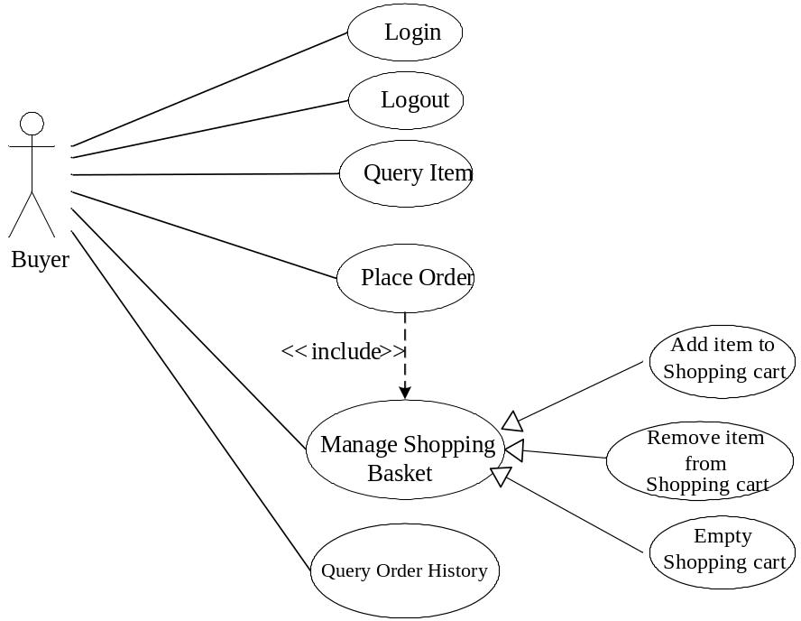

- Detailed class diagram (15 marks)
Grading standard:
- 10 marks for the classes
- 5 marks for the relationships

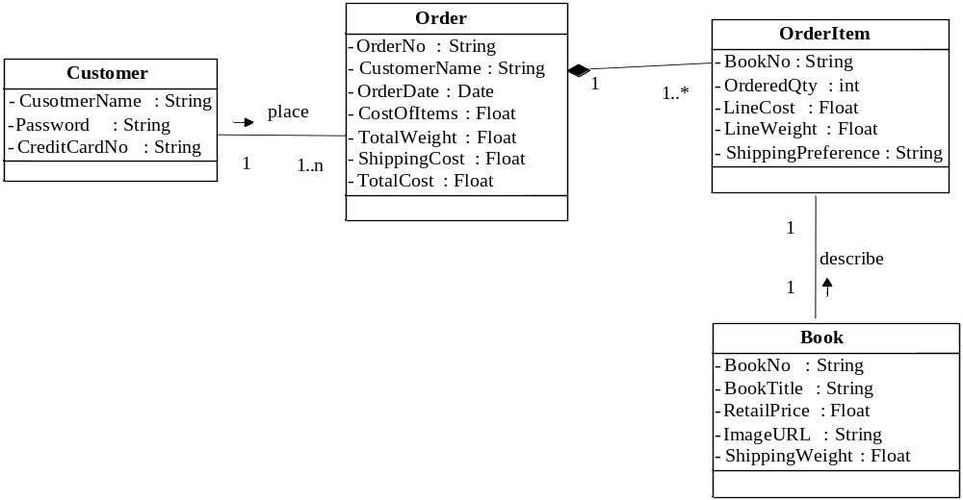3. Sequence diagram (12 marks)

Grading standard:
  - Any 3 of the following sequence diagrams will be OK
  - 4 marks for each diagram, and 1.5 marks for the objects, 2.5 marks for the sequences

A. Login
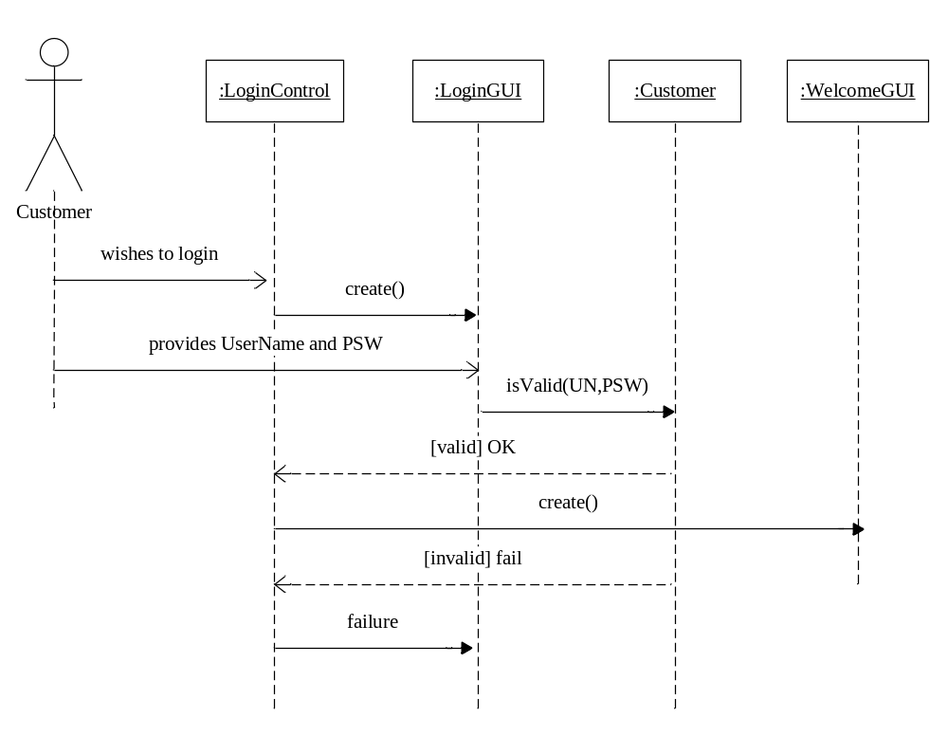

B. Place Order
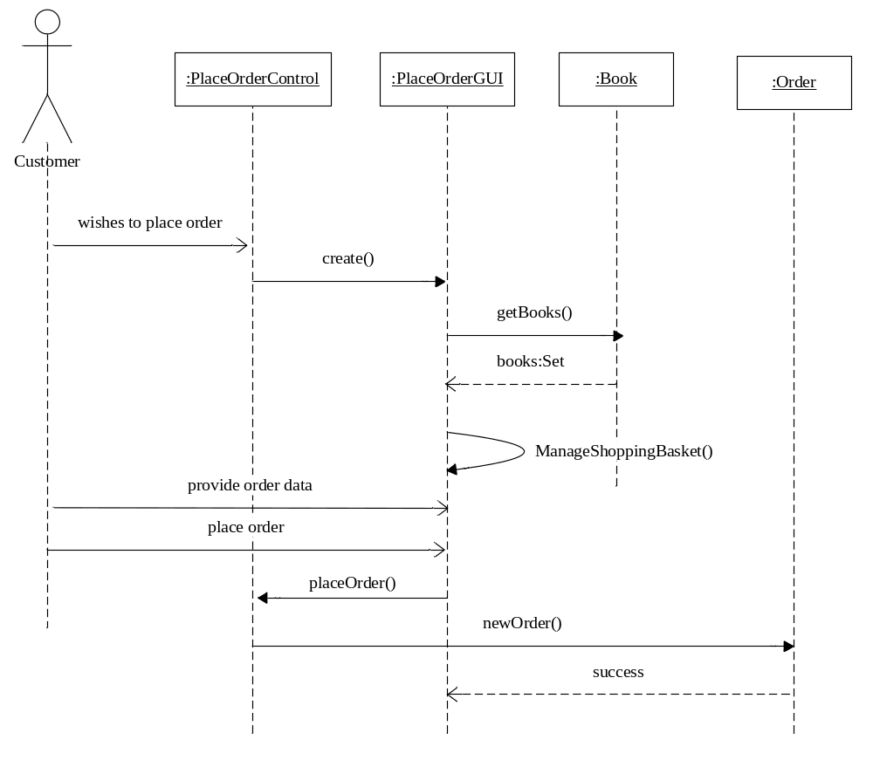
C. Query Order History
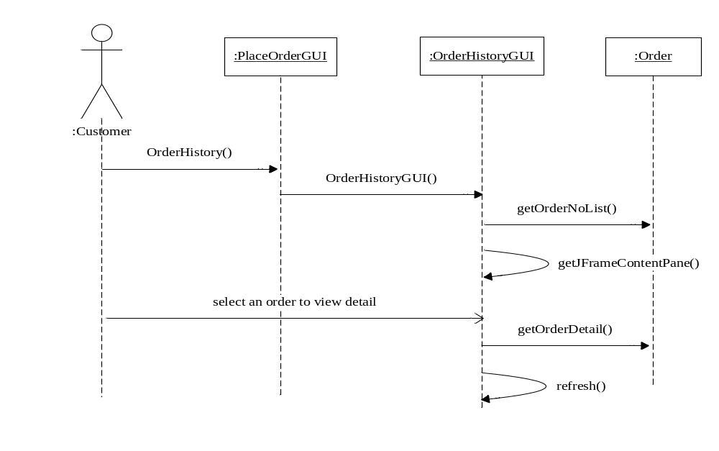

D. Add Item to Shopping Cart
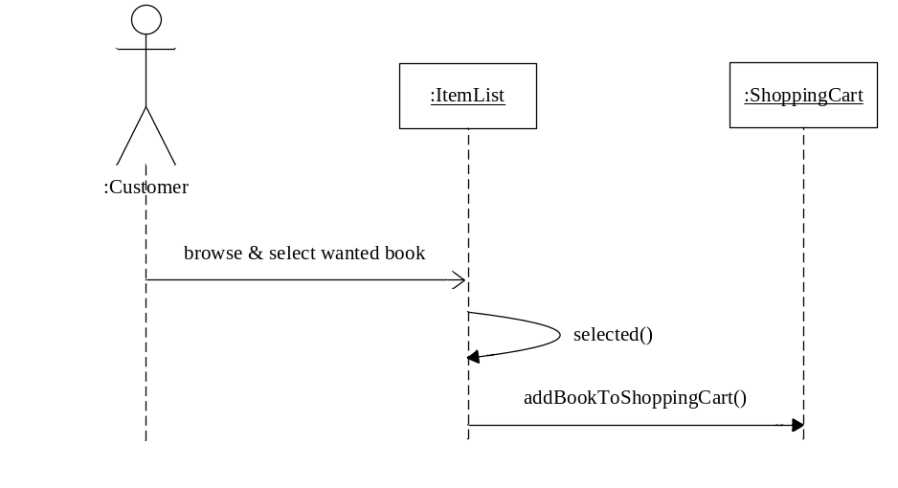

E. Remove Item from Shopping Cart
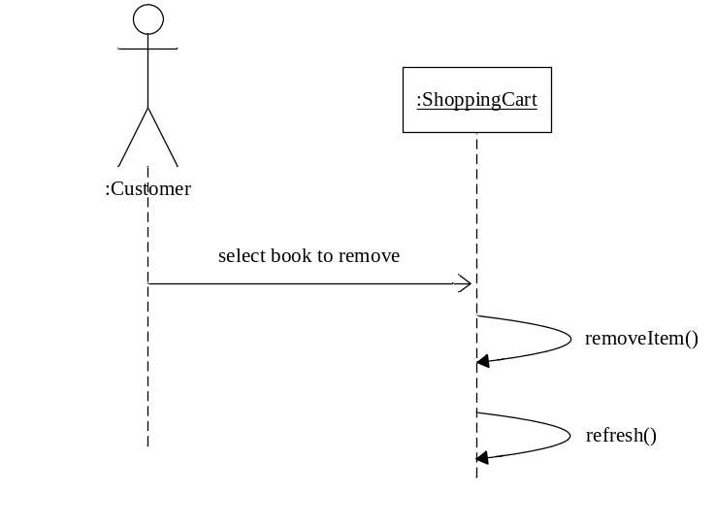
F. Empty Shopping Cart

