软 件 学 院
考试试卷标准答案及评分表

课程名称 |  |  | 软件工程 |  |  |  |  |  |  |  |  |  |  |  |  |  |  |  |  |  |  |  |  |  |  |  |  | 任课教师 |  |  |  | 张 爽
计划学时 |  |  | 64 学时 |  |  |  |  |  |  |  |  |  |  |  |  |  |  |  |  |  |  |  |  |  |  |  |  | 开课时间 |  |  |  | 10 周到 19 周
考试时间 |  |  | 2009 年 1 月 12 日 |  |  |  |  |  |  |  |  |  |  |  |  |  |  |  |  |  |  |  |  |  |  |  |  | 考试方式 |  |  |  | 闭卷
班 级 |  |  | 软0601～0610, 软一061 |  |  |  |  |  |  |  |  |  |  |  |  |  |  |  |  |  |  |  |  |  |  |  |  | 人 数 |  |  |  | 334人
试 卷 |  |  | □ 试卷A □ 试卷B
第一大题 | 总分 |  |  |  |  |  | 17 |  |  |  |  |  |  |  |  |  |  |  | 小题数 |  |  |  |  |  |  | 13 |  |  |  |  | 每小题分数 |  |  |  |  |  |  | 1-3
第一大题 | 标  准  答  案 | 1 |  |  | 2 |  |  |  |  | 3 |  |  |  |  | 4 |  | 5 |  |  |  | 6 |  | 7 |  |  |  |  | 8 | 9 |  | 10 |  |  | 11 |  |  | 12 |  | 13
第一大题 | 标  准  答  案 | A |  |  | B |  |  |  |  | B |  |  |  |  | C |  | B |  |  |  | C |  | A |  |  |  |  | A | C |  | ①A ②B  ③C |  |  | ①C ② E |  |  | C |  | ① A  ② E
第一大题 | 评分标准 |  |  |  |  |  |  |  |  |  |  |  |  |  |  | 每个选择1分
第二大题 | 总分 |  |  |  |  |  | 16 |  |  |  |  |  |  |  |  |  |  |  | 小题数 |  |  |  |  |  |  | 5 |  |  |  |  | 每小题分数 |  |  |  |  |  |  | 2-4
第二大题 | 标准  答案 |  |  | - (4 marks) ①data, ②action (此2个答案先后顺序无关)  - (2 marks) Documentation  - (4 marks) ①high ②low  - (4 marks) ①execution-based testing, ②nonexecution-based testing  - (2 marks) software lifecycle model
第二大题 | 评分标准 |  |  |  |  |  |  |  |  |  |  | 每个填空2分
第三大题 | 总分 |  |  |  |  |  |  | 12 |  |  |  |  |  |  |  |  |  | 小题数 |  |  |  |  |  |  | 12 |  |  |  |  |  | 每小题分数 |  |  |  |  |  | 1
第三大题 | 标准  答案 |  |  | 1 |  |  |  |  | 2 |  |  |  |  | 3 |  |  |  |  |  |  | 4 | 5 |  |  |  |  | 6 |  | 7 |  | 8 |  | 9 |  | 10 |  | 11 |  |  | 12
第三大题 |  |  |  | F |  |  |  |  | F |  |  |  |  | T |  |  |  |  |  |  | F | T |  |  |  |  | F |  | F |  | T |  | F |  | F |  | F |  |  | F
第三大题 | 评分标准 |  |  |  |  |  |  |  |  |  | 每个判断1分
第四大题 | 总分 |  |  |  |  |  |  | 15 |  |  |  |  |  |  |  |  |  | 小题数 |  |  |  |  |  |  | 2 |  |  |  |  |  | 每小题分数 |  |  |  |  |  | 6~9
第四大题 | 第一  小题  标准  答案 |  |  | - Because neither top-down nor bottom-up integration is suitable for all the artifacts, the solution is to partition them. The logic artifacts are integrated top down, and all major design faults can be caught early. The operational artifacts are integrated bottom up. They thus receive a thorough testing, unshielded by defensively programmed artifacts that invoke them, and therefore can be reused with confidence in other products. When all artifacts have been appropriately integrated, the interfaces between the two groups of artifacts are tested, one by one.  - Strength:  - fault isolation  - major design faults show up early  - potentially reusable code artifacts are adequately tested
第四大题 | 第一小题评分标准 |  |  |  |  |  |  |  |  |  |  |  |  |  |  |  |  |  |  |  |  |  |  | 共计6分。  - 定义阐述3分  - 优势3分，每小点1分
第四大题 | 第二  小题  标准  答案 |  |  | - The first reason is to correct faults, whether specification faults, design faults, coding faults, documentation faults, or any other types of faults. This is termed corrective maintenance. Maintenance programmers spend about 17.5 percent of their time on corrective maintenance.  2. Most of maintenance programmers’ time is spent on the second type of maintenance, perfective maintenance. Here, changes are made to the code to improve the effectiveness of the product. For instance, the client may wish additional functionality added to request that the product be modified so that it runs faster. Improving the maintainability of a product is another example of perfective maintenance.  3. The third reason for changing a product is adaptive maintenance, changes made to the product to react the changes in the environment in which the product operates. For example, a product almost certainly has to be modified if it is ported to a new compiler, operating system, or hardware.
第四大题 | 第二小题评分标准 |  |  |  |  |  |  |  |  |  |  |  |  |  |  |  |  |  |  | 共计9分，每小点3分
第五大题 | 总分 |  |  |  |  | 40 |  |  |  |  |  |  |  |  |  |  | 小题数 |  |  |  |  |  | 3 |  |  |  |  |  |  | 每小题分数 |  |  |  |  |  | 9~16
第五大题 | 标准  答案 |  |  |  |  |  |  |  |  |  |  |  | 见附录
第五大题 | 评分  标准 |  |  |  |  |  |  |  |  |  |  |  | 见附录

填表日期： 2009 年 1 月 12 日

附录 第五大题答案：

- Use-case diagram (16 marks)
Grading standard:
- 6 marks for each of the actor.
- 10 marks for the use cases
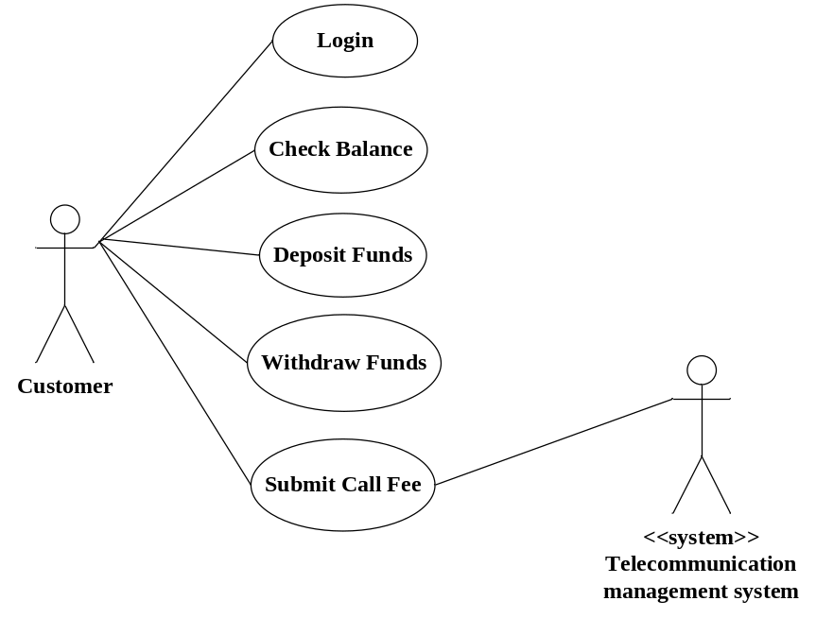

- Class diagram (15 marks)
Grading standard:
- 10 marks for the classes
- 5 marks for the relationships

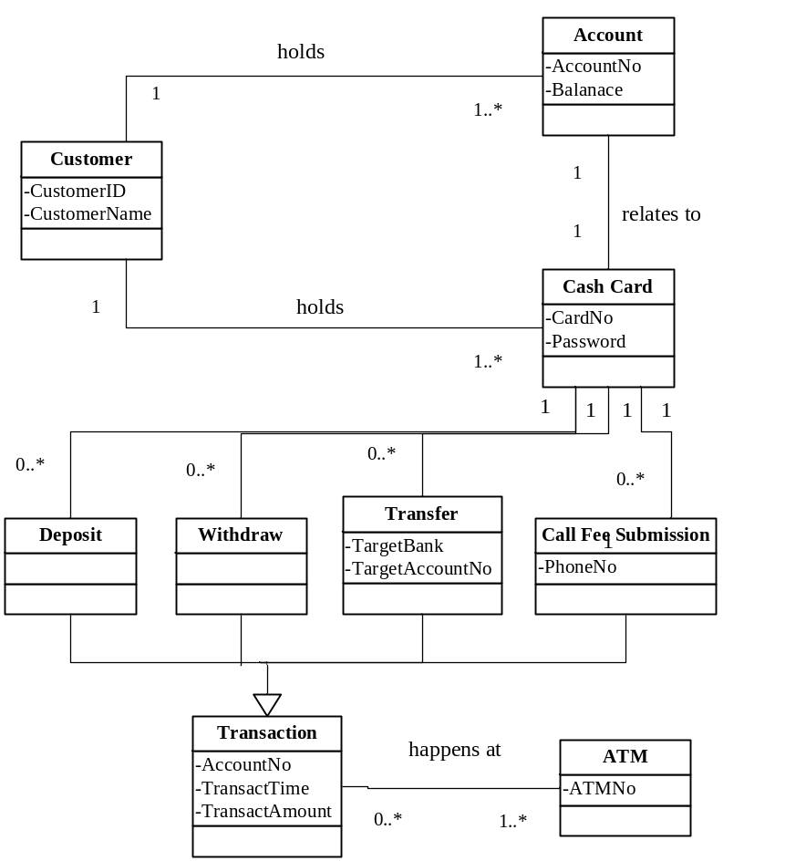

- Sequence diagram (9 marks)
Grading standard: (1) any 3 diagrams of the following ones are OK.
(2) 3 marks for each diagram

1) Login
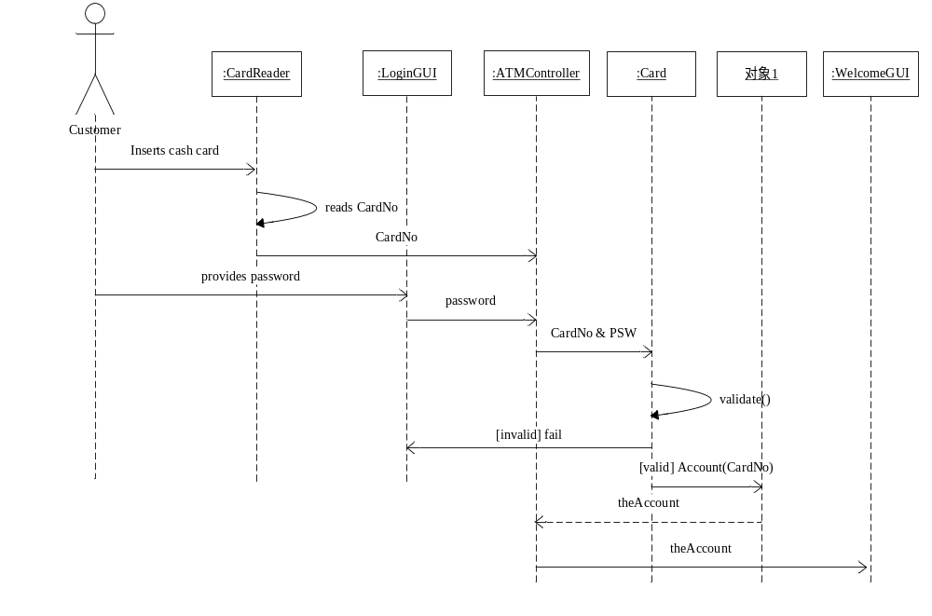2) Check balance
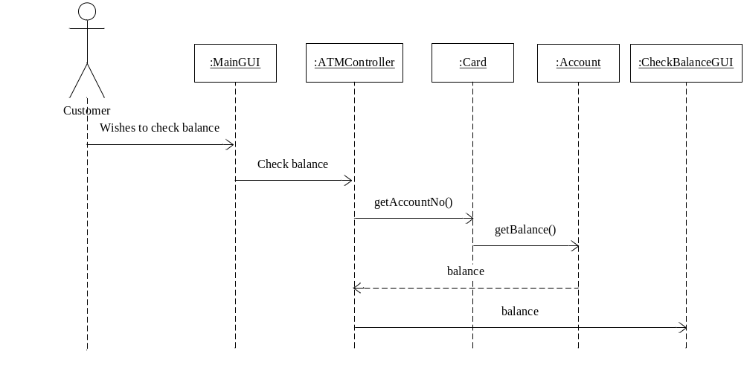
3) Deposit Funds
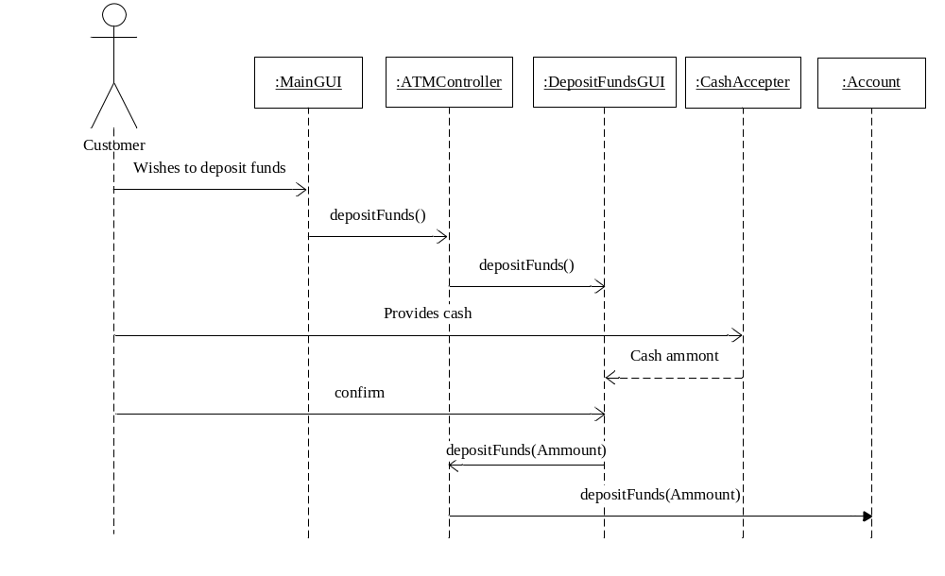
4) Withdraw Funds

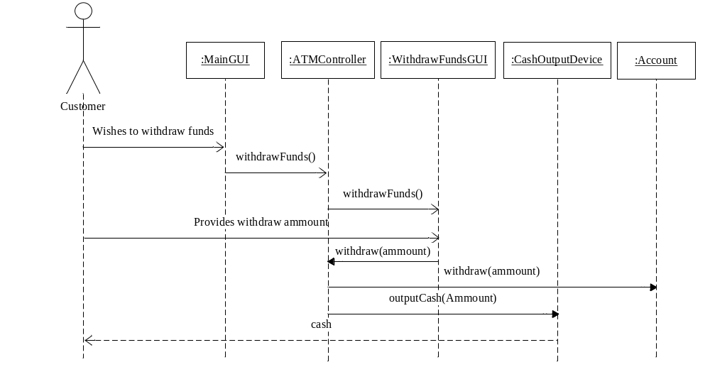
5) Submit Call Fee

