软 件 学 院
考试试卷标准答案及评分表

课程名称 |  |  | 软件工程 |  |  |  |  |  |  |  |  |  |  |  |  |  |  |  |  |  |  |  |  |  |  |  |  |  |  |  | 任课教师 |  |  |  |  |  |  | 张 爽
计划学时 |  |  | 64 学时 |  |  |  |  |  |  |  |  |  |  |  |  |  |  |  |  |  |  |  |  |  |  |  |  |  |  |  | 开课时间 |  |  |  |  |  |  | 10 周到 19 周
考试时间 |  |  | 2009 年 1 月 12 日 |  |  |  |  |  |  |  |  |  |  |  |  |  |  |  |  |  |  |  |  |  |  |  |  |  |  |  | 考试方式 |  |  |  |  |  |  | 闭卷
班 级 |  |  | 软0601～0610, 软一061 |  |  |  |  |  |  |  |  |  |  |  |  |  |  |  |  |  |  |  |  |  |  |  |  |  |  |  | 人 数 |  |  |  |  |  |  | 334人
试 卷 |  |  | □ 试卷A □ 试卷B
第一大题 | 总分 |  |  |  |  |  | 17 |  |  |  |  |  |  |  |  |  |  |  |  |  |  | 小题数 |  |  |  |  |  | 13 |  |  |  |  |  |  |  |  | 每小题分数 |  |  |  |  |  |  | 1-3
第一大题 | 标  准  答  案 | 1 |  |  | 2 |  |  |  |  | 3 |  |  |  | 4 |  |  | 5 |  |  |  | 6 |  |  |  | 7 |  |  |  |  | 8 |  | 9 |  | 10 |  |  |  |  |  | 11 |  |  | 12 |  | 13
第一大题 | 标  准  答  案 | D |  |  | A |  |  |  |  | A |  |  |  | B |  |  | C |  |  |  | ①C ②B |  |  |  | D |  |  |  |  | D |  | C |  | ①C ②B  ③A |  |  |  |  |  | ①C ②B |  |  | B |  | A
第一大题 | 评分标准 |  |  |  |  |  |  |  |  |  |  |  |  |  |  |  |  | 每个选择1分
第二大题 | 总分 |  |  |  |  |  | 16 |  |  |  |  |  |  |  |  |  |  |  |  |  |  | 小题数 |  |  |  |  |  | 4 |  |  |  |  |  |  |  |  | 每小题分数 |  |  |  |  |  |  | 2-6
第二大题 | 标准  答案 |  |  | - ①corrective, ②perfective, ③adaptive (此3个答案先后顺序无关)  - ①data, ②action (此2个答案先后顺序无关)  - (4 marks) ①cohesion ②coupling(此2个答案先后顺序无关)  - ①client, ②developers, ③user  - (2 marks) regression fault  - (2 marks) fragile base class
第二大题 | 评分标准 |  |  |  |  |  |  |  |  |  |  | 每个填空2分
第三大题 | 总分 |  |  |  |  |  |  | 12 |  |  |  |  |  |  |  |  |  |  | 小题数 |  |  |  |  |  |  |  | 12 |  |  |  |  |  |  |  | 每小题分数 |  |  |  |  |  |  |  | 1
第三大题 | 标准  答案 |  |  | 1 |  |  |  |  | 2 |  |  |  |  |  | 3 |  |  |  |  | 4 |  |  |  | 5 |  |  |  |  | 6 |  |  |  | 7 |  |  |  | 8 |  | 9 |  | 10 |  | 11 |  |  | 12
第三大题 |  |  |  | F |  |  |  |  | T |  |  |  |  |  | T |  |  |  |  | F |  |  |  | T |  |  |  |  | F |  |  |  | F |  |  |  | T |  | F |  | F |  | T |  |  | F
第三大题 | 评分标准 |  |  |  |  |  |  |  |  |  | 每个判断1分
第四大题 | 总分 |  |  |  |  |  |  | 15 |  |  |  |  |  |  |  |  |  |  | 小题数 |  |  |  |  |  |  |  | 2 |  |  |  |  |  |  |  | 每小题分数 |  |  |  |  |  |  |  | 6~9
第四大题 | 第一  小题  标准  答案 |  |  | - Because neither top-down nor bottom-up integration is suitable for all the artifacts, the solution is to partition them. The logic artifacts are integrated top down, and all major design faults can be caught early. The operational artifacts are integrated bottom up. They thus receive a thorough testing, unshielded by defensively programmed artifacts that invoke them, and therefore can be reused with confidence in other products. When all artifacts have been appropriately integrated, the interfaces between the two groups of artifacts are tested, one by one.  - Strength:  - fault isolation  - major design faults show up early  - potentially reusable code artifacts are adequately tested
第四大题 | 第一小题评分标准 |  |  |  |  |  |  |  |  |  |  |  |  |  |  |  |  |  |  |  |  |  |  |  |  | 共计6分。  - 定义阐述3分  - 优势3分，每小点1分
第四大题 | 第二  小题  标准  答案 |  |  | “It is the code/program which is executable and used by the users finally. So, as long as we do a good job in implementation phase, we can guarantee the success of a software product.”  （1）The above statement is wrong. (2分)  （2）Although the executable code/program is used by the users finally, the developers should go through a series of steps/phases to achieve it, including requirements, analysis, design, implementation & integration and maintenance phase. And the output of each step or phase will influence the success of a software product/project. The aim of requirements phase is to determine the client’s needs. The aim of analysis phase is to analyze and refine the requirements to achieve the detailed understanding of the requirements essential for developing a software product correctly and maintaining it easily. The design phase is to show how the product is to do it, i.e., to refine the artifacts of the analysis until the material is in a form that can be implemented by the programmers. Implement is to implement the target software product in the chosen implementation language(s). Once the software product is delivered to the users and accepted by the users, it needs maintenance until retirement. The above shows that the success of any single phase can not guarantee the success of the whole software product.  Code/program is only the implementation phase’s product, which can not ensure a successful development. （7分）
第四大题 | 第二小题评分标准 |  |  |  |  |  |  |  |  |  |  |  |  |  |  |  |  |  |  |  |  |  | 共计9分
第五大题 | 总分 |  |  |  |  | 40 |  |  |  |  |  |  |  |  |  | 小题数 |  |  |  |  |  |  |  |  | 3 |  |  |  |  |  |  |  |  |  |  | 每小题分数 |  |  |  |  |  | 9~16
第五大题 | 标准  答案 |  |  |  |  |  |  |  |  |  |  |  | 见附录
第五大题 | 评分  标准 |  |  |  |  |  |  |  |  |  |  |  | 见附录

注：如果内容太多填写不下，可加附录。

填表日期： 2007 年 12 月 16 日

附录 第五大题答案：

- Use-case diagram (16 marks)
Grading standard:
- 6 marks for each of the actor.
- 10 marks for the use cases
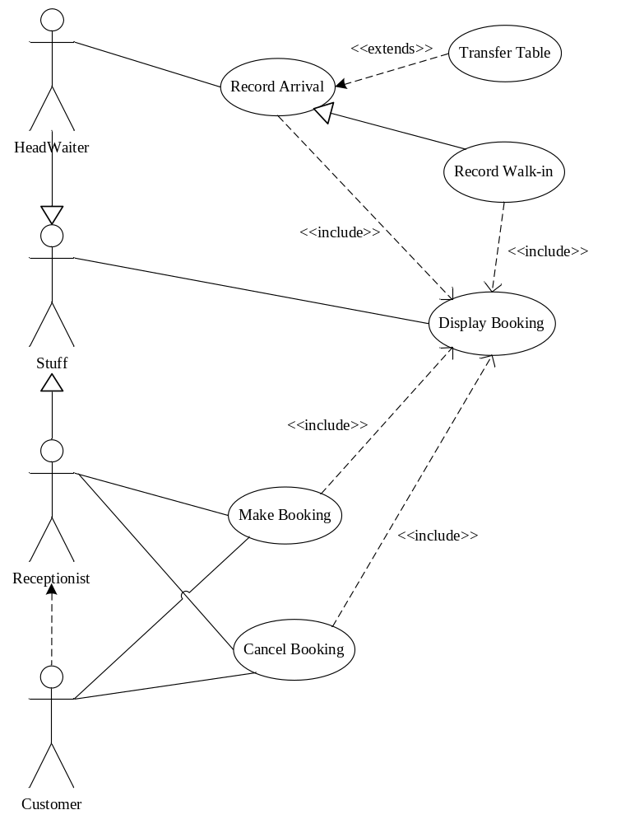
- Detailed class diagram (15 marks)
Grading standard:
- 10 marks for the classes
- 5 marks for the relationships
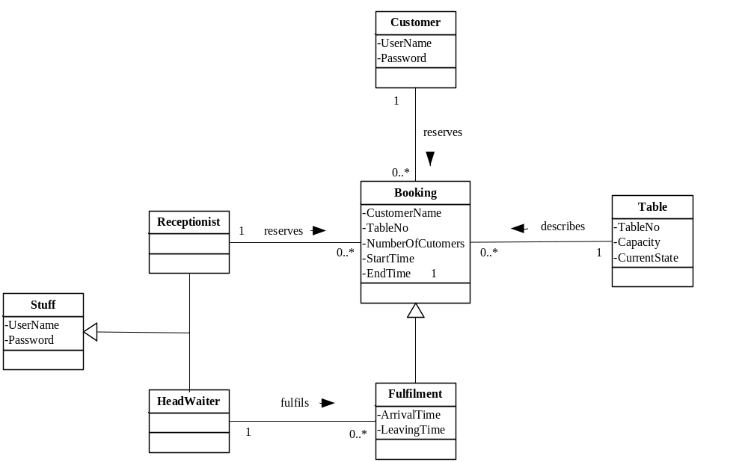
- Sequence diagram (9 marks)
Grading standard: (1) any 3 diagrams of the following ones are OK.
(2) 3 marks for each diagram
  - Make Booking
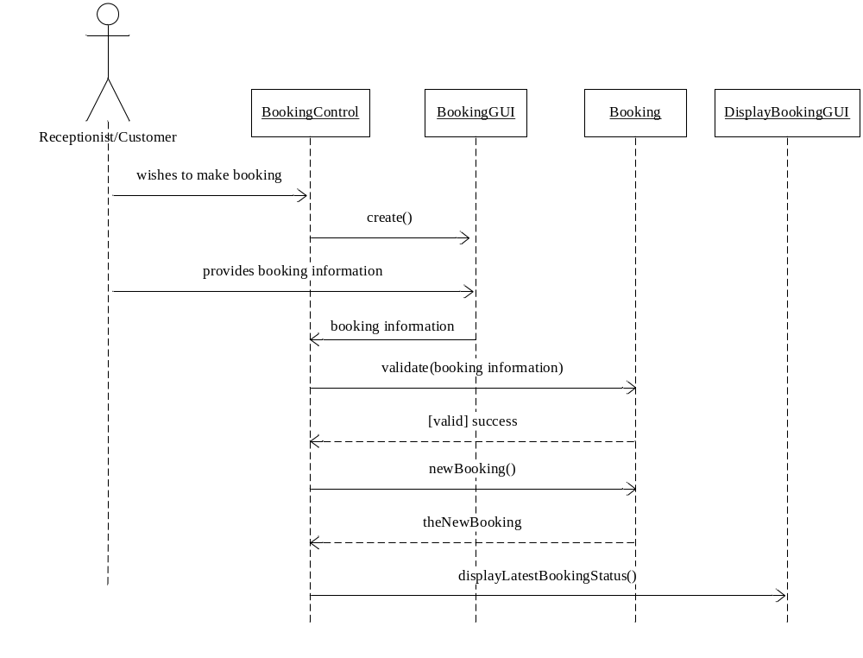
（2）Cancel Booking
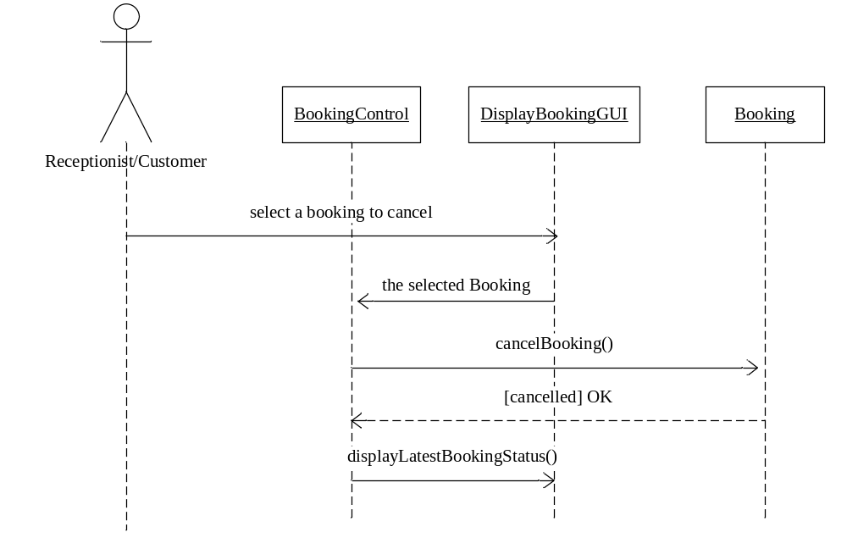
（3）Record Arrival
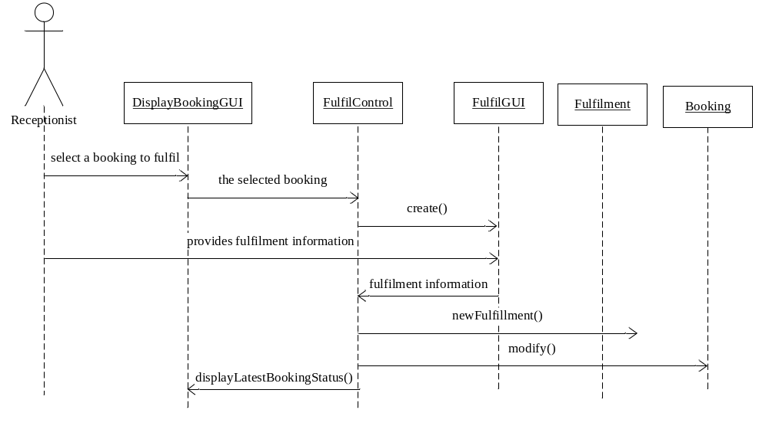(4) Display Booking
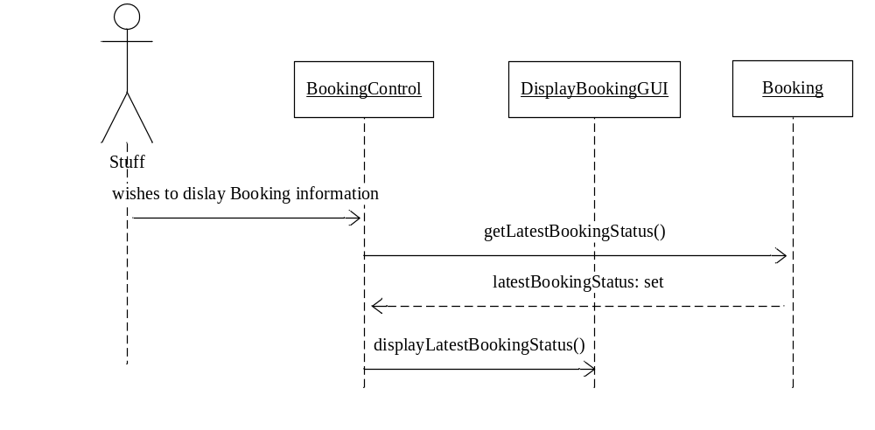
(5) Record Walk-in
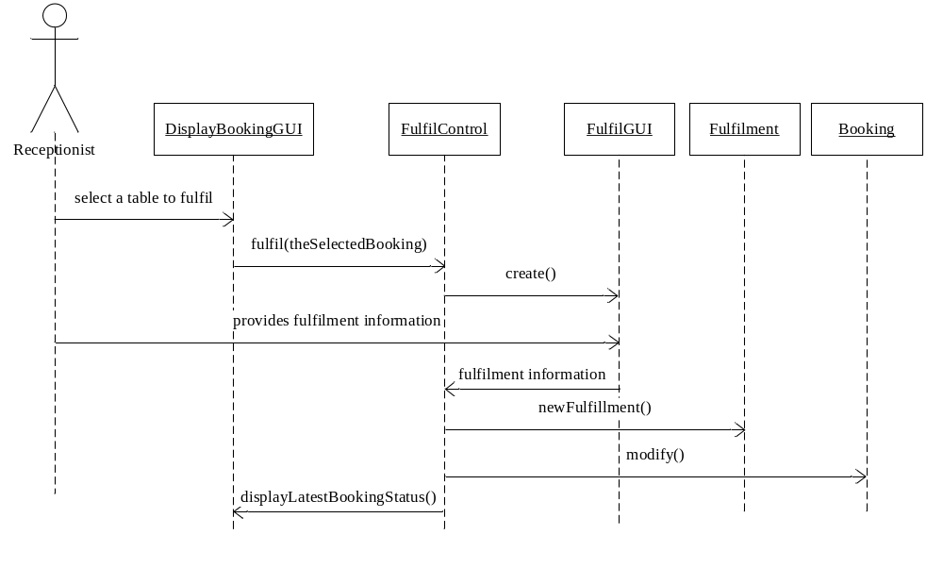
（6）Transfer Table
