# Report

**Build a Forward Planning Agent**

**Analyze the search complexity as a function of domain size, search algorithm, and heuristic**

|  |  |  |  |  |
| --- | --- | --- | --- | --- |
|  | **Air Cargo 1** | **Air Cargo 2** | **Air Cargo 3** | **Air Cargo 4** |
|
| **Actions** | 20 | 72 | 88 | 104 |
| **Breath First Search** | 43 | 3343 | 14663 | 99736 |
| **Depth First Search** | 21 | 624 | 408 | 25174 |
| **Uniform Cost Search** | 60 | 5154 | 18510 | 113339 |
| **Greedy with h unmet goals** | 7 | 17 | 25 | 29 |
| **Greedy with h pg level sum** | 6 | 9 | 14 | 17 |
| **Greedy h pg max level** | 6 | 27 | 21 | 56 |
| **Greedy with pg set level** | 6 | 9 | 35 | 107 |
| **A* h unmet goals** | 50 | 2467 | 7388 | 34330 |
| **A* h pg level sum** | 28 | 357 | 369 | 1208 |
| **A*h pg max level** | 43 | 2787 | 9580 | 62077 |
| **A* h pg set level** | 33 | 1037 | 3423 | 22606 |

Table 1: Nodes expanded vs. number of actions for different algorithms and heuristics

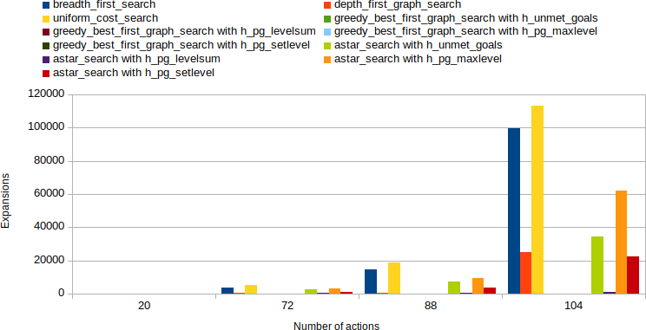

Figure 1: Nodes expanded vs. number of actions for different algorithms and heuristics

It appears from Table 1, Fig. 1, with increased domain size, this number of expanded nodes increases. Uniform cost search was the maximum number of nodes expanded. Greedy Best First Graph Search with different heuristics, in particular the heuristic function of LEVELSUM, had the minimum number of nodes extended.

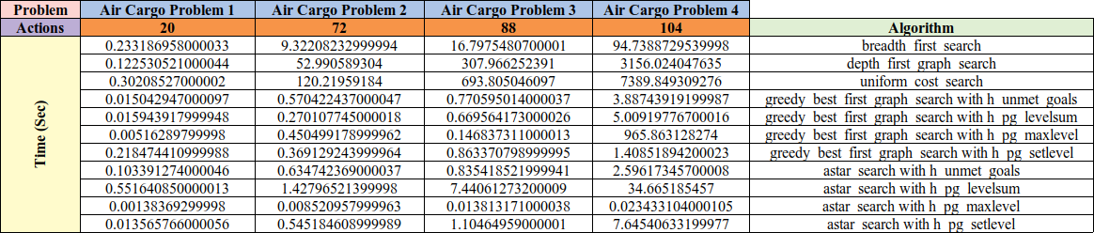**Analyze search time as a function of domain size, search algorithm, and heuristic**

Table 2: Search time vs. number of actions for different algorithms and heuristics

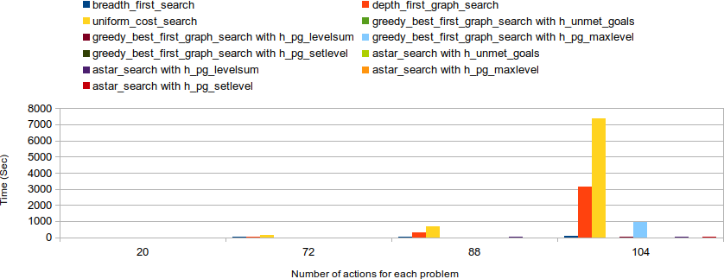

Figure 2: Search time vs. number of actions for different algorithms and heuristics

It is displayed in Table 2, Fig. 2, with increasing domain size, the search time increases. Problem 1, with 20 actions, consumed the shortest search time in all algorithms, while problem 4 took the longest search time with 104 actions. For every problem, A* consumed the shortest search time with MAXLEVEL heuristic, while Uniform cost search consumed the longest search time with problems 2, 3.

**Analyze the optimality of solution as a function of domain size, search algorithm, and heuristic**

|  |  |  |  |  |
| --- | --- | --- | --- | --- |
|  | **Air Cargo 1** | **Air Cargo 2** | **Air Cargo 3** | **Air Cargo 4** |
|
| **Actions** | 20 | 72 | 88 | 104 |
| **Breath First Search** | 6 | 9 | 12 | 14 |
| **Depth First Search** | 20 | 619 | 392 | 24132 |
| **Uniform Cost Search** | 6 | 9 | 12 | 14 |
| **Greedy with h unmet goals** | 6 | 9 | 15 | 18 |
| **Greedy with h pg level sum** | 6 | 9 | 14 | 17 |
| **Greedy h pg max level** | 6 | 9 | 13 | 17 |
| **Greedy with pg set level** | 6 | 9 | 17 | 23 |
| **A* h unmet goals** | 6 | 9 | 12 | 14 |
| **A* h pg level sum** | 6 | 9 | 12 | 15 |
| **A*h pg max level** | 6 | 9 | 12 | 14 |
| **A* h pg set level** | 6 | 9 | 12 | 14 |

Table 3: Plan length vs. number of actions for different algorithms and heuristics

Table 3 shows that the length of the plan increases with the increase of the domain size. Depth-First has also been shown to have produced the longest plan for all problems. Other than Depth-First algorithms have produced the same plan length for problems 1 and 2. With increasing domain sizes (i.e. problems 3 and 4), the shortest plans were produced by Breadth-First, Uniform-cost and A*.

1. **Which algorithm or algorithms would be most appropriate for planning in a very restricted domain (i.e., one that has only a few actions) and needs to operate in real time?**

A* with MAXLEVEL heuristics for all problems consumed the shortest time between all algorithms. In addition, A* with MAXLEVEL is one of the shortest plan algorithms. A* with MAXLEVEL would therefore be suitable for the planning of a very limited domain in real time.

1. **Which algorithm or algorithms would be most appropriate for planning in very large domains (e.g., planning delivery routes for all UPS drivers in the U.S. on a given day)?**

A* with MAXLEVELheuristic consumed the shortest time between all algorithms for all problems, despite A* with MAXLEVEL, many expansions and many new nodes were generated. In addition, A* is one of the algorithms with MAXLEVEL that produced the shortest plans for all problems. A* with MAXLEVEL would therefore be suitable for planning very large domains. Greedy Best First search can also be used in large domains because Greedy Best First Search( with different heuristics) produced minimum expansions and new nodes. With MAXLEVEL heuristic, however, Greedy 's best first search( with different heuristics) took longer than A*.

1. **Which algorithm or algorithms would be most appropriate for planning problems where it is important to find only optimal plans?**

Uniform Cost and Breadth First (all are identical as step costs). A* is used as a graph, so that consistent (not only acceptable) heuristics are required to be optimal.