**Answer Sheet Submitted by**

Justin Chong

Name:

U1921177E

Matric Number:

Lab Group:

IL03

30/10/20

Date:

**Exercise 1: (Insert screenshot of the Debug session, which must include Register, Disassemble, Memory (starting from 0x 4000 0400) and command windows)**

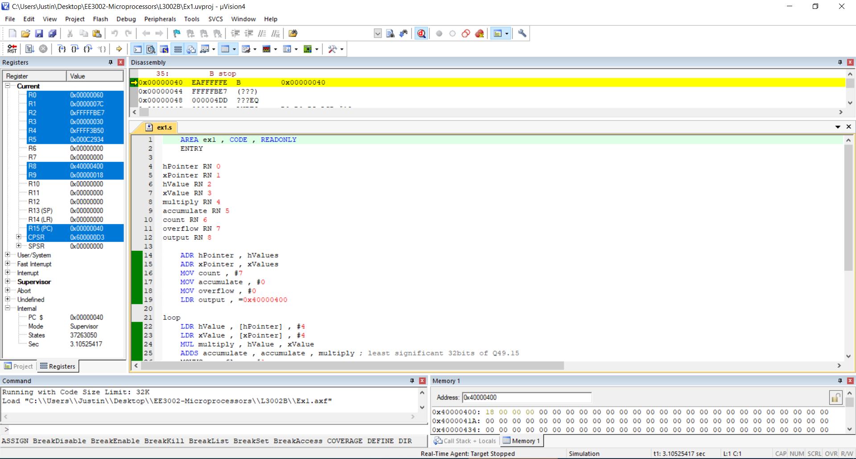

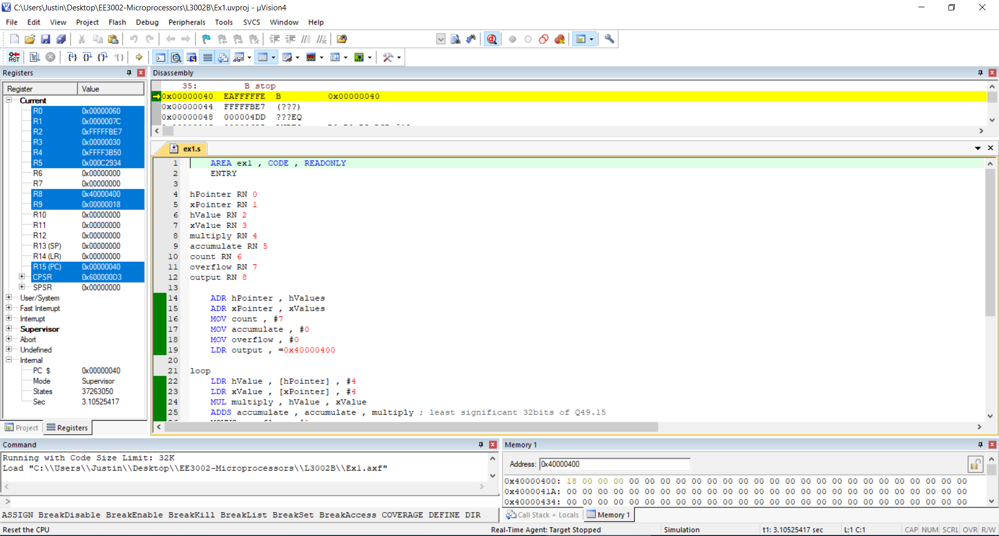

Please type in your answer in the boxes below:

128

(1_1) State the number of bytes used in your code   
 (include literal pool and data stored in the program memory)

(1_2) State the Q17.15 format of the coefficient to hex data :

|  |  |
| --- | --- |
| **Coefficients** | **Q17.15 format represented in hexadecimal** |
| -0.032 | 0x FFFF FBE7 |
| 0.038 | 0x 0000 04DD |
| 0.048 | 0x 0000 0625 |
| -0.048 | 0X FFFF F9DB |

Let’s student explain how they derive the above numbers.

(1_3) Verify that your digital filter output is correct:

Correct answer = 24.324

R9 value = 0x18 = 24

(1_4) What do you check whether your digital filter output has overflown? Why is the Z flag = 1

|  |
| --- |
| I check the V (signed overflow) flag to see if the output has overflown. The Z flag == 1 when the result of the flag-setting instruction is zero. |

**Exercise 2 (Insert screenshot of the Debug session, which must include Register, Disassemble, Memory (starting from 0x 4000 0400) and command windows)**

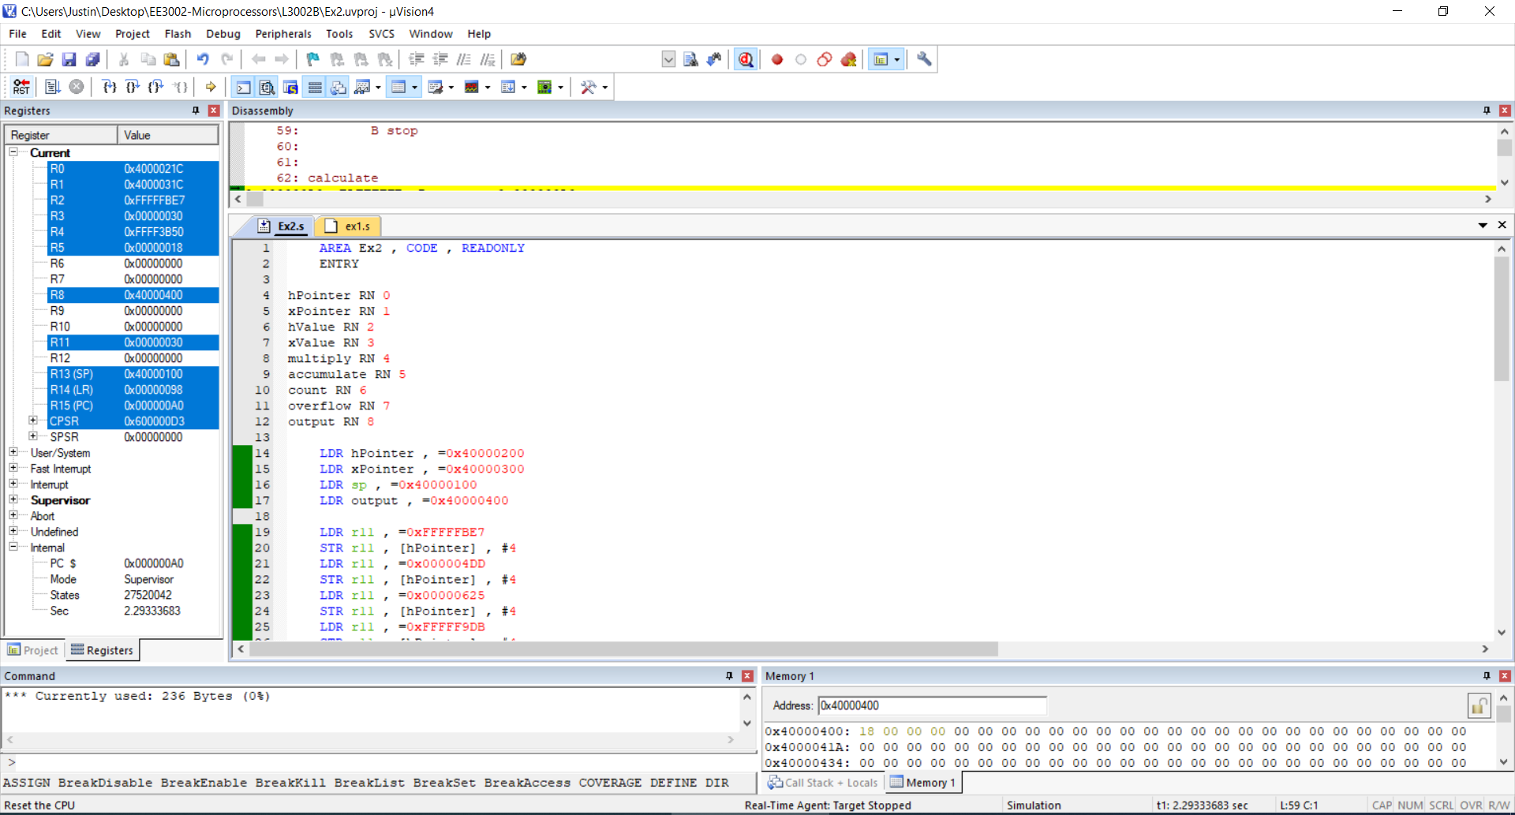

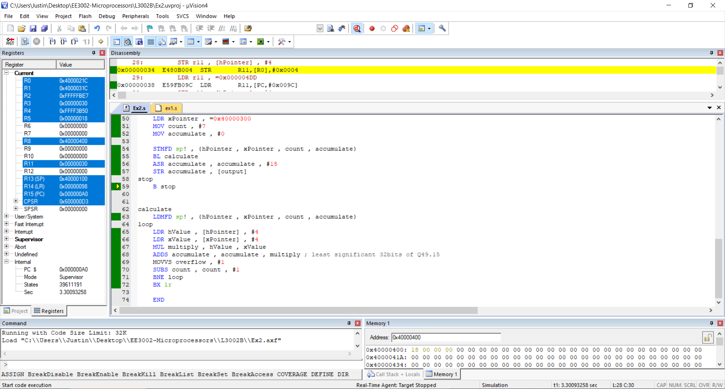

(2_1) State the number of bytes used in your code   
 (include literal pool and data stored in the program memory)

236

(2_2) Fill in the content of the stack (FD) after your program pushes the data into the stack

|  |  |
| --- | --- |
| Address | Content |
| 0x4000 0100 | 00 00 00 00 |
| 0x4000 000FC | 07 00 00 00 |
| 0x4000 000F8 | 00 00 00 00 |
| 0x4000 000F4 | 00 03 00 40 |
| 0x4000 000F0 | 00 02 00 40 |
| 0x4000 000EC | 00 00 00 00 |
| SP (What is the value of SP after the completion of the program) | 0x4000 0100 |

(2_3) Student to list down their mistakes when programming. How do they debug their code?

|  |
| --- |
| I loaded the wrong values into memory when entering values of the input data.  I debug by running the program step by step and checking the register values to make sure everything is correct. |

**Exercise 3: Optional Questions (Insert screenshot of the Debug session, which must include Register, Disassemble, Memory (starting from 0x 4000 0400) and command windows). Please expand the page if you need to show more code.**

**Declaration:**

**Chong Zhi Yu Justin**

I,   un understand that submitting work that isn’t

my own may result in no mark being awarded to this lab component.