Answer Sheet Submitted by
Chong Zhi Yu Justin
Name:
U1921177E
Matric Number:
Lab Group:
IL03
9 / 10 / 20
Date:

Exercise 1A: (insert screenshot of the Debug session, which must include Register, Disassemble, Memory and command windows)

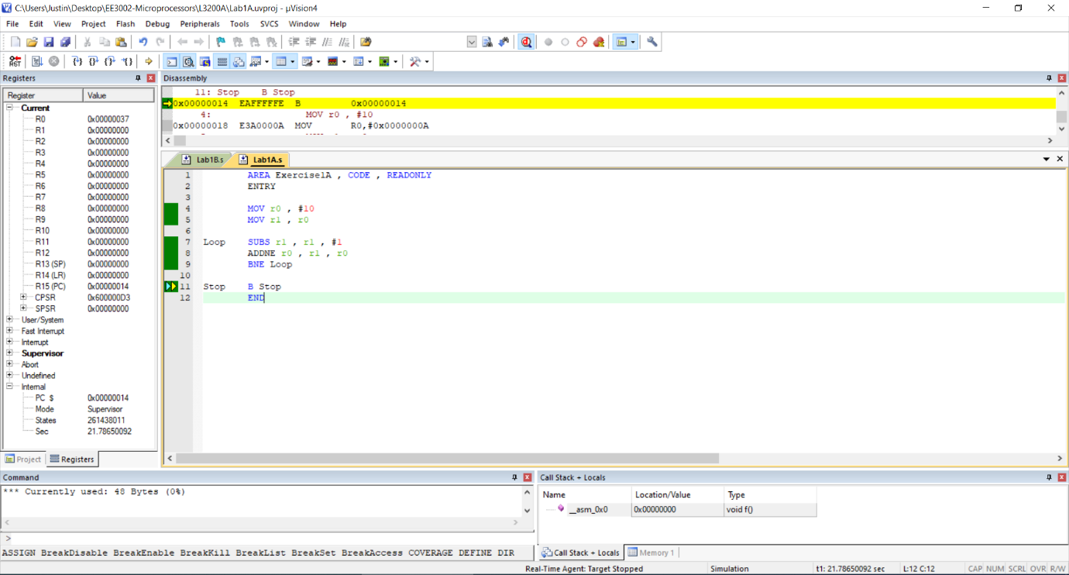

Exercise 1B (insert screenshot of the Debug session, which must include Register, Disassemble, Memory and command windows) Exercise 1B

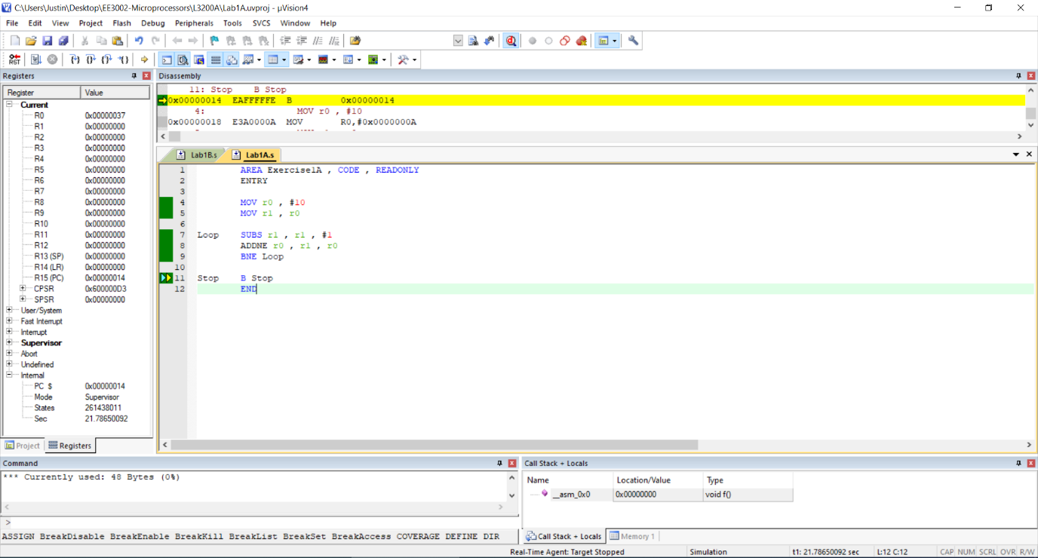

Please type in your answer in the boxes below:

(1B_1) State the number of bytes of the revised programming code (including the literal pool and data in program memory)

(1B_2) What is the end address of your programming code?:

(1B_3) State the conditional branch statement used:

(1B_4) State the additional instruction used in the revised code:

Exercise 2:
Fill in the Table below
Original temperature Celsius (oC) in decimal format | Represent in hex format (Q24.8) | Round up temperature Celsius (oC) in integer format (Q32.0) | Represent in hex format (Q32.0)
16.5 |  | 17
17.6 |  | 18
18.9 |  | 19
20.1 |  | 20
22.5 |  | 23
26.7 |  | 27
28.9 |  | 29
35.6 |  | 36
36.2 |  | 36
37.6 |  | 38

Insert screenshot of the Debug session, which must include Register, Disassemble, Memory (starting from 0x40000100) and command windows.

Please type in your answer in the boxes below:

(2_1) State the number of bytes used in your program memory
(2_2) State the number of bytes to store the
original temperatures (or converted temperatures)

(2_3) State the memory range (or ending address) of
the converted FahrenheitTable.

(2_4) Manually convert the readings in the FahrenheitTable into
decimal values in Q32.0 (or Q24.8).

(2_5) How do you modify your code to have both Celsius and Fahrenheit readings in Q24.8 format? Please insert a screenshot of the modified code, which must include Register, Disasemble, Memory and command windows.

Exercise 3: (optional exercise). Insert screenshot, which must include Register, Dis-assemble, Memory and command windows)

Declaration:
<name>,
I, understand that submitting work that isn’t my
own may result in no mark being awarded to this lab component.

