RIZAL THROUGH PLAY
Instructor Monitoring Portal
User Manual • Version 1.0 • April 2026

1. INTRODUCTION
The Rizal Through Play (RTP) Instructor Monitoring Portal is a web-based dashboard designed to help instructors track and monitor their students' progress in the Rizal Through Play educational game. Student data — including chapters completed, time played, puzzles solved, and checkpoints reached — is automatically synced from the game in real time. No manual data entry is required.
This manual is intended for instructors who have been issued an account by the system administrator.
2. ACCESSING THE PORTAL
To open the portal, open any web browser (Google Chrome, Microsoft Edge, Firefox, etc.) and navigate to the portal's web address provided by your administrator.
NOTE: The portal is best viewed on a desktop or laptop computer with a screen width of at least 1024 pixels.

3. LOGGING IN
When you open the portal, you will land on the Login Page.
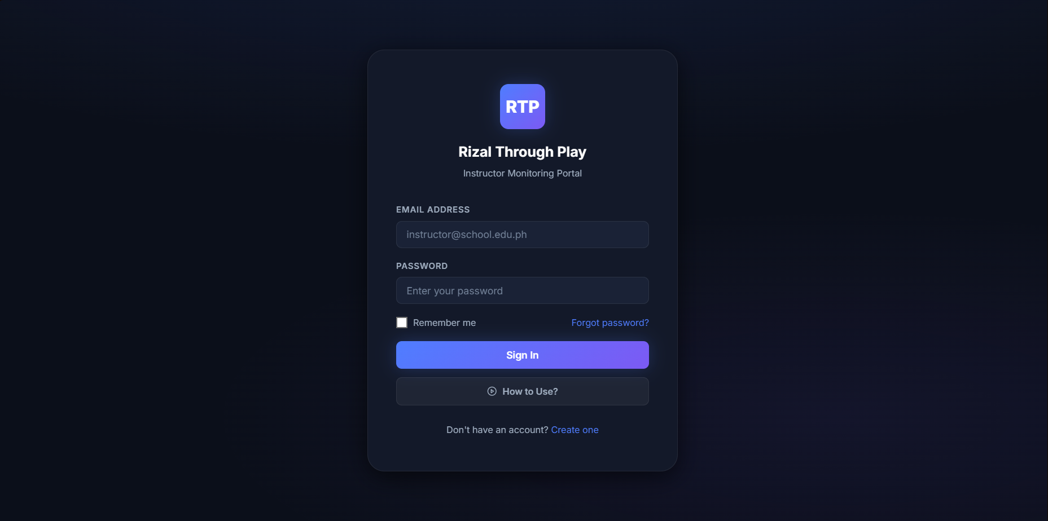
Steps to Log In
- Enter your Email Address in the first field (e.g., instructor@school.edu.ph).
- Enter your Password in the second field.
- (Optional) Check the Remember me box if you want the portal to keep you logged in on this device.
- Click the Sign In button.
If your credentials are correct, you will be taken directly to the Dashboard.
Forgot Your Password?
- Click the Forgot password? link on the login page.
- Enter your registered email address.
- Click the reset button. A password reset email will be sent to your inbox.
- Open the email, click the link, and create a new password.
- Return to the login page and sign in with your new password.
Don't Have an Account?
Click the Create one link at the bottom of the login card and fill in the registration form. You will need to provide your full name, username, email address, contact number, birth date, and a password.

IMPORTANT: Full Name and Username must be unique — no two instructor accounts can share the same name or username. You will see an error if the value is already taken.

4. THE TUTORIAL GUIDE (HOW TO USE?)
First-Time Welcome
The first time you visit the login page, a welcome prompt will automatically appear asking: "Welcome to RTP Monitoring! Would you like a quick tutorial on how to use the dashboard and track your students?"
- Click "Yes, show me" to activate the tutorial highlight.
- Click "No, thanks" to skip it.
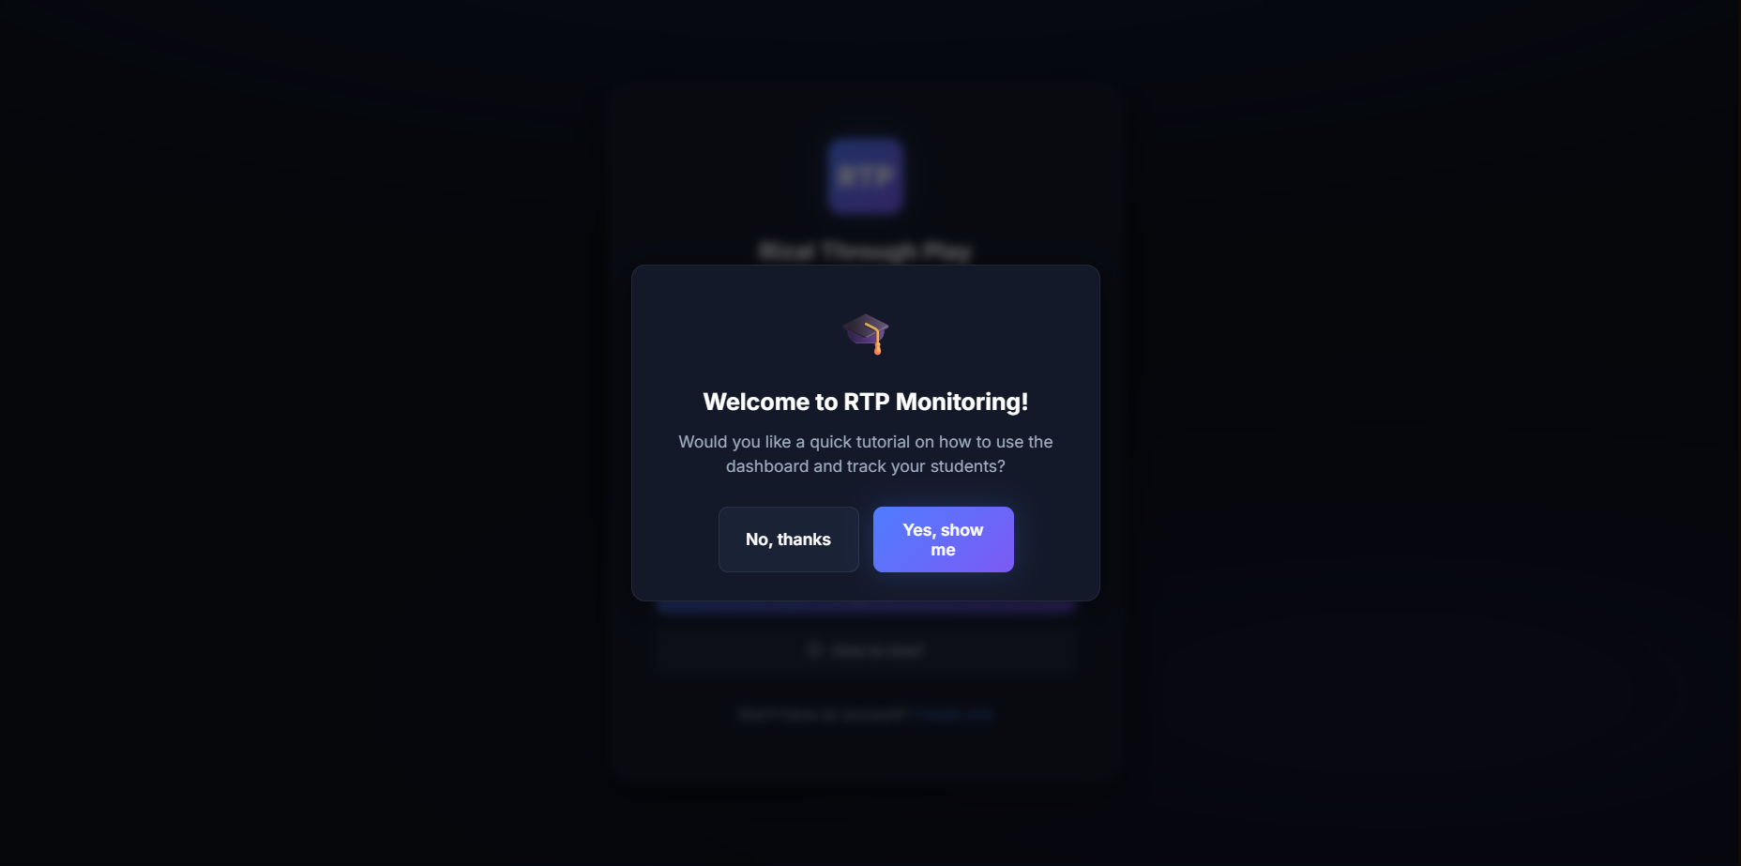
This prompt only appears once per device and will not appear again after your first visit.

How to Use? Button
At the bottom of the login card, there is a How to Use? button (with a play icon ▶). Clicking this button opens a video guide in a new browser tab.
Tutorial Highlight Mode
If you clicked 'Yes, show me' on the welcome prompt:
- The background of the login page will blur and darken.
- The How to Use? button will glow and become highlighted.
- A small tooltip box will appear to the right of the button explaining what it does.
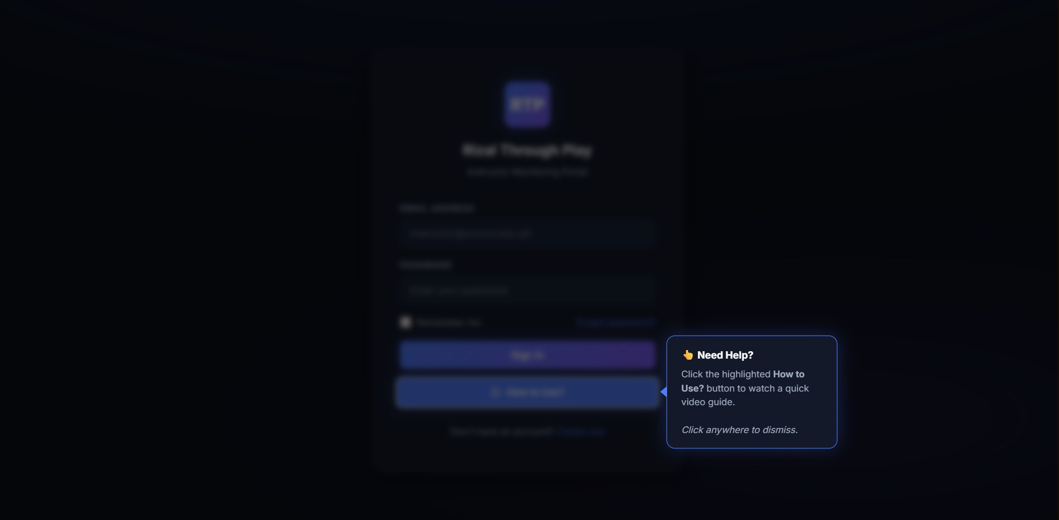
- Click anywhere on the dark background to dismiss the tutorial highlight.
5. THE DASHBOARD
After logging in, you will be taken to the Student Monitoring Dashboard. This is the main page of the portal.
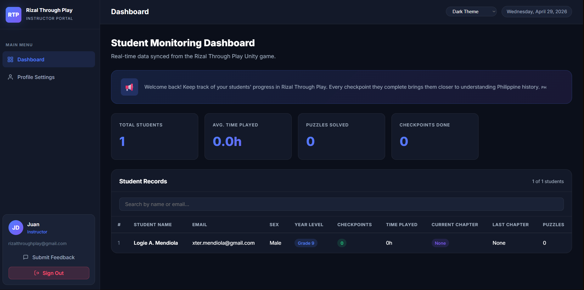
Message of the Day
At the top of the dashboard, there is a blue banner with a motivational message for instructors.
Summary Statistics
Below the banner, four summary cards display key statistics for your students only:
Card | What It Shows
Total Students | The total number of students assigned to you
Avg. Time Played | The average number of hours your students have spent in the game
Puzzles Solved | The combined total of puzzles solved across all your students
Checkpoints Done | The combined total of checkpoints completed across all your students

These numbers update in real time as students play the game.
Student Records Table
Below the statistics, a full table lists every student assigned to you. Each row contains:
Column | Description
# | Row number
Student Name | The student's full name
Email | The student's registered email address
Sex | The student's sex as registered in the game
Year Level | The student's year level
Checkpoints | Number of checkpoints the student has completed
Time Played | Total hours the student has spent in the game
Current Chapter | The chapter the student is currently on
Last Chapter | The last chapter the student finished
Puzzles | Number of puzzles the student has solved

NOTE: If no students appear, it means no students have been assigned to your name in the game yet, or students have not yet started playing.

6. SEARCHING AND FILTERING STUDENTS
Above the student records table, there is a search bar.
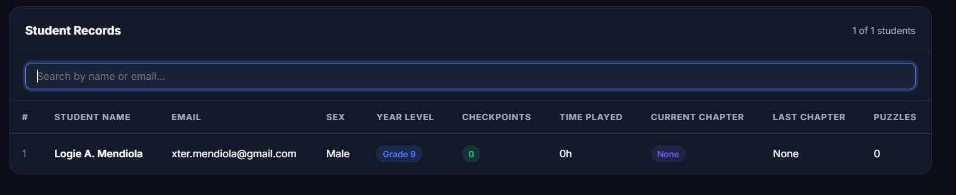
- Type any part of a student's name or email address to filter the list instantly.
- The counter in the top-right of the table (e.g., '12 of 30 students') updates to show matching results.
- Clear the search bar to return to the full list.
7. PROFILE SETTINGS
To manage your account, click Profile Settings in the left sidebar.
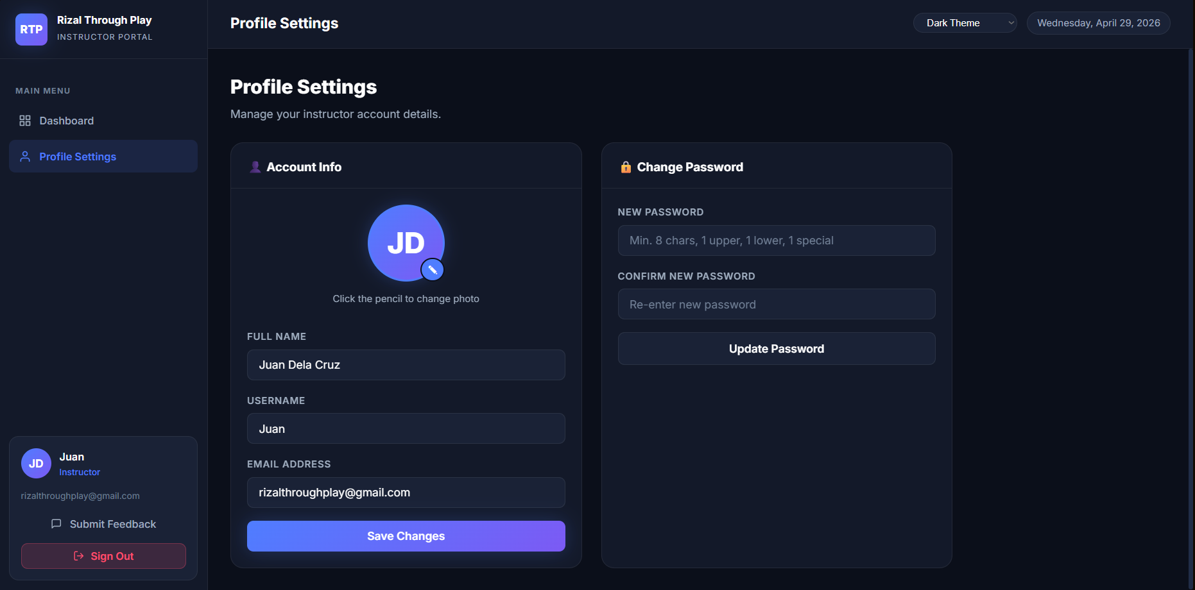
Updating Your Account Information
In the Account Info card, you can update:
- Full Name — Your display name used throughout the portal.
- Username — A short name or handle.
- Email Address — Your login email.
After making changes, click Save Changes.
IMPORTANT: Changing your Full Name is critical — the dashboard only shows students whose instructor name in the game matches your Full Name in the portal exactly. The system will block you from using a name already registered to another instructor account.

Password Requirements
Your password must meet the following requirements:
- At least 8 characters
- At least 1 uppercase letter (A–Z)
- At least 1 lowercase letter (a–z)
- At least 1 special character (e.g., !, @, #, $)
Changing Your Profile Photo
- On the Profile Settings page, click the pencil icon (✎) on your profile photo.
- Select an image file from your computer.
- The photo will upload automatically and update across the portal.
8. SUBMITTING FEEDBACK
To share your experience or report issues, click Submit Feedback in the left sidebar.
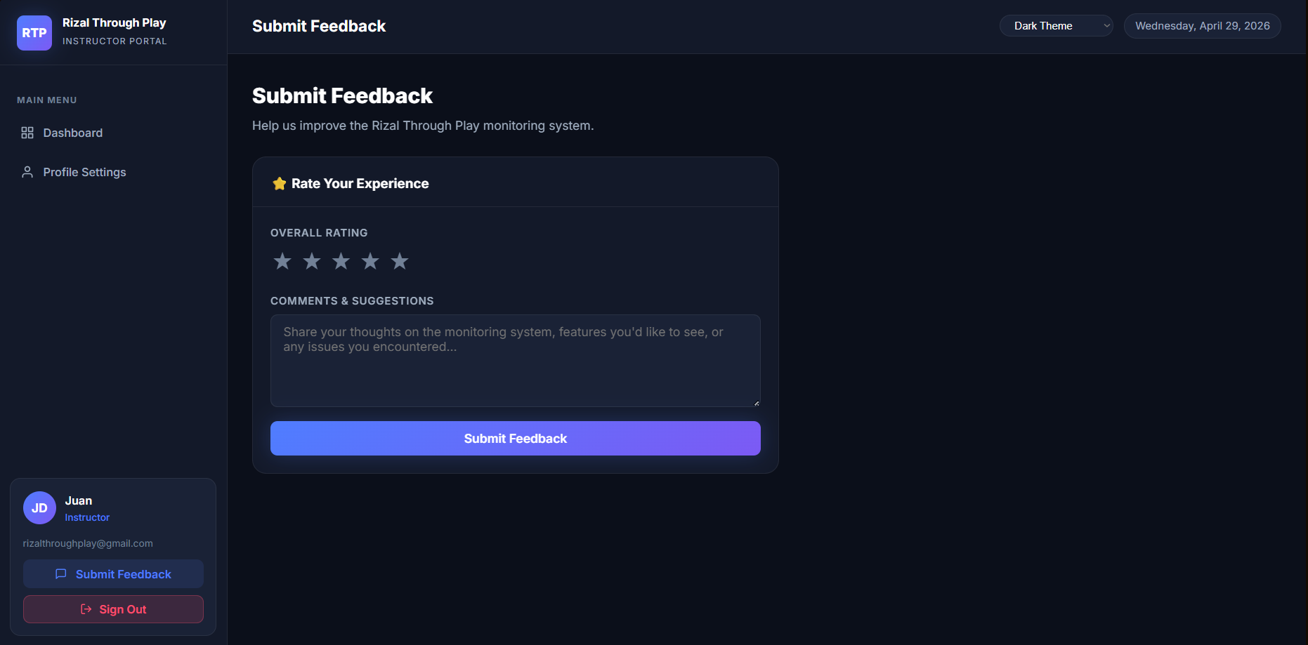

How to Submit Feedback
- Click the star rating (1 to 5 stars) to rate your experience.
- Type your comments or suggestions in the Comments & Suggestions text box.
- Click Submit Feedback.
A green success message will appear once your feedback has been recorded.
Stars | Rating Label
★☆☆☆☆ | Poor
★★☆☆☆ | Fair
★★★☆☆ | Good
★★★★☆ | Very Good
★★★★★ | Excellent

9. CHANGING THE THEME
In the top-right corner of the portal (visible on any page after login), there is a theme selector dropdown.
Theme | Description
Dark Theme | Deep navy dark mode (default)
Light Theme | Clean white background
Midnight Purple | Dark purple tone
Ocean Blue | Deep ocean dark blue

The selected theme applies immediately.
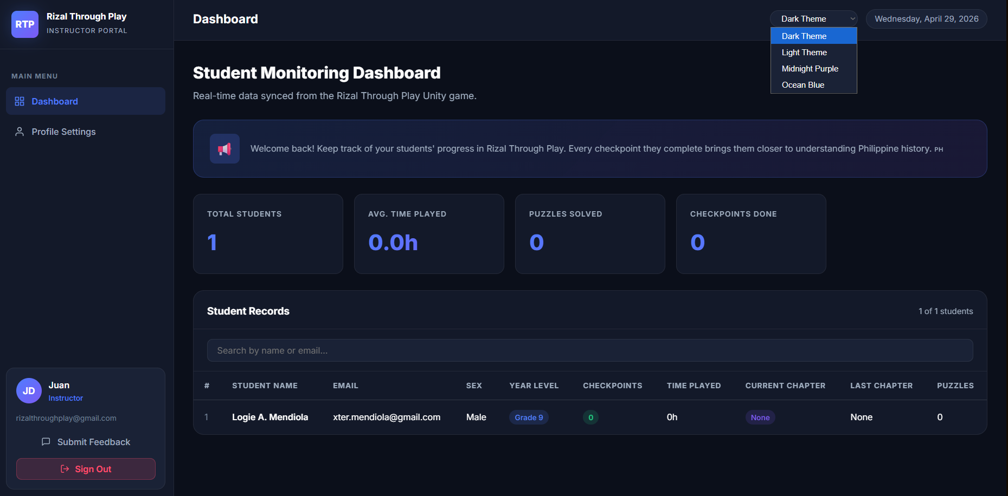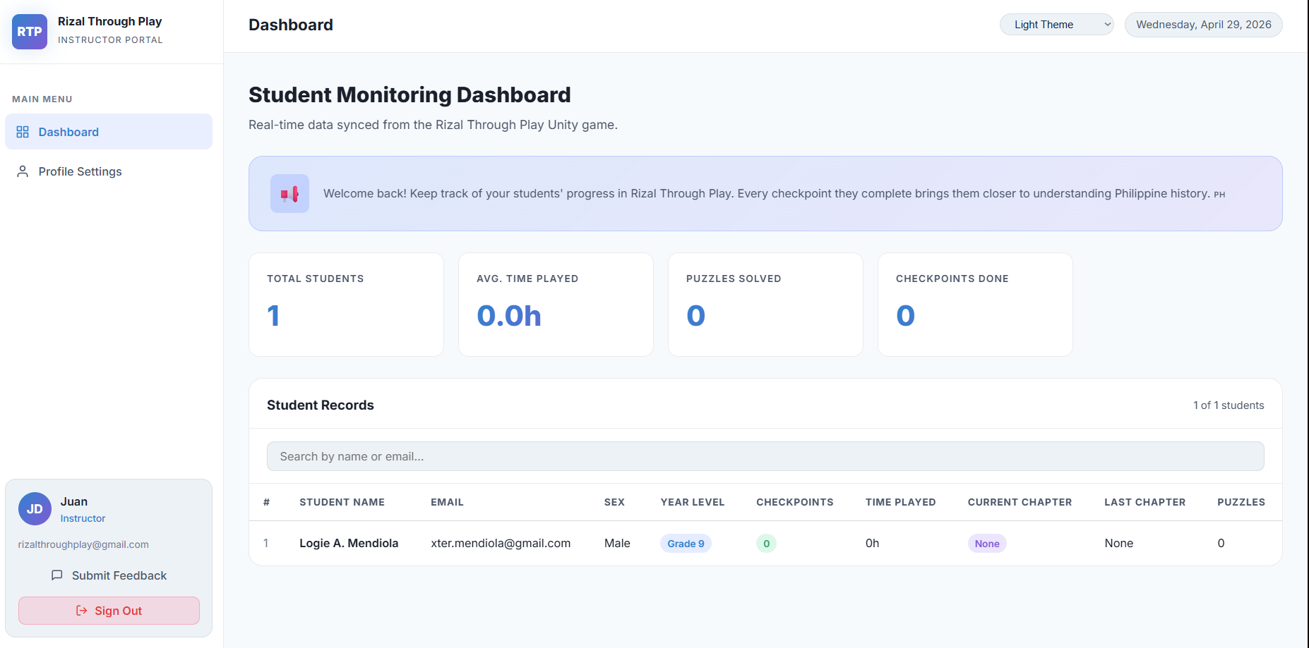
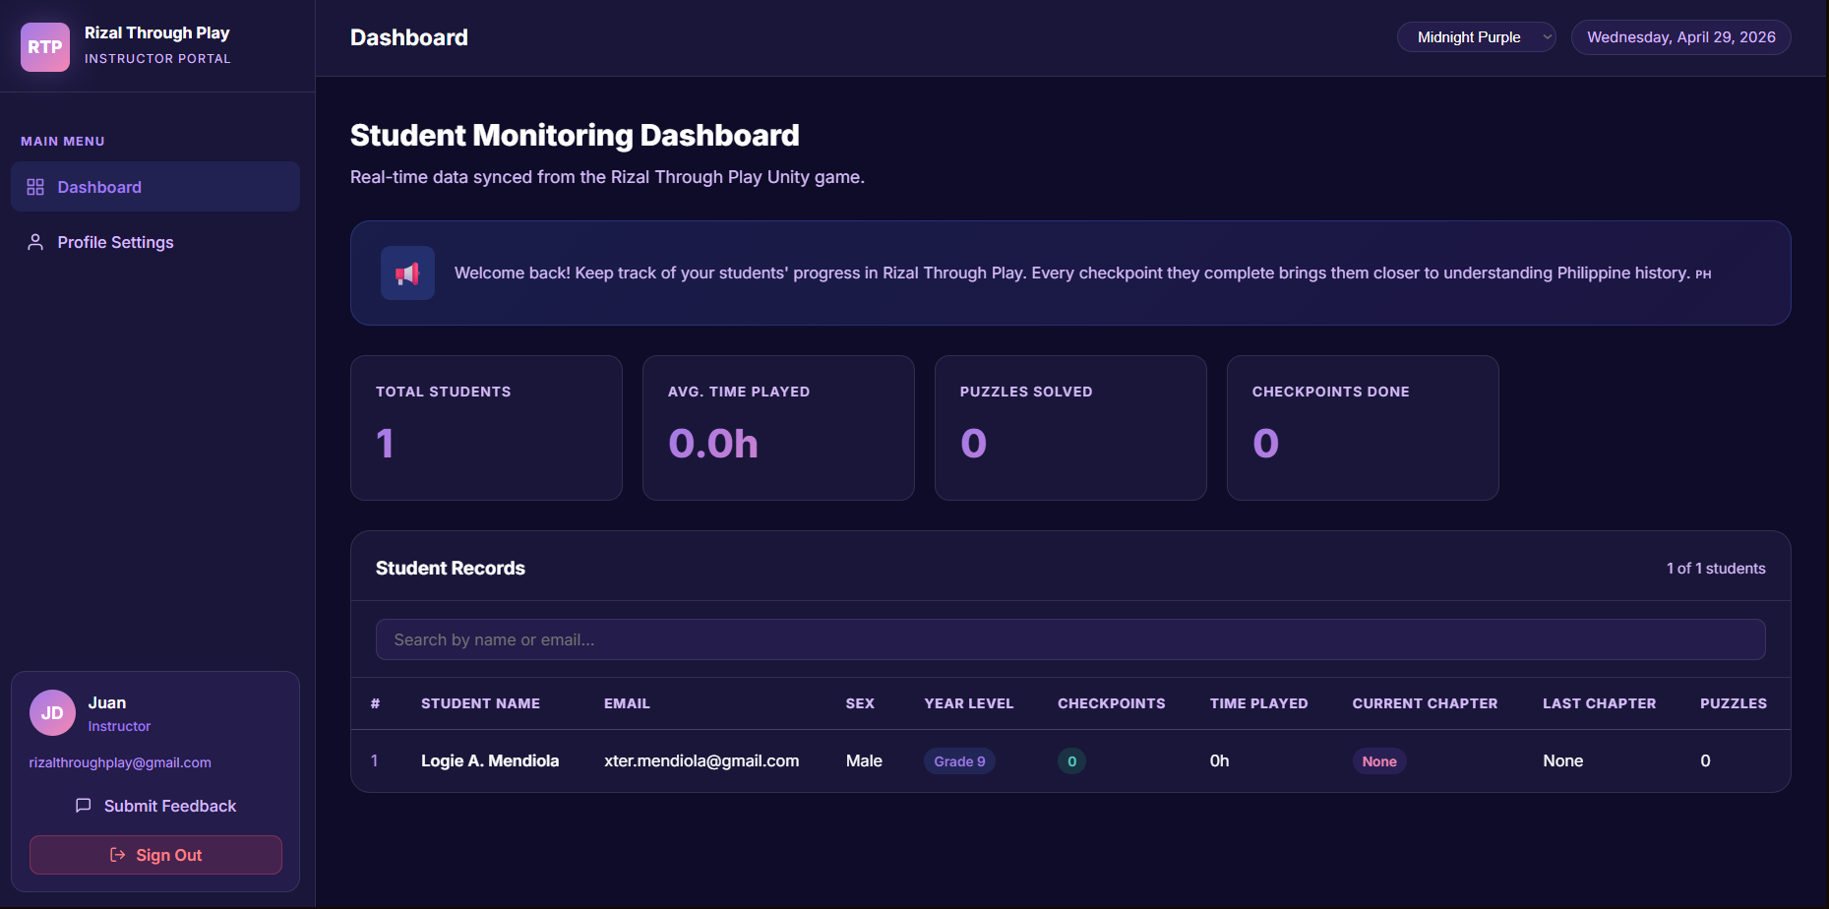
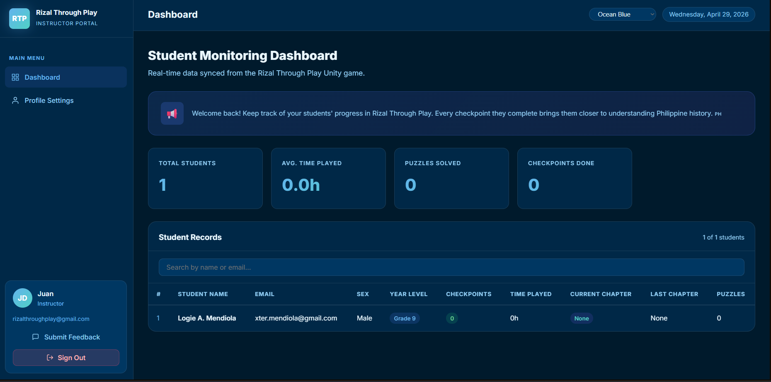
10. SIGNING OUT
- In the lower-left corner of the sidebar, click the Sign Out button.
- A confirmation dialog will appear: "Are you sure you want to sign out?"
- Click Sign Out to confirm, or Cancel to go back.
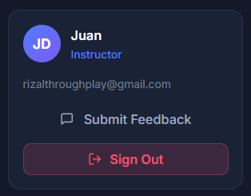
You will be redirected to the Login page after signing out.
TIP: Always sign out when using a shared or public computer.
11. FREQUENTLY ASKED QUESTIONS
Q: Why are there no students on my dashboard?
A: There are two possible reasons: (1) No students have been assigned your name as their instructor in the game yet. (2) The name in the game does not exactly match the Full Name saved in your Profile Settings. Check your name under Profile Settings and make sure it matches exactly.
Q: The data looks outdated. How do I refresh it?
A: The dashboard updates in real time automatically. If data seems outdated, try refreshing the browser page (press F5 or Ctrl + R).
Q: I forgot my password. What should I do?
A: Click Forgot password? on the Login page and follow the steps in Section 3 of this manual.
Q: Can I see students from another instructor?
A: No. The portal only shows students whose instructor field in the game matches your Full Name exactly. Each instructor only sees their own students.
Q: The tutorial prompt no longer appears. How do I see it again?
A: The prompt only shows once per device. You can still access the video guide at any time by clicking the How to Use? button at the bottom of the Login page.
Q: I changed my email but it says I need to log out first.
A: For security reasons, Firebase requires a recent login to change your email. Simply sign out and sign back in, then update your email in Profile Settings.
Q: I tried to use a name or username that's already taken. What do I do?
A: The system prevents duplicate Full Names and Usernames across instructor accounts to avoid data being shared between accounts. Choose a different name or username that hasn't been registered yet.
Q: Who do I contact if I have a technical problem?
A: Contact your system administrator or the RTP development team. You can also use the Submit Feedback page to report issues.

End of User Manual | Rizal Through Play — Instructor Monitoring Portal | For internal use only.

