MFIN7037 Quantitative Trading

Assignment 1

|  |  |
| --- | --- |
| 3035424736 | YU Mengke |
| 3035424827 | ZENG Siyang |

**Output Snapshots of Task 1 & 2**

Task One

|  |
| --- |
| > quantile(task_one$ID, c(.01, .05, .50, .95, .99))  1% 5% 50% 95% 99%  -0.188 -0.140 -0.040 0.056 0.100  > quantile(task_one$ret_t2_t12, c(.01, .05, .50, .95, .99))  1% 5% 50% 95% 99%  -0.81215468 -0.57616575 0.09087013 1.15789475 2.66101697 |

Log of Cumulative Return for Strategy One

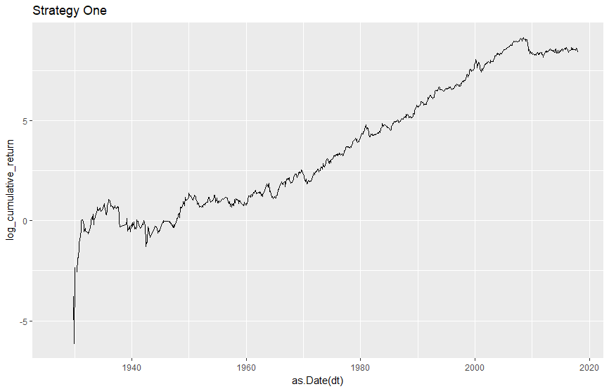

Log of Cumulative Return for Strategy Two

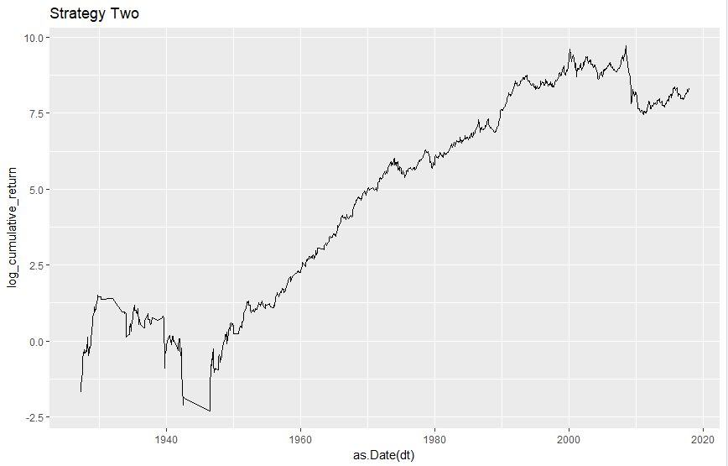

Mean, Standard Deviation, & Sharpe Ratio for Strategies

|  |
| --- |
| [1] "strategy one mean"  [1] 0.01129157  [1] "strategy one sd"  [1] 0.07246755  [1] "strategy one sharpe"  [1] 0.5397607  [1] "strategy two mean"  [1] 0.01299024  [1] "strategy two sd"  [1] 0.08551109  [1] "strategy two sharpe"  [1] 0.5262419 |

Regression of Strategy One on Fama French Three Factor

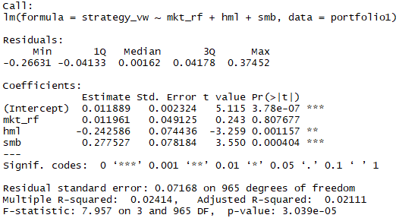

Regression of Strategy Two on Fama French Three Factor

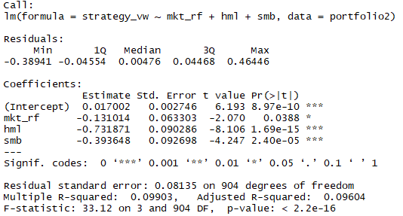

Event Study for Strategy One

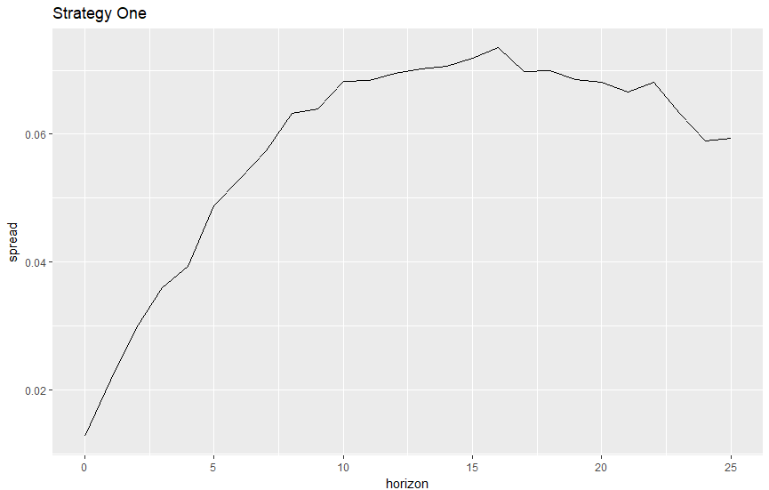

Event Study for Strategy Two

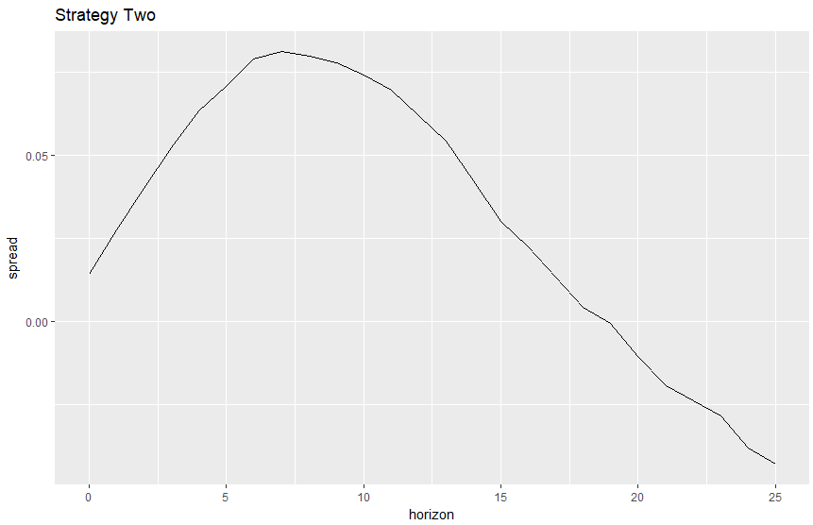

**Task 3**

1.a.

First, we should notice that both strategies suggested by assignment description are “long high momentum and short low momentum”, but controlling for different levels of information discreteness. In either strategy, we focus on the market subset with extreme level of information discreteness -- extremely discrete, or extremely continuous. This fact may be the cause.

The possible reasons can be divided into two categories:

(1) Something happens to numerator of Sharpe ratio. For example, either subset of market may imply poor performance of stock price. Extremely discrete stock may be the company that often (positively or negatively) surprises investors without signals, or in other word, fails to manage market expectation. Meanwhile, extremely continuous stock may be the company that has no catalyst of stock price, or in other word, fail to attract attention and transaction.

(2) Something happens to denominator of Sharpe ratio. For example, rather than pure momentum strategy, we have a lower number of stocks in our portfolio, which naturally leads to higher volatility.

1.b.

For the hypothesis about numerator, we can check the performance of portfolio with more neutral bins of information discreteness. For the hypothesis about denominator, we can check the volatility of different portfolios of stock, especially for the size of stock list.

1.c.

In our opinion, it really depends on the distributional characteristics of market. For example, if we assume stocks evenly fall in each cell of the bins grid, the above result will not change much.

1.d.

Breakpoint calculations may make difference, but still work in ways discusses before, for example, really depending on the distributional characteristics of market.

2.

(1) Time of Data Sample

In the paper, they used the data during 1927 to 2007, but we additionally used the data after 2007. The data during and after last financial crisis are enough to change the result. Also, we just simply put all data together, instead of divide them into two sets.

(2) Measure of Portfolio

In the paper, they look at the six-month and three-year return of stocks selected, in other word, assuming holding the stocks for that period. For assignment, we adopt the method as if we adjust the portfolio each month and keep monitoring returns. The way of trading is also a key factor of returns.

(3) Stock Universe

In the paper, they extra did “firm-level accounting” adjustment and eliminated firms with negative book value. The both adjustments may create bias for stock universe.

3.

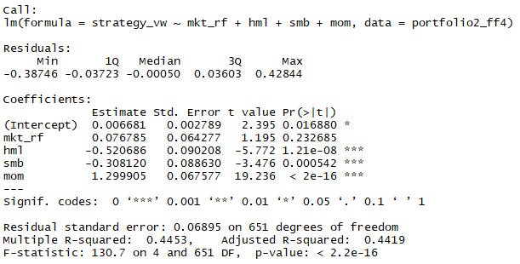

According to the above regression result, strategy two seems to outperform Fama French momentum by showing a positive alpha.

Here is one explanation to the result. The continuous stocks may be mainly those with large market cap and stable operation. Rather than dealing with almost all stocks in market in the way of Fama French four factor model, strategy two deals with safer stocks. The strategy of playing safe can help survive market crash.

4.

If market can’t respond swiftly to the information difficult to process, that may imply that market has not realize and react to opportunities until news coverage is much enough. If so, the stocks with high news coverage should perform better than those with low news coverage in next few months. However, according to the frog paper, lower news coverage stocks seem to perform better, while many numbers cannot pass t-test. An interpretation is that maybe some players have acted on the opportunities before the rest crowd of market and media.