%%%%%%%%%%%%%%%%%%%%%%%%%%%%%%%%%%%%%%%%%%%%%%%%%%%%%%%

**Example 1**

We consider the initial value problem with a source term,

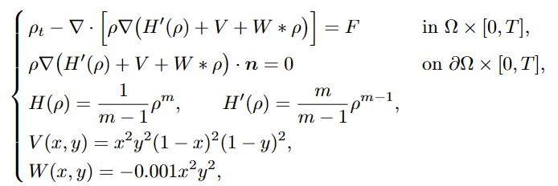where we take m=3, Ω=(0,1)2 and T=0.2. The exact solution is given by:



The source term F is computed by substituting the above exact solution into the equation atρ.

%%%%%%%%%%%%%%%%%%%%%%%%%%%%%%%%%%%%%%%%%%%%%%%%%%%%%%%

**Result**

1. **Free energy**
2. **Mesh size(h=1/4), time step(tau=1/20000)**

The free energy at T=0: 6.280115e-04

The free energy at T=1.000000e-02: 6.277271e-04

The free energy at T=2.000000e-02: 6.274447e-04

The free energy at T=3.000000e-02: 6.271643e-04

The free energy at T=4.000000e-02: 6.268858e-04

The free energy at T=5.000000e-02: 6.266091e-04

The free energy at T=6.000000e-02: 6.263344e-04

The free energy at T=7.000000e-02: 6.260614e-04

The free energy at T=8.000000e-02: 6.257903e-04

The free energy at T=9.000000e-02: 6.255210e-04

The free energy at T=1.000000e-01: 6.252535e-04

The free energy at T=1.100000e-01: 6.249877e-04

The free energy at T=1.200000e-01: 6.247237e-04

The free energy at T=1.300000e-01: 6.244614e-04

The free energy at T=1.400000e-01: 6.242008e-04

The free energy at T=1.500000e-01: 6.239419e-04

The free energy at T=1.600000e-01: 6.236846e-04

The free energy at T=1.700000e-01: 6.234290e-04

The free energy at T=1.800000e-01: 6.231750e-04

The free energy at T=1.900000e-01: 6.229226e-04

The free energy at T=2.000000e-01: 6.226718e-04

1. **Mesh size(h=1/8), time step(tau=1/20000)**

The free energy at T=0: 6.309756e-04

The free energy at T=1.000000e-02: 6.307558e-04

The free energy at T=2.000000e-02: 6.305380e-04

The free energy at T=3.000000e-02: 6.303221e-04

The free energy at T=4.000000e-02: 6.301082e-04

The free energy at T=5.000000e-02: 6.298962e-04

The free energy at T=6.000000e-02: 6.296861e-04

The free energy at T=7.000000e-02: 6.294779e-04

The free energy at T=8.000000e-02: 6.292715e-04

The free energy at T=9.000000e-02: 6.290670e-04

The free energy at T=1.000000e-01: 6.288642e-04

The free energy at T=1.100000e-01: 6.286633e-04

The free energy at T=1.200000e-01: 6.284642e-04

The free energy at T=1.300000e-01: 6.282668e-04

The free energy at T=1.400000e-01: 6.280712e-04

The free energy at T=1.500000e-01: 6.278773e-04

The free energy at T=1.600000e-01: 6.276851e-04

The free energy at T=1.700000e-01: 6.274947e-04

The free energy at T=1.800000e-01: 6.273059e-04

The free energy at T=1.900000e-01: 6.271187e-04

The free energy at T=2.000000e-01: 6.269333e-04

1. **Mesh size(h=1/16), time step(tau=1/20000)**

The free energy at T=0: 6.305191e-04

The free energy at T=1.000000e-02: 6.303154e-04

The free energy at T=2.000000e-02: 6.301137e-04

The free energy at T=3.000000e-02: 6.299141e-04

The free energy at T=4.000000e-02: 6.297164e-04

The free energy at T=5.000000e-02: 6.295207e-04

The free energy at T=6.000000e-02: 6.293269e-04

The free energy at T=7.000000e-02: 6.291351e-04

The free energy at T=8.000000e-02: 6.289452e-04

The free energy at T=9.000000e-02: 6.287571e-04

The free energy at T=1.000000e-01: 6.285709e-04

The free energy at T=1.100000e-01: 6.283866e-04

The free energy at T=1.200000e-01: 6.282041e-04

The free energy at T=1.300000e-01: 6.280234e-04

The free energy at T=1.400000e-01: 6.278445e-04

The free energy at T=1.500000e-01: 6.276674e-04

The free energy at T=1.600000e-01: 6.274920e-04

The free energy at T=1.700000e-01: 6.273184e-04

The free energy at T=1.800000e-01: 6.271465e-04

The free energy at T=1.900000e-01: 6.269762e-04

The free energy at T=2.000000e-01: 6.268077e-04

1. **Mesh size(h=1/32), time step(tau=1/20000)**

The free energy at T=0: 6.305346e-04

The free energy at T=1.000000e-02: 6.303355e-04

The free energy at T=2.000000e-02: 6.301384e-04

The free energy at T=3.000000e-02: 6.299434e-04

The free energy at T=4.000000e-02: 6.297503e-04

The free energy at T=5.000000e-02: 6.295593e-04

The free energy at T=6.000000e-02: 6.293702e-04

The free energy at T=7.000000e-02: 6.291830e-04

The free energy at T=8.000000e-02: 6.289977e-04

The free energy at T=9.000000e-02: 6.288144e-04

The free energy at T=1.000000e-01: 6.286329e-04

The free energy at T=1.100000e-01: 6.284533e-04

The free energy at T=1.200000e-01: 6.282756e-04

The free energy at T=1.300000e-01: 6.280996e-04

The free energy at T=1.400000e-01: 6.279255e-04

The free energy at T=1.500000e-01: 6.277531e-04

The free energy at T=1.600000e-01: 6.275825e-04

The free energy at T=1.700000e-01: 6.274137e-04

The free energy at T=1.800000e-01: 6.272466e-04

The free energy at T=1.900000e-01: 6.270811e-04

The free energy at T=2.000000e-01: 6.269174e-04

1. **Order**
2. **Mesh size(h=1/4), time step(tau=1/20000)**

rho_L2_error_4 = 4.7276e-03

rho_H1_error_4 =1.0151e+00

1. **Mesh size(h=1/8), time step(tau=1/20000)**

rho_L2_error_8 = 1.3945e-03 (Convergence order = 1.761372)

rho_H1_error_8 = 4.8975e-01 (Convergence order = 1.051562)

1. **Mesh size(h=1/16), time step(tau=1/20000)**

rho_L2_error_16 = 3.2329e-04 (Convergence order = 2.108849)

rho_H1_error_16 = 1.9434e-01 (Convergence order = 1.333442)

1. **Mesh size(h=1/32), time step(tau=1/20000)**

rho_L2_error_32 = 6.9996e-05 (Convergence order = 2.207464)

rho_H1_error_32 = 8.4991e-02 (Convergence order = 1.193203)

1. **Numerical result**

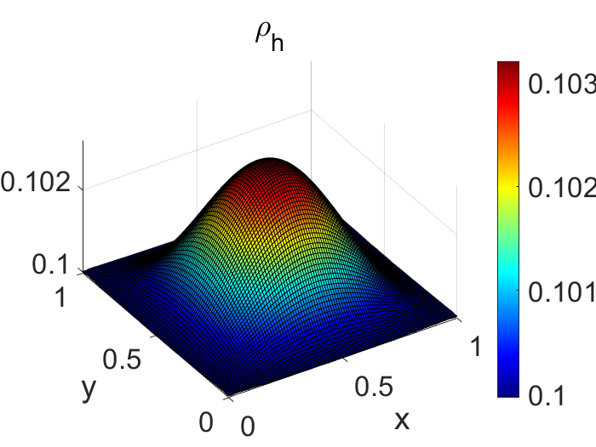

Figure 1 Mesh size(1/32), time step(tau=1/20000)