Figure 1 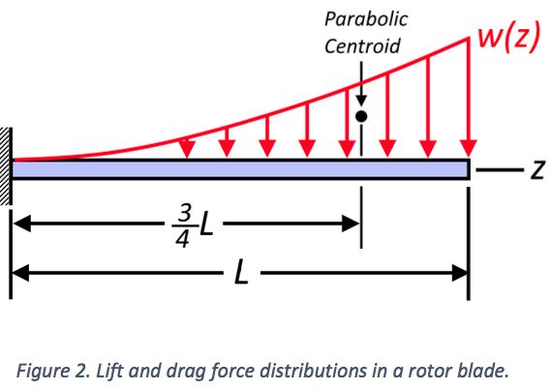

Equations Representing the geometry of the beam for reference

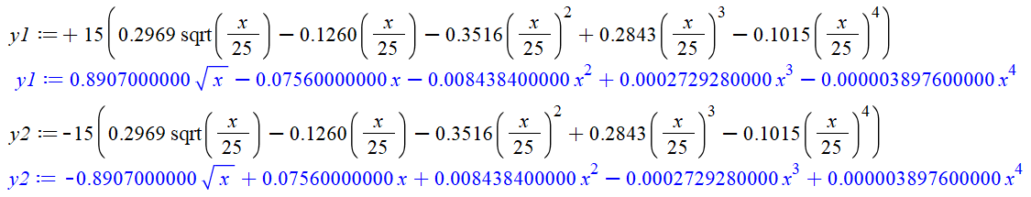

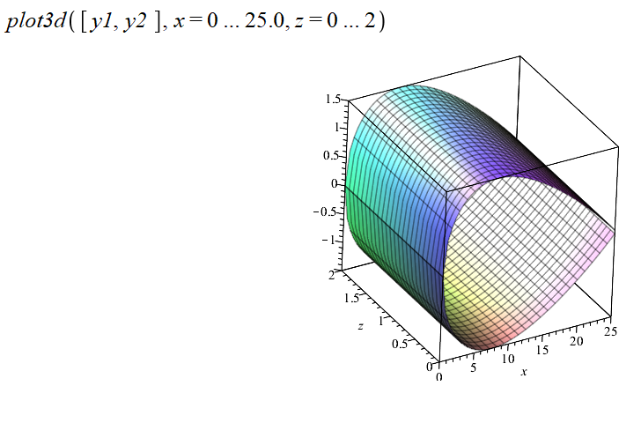

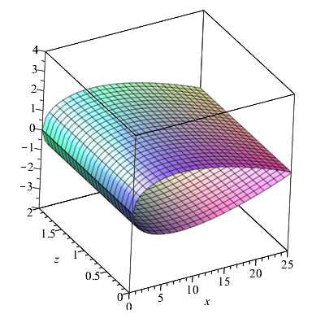

1. Find the 6 reaction forces , , , , , and at the cantilevered edge of the blade. Leave your results **in symbolic terms**. These will be largest forces and moments in the blade, hence the stresses will be largest at the cantilevered edge.
   1. Start by integrating the lift and drag distributed loads, and , along the length of the blade to find the net force induced by the loads. Recognize that these forces are not oriented along the *x* and *y* axes, but you are asked to find and .

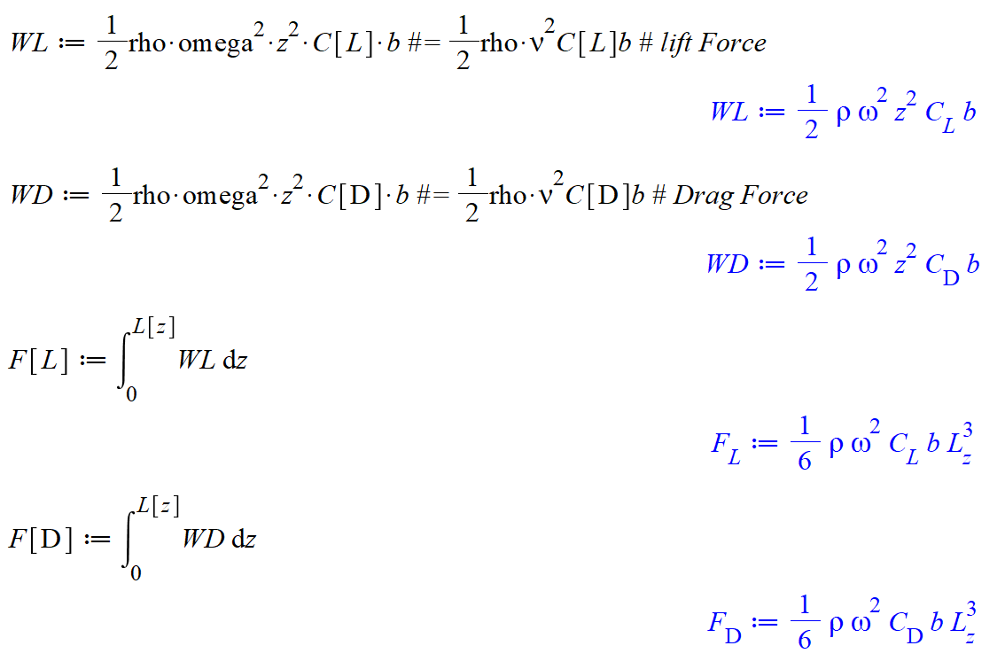

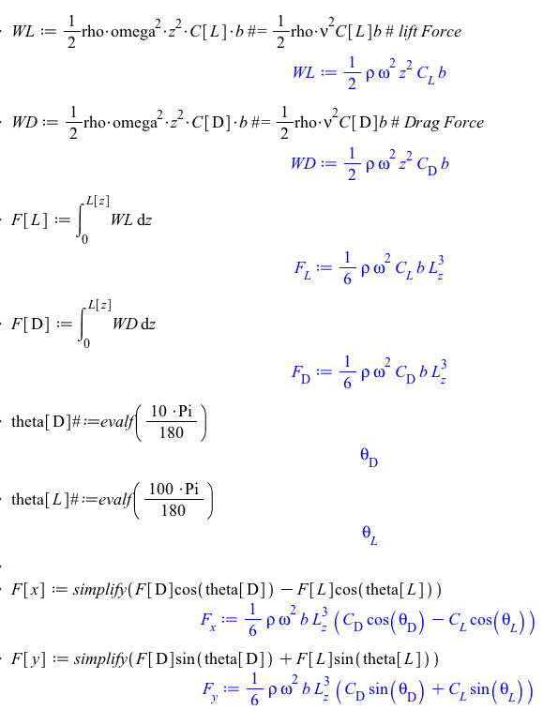

* 1. Using your expressions for and , determine the bending moments and at the cantilevered edge. Recall that a distributed load can be thought of as a point load acting at the centroid of the distribution. The centroid of a parabola is shown in Figure 2.

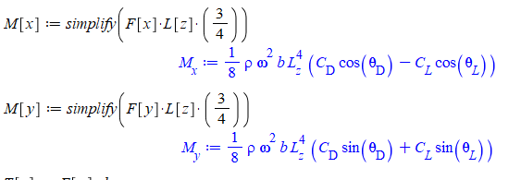

* 1. Determine by constructing an equivalent force-couple system at the shear center, C. In other words, where is as shown in Figure 1.

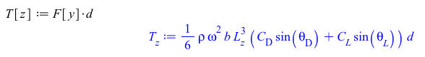

* 1. Compute the axial reaction force, , by assuming the rotor blade is a particle with mass acting at a distance from the cantilevered edge.

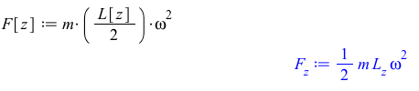

1. Determine the maximum shear stress in the cross section, , and the angle of twist per unit length, , induced by the torque . Leave both and in **symbolic terms.**
   1. To find you will need to know the area enclosed by the midline. Recognize that I’ve already given you the equation of the midline, .



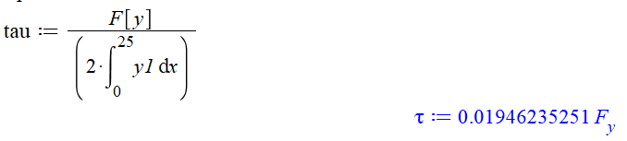

* 1. To find you will need to find the torsional constant, . Typically, this would involve evaluating a contour integral. However, because the thickness, , is constant everywhere, we can just write



Generally, with y1 as constant variable

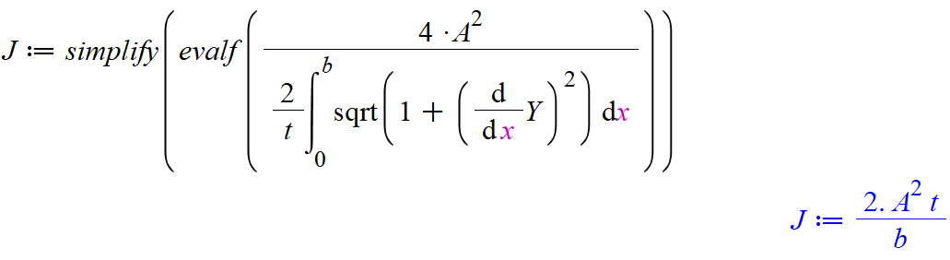

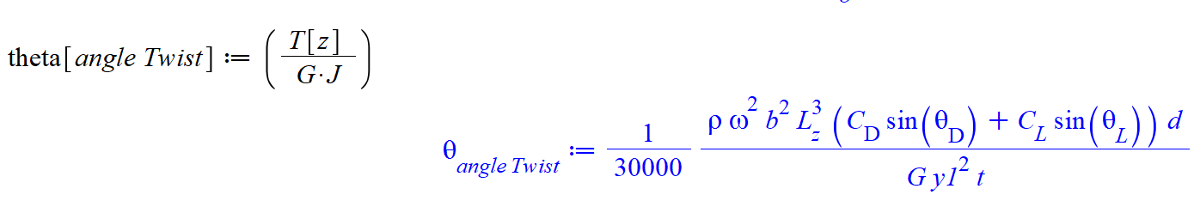

Using y1(x)=… as defined from above

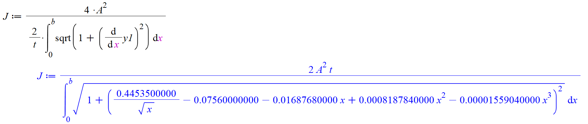

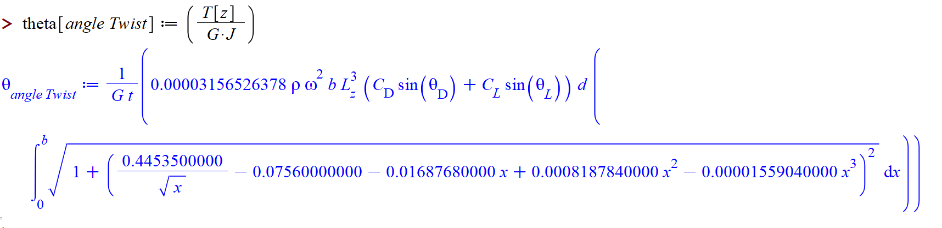

1. Determine the angle to the plane of loads, , the angle to the neutral axis, , and the maximum bending stress in the cross section, , induced by the bending moments and . Leave in symbolic terms. You may assume the moments of inertia about the centroid are , , and .
   1. Suggestion: If you find that you may assume that to simplify your expression for .
2. Determine the maximum normal stress, , induced by the centripetal force . You may assume the total area of the cross section is given by .
3. Using the maximum principal stress criterion, and a safety factory 1.3, determine the maximum angular velocity of the blade, , in units of RPM. Because carbon fiber is brittle, it will fracture before yielding. Thus, instead of a yield stress you may use an ultimate tensile strength of .
   1. Suggestion: Calculate the ratio . If this ratio is less than you may ignore when calculating the maximum principal stress.
4. Write a short paragraph discussing what you learned from the project. Discuss what assumptions or simplifications were made to solve the problem.