**Part 1 (easier):** Because the cracks run at roughly 45 degree angles, my first instinct was that they were probably shear failures under compression (i.e. the weight of the house). Draw a Mohr's circle for a stress element in compression to solve for the orientation of the shear stresses. *(Hint: this should look a lot like the compression fracture in design problem 1.)*

|  |
| --- |
| Sigma1  Sigma2=0    Theta = 45 Degrees  Tau_Max |

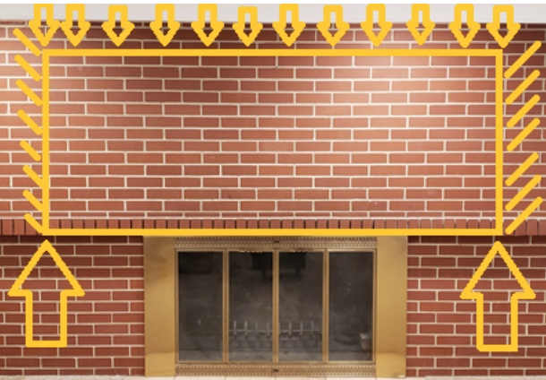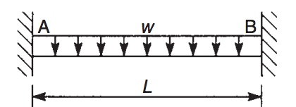 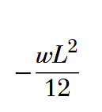 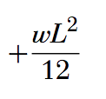

**Part 2 (harder):** I had the mortar inspected by a civil engineer to confirm that the cracks were mainly cosmetic, and the underlying structure was still sound. He pointed out that because mortar is much stronger in compression than tension, the cracks were better explained by tension than shear. Treat the fireplace as a beam with a distributed load on top, cantilevered at both ends:

1. Neglect the reaction forces in the x-direction, but each end should still have a reaction force in y and a reaction moment (total of 4 constraints). Note that this makes the beam statically indeterminate (2 equations, 4 constraints) so you'll need Castigliano's theorem to derive two more expressions at one end of the beam: (1) displacement should be fixed to 0, and (2) rotation should also be fixed to 0. Solve for the reaction forces and moments. Neglect shear.

|  |
| --- |
| W  M_RA Mo  X  F[RA] |

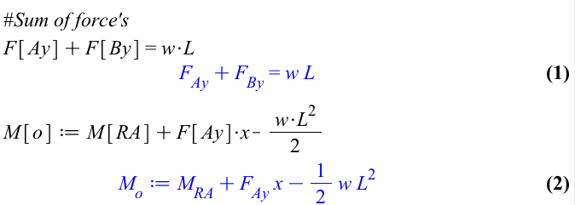

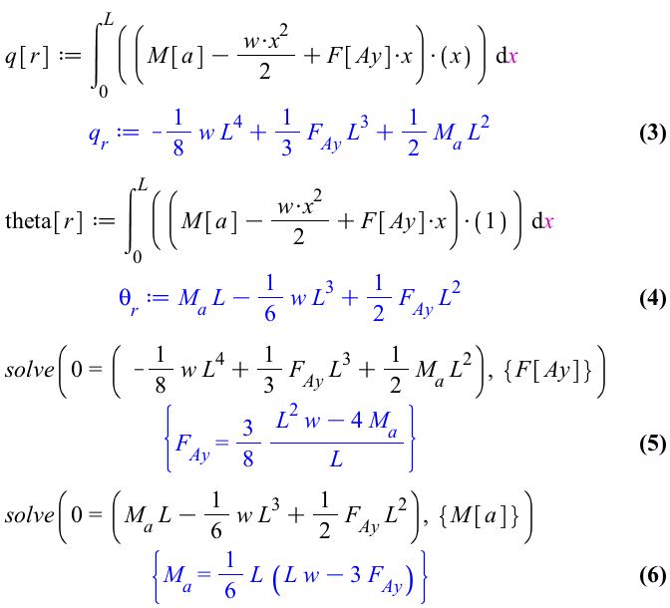

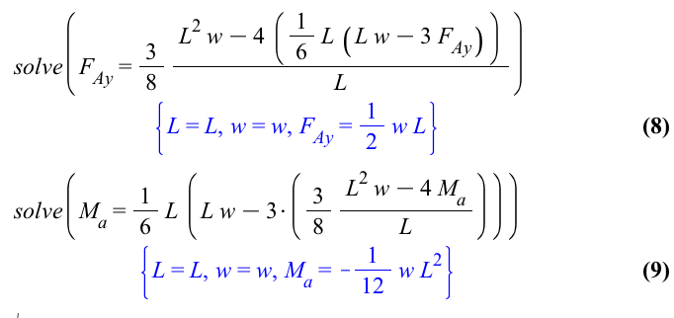

1. Draw the shear and bending moment diagrams to show that the maximum bending stress (My/I) follows a U-shape along the length of the beam.

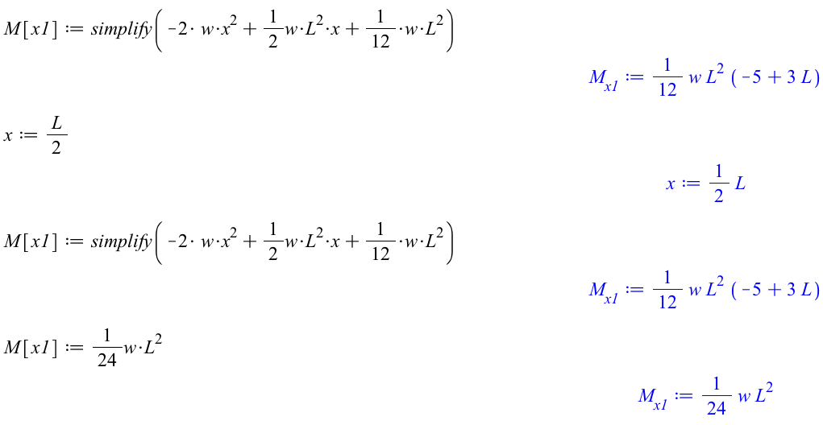 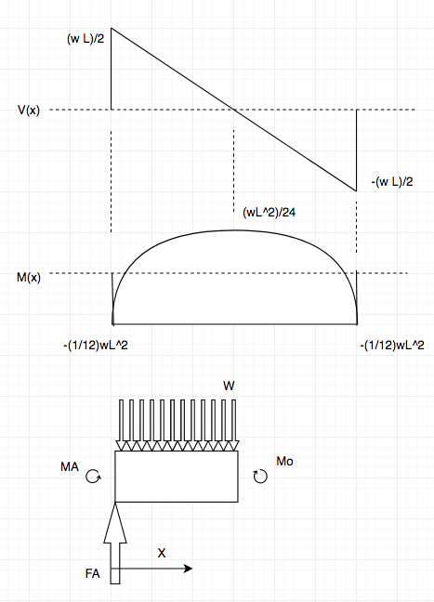

Of course, neither analysis is perfect because they both rely on beam theory, which assumes that the masonry can be treated as a 1-D object (i.e. many times wider than it is tall, which clearly it isn't). The real answer involves some kind of 3-D stress state. But both make pretty good first-order approximations.

What I learned:

I learned to use Castigliano's theorem, and how to determine the deflection and angler rotation for a beam. Also learned that you could use Castigliano's theorem to solve a statically indeterminant problem.