**Homework Set 3&4:**

1. A point on a body in plane stress is not necessarily

in plane strain. Starting from the 3D Hooke’s Law

(Eqn 3.30), derive equation (3.32a), then write an

expression for ezz in plane stress.

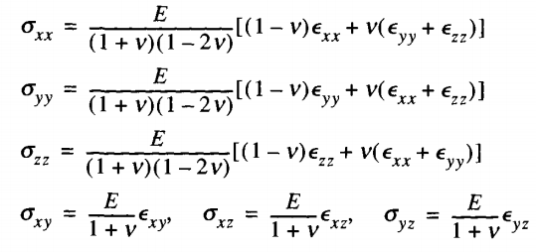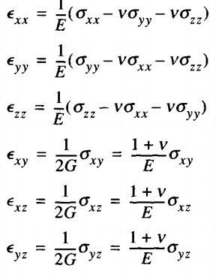

eq 3.30 eq 3.32a

2) 3.7

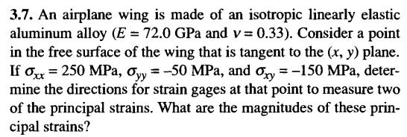

1. 3.17. Also find the maximum shear stress and the

orientation of the volume element on which it acts.

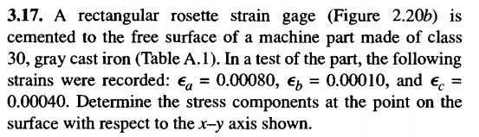





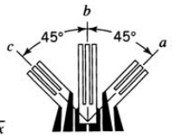

4) 4.5

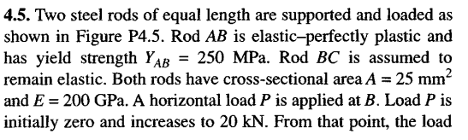

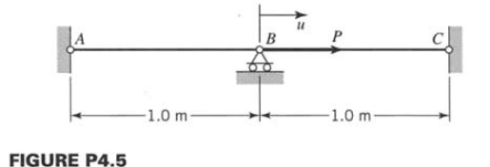

5) 4.36 (Note: Part c goes onto the next page)

