**Homework Set 6:**

1) 6.16



---------------From the Book --------------

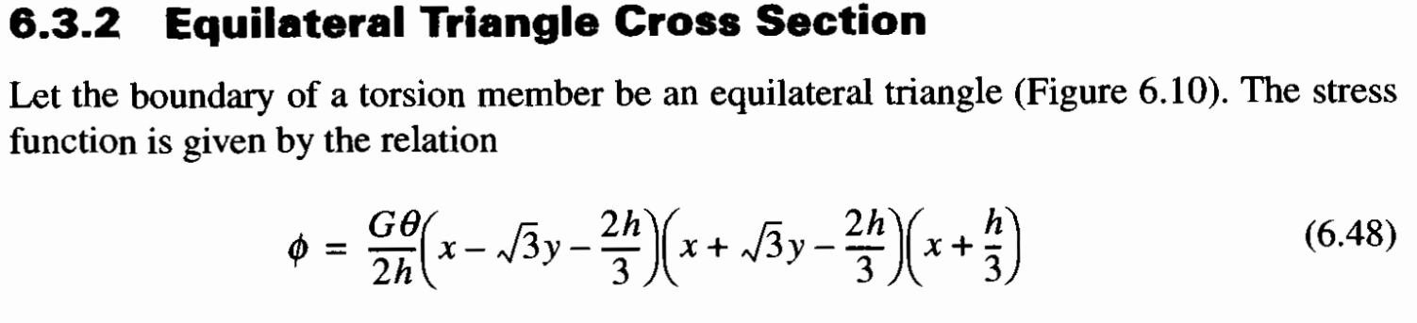

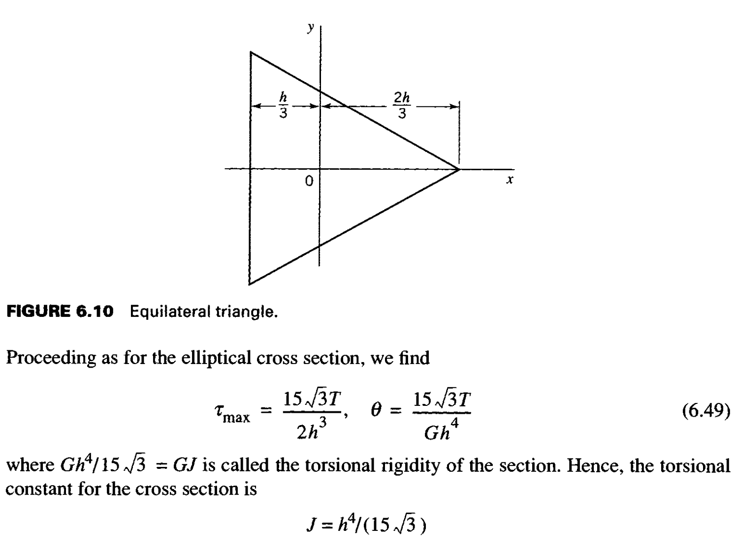

2) 6.17

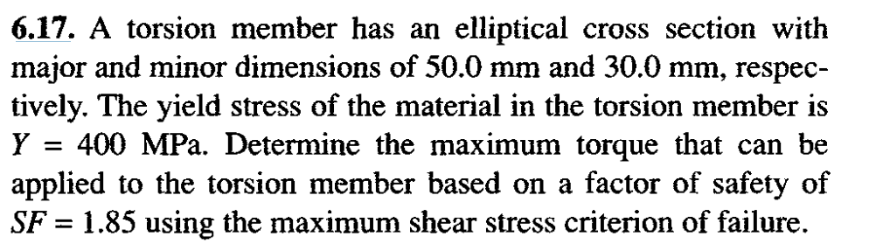

3) 6.20

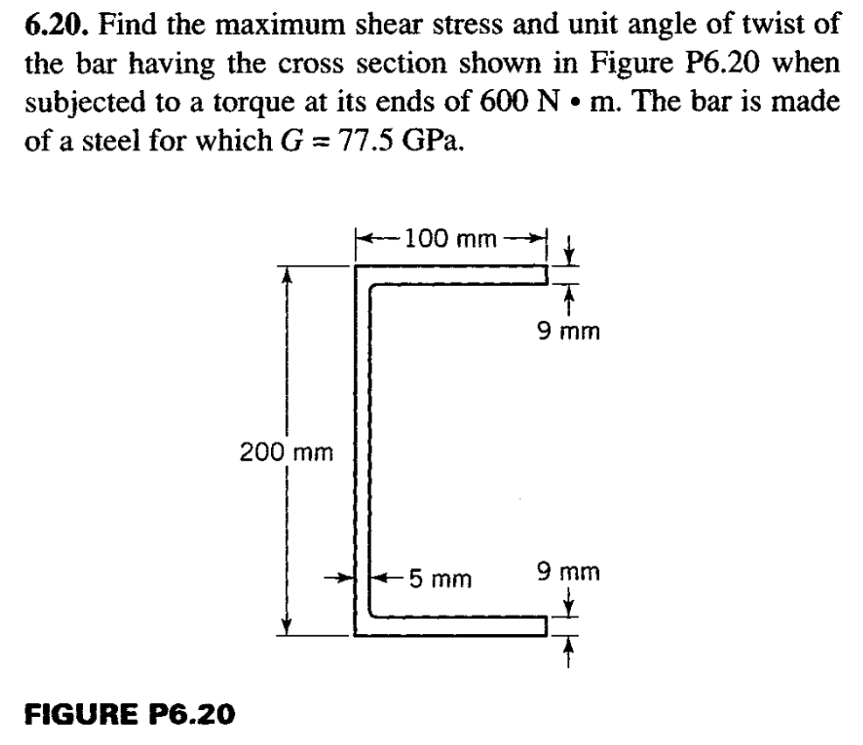

4) 6.45 (Note: G is given on the previous page, just before 6.42)

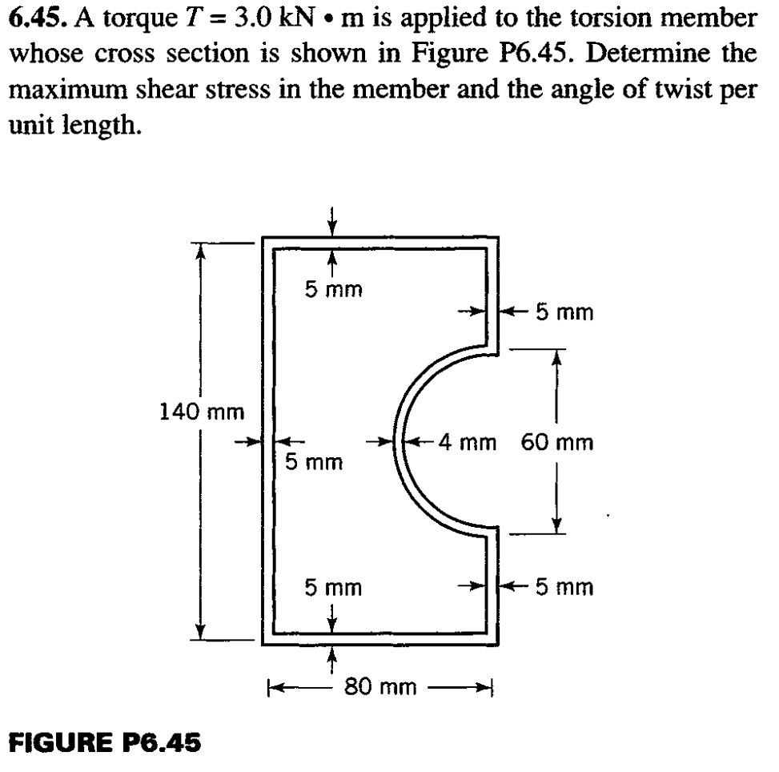

5) 6.57

