**Homework Set 6:**

1) 6.16

Dear Grader,

Dr. Burk Said it was fine for me to submit my HW this way. Please contact me if you are unsure where I got my calculations, my source code can be found on GitHub @

<https://github.com/Zenif-NIght/AdvSolids>

Regards,

Christopher



---------------From the Book --------------

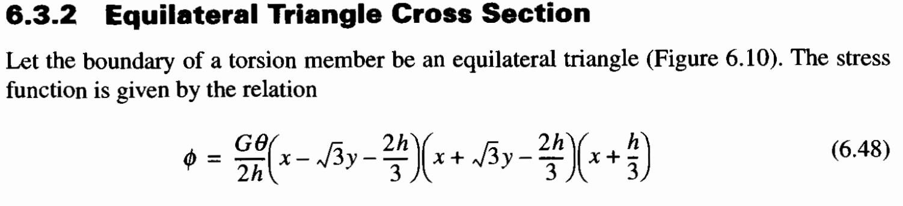

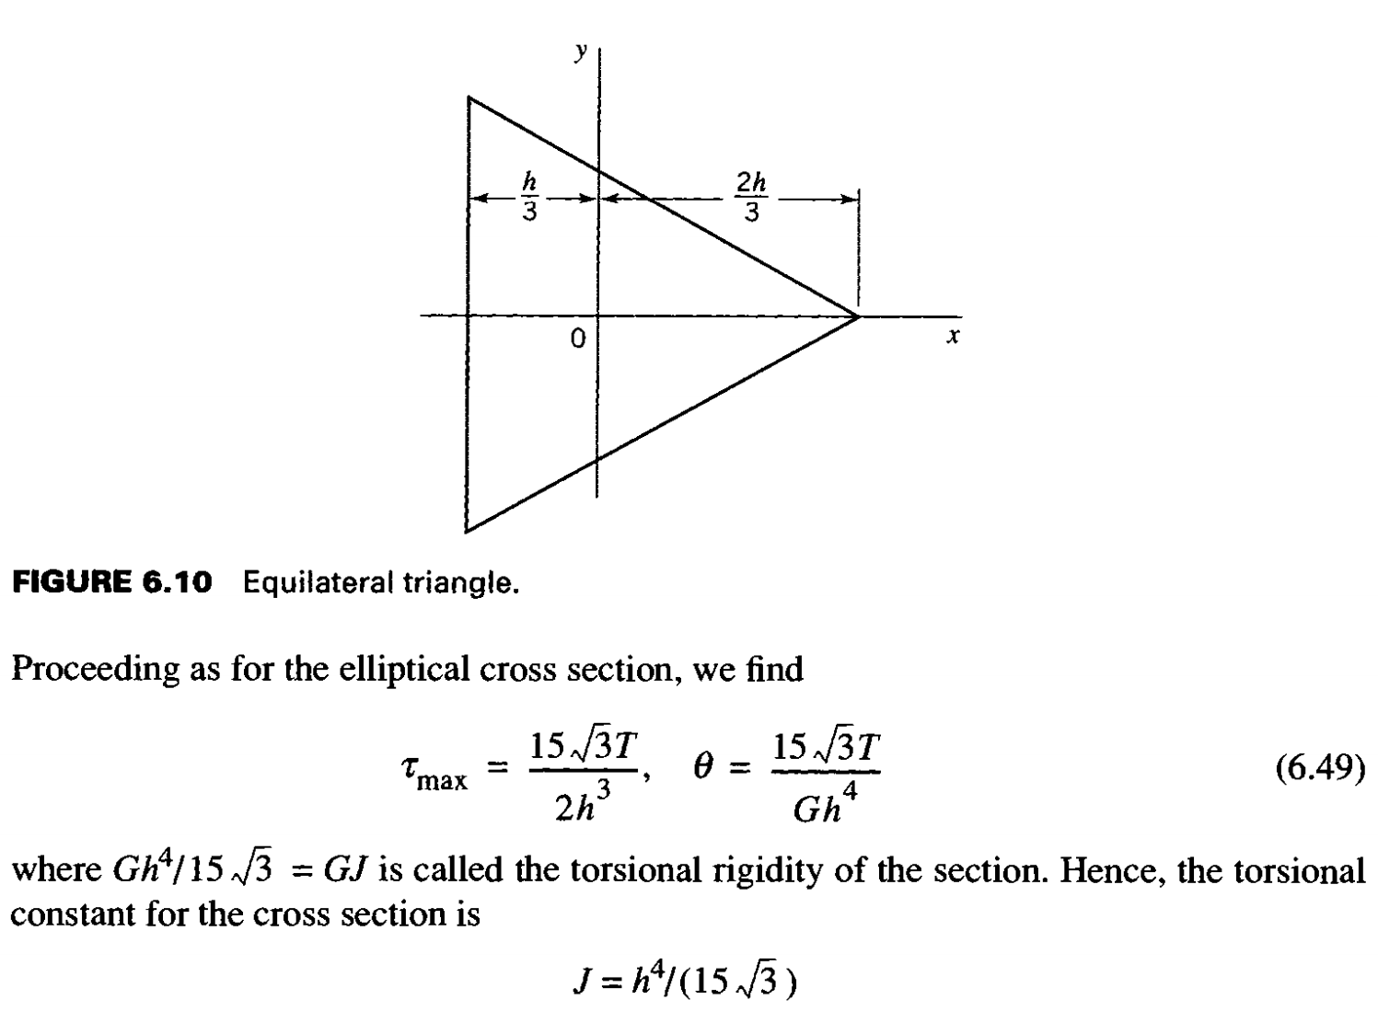

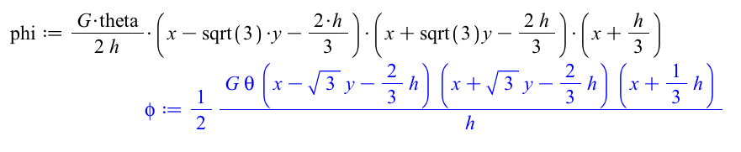

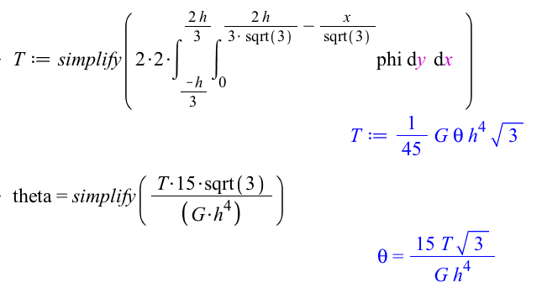

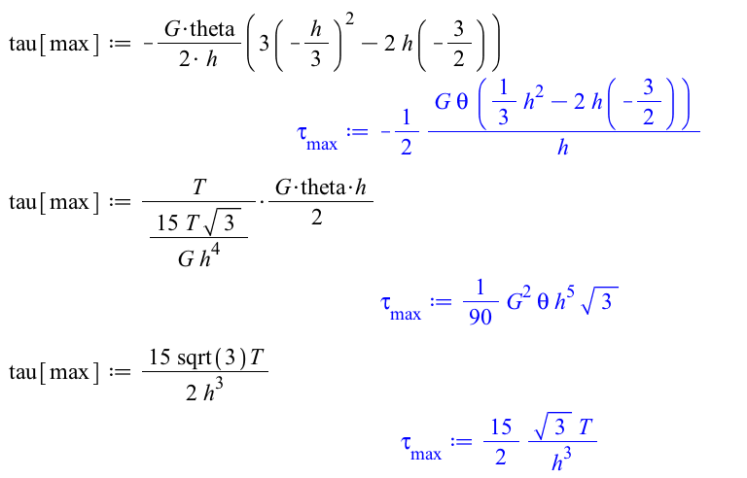

2) 6.17

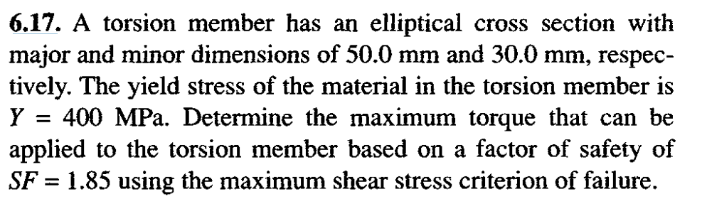

h=0.03mm

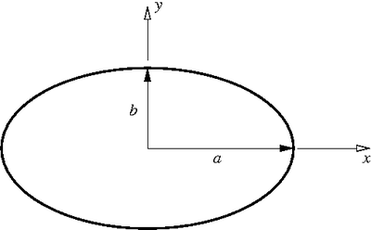

b=0.05m

Find the With the SF=1.85 & Y = 400 MPa

Definition =1.85

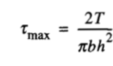Solve for T

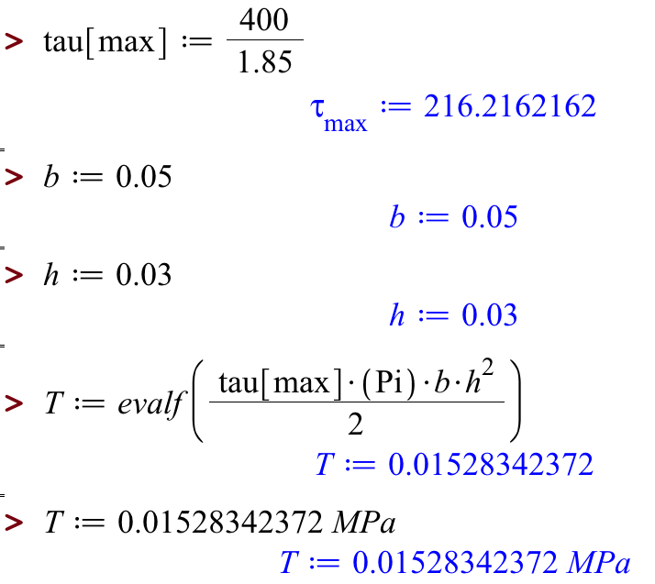

3) 6.20

|  |  |
| --- | --- |
|  | ( 6.6 )  if (b/h is > 10)  { then you can use c=1}  Else  { c = 0.91}  Then we can find J |

|  |  |
| --- | --- |
|  |  |

4) 6.45 (Note: G is given on the previous page, just before 6.42)

Side 2, t =0.005m

|  |  |
| --- | --- |
| Side 6, t =0.005m  Side 5, t =0.004m  Side 4, t =0.005m  Side 3, t =0.005m  Side 1, t =0.005m  Find the Area of midline: |  |

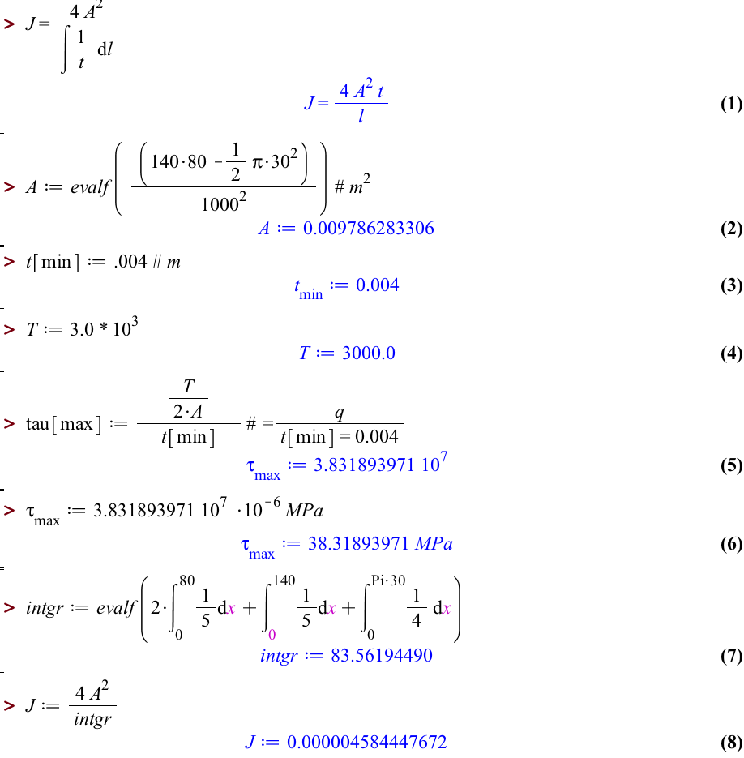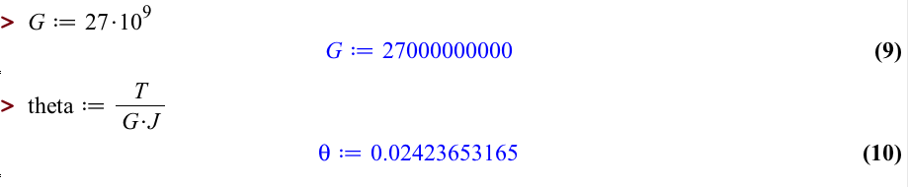

5) 6.57

|  |  |
| --- | --- |
| Side 6  Side 4  Side 5  Side 3  Side 2  Side 1 |  |