**MAE 3040 Design Problem 2**

Chapters 6-8 – Torsion and Bending in Beams

Due Fri. 11/15

The goal of this design problem is to analyze the rotor blade of a model helicopter and determine the maximum angular velocity the blade can withstand before failure. The specific rotor blade you will be analyzing is made by wrapping a woven carbon fiber composite around a foam core. The foam core exists only to give the blade its shape before the carbon fiber is set. It can be assumed the foam offers no structural benefit. Consequently, the cross section of the blade can be treated as hollow with the dimensions shown in Figure 1.

Figure 1. A model helicopter rotor blade. The blade has a chord of 25 mm, a thickness of 3 mm, and a out-of-page length of 350 mm. The angle of attack of the blade is 10 degrees.

The rotor blade is using a NACA 0012 airfoil, which means that its midline (solid line in Figure 1) is described by the equations

$$y\left(x\right)=±15\left[0.2969\sqrt{\frac{x}{25}}-0.1260\left(\frac{x}{25}\right)-0.3516{\left(\frac{x}{25}\right)}^{2}+0.2843{\left(\frac{x}{25}\right)}^{3}-0.1015{\left(\frac{x}{25}\right)}^{4}\right]$$

It will be assumed that the cross section has a constant thickness of $t=0.5$ mm centered on the midline. The blade is $L=350$ mm long and it is rigidly attached to the rotor grips. Thus, the blade may be treated as a cantilevered beam. From dynamics we know that the speed of the rotor blade is given by

$$v=ωz$$

where $ω$ is the angular velocity in radians per second and $z$ is the distance from the cantilevered edge of the blade. From fluid mechanics we know that the lift and drag forces acting on the rotor blade can be modeled as distributed loads with

$$w_{L}\left(z\right)=\frac{1}{2}ρv^{2}C_{L}b=\frac{1}{2}ρω^{2}z^{2}C_{L}b$$

$$w_{D}\left(z\right)=\frac{1}{2}ρv^{2}C_{D}b=\frac{1}{2}ρω^{2}z^{2}C_{D}b$$

where $ρ=1.2 kg/m^{3}$ is the density of air, $b=25 mm$ is the chord width of the blade, $C_{L}$ is the lift coefficient, and $C_{D}$ is the drag coefficient. Note that both of these distributed loads vary with $z^{2}$, so they are parabolic along the length of the blade, as shown in Figure 2.

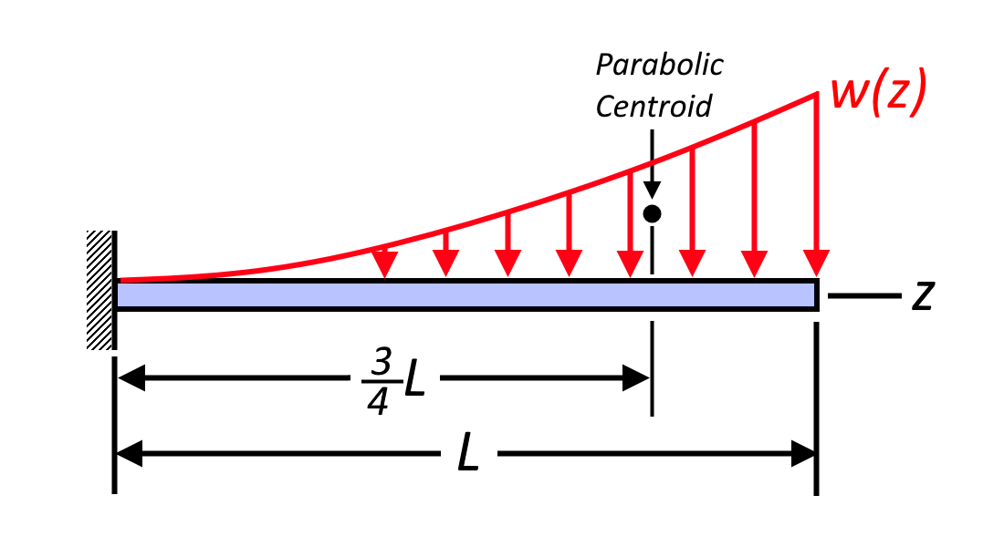

Figure . Lift and drag force distributions in a rotor blade.

Both the lift and drag coefficient depend on the angle of attack of the blade. For this problem an angle of attack of $γ={10}^{∘}$ will be chosen resulting in $C_{L}=1.00$ and $C_{D}=0.05$. Because an angle of attack of ${10}^{∘}$ is used, the drag and lift forces are oriented at angles of ${10}^{∘}$ and ${100}^{∘}$ respectively from the *x*-axis. The line of action for both forces is shown in Figure 1 by the dashed line. It may be assumed that both forces induced by these distributed loads pass through a point known as the center of pressure, denoted by point *P* in Figure 1. Point *P* is located 2 mm to the right of the leading edge of the blade.

The shear center of the cross section acts 8 mm to the right of the leading edge of the blade and is denoted by point *C* in Figure 1. Additionally, the centroid is located 11.6 mm to the right of the leading edge, and is denoted by point *O* in Figure 1.

In addition to the lift and drag forces, there are also centripetal forces induced by the centripetal acceleration of the blades. In general, the centripetal force acting on a particle is given by

$$F_{c}=mrω^{2}$$

Where $m$ is the mass of the particle and $r$ is the distance between the particle and the center of rotation.

Given the preceding information, do the following in a neat, concise manner:

1. Find the 6 reaction forces $F_{x}$, $F_{y}$, $F_{z}$, $M_{x}$, $M_{y}$, and $T_{z}$ at the cantilevered edge of the blade. Leave your results in symbolic terms. These will be largest forces and moments in the blade, hence the stresses will be largest at the cantilevered edge.
   1. Start by integrating the lift and drag distributed loads, $w_{L}$ and $w_{D}$, along the length of the blade to find the net force induced by the loads. Recognize that these forces are not oriented along the *x* and *y* axes, but you are asked to find $F_{x}$ and $F_{y}$.
   2. Using your expressions for $F_{x}$ and $F_{y}$, determine the bending moments $M_{x}$ and $M_{y}$ at the cantilevered edge. Recall that a distributed load can be thought of as a point load acting at the centroid of the distribution. The centroid of a parabola is shown in Figure 2.
   3. Determine $T_{z}$ by constructing an equivalent force-couple system at the shear center, C. In other words, $T_{z}=F_{y}d$ where $d$ is as shown in Figure 1.
   4. Compute the axial reaction force, $F_{z}$, by assuming the rotor blade is a particle with mass $m=40 g$ acting at a distance $r=L/2$ from the cantilevered edge.
2. Determine the maximum shear stress in the cross section, $τ$, and the angle of twist per unit length, $θ$, induced by the torque $T_{z}$. Leave both $τ$ and $θ$ in symbolic terms.
   1. To find $τ$ you will need to know the area enclosed by the midline. Recognize that I’ve already given you the equation of the midline, $y\left(x\right)$.
   2. To find $θ$ you will need to find the torsional constant, $J$. Typically this would involve evaluating a contour integral. However, because the thickness, $t$, is constant everywhere, we can just write
$$\oint{\frac{dl}{t}}=\frac{2}{t}\int_{0}^{b}{\sqrt{1+{\left(\frac{dy}{dx}\right)}^{2}}dx}$$

3. Determine the angle to the plane of loads, $ϕ$, the angle to the neutral axis, $α$, and the maximum bending stress in the cross section, $σ_{B}$, induced by the bending moments $M_{x}$ and $M_{y}$. Leave $σ_{B}$ in symbolic terms. You may assume the moments of inertia about the centroid are $I_{x}=28 mm^{4}$, $I_{y}=780 mm^{4}$, and $I_{xy}=0$.
   1. Suggestion: If you find that $α<5^{∘}$ you may assume that $\tan\left(α\right)≈0$ to simplify your expression for $σ_{B}$.
4. Determine the maximum normal stress, $σ_{N}$, induced by the centripetal force $F_{z}$. You may assume the total area of the cross section is given by $A=19 {mm}^{2}$.
5. Using the maximum principal stress criterion, and a safety factory 1.3, determine the maximum angular velocity of the blade, $ω$, in units of RPM. Because carbon fiber is brittle, it will fracture before yielding. Thus, instead of a yield stress you may use an ultimate tensile strength of $σ_{u}=800 MPa$.
   1. Suggestion: Calculate the ratio $τ/\left(σ_{B}+σ_{N}\right)$. If this ratio is less than $0.1$ you may ignore $τ$ when calculating the maximum principal stress.
6. Write a short paragraph discussing what you learned from the project. Discuss what assumptions or simplifications were made to solve the problem.