(1) 1.22. Identify which figure you used to get each property and explain how you calculated it. Not every property will be in every figure)

1.22. For the steels whose stress-strain diagrams are represented by Figures 1.8 to 1.10, determine the following properties as appropriate: the yield point, the yield strength, the upper yield point, the lower yield point, the modulus of resilience, the ultimate tensile strength, the strain at fracture, the percent elongation.

1.26.

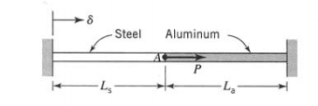

A steel bar and an aluminum bar are joined end to end and fixed between two rigid walls as shown in Figure P1.26. The cross-sectional area of the steel bar is A, and that of the aluminum bar is A,. Initially, the two bars are stress free. Derive general expressions for the deflection of point A, the stress in the steel bar, and the stress in the aluminum bar for the following conditions:

a. A load P is applied at point A.

b. The left wall is displaced an amount 6 to the right.

1.28. A steel shaft of circular cross section is subjected to a twisting moment T. The controlling factor in the design of the shaft is the angle of twist per unit length (y/L; see Eq. 1 S). The maximum allowable twist is 0.005 rad/m, and the maximum shear stress is z,,, = 30 MPa. Determine the diameter at which the maximum allowable twist, and not the maximum shear stress, is the controlling factor. For steel, G = 77 GPa

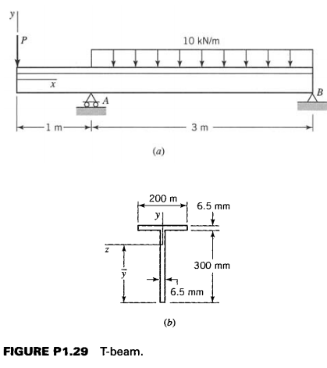

(1.29-1.30, then use Mohr’s Circle to calculate the maximum normal stress and maximum shear stress at the top surface of the beam. (Use P=18 kN. Also, the cross section in Figure (b) should be 200 mm wide, not 200 m))

1.29. An elastic T-beam is loaded and supported as shown in Figure P1.29~. The cross section of the beam is shown in Figure P1.296.

a. Determine the location j of the neutral axis (the horizontal centroidal axis) of the cross section.

b. Draw shear and moment diagrams for the beam. c. Determine the maximum tensile stress and the maximum compressive stress in the beam and their locations.

1.30. Determine the maximum and minimum shear stresses in the web of the beam of Problem 1.29 and their locations. Assume that the distributions of shear stresses in the web, as in rectangular cross sections, are directed parallel to the shear force V and are uniformly distributed across the thickness (t = 6.5 mm) of the web. Hence, Eq. 1.9 can be used to calculate the shear stresses

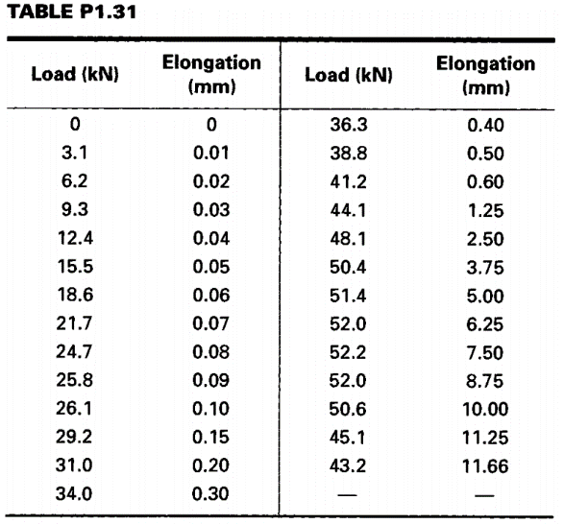1.31. A steel tensile test specimen has a diameter of 10 mm and a gage length of 50 mm. Test data for axial load and corresponding data for the gage-length elongation are listed in Table

P1.31. Convert these data to engineering stress-strain data and determine the magnitudes of the toughness U, and the ultimate strength 0,.

1.32. Using an expanded strain scale, plot the stress-strain diagram for small strains using the data in Prob 1.31 and determine the modulus of elasticity E, the yield strength \sigma_YS for an offset of 0.2%, the proportional limit \sigma_PL, and the modulus of resilience.