1) 5.4-5.5

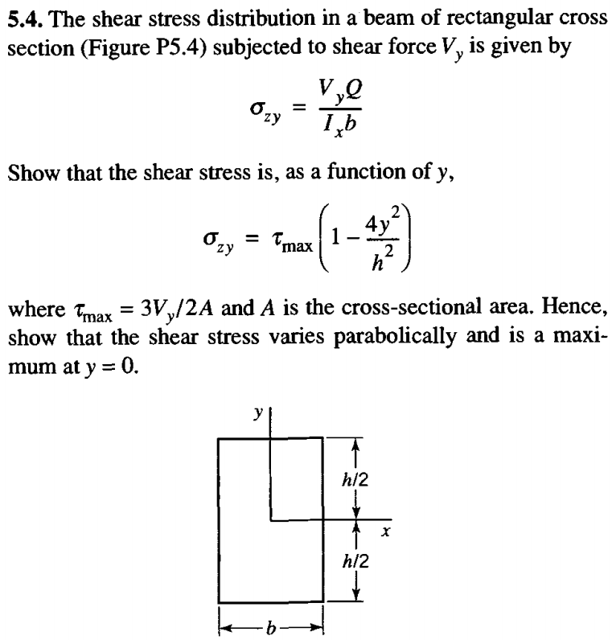

5.5. By means of Eqs. 5.6 and 5.7 and the formula for shear stress in a beam of rectangular cross section given in Problem 5.4, show that the correction coefficient k (see Eq. 5.14) is 1.20.

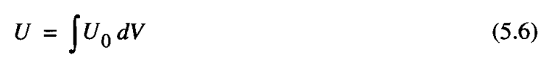

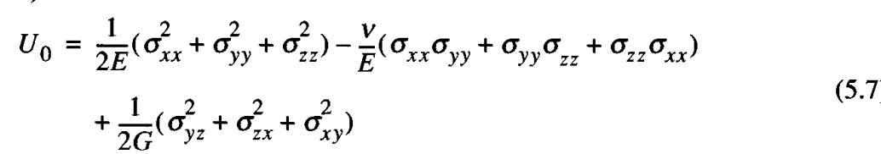

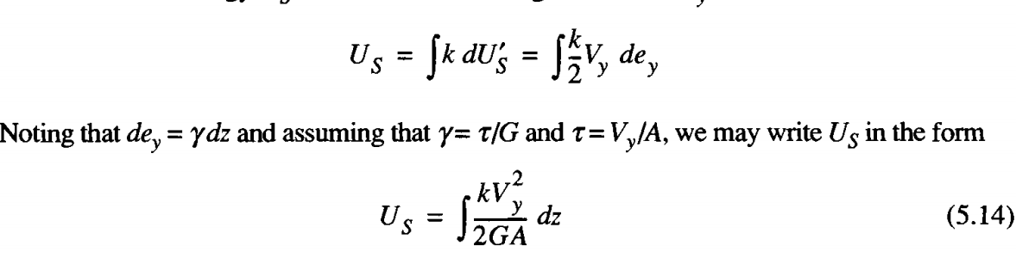

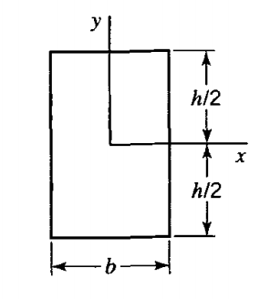

2) 5.11

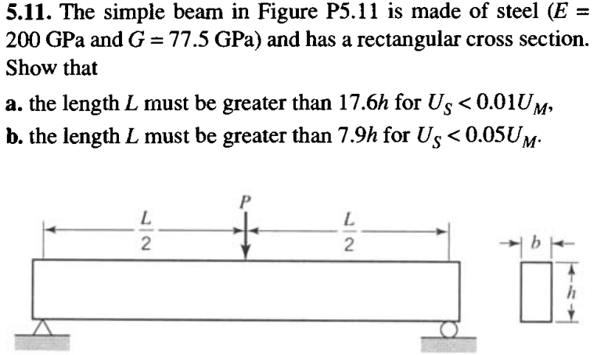

3) 5.15-5.16

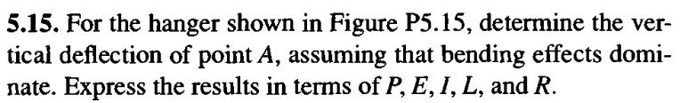

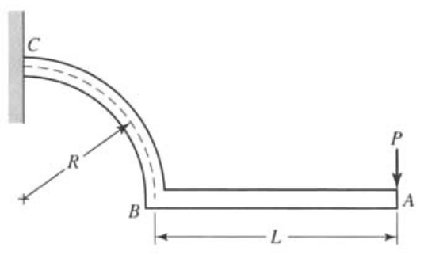

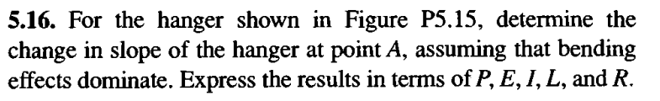



4) 5.34

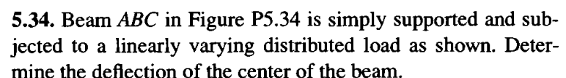

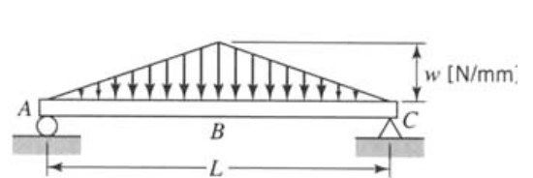

5) 5.67

