1. A furnace with an aperture of 20 mm diameter and **emissive power of 3.72×105 W/m2** is used to calibrate a heat flux gage having a sensitive area **of 1.6×10−5 m2** . At what distance, measured along the normal direction from the aperture, should the gage be positioned to receive irradiation of **1000 W/m2** ? If the gage is tilted off normal by **20 degrees**, what will the irradiation be at this distance?

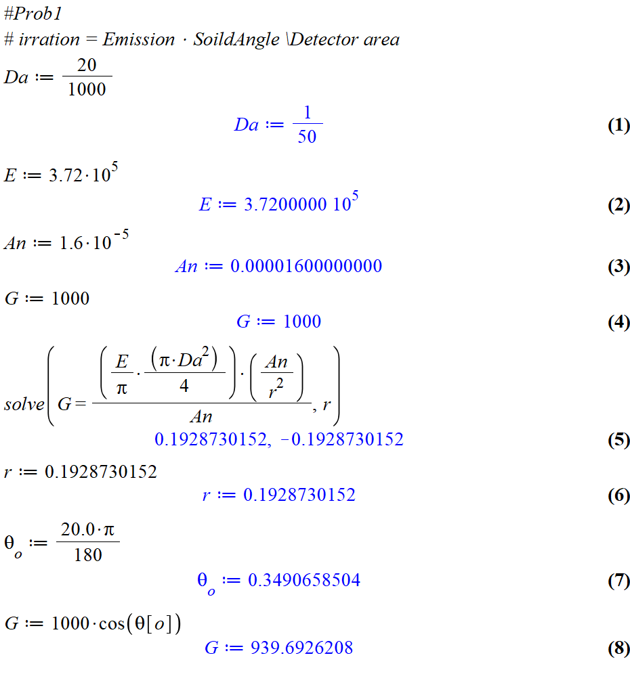

**939.6926208 W/m2**

1. On an overcast day the directional distribution of the solar radiation incident on the earth’s surface may be approximated by an expression of the form Ii = In cos θ, where In = 80 W/m2 -sr is the total intensity of radiation directed normal to the surface and θ is the zenith angle. What is the solar irradiation at the earth’s surface?

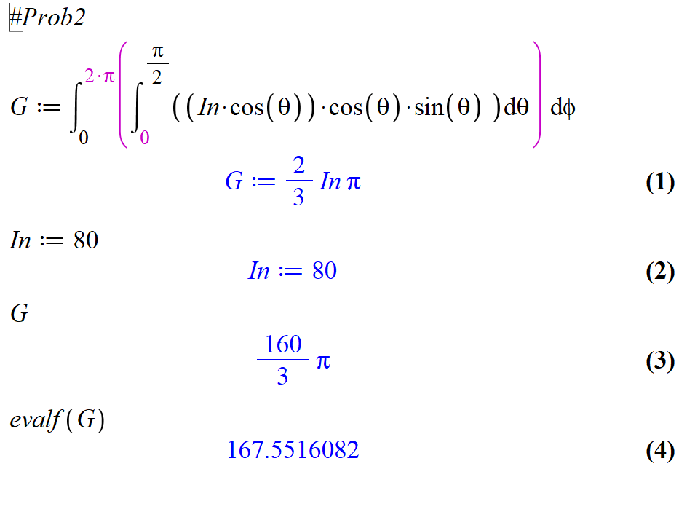

**167.5516082 W/m2**

1. Determine the fraction of total, hemispherical **emissive power** that leaves a diffuse surface for the angle ranges of π/4 ≤ θ ≤ π/2 and 0 ≤ φ ≤ π.

|  |  |
| --- | --- |
| **0.25** |  |

1. Assuming the earth’s surface is black, estimate its temperature if the sun has an equivalent blackbody temperature of 5800 K. The diameters of the sun and earth are 1.39 × 109 m and 1.29 × 107 m, respectively, and the distance between the sun and earth is 1.5 × 1011 m.

|  |  |
| --- | --- |
|  | Natural Sciences Grade 7  Form [HERE](https://images.app.goo.gl/75xRwh5CBRgyJTtW7) |

1. Estimate the wavelength corresponding to maximum emission from each of the following surfaces: the sun (5800 K), a tungsten filament (2500 K), a heated metal surface (1500 K), and a cryogenically cooled metal surface (60 K). What fraction of the surface emission is in the ultraviolet (λ ≤ 400 nm), visible (400 nm ≤ λ ≤ 700 nm), and infrared (700 nm ≤ λ) for each surface

|  |  |
| --- | --- |
| Find the fraction of energy that is release in each of the spectrums    SUN: 🡪  F[UV] := **0.125**  F[VIS] := **0.356**  F[IS] := **0.509** |  |

1. The spectral, hemispherical emissivity of tungsten may be approximated by the distribution depicted below. Consider a cylindrical tungsten filament that is of diameter D = 0.8 mm and length L = 20 mm. The filament is enclosed in an evacuated bulb and is heated by an electrical current to a steady-state temperature of 2900 K. What is the total hemispherical emissivity when the filament temperature is 2900 K? Assuming the surroundings are at 300 K, what is the initial rate of cooling when the current is switched off? 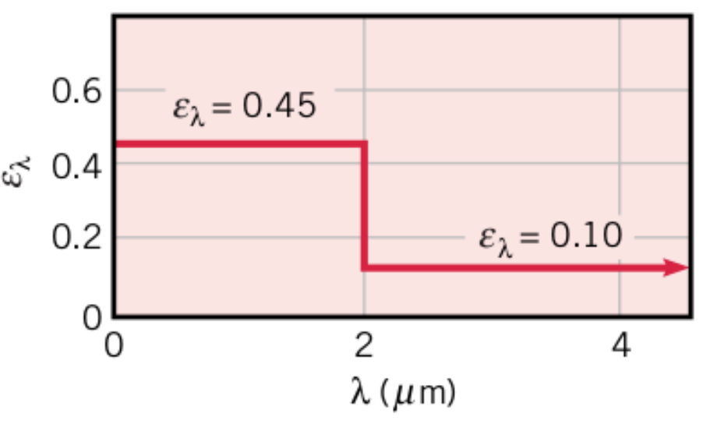

|  |  |
| --- | --- |
| **With help (lecture 21- example 4)**    **0.3520** | **-1977 K/s** |

1. An opaque surface with the prescribed spectral, hemispherical reflectivity distribution is subjected to the spectral irradiation shown.

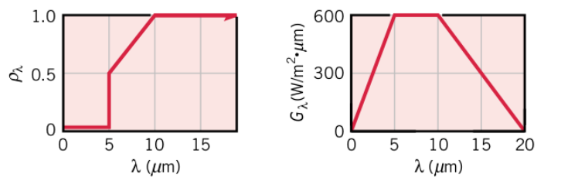

(a) Sketch the spectral, hemispherical absorptivity distribution.

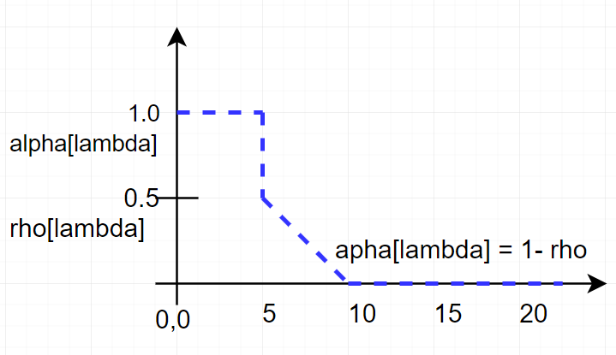

(b) Determine the total irradiation on the surface.

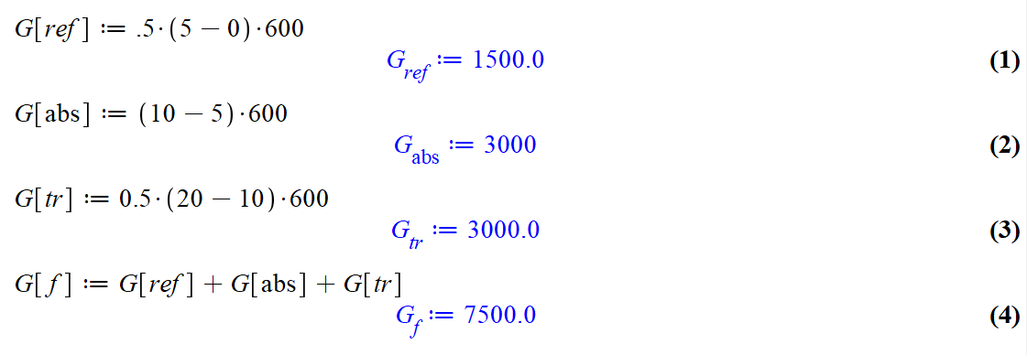

**7500**.0 W/m2

(c) Determine the radiant flux that is absorbed by the surface.

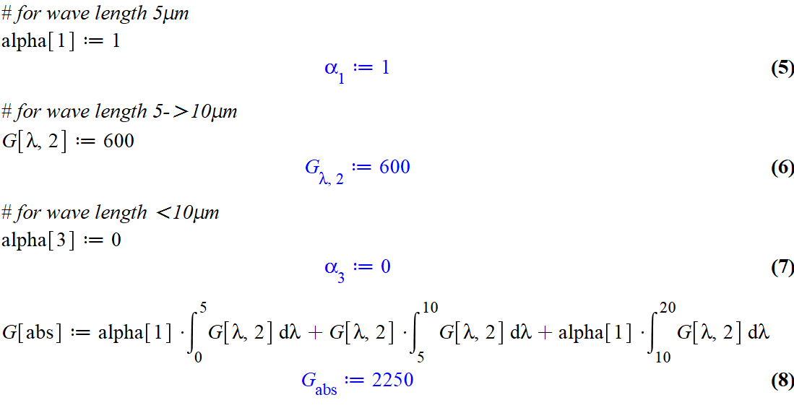

**2250**

(d) What is the total, hemispherical absorptivity of this surface?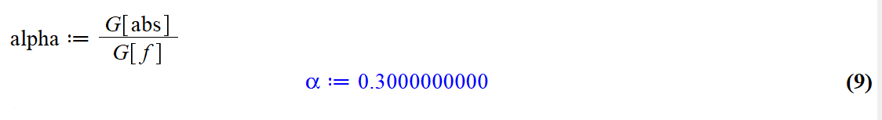

**0.3000000000**

1. An opaque, horizontal plate has a thickness **of L = 21 mm** and thermal **conductivity k = 25 W/m-K**. Water flows adjacent to the bottom of the plate and is at a **temperature of T∞,w = 25◦C.** Air flows above the plate at T**∞,a = 260◦C** **with ha = 40 W/m2 -K.** The top of the plate is diffuse and is irradiated with **G = 1450 W/m2** , of which **435 W/m2** is reflected. The steady-state top and bottom plate temperatures **are Tt = 43◦C** and **Tb = 35◦C,** respectively. Determine the transmissivity, reflectivity, absorptivity, and emissivity of the plate. Is the plate gray? What is the radiosity associated with the top of the plate? What is the convective heat transfer coefficient associated with the water flow?