A full journal bearing has a journal **diameter of 25 mm**, with a unilateral tolerance **of 20.03 mm.** The bushing bore has a **diameter of 25.03 mm** and a unilateral **tolerance of 0.04 mm**. The **l/d** ratio is **1/2**. The load is **1.2** **kN** and the journal runs **at 1100 rev/min**. If the average **viscosity is 55 mPa** ? s, find the minimum film thickness, the power loss, and the side flow for the minimum clearance assembly.

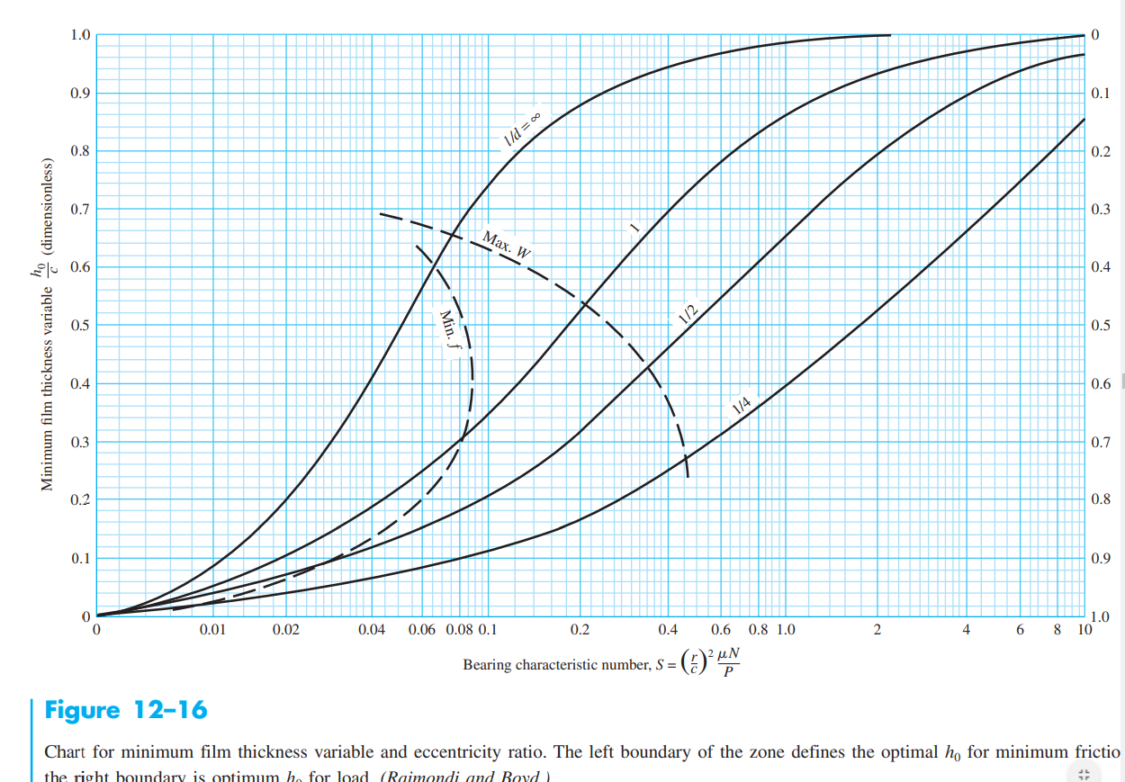

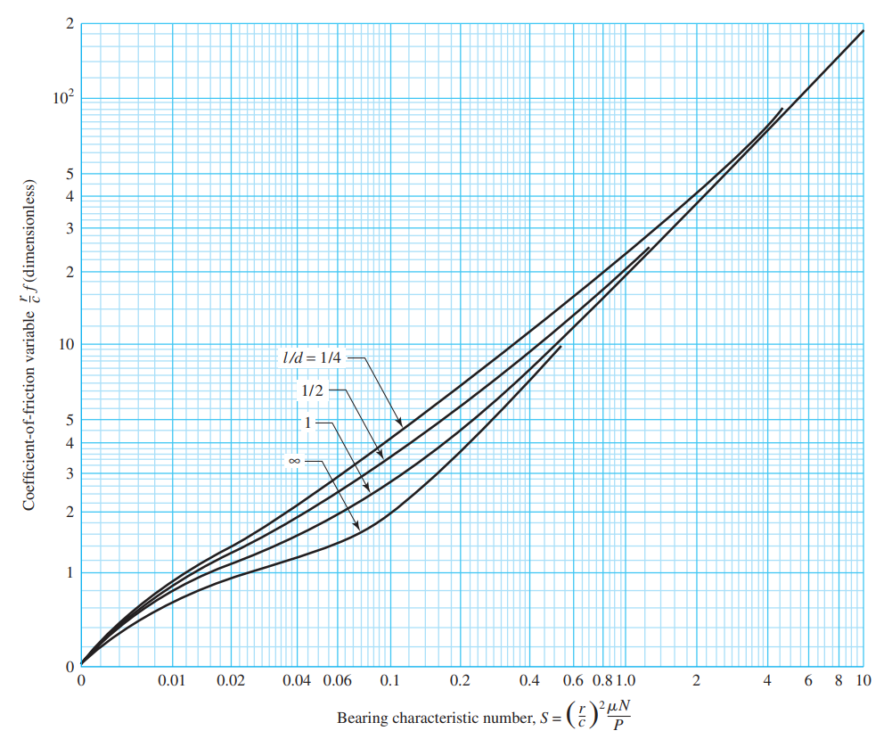

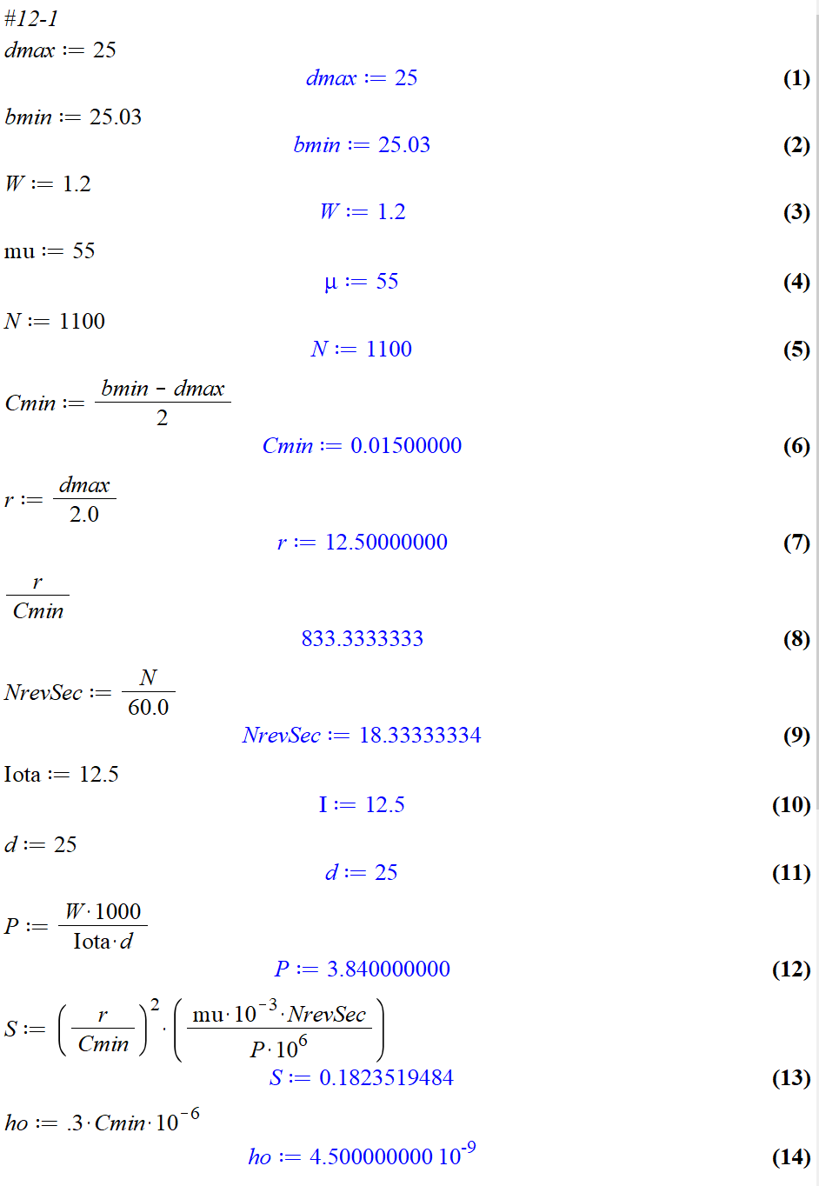

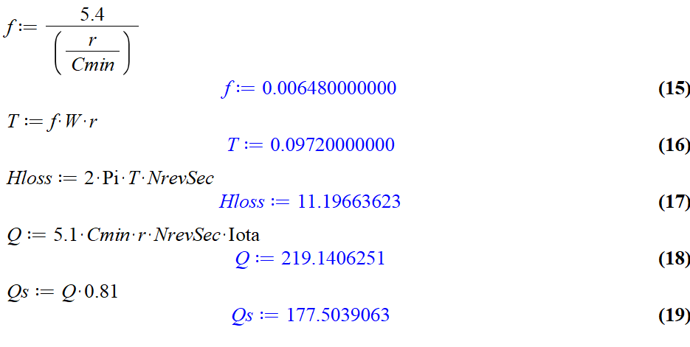

12-3) A journal bearing has a journal diameter **of 3.000 in**, with a unilateral tolerance of **20.001 in**. The bushing bore has a diameter of **3.005 in** and a unilateral tolerance of **0.004 in**. The bushing is **1.5 in** long. The journal speed is **600 rev/min** and the load is **800 lbf**. For both **SAE 10** and **SAE 40**, lubricants, find the minimum film thickness and the maximum film pressure for an operating temperature **of 150°F** for the minimum clearance assembly.

