|  |  |
| --- | --- |
| 6-11) Two steels are being considered for manufacture of as-forged connecting rods subjected to bending loads. One is **AISI 4340 Cr-Mo-Ni steel capable** of being heat-treated to a tensile strength of **260 kpsi**. The other is a **plain carbon steel** **AISI 1040** with an attainable **Sut of 113 kpsi**. Each rod is to have a size giving an equivalent diameter **de of 0.75 in**.  Determine the endurance limit for each material.  Is there any advantage to using the alloy steel for this fatigue application? | -**11.1**  What is the value of k_a for AISI 4340 steel?  0.1578    **6-11.2**  What is the value of k_b for AISI 4340 steel?  0.9065  **6-11.3**  What is the value of k_c for AISI 4340 steel?  1  **6-11.4**  What is the value of k_d for AISI 4340 steel?  1  **6-11.5**  What is the value of k_e for AISI 4340 steel?  1  **6-11.6**  What is the value of k_f for AISI 4340 steel?  1  **6-11.7**  What is the endurance limit for AISI 4340 steel? (express in ksi)  **6-11.8**  What is the value of k_a for AISI 1040 steel?  **6-11.9**  What is the value of k_b for AISI 1040 steel?  **6-11.10**  What is the endurance limit for the AISI 1040 steel? (express in ksi) |

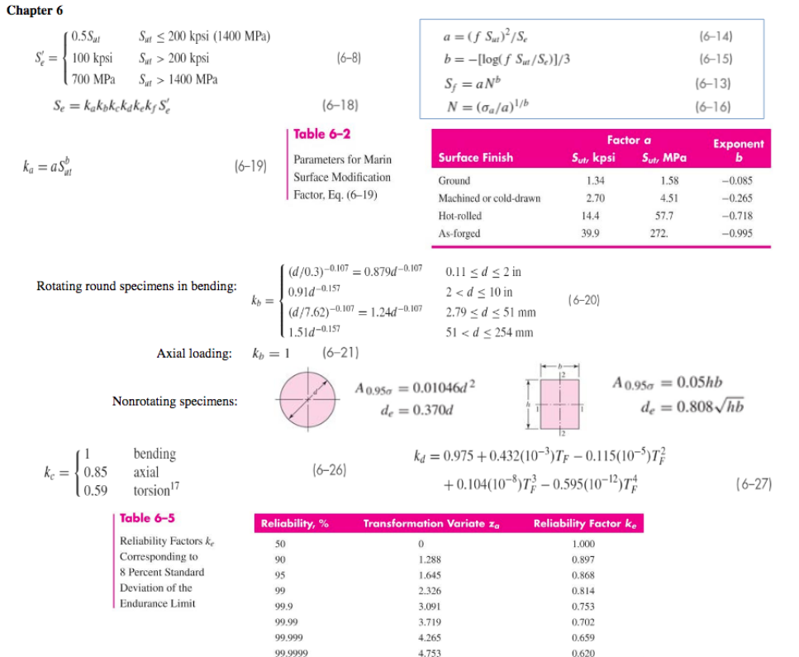

|  |  |
| --- | --- |
| 6-13) A solid square rod is cantilevered at one end. The rod is **0.6 m long** and supports a completely reversing transverse load at the other end **of 62 kN**. The material is **AISI 1080 hot-rolled steel**. If the rod must support this load for **104 cycles** with a design factor of **1.5**, what dimension should the square cross section have? Neglect any stress concentrations at the support end. |  |

|  |  |
| --- | --- |
| 6-14) A rectangular bar is cut from an AISI 1020 cold-drawn steel flat. The bar is 2.5 in wide by 3 in 8  thick and has a 0.5-in-dia. hole drilled through the center as depicted in Table A–15–1. The bar is concentrically loaded in push-pull fatigue by axial forces *Fa*, uniformly distributed across the width. Using a design factor of *nd* 5 2, estimate the largest force *Fa* that can be applied ignoring column action. |  |