MAE 3210 - Spring 2020 - Homework 4

Homework 4 is due online through Canvas in PDF format by 11:59PM on Monday

March 16.

You are required to submit code for all functions and/or subroutines built to solve

these problems, which is designed to be easy to read and understand, in your chosen

programming language, and which you have written yourself. The text from

your code should both be copied into a single PDF file submitted on canvas. Your

submitted PDF must also include responses to any assigned questions,

which for problems requiring programming should be based on output

from your code. For example, if you are asked to find a numerical answer to a

problem, the number itself should be included in your submission.

NOTE: For this homework you are welcome to solve problem 1 by hand, without

using programming or submitting code. However, you are required to solve problems 3-4 with programming, and a copy of your code must be submitted. Use of MS

excel (or equivalent software) is acceptable and encouraged for problem 2; please

include a copy of your final spreadsheet within your submitted PDF.

1. Consider the optimization problem:

Maximize f(x, y) = −3x + y

subject to the constraints x

x2 + y ≤ 4,

−2x + y ≤ 0,

x ≥ 0.5,

y ≥ 0.

**(a) Plot the feasible solution space in the x − y plane.**

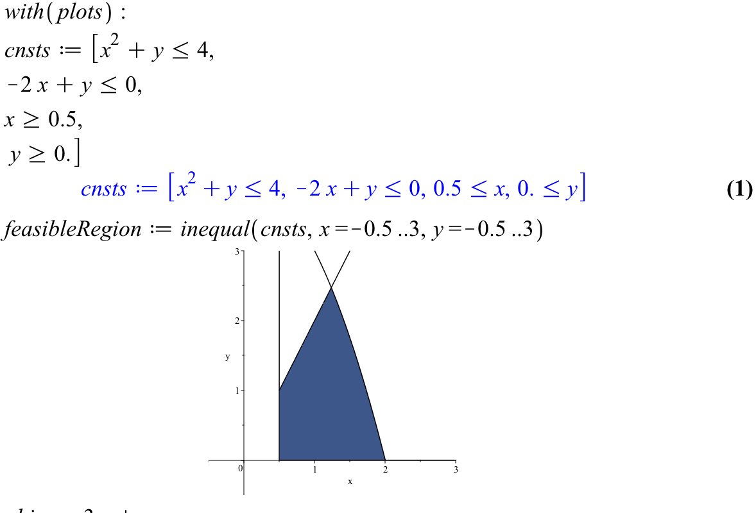

**(b) Solve the optimization problem by using the graphical method.**

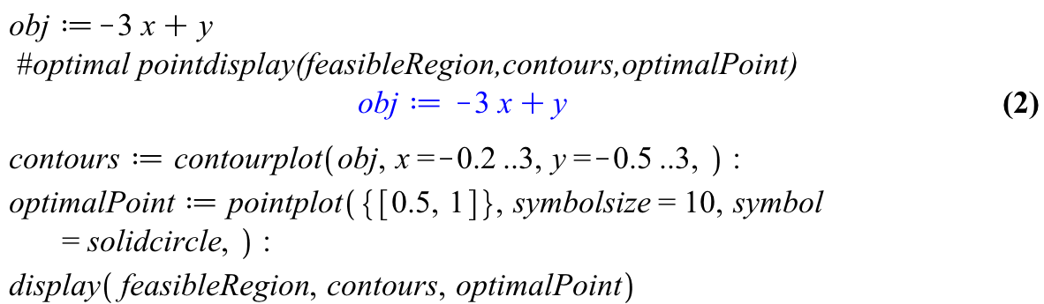

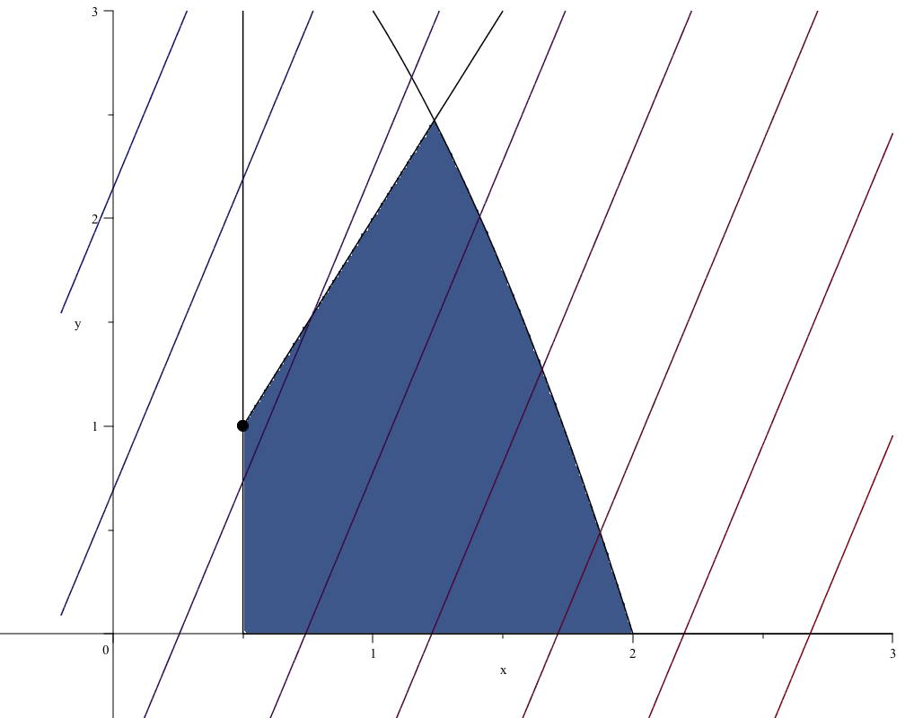

The objective function is maximized by the **point (0.5, 1)**

2. An aerospace company is developing a new fuel additive for commercial airliners.

The additive is composed of three ingredients: X, Y, and Z. For peak performance, the total amount of additive must be at least 6 mL/L of fuel. For safety reasons, the sum of the highly flammable Y and Z ingredients must not exceed 2.5 mL/L. In addition, for the additive to work, the amount of Z must be greater than or equal to twice the amount of Y , and the amount of X must be greater than or equal to three quarters of the amount of Y . If the cost per mL for the

ingredients X, Y and Z is 20 cents, 3 cents, and 5 cents, respectively, use MS excel to determine the minimum cost of the additive mixture for each liter of fuel.

3. Use least squares regression to fit a straight line to the data

x 0 2 4 6 9 11 12 15 17 19

y 5 6 7 6 9 8 7 10 12 12

Along with the slope and intercept, compute the standard error of the estimate

and the correlation coefficient. Plot that data and the regression line.

4. The following data are provided

x 1 2 3 4 5

y 2.2 2.8 3.6 4.5 5.5

Perform least squares regression to fit these data to the following model

y = a0 + a1x +

a2

x

.

Note that this problem was solved in class, but here you are asked to reproduce

the result on your own.