Assignment 4 : create war on Jenkins master put war on s3 . In jenkins slave get object war and deploy it

Step-1 Configure Jenkins master on ec2 instance and start tomcat server.

Create Jenkins slave on second instance

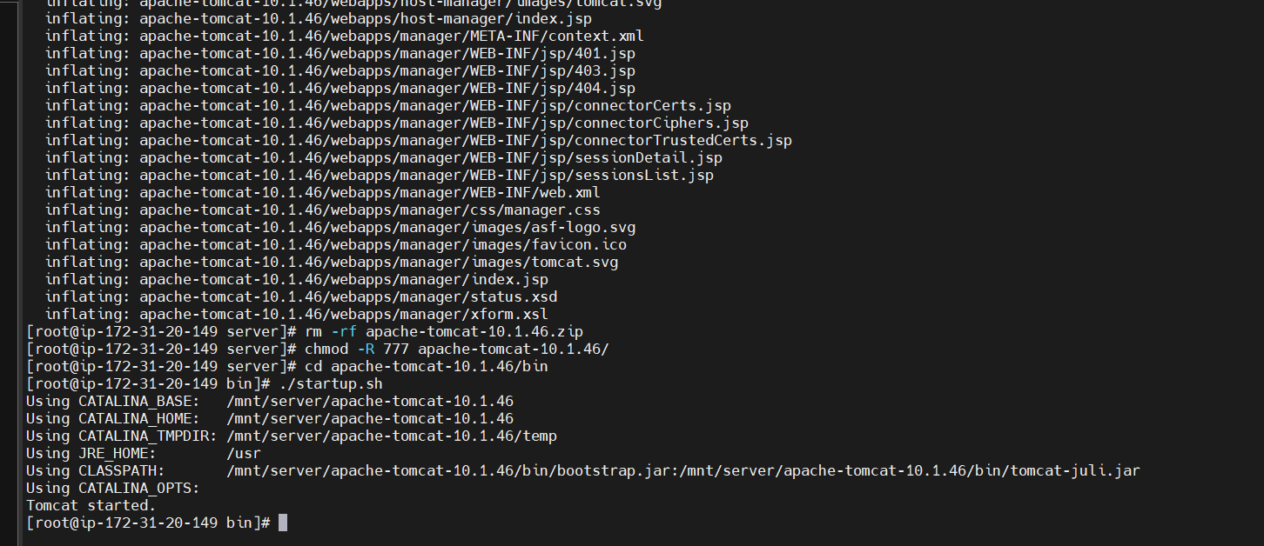

Step -2 Add node on Jenkins master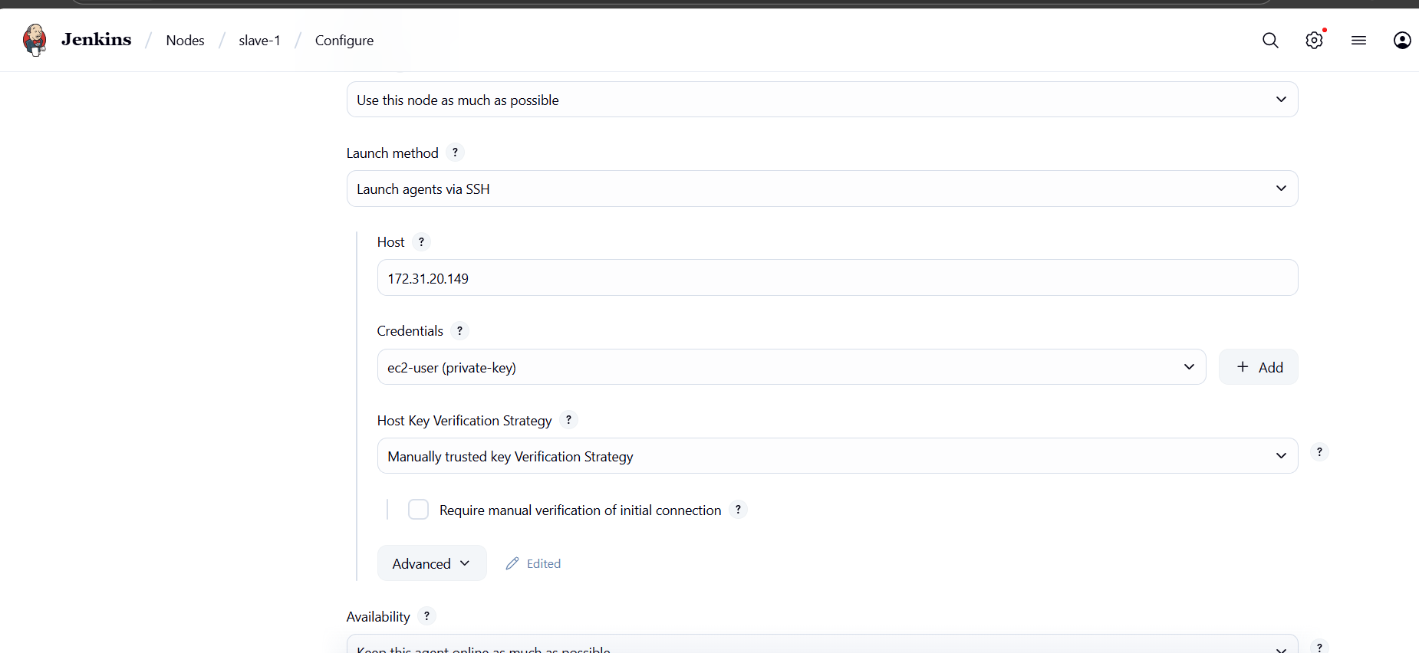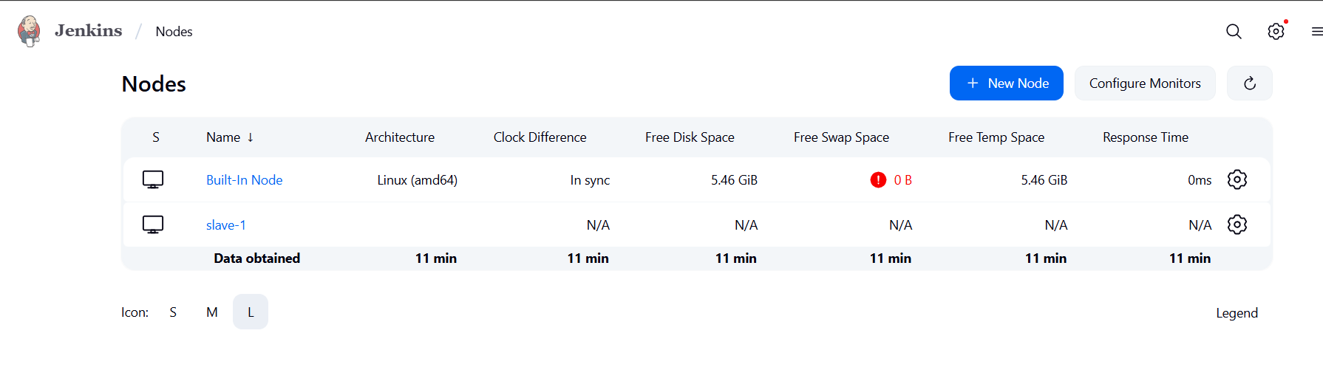

Step -3 Attach IAM role to Jenkins master as well as slave

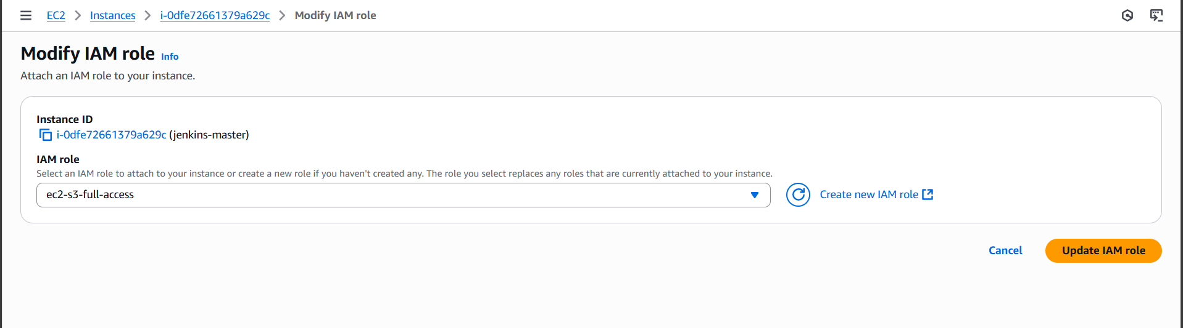

Step -4 Create a free style job on Jenkins master in which we have to build a war file by maven build in steps and upload it in s3 bucket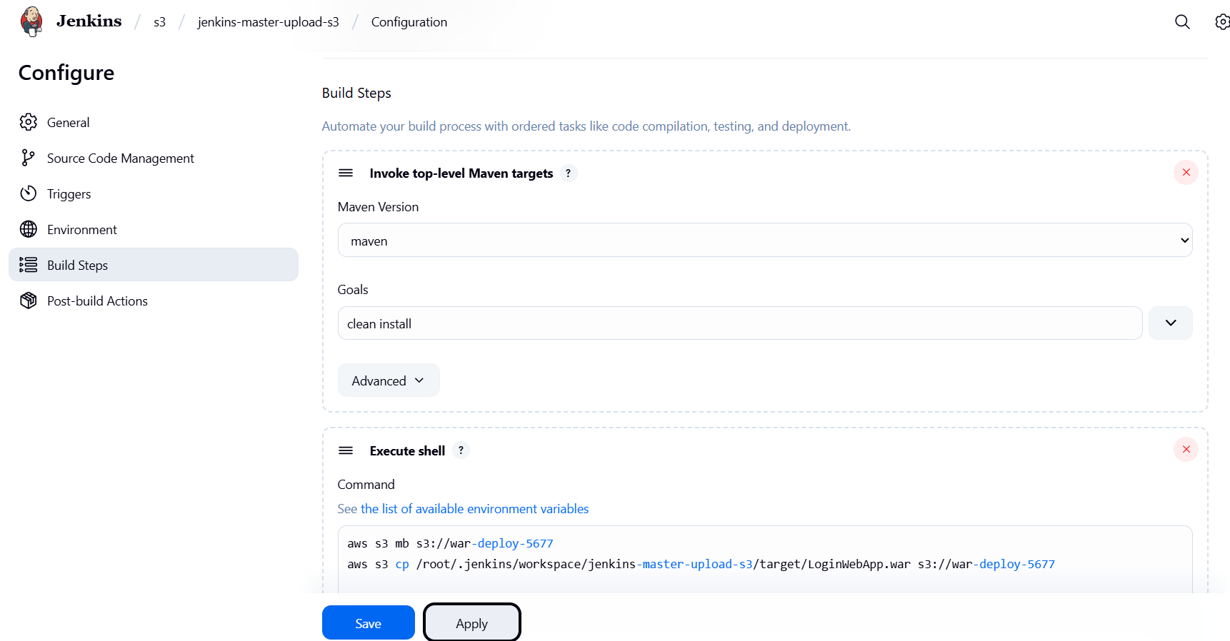

Step -5 Save and apply the job and build the pipeline the bucket will be visible in s3 after build

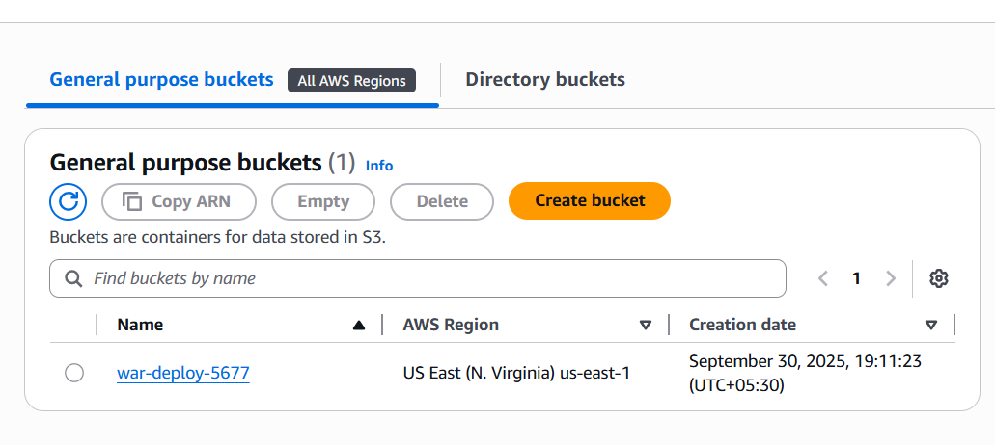

Step -6 Create 2nd job in which get war on slave and deploy it on tomcat server 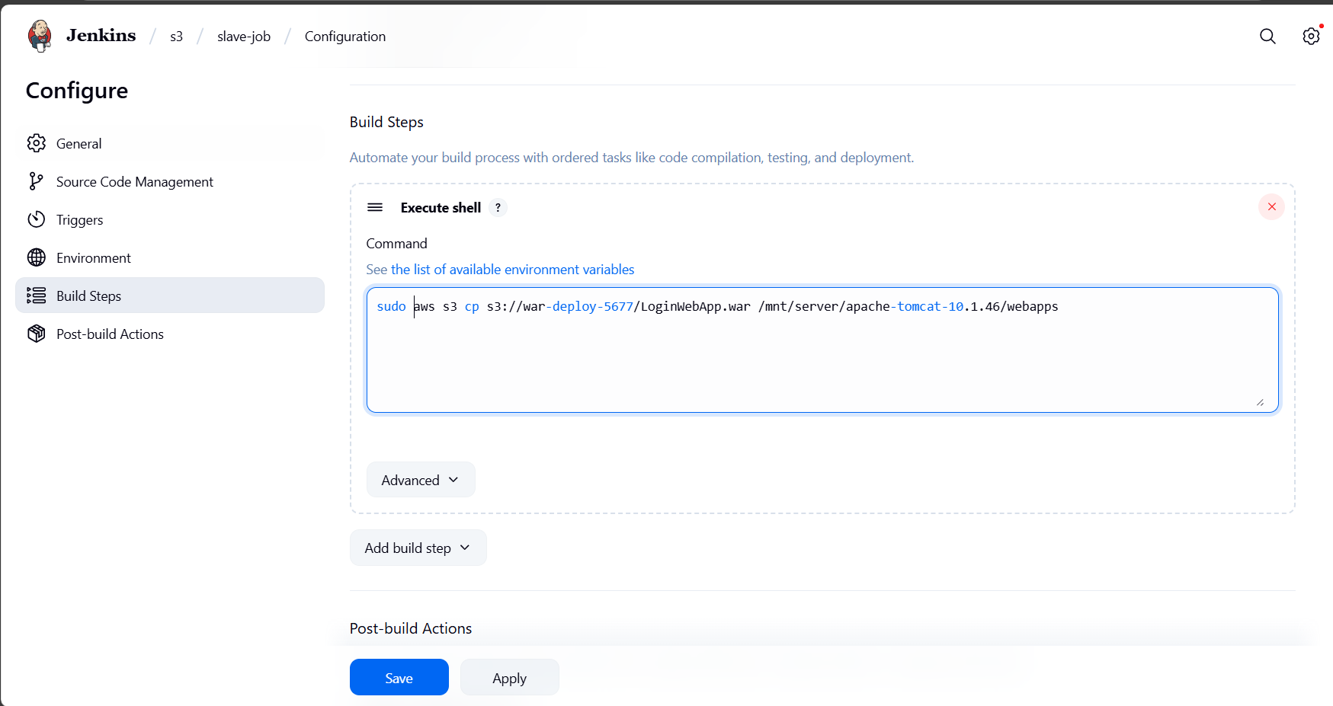

Build it!

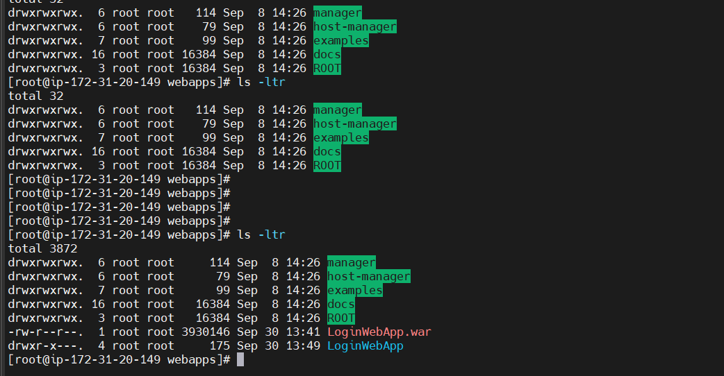

Step -7 Access it on browser from slave

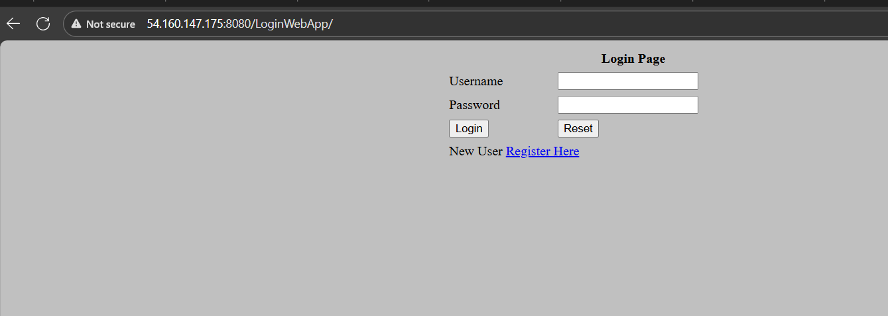

Done !!!