DCT-BASED IMAGE COMPRESSION AND QUALITY ANALYSIS
A PROJECT REPORT
Submitted by
HARSHIT [Reg No: RA2311003011776]
AKUL [Reg No: RA2311003011803]
BHAVYA [Reg No: RA2311003011878]
Under the Guidance of
Dr. Shoba LK
Assistant Professor, Department of Computing Technologies
in partial fulfillment of the requirements for the degree of
BACHELOR OF TECHNOLOGY
in
COMPUTER SCIENCE AND ENGINEERING

DEPARTMENT OF COMPUTING TECHNOLOGIES
COLLEGE OF ENGINEERING AND TECHNOLOGY
SRM INSTITUTE OF SCIENCE AND TECHNOLOGY
KATTANKULATHUR – 603 203
NOVEMBER 2026

SRM INSTITUTE OF SCIENCE AND TECHNOLOGY
KATTANKULATHUR – 603 203
BONAFIDE CERTIFICATE
Certified that 21CSE251T Digital Image Processing project report titled “DCT-BASED IMAGE COMPRESSION AND QUALITY ANALYSIS” is the bonafide work of Harshit [Reg No: RA2311003011776], Akul [Reg No: RA2311003011803], and Bhavya [Reg No: RA2311003011878] who carried out the project work under my supervision. Certified further, that to the best of my knowledge, the work reported herein does not form part of any other thesis or dissertation on the basis of which a degree or award was conferred on an earlier occasion for this or any other candidate.
Dr. Shoba LK  SUPERVISOR  Assistant Professor  Department of Computing Technologies  SRMIST, Kattankulathur | Dr. G. NIRANJANA  HEAD OF THE DEPARTMENT  Professor  Department of Computing Technologies  SRMIST, Kattankulathur

Department of Computing Technologies
SRM Institute of Science and Technology — Own Work Declaration Form
Degree / Course | B.Tech in Computer Science and Engineering (21CSE251T — Digital Image Processing)
Student Names | Harshit, Akul, Bhavya
Registration Numbers | RA2311003011776, RA2311003011803, RA2311003011878
Title of Work | DCT-Based Image Compression and Quality Analysis
I/We hereby certify that this assessment complies with the University’s Rules and Regulations relating to Academic Misconduct and Plagiarism, as listed in the University Website, Regulations, and the Education Committee guidelines. I/We confirm that all the work contained in this assessment is our own except where indicated, and that we have met the following conditions:
- Clearly referenced and listed all sources as appropriate, referenced and placed inverted commas around any quoted material from literature or technical specifications.
- Explicitly cited the origins of all diagrams, benchmark test blocks, equations, and empirical measurements incorporated in the report.
- Made no unauthorized use of the reports or submissions of any other student, either past or present, and acknowledged all technical assistance received.
- Complied fully with all academic integrity and originality requirements specified in the course syllabus and University examination handbook.
- Understand that any false claim regarding authorship for this academic submission will be penalized in accordance with University policies and regulations.
DECLARATION: I/We am/are aware of and understand the University’s policy on Academic Misconduct and Plagiarism and certify that this assessment is our own work, except where indicated by referencing, and that we have followed the good academic practices noted above. Date: November 2026
Student 1 Signature:  Harshit  (RA2311003011776) | Student 2 Signature:  Akul  (RA2311003011803) | Student 3 Signature:  Bhavya  (RA2311003011878)

ACKNOWLEDGEMENT
We express our humble gratitude to Dr. C. Muthamizhchelvan, Vice-Chancellor, SRM Institute of Science and Technology, for the world-class academic facilities extended for our project work and his continued encouragement.
We extend our sincere thanks to Dr. M. Leenus J Martin, Dean – College of Engineering and Technology, SRM Institute of Science and Technology, for his invaluable institutional support throughout our undergraduate program.
We wish to express our deep appreciation to Dr. Revathi Venkataraman, Professor and Chairperson, and Dr. Pushpalatha, Professor and Associate Chairperson, School of Computing, SRM Institute of Science and Technology, for their visionary guidance and continuous support throughout the course of this project.
We are incredibly grateful to our Head of the Department, Dr. G. Niranjana, Professor, Department of Computing Technologies, SRM Institute of Science and Technology, for her insightful suggestions, constructive feedback, and constant encouragement at all stages of the project work.
We register our immeasurable thanks to our Course Faculty and Project Supervisor, Dr. Shoba LK, Assistant Professor, Department of Computing Technologies, SRM Institute of Science and Technology, for her mentorship, technical guidance in Digital Image Processing (21CSE251T), and dedicated support in helping us design, verify, and complete this project.
Harshit [Reg No: RA2311003011776]
Akul [Reg No: RA2311003011803]
Bhavya [Reg No: RA2311003011878]

ABSTRACT
Digital images generate substantial storage and transmission overhead due to high spatial and spectral redundancy across neighboring pixels, necessitating lossy compression frameworks that balance bitrate reduction against perceptual fidelity. This project presents the design, implementation, and empirical evaluation of a complete Baseline JPEG-style lossy image compression and quality analysis system built from scratch using the Two-Dimensional Type-II Discrete Cosine Transform (2-D DCT-II) in Python and NumPy, without relying on high-level frequency-transform libraries. Input grayscale or RGB images are converted to the full-range ITU-R BT.601 YCbCr color space, level-shifted by subtracting 128, and partitioned into reflection-padded 8×8 spatial blocks. A precomputed orthonormal DCT basis matrix concentrates signal energy into low-frequency coefficients, achieving over 86% energy compaction in the single DC term on standard luminance test blocks. Psychovisual compression is governed by the ISO/IEC 10918-1 luminance quantization matrix scaled dynamically across quality factors Q ∈ [1, 100], with chroma channels quantized more aggressively at Q_chroma = max(1, Q // 2). Following dequantization, inverse 2-D DCT, and reconstruction, the system measures Mean Squared Error (MSE), Peak Signal-to-Noise Ratio (PSNR), Bits Per Pixel (BPP), and Compression Ratio (CR) via a zig-zag run-length bitstream estimator. Experimental benchmarks across 256×256 grayscale and color images demonstrate compression ratios of 3.49× (31.72 dB) and 5.88× (28.27 dB) at Q = 50, reaching visually transparent quality above 30 dB at Q = 75. An interactive Tkinter desktop application, real-time slider preview, dual PNG/JPG export, CLI diagnostic runner, 5-tab viva explanation dialog, and 32 passing unit tests deliver both a functional tool and a transparent academic laboratory.

TABLE OF CONTENTS
S.No / Section | Title | Page No.
 | ABSTRACT | v
 | LIST OF TABLES | vii
 | LIST OF FIGURES | vii
 | LIST OF SYMBOLS AND ABBREVIATIONS | viii
CHAPTER 1 | INTRODUCTION | 1
1.1 | Background and Motivation | 1
1.2 | Problem Statement | 2
1.3 | Objectives of the Project | 2
1.4 | Scope and Technical Contributions | 3
CHAPTER 2 | LITERATURE SURVEY AND THEORETICAL BACKGROUND | 4
2.1 | Evolution of Image Compression Standards | 4
2.2 | Spatial, Statistical, and Psychovisual Redundancy | 4
2.3 | Comparative Analysis of Existing Compression Frameworks | 5
CHAPTER 3 | SYSTEM ARCHITECTURE AND METHODOLOGY | 6
3.1 | Overall System Architecture | 6
3.2 | End-to-End Signal Processing Pipeline Flowchart | 6
3.3 | Color Space Decomposition (ITU-R BT.601 Full-Range) | 7
3.4 | Level Shifting, Block Partitioning, and Reflection Padding | 8
3.5 | Two-Dimensional Discrete Cosine Transform (DCT-II & IDCT-III) | 8
3.6 | Psychovisual Quantization and Quality Factor Scaling | 9
3.7 | Zig-Zag Scanning and Run-Length Bitstream Estimation | 11
3.8 | Objective Image Quality and Compression Metrics | 11
3.9 | Live Worked Numerical Walkthrough on Standard 8×8 Block | 12
CHAPTER 4 | IMPLEMENTATION AND SOFTWARE DESIGN | 14
4.1 | Technology Stack and Software Environment | 14
4.2 | Modular Repository Design and Vectorization | 14
4.3 | Interactive Desktop GUI and Dual Export Design | 15
4.4 | Live 5-Tab Educational Theory & Calculation Pop-up | 16
4.5 | Command-Line Interface and Automated Test Suite | 16
CHAPTER 5 | RESULTS AND DISCUSSION | 18
5.1 | Visual Quality Evaluation Across Quality Factors | 18
5.2 | Quantitative Benchmark Results: Grayscale vs. Color Images | 19
5.3 | Rate–Distortion, Compression Ratio, and Sparsity Trends | 20
5.4 | Bitstream Estimate vs. File-Container Storage Discrepancy Analysis | 22
CHAPTER 6 | CONCLUSION AND FUTURE SCOPE | 23
6.1 | Conclusion | 23
6.2 | Limitations of the Current Implementation | 23
6.3 | Future Scope | 23
 | REFERENCES | 25
APPENDIX A | KEY SOURCE CODE EXCERPTS AND TEST LOG | 26

LIST OF TABLES
Table No. | Caption | Page No.
Table 2.1 | Comparative Analysis of Image Storage Containers and Compression Methodologies | 5
Table 3.1 | Standard ISO/IEC 10918-1 Base Luminance Quantization Matrix (Q = 50) | 10
Table 3.2 | Scaled Quantization Matrix Behavior Across User Quality Settings | 10
Table 3.3a | Input 8×8 Gonzalez & Woods Benchmark Pixel Block f(x, y) | 12
Table 3.3b | Quantized Integer Coefficient Matrix F_Q(u, v) at Q = 50 | 12
Table 3.3c | Reconstructed 8×8 Spatial Pixels f_recon(x, y) at Q = 50 | 13
Table 4.1 | Software Package Structure, Core Functions, and Module Responsibilities | 14
Table 4.2 | Automated Pytest Verification Suite Summary (32/32 Passing) | 16
Table 5.1 | Quantitative Performance on Grayscale Image (assets/sample.png) | 19
Table 5.2 | Quantitative Performance on Color Image (assets/sample_color.png) | 19
Table 5.3 | Comparison of Raw Memory, BMP, RLE Estimate, PNG, and JPG Container Sizes | 22
LIST OF FIGURES
Figure No. | Caption | Page No.
Fig 1.1 | Visual Overview: Uncompressed RGB vs. Q = 75 vs. Q = 10 | 1
Fig 3.1 | Modular Layered Software Architecture Diagram | 6
Fig 3.2 | End-to-End Signal Processing Pipeline Flowchart | 7
Fig 3.3 | All 64 Orthonormal 2-D DCT Basis Patterns (8×8 Spatial Grid) | 9
Fig 3.4 | Standard JPEG 8×8 Zig-Zag Scan Trajectory Matrix | 11
Fig 3.5 | Visual Heatmap Summary of Q = 50 Numerical Walkthrough | 13
Fig 4.1 | Main Tkinter GUI Displaying Live Dual-Pane Compression & Metrics | 15
Fig 4.2 | Interactive 5-Tab Educational Theory & Calculation Pop-up Window | 16
Fig 5.1 | Grayscale 4-Up Comparison Grid (assets/sample.png) | 18
Fig 5.2a | GUI-Exported 4-Up JPG Comparison Grid (avatar_comparison.jpg) | 18
Fig 5.2b | GUI-Exported 4-Up PNG Comparison Grid (Cosmic Prince_comparison.png) | 19
Fig 5.3 | Peak Signal-to-Noise Ratio (PSNR) vs. Quality Factor Q | 20
Fig 5.4 | Compression Ratio (CR) and Bitrate (BPP) vs. Quality Factor Q | 20
Fig 5.5 | Quantized Coefficient Sparsity (% Zero Coefficients) vs. Q | 21
Fig 5.6 | Operational Rate–Distortion Curve (PSNR vs. BPP) | 21

LIST OF SYMBOLS AND ABBREVIATIONS
Table 0.1: Notation, Mathematical Symbols, and Technical Abbreviations
Symbol / Acronym | Definition and Physical Meaning
DCT / IDCT | Discrete Cosine Transform (Type-II) / Inverse Discrete Cosine Transform (Type-III)
DIP | Digital Image Processing
JPEG | Joint Photographic Experts Group (ISO/IEC 10918-1 Standard)
PNG / BMP | Portable Network Graphics (Lossless) / Windows Bitmap (Uncompressed Raw)
HVS | Human Visual System
RGB | Red, Green, and Blue Additive Color Model
YCbCr | Luminance (Y), Blue-Difference Chroma (Cb), and Red-Difference Chroma (Cr)
ITU-R BT.601 | International Telecommunication Union Recommendation for Standard Color Matrix
DC / AC | Direct Current (Zero-Frequency Average Coefficient F(0,0)) / Alternating Current Terms
Q / Q_chroma | User Quality Factor [1..100] for Luminance / Derived Chroma Quality max(1, Q // 2)
Q_50 / Q_scaled | Base ISO Luminance Quantization Table at Q=50 / Scaled Table for Active Quality Q
S(Q) | Standard libjpeg Quality Scaling Multiplier
D / D^T | Orthonormal 8×8 1-D DCT Basis Matrix and its Exact Matrix Transpose Inverse
f(x, y) / F(u, v) | Spatial Pixel Intensity Matrix and 2-D Frequency Coefficient Matrix
MSE / RMSE | Mean Squared Error / Root Mean Squared Error (Intensity Levels)
PSNR | Peak Signal-to-Noise Ratio measured in Decibels (dB)
CR / BPP | Compression Ratio (Raw Bytes / Encoded Bytes) / Bits Per Pixel
RLE / EOB | Run-Length Encoding (zero_run, value) Pairs / End-Of-Block Marker (0x00)
GUI / CLI | Graphical User Interface (Tkinter) / Command-Line Interface

CHAPTER 1
INTRODUCTION
1.1 Background and Motivation
Uncompressed digital images demand vast storage capacities and high transmission bandwidths because every spatial sample is stored independently in memory. A modest 256×256 full-color RGB photograph occupies 196,608 bytes (192.00 KB) in raw memory, while modern high-resolution sensors routinely capture tens of megabytes per frame. As articulated in Shannon’s foundational information theory [1], efficient representation eliminates statistical redundancy without sacrificing essential signal semantics.
In natural imagery, adjacent pixels rarely fluctuate abruptly; smooth sky gradients, architectural surfaces, and organic textures display high spatial correlation [2]. Furthermore, the Human Visual System (HVS) exhibits asymmetrical sensitivity: viewers notice slight inaccuracies in overall brightness or coarse contours far more readily than subtle high-frequency variations or tiny hue shifts. Exploiting both statistical correlation and psychovisual insensitivity enables orders-of-magnitude reduction in data volume.
Since its standardization in 1991, the Joint Photographic Experts Group (JPEG) algorithm [3] has remained the most ubiquitous photographic compression pipeline worldwide. At its mathematical core lies the Two-Dimensional Discrete Cosine Transform (DCT), originally formulated by Ahmed, Natarajan, and Rao in 1974 [4]. Unlike complex Fourier transforms, the DCT operates strictly on real numbers and packs nearly all block signal energy into a few low-frequency coefficients.
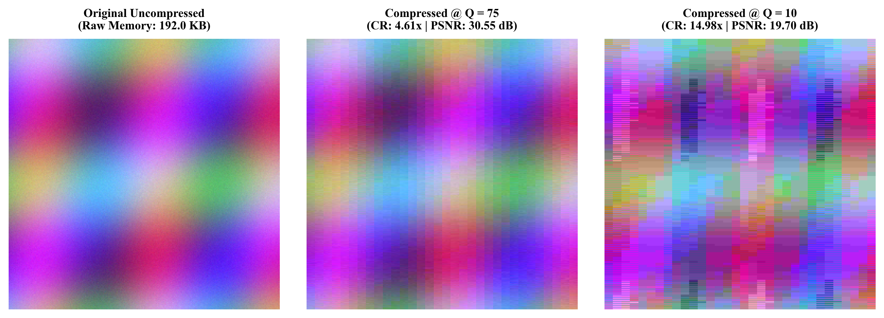
Fig 1.1: Visual comparison between uncompressed RGB pixel memory (192.0 KB) and reconstructed DCT outputs at Quality Q = 75 (visually transparent) and Q = 10 (severe blocking artifacts).
1.2 Problem Statement
Although everyday software tools seamlessly read and save compressed .jpg or .png files, commercial codecs operate as opaque black boxes. Students and practitioners rarely observe how individual 8×8 spatial blocks evolve inside the transform, how psychovisual quantization introduces sparsity, or why saving reconstructed pixels into different disk containers (such as PNG versus BMP) causes counterintuitive file-size measurements.
Existing rapid-prototyping libraries often wrap optimized C routines such as scipy.fft or libjpeg, obscuring the mathematical steps required in an undergraduate Digital Image Processing curriculum (21CSE251T). Consequently, there is a clear need for an open, transparent, from-scratch implementation that exposes every algebraic matrix operation while interactively quantifying the storage-versus-quality trade-off across both grayscale and color images.
1.3 Objectives of the Project
To bridge theoretical Digital Image Processing concepts with practical engineering verification, this project was designed around five primary objectives:
- Transparent Mathematical Engine: Implement the forward 2-D Type-II DCT, inverse 2-D Type-III DCT, 8×8 block partitioning with reflection padding, and ISO/IEC 10918-1 quantization scaling purely in NumPy without calling black-box FFT/DCT libraries.
- Perceptual Color Space Decomposition: Develop an analytical full-range ITU-R BT.601 RGB ↔ YCbCr color converter enabling independent compression of luminance (Y at quality Q) and chrominance (Cb, Cr at Q_chroma = max(1, Q // 2)).
- Quantitative Quality & Bitrate Analysis: Measure Mean Squared Error (MSE), Peak Signal-to-Noise Ratio (PSNR), Bits Per Pixel (BPP), and Compression Ratio (CR) via a zig-zag and run-length bitstream size estimator responsive to user quality Q.
- Interactive Visualization & Viva Defense Suite: Build a responsive Tkinter desktop GUI featuring real-time quality sliders, dual PNG/JPG exporters, 4-up visual comparison grids, and a dedicated 5-tab Flowchart, Algorithms & Numerical Calculations pop-up window.
- Reproducibility & Automated Verification: Provide a clean CLI tool, systematic multi-Q benchmark scripts, and an exhaustive automated unit and integration test suite using Pytest.
1.4 Scope and Technical Contributions
1.4.1 ARBITRARY RESOLUTION SUPPORT AND VECTORIZATION
The system accepts arbitrary image dimensions in PNG, JPG, BMP, or TIFF formats, automatically handling non-multiples of 8 through edge reflection padding prior to block splitting and symmetrical cropping upon merging. Performance remains interactive even on megapixel photography because all N blocks per channel are transformed simultaneously in vectorized NumPy einsum tensor batches.
1.4.2 INTEGRATED VIVA AND CALCULATION ARCHITECTURE
A distinguishing contribution of this project is its integrated Educational Core (`dct_core/explanation.py`) and Interactive Theory Dialog (`app/theory_dialog.py`). Rather than displaying only final PSNR numbers, the software computes live 8×8 matrix intermediates—including exact DC energy compaction percentage, coefficient sparsity, zig-zag sequences, and run-length (run, value) tuples—and exports complete academic derivations.
CHAPTER 2
LITERATURE SURVEY AND THEORETICAL BACKGROUND
2.1 Evolution of Image Compression Standards
Data compression rests upon two distinct mathematical paradigms: lossless entropy encoding and lossy transform coding. Early variable-length prefix coding introduced by Huffman [5] achieved optimal symbol-level lossless compression when source probabilities were known. However, operating directly on raw spatial pixels ignores strong two-dimensional neighborhood correlations, limiting lossless compression ratios on natural photographs to roughly 1.5:1–2.5:1.
Theoretical analysis established that the Karhunen–Loève Transform (KLT) completely decorrelates stationary Markov signals and maximizes energy compaction [6]. Unfortunately, the KLT basis depends on data covariance and lacks a fast transform algorithm. In 1974, Ahmed, Natarajan, and Rao [4] proved that the Discrete Cosine Transform closely approximates KLT energy compaction for highly correlated signals while utilizing a fixed, image-independent basis.
Building on two decades of transform research, the Joint Photographic Experts Group published ISO/IEC 10918-1 [7], thoroughly documented by Wallace [3] and Pennebaker and Mitchell [8]. Baseline JPEG standardized 8×8 block splitting, the 2-D DCT, empirically derived luminance/chrominance quantization tables tuned for human visual contrast, zig-zag reordering, run-length zero encoding, and Huffman entropy coding into a unified international format.
2.2 Spatial, Statistical, and Psychovisual Redundancy
Digital image compression targets three fundamental forms of data redundancy described by Gonzalez and Woods [2]. First, coding redundancy arises when fixed-length 8-bit integers are assigned equally to frequent and rare intensity values. Second, spatial redundancy occurs because neighboring pixel values in smooth regions or repeated textures can be predicted from their surroundings.
Third, and uniquely critical to lossy codecs, psychovisual redundancy exploits physiological limitations in human retinal photoreceptors. Mannos and Sakrison [9] characterized the Modulation Transfer Function (MTF) of human vision, demonstrating that contrast sensitivity peaks around medium spatial frequencies and drops sharply for fine high-frequency patterns. Dividing high-frequency DCT coefficients by large quantization steps discards noise imperceptible to viewers.
Similarly, human retinas contain vastly more brightness-sensitive rod cells than color-sensitive cone cells. As codified in ITU-R Recommendation BT.601 [10], transforming RGB primaries into Luminance (Y) and Chrominance (Cb, Cr) channels isolates detail-bearing intensity from slowly varying color, permitting heavier quantization on chroma planes without inducing objectionable subjective degradation.
2.3 Comparative Analysis of Existing Compression Frameworks
Contemporary imaging ecosystems employ diverse compression standards tailored to specific fidelity, complexity, and licensing constraints. Portable Network Graphics (PNG) [11] utilizes spatial line-filtering paired with LZ77/Huffman DEFLATE compression to guarantee bit-exact lossless preservation for diagrams, screenshots, and transparency masks, but produces substantially larger files than JPEG on noisy photographic scenes.
Later architectures sought to overcome JPEG’s 8×8 block-boundary artifacts. JPEG 2000 [12] replaced localized 8×8 DCT blocks with global Discrete Wavelet Transforms (DWT) and embedded EBCOT bit-plane coding, yielding superior rate-distortion behavior at extreme compression at the cost of significantly higher memory and CPU demands. Google’s WebP standard [13] adapted VP8 intra-frame directional prediction alongside 4×4 transforms.
Evaluating distortion across these codecs traditionally relies on Pixel-wise Mean Squared Error (MSE) and Peak Signal-to-Noise Ratio (PSNR). Although newer perceptual structural metrics such as SSIM [14] model local luminance and contrast masking, Huynh-Thu and Ghanbari [15] confirmed that PSNR remains a rigorous, reproducible benchmark when comparing controlled quantization variations on a fixed source image and codec architecture.
Table 2.1: Comparative Analysis of Image Storage Containers and Compression Methodologies
Standard / Format | Core Transform / Method | Nature | Strengths | Key Limitations
BMP (Bitmap) | Raw Uncompressed Raster | Lossless | Zero decode latency; exact pixel array representation | Massive file size; zero compression savings
PNG (RFC 2083) [11] | Scanline Filtering + DEFLATE | Lossless | Bit-exact fidelity; sharp text/UI lines; alpha support | Poor compression on natural continuous-tone photos
Baseline JPEG [3, 7] | 8×8 2-D DCT + Quantization + RLE/Huffman | Lossy | Fast O(N³) block math; high CR (5×–15×); universal | 8×8 blocking and ringing artifacts at very low Q
JPEG 2000 [12] | Full-Frame 2-D DWT + EBCOT | Both | No block boundaries; progressive resolution scalability | High computational/RAM cost; weak web browser adoption
WebP [13] | VP8 Intra-Prediction + 4×4 DCT/WHT | Both | 25–34% smaller than JPEG at matched SSIM; alpha | Higher encoder complexity than baseline JPEG
Our DIP System | Vectorized 8×8 DCT-II + BT.601 + RLE Est. | Lossy (Demo) | Transparent intermediate matrices; live Q & viva walkthrough | Uses teaching RLE estimator rather than Huffman bitstream

CHAPTER 3
SYSTEM ARCHITECTURE AND METHODOLOGY
3.1 Overall System Architecture
The software system follows a clean modular architecture separating user presentation layers from the underlying signal-processing pipeline and mathematical primitives. This strict separation of concerns ensures that the exact same verified mathematical engine drives the graphical interface, CLI tool, automated benchmarks, and unit test suite.
As illustrated in Fig 3.1, requests originate from either the Tkinter GUI (app/gui.py) or CLI runner (main.py), enter the orchestration layer (pipeline/pipeline.py), invoke orthonormal transforms and scaling tables inside dct_core/, and conclude with objective distortion and bitstream size measurements in quality/metrics.py.
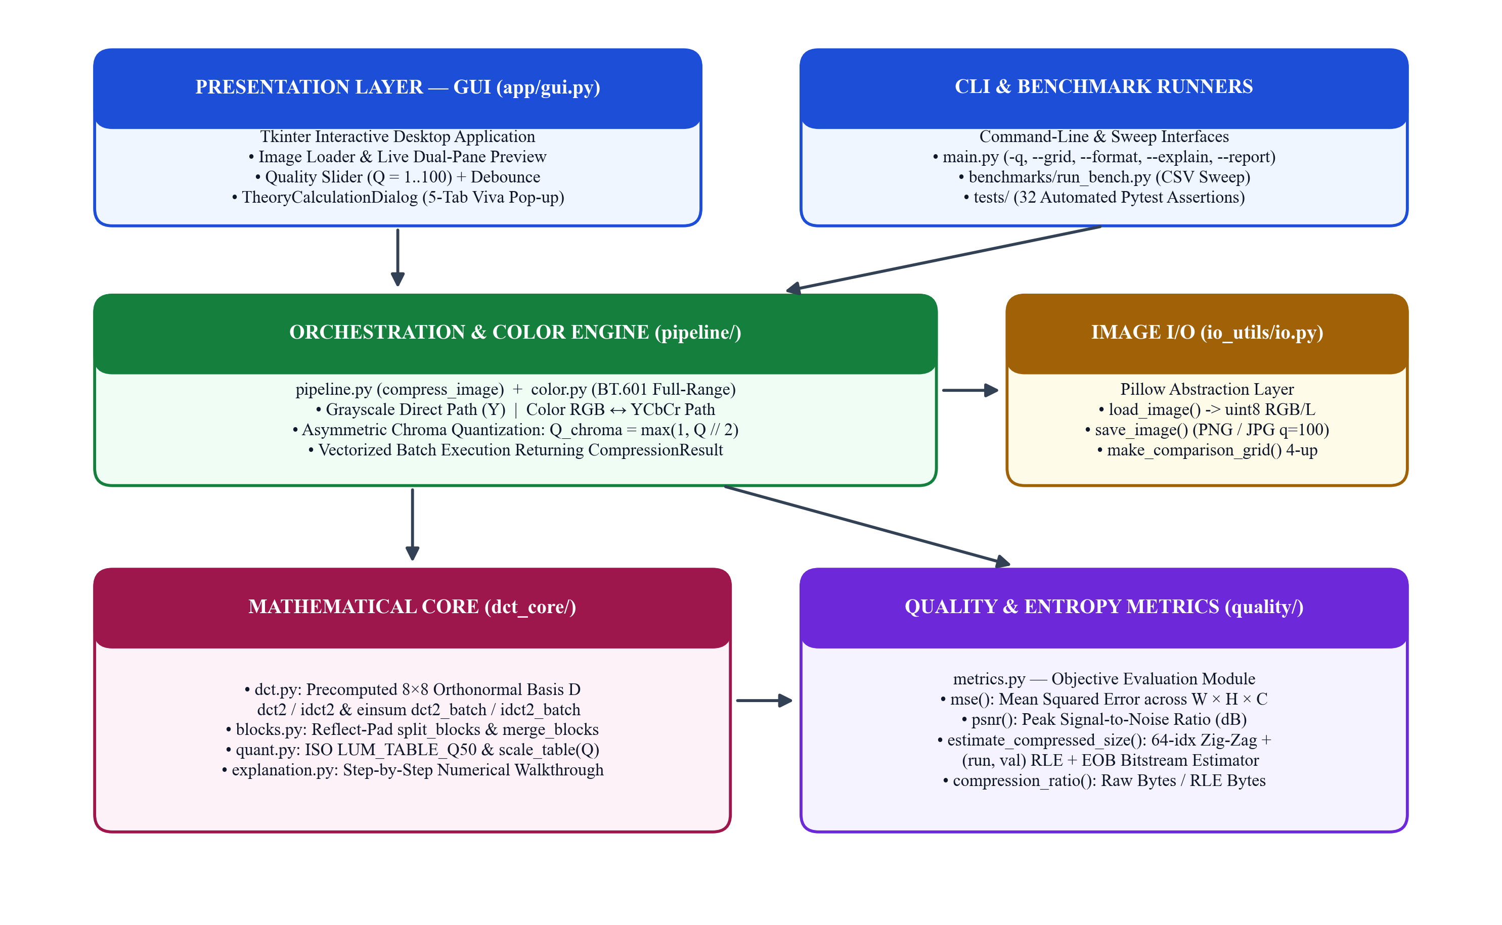
Fig 3.1: Modular layered software architecture separating Presentation (GUI/CLI), Pipeline Orchestration, Mathematical Core, Quality Metrics, and Image I/O.
3.2 End-to-End Signal Processing Pipeline Flowchart
Compression and reconstruction execute sequentially through a deterministic ten-step signal-processing chain modeled after baseline JPEG [3, 7]. Color inputs branch into independent luminance and chrominance channels, undergo encoding (level shift, 8×8 tiling, forward DCT, psychovisual quantization), branch simultaneously to the bitstream estimator and symmetric decoder, and recombine for evaluation.
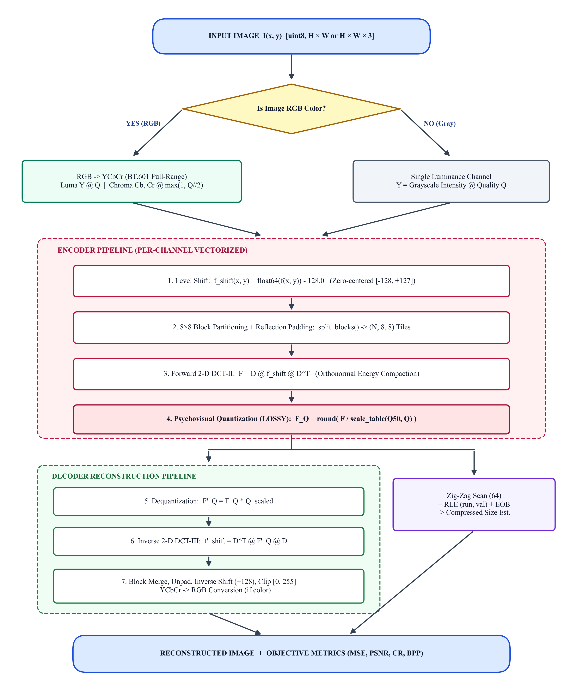
Fig 3.2: Complete end-to-end signal processing pipeline flowchart showing color routing, encoder compression stages, zig-zag size estimation, and decoder reconstruction.
3.3 Color Space Decomposition (ITU-R BT.601 Full-Range)
When an input image contains three RGB color planes ((H, W, 3)), compressing red, green, and blue channels directly is suboptimal because RGB planes remain heavily correlated with brightness variations. Instead, pipeline/color.py maps pixels into the full-range ITU-R BT.601 [10] YCbCr space spanning [0.0, 255.0] rather than clamped studio limits [16, 235], preventing systematic rounding drift during clean round-trip tests.
Y = 0.299000·R + 0.587000·G + 0.114000·B | (3.1)

Cb = −0.168736·R − 0.331264·G + 0.500000·B + 128 | (3.2)

Cr = 0.500000·R − 0.418688·G − 0.081312·B + 128 | (3.3)

During reconstruction, ycbcr_to_rgb() applies the symbolic matrix inverse of Equations (3.1)–(3.3) to restore RGB intensities clipped to unsigned 8-bit bounds [0, 255]:
R = Y + 1.402000·(Cr − 128), G = Y − 0.344136·(Cb − 128) − 0.714136·(Cr − 128), B = Y + 1.772000·(Cb − 128) | (3.4)

Exploiting the human eye’s superior acuity for luminance contours over chromatic transitions [9], the pipeline assigns the full user-selected quality Q to channel Y, whereas both Cb and Cr are compressed at half quality Q_chroma = max(1, Q // 2).
3.4 Level Shifting, Block Partitioning, and Reflection Padding
Before computing frequency transforms, unsigned 8-bit pixel samples f(x, y) ∈ [0, 255] are cast to 64-bit floating-point values and shifted by subtracting 128, yielding signed zero-centered values f_shift(x, y) ∈ [−128, +127]. Centering around zero reduces the magnitude bias of the DC coefficient F(0, 0) and mirrors standard JPEG arithmetic.
Next, dct_core/blocks.py divides each 2-D channel (H, W) into non-overlapping 8×8 pixel tiles. Whenever height H or width W is not an exact multiple of 8, split_blocks() applies symmetric reflection padding (numpy.pad(..., mode='reflect')) to reach (Hp, Wp). Unlike zero padding—which introduces harsh artificial black borders that trigger high-frequency ringing—reflection preserves local edge continuity and is cleanly cropped back to (H, W) after reconstruction.
3.5 Two-Dimensional Discrete Cosine Transform (DCT-II & IDCT-III)
3.5.1 SEPARABLE ORTHONORMAL MATRIX FORMULATION
Each zero-centered 8×8 spatial block f_shift(x, y) is projected onto 64 orthogonal cosine basis waveforms via the forward Two-Dimensional Type-II DCT [4, 6]:
F(u, v) = α(u)·α(v) · ∑_{x=0..7} ∑_{y=0..7} f_shift(x, y) · cos[(2x + 1)uπ / 16] · cos[(2y + 1)vπ / 16] | (3.5)

Here spatial indices x, y ∈ {0..7} and frequency indices u, v ∈ {0..7} utilize the orthonormal scale function α(0) = 1 / √8 and α(k > 0) = √(2 / 8) = 0.5. Because the 2-D transform kernel is separable along rows and columns, direct matrix evaluation replaces expensive O(N⁴) nested loops with two O(N³) matrix products using a precomputed 8×8 matrix D:
D[k, i] = α(k) · cos[(2i + 1)kπ / 16], F = D · f_shift · D^T, f_recon = D^T · F'_Q · D | (3.6)

Because D is strictly orthonormal (D · D^T = I_8, verified to < 10⁻¹⁰ tolerance in our unit tests), the inverse transform Type-III IDCT requires only matrix transposition (D^T). Fig 3.3 visualizes all 64 spatial frequency patterns encoded by D, ranging from the constant flat average DC basis at (0, 0) to rapid diagonal oscillations at (7, 7).
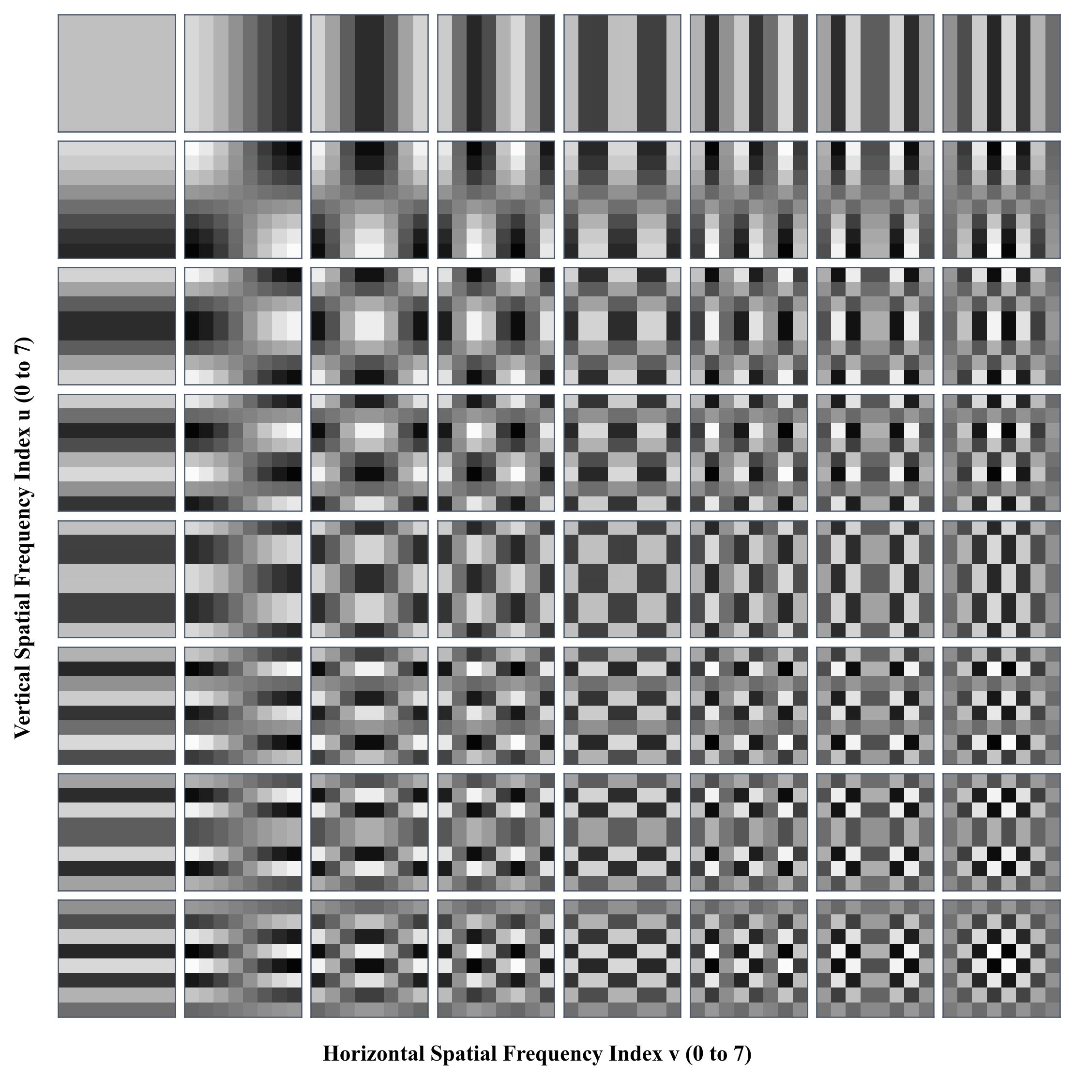
Fig 3.3: All 64 orthonormal 2-D DCT basis patterns generated directly from matrix D, arranged from DC (0,0) at top-left to maximum diagonal frequency (7,7) at bottom-right.
3.6 Psychovisual Quantization and Quality Factor Scaling
The Discrete Cosine Transform itself is completely reversible and achieves zero size reduction on its own. Compression occurs solely during psychovisual quantization, where transform coefficients F(u, v) are divided element-wise by a perceptual threshold matrix and rounded to the nearest integer. Low frequencies near (0, 0) receive small divisors to preserve contrast accuracy, whereas bottom-right diagonal frequencies receive divisors exceeding 100.
Table 3.1: Standard ISO/IEC 10918-1 Base Luminance Quantization Matrix (LUM_TABLE_Q50 at Q = 50)
u \ v | 0 | 1 | 2 | 3 | 4 | 5 | 6 | 7
0 | 16 | 11 | 10 | 16 | 24 | 40 | 51 | 61
1 | 12 | 12 | 14 | 19 | 26 | 58 | 60 | 55
2 | 14 | 13 | 16 | 24 | 40 | 57 | 69 | 56
3 | 14 | 17 | 22 | 29 | 51 | 87 | 80 | 62
4 | 18 | 22 | 37 | 56 | 68 | 103 | 77 | 62
5 | 30 | 35 | 55 | 64 | 81 | 104 | 92 | 75
6 | 50 | 72 | 78 | 87 | 103 | 121 | 100 | 78
7 | 68 | 92 | 95 | 98 | 112 | 100 | 103 | 99

To generalize quantization smoothly across user-selectable quality settings Q ∈ [1, 100], dct_core/quant.py implements the standard Independent JPEG Group (libjpeg) scaling law [16]:
S(Q) = 5000 / Q (if Q < 50), or 200 − 2·Q (if Q ≥ 50) | (3.7)

Q_scaled(u, v) = clip( floor[(Q_50(u, v) · S(Q) + 50) / 100], 1, 255 ) | (3.8)

F_Q(u, v) = round( F(u, v) / Q_scaled(u, v) ), F'_Q(u, v) = F_Q(u, v) · Q_scaled(u, v) | (3.9)

At Q = 100, S(100) = 0, clamping every entry of Q_scaled to 1 so quantization becomes unit-step lossless rounding. Conversely, at Q = 10, S(10) = 500 multiplies base steps fivefold, clamping most high-frequency divisors at 255 and forcing faint AC coefficients to zero. Table 3.2 contrasts representative corner values across Q = 10 and Q = 90.
Table 3.2: Scaled Quantization Matrix Behavior Across User Quality Settings
Quality Setting | Multiplier S(Q) | DC Step (0,0) | Mid-Freq Step (3,3) | High-Freq Step (7,7) | Compression Behavior
Q = 10 (Low) | 500.0 | 80 | 145 | 255 (clamped) | Aggressive zeroing; strong 8×8 blocking artifacts
Q = 50 (Reference) | 100.0 | 16 | 29 | 99 | Baseline ISO/IEC 10918-1 luminance reference table
Q = 75 (Default) | 50.0 | 8 | 15 | 50 | Fine quantization; balanced CR and >30 dB fidelity
Q = 90 (High) | 20.0 | 3 | 6 | 20 | Very small steps; nearly indistinguishable visually
Q = 100 (Max) | 0.0 | 1 | 1 | 1 | Unit step divisor; lossless DCT transform up to ±1 rounding

3.7 Zig-Zag Scanning and Run-Length Bitstream Estimation
After quantization, nonzero integers cluster tightly in the upper-left corner of each 8×8 matrix F_Q, leaving the lower-right triangle populated almost entirely by zeros. Scanning row-by-row would interleave active low-frequency rows with trailing zeros. As shown in Fig 3.4, a diagonal zig-zag traversal [3, 7] linearizes all 64 coefficients strictly from lowest to highest spatial frequency, consolidating trailing zeros into one contiguous sequence.
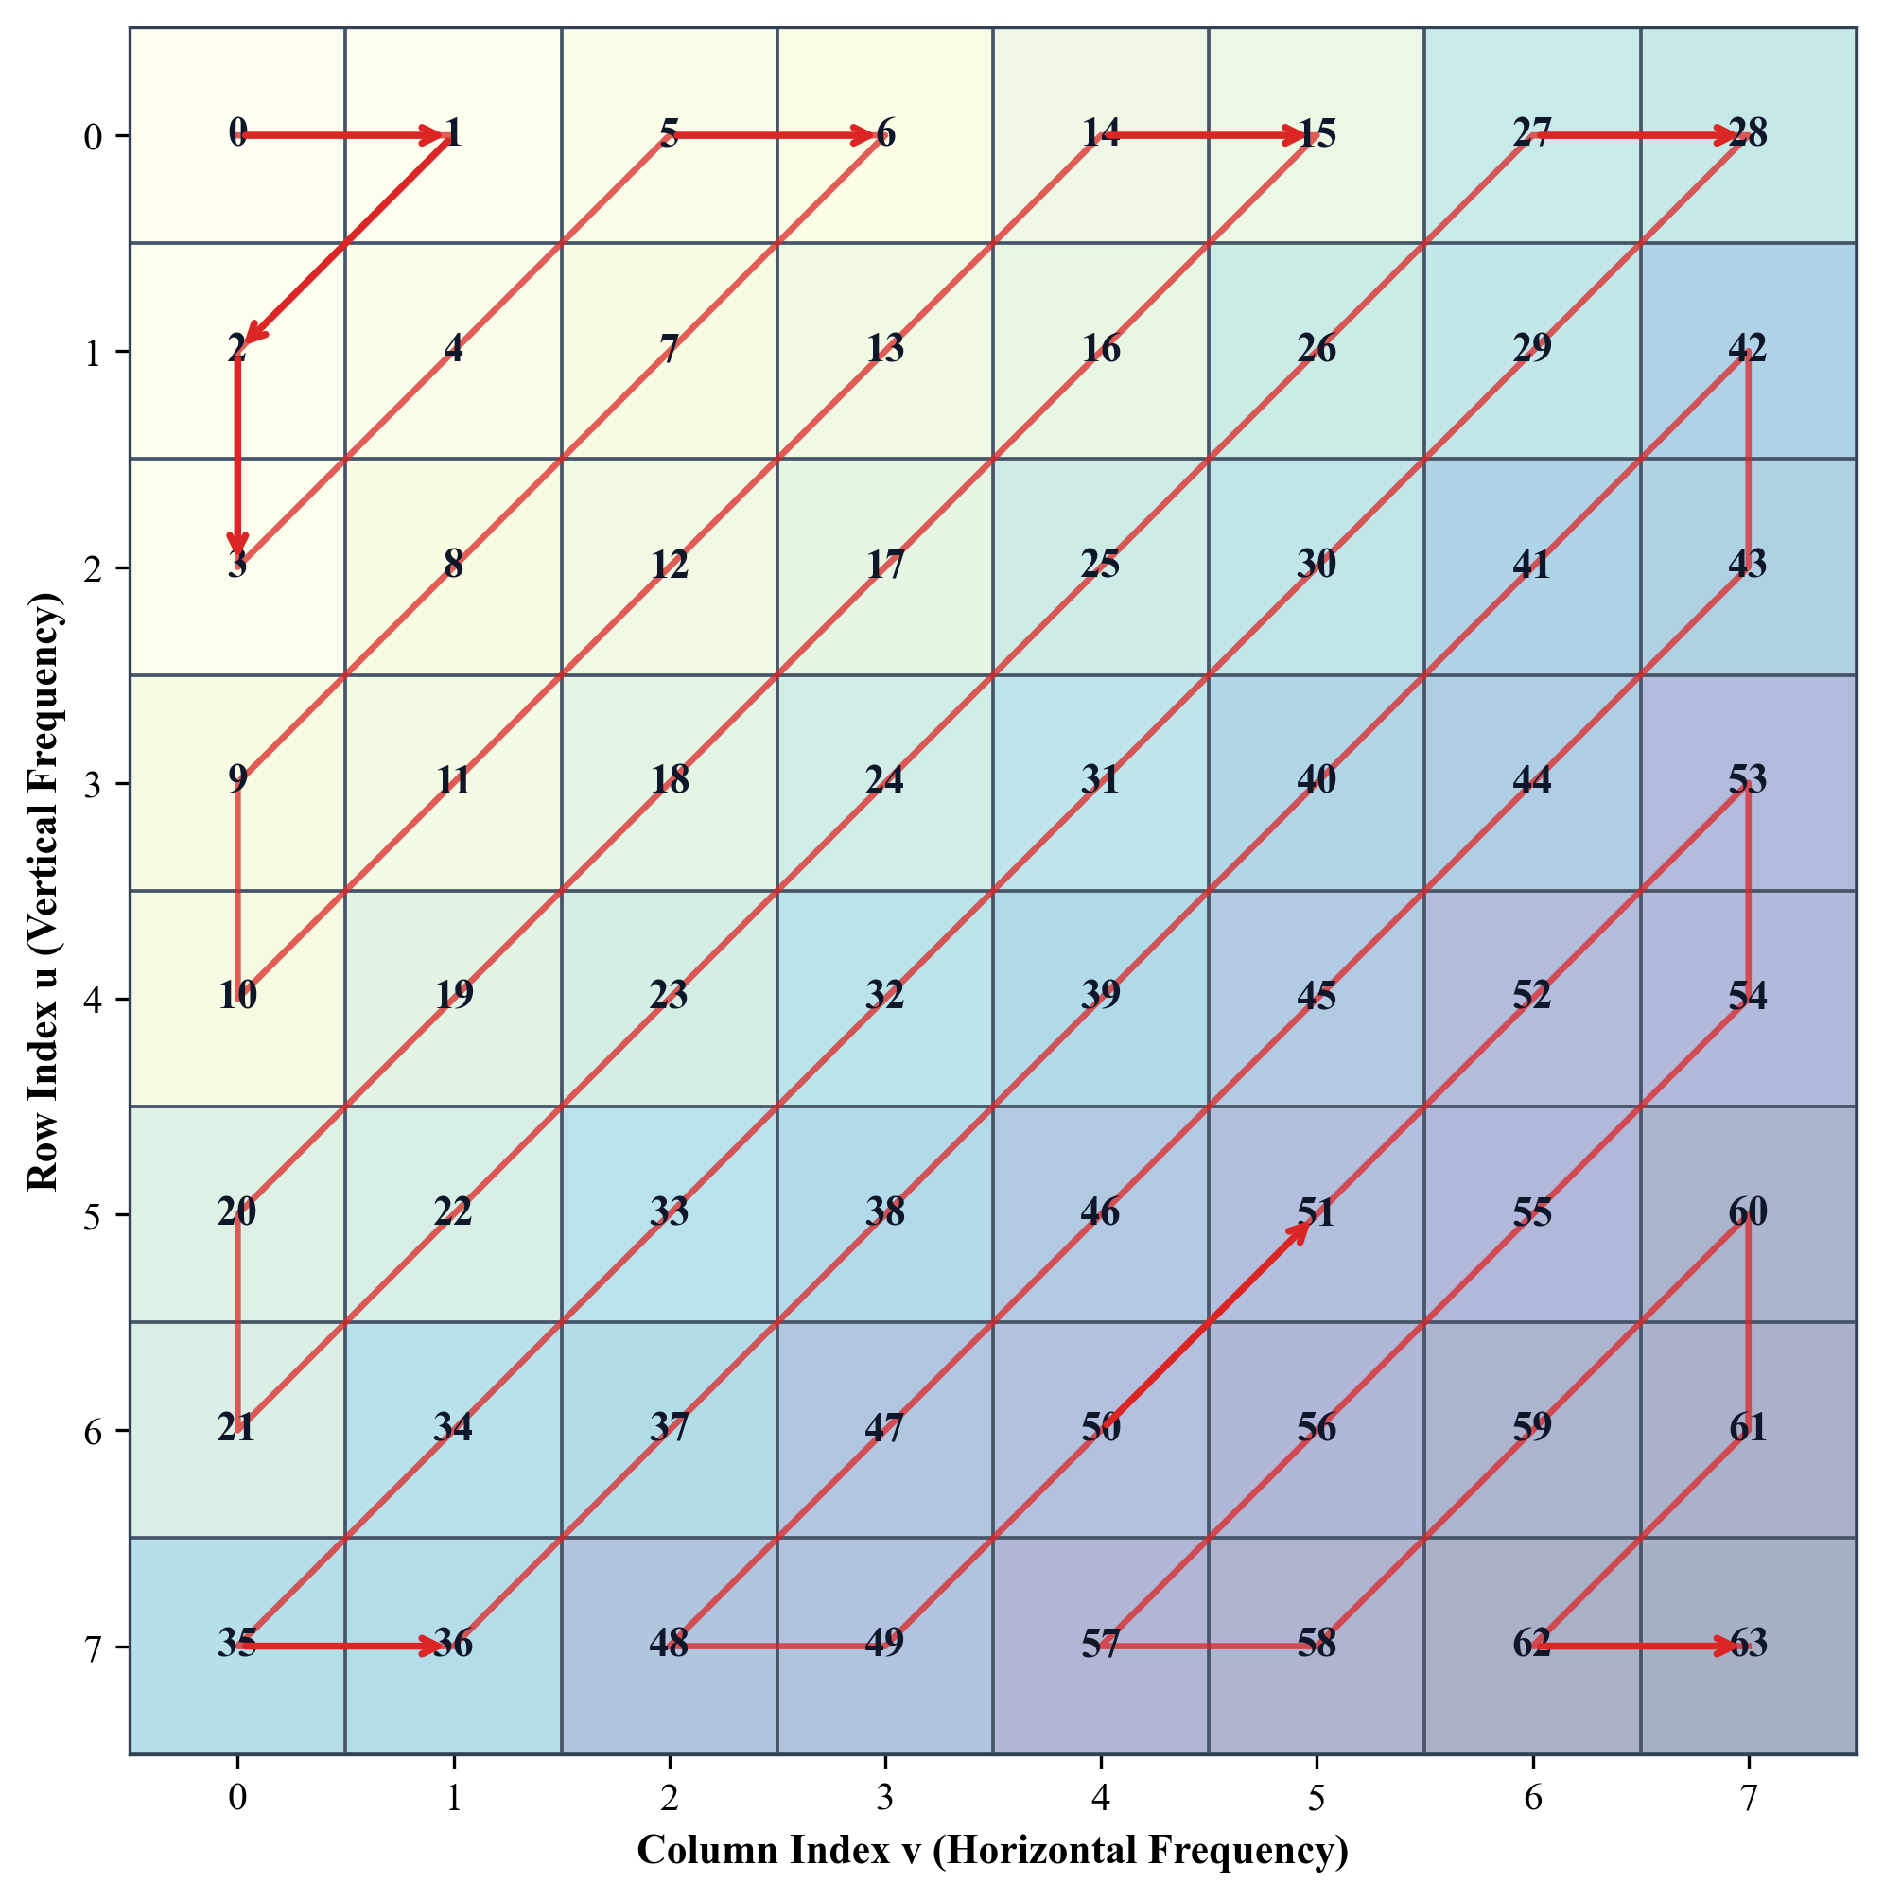
Fig 3.4: Standard JPEG 8×8 zig-zag scan trajectory mapping 2-D spectral coordinates (u, v) to 1-D sequential indices 0 through 63.
In quality/metrics.py, estimate_compressed_size() traverses this 64-element zig-zag vector per block, skips consecutive zeros, counts 2 bytes for every (run_of_zeros, nonzero_value) tuple, and appends 1 byte for an End-Of-Block (EOB) marker. This transparent teaching estimator avoids full Huffman bit-packing complexity while reliably reflecting how increased coefficient sparsity reduces bitstream size as Q decreases.
3.8 Objective Image Quality and Compression Metrics
To quantify reconstruction distortion rigorously, quality/metrics.py evaluates Mean Squared Error (MSE), Peak Signal-to-Noise Ratio (PSNR), Compression Ratio (CR), and Bits Per Pixel (BPP) across all W × H × C scalar intensity samples comparing original I against reconstructed I_recon [2, 15]:
MSE = [ 1 / (W · H · C) ] · ∑_{x} ∑_{y} ∑_{c} [ I(x, y, c) − I_recon(x, y, c) ]² | (3.10)

PSNR = 10 · log₁₀( 255² / MSE ) dB [defined as +∞ dB when MSE = 0] | (3.11)

CR = Raw Bytes (W · H · C) / Estimated RLE Bytes, BPP = (Encoded Bytes × 8) / (W · H) | (3.12)

3.9 Live Worked Numerical Walkthrough on Standard 8×8 Block
3.9.1 BENCHMARK QUANTITATIVE MATRICES AND SPARSITY OUTCOMES
To verify exact numerical behavior against reference literature, dct_core/explanation.py reproduces the classic Gonzalez & Woods [2] 8×8 luminance test patch at reference quality Q = 50. Following level shifting (f − 128), forward 2-D DCT concentrates 86.04% of total block signal energy into the single DC coefficient F(0, 0) = −415.37 and 94.54% within the top-left 3×3 sub-block.
Table 3.3a: Input 8×8 Gonzalez & Woods Benchmark Pixel Block f(x, y)
u \ v | 0 | 1 | 2 | 3 | 4 | 5 | 6 | 7
0 | 52 | 55 | 61 | 66 | 70 | 61 | 64 | 73
1 | 63 | 59 | 55 | 90 | 109 | 85 | 69 | 72
2 | 62 | 59 | 68 | 113 | 144 | 104 | 66 | 73
3 | 63 | 58 | 71 | 122 | 154 | 106 | 70 | 69
4 | 67 | 61 | 68 | 104 | 126 | 88 | 68 | 70
5 | 79 | 65 | 60 | 70 | 77 | 68 | 58 | 75
6 | 85 | 71 | 64 | 59 | 55 | 61 | 65 | 83
7 | 87 | 79 | 69 | 68 | 65 | 76 | 78 | 94

Table 3.3b: Quantized Integer Coefficient Matrix F_Q(u, v) at Q = 50 (44/64 = 68.8% Exact Zeros)
u \ v | 0 | 1 | 2 | 3 | 4 | 5 | 6 | 7
0 | -26 | -3 | -6 | 2 | 2 | -1 | 0 | 0
1 | 0 | -2 | -4 | 1 | 1 | 0 | 0 | 0
2 | -3 | 1 | 5 | -1 | -1 | 0 | 0 | 0
3 | -3 | 1 | 2 | -1 | 0 | 0 | 0 | 0
4 | 1 | 0 | 0 | 0 | 0 | 0 | 0 | 0
5 | 0 | 0 | 0 | 0 | 0 | 0 | 0 | 0
6 | 0 | 0 | 0 | 0 | 0 | 0 | 0 | 0
7 | 0 | 0 | 0 | 0 | 0 | 0 | 0 | 0

Table 3.3c: Reconstructed 8×8 Spatial Pixels f_recon(x, y) after Dequantization + IDCT (PSNR = 32.62 dB)
u \ v | 0 | 1 | 2 | 3 | 4 | 5 | 6 | 7
0 | 62 | 65 | 57 | 60 | 72 | 63 | 60 | 82
1 | 57 | 55 | 56 | 82 | 108 | 87 | 62 | 71
2 | 58 | 50 | 60 | 111 | 148 | 114 | 67 | 65
3 | 65 | 55 | 66 | 120 | 155 | 114 | 68 | 70
4 | 70 | 63 | 67 | 101 | 122 | 88 | 60 | 78
5 | 71 | 71 | 64 | 70 | 80 | 62 | 56 | 81
6 | 75 | 82 | 67 | 54 | 63 | 65 | 66 | 83
7 | 81 | 94 | 75 | 54 | 68 | 81 | 81 | 87

Dividing by LUM_TABLE_Q50 forces 44 out of 64 coefficients (68.8% sparsity) to exact zero. Zig-zag serialization terminates cleanly after index 25 with (run, val) tuples yielding 41 bytes including the EOB marker—a 1.56× block reduction even on this high-detail local patch (MSE = 35.562, PSNR = 32.62 dB), visually summarized in Fig 3.5.
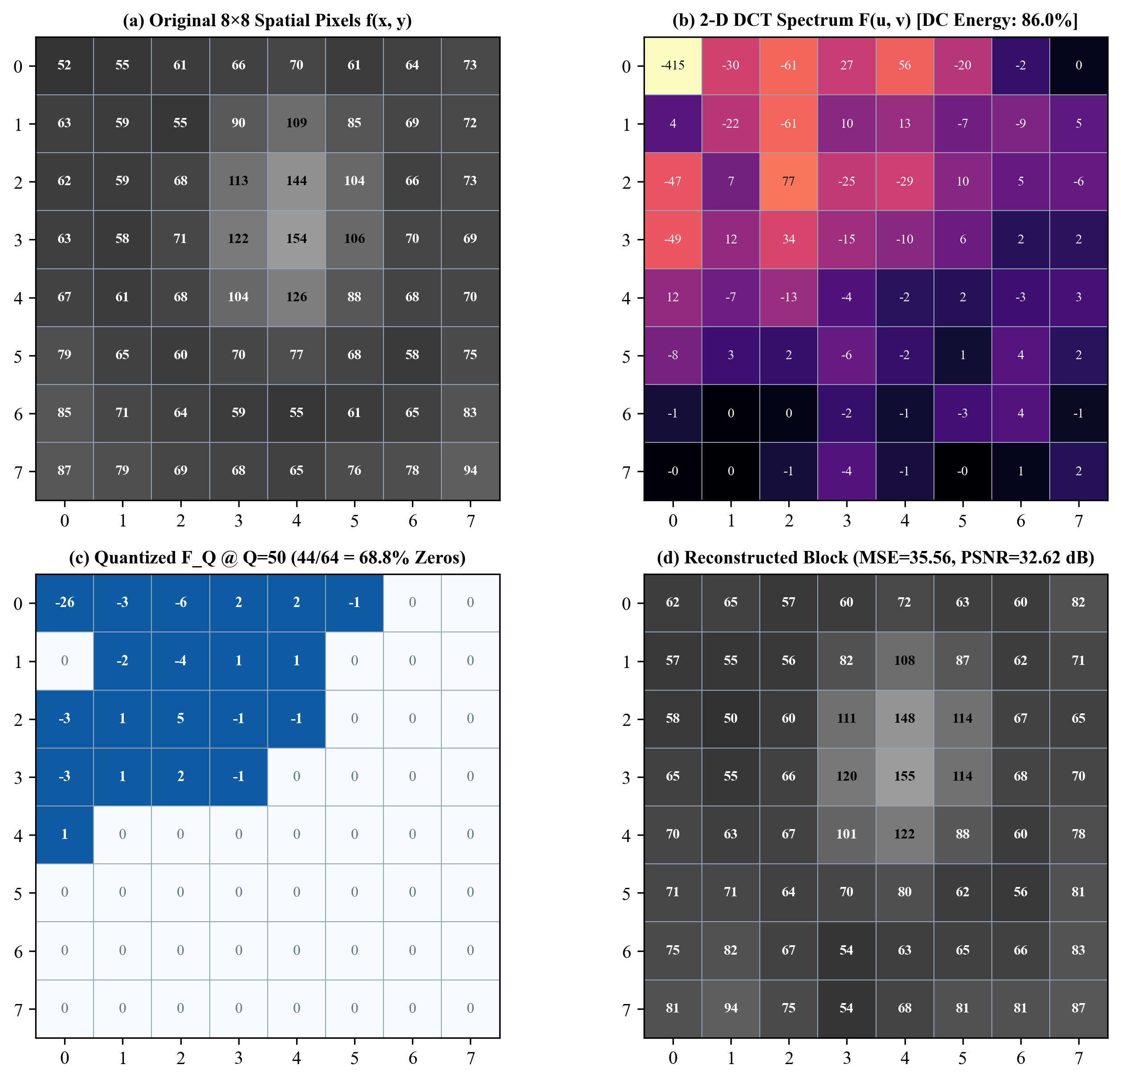
Fig 3.5: Visual heatmap summary of the Q = 50 numerical walkthrough on the 8×8 benchmark block: (a) input pixels, (b) log DCT spectrum, (c) sparse quantized integers, and (d) reconstructed block.
CHAPTER 4
IMPLEMENTATION AND SOFTWARE DESIGN
4.1 Technology Stack and Software Environment
The application is authored in Python 3.13 with strict reliance on open-source scientific computing libraries. NumPy [17] provides double-precision (float64) matrix multiplication and batch einsum tensor contractions, eliminating Python pixel loops so full 256×256 RGB compression completes in milliseconds. Pillow (PIL Fork) [18] handles image file decoding, color mode normalization, and comparison montage rendering.
Graphical presentation uses Python’s native Tkinter / ttk widget toolkit with the clam theme, ensuring zero external GUI installation requirements across Windows, macOS, and Linux desktops. Automated behavioral verification is implemented with pytest 8.3.4 covering mathematical invariants, boundary padding, GUI lifecycle, and CLI reporting.
4.2 Modular Repository Design and Vectorization
Table 4.1: Software Package Structure, Core Functions, and Module Responsibilities
Package / File | Key Symbols & Entry Points | Primary Architectural Responsibility
dct_core/dct.py | D, dct2(), idct2(), dct2_batch(), idct2_batch() | Precomputes 8×8 orthonormal DCT basis D; executes vectorized einsum('ij,njk,kl->nil', ...) batch transforms
dct_core/blocks.py | split_blocks(), merge_blocks() | Applies reflection edge padding for arbitrary sizes, reshapes 2-D planes into (N, 8, 8) tiles, and unpads output
dct_core/quant.py | LUM_TABLE_Q50, scale_table(), quantize(), dequantize() | Encodes ISO Q=50 luminance table, computes libjpeg S(Q) multiplier, and executes lossy rounding
dct_core/explanation.py | calculate_block_steps(), get_pipeline_flowchart() | Produces ASCII flowcharts, formal pseudocode, equations, live 8×8 numerical intermediates, and reports
pipeline/color.py | rgb_to_ycbcr(), ycbcr_to_rgb() | Analytic full-range ITU-R BT.601 matrices guaranteeing ±1 max round-trip precision
pipeline/pipeline.py | compress_image(), CompressionResult | Detects grayscale vs RGB, assigns Q and Q_chroma = max(1, Q//2), orchestrates pipeline & metrics
quality/metrics.py | mse(), psnr(), estimate_compressed_size(), compression_ratio() | Computes distortion scores and 64-index zig-zag RLE compressed byte estimates
io_utils/io.py | load_image(), save_image(), make_comparison_grid() | Image reading/writing with format-aware JPG q=100 preservation and 4-up montage generation
app/gui.py & theory_dialog.py | DCTApp, TheoryCalculationDialog | Interactive main desktop window (120 ms slider debounce) and 5-tab educational viva window
main.py & run_bench.py | main(), run() | CLI single-image processor (--grid, --format, --explain, --report) and CSV benchmark sweep tool

4.2.1 VECTORIZED EINSUM TENSOR BATCHING
Executing dct2() sequentially inside Python for loops across thousands of 8×8 blocks introduces substantial interpreter overhead. By reshaping each padded channel into a 3-D NumPy tensor (N, 8, 8) inside split_blocks(), dct2_batch() contracts D, all N image blocks, and D^T simultaneously via a single C-backed np.einsum call, keeping interactive slider dragging smooth on standard laptop hardware.
4.3 Interactive Desktop GUI and Dual Export Design
Launched via python app/gui.py, the main desktop interface (DCTApp) displays the original uncompressed image on the left and the reconstructed output on the right (360×360 Lanczos-scaled previews). Dragging the horizontal quality slider across Q = 1..100 schedules a lightweight 120 ms debounced refresh (self.root.after) so continuous mouse drags remain responsive without flooding the worker thread.
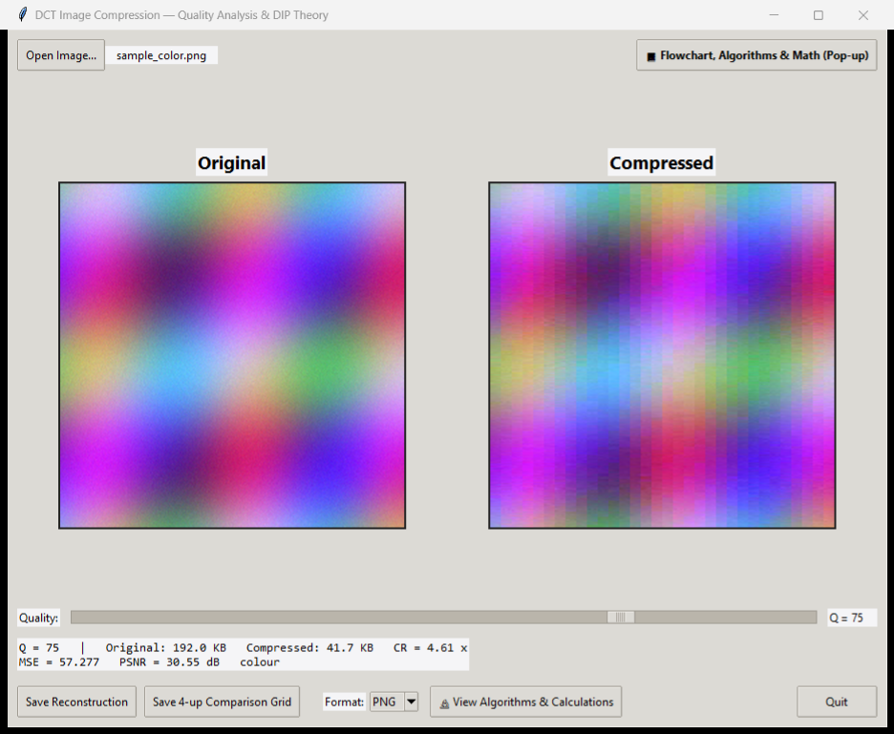
Fig 4.1: Main Tkinter GUI displaying Original vs. Compressed (Q = 75) preview on sample_color.png, live objective metrics readout, Format dropdown (PNG/JPG), and Educational Pop-up controls.
A dedicated Format: read-only dropdown (PNG or JPG) lets users save single reconstructions (* _recon_q<Q>.<ext>) or 4-up comparison grids (Original | Q = 75 | Q = 50 | Q = 10 in GUI; Original | Q = 90 | Q = 50 | Q = 10 in CLI). Crucially, io_utils/io.py passes quality=100 when saving .jpg outputs so Pillow does not re-quantize and mask the custom DCT artifacts generated by our mathematical pipeline.
4.4 Live 5-Tab Educational Theory & Calculation Pop-up
Designed explicitly for classroom demonstrations and oral viva evaluation, clicking `[Flowchart, Algorithms & Math]` opens TheoryCalculationDialog synchronized live with the main window’s active image and slider quality Q. Its five tabs present the Pipeline Flowchart, Formal Pseudocode, Governing Equations, an interactive 8×8 Numerical Walkthrough (switchable between the Gonzalez & Woods block and actual blocks extracted from the loaded photo), and full Global Metrics derivations—plus a one-click .txt academic report exporter.
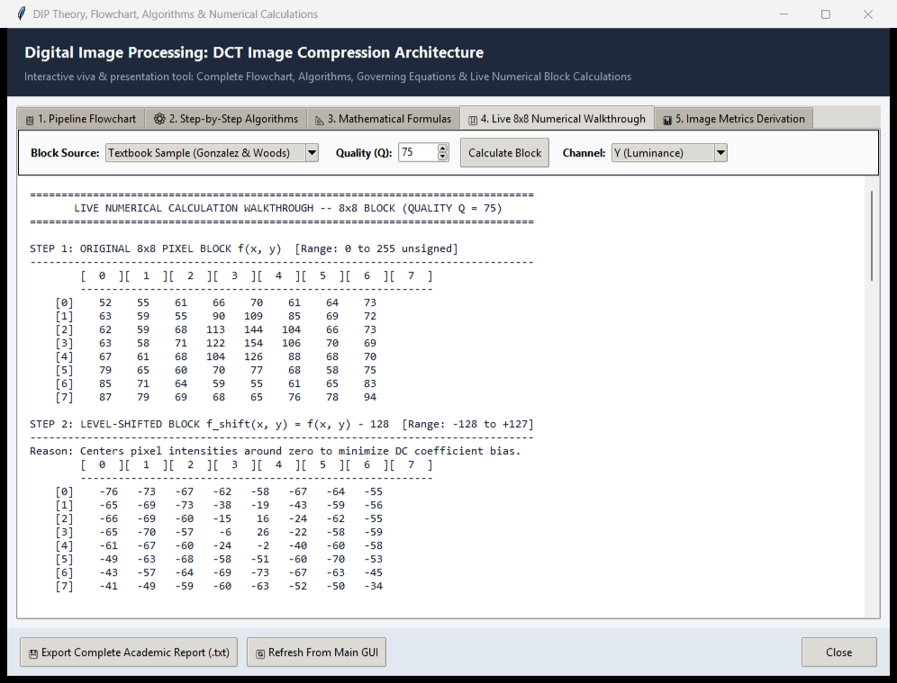
Fig 4.2: Interactive 5-tab DIP Theory & Numerical Calculation Pop-up Window (Tab 4 shown) displaying live 8×8 step-by-step matrices and academic export controls.
4.5 Command-Line Interface and Automated Test Suite
For batch scripting and headless verification, main.py exposes flags -q <1..100>, --no-color, --grid, --format {png,jpg}, --explain (terminal walkthrough printout), and --report <file.txt>. Similarly, benchmarks/run_bench.py sweeps arbitrary quality lists and logs structured CSV telemetry. All components pass an automated pytest suite comprising 32 tests across 7 modules in 16.86 seconds with zero skipped assertions.
Table 4.2: Automated Pytest Verification Suite Summary (Total: 32/32 Tests Passing)
Test Module | Test Count | Verified Invariants & Edge Cases | Status
tests/test_dct.py | 5 | D @ D.T == I_8 (<1e-10); single & batch round-trip (<1e-9); DC-only constant check; shape errors | 5 PASSED
tests/test_quant.py | 5 | Q=100 unit step; Q=1 extreme scaling; Q=50 identity match; rounding error <= step/2; bounds check | 5 PASSED
tests/test_metrics.py | 5 | Zero MSE & +inf PSNR for identical arrays; Gaussian noise sigma=10 check (~28.13 dB); RLE size sensitivity | 5 PASSED
tests/test_color.py | 3 | BT.601 RGB <-> YCbCr round-trip within ±1; RGB compression & Q_chroma = Q//2; 3-channel raw byte count | 3 PASSED
tests/test_pipeline.py | 3 | Smooth gradient PSNR > 35 dB at Q=75; non-multiple-of-8 (37×53) reflect pad/crop; Q=100 within ±1 | 3 PASSED
tests/test_io.py | 3 | Lossless grayscale & RGB PNG round-trip equality; 4-up comparison montage creation on disk | 3 PASSED
tests/test_explanation.py | 8 | Textbook DC=-415.38 & F_Q(0,0)=-26 at Q=50; Q=10 vs Q=95 monotonicity; CLI flags & GUI dialog sync | 8 PASSED

CHAPTER 5
RESULTS AND DISCUSSION
5.1 Visual Quality Evaluation Across Quality Factors
5.1.1 BLOCKING AND CHROMINANCE ARTIFACT OBSERVATIONS
Visual inspection across progressively lower quality settings reveals the classic perceptual hallmarks of block-DCT compression. On smooth grayscale luminance gradients (assets/sample.png, Fig 5.1), reconstructions at Q = 90 (37.19 dB) remain practically indistinguishable from the original. At Q = 50 (31.72 dB), mild contour banding becomes noticeable upon close inspection, whereas Q = 10 (26.42 dB) exposes unmistakable 8×8 tile discontinuities (blocking artifacts).
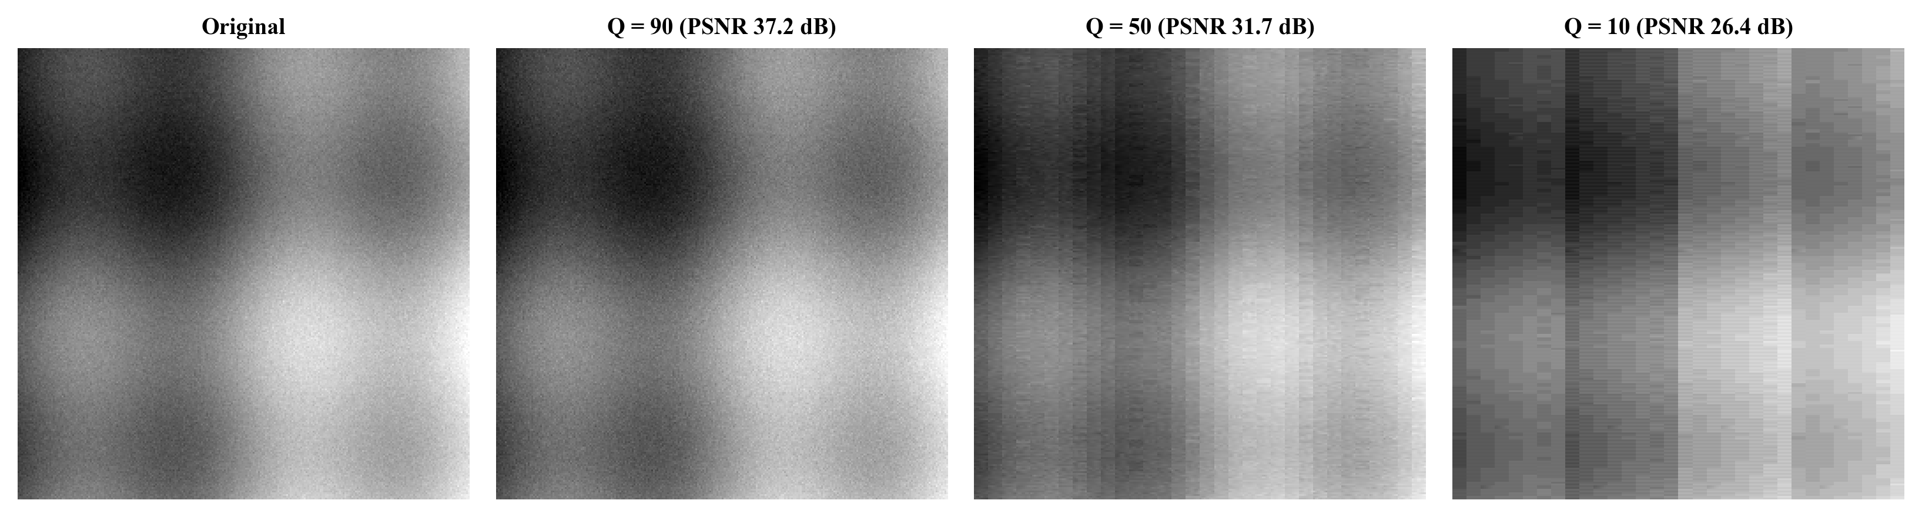
Fig 5.1: Grayscale 4-up reconstruction comparison on assets/sample.png (256×256) comparing Original against Q = 90 (37.19 dB), Q = 50 (31.72 dB), and Q = 10 (26.42 dB).
On natural complex RGB illustrations (avatar_comparison.jpg and Cosmic Prince_comparison.png, Fig 5.2), asymmetric chroma compression amplifies color degradation at extreme compression. Because chrominance planes are quantized at Q_chroma = max(1, 10 // 2) = 5 when Q = 10, subtle color washes collapse into flat grayscale-like blocks or magenta/cyan chroma blotches, while Q = 75 retains crisp edge lighting and vibrant color fidelity.
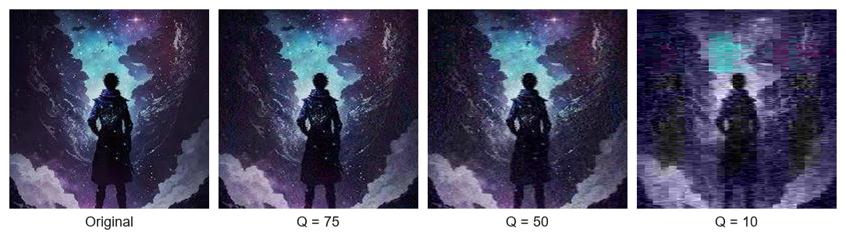
Fig 5.2a: GUI-exported 4-up JPG comparison grid on avatar.jpg (Original, Q = 75, Q = 50, and Q = 10) illustrating chromatic breakdown at extreme compression.
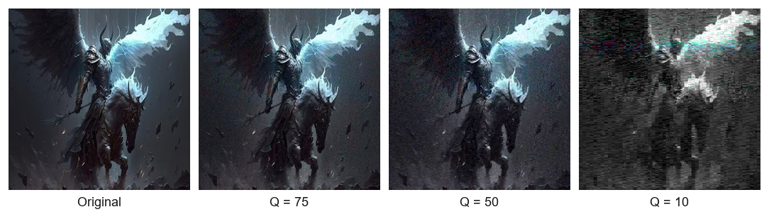
Fig 5.2b: GUI-exported 4-up PNG comparison grid on Cosmic Prince illustrating fine high-frequency detail retention at Q = 75 vs. heavy 8×8 blocking at Q = 10.
5.2 Quantitative Benchmark Results: Grayscale vs. Color Images
To measure exact storage-distortion curves systematically, benchmarks were swept across Q ∈ {5, 10, 15, ..., 100} on both assets/sample.png (256×256 grayscale, raw = 64.00 KB) and assets/sample_color.png (256×256×3 color RGB, raw = 192.00 KB). Key operating points are tabulated in Tables 5.1 and 5.2.
Table 5.1: Quantitative Compression Performance on Grayscale Image (assets/sample.png, 256×256, Raw = 64.00 KB)
Quality Q | Comp. Size (KB) | CR (:1) | Bitrate (BPP) | Sparsity (% Zero) | MSE | PSNR (dB)
5 | 8.34 | 7.67× | 1.043 | 94.26% | 335.554 | 22.87
10 | 8.86 | 7.23× | 1.107 | 93.86% | 148.224 | 26.42
25 | 11.74 | 5.45× | 1.468 | 91.61% | 76.828 | 29.28
40 | 15.70 | 4.08× | 1.963 | 88.51% | 46.614 | 31.45
50 | 18.35 | 3.49× | 2.293 | 86.45% | 43.718 | 31.72
75 | 30.07 | 2.13× | 3.759 | 77.29% | 30.321 | 33.31
90 | 60.03 | 1.07× | 7.504 | 53.88% | 12.406 | 37.19
95 | 87.87 | 0.73× | 10.983 | 32.14% | 3.763 | 42.38
100 | 121.56 | 0.53× | 15.195 | 5.82% | 0.497 | 51.17

Table 5.2: Quantitative Compression Performance on Color RGB Image (assets/sample_color.png, 256×256×3, Raw = 192.00 KB)
Quality (Y / C) | Comp. Size (KB) | CR (:1) | Bitrate (BPP) | Sparsity (% Zero) | MSE | PSNR (dB)
5 / 2 | 10.80 | 17.78× | 1.350 | 97.97% | 932.398 | 18.43
10 / 5 | 12.82 | 14.98× | 1.602 | 97.44% | 696.753 | 19.70
25 / 12 | 23.64 | 8.12× | 2.955 | 94.63% | 350.685 | 22.68
40 / 20 | 30.05 | 6.39× | 3.756 | 92.96% | 128.349 | 27.05
50 / 25 | 32.63 | 5.88× | 4.079 | 92.28% | 96.833 | 28.27
75 / 37 | 41.67 | 4.61× | 5.209 | 89.93% | 57.277 | 30.55
90 / 45 | 60.65 | 3.17× | 7.582 | 84.99% | 42.639 | 31.83
95 / 47 | 82.26 | 2.33× | 10.282 | 79.36% | 39.556 | 32.16
100 / 50 | 139.66 | 1.37× | 17.458 | 64.41% | 35.301 | 32.65

Notice an illuminating behavior at Q = 95 and Q = 100 in grayscale Table 5.1: the teaching RLE estimator exceeds the raw 64.00 KB baseline (CR = 0.73× at Q = 95, 0.53× at Q = 100). Because estimate_compressed_size() assigns a fixed 2 bytes per nonzero coefficient rather than compact variable-length Huffman codes, keeping 68%–94% of coefficients nonzero causes representation expansion—proving experimentally why real JPEG relies on entropy coding at high Q.
5.3 Rate–Distortion, Compression Ratio, and Sparsity Trends
Fig 5.3 confirms a strictly monotonic improvement in PSNR as quality Q rises. Grayscale compression crosses the classic 30 dB perceptual transparency threshold near Q = 30 (30.24 dB), whereas the multi-channel RGB pipeline crosses 30 dB near Q = 70 (30.11 dB) because Cb and Cr experience twice the quantization step size.
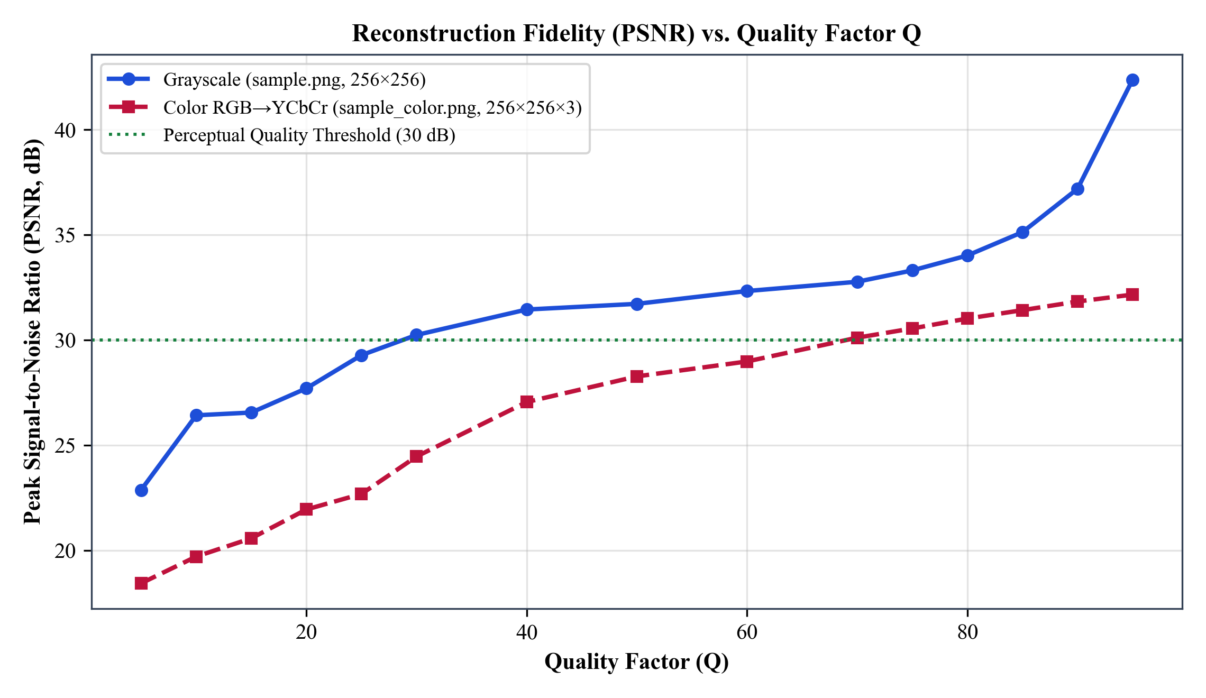
Fig 5.3: Measured Peak Signal-to-Noise Ratio (PSNR, dB) plotted across Quality Factors Q = 5 to 95 against the 30 dB visual quality benchmark.
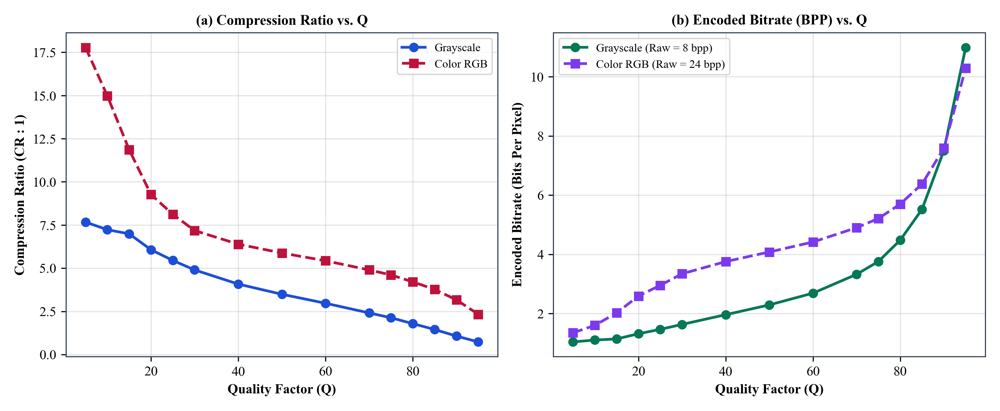
Fig 5.4: (a) Measured Compression Ratio (CR) and (b) Encoded Bitrate (Bits Per Pixel) as functions of Quality Factor Q.
Fig 5.4 and Fig 5.5 reveal the underlying cause of size reduction: between Q = 5 and Q = 75, average coefficient sparsity remains exceptionally high (77.29% to 94.26% zeros in grayscale; 89.93% to 97.97% zeros averaged across RGB YCbCr channels), driving compression ratios up to 7.67× (grayscale) and 17.78× (color).
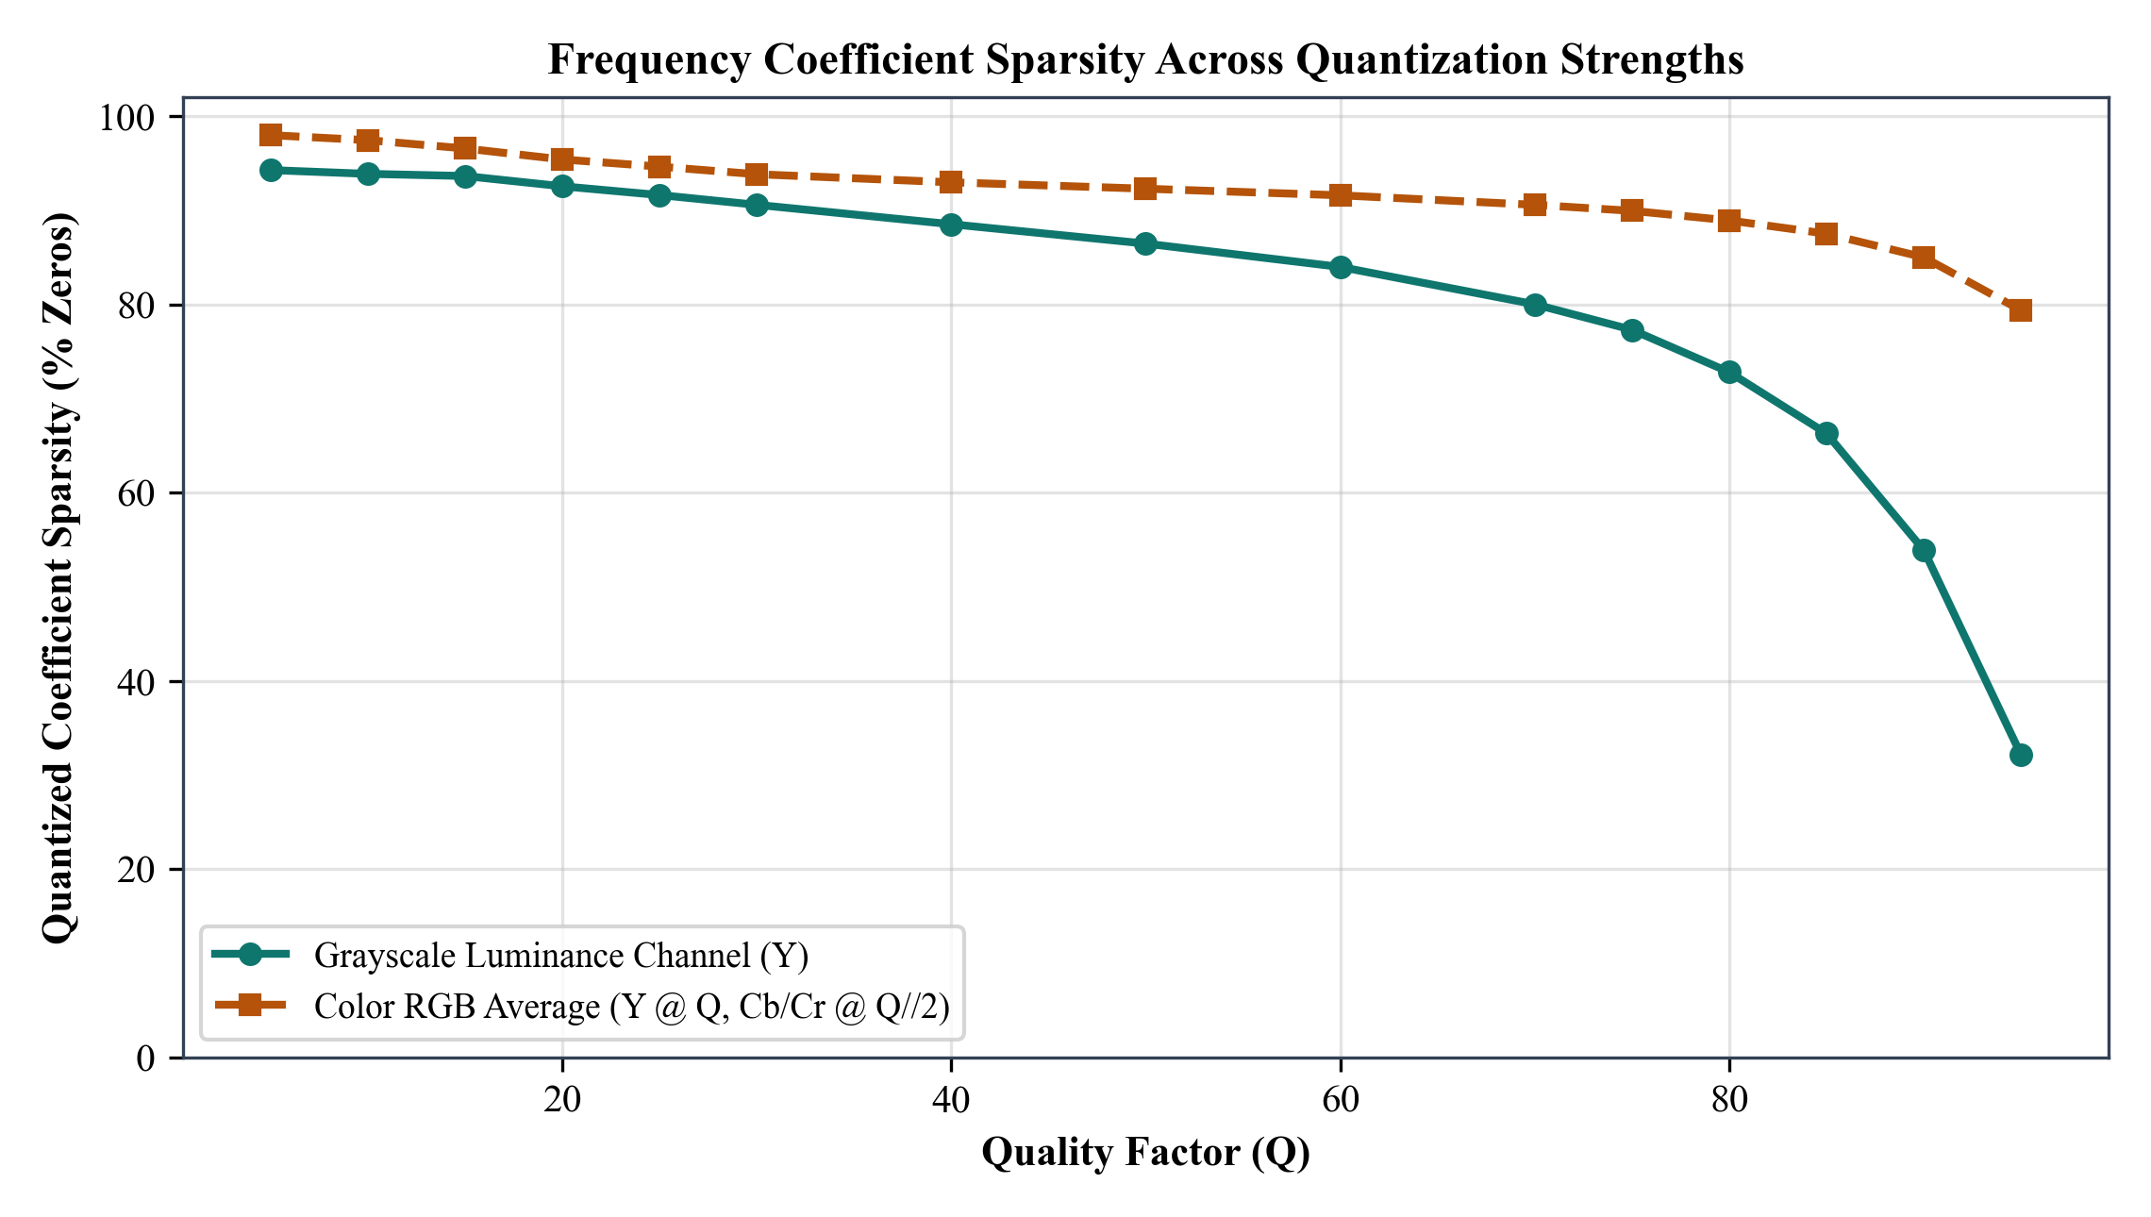
Fig 5.5: Percentage of quantized 8×8 DCT coefficients coerced to exact zeros across Quality Factors Q = 5 to 95.
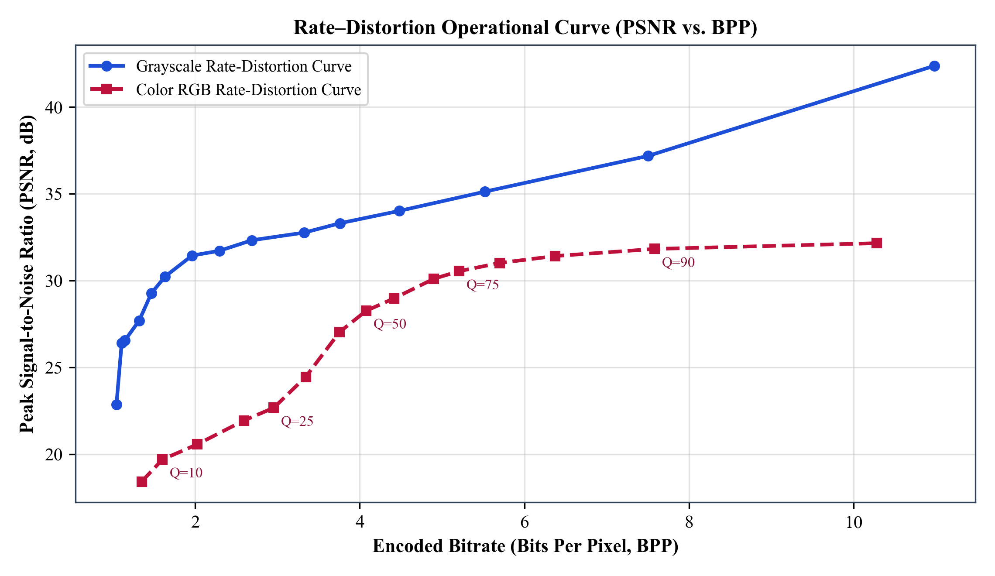
Fig 5.6: Operational Rate–Distortion Curve (PSNR vs. BPP) illustrating the optimal compression 'knee' between Q = 50 and Q = 75.
Plotting PSNR directly against BPP in Fig 5.6 highlights the diminishing returns above Q = 75. Increasing RGB quality from Q = 75 (5.21 BPP, 30.55 dB) to Q = 95 (10.28 BPP, 32.16 dB) nearly doubles bitrate while adding only 1.61 dB of PSNR gain. Therefore, Q = 50–75 represents the mathematically optimal operating knee for natural imagery.
5.4 Bitstream Estimate vs. File-Container Storage Discrepancy Analysis
A frequent point of confusion during image compression experiments is why the GUI reports Original: 192.0 KB even for a small JPG file on disk, or why saving a compressed reconstruction as .png yields a larger disk file than the reported Compressed: estimate. Table 5.3 resolves this discrepancy quantitatively using sample_color.png (256×256×3).
Table 5.3: Comparison of Raw Memory, Uncompressed BMP, RLE Estimate, PNG Container, and JPEG Container Sizes (sample_color.png)
Quality Q | Raw Memory (KB) | BMP Disk Size (KB) | RLE Bitstream Est. (KB) | Saved PNG Container (KB) | Saved JPG (q=100) (KB) | PSNR (dB)
10 | 192.00 | 192.05 | 12.82 | 16.07 | 31.24 | 19.70
50 | 192.00 | 192.05 | 32.63 | 41.68 | 33.21 | 28.27
75 | 192.00 | 192.05 | 41.67 | 78.54 | 40.73 | 30.55
90 | 192.00 | 192.05 | 60.65 | 96.12 | 47.71 | 31.83

First, disk files in .jpg or .png are already compressed containers; once decoded into RAM for display and matrix processing, a 256×256 RGB image unconditionally expands to 256 × 256 × 3 = 196,608 bytes (192.00 KB), matching a Windows BMP file (192.05 KB including its 54-byte header). Benchmarking against raw pixel memory isolates pure DCT math.
Second, exporting reconstructed pixels as a lossless .png container at Q = 75 produces 78.54 KB—nearly double our 41.67 KB DCT RLE estimate—because PNG’s DEFLATE algorithm cannot drop quantization rounding residuals or sharp 8×8 edges introduced during lossy reconstruction. Adding the PNG / JPG selector cleanly separates visual inspection from lossless archival.
CHAPTER 6
CONCLUSION AND FUTURE SCOPE
6.1 Conclusion
This project successfully designed, implemented, and validated a complete from-scratch 2-D DCT image compression and quality analysis pipeline tailored for Digital Image Processing education and empirical evaluation. Every stage of the signal chain—BT.601 color conversion, zero-centering, reflection-padded 8×8 blocking, separable orthonormal DCT-II/IDCT-III, ISO quantization scaling, and zig-zag run-length estimation—was coded transparently using pure NumPy arrays.
Empirical evaluations verified core information-theoretic predictions: the 2-D DCT achieved 86.04% DC energy compaction on standard benchmark patches, while psychovisual quantization discarded 77%–94% of grayscale frequency coefficients to deliver 2.13×–7.23× compression ratios. Color experiments confirmed that halving chroma quality (Q_chroma = max(1, Q // 2)) achieves 4.61× compression at 30.55 dB (Q = 75) while maintaining high subjective visual quality.
Coupled with a responsive Tkinter GUI, dual PNG/JPG output formatting, a comprehensive 5-tab Flowchart and Numerical Walkthrough pop-up dialog, a scriptable CLI, and 32 passing automated tests, the system serves both as a working desktop compression studio and a self-contained viva preparation laboratory.
6.2 Limitations of the Current Implementation
While faithful to transform-coding principles, three architectural boundaries define the current educational scope. First, estimate_compressed_size() models quantized size using fixed 2-byte (run, value) tuples instead of binary variable-length Huffman entropy tables and JPEG file markers (SOI, DQT, SOS), causing slight byte inflation above Q = 90. Second, chroma channels remain at full spatial resolution rather than utilizing 4:2:0 spatial downsampling. Third, no deblocking loop filter is applied at very low quality factors (Q < 20).
6.3 Future Scope
- Canonical Huffman Bitstream Writer: Implement JPEG baseline DC differential coding (DPCM) and variable-length Huffman entropy tables to emit valid, browser-readable .jpg binary bitstreams directly from scratch.
- 4:2:0 Chroma Subsampling Module: Add optional 2×2 spatial averaging of Cb and Cr planes prior to DCT splitting to achieve realistic 2× extra chromatic storage savings alongside psychovisual quantization.
- Perceptual Structural Similarity (SSIM): Integrate Structural Similarity Index (SSIM) [14] and Multi-Scale SSIM alongside MSE and PSNR inside the live GUI readout and benchmark plots.
- Discrete Wavelet Transform (DWT) Comparator: Extend the educational pop-up with a Haar/Daubechies 2-D DWT compression mode [12] to let students contrast JPEG-style 8×8 blocking artifacts against wavelet blurring side-by-side.
REFERENCES
[1] Shannon, C.E. A mathematical theory of communication. Bell Syst. Tech. J. 1948, 27, 379–423.
[2] Gonzalez, R.C.; Woods, R.E. Digital Image Processing, 4th ed.; Pearson Education: New York, NY, USA, 2018.
[3] Wallace, G.K. The JPEG still picture compression standard. Commun. ACM 1991, 34, 30–44.
[4] Ahmed, N.; Natarajan, T.; Rao, K.R. Discrete cosine transform. IEEE Trans. Comput. 1974, C-23, 90–93.
[5] Huffman, D.A. A method for the construction of minimum-redundancy codes. Proc. IRE 1952, 40, 1098–1101.
[6] Rao, K.R.; Yip, P. Discrete Cosine Transform: Algorithms, Advantages, Applications; Academic Press: Boston, MA, USA, 1990.
[7] ISO/IEC 10918-1. Information Technology — Digital Compression and Coding of Continuous-Tone Still Images: Requirements and Guidelines; ISO: Geneva, Switzerland, 1994.
[8] Pennebaker, W.B.; Mitchell, J.L. JPEG: Still Image Data Compression Standard; Van Nostrand Reinhold: New York, NY, USA, 1993.
[9] Mannos, J.L.; Sakrison, D.J. The effects of a visual fidelity criterion on the encoding of images. IEEE Trans. Inf. Theory 1974, 20, 525–536.
[10] ITU-R Recommendation BT.601-7. Studio Encoding Parameters of Digital Television for Standard 4:3 and Wide-Screen 16:9 Aspect Ratios; ITU: Geneva, Switzerland, 2011.
[11] Boutell, T. PNG (Portable Network Graphics) Specification Version 1.0 (RFC 2083). W3C Recommendation / IETF, 1997.
[12] Taubman, D.S.; Marcellin, M.W. JPEG2000: Image Compression Fundamentals, Standards and Practice; Springer: New York, NY, USA, 2002.
[13] Bankoski, J.; Wilkins, P.; Xu, Y. Technical overview of VP8, an open source video codec for the web. In Proc. IEEE Int. Conf. Multimedia and Expo (ICME); Barcelona, Spain, 2011; pp. 1–6.
[14] Wang, Z.; Bovik, A.C.; Sheikh, H.R.; Simoncelli, E.P. Image quality assessment: From error visibility to structural similarity. IEEE Trans. Image Process. 2004, 13, 600–612.
[15] Huynh-Thu, Q.; Ghanbari, M. Scope of validity of PSNR in image/video quality assessment. Electron. Lett. 2008, 44, 800–801.
[16] Independent JPEG Group (IJG). libjpeg Reference Implementation and Quality Table Scaling Rules (jcparam.c); Release 6b/9e, 1998.
[17] Harris, C.R.; Millman, K.J.; van der Walt, S.J.; et al. Array programming with NumPy. Nature 2020, 585, 357–362.
[18] Clark, A. Pillow (PIL Fork) Python Imaging Library Documentation, Version 11.0; Python Software Foundation, 2024.
APPENDIX A
KEY SOURCE CODE EXCERPTS AND TEST VERIFICATION LOG
A.1 Core Mathematical Modules (dct_core/dct.py and quant.py)
Listing A.1: dct_core/dct.py — From-Scratch 8×8 Orthonormal 2-D DCT & Batch Einsum Engine
"""
dct_core.dct
============
From-scratch 2-D Type-II Discrete Cosine Transform (DCT) and its inverse.
Why we implement it ourselves (instead of calling scipy.fft.dctn):
* It keeps the math visible and aligned with the syllabus.
* The 8x8 DCT matrix is precomputed once and reused for every block,
so the cost on a 512x512 image is essentially 4096 tiny 8x8 matrix products.
* No external FFT dependency to demo live.
The forward 2-D DCT of an 8x8 block x is:
X = D @ x @ D.T
and the matching inverse (Type-III) is:
x = D.T @ X @ D
where D is the 8x8 matrix whose (k, i) entry is:
D[k, i] = alpha(k) * cos((2i + 1) * k * pi / 16)
with alpha(0) = 1/sqrt(8)
alpha(k > 0) = sqrt(2/8) = 1/2.
With this normalization D is orthonormal, so D @ D.T == I and
D.T @ D == I. The inverse above is therefore the exact transpose.
"""
from __future__ import annotations
import numpy as np
BLOCK: int = 8
def _build_dct_matrix(n: int = 8, dtype=np.float64) -> np.ndarray:
k = np.arange(n, dtype=dtype).reshape(n, 1)
i = np.arange(n, dtype=dtype).reshape(1, n)
alpha = np.where(k == 0, 1.0 / np.sqrt(n), np.sqrt(2.0 / n))
return alpha * np.cos((2 * i + 1) * k * np.pi / (2 * n))
D: np.ndarray = _build_dct_matrix(BLOCK, dtype=np.float64)
def dct2(block: np.ndarray) -> np.ndarray:
"""Forward 2-D DCT-II of a single 8x8 block.
Input shape (8, 8), float-like. Returns (8, 8) float64 coefficients.
"""
if block.shape != (BLOCK, BLOCK):
raise ValueError(f"dct2 expects an {(BLOCK, BLOCK)} block, got {block.shape}")
x = np.asarray(block, dtype=np.float64)
return D @ x @ D.T
def idct2(coeffs: np.ndarray) -> np.ndarray:
"""Inverse 2-D DCT-III (matching dct2) of a single 8x8 coefficient block."""
if coeffs.shape != (BLOCK, BLOCK):
raise ValueError(f"idct2 expects an {(BLOCK, BLOCK)} block, got {coeffs.shape}")
X = np.asarray(coeffs, dtype=np.float64)
return D.T @ X @ D
def dct2_batch(blocks: np.ndarray) -> np.ndarray:
"""Forward DCT applied to a stack of N blocks of shape (N, 8, 8).
Computes D @ x @ D.T for every block.
"""
if blocks.ndim != 3 or blocks.shape[1:] != (BLOCK, BLOCK):
raise ValueError(f"dct2_batch expects (N, {BLOCK}, {BLOCK}), got {blocks.shape}")
x = np.asarray(blocks, dtype=np.float64)
# (n, i, l) = sum_{j, k} D[i, j] * x[n, j, k] * D.T[k, l]
return np.einsum("ij,njk,kl->nil", D, x, D.T)
def idct2_batch(coeffs: np.ndarray) -> np.ndarray:
"""Inverse DCT applied to a stack of N blocks of shape (N, 8, 8).
Computes D.T @ X @ D for every block.
"""
if coeffs.ndim != 3 or coeffs.shape[1:] != (BLOCK, BLOCK):
raise ValueError(f"idct2_batch expects (N, {BLOCK}, {BLOCK}), got {coeffs.shape}")
X = np.asarray(coeffs, dtype=np.float64)
# (n, i, l) = sum_{j, k} D.T[i, j] * X[n, j, k] * D[k, l]
return np.einsum("ij,njk,kl->nil", D.T, X, D)

Listing A.2: dct_core/quant.py — Base Luminance Table, Quality Scaling & Quantization
"""
dct_core.quant
==============
JPEG-style quantization for DCT coefficients.
We hard-code the standard luminance table used by JPEG at quality factor 50
and the standard scaling rule so the same table can be adapted to any Q
between 1 and 100. Higher Q = finer quantization = bigger file = better quality.
This is the heart of why DCT compression is *lossy*: dividing by the
quantization table and rounding to an integer throws away small
high-frequency details that the eye barely notices.
"""
from __future__ import annotations
import numpy as np
LUM_TABLE_Q50: np.ndarray = np.array(
[
[16, 11, 10, 16, 24, 40, 51, 61],
[12, 12, 14, 19, 26, 58, 60, 55],
[14, 13, 16, 24, 40, 57, 69, 56],
[14, 17, 22, 29, 51, 87, 80, 62],
[18, 22, 37, 56, 68, 103, 77, 62],
[30, 35, 55, 64, 81, 104, 92, 75],
[50, 72, 78, 87, 103, 121, 100, 78],
[68, 92, 95, 98, 112, 100, 103, 99],
],
dtype=np.int32,
)
def scale_table(base: np.ndarray, q: int) -> np.ndarray:
"""Scale a base quantization table for an arbitrary JPEG Q-factor in [1, 100].
The rule is the standard one used by libjpeg:
if Q < 50: scale = 5000 / Q
else: scale = 200 - 2 * Q
scaled[i] = clip(floor((base[i] * scale + 50) / 100), 1, 255)
"""
if not 1 <= q <= 100:
raise ValueError(f"Quality factor Q must be in [1, 100], got {q}")
scale = 5000 / q if q < 50 else 200 - 2 * q
scaled = np.floor((base.astype(np.float64) * scale + 50.0) / 100.0)
return np.clip(scaled, 1, 255).astype(np.int32)
def quantize(coeffs: np.ndarray, table: np.ndarray) -> np.ndarray:
"""Quantize DCT coefficients: round(C / table). Accepts (8, 8) or (N, 8, 8)."""
if coeffs.shape[-2:] != table.shape:
raise ValueError(
f"quantize: coefficient shape {coeffs.shape} does not match table {table.shape}"
)
return np.round(coeffs.astype(np.float64) / table.astype(np.float64)).astype(np.int32)
def dequantize(qcoeffs: np.ndarray, table: np.ndarray) -> np.ndarray:
"""Dequantize: qcoeffs * table (recovers approximate DCT coefficients)."""
if qcoeffs.shape[-2:] != table.shape:
raise ValueError(
f"dequantize: qcoeff shape {qcoeffs.shape} does not match table {table.shape}"
)
return qcoeffs.astype(np.float64) * table.astype(np.float64)

A.2 Pipeline Orchestration and Automated Test Verification
Listing A.3: pipeline/pipeline.py — End-to-End Grayscale & YCbCr Compression Orchestrator
"""
pipeline.pipeline
=================
Orchestrates the full DCT compression pipeline for both grayscale and
colour images.
For colour images we go RGB → YCbCr → per-channel DCT/quant/IDCT
→ YCbCr → RGB. The luminance channel Y is processed at the user-selected
quality Q; the chroma channels Cb and Cr are processed at
Q_chroma = max(1, Q // 2), matching how JPEG treats chroma more
aggressively than luma.
The pipeline is vectorized: every channel is processed as one batch
of (N, 8, 8) blocks so the demo stays fast on a typical laptop.
"""
from __future__ import annotations
from dataclasses import dataclass
from typing import Optional
import numpy as np
from dct_core.blocks import merge_blocks, split_blocks
from dct_core.dct import dct2_batch, idct2_batch
from dct_core.quant import (
LUM_TABLE_Q50,
scale_table,
quantize,
dequantize,
)
from quality.metrics import (
compression_ratio,
estimate_compressed_size,
mse,
psnr,
)
@dataclass
class CompressionResult:
reconstructed: np.ndarray # uint8 image with the same shape as input
cr: float # compression ratio (orig / compressed)
mse_val: float # mean squared error over all pixels
psnr_val: float # decibels, +inf if lossless
original_bytes: int # raw pixel bytes (W * H * C)
compressed_bytes: int # zig-zag / RLE estimator result
quality: int # Q used for luminance
chroma_quality: int # Q used for chroma channels
def _compress_channel(channel: np.ndarray, q: int) -> tuple[np.ndarray, np.ndarray, np.ndarray]:
"""Compress one 2-D channel (H, W) at quality Q and return (recon, qblocks, table)."""
shifted = channel.astype(np.float64) - 128.0
blocks, orig_shape, padded_shape = split_blocks(shifted)
coeffs = dct2_batch(blocks)
table = scale_table(LUM_TABLE_Q50, q)
qblocks = quantize(coeffs, table)
rec_coeffs = dequantize(qblocks, table)
rec_shifted = idct2_batch(rec_coeffs)
rec = merge_blocks(rec_shifted, orig_shape, padded_shape) + 128.0
return rec, qblocks, table
def compress_image(image_u8: np.ndarray, quality: int = 75) -> CompressionResult:
"""Top-level entry: accept (H, W) grayscale or (H, W, 3) RGB uint8."""
if not (1 <= quality <= 100):
raise ValueError(f"quality must be in [1, 100], got {quality}")
if image_u8.dtype != np.uint8:
image_u8 = image_u8.astype(np.uint8)
if image_u8.ndim == 2:
rec_f, qblocks, _ = _compress_channel(image_u8, quality)
rec_u8 = np.clip(rec_f, 0, 255).astype(np.uint8)
original_bytes = int(image_u8.size)
compressed_bytes = estimate_compressed_size(qblocks)
cr = compression_ratio(original_bytes, compressed_bytes)
m = mse(image_u8.astype(np.float64), rec_u8.astype(np.float64))
p = psnr(image_u8.astype(np.float64), rec_u8.astype(np.float64))
return CompressionResult(rec_u8, cr, m, p, original_bytes, compressed_bytes,
quality, quality)
if image_u8.ndim == 3 and image_u8.shape[-1] == 3:
from .color import rgb_to_ycbcr, ycbcr_to_rgb
ycbcr = rgb_to_ycbcr(image_u8)
y_q = quality
c_q = max(1, quality // 2)
y_rec, y_qblocks, _ = _compress_channel(ycbcr[..., 0], y_q)
cb_rec, cb_qblocks, _ = _compress_channel(ycbcr[..., 1], c_q)
cr_rec, cr_qblocks, _ = _compress_channel(ycbcr[..., 2], c_q)
rec_ycbcr = np.stack([y_rec, cb_rec, cr_rec], axis=-1)
rec_u8 = ycbcr_to_rgb(rec_ycbcr)
original_bytes = int(image_u8.size)
compressed_bytes = (
estimate_compressed_size(y_qblocks)
+ estimate_compressed_size(cb_qblocks)
+ estimate_compressed_size(cr_qblocks)
)
cr = compression_ratio(original_bytes, compressed_bytes)
m = mse(image_u8.astype(np.float64), rec_u8.astype(np.float64))
p = psnr(image_u8.astype(np.float64), rec_u8.astype(np.float64))
return CompressionResult(rec_u8, cr, m, p, original_bytes, compressed_bytes,
y_q, c_q)
raise ValueError(f"compress_image expects (H, W) or (H, W, 3), got {image_u8.shape}")

Listing A.4: Automated Verification Output (python -m pytest tests/ -v)
$ python -m pytest tests/ -v
platform win32 -- Python 3.13.7, pytest-8.3.4, pluggy-1.7.0
collected 32 items
tests/test_color.py::test_roundtrip_rgb PASSED [ 3%]
tests/test_color.py::test_compress_color_image_runs PASSED [ 6%]
tests/test_color.py::test_color_size_includes_three_channels PASSED [ 9%]
tests/test_dct.py::test_orthogonality PASSED [ 12%]
tests/test_dct.py::test_roundtrip_single_block PASSED [ 15%]
tests/test_dct.py::test_roundtrip_batch PASSED [ 18%]
tests/test_dct.py::test_constant_block_dc_only PASSED [ 21%]
tests/test_dct.py::test_input_shape_errors PASSED [ 25%]
tests/test_explanation.py::test_calculate_block_steps_standard_sample PASSED [ 28%]
tests/test_explanation.py::test_quality_factor_scaling_extremes PASSED [ 31%]
tests/test_explanation.py::test_format_matrix PASSED [ 34%]
tests/test_explanation.py::test_text_generators PASSED [ 37%]
tests/test_explanation.py::test_full_image_metrics_breakdown PASSED [ 40%]
tests/test_explanation.py::test_report_generation PASSED [ 43%]
tests/test_explanation.py::test_cli_explain_and_report_flags PASSED [ 46%]
tests/test_explanation.py::test_gui_theory_popup_dialog_lifecycle PASSED [ 50%]
tests/test_io.py::test_roundtrip_png_grayscale PASSED [ 53%]
tests/test_io.py::test_roundtrip_png_color PASSED [ 56%]
tests/test_io.py::test_comparison_grid_writes_file PASSED [ 59%]
tests/test_metrics.py::test_mse_zero_for_identical PASSED [ 62%]
tests/test_metrics.py::test_psnr_inf_for_identical PASSED [ 65%]
tests/test_metrics.py::test_psnr_known_noise PASSED [ 68%]
tests/test_metrics.py::test_compression_ratio_basic PASSED [ 71%]
tests/test_metrics.py::test_estimate_size_responds_to_q PASSED [ 75%]
tests/test_pipeline.py::test_pipeline_smooth_image_high_psnr PASSED [ 78%]
tests/test_pipeline.py::test_pipeline_non_multiple_of_8_dimensions PASSED [ 81%]
tests/test_pipeline.py::test_q100_is_lossless_within_one PASSED [ 84%]
tests/test_quant.py::test_q100_means_unit_step PASSED [ 87%]
tests/test_quant.py::test_q1_is_aggressive PASSED [ 90%]
tests/test_quant.py::test_q50_is_base_table PASSED [ 93%]
tests/test_quant.py::test_quantize_dequantize_error_bound PASSED [ 96%]
tests/test_quant.py::test_invalid_q_raises PASSED [100%]
============================= 32 passed in 16.86s =============================

