

**Student Name:** Wedaralalage Fleming Zenith Fernando

**Student ID:** 20211594

**UoW Number:** 19574189

**Degree:** Compuer Science L4

**Unit Code and Description**: Software development (Pro) 4COSC006C

**Module Leader:** Mr. Saman Hettiarachchi

**Assignment Number:** 1

**Assignment Type:** Individual

**Issue Date:** 25th October 2022

**Hand in Date:** 13th December 2022

|  |
| --- |
| **4COSC001W: Software Development I – TEST PLAN for Part 1** Student Name/ID: Wedaralalage Fleming Zenith Fernando  Seminar Day/Time: 13th December 2022 Module Tutor: Mr. Saman Hettiarchchi |

|  |  |  |  |  |  |
| --- | --- | --- | --- | --- | --- |
|  | Student Name: W.F.Z. Fernando Student ID: 20211594 | | | | |
|  | TEST PLAN for Part 1  Submit completed test plan with your code solution | | | | |
| Test Component | Test No. | Test Input | A - Expected Result | B - Actual Result  (Or state ‘not attempted’) | Pass/Fail  (‘A’ matches ‘B’ == Pass) |
| Progress | 1 | Pass = 120  Defer = 0  Fail = 0 | ‘Progress’ displayed | Progress | Pass |
| Progress (module trailer) | 2.1 | Pass = 100  Defer = 20  Fail = 0 | ‘Progress (module trailer)’ displayed | Progress (module trailer) | Pass |
| 2.2 | Pass = 100  Defer = 0  Fail = 20 | ‘Progress (module trailer)’ displayed | Progress (module trailer) | Pass |
| Module retriever | 3.1 | Pass = 80  Defer = 20  Fail = 20 | ‘Module retriever’ is displayed | Module retriever | Pass |
| 3.2 | Pass = 60  Defer = 0  Fail = 60 | ‘Module retriever’ is displayed | Module retriever | Pass |
| 3.3 | Pass = 40  Defer = 80  Fail = 0 | ‘Module retriever’ is displayed | Module retriever | Pass |
| 3.4 | Pass = 20  Defer = 40  Fail = 60 | ‘Module retriever’ is displayed | Module retriever | Pass |
| 3.5 | Pass = 0  Defer = 60  Fail = 60 | ‘Module retriever’ is displayed | Module retriever | Pass |
| Exclude | 4.1 | Pass = 40  Defer = 0  Fail = 80 | ‘Exclude’ displayed | Exclude | Pass |
| 4.2 | Pass = 20  Defer = 0  Fail = 100 | ‘Exclude’ displayed | Exclude | Pass |
| Validation | 5.1 | Pass = a | ‘Integer required’ | Integer required | Pass |
| 5.2 | Pass = 5 | ‘Out of range’ | Out of range | Pass |
| 5.3 | Pass = 100  Defer = 40  Fail = 0 | ‘Total incorrect’ displayed | Total incorrect | Pass |
| Loops for multiple inputs | 6.1 | Program loops | Predicts multiple progression outcomes | Predicts multiple progression outcomes | Pass |
| 6.2 | Enter ‘q’ | Exits loop | Exits loop | Pass |
| Histogram | 7.1 |  | Progress 1 : *  Trailer 2 : **  Retriever 4: *****  Excluded 3: ** | Progress 1 : *  Trailer 2 : **  Retriever 4: *****  Excluded 3: ** | Pass |
| 7.2 |  | 10 outcomes in total. | 10 outcomes in total. | Pass |

**Test Cases**

Test case 1

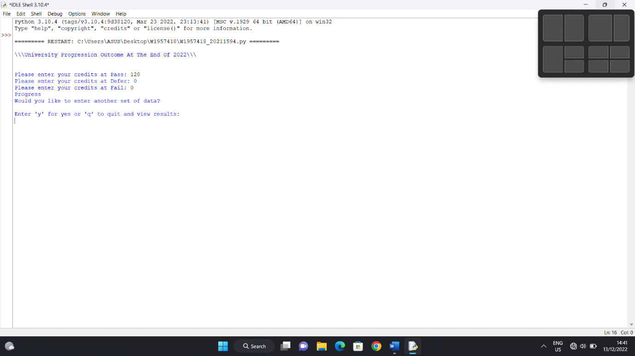

Test case 2.1

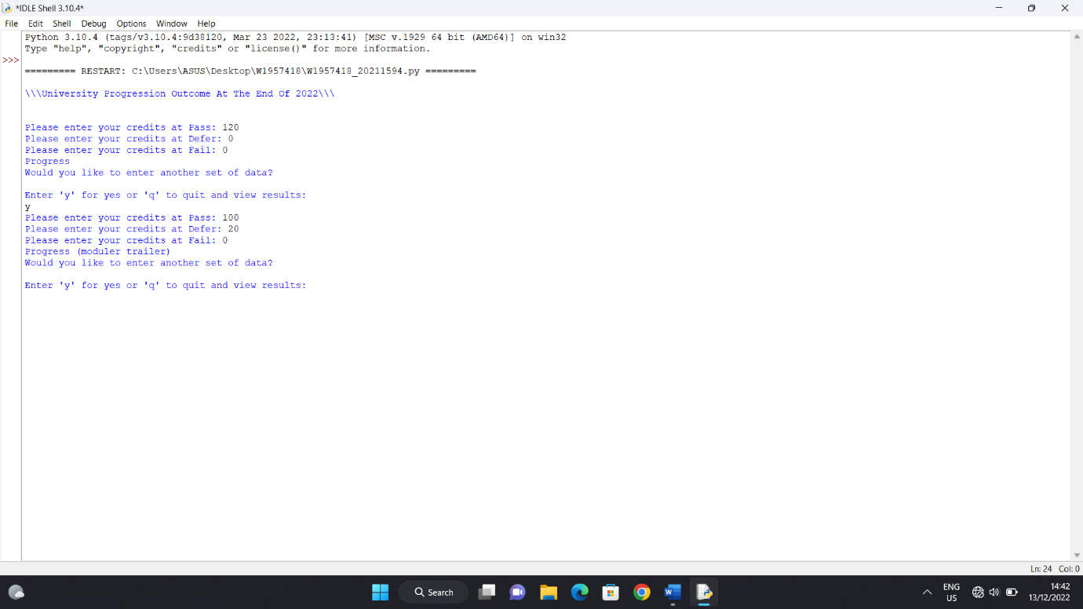

Test case 2.2

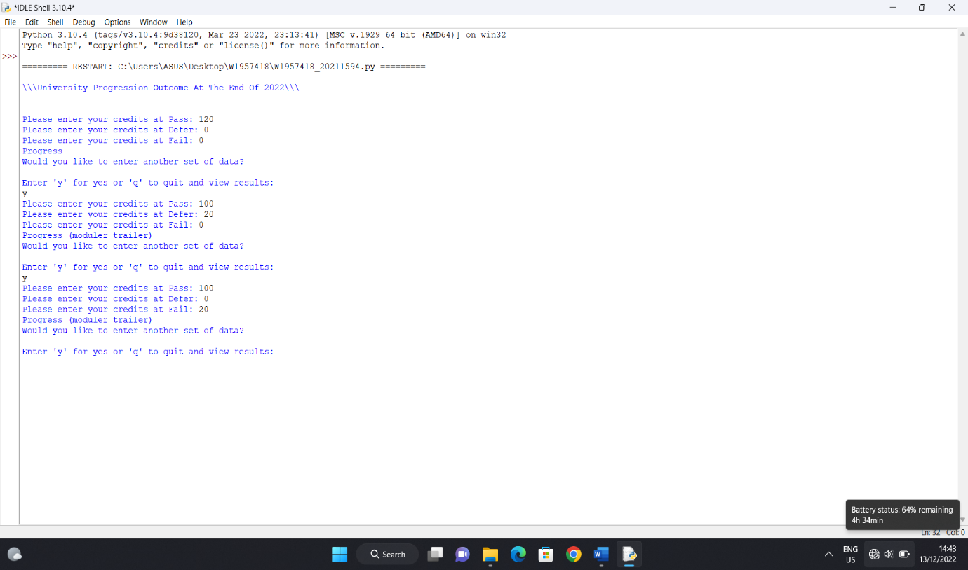

Test case 3.1

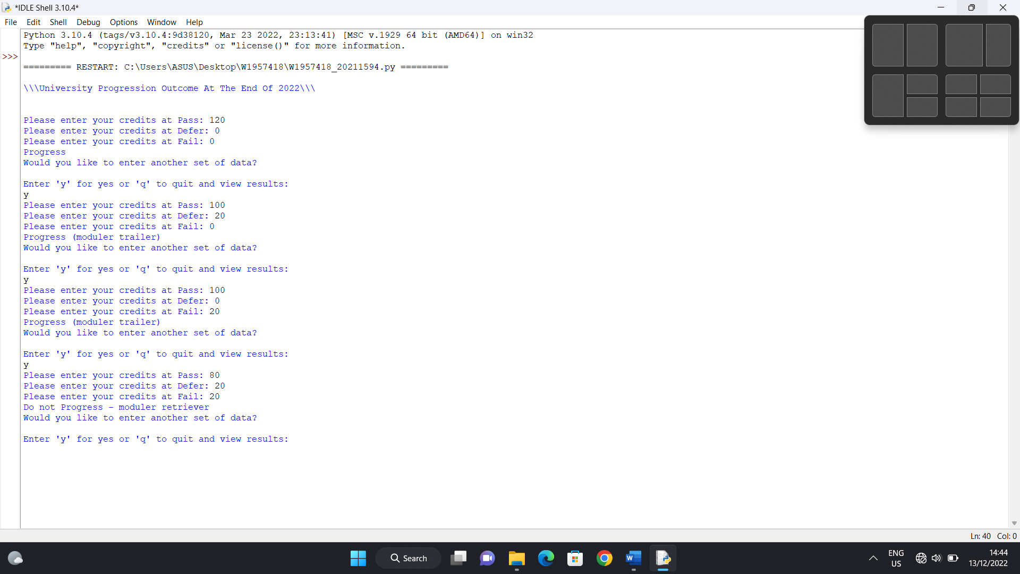

Test case 3.2

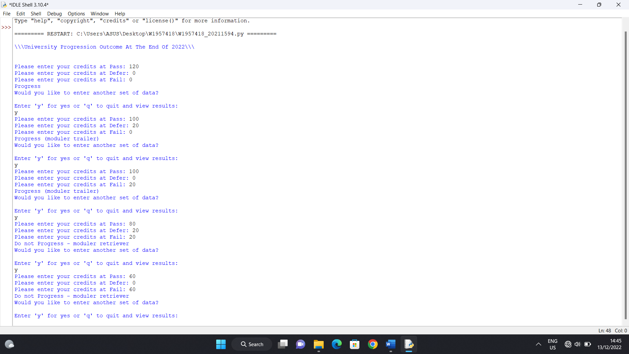

Test case 3.3

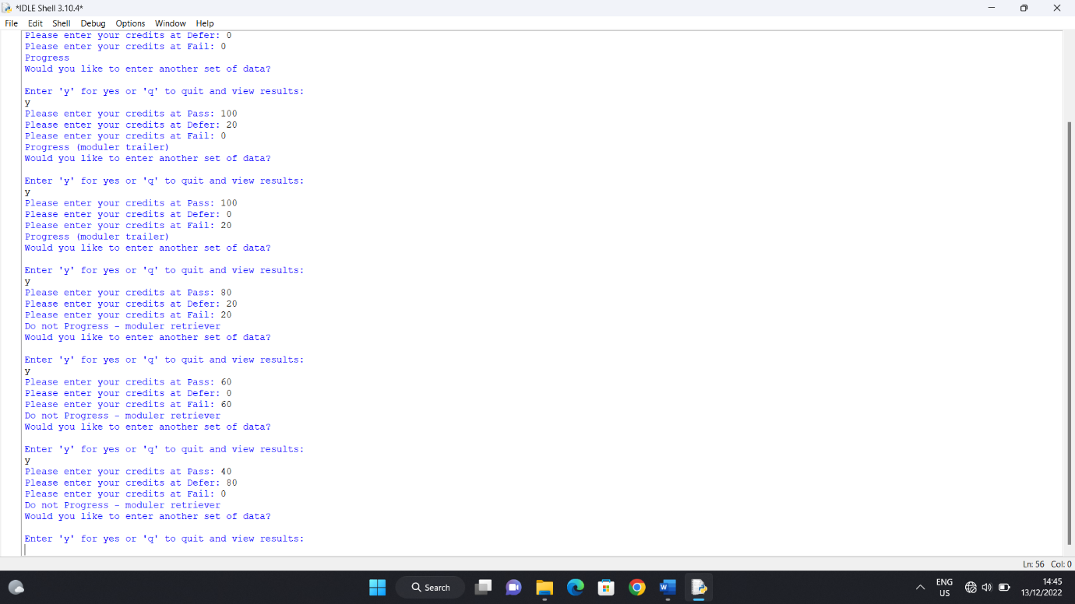

Test case 3.4

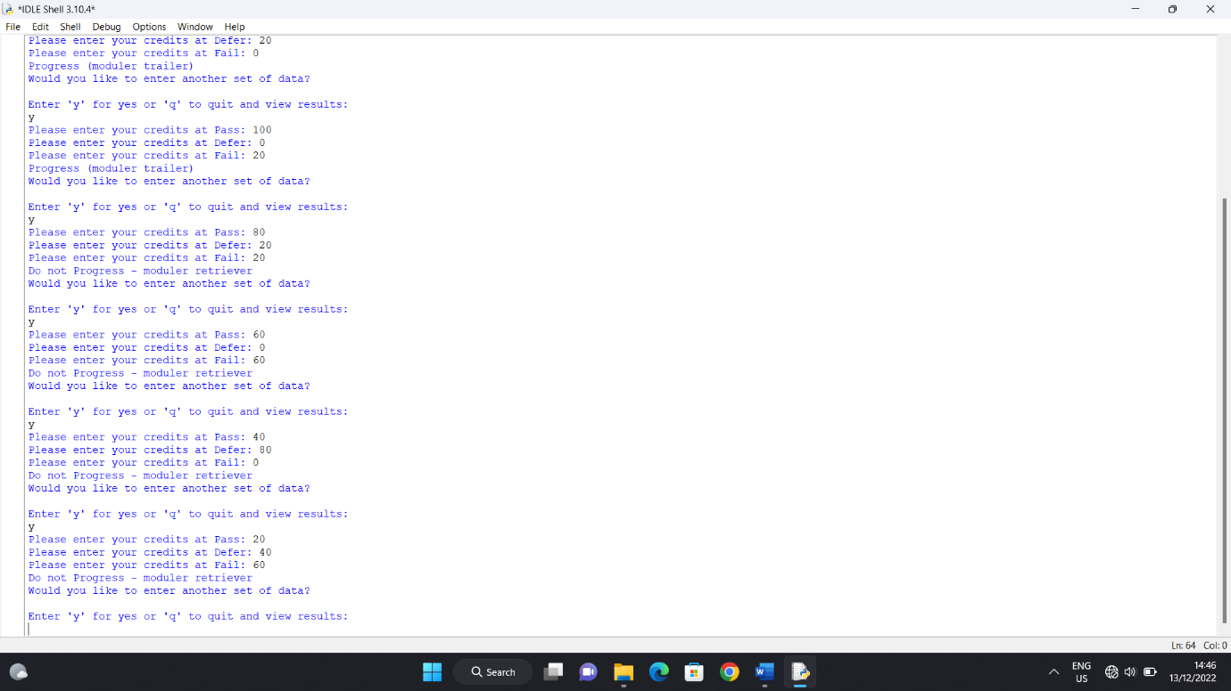

Test case 3.5

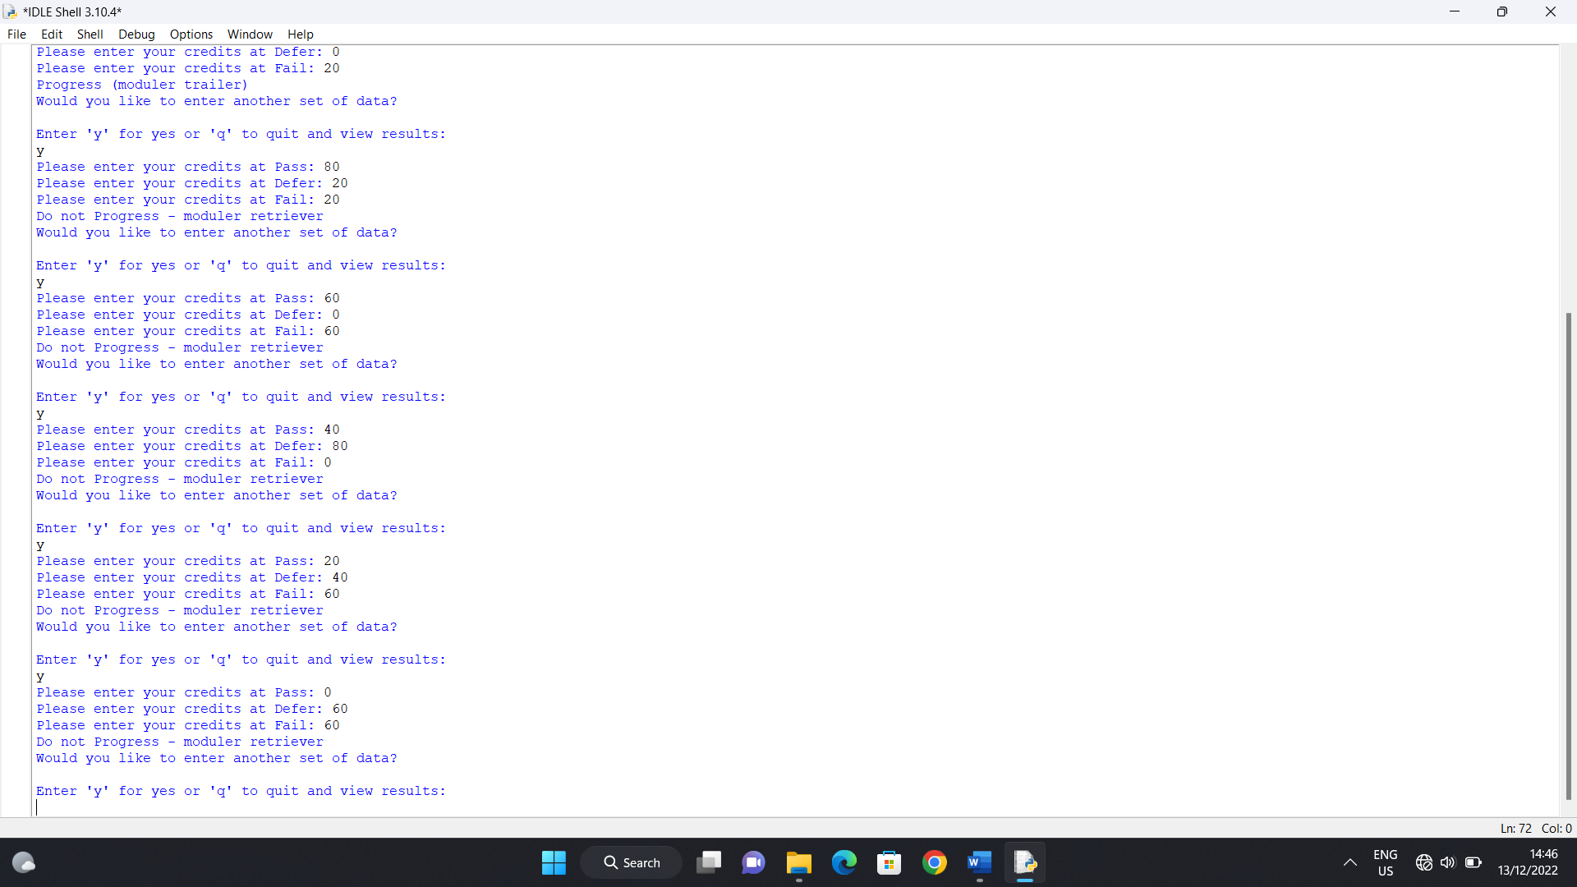

Test case 4.1

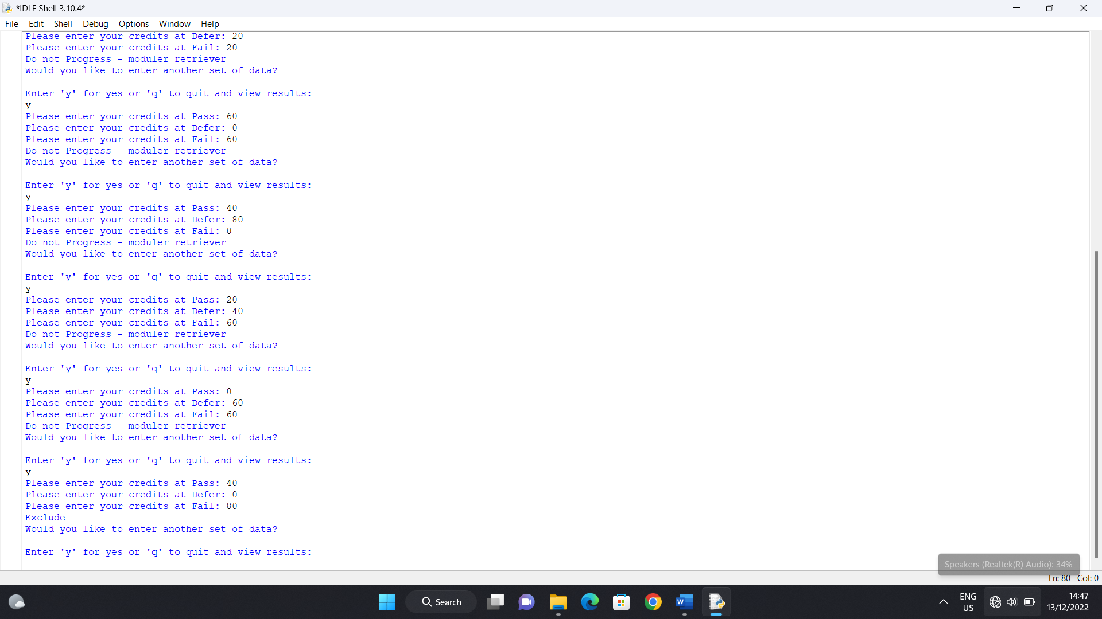

Test case 4.2

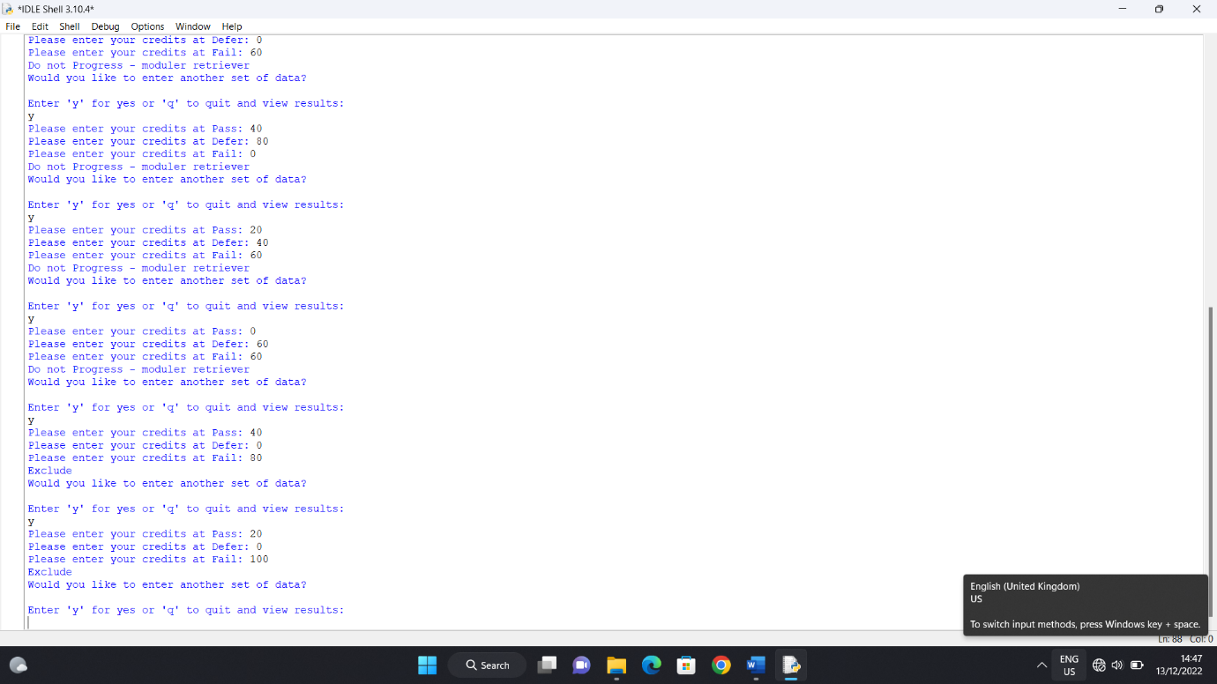

Test case 5.1

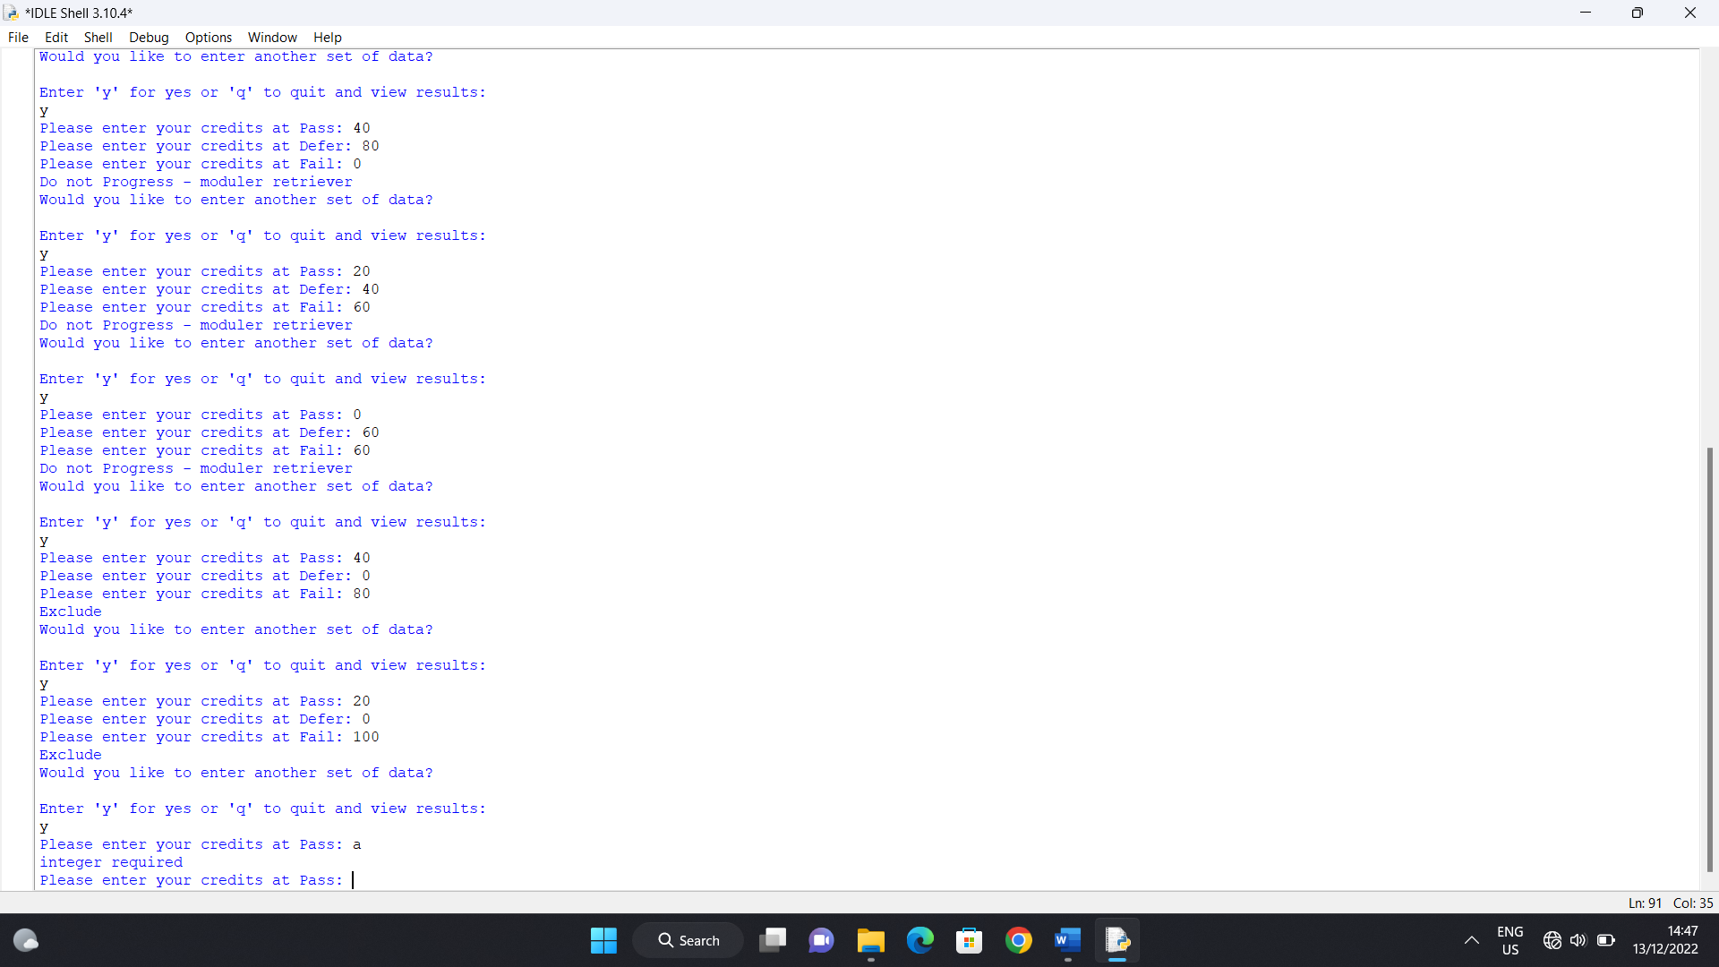

Test case 5.2

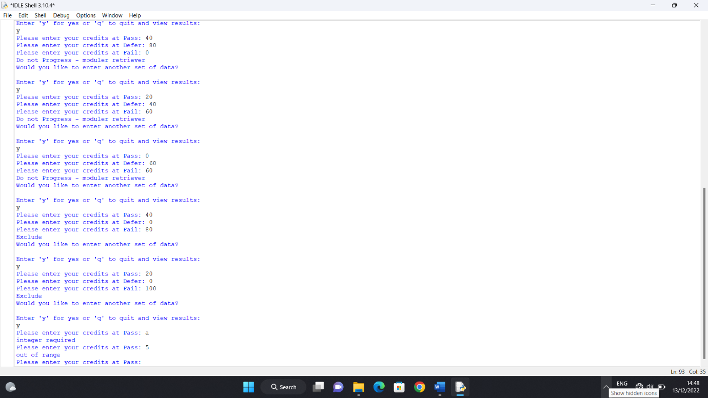

Test case 5.3

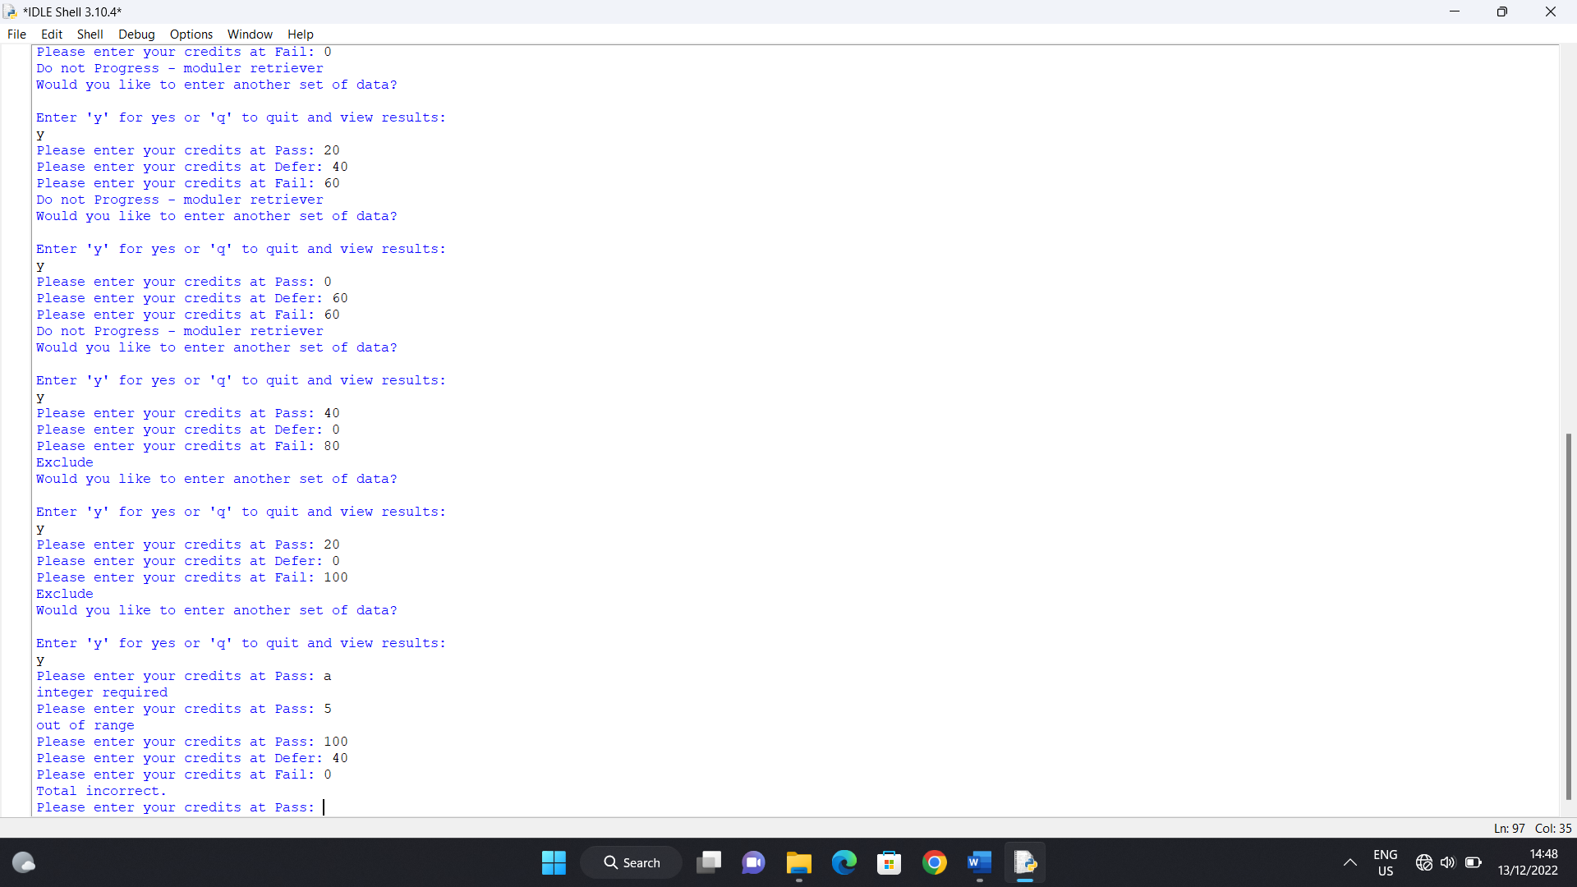

Test case 6.1

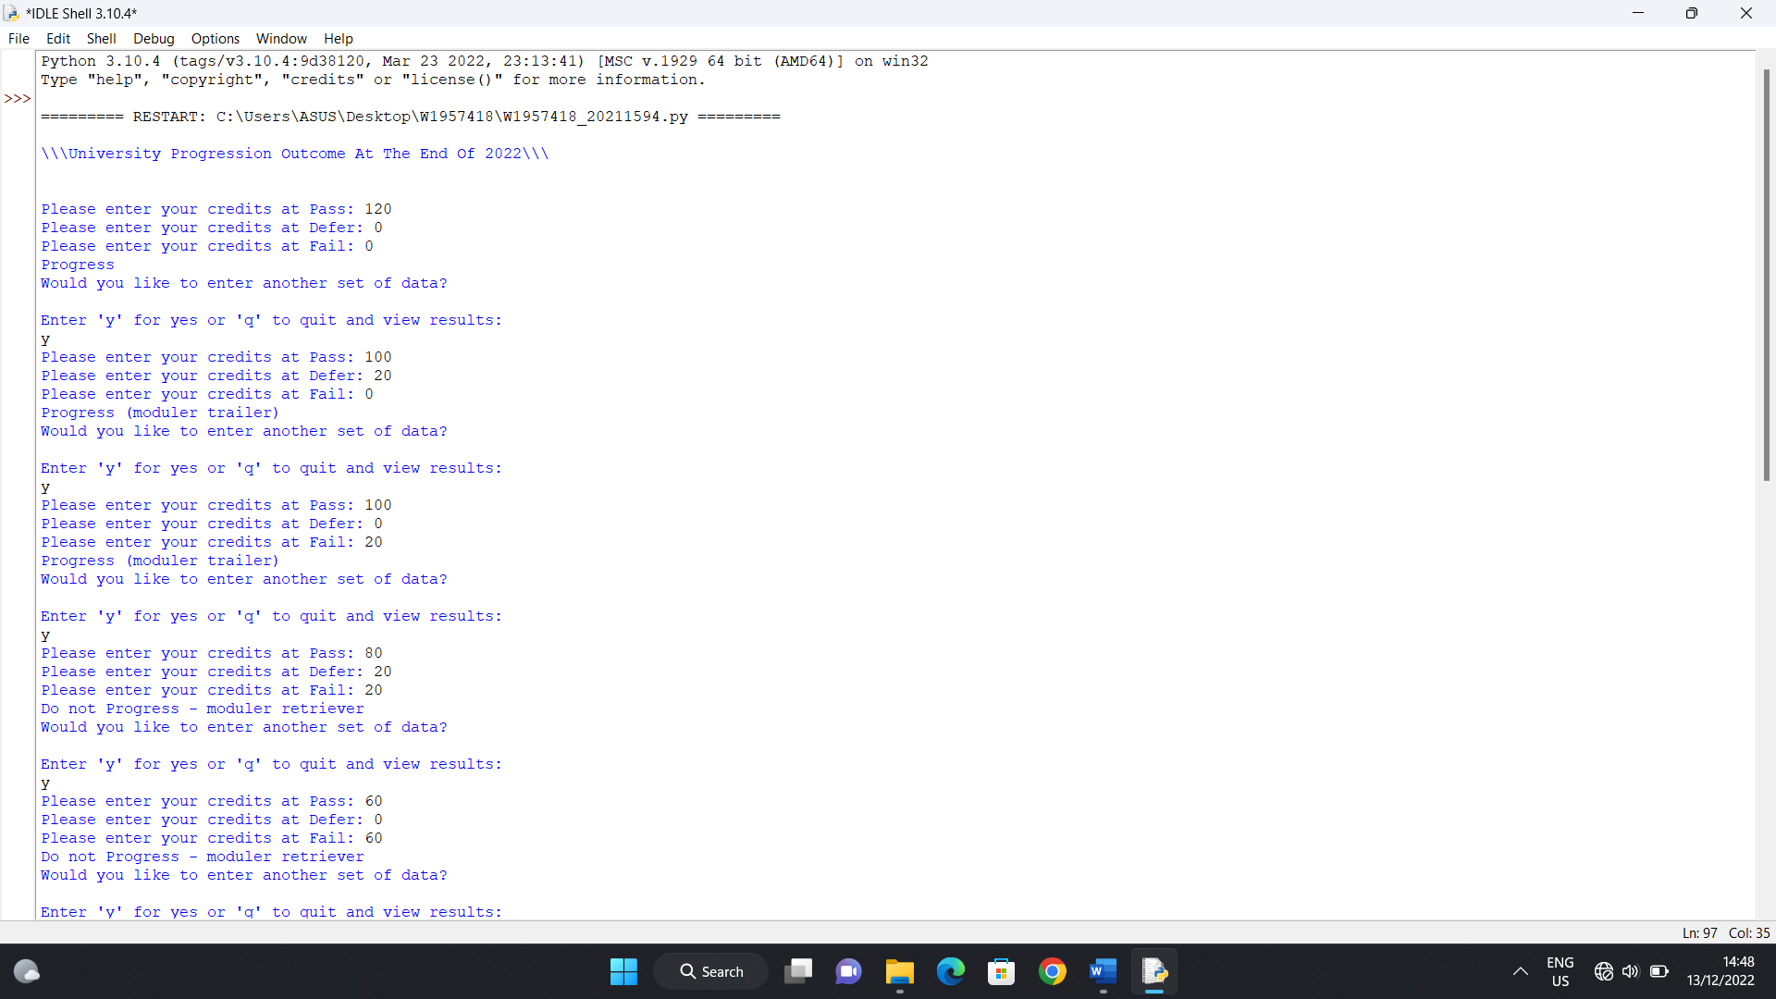

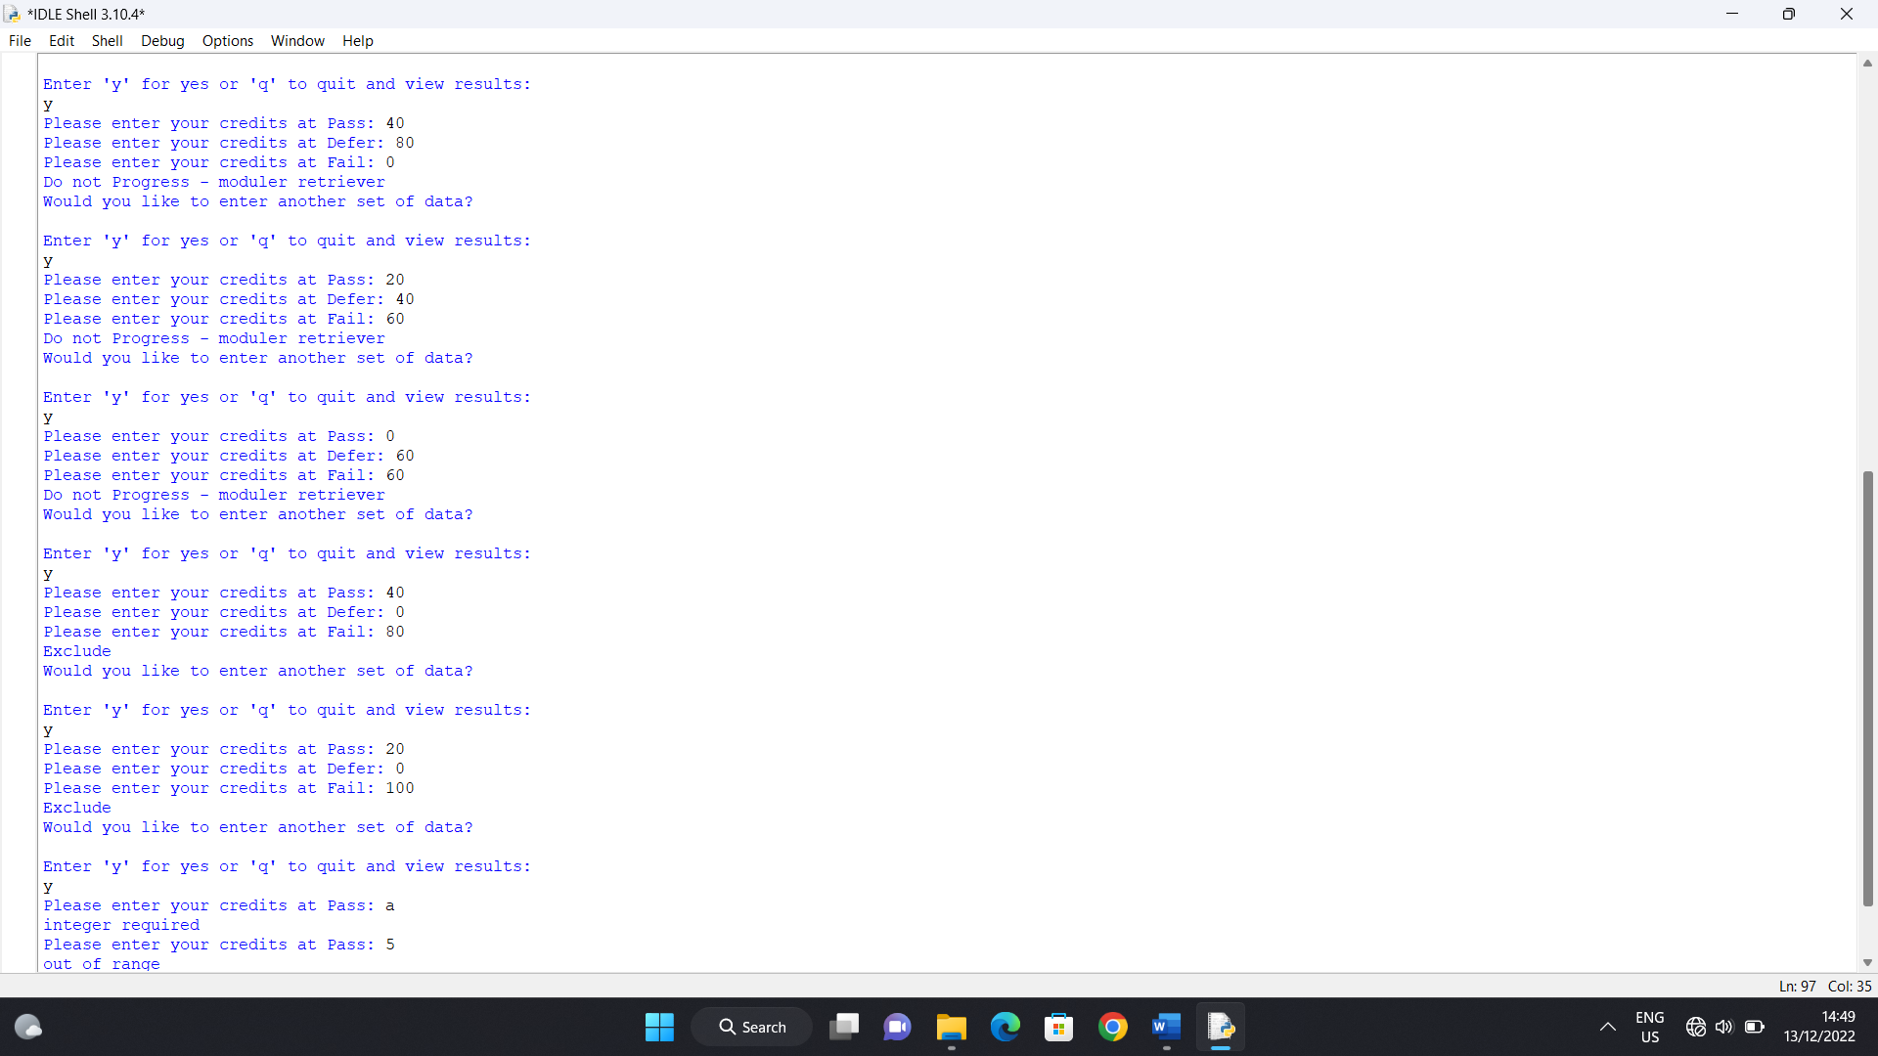

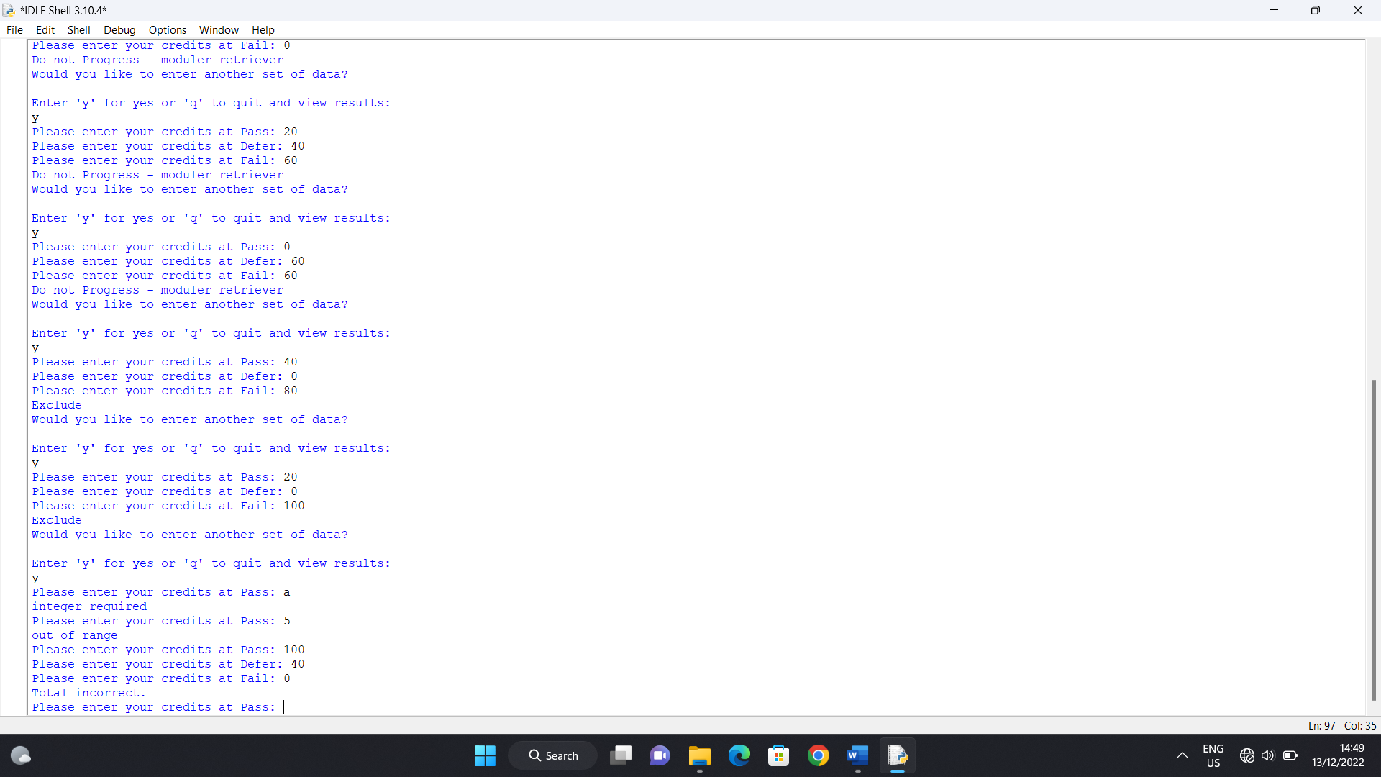

Test cases 6.2, 7.1 & 7.2

