# 2. Analysis

## 2.1 Introduction to Analysis

Analysis may be defined as the process of collection an gathering of data and information for the betterment of the system. It can be regarded as the first step while developing a software or any type of program. We have to do the analysis in order to collect the required information and make our system better. Analysis is required to get the required functions in our system and run it without any further difficulties.

**Analysis may be defined as the** detailed examination of anything complex in order to understand its nature or to determine its essential features.

Requirement analysis is also conducted in order to gather the requirements that the system will have and the features the users require. We can do requirement analysis through group discussions, interviews, focused groups etc.

For my project analysis plays a vital role for the betterment of my website that I am going to develop.

Some of the types of analysis are:

### P.E.S.T. Analysis:

 P.E.S.T. is an acronym for the Political, Economic, Social, and Technological factors of the external macro-environment. Such external factors usually are beyond the firm's control and sometimes present themselves as threats. P.E.S.T. analysis helps us to deal with various factors involving the political, economic, social and technical aspects.

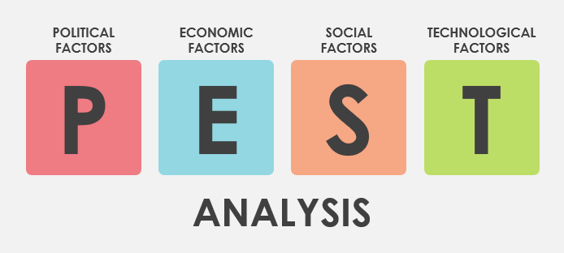

### SWOT analysis:

It is also a type of analysis it helps a company to find its various features. By using this analysis, we can find the strength the company possesses, company’s weakness, future opportunities, and various threats that may occur while operating a company.

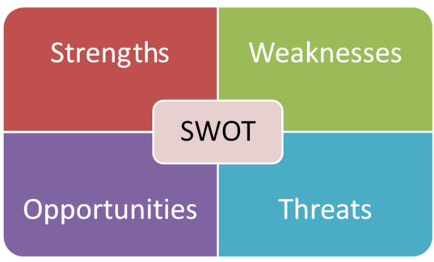

## 2.2 Feasibility Study

Feasibility study covers all the factors while developing a system/software. It helps to develop the software without any trouble. Moreover, feasibility study includes the different study types as economic feasibility, technical feasibility, social feasibility etc.

As per my perspective I will be also analyzing the problems that may arise I the future and the various ways to tackle such problems. This will help my system to last longer and provide quality service.

Some of the types of feasibility study to help my project are:

1. Economic Feasibility:

In this feasibility study the matters that involve money are done. This helps us to analyze that how much budget is required to make our project. It helps us to spend the allocated budget for the project.

As for my project as my project is for academic purpose the budget is not used in any manner. This project is being prepared for academic purpose only.

1. Legal Feasibility:

In this study we check if our project meets the legal requirements of the nation or not. It checks if any kinds of law were breached while developing the project.

My project will be legally feasible because there will not be used any kinds of illegal methods to develop the project. The project will be made under the legal circumstances.

1. Technical Feasibility:

In this study we find out if the project we are about to develop is technically and physically possible or not.

To develop the project i already have all the technical and physical equipment’s so there will not be any kinds of trouble regarding the technical requirements as well as physical requirements.

1. Operational Feasibility:

In this study we find out whether our system operates properly or not or rather that that it checks if our system is able to interact with the users or not.

My project is going to be a simple website so there will be no any problem regarding the operational issues

1. Schedule Feasibility:

This study helps us to identify if our system will be completed in the given time. If our project is completed on time the it will achieve the schedule feasibility.

I have been given enough time for the completion of my project so there will not be any problems regarding the schedule feasibility.

## 2.3 Requirement Analysis

In this method we gather all the necessary requirements and separate the into either Functional or Non-Functional. The analysis is done according to the requirements.

#### Functional Requirement

Functional requirements are directly involved system. They play a major role in development of the system. These requirements are a must have for the system.

Functional requirements included in my project are:

|  |  |  |  |  |  |
| --- | --- | --- | --- | --- | --- |
| Functional ID | Functions in my project | Data | Rational | Dependency | Remarks |
| F01 | Registration | User information | Different names of the users | F01 | Add new members |
| F02 | Login | Email and Password | Give access to the users | F01 | Help to access website |
| F03 | User Update | Information Update | User Information can be changed | F02 | New information is set replacing previous one |
| F04 | Admin Login | Admin details  (Email and Password) | Admin | F04 | Opens admin dashboard |
| F05 | Post Information | Futsal Activities | For the users | F04 | Tournaments,  news |
| F06 | Information  Update | Update futsal details/plans | Update | F04 | Tournament updates |
| F07 | Admin Update (Profile) | Update the admin details | Admin | F04 | Details of the admin will be Updated |
| F08 | Booking | To book | Readers to the admin | F02 | Users can book |
| F09 | Cancel Booking | To cancel booking | Cancellation | F02 | Users can cancel booking |

Table: Functional Requirements

#### Non-Functional Requirements:

These attributes are indirectly related to the project/system. Even though they are indirectly related they play major roles in our system.

Table of non-functional requirements of my project are:

|  |  |  |  |  |  |
| --- | --- | --- | --- | --- | --- |
| Non-Functional Id | Functions | Data | Rational | Dependency | Remarks |
| N01 | Responsive | - | Supports different screen sizes/resolutions | - | Run on various screen sizes. |
| N02 | Reliable | - | Trustworthy | - | Users can rely on website |
| N03 | Robust | - | Multiplatform | - | Should run on different platforms |
| N04 | Usability | - | User friendly | - | Easy to use |
| N05 | Multi-Browser support | - | Tested in different browsers | - | Operates in different browser |
| N06 | Scalability | - | To be able to handle workloads | - | Easy data flow |

Table: Non-Functional Requirements

### MOSCOW Prioritization:

MOSCOW prioritization is a popular [prioritization technique](https://www.productplan.com/strategies-prioritize-product-features/) for managing requirements. It is commonly used to help key stakeholders understand the significance of initiatives in a specific release.

#### MOSCOW prioritization of functional requirements:

|  |  |  |
| --- | --- | --- |
| ID | Functionalities | Priority |
| F01 | Registration | Must have |
| F02 | Login | Must have |
| F03 | User Update | Must have |
| F04 | Admin Login | Should have |
| F05 | Post information | Should have |
| F06 | Information Update | Would have |
| F07 | Admin Update | Would have |
| F08 | Booking | Must have |
| F09 | Cancel Booking | Must have |

Table: MOSCOW Prioritization for the Functional Requirements

``

#### MOSCOW Prioritization for the Non-Functional Requirements:

|  |  |  |
| --- | --- | --- |
| ID | Functionalities | Priority |
| N01 | Responsive | Must have |
| N02 | Reliable | Should have |
| N03 | Robust | Must have |
| N04 | Usability | Must have |
| N05 | Multi-Browser support | Must have |
| N06 | Scalability | Won't have |

Table: MOSCOW Prioritization for the Non-Functional Requirements

## 2.4 Use Case Diagram

Use case diagram can be defined as the diagrammatic representation of interaction between the actors involved and their actions in a system. It helps us to understand what activities are being conducted by the actors involved.

My project involves two actors one being the admin himself and the other one is the users. A Use case diagram is given below in which we can see the activities carried out by the actors.

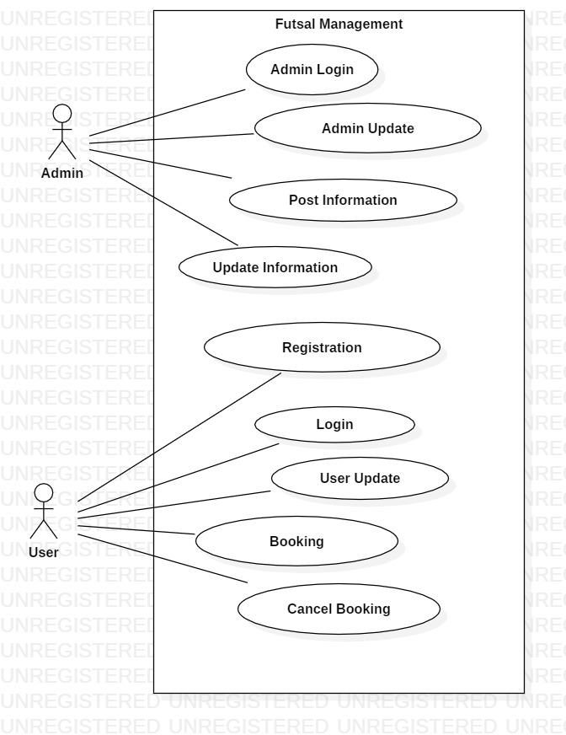

Fig: Use Case Diagram

## 2.4 NLA with Initial Class Diagram

### Introduction

As per the college’s requirement we are required a computer project. For my project I have decided to develop a website. This website will be for the proper management of a futsal system. This futsal management website will include the facilities like booking, registration etc.

By using the website, the users can register their account and log into the website’s account so that they can access the futsal system online. There they can book a particular futsal in which they desire and also set the time for the booking. They can also view various posts posted by the admin (futsal owner), search for available booking. Register for upcoming events, give feedbacks, reviews, cancel booking etc. they can easily update their user profiles. There will also be an admin panel to handle the website, update posts etc.

The candidate class list is:

Nouns:

1. College
2. Futsal
3. Users
4. Comment
5. Register
6. Review
7. Admin
8. Booking

Verbs:

1. Booking futsal
2. Search
3. Create
4. Update
5. Cancel

Final Class I have selected for the initial Class Diagram are:

1. Booking
2. User
3. Review
4. Register
5. Admin

Reason I selected the classes are

|  |  |
| --- | --- |
| Booking | It allows the users t book the futsal for use |
| User | Without use the website is not complete, user play a vital role in completion of the website |
| Review | The users can post regarding the futsal, their matches, tournaments |
| Register | In order to use the website fully we should register our account first |
| Admin | Admin is needed to maintain the futsal, website, update blogs, information etc. |

Table: Classes selected

### Initial Class Diagram

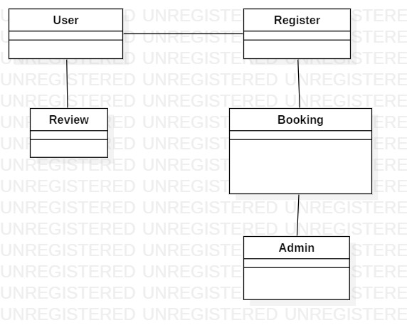

Fig: Initial Class Diagram