# 3. Design

## 3.1. Introduction

Design refers to creating any image or item on the basis of perspective. Design involves the user perspectives and requirements. while designing a certain object we first find how the object looks and then we do the designing process. Some advantages of designing are:

1. Sets a good impression with customers.
2. Helps to form trust regarding the proposed project.
3. Helps to find what our application or project will look like.

3.2. Structural Design:

The process of investigating the stability, strength and rigidity of a project. It is done for the structural view of a project. Some examples of structural design are: class diagram, flow chart and data flow diagram.

The structural design used for my project are:

### a. Class Diagram

It is a static diagram for the static view of the project. It helps to find what entities are to be included while developing a project.

In my project I have used the class diagram to represent the entities involved while developing the system.

#### Justification:

I my project the class diagram helps to view the static view and the working process of my project. In my project the admin will himself will manipulate the customer account as well as the customer himself. They will also be able to give reviews about the project.

#### Notation used:

Aggregation notation: This notation is used to configure the objects for making the complex type of object.

Composition notation: This notation is used for the composite objects.

Association notation: This type of notation is used to inter-relate the class.

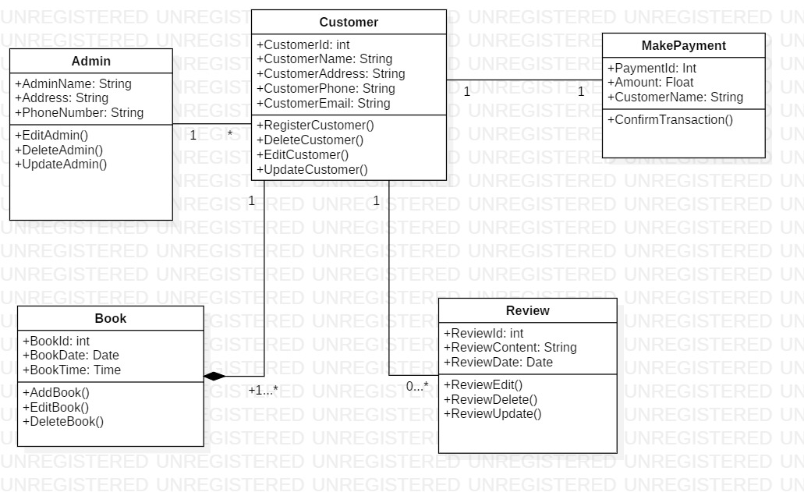

Fig: class diagram

#### Explanation:

My Class diagram consists of 5 classes which are very important for function of my project. There will be a main admin account. The admin can add new customers. After the customer account is created, they can use the website as per their requirement. After they login they can search for the availability of futsal for booking. If available booking can be done if not, they can’t. They can even cancel the booking. They can also post their reviews.

### b. DFD Diagram

DFD is also a type of structural design. The term DFD stands for Data Flow Diagram. This diagram shows the flow of data in our project and how the data are processed. It helps to find the output of our project.

In the image provided below we can easily find out the working mechanism and data flow of my project.

#### Justification:

Data flow diagram are used to graphically represent the flow of data in a information system. It is an essential part of a project because it helps to find the proper flow of data in the system.

#### Notations used:

Process Notation: This notation helps to transfer the incoming data flow into the outgoing data flow.

External entity notations: This notation gives a clue about the objects outside of the system.

Data flow notation: This notation helps to find the flow of data in what direction.

Data stores Notation: This notation shows the database of the system.

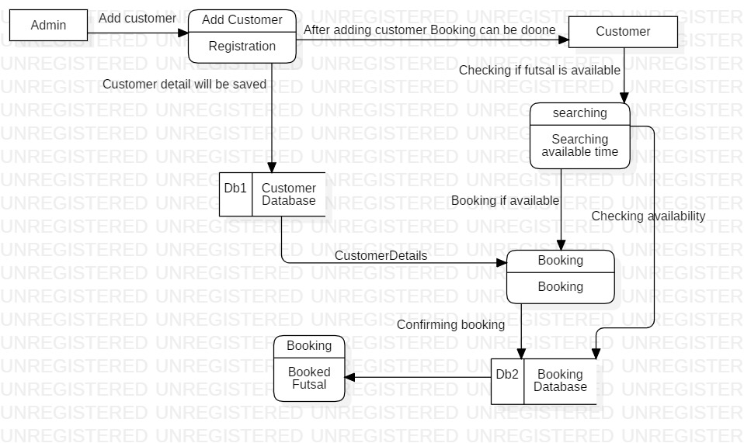

Fig: DFD Diagram

#### Explanation:

The admin is the main entity. First the admin adds the customer. After the customer login they can access the website. They can then book futsal according to their need. The customer data will be stored in the customer database. Booking details will be saved in the booking database.

## 3.3. Behavioral Design:

Behavioral design helps to communicate between two or more objects. It helps to create flexibility among objects.it helps to see how the work is done in the system. The examples of behavioral’ design is: activity and Sequence diagram.

### Activity Diagram:

It Shows the dynamic aspects of a system. It helps to track the activity carried out by the system. It describes the operation of system. Each activity is carried out by using the control flow.

In my project I have also used the activity diagram. It shows the flow of operation and how activities are done in the system.

#### Justification:

Used to see dynamic aspects of the system. It helps to track the systematic flow of process. In my project’s activity diagram, we can easily see what activity is done after what.

#### Notations used:

Start Point: This is the point which represents the initial action state.

Decision branching: This notation helps to decide like if/else condition.

Action flow: This notation helps to flow the object from one action state to another.

Action State: This point represents the non-interruptible actions of the step.

##### Synchronization:

Fork node: This notation helps to split the one action state into two or many.

Join node: This notation helps to combine the two or many action states to one action state.

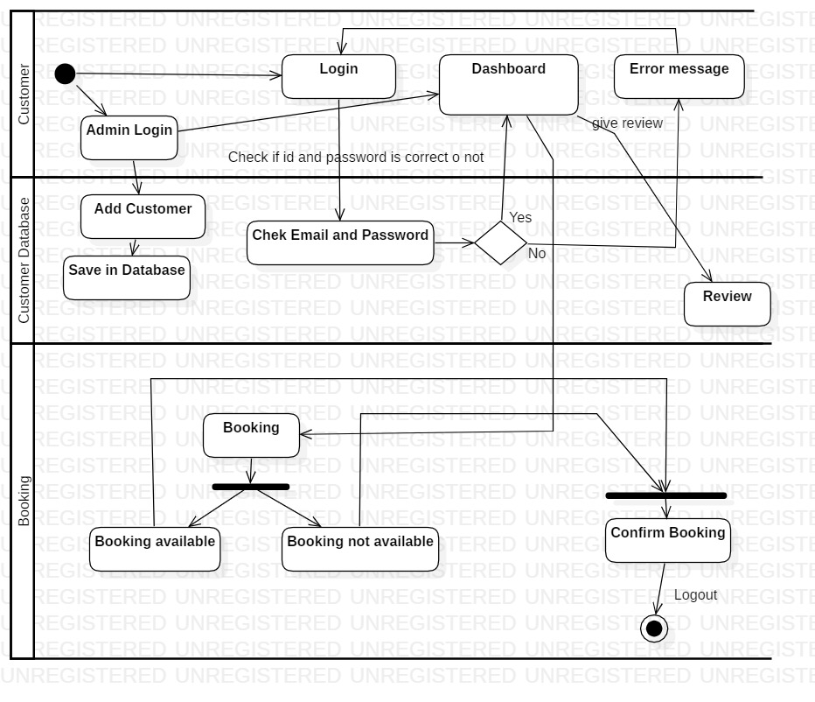

Fig: Activity diagram

#### Explanation:

In the diagram above the admin logs in the system then he can create the customer after the customer account is created, they can access the website. Then if login is successful, they can book futsal.

### Sequence Diagram:

Sequence diagram provide detail about how the system is operated. It helps to find the activities done in the system sequentially. It tracks the data flow and activities carried out between various entities or objects.

I have also used the sequence diagram in my project. The diagram is given below.

#### Justification:

I have created a sequence diagram to know the flow of data and the interactions between the objects.

#### Notations used:

Lifeline: This notation helps to represent the all instance in every interaction.

Message: This notation helps to send the text.

Actor: This notation is for the object which is important for the system to run.

Combine fragment: This type of notation helps to write down the if/else statement.

Message reply: This notation helps to reply the text to the object.

Self-message: This notation helps to write the text to own self object.

Object: This is the class like structure without which system flow isn't possible.

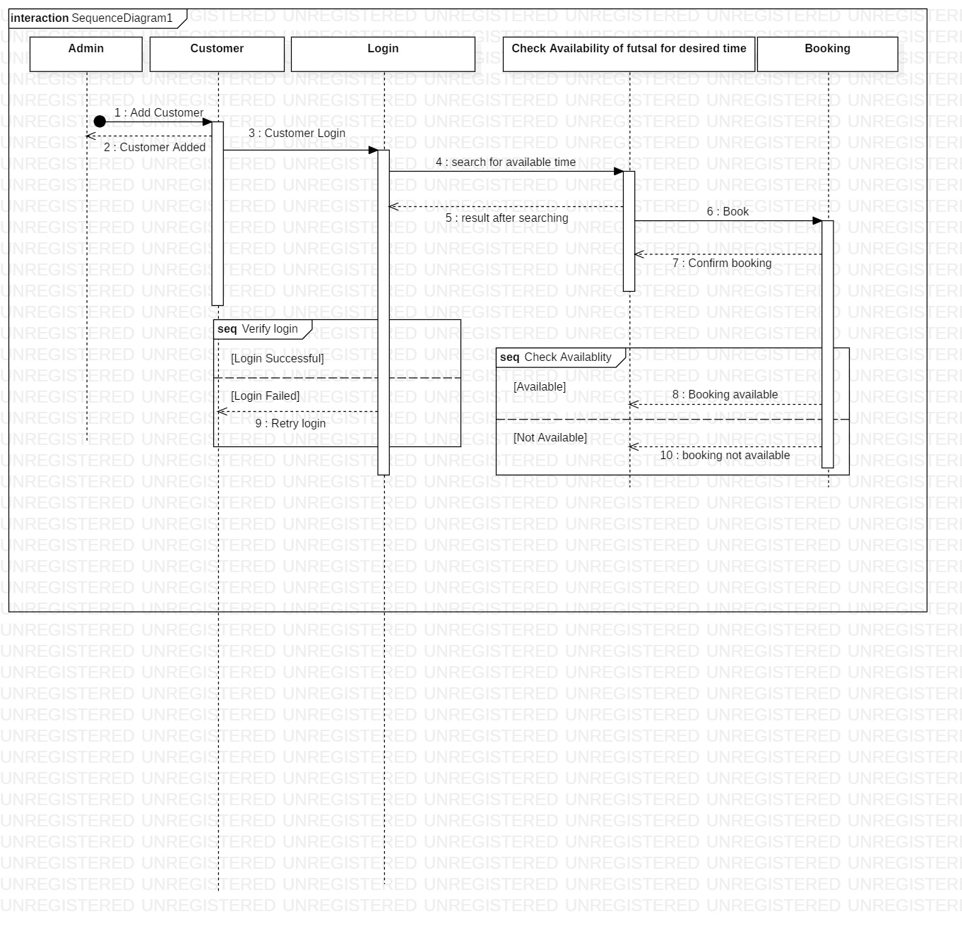

Fig: Sequence diagram

#### Explanation:

In the diagram above the flow of data is shown. We can clearly see how the data flows inn the system, we can also see the processes that are done after completion of certain task.

## 3.4. Database Management System

It is the management of the database using various processes. We create various databases according to the requirement and we can also carry out various activities like add, delete update etc.

Some advantages of using the DBMS are:

* Data Abstraction
* Data security
* Data independence
* Robust data integrity
* Simple access using API

### Data Dictionary

It is also called a metadata. It contains various files and sets of data. Data dictionary contains the databases the tables etc. it is an important component of the relational database. It contains various elements of a database.

#### Justification:

In my data dictionary I have altogether 5 entities in the metadata. List pf those entities are:

Data Dictionary of Admin

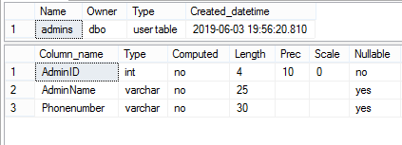

Data Dictionary of Customer

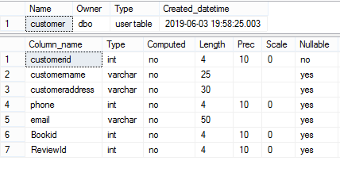

Data Dictionary of Booking

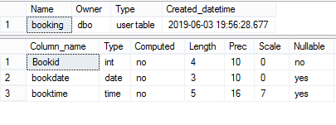

Data Dictionary of Payment

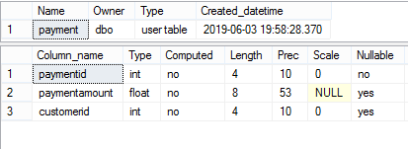

Data Dictionary of Review

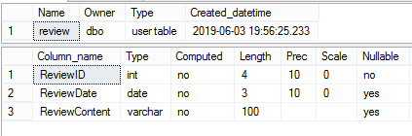

#### Explanation:

The above pictures include the entities used in the system. It shows the datatype, length, null or not-null value etc.

### ER Diagram:

It is also known as Entity Relationship Diagram. Ir provides the relation between the entities.it helps to develop complex database.

#### Justification;

For my project I have altogether 5 entities. The entities with proper column name are:

* Admin
* Customer
* Booking
* Payment
* Review

#### Notations Used:

Fields: This notation is used to classify the entity and their columns.

Keys:

Primary key: This key uniquely identifies the column.

Foreign key: This key is created any time an attribute relates to another entity.

##### Cardinality and Ordinality

Cardinality and Ordinality are the notations that are used to relate the one instance of one entity to another instance of another entity.:

One to many: This notation helps to relate the one instance of one entity with the many instance of another entity.

Many to many: This notation helps to relate the maximum number of times an instance in one entity with other many instance of another entity.

There is also another notation i.e. (One to one)

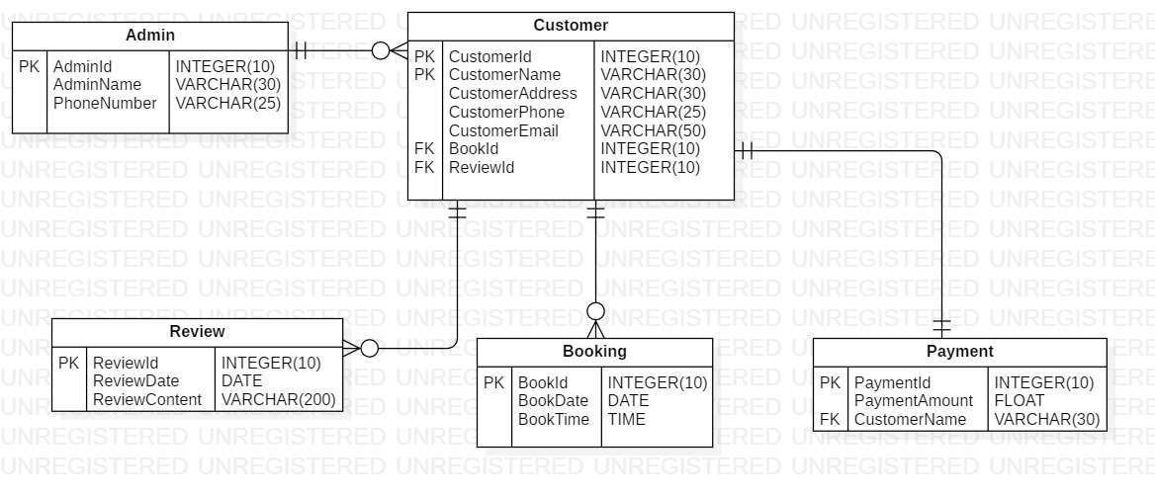

Fig: ER diagram

#### Explanation

In the diagram above the relation between various entities are shown as well as the various entity types. It shows the dependency of each entity with another entity.

## 3.5. Architecture

It is an important fundamental structure to give shape tour system. It is also regarded as the blue print of the system. It helps in the designing, development of the system and its maintainability.

I used the 3-tier architecture for my project. As it is the most commonly used architecture in the DBMS.

A 3-tier architecture separates its tiers from each other based on the complexity of the users and how they use the data present in the database. (dbms_architecture,2.19)

The 3-tier architecture works with the help of the Presentation, Application and Database tier.

1. Presentation tier

In the presentation tier the operations of users will be done. They can only see the objects available to them. They have no access to the database. More like they can only see the frontend of the system.

1. Application tier

In this tier the connection between the application server and the database is shown. The users can only see the virtual database. It can also be called the abstract database.

1. Database tier

In the database tier all the data’s regarding the system will be stored. The query and its processing will also be shown.

#### Justifications:

For the final completion of the project the prototype of the system is listed below. The prototype will more or less be similar to the actual website(webpage).

## Prototype Of the project (Paper Prototype)

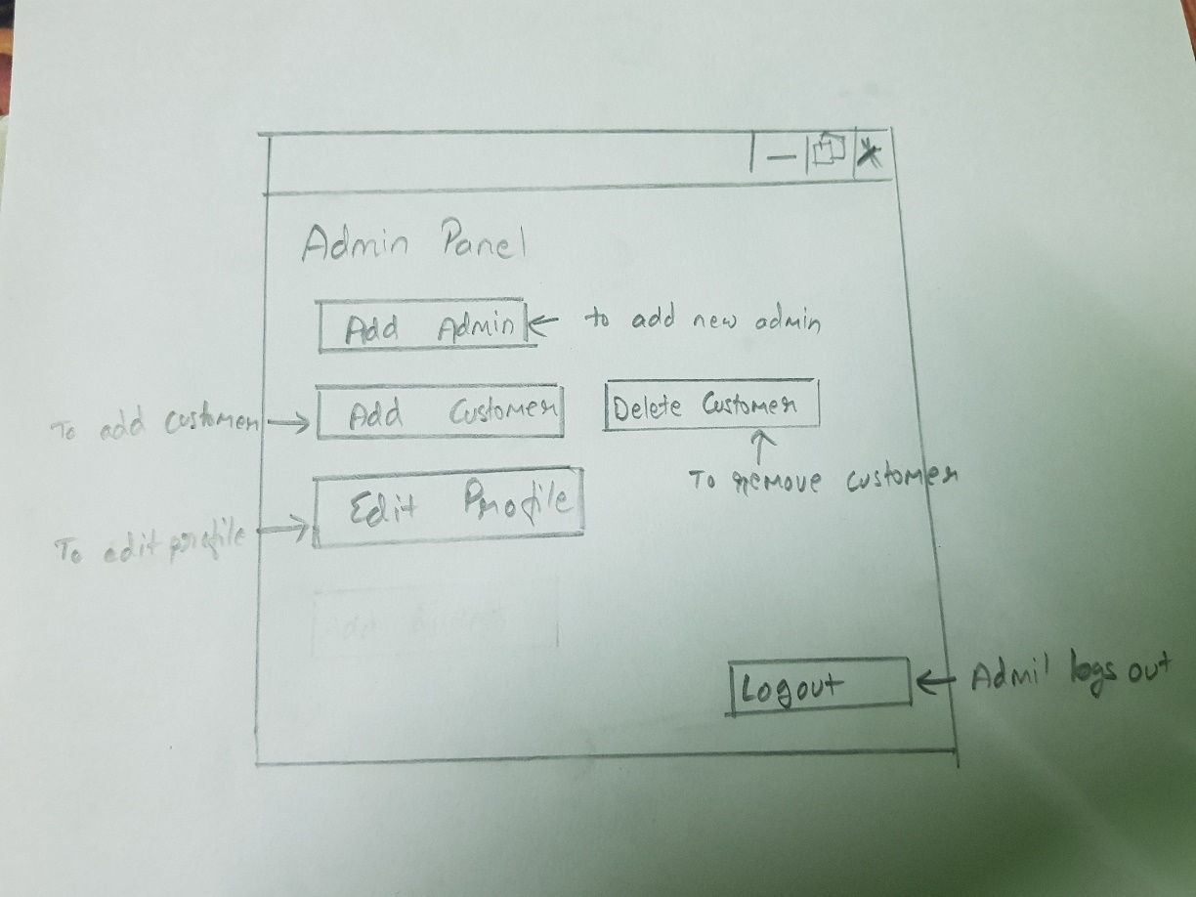

Pic: Admin Panel

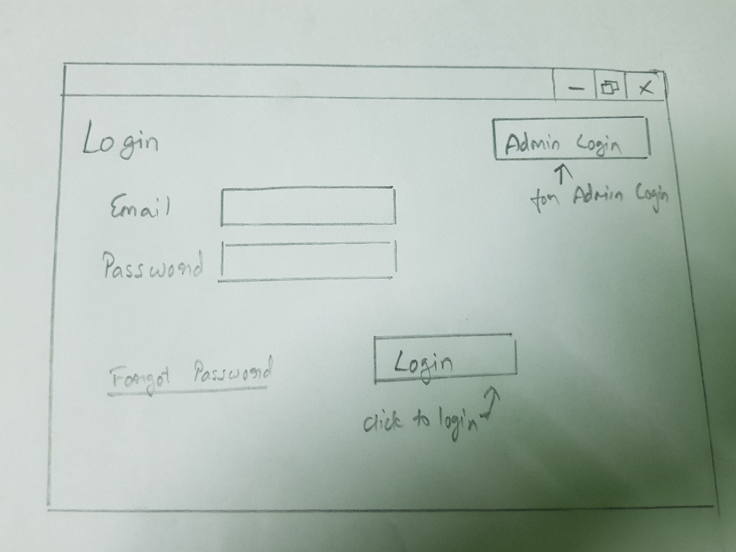

Pic: Login Page

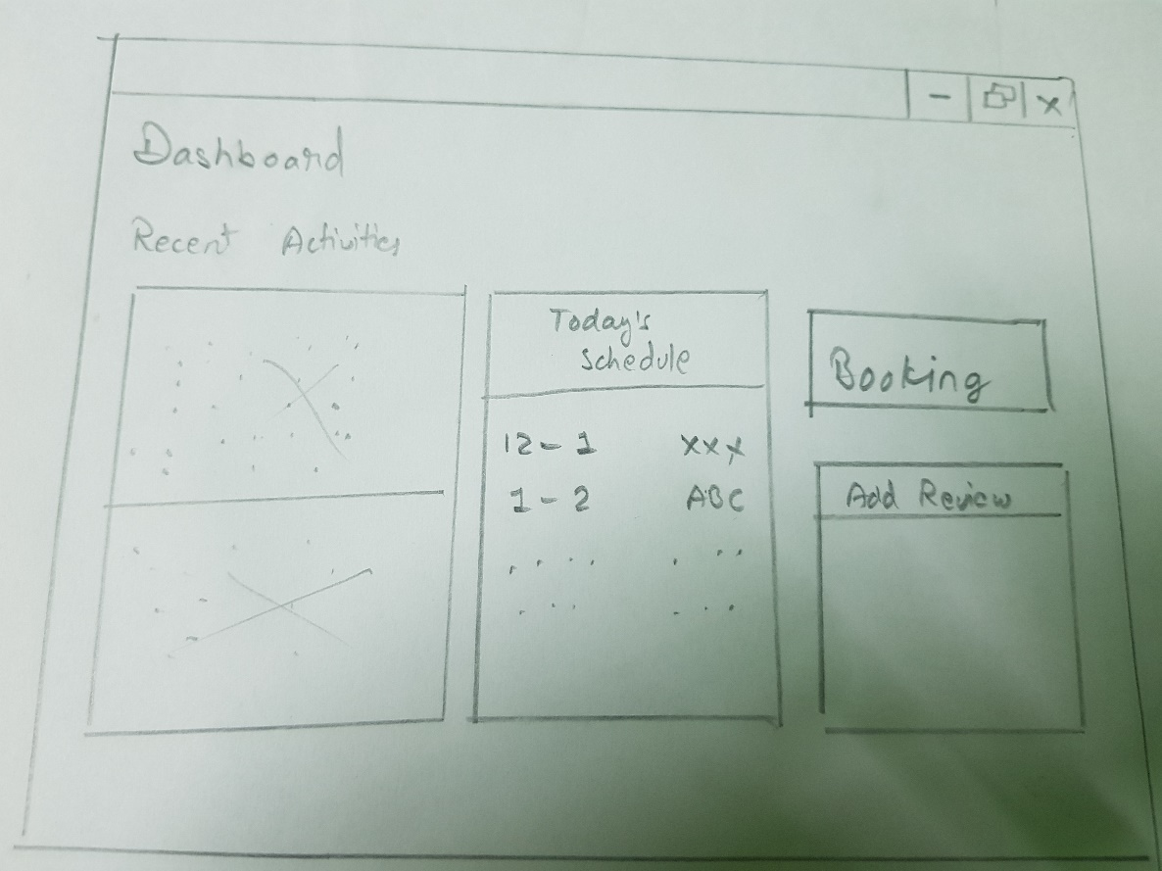

Pic: Dashboard

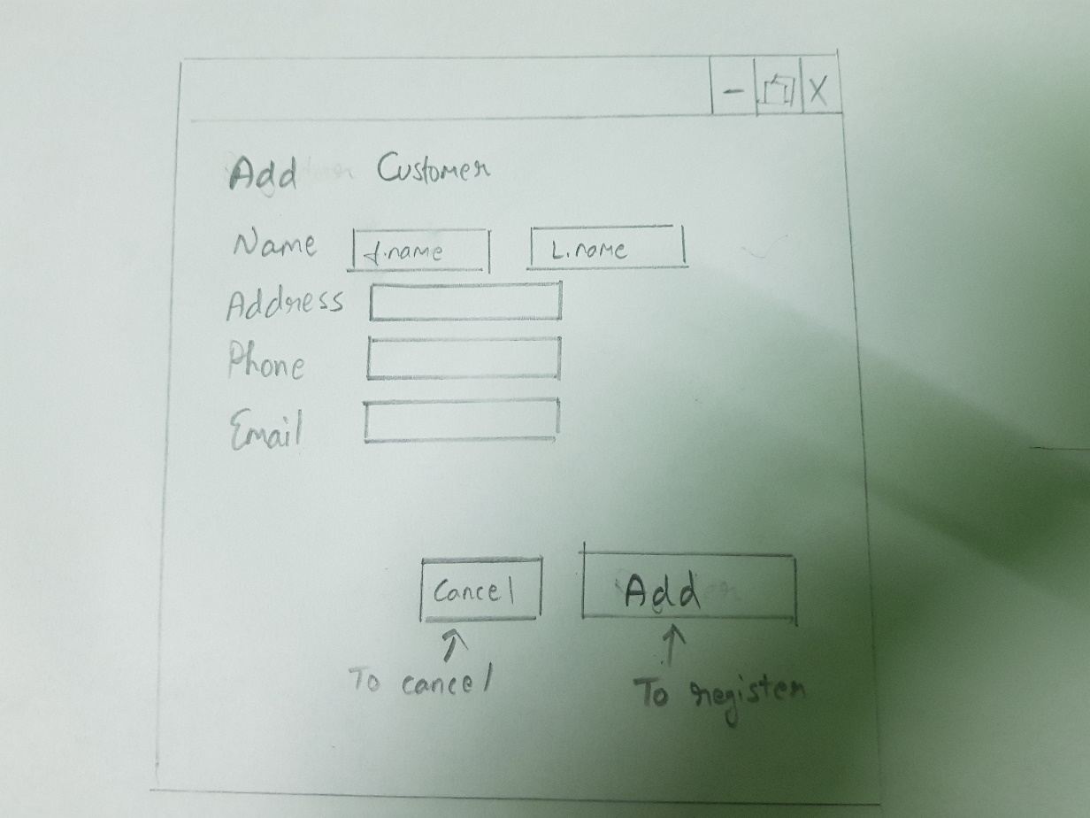

Pic: Customer Registration

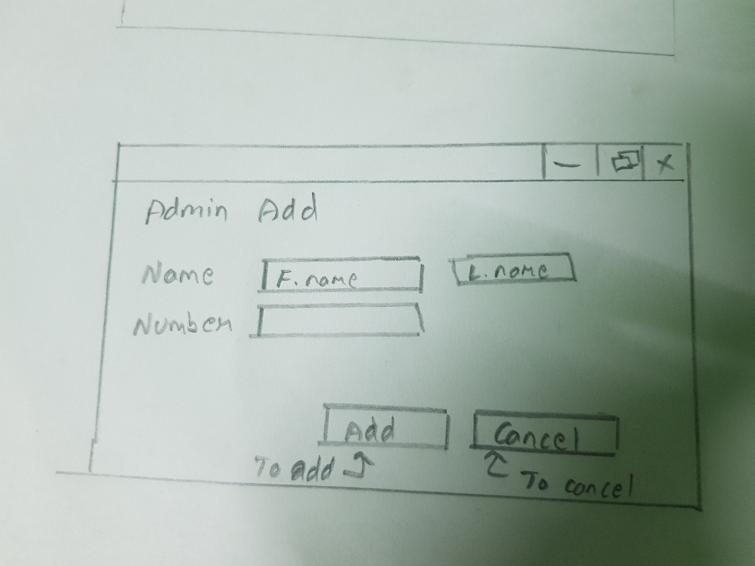

Pic: Add admin page

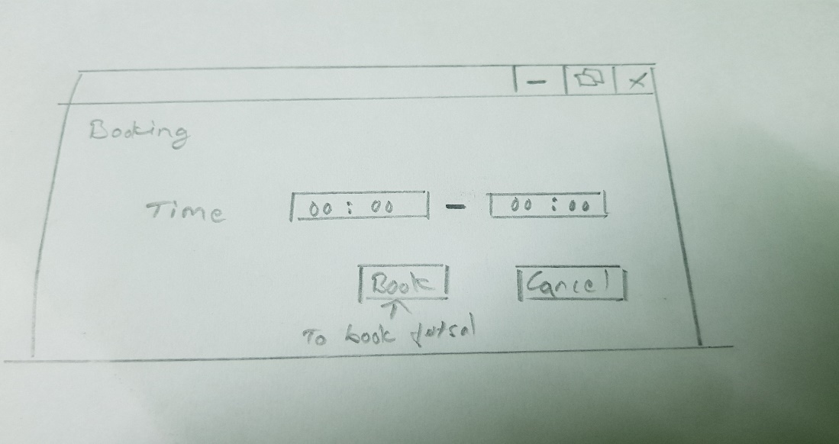

Pic: Booking Page

Explanation

The above images are the images of the paper prototyping. The prototyping is a basis for the actual design of the system they may also vary according to the situation and desire. Prototype helps to develop the website easily and gives information about how system will look after completion.