Project Proposal

on

“Futsal Management System”

Zenith Prajapati

00174448

Computer Project

L5DC

Softwarica College of IT & E-Commerce

Kathmandu, Nepal

April 9,1019

Contents

Chapter 1: Introduction 3

1.1 Project Information 3

1.2 Justification of Project. 4

Background 4

Problem Statement 4

1.3 Description of Project 4

1.4 Overview of the Project 4

Chapter 2: Scope of the Project 5

2.1. Scope 5

2.2. Objectives 5

2.3. Aims 5

2.4. Limitations 5

2.5. Scope Overview 5

Chapter 3: Development Technology 6

3.1 Waterfall model 6

3.2 Design pattern 7

3.3 System Architecture 8

Chapter 4: Project Plan 9

4.1 Work Breakdown Structure 9

4.2 Milestone 11

4.3 Scheduling 11

• Time Estimation Table: 11

• GANTT Chart 11

Chapter 5: Risk Management 12

Chapter 6: Configuration Management 13

Chapter 7: Conclusion 14

Chapter 8: Bibliography 15

# Chapter 1: Introduction

## 1.1 Project Information

My topic for the project of Computer Programming (CP) is “Futsal Management System”. This system can be used by the local futsal organizations for their daily purposes. It will be a website specially designed to manage the regular activities of a futsal organization. It will help the futsal owners to conduct daily activities without any worries and smoothly. In this website the owners can book the owners can conduct various activities like daily futsal booking, tournament organizing, gallery updating events etc. the customers will be able to book futsal for using. They will also be able to post some comments regarding the futsal.

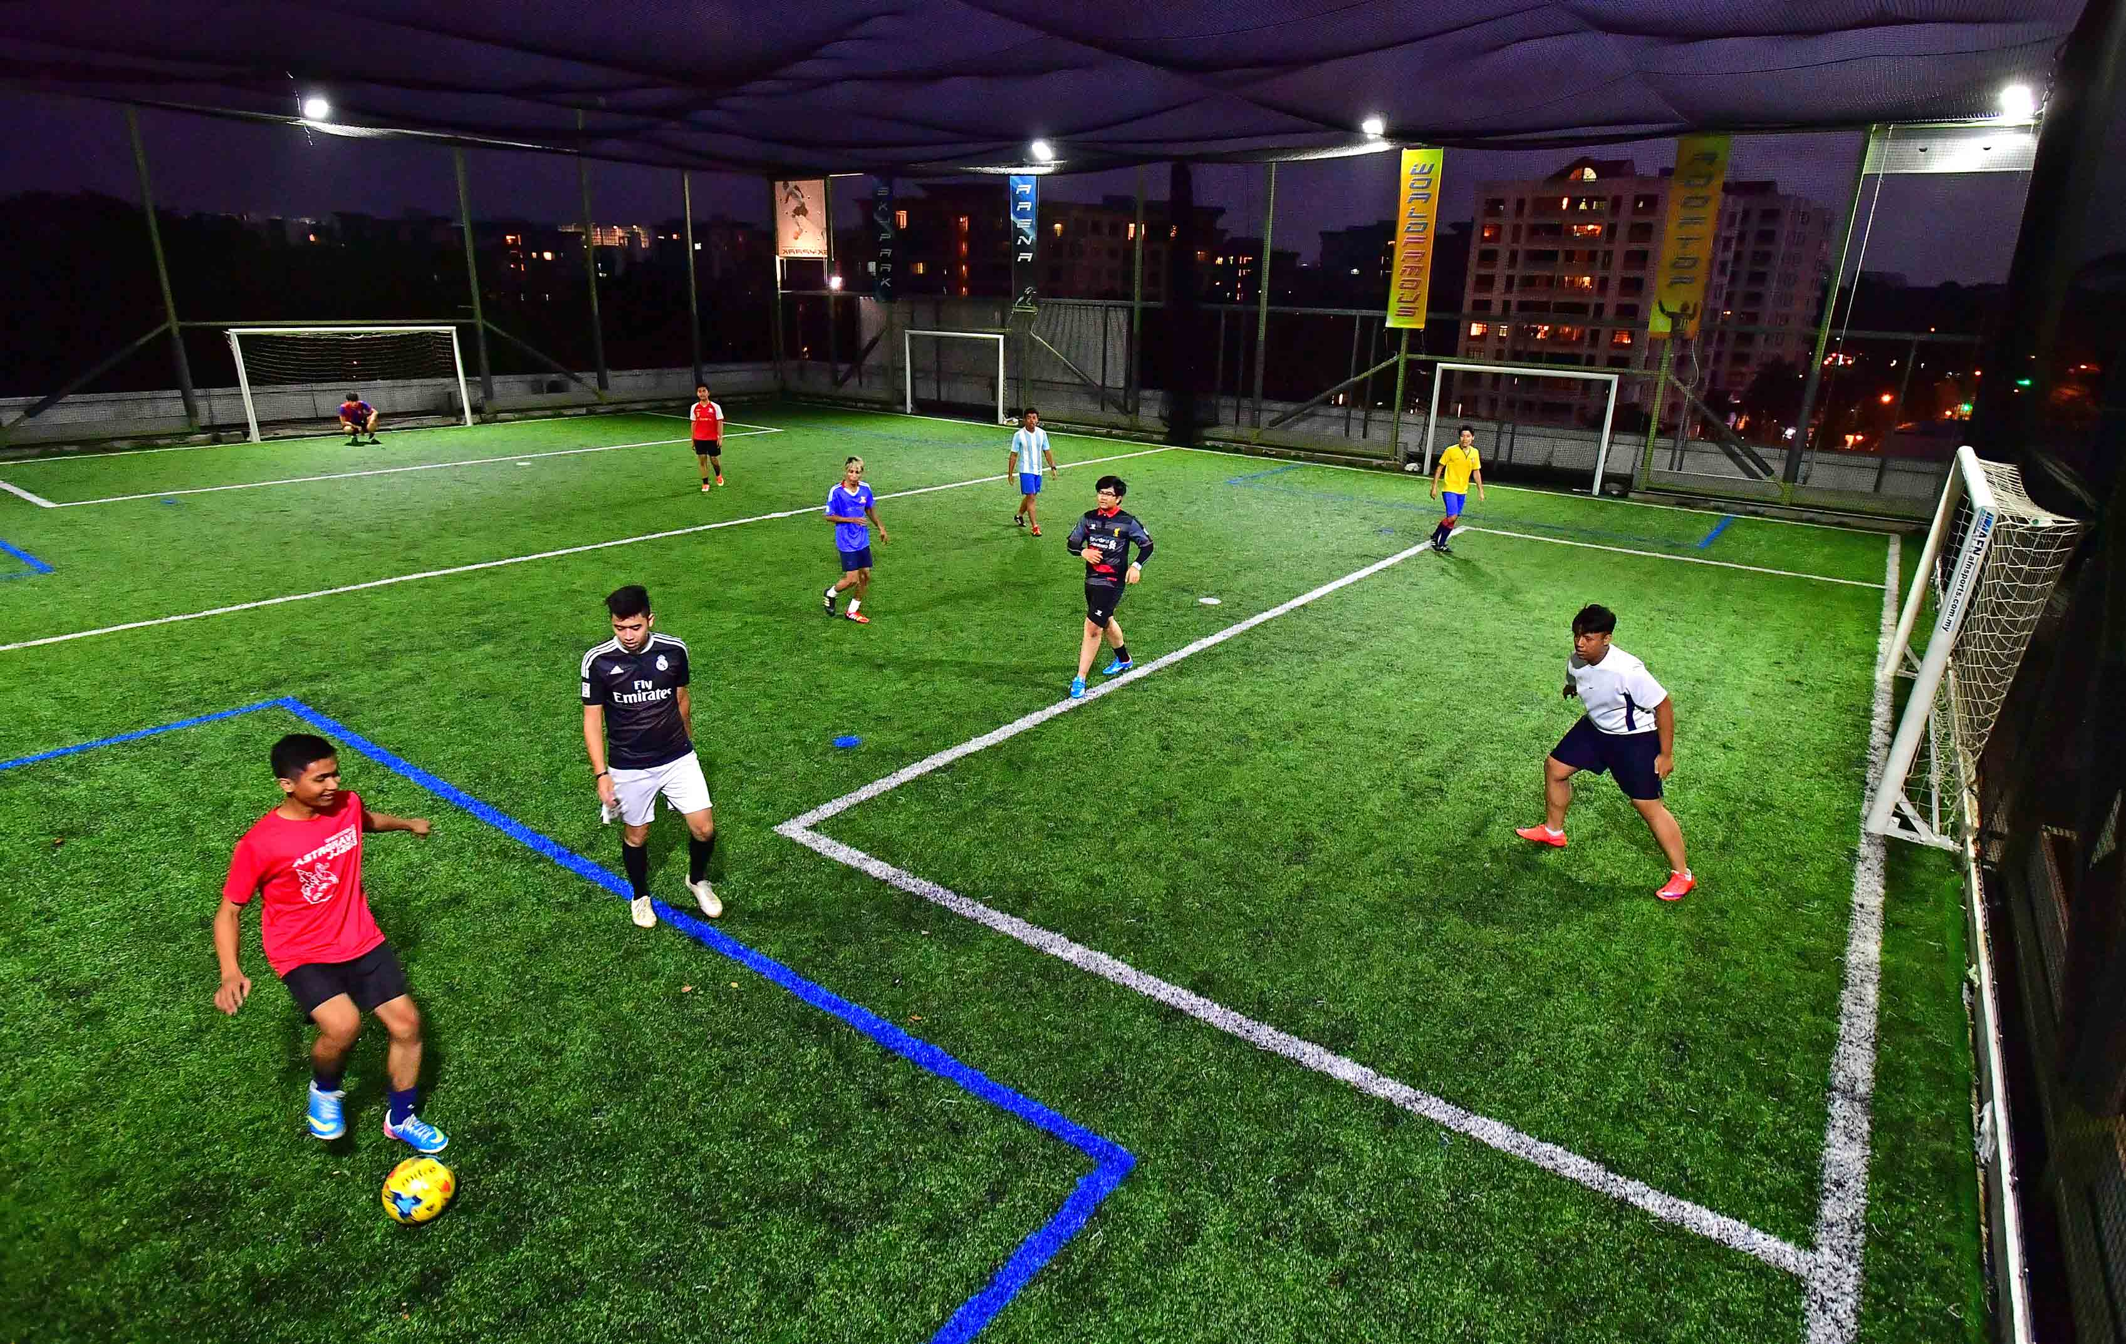

Pic: Futsal

The system will be web based and it will be prepared using the various development tools such as PHP, JavaScript etc. this proposal also includes the various processes taken to prepare the website and the timetable representing the tasks done.

## 1.2 Justification of Project.

### Background

This system will be built for the users to easily manage and organize a Futsal. It will be a web-based website accessible to the users around the world. It can be used for the satisfaction of the customers. The customers can easily access the website and use the available contents. They can also book the shift they want to use the futsal for.

### Problem Statement

A number of new futsal organizations are being built. This will also increase the demand of the users. The number of users will also increase. They will start demanding about the quality rather than quantity. We should be able to fulfill the demands of the users. To maintain the quality of the website we need advanced features. To add such advanced features some investment is also required so the project budget will also increase according to the demand of the users. The website also needs to be available 24 hours to the maintenance cost etc. will also increase.

## 1.3 Description of Project

* Key Features:
* Online booking
* Organizing Tournament
* User friendly interface
* User feedback

## 1.4 Overview of the Project

The project is built to give user satisfaction while using the website. The project is built using PHP, JavaScript etc. and other required tools to maintain the standard of the website.

# Chapter 2: Scope of the Project

## 2.1. Scope

* Maintaining futsal
* For booking futsal
* Increasing futsal business
* To provide user feedbacks

## 2.2. Objectives

* To organize futsal easily
* To carry out daily management of a futsal
* To give users easy access
* To ease the burden of the futsal owners by limiting work

## 2.3. Aims

* To Increase the number of online web users.
* To help in managing futsal
* To provide users the information

## 2.4. Limitations

* Accessing the website requires internet facility
* Multiple users may not be able to use the website’s facility
* Low level equipment may not be able to access the system

## 2.5. Scope Overview

As the website is built using the PHP, and other necessary tool like HTML, JavaScript, CSS etc. it will be user friendly. It will use the MySQL database to store data for future references. The data will also be easily accessible. So, there will be no problem regarding the data loss.

# Chapter 3: Development Technology

Various methods can be used to develop a website. Some of them are waterfall, incremental development, extreme programming, iterative, agile, scrum etc. To develop my project, I will use the most beneficial development method. I will use the required method to develop my project.

## 3.1 Waterfall model

For my project I choose to use the waterfall model because it is suitable to use for a small-scale industry and is also easy to use. It is a perfect method to develop software and small applications for small organization. In this model to do a task previous task should be completed fully. It follows the sequentially without skipping any tasks. As waterfall model is best for the small-scale organization**. WaterfallModel** illustrates the software development process in a linear sequential flow hence it is referred as **Linear-Sequential Life Cycle Model.*****(Toolsqa, 2019)***

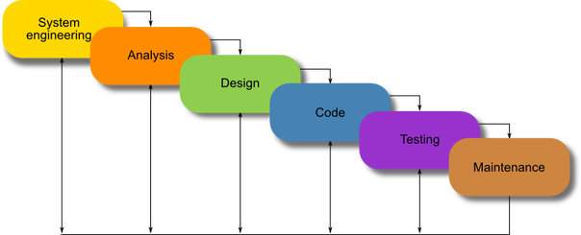

Pic: Waterfall model

There are also other development methodologies such as agile, scrum, extreme programming, spiral etc. but still I decided to use the waterfall model the reasons of using waterfall over some of the other models are:

Why waterfall model over Scrum?

* This project is a single individual task but scrum requires to divide the task into parts so waterfall model is more suitable.
* Scrum requires the developer to discuss the task with the manager but in this project, we are required to do all the task ourselves so waterfall is used.

Why waterfall over Agile?

* Waterfall model is a firm method whereas agile is not firm.
* Waterfall model being the internal phase does not require the customer opinion
* After the steps are comped the developer cannot do the same task so the job will end fast.

## 3.2 Design pattern

A repeatable solution to the commonly occurring problem in software design is known as design pattern. (sourcemaking, 2019)

Its main objective is to help the user in fast project development. It helps the developer to interact with the software. For the completion of my project I decided to use the MVC design pattern.

* Model View Controller pattern

Model view controller is required for the development of any kind of user interactions applications and websites. The system is divided into 3 different forms i.e. Model, View, and Controller. This help in the easy process of the system.

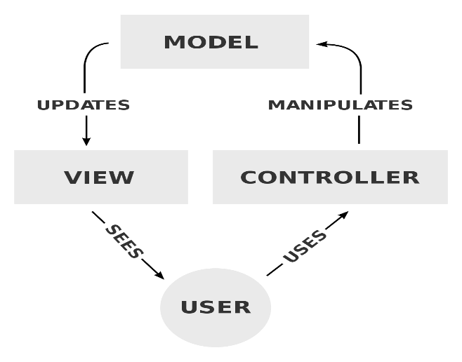

## 3.3 System Architecture

A Framework compromised of relations and interactions between the components of the application is known as a System Architecture. Such as user interfaces, client servers, web servers and databases. Internet is also a necessary component.

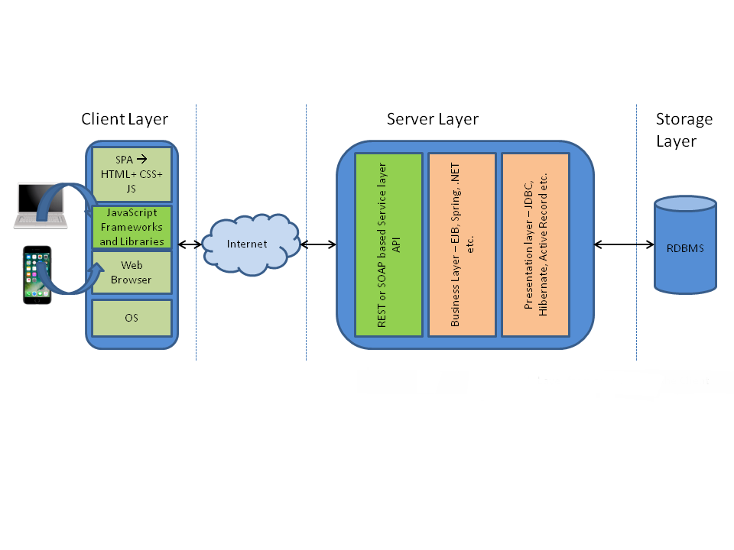

# Chapter 4: Project Plan

## 4.1 Work Breakdown Structure

The Work breakdown structure helps a developer to follow a set of tasks for completion of project. As my project is for education purpose there is a deadline set for the submission of my project so for this purpose the WBS is important. WBS helps to separate the task to be done according to the time required for its completion.

The figure after total analysis of the system is:

**Futsal Management System**

White Box Testing

Black Box Testing

Integration Testing

Unit Testing

Building Database

Class Diagram

Database Design

UI Design

Class Diagram

Feasibility Study

NLA

Requirement Specification

Configuration Management

Risk Management

Project Plan

Final Deadline

Testing

Analysis

Design

Implementation

Project Management

Ma

Behavioral Design

Project Submission

Use case Diagram

Coding

Proposal Submission

Fig: WBS figure form

Tabular Form of WBS and Time Estimation.

|  |  |  |
| --- | --- | --- |
| WBS | Task Name | No. Of Days |
| **0** | **Futsal Management System** | **108** |
| **1**  1.1  1.2  1.3  1.4 | **Project Management**  Project Plan  Risk Management  Configuration  Proposal Submission | **16**  6  5  4  1 |
| **2**  2.1  2.2  2.3  2.4 | **Analysis**  Requirement Specification  Use Case Diagram  Class Diagram  Feasibility Study | **28**  10  3  3  12 |
| **3**  3.1  3.2  3.3 | **Design**  Behavioral Design  UI Design  Database Design | **25**  3  14  8 |
| **4**  4.1  4.2 | **Implementation**  Building Database  Coding | **20**  8  12 |
| **5**  5.1  5.2  5.3  5.4 | **Testing**  Unit Testing  Integration Testing  White Box Testing  Black Box Testing | **7**  2  2  2  1 |
| **6**  6.1 | **Final Deadline and Documentation**  Project Submission | **11**  11 |

Table: WBS Tabular Form

## 4.2 Milestone

Milestones are essential equipment for project development. We must set a certain set of milestones for completion of ours project. All the programmers create a date for each task of their project to finish the project in the accurate time. All the task has some time allotted for completion. These tasks should be completed in the allotted time limit for betterment of the project. Milestones helps developers or programmers to be in an advantage. For my project I have also set some milestones.

|  |  |
| --- | --- |
| **Milestones** | **Date Completion** |
| Proposal | 9 April 2018 |
| Analysis | 8 May 2018 |
| Design | 3 June 2018 |
| Coding | 24 June 2018 |
| Testing | 1 July 2018 |
| Final Documentation | 12 July 2018 |

Table: Milestone of the project

## 4.3 Scheduling

### Time Estimation Table

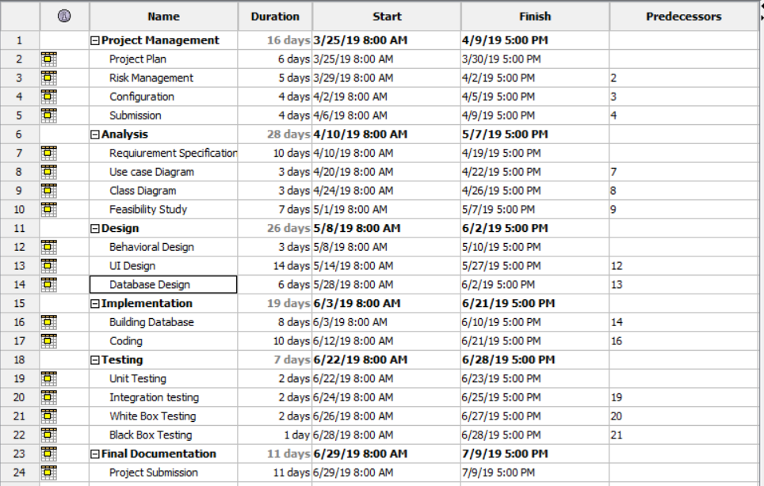

### GAANT:

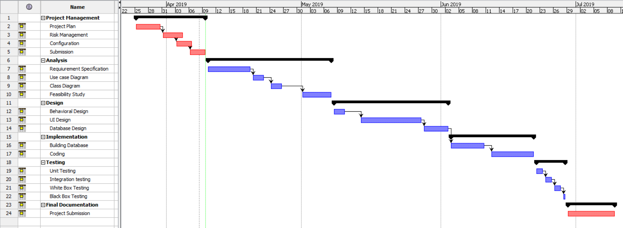

FIg: GANTT chart

# Chapter 5: Risk Management

Risk management are done to verify and to analyze the risk that are seen on the future and to deal with it in the proper way. In this project also there might be some of the risk factor that must be analyze by me to outcome the best project.

For my project there might be many risks, so to deal with it I should find out the impact of the risk. And impact is found out by looking at the combination of likelihood and consequences.

The formula (impact (I) = likelihood (L) * consequence (C)) is used to calculate the impact. The likelihood and consequences are defined as:

|  |  |
| --- | --- |
| **Likelihood (L)** | **Value** |
| Low | 1 |
| Medium | 2 |
| High | 3 |

Table: Likelihood

|  |  |
| --- | --- |
| **Consequences (C)** | **Value** |
| Very Low | 1 |
| Low | 2 |
| Medium | 3 |
| High | 4 |
| Very High | 5 |

Table: Consequence

|  |  |  |  |  |  |
| --- | --- | --- | --- | --- | --- |
| **SN** | **Risks** | **Likelihood** | **Consequence** | **Impact** | **Actions** |
| 1 | Natural disaster | 2 | 4 | 8[2*4] | Backup |
| 2 | Hardware/ Software Crash | 2 | 3 | 6[2*3] | Regular Maintenance |
| 3 | Theft | 3 | 3 | 9[3*3] | Keeping backup |
| 4 | Not finishing in time | 2 | 4 | 8[2*4] | Milestone Checking |
| 5 | System infection | 3 | 2 | 6[3*2] | Antivirus Software |
| 6 | Requirements may not meet | 3 | 1 | 3[3*1] | Taking information from similar websites |

Table: Risk Management Analysis

# Chapter 6: Configuration Management

The configuration management to develop my project is given below:

# Chapter 7: Conclusion

After the proposal is finally completed defining the task that will be done while preparing the project. The topic of the proposal is Futsal management system. This will develop a website to carry out the daily task of a Futsal organization. The system will be developed in PHP programming language and the tools and techniques that will be required are analyzed. The aims and objectives along with the scope that will be on the project or that will not be on the project is also mentioned. The time required for the completion of project is also mentioned in the proposal. The time frame is divided onto various parts and the time analysis is also reported in the proposal.

As the project is a small-scale project waterfall model is used to prepare the project as it is a systematic approach for a small size project. And it also suits the scenario.

The risk that may arise while developing a website are all listed on the proposal. Also, the necessary steps to be taken to overcome such risk are also mentioned. This will help to minimize the risk while developing the project.

# Chapter 8: Bibliography

Gantt.com. (2019). What is a Gantt chart? [online] Available at: <http://www.gantt.com/> [Accessed 7 April. 2019].

www.toolsqa.com (2019). SDLC Waterfall Model. [online] Available at: <https://www.toolsqa.com/software-testing/waterfall-model/> [Accessed 3 April. 2019].