[Progress in Biophysics and Molecular Biology xxx (2017) 1e5](https://doi.org/10.1016/j.pbiomolbio.2018.01.003)

Progress in Biophysics and Molecular Biology

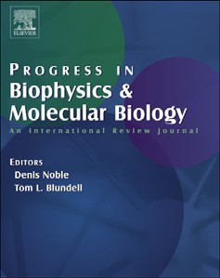

journal homepage: www.elsevier.com/locate/pbiomolbio

Quantum Mechanics predicts evolutionary biology

Utkarsh Agnihotri

B.Tech. CS(bcs2017013), Invertis University, Bareilly, Uttar Pradesh, India.

a r t i c l e i n f o

Article history:

Received 21 November 2017

Received in revised form

9 January 2018

Accepted 10 January 2018

Available online xxx

a b s t r a c t

The shortcomings of biology more evident in the field of Quantum Biology and nowhere else. The application of Quantum Mechanics to evolutionary biology can be done by merging Quantum Mechanics with the fundamentals of evolution’s Physiology-namely negentropy, chemiosmosis and homeostasis- This offers a real opportunity to understand how physics evaluates the basic principles of biology. Negentropy and chemiosmosis provides deter-minims on the unicell, whereas homeostasis constitutes Free Will as it offers a statistic range of physiologic set points. Similarly, on this basis several principles of Quantum Mechanics apply directly to biology. The Pauli Exclusion Principle is an example being both deterministic and probabilistic, whereas the Heisenberg Uncertainty Principle is probabilistic.

© 2018 Published by Elsevier Ltd.

Contents

1. Introduction . . . . . . . . . . . . . . . . . . . . . . . . . . . . . . . . . . . . . . . . . . . . . . . . . . . . . . . . . . . . . . . . . . . . . . . . . . . . . . . . . . . . . . . . . . . . . . . . . . . . . . . . . . . . . . . . . . . . . . . 00

2. Lipid control of calcium homeostasis as the history of vertebrates: a key to reductionist Quantum Mechanical approach . . . . . . . . . . . . . . . . . . . . . . . . 00

3. Quantum Mechanics and origins and causation in biologic evolution . . . . . . . . . . . . . . . . . . . . . . . . . . . . . . . . . . . . . . . . . . . . . . . . . . . . . . . . . . . . . . . . . . . . . 00

4. Predictive value of a Quantum Mechanical approach to evolution . . . . . . . . . . . . . . . . . . . . . . . . . . . . . . . . . . . . . . . . . . . . . . . . . . . . . . . . . . . . . . . . . . . . . . . 00

5. The unicell-multicell approach predicts the iterative evolution of Niche construction: a holistic approach . . . . . . . . . . . . . . . . . . . . . . . . . . . . . . . . . . . . . 00

6. The forward-direction of evolution predicts the role of Quantum Mechanics . . . . . . . . . . . . . . . . . . . . . . . . . . . . . . . . . . . . . . . . . . . . . . . . . . . . . . . . . . . . . . . 00

7. Is there a homolog for Quantum coherence? . . . . . . . . . . . . . . . . . . . . . . . . . . . . . . . . . . . . . . . . . . . . . . . . . . . . . . . . . . . . . . . . . . . . . . . . . . . . . . . . . . . . . . . . . . . 00

8. The cytoskeleton as the homolog for self-organization and consciousness . . . . . . . . . . . . . . . . . . . . . . . . . . . . . . . . . . . . . . . . . . . . . . . . . . . . . . . . . . . . . . . . 00

9. Discussion . . . . . . . . . . . . . . . . . . . . . . . . . . . . . . . . . . . . . . . . . . . . . . . . . . . . . . . . . . . . . . . . . . . . . . . . . . . . . . . . . . . . . . . . . . . . . . . . . . . . . . . . . . . . . . . . . . . . . . . . . 00

9.1. Synchronic v diachronic . . . . . . . . . . . . . . . . . . . . . . . . . . . . . . . . . . . . . . . . . . . . . . . . . . . . . . . . . . . . . . . . . . . . . . . . . . . . . . . . . . . . . . . . . . . . . . . . . . . . . . 00

Acknowledgement . . . . . . . . . . . . . . . . . . . . . . . . . . . . . . . . . . . . . . . . . . . . . . . . . . . . . . . . . . . . . . . . . . . . . . . . . . . . . . . . . . . . . . . . . . . . . . . . . . . . . . . . . . . . . . . . . 00

References . . . . . . . . . . . . . . . . . . . . . . . . . . . . . . . . . . . . . . . . . . . . . . . . . . . . . . . . . . . . . . . . . . . . . . . . . . . . . . . . . . . . . . . . . . . . . . . . . . . . . . . . . . . . . . . . . . . . . . . . 00

1. Introduction

The deficiencies of biology are more unmistakable in the arena of Quantum Biology and nowhere else. in the on- going effort to apply Quantum Mechanics to evolutionary environmental science. All of these experiments have enlisted the direct application of the principles of QM to the physiologic properties of biology being product of evolution, rather than to the

latter’s ontologic origins and epistemologic. It is analogous trying to understand the internal combustion engine of the automobile by applying physics to its wheels or transmission. However, the application of QM to the origin and cause of evolution at the cellular level reveals its mechanistic principles and offers the real opportunity to understand how and why physics constitutes the basics of biology .

E-mail address: [agni.utk27@gmail.com.](mailto:agni.utk27@gmail.com.)

https://doi.org/10.1016/j.pbiomolbio.2018.01.003

0079-6107/© 2018 Published by Elsevier Ltd.

2. Lipid control of calcium homeostasis as the history of vertebrates: a key to reductionist Quantum Mechanical approach

Reduction of biology to Quantum Mechanics offers useful insights to the cellular level of biology. It has previously been shown that the direction and magnitude of gene change can be seen as diffrentiating internal and external responses to major deteriorations in the environment. Throughout, these changes in genets are in service to the balancing selection of calcium and lipid homeostasis. The pressure of selection for this mechanism began with the rise in CO2 in the atmosphere, causing acidiﬁcation of the seas by the carbonic acid formed on leaching calcium from the rock. Calcium is highly toxic at high levels, so its channels appear to have evolved to regulate intracellular genome. Subsequently, with the rise in atmospheric oxygen over the course of the Phanerozoic Era has caused endoplasmic reticulum stress, which in turn caused calcium leak into the cytoplasm. In response, the cells acquired peroxisomes, they utilize lipids to neutralize the effects of increased cytosolic calcium. The power of prediction of the Quantum Mechanical approach can be expressed by entraining intracellular calcium, followed by controlling it through cellular interactions manifested by the effects of soluble growth receptors.

3. Quantum Mechanics and origins and causation in biologic evolution

There is a belief that the Laws of Physics determine all of the Natural Phenomena bringing the question on to how physics has understood the principles of biology. The riddle still remains unsolved.

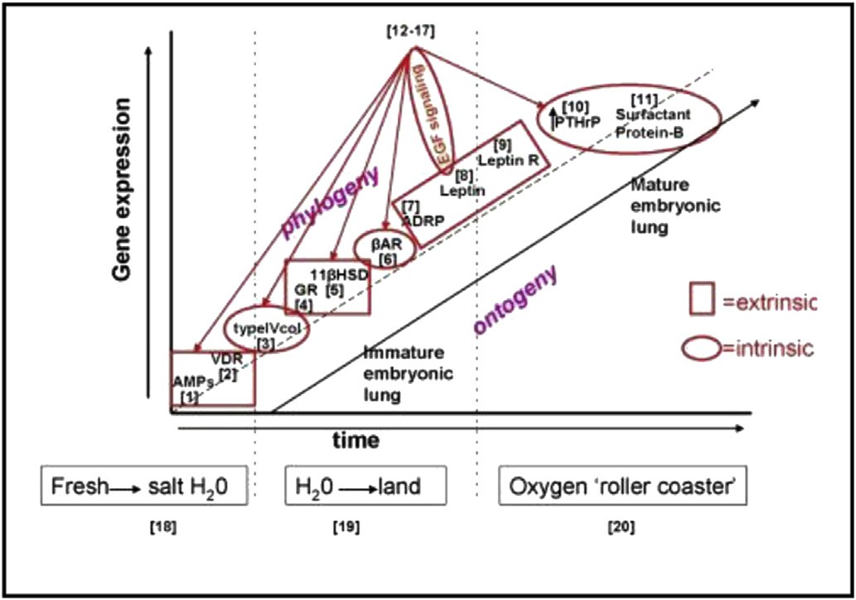

All have concluded that biology is just too complicated. it has also been claimed that life is simple we have made it a complex phenomenon from our, self- serving perspective. Alternatively, it has been stated that there are common diffeerence between physics and biology. It is prestated that those differences are due to their common origin otherwise referred to as the Big Bang. After all, stellar evolution and Black Holes came about through Darwinian-like mechanisms. It is feasible that in the aftershock of the Big Bang, based on Newton's Third Law of Motion, an ‘equal and opposite reaction’ was met by organisms, given that the only existing thing at the time was the Singularity. It was on that basis that chemistry has come about. Although it can be argued that we do not know the origins, initial conditions and mechanisms of evolution because we were not present when it happened, there are ways in which we can hypothesize how and why it occurred that are scientiﬁcally arguable. Elsewhere, it has been argued that since lipids were highly important in the evolution of eukaryotes, that they played a vital role in initial conditions of life based on the fact that evolution is pre-adaptive. Lipids immersed in water may have formed the basis for life since the frozen snowball asteroids that formed the Earth's oceans and spontaneously form micelles when immersed in water exhibiting hysteresis as molecular ‘memory’, able to recall their shape and size, which is necessary for evolution. In the process of forming life, the lipid membranes that encarcerated the internal and external environments generated an ambiguity that became the basis of life . Under these conditions, several differences of Quantum Mechanics apply-such as the Pauli Exclusion Principle, non-localization, the Heisenberg Uncertainty

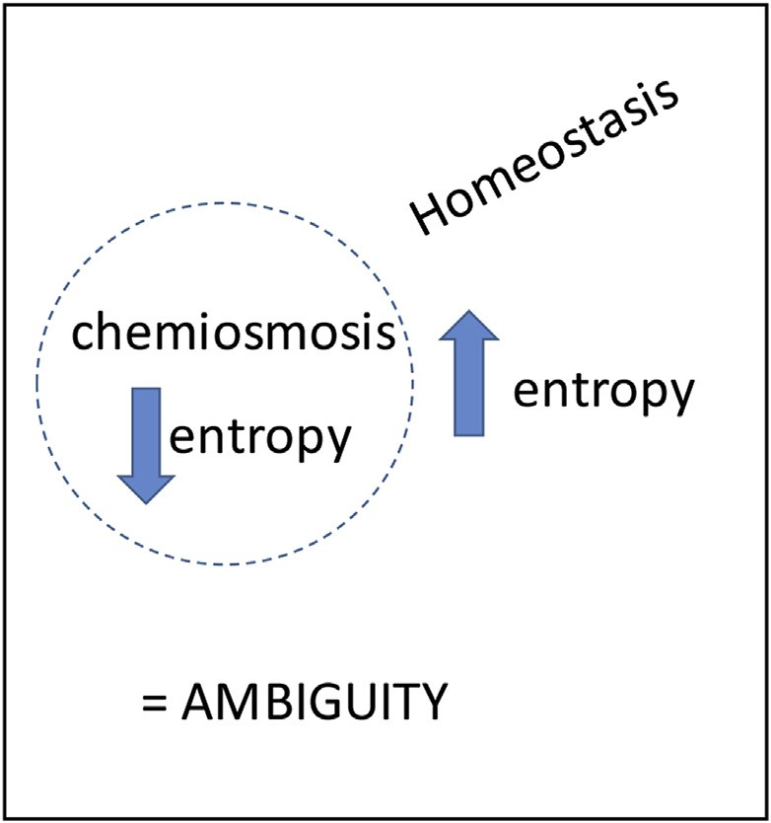

Principle and Coherence. It has also been proposed that there are three Principles of Physiology namely negentropy, chemiosmosis and homeostasis. The ﬁrst two principles show determinism in the unicell, whereas homeostasis displays Free Will as it offers a wide range of potential set points. Thus, life exists and has ever existed between the boundaries of determinism and Free Will. Similarly, the Pauli Exclusion Principle also gives boundaries of determinism and Free Will in the physical reality since electron spin is ruled by its four quantum numbers, the ﬁrst determines the second and third when ﬁlling the electron's quantum energy state. The fourth quantum number is time-dependent, offering a range of many electron energy levels, showing Free Will in physical terms. So there is a factor for determinism and Free Will in the formation of the elements that biology must agree with. Biology, in turn, mimics the Quantum Mechanical principles through homologies with the Three Principles of Physiology.

Another feature of Quantum Mechanics is non-localization, the concept that the elements of the universe are distributed all along. The same phenomenon holds true for biology in the form of pleiotropy. A gene can be found in many different parts or tissues of the organism as a result of the mechanism of evolution, which acts to identify genes in the organism's history that could be used in subsequent situations. The happening of this process under various environmental conditions consists of the process of evolution. Under stress, the same gene can be expressed in different parts, but always by referencing the original unicellular Principles of Physiology, distributed throughout the organism in a non-localized manner. This distributive property has the same origin with the non-localization principle of Quantum Mechanics.

Life began as an uncertainty, the inner free energy or entropy of the cell was negative, in contrast to the positive entropy outside of the cell. That variable entropy generated an obscurity that acted as the on-going driver for the following evolution of the organism over time phylogenetically. It forms a resource of interfacing with the physical environment that exists in a eternal vague state of uncertainty, allowing the biologic system to commendably cope with the ‘not knowing with certainty’ characteristic of the Heisenberg Uncertainty Principle. For example, Niels Bohr elucidated the seemingly contradictory duality of light as both particle and wave due to the differences in the way that it is detected, which is homologous with the uncertainty of the cell, coping with such paradoxes, as described above. So maybe it is because physics, like life itself exists in an indeterminate state regarding its surroundings that allows it to cope and expect it.

4. Predictive value of a Quantum Mechanical approach to evolution

Extrapolation is necessary for ‘hard’ science. following is a way of understanding biology systematically, allowing it to be interfaced with Quantum Mechanics functionally, revealing the common source of the Big Bang.

Previously, the idea that the unicell was the ﬁrst Niche Construction was postulated. By suppressing the environment through endosymbiosis.

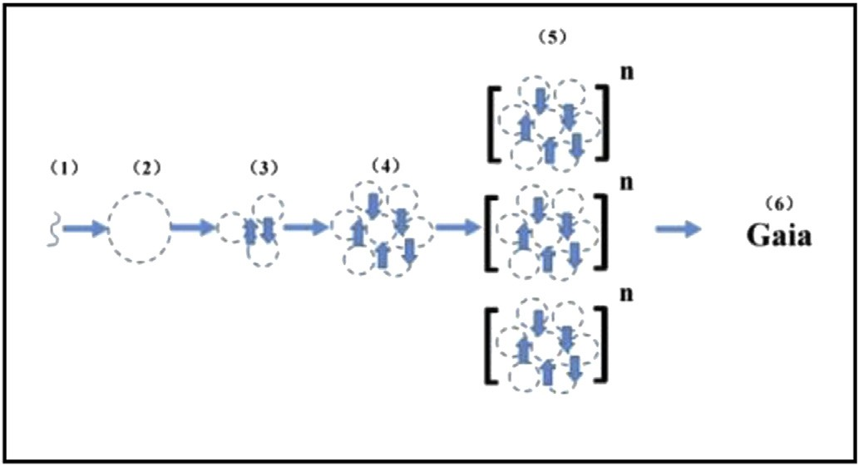

The consequent communication between cells in support of metabolic cooperativity was demonstrated by the principle of Niche Construction, in amalgamation with the legacy of epigenetic marks, eventually giving rise to larger community. The extensive propagation of these properties concluded in Gaia, the concept of the organic unity of the Earth. Over the course of the Earth's history, increase and decrease in the concentration of oxygen and carbon dioxide in the atmosphere enforced physiologic stresses on life forms. By outlining the phenotypic changes under such conditions, the evolution of the mammals was traced from its unicellular origins.

6. The forward-direction of evolution predicts the role of

Quantum Mechanics

Seen from the origins, evolution can accurately be seen homologous with Quantum Mechanics. Dropping the process for the origin of life to its elements, expressed as the Principles of Physiology offers the prospect to see the one-to-one interactions between QM and physiology, much like Mendeleev's Periodic Table, reducing the Elements to their atomic numbers. Thus, QM can be realised directly to the process of evolution by considering its homology with the Pauli Exclusion Principle or Heisenberg Uncertainty Principle.

Pauli Exclusion Principle: is the quantum mechanical principle that no two electrons may have the same quantum number in a quantum system. This results from the ﬁlling of the four quanta of energy, with the ﬁrst quantum determining the position of the second and third. The last quantum number is time-dependent, and is therefore probabilistic. As a result, the electron exists between the boundaries of determinism and chance. Similarly, the cell exists between the determinism of negentropy and chemiosmosis, and the probabilistic Free Will of homeostasis.

Non-Localization: describes the distribution of physical properties throughout the Universe. And because biology produces pleiotropic traits by acquiring the same gene over the course of its history under different environmental conditions, it also exhibits non-local behavior.

Heisenberg Uncertainty Principle: life began at the edge

between negative internal and positive external entropy, generating an ambiguous condition. It is this ‘uncertainty’ that forms the basis for evolution as problem solving, conferring the capacity of biology to cope with Heisenberg's Principle.

7. Is there a homolog for Quantum coherence?

In physics, two wave sources are coherent when both their phase, frequency and waveform overlap. This is essentially what happens when a growth factor, endocrine hormone or neuroendocrine hormone stimulates its receptor, ultimately increasing calcium waves that transduce the signal to affect the physiology of the cell, tissue, organ and organism.

8. The cytoskeleton as the homolog for self-organization and consciousness

Seen descriptively, the cytoskeleton is the superstructure of the cell. For example, actin ﬁbers integrate many aspects of the cytoarchitecture. They anchor many proteins and enzymes, and keeps some membrane proteins anchored in speciﬁc sites within the plasma membrane, such as ion pumps and channels.

Holistically the cytoskeleton functions to coordinate all of the functions of the cell in response to the environment, homeostatic, mitotic and meitotic alike. As such, it acts as the homolog for the

‘consciousness’ of the cell. The nature and origins of that property are referred to as the ‘hard’ problem, which may be understood mechanistically as follows.

Hameroff and Penrose have reduced consciousness to the microtubules of the brain, acting to transduce its activity through the cytoskeleton. This is yet another attempt to solve the ‘hard’ problem of consciousness based on descriptive biology. Seen from its diachronic origins, microtubules are elements of the cytoskeleton, which act as the transducers for all aspects of cell biology-homeostasis, mitogenesis and meiosis alike. The signiﬁcance of this relationship can be seen in experiments testing the effect of microgravity on cellular structure and function. When yeast are put in microgravity, for example, they lose their abilities to polarize and bud, essentially placing the organism in suspended animation since polarization is neces- sary for calcium ﬂux and budding is the way that yeast reproduce. Such effects are similar to those seen when lung and bone cells are put in microgravity, causing a loss of Parathyroid Hormone-related Protein (PTHrP) gene expression. PTHrP is a key pleiotropic gene that determines a wide variety of vertebrate traits ranging from the formation of alveoli

to glomerular ﬁltration, bone calciﬁcation and brain regeneration/function.

As alluded to above, microgravity causes yeast, lung and bone cells alike to devolve into a seeming state of ‘suspended animation’ has suggested that anesthetics have the same net effect physicochemically. It is hypothesized that this is the biologic equivalent of what is referred to in QM as wave collapse due to dissociation of the process (consciousness) from its physical envi- ronment, in this case that of gravity , which is intimately linked with the fabric of space-time.

The central and peripheral mechanisms integrated by PTHrP, for example, are the epitome of holistic physiology, providing insight to the nature of consciousness, acting to interconnect the cells of the body physiologically. Beyond that, because of the connection to physics as gravity, there is a continuum from the inanimate to the animate that was produced by the Big Bang, to which all of these

properties are referenced by QM. As a result, the process of evolution can ultimately be expressed mathematically as a function of QM as it applies to ontogeny and phylogeny.

9. Discussion

9.1. Synchronic v diachronic

The Periodic Table acts to construct an algorithm for under- standing the interrelationships between the elements based on atomic number. That, in turn is due to Pauli Exclusion Principle, which confers both determinism and probability on physics; like the Periodic Table of Physics, a cellular perspective on biologic evolution as the First Principles of Biology provides the mechanistic link to Physics, the former similarly indicating that biology exists between the determinism of negentropy and the probability of homeostasis.

The common thread between physics and biology is that both are predicated on self-organization and self-reference as their operating system. The origins of these properties are not known, though, for example, there is now empirical evidence that atoms of Yttrium will align themselves spontaneously, indicating that there is a mechanism for self-organization.

Speculatively, there is a consensus that the Cosmos resulted from the explosion of the Singularity, known as the Big Bang. But Newton's Third Law of Motion would dictate that for every action there is an equal and opposite reaction. Based on parsimony, since the only organizational frame of reference in existence at that time was the Singularity, hypothetically biology was the consequent manifestation, acting like a pseudo-singularity. This concept is consistent with what we know of epigenetic inheritance, actively accumulating ‘marks’ that are assimilated by the germ cells of the adult, imparted to the offspring during reproduction. This scenario is one-hundred-and-eighty degrees out of sync with Darwinian evolution, which imbues the adults, not the egg and sperm, with agency for Natural Selection through mate selection. Thus, like the Red Queen in “Alice in Wonderland”, the unicell is doing everything in its power to maintain the equipoise formed by the Singularity, delegating the offspring phenotype to interface with the environment in order to optimally collect data to carry back to the germ cells, zygote, embryo, and offspring of the next generation. And even beyond the offspring, the entire life cycle mediates the collection of marks since the endocrine system itself is under epigenetic control. By seeing the process of evolution from the cellular perspective, many otherwise dogmatic aspects of biology can be understood mechanistically, including heterochrony, homeostasis/homeorhesis, pleiotropy, the life cycle, the cell, and phenotype.

Like the advent of Heliocentrism, this novel perspective on evolution provides a wholly different concept of origins and causation in biology. It is reminiscent of Waddington, envisioning a horse and cart seen through a window, exhorting us to think of the horse as more than just what we can see before us because there is an arc of evolutionary history just below the surface. By connecting the dots between physics and biology, there is a continuous path from the Singularity/Big Bang to the period at the end of this sentence.

References

Baggott, J., 2011. The Quantum Story. Oxford University Press, Oxford.

Barrow, J.D., Tipler, F.J., 1988. The Anthropic Cosmological Principle. Oxford University

Press, Oxford.

Berner, R.A., 1990. Atmospheric carbon dioxide levels over phanerozoic time. Science

249, 1382e1386.

Berner, R.A., 2003. The long-term carbon cycle, fossil fuels and atmospheric

composition. Nature 426, 323e326.

Berner, R.A., Vandenbrooks, J.M., Ward, P.D., 2007. Evolution. Oxygen and evolution.

Science 316, 557e558.

Birks, J.B., 1962. Rutherford at Manchester. Heywood, London.

Bohm, D., 1980. Wholeness and the Implicate Order. Routledge, New York.

Bohm, D., Hiley, B., 1975. On the intuitive understanding of non-locality as implied

by Quantum theory. Found. Phys. 5, 93e109.

Bosch, R.J., Rodríguez-Puyol, D., Bover, J., Rodríguez-Puyol, M., 1999. Parathyroid

hormone-related protein: roles in the glomerulus. Exp. Nephrol. 7, 212e216.

Case, R.M., Eisner, D., Gurney, A., Jones, O., Muallem, S., Verkhratsky, A., 2007.

Evolution of calcium homeostasis: from birth of the first cell to an omnipresent

signaling system. Cell Calcium 42, 345e350.

Davies, P.C., Walker, S.I., 2016. The hidden simplicity of biology. Rep. Prog. Phys. 79,

102601.

De Duve, C., 1969. Evolution of the peroxisome. Ann. NY Acad. Sci. 168, 369e381.

De Loof, A., 2016. The cell's self-generated "electrome": the biophysical essence of

the immaterial dimension of Life? Commun. Integr. Biol. 9, e1197446.

Deamer, D., 2017. The role of lipid membranes in Life's origin. Life 7 (1).

Einstein, A., 1916. Relativity: the Special and General Theory. H. Holt and Company,

New York.

Gabald_on, T., Pittis, A.A., 2015. Origin and evolution of metabolic sub-cellular

compartmentalization in eukaryotes. Biochimie 119, 262e268.

Golub, M.S., Hogrefe, C.E., Malka, R., Higgins, J.M., 2014. Developmental plasticity of

red blood cell homeostasis. Am. J. Hematol. 89, 459e466.

Gould, S.J., Vrba, E.S., 1982. A missing term in the science of form. Paleobiology 8,

4e15.

Gray, M.W., 2017. Lynn Margulis and the endosymbiont hypothesis: 50 years later.

Mol. Biol. Cell 2017 (28), 1285e1287.

Gu, Z., Liu, Y., Zhang, Y., Jin, S., Chen, Q., Goltzman, D., Karaplis, A., Miao, D., 2012.

Absence of PTHrP nuclear localization and carboxyl terminus sequences leads

to abnormal brain development and function. PLoS One 7, e41542.

Hameroff, S., 1998. Anesthesia, consciousness and hydrophobic pocketsea unitary

quantum hypothesis of anesthetic action. Toxicol. Lett. 100e101, 31e39.

Hameroff, S., Penrose, R., 2014. Consciousness in the universe: a review of the 'Orch

OR' theory. Phys. Life Rev. 11, 39e78.

Hamley, I.W., 2007. Introduction to Soft Matter. Wiley, Hoboken.

Harnad, S., 1998. Explaining consciousness: the hard problem. Trends Cogn. Sci. 2,

234e235.

Heisenberg, W., 1927. Über den anschaulichen Inhalt der quantentheoretischen

Kinematik und Mechanik. Zeitschrift fur Physik 43, 172e198.

Heisenberg, W., 1949. The Physical Principles of the Quantum Theory. Dover Books,

Mineola.

Krane, K.S., 1987. Introductory Nuclear Physics. Wiley, Hoboken.

Lovelock, J., 2009. The Vanishing Face of Gaia. Basic Books, New York.

Mitchell, M.J., Oliver, E.J., Cliffe, K.A., Maroto-Valer, M., 2010. A model of carbon

dioxide dissolution and mineral carbonation kinetics. Proc. Royal Soc. A 466,

1265e1290.

Pauli, W., 1925. Über den Zusammenhang des Abschlusses der Elektronengruppen

im Atom mit der Komplexstruktur der Spektren. Z. Phys. 31, 765e783.

Philbrick, W.M., 1998. Parathyroid hormone-related protein is a developmental

regulatory molecule. Eur. J. Oral Sci. 106, 32e37.

Polanyi, M., 1968. Life's irreducible structure. Live mechanisms and information in

DNA are boundary conditions with a sequence of boundaries above them.

Science 160, 1308e1312.

Popper, K., 1963. Conjectures and Refutations. Routledge and Kegan Paul, London.

Prigogine, I., Stengers, I., 1984. Order Out of Chaos. Bantam, New York.

Purevdorj-Gage, B., Sheehan, K.B., Hyman, L.E., 2006. Effects of low-shear modeled

microgravity on cell function, gene expression, and phenotype in Saccharomyces

cerevisiae. Appl. Environ. Microbiol. 72, 4569e4575.

Rubin, L.P., Kifor, O., Hua, J., Brown, E.M., Torday, J.S., 1994. Parathyroid hormone

(PTH) and PTH-related protein stimulate surfactant phospholipid synthesis in

rat fetal lung, apparently by a mesenchymal-epithelial mechanism. Biochim.

Biophys. Acta 1223, 91e100.

Schlosshauer, M., 2005. Decoherence, the measurement problem, and interpretations

of quantum mechanics. Rev. Mod. Phys. 76, 1267e1305.

Schrodinger, E., 1944. What Is Life? Cambridge University Press, Cambridge.

Schuster, S., Marhl, M., H€ofer, T., 2002. Modelling of simple and complex calcium

oscillations. From single-cell responses to intercellular signalling. Eur. J. Biochem.

269, 1333e1355.

Sherrington, C.S., 1957. Man on His Nature. Cambridge University Press, Cambridge.

Sia, P.I., Luiten, A.N., Stace, T.M., Wood, J.P., Casson, R.J., 2014. Quantum biology of

the retina. Clin. Exp. Ophthalmol. 42, 582e589.

Simmonds, C.S., Kovacs, C.S., 2010. Role of parathyroid hormone (PTH) and PTHrelated

protein (PTHrP) in regulating mineral homeostasis during fetal development.

Crit. Rev. Eukaryot. Gene Expr. 20, 235e273.

Singh, S., 2005. Big Bang: the Origins of the Universe. Harper Perennial, New York.

Smolin, L., 1997. The Life of the Cosmos. Oxford University Press, Oxford.

Torday, J.S., 2003. Parathyroid hormone-related protein is a gravisensor in lung and

bone cell biology. Adv. Space Res. 32, 1569e1576.

Torday, J.S., 2015. Pleiotropy as the mechanism for evolving novelty: same signal,

different result. Biology 4, 443e459.

Torday, J.S., 2016a. Life is simple-biologic complexity is an epiphenomenon. Biology

5 (2).

Torday, J.S., 2016b. The cell as the first niche construction. Biology 5 (2).

Torday, J.S., 2016c. Heterochrony as diachronically modified cell-cell interactions.

Biology 5 (1).

Torday, J.S., Miller,W.B., 2016a. The unicellular state as a point source in a Quantum

biological system. Biology 5 (2).

Torday, J.S., Miller Jr., W.B., 2016b. On the evolution of the mammalian brain. Front.

Syst. Neurosci. 10, 31.

Torday, J.S., Miller, W.B., 2016c. Phenotype as agent for epigenetic inheritance.

Biology 5 (3).

Torday, J.S., Miller Jr., W.B., 2017. The resolution of ambiguity as the basis for life: a

cellular bridge between Western reductionism and Eastern holism. Prog. Biophys.

Mol. Biol. 131, 288e297.

Torday, J.S., Rehan, V.K., 2011. A cell-molecular approach predicts vertebrate evolution.

Mol. Biol. Evol. 28, 2973e2981.

Torday, J.S., Rehan, V.K., 2012. Evolutionary Biology, Cell-cell Communication and

Complex Disease. Wiley, Hoboken.

Torday, J.S., Rehan, V.K., 2017. Evolution, the Logic of Biology. London. Wiley-

Blackwell.

Valance, C., 2017. Astrochemistry. World Scientific Publishing Company,

Hackensack.

Waddington, C., 1957. The Strategy of the Genes. Routledge, Oxfordshire.

Zhang, X., Ho, S.M., 2011. Epigenetics meets endocrinology. J. Mol. Endocrinol. 46,

11e32.

Zhang, J., Hess, P.W., Kyprianidis, A., Becker, P., Lee, A., Smith, J., Pagano, G.,

Potirniche, I.-D., Potter, A.C., Vishwanath, A., Yao, N.Y., Monroe, C., 2017.

Observation of a discrete time crystal. Nature 543, 217