PROJECT PLAN · SYSTEM ARCHITECTURE · DEVELOPMENT WORKFLOW
Blockchain
Land Registry
A hierarchical, identity-bound, escrow-secured land registry with geospatial validation, tamper-evident documents and event-driven synchronization

Document | Master project plan, architecture and engineering workflow
Edition | Consolidated edition
Date | 2 October 2026
Test network | Ethereum Sepolia testnet (chain ID 11155111)
Audience | Project team, implementing engineer, academic reviewers
Contents
About this document
Part I — Project Overview
1. Project vision and scope
2. Core architectural principles
3. Master architecture
Part II — Governance, Identity and Access
4. Inspector governance network
5. Identity and wallet binding
Part III — Land Registration and Integrity
6. From land application to registered land
7. Preventing duplicate land registration
8. Geospatial boundaries and maps
9. Document management and integrity
Part IV — Escrow-Based Ownership Transfer
10. Escrow design
Part V — Synchronization, Contracts and Performance
11. Event-driven database synchronization
12. Smart-contract architecture
13. Performance optimization
14. User workflows
Part VI — Evaluation and Research
15. Research framing
16. Experiment design
Part VII — Development Workflow for the Implementing Engineer
17. How to use this workflow
18. Environment strategy
19. Large-file storage strategy
20. Roadmap overview
Phase-by-phase development plan
Phase 0 — Foundations and architecture freeze
Phase 1 — Identity and inspector governance contracts
Phase 2 — Land registry core and duplicate prevention
Phase 3 — Escrow, transfers and contract completion
Phase 4 — Backend foundation: API, database and authentication
Phase 5 — Event indexer and read model
Phase 6 — Documents and large-file storage
Phase 7 — Geospatial validation and maps
Phase 8 — Frontend and end-to-end integration
Phase 9 — Security hardening and verification
Phase 10 — Performance measurement and research experiments
Phase 11 — Release, documentation and paper
21. Cross-cutting practices
22. Risk register
23. Final definition of done
Appendix — Glossary

About this document
This is the consolidated master document for the Blockchain Land Registry project. It combines the project plan, the full architecture explanation and a new engineer-oriented development workflow into one reference. The earlier working draft was organized as a long running list; here the same material is grouped into parts, with diagrams, tables and consistent terminology.
Table 1. How the document is organized
Part | What it covers | Most useful for
I — Project Overview | Vision, scope, principles, master architecture and technology stack. | Everyone; start here.
II — Governance, Identity and Access | Inspector hierarchy, jurisdictions, identity binding, KYC adapter, wallet recovery and authentication. | Contract and backend engineers; reviewers.
III — Land Registration and Integrity | Application workflow, three-layer duplicate protection, geospatial design and document integrity. | Backend, data and frontend engineers.
IV — Escrow-Based Ownership Transfer | Escrow design, lifecycle, purchase walkthrough and exact-payment protection. | Contract engineers; reviewers.
V — Synchronization, Contracts and Performance | Event-driven database sync, contract responsibilities, events, optimization and user workflows. | Backend and contract engineers.
VI — Evaluation and Research | Research questions, experiment designs and paper structure. | Researchers; the paper author.
VII — Development Workflow | The step-by-step build plan in twelve long phases, using the Ethereum Sepolia testnet and a large-file storage strategy. | The implementing engineer.

WHAT CHANGED FROM THE EARLIER DRAFT
Network. Earlier drafts named the Polygon Amoy testnet. All testing and deployment in this edition use the Ethereum Sepolia testnet (chain ID 11155111). The architecture does not depend on the network; only configuration values change.
Current-API note. The map polygon-drawing approach was updated: the Google Maps Drawing Library is no longer available, so the plan uses an editable polygon or a maintained alternative.

Part I — Project Overview

1. Project vision and scope

1.1 The project in one sentence
A hierarchical, identity-bound, blockchain-based land registry with escrow-secured ownership transfer, geospatial duplicate detection, tamper-evident document storage, and event-driven off-chain synchronization.

This document is the master design for the project. It explains what the system is, why each component exists, how the components fit together, how the work should be tested and measured, and — in the final part — how an engineer should actually build it, phase by phase.

1.2 Why the design changed
The first version of the project was effectively one smart contract plus a React front end. The revised requirements turn it into a proper multi-layer land-registration platform with:
- Identity — verified users, with one active wallet per verified identity.
- Hierarchical inspector governance — roles, levels and jurisdictions instead of a single inspector wallet.
- Escrow — buyer funds are held by a contract and released only on approved settlement.
- Geospatial validation — land boundaries stored as polygons and checked for overlap.
- Event-driven synchronization — a database that mirrors blockchain events and cannot be edited by hand.
- Document integrity — private file storage with hashes anchored on-chain.
- Measurable security and performance — every claim backed by an experiment.
DESIGN RULE
Keep the system logically clean. Do not add features independently — every component must have one specific responsibility, and every security rule must be testable.

1.3 Scope decision: no machine learning
The earlier plan included a machine-learning risk model. That has been removed. The ML model, dataset, precision/recall evaluation, risk score and inference service are all out of scope. Because the original report treated ML as planned rather than completed, this is a scope decision, not the deletion of a finished module.
The system does not need AI to be intelligent. It uses deterministic, rule-based validation, which is easier to explain, test and reproduce:
Table 2. Deterministic validation rules
Condition detected | Outcome | Enforced by
Duplicate parcel ID | BLOCK | Smart contract
Polygon overlaps an existing land parcel | FLAG | PostGIS + inspector
Document hash changed since it was anchored | FLAG | Backend integrity check
Transfer request has expired | BLOCK | Escrow contract
Inspector is outside the land's jurisdiction | BLOCK | Inspector registry
Two approvals are required but only one exists | BLOCK | Land registry / escrow
Seller no longer owns the property | BLOCK | Land registry

1.4 Starting point: current prototype versus target design
The existing prototype is not thrown away. Its security logic — role-based access control, the seller re-check, exact-payment validation and reentrancy protection — remains valuable and is carried forward. The table shows what changes.
Table 3. What changes from the prototype
Area | Current prototype | Target design
Contracts | One LandRegistry contract holds land records, inspector, transfers, payment and history. | Four focused contracts: identity, inspectors, land, escrow.
Inspectors | A single inspector wallet is assigned at deployment; administrator tooling to grant or revoke inspectors is missing. | Registry of inspectors with level, jurisdiction, expiry and revocation; multi-inspector approvals.
Payment | Buyer calls completeTransfer() and pays the seller directly. | Buyer funds are locked in escrow and released only after approval and settlement.
Transfer requests | Several competing requests can exist and there is no cancellation path. | Explicit lifecycle with cancel, reject, expire and refund paths.
Registration | Landowner calls registerLand(); record becomes Pending on-chain. | Off-chain application first; only approved land is written on-chain.
Duplicates | Not systematically prevented. | Three layers: exact parcel key, spatial overlap, document cross-check.
Dashboard | Multiple sequential blockchain reads per land record; does not scale. | Indexed PostgreSQL read model with pagination and search.
Machine learning | Planned only. | Removed; replaced by deterministic rules.

2. Core architectural principles

2.1 Four kinds of truth
The easiest way to understand the whole architecture is to see that the system keeps four different kinds of truth, each in the place best suited to hold it.
Table 4. The four kinds of truth
Kind of truth | Question it answers | Handled by
Identity truth | Who is this person? | KYC process + IdentityRegistry contract
Land truth | What parcel exists and who owns it? | LandRegistry contract on the blockchain
Document truth | Has the document changed? | Private object storage + SHA-256 hash anchored on-chain
Search truth | How do we find information quickly? | PostgreSQL + PostGIS (derived read model)

DESIGN RULE
The search database may be rebuilt from blockchain events. The blockchain cannot be rebuilt from an arbitrary database edit. This is the core architectural philosophy of the project.

2.2 What lives on-chain and what lives off-chain
This table is the master architectural rule. When in doubt about where a piece of data belongs, consult it first.
Table 5. On-chain versus off-chain data placement
Data | Blockchain | PostgreSQL / object storage
Land ID | Yes | Copy / index
Parcel key | Yes | Yes
Current owner | Yes | Derived copy
Verification state | Yes | Derived copy
Ownership history | Yes (events) | Indexed copy
Transfer state | Yes | Indexed copy
Escrow state | Yes | Indexed copy
Wallet address | Where required | Yes
KYC status | Maybe an authorization flag | Yes
Aadhaar number | Never | Preferably not stored, unless legally required
Aadhaar document | Never | Not in the prototype
PDF documents | Never | Yes (private object storage)
Polygon geometry | Hash / reference only | Yes (PostGIS)
GeoJSON | Never | Yes
Search indexes | Never | Yes
Audit metadata | Event-derived | Yes
Document hash | Yes | Yes

2.3 Separation of responsibilities
Each layer does one job. The smart contracts decide who may do what and who owns what. The backend validates, stores private data and serves queries. The indexer keeps the database in step with the chain. The frontend presents and signs. Nothing is duplicated across layers except as a clearly labelled, derived copy.

3. Master architecture
Figure 1 shows the complete system. Users interact through a React front end with a MetaMask wallet. Blockchain operations go directly from the wallet to the contracts. Everything that needs private data, files, validation or fast search goes through the FastAPI backend. Contract events flow back through the indexer into PostgreSQL, which feeds search, audit and reports.
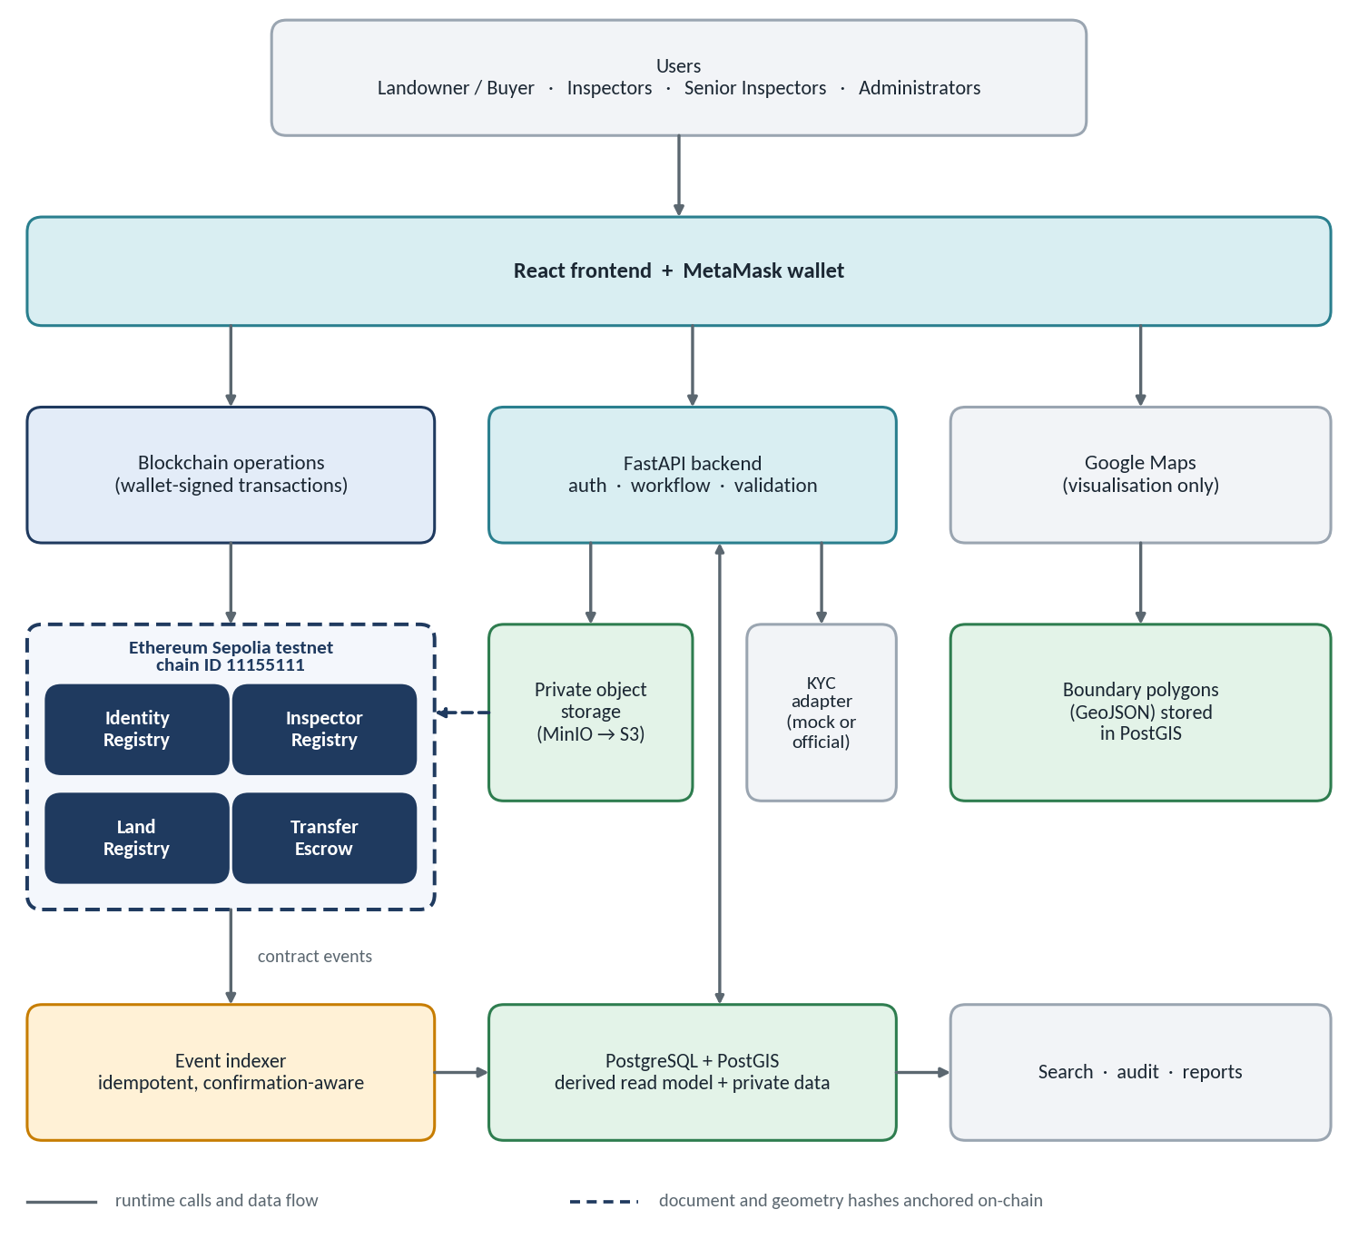
Figure 1. Master system architecture (deployed on the Ethereum Sepolia testnet).

3.1 Layers and responsibilities
Table 6. System layers
Layer | Components | Responsibility
Presentation | React, Vite, ethers.js, MUI, Google Maps JavaScript API | User interface, wallet connection and transaction signing, map display.
Application | FastAPI, SQLAlchemy, Pydantic | Wallet authentication, application workflow, validation, document handling, search API.
Blockchain | IdentityRegistry, InspectorRegistry, LandRegistry, TransferEscrow (Solidity, OpenZeppelin) | Authoritative land, authorization and payment state.
Data | PostgreSQL + PostGIS; private object storage (MinIO in development, S3-compatible in deployment) | Read model, private data, geometries, files.
Integration | Event indexer, KYC adapter, Google Maps | Synchronize chain to database, plug in identity providers, visualize boundaries.

3.2 Technology stack
Table 7. Technology stack
Area | Technology
Frontend | React, Vite, ethers.js, Material UI, Google Maps JavaScript API
Backend | Python, FastAPI, SQLAlchemy, Pydantic
Database | PostgreSQL with PostGIS
File storage | MinIO during development; S3-compatible private object storage (AWS S3, Azure Blob or equivalent) for deployment; optional encrypted IPFS for redundancy
Blockchain | Solidity, OpenZeppelin, Hardhat; Ethereum Sepolia testnet for integration testing and the final demonstration
Security testing | Slither, Hardhat tests, fuzz and property testing

NETWORK CHOICE
Earlier drafts targeted the Polygon Amoy testnet. This edition standardizes on Ethereum Sepolia (chain ID 11155111) everywhere. The architecture itself is network-agnostic: chain ID, RPC endpoint and contract addresses are configuration values, so switching networks later is a configuration change, not a redesign.
Mainnet is never used in this project.

Part II — Governance, Identity and Access

4. Inspector governance network

4.1 No second blockchain is needed
The requirement is a network of inspectors with levels inside it. That is a governance structure, not a separate blockchain. The inspector network lives inside the contracts on the existing chain, as an *Inspector Governance Network*. The blockchain therefore knows, for every action: who is allowed to do what, and for which jurisdiction.

4.2 Hierarchy and levels
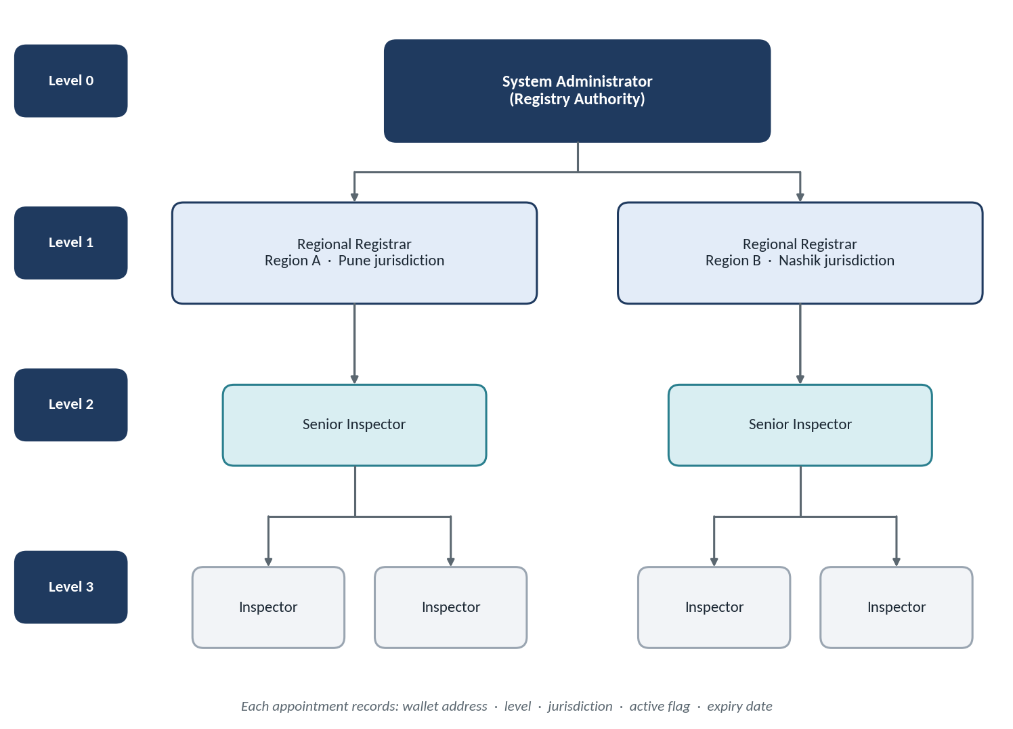
Figure 2. Inspector governance hierarchy with jurisdictions.
Table 8. Inspector levels
Level | Role | Typical authority
0 | System Administrator | Appoints and revokes registrars; configures approval requirements.
1 | Regional Registrar | Appoints and revokes inspectors inside their own region.
2 | Senior Inspector | Gives second-level approval for high-value transfers; handles appeals.
3 | Inspector | Reviews applications and gives first-level verification and approval.

NOTE
These are project roles. They are not claims about an actual government hierarchy.

4.3 The inspector record
A separate InspectorRegistry.sol stores every inspector rule, instead of burying them inside LandRegistry.sol. Each inspector is a small record:
struct Inspector {
address wallet;
uint8 level;
uint256 jurisdictionId;
bool active;
uint256 validUntil; // appointment expiry
}

// Example
// Inspector A -> Pune jurisdiction -> Level 3 -> Active

4.4 Why jurisdiction matters
Suppose Land A is in Pune and Land B is in Nashik. A Pune inspector must not be able to approve Nashik land. The contracts therefore check, on every inspector action:
require(inspector.jurisdictionId == land.jurisdictionId);

// Authorization chain
// Wallet -> InspectorRegistry -> role + level + jurisdiction -> LandRegistry

This is much more realistic than the current single-inspector model, which assigns one inspector wallet at deployment and uses plain access control.

4.5 Sensitive operations require several inspectors
The hierarchy becomes genuinely useful when sensitive operations need more than one approver:
Table 9. Approval requirements
Operation | Approval required
Normal verification | One inspector verifies the land.
High-value ownership transfer | Inspector A and Senior Inspector B must both approve — or, alternatively, 2 of 3 authorized inspectors.

This is far stronger than one wallet controlling everything. It also gives the research paper a concrete question: single-inspector authorization versus multi-inspector authorization, studied by testing the security properties of each configuration rather than making a vague better/worse claim.

4.6 InspectorRegistry responsibilities
- Inspector roles and hierarchy
- Jurisdiction assignment
- Activation, revocation and expiry
- Approval requirements
- Functions: addInspector(), removeInspector(), changeInspectorLevel(), assignJurisdiction(), revokeInspector(), isAuthorizedInspector()

5. Identity and wallet binding

5.1 The principle: one verified identity, one active wallet
The original idea was "one user = one wallet". That needs a small correction. A person can always create Wallet A, Wallet B and Wallet C; Ethereum-style wallets are not unique human identities, and no contract can physically prevent that. The rule that can be enforced is:
DESIGN RULE
One verified platform identity may have one active registered wallet — and each wallet maps to one identity.

Table 10. Identity–wallet relationship
Direction | Constraint
identity_id → wallet | At most one active wallet per verified identity.
wallet → identity | A wallet belongs to exactly one identity.

The off-chain users table holds the identity record:
users
------------------------------------
user_id
wallet_address
role
kyc_status
kyc_verified_at
wallet_status
created_at

5.2 KYC and Aadhaar: handle with care
Aadhaar authentication and eKYC cannot simply be implemented as "upload an Aadhaar image and let our backend check it". UIDAI's regulations describe Aadhaar authentication and eKYC as being performed through an authorized requesting entity, under defined consent and conditions, and UIDAI also provides defined offline-verification mechanisms.
For the B.Tech prototype the correct engineering design is a KYC adapter: a stable interface behind which a real provider can be plugged in later.
Table 11. KYC adapter options
Adapter backend | When to use it
Official Aadhaar integration | Only if the project is authorized to use it.
Mock / test KYC provider | The academic prototype: KYC verified = TRUE with an internal UUID as the KYC reference.

PRIVACY RULE
Do not store the Aadhaar number, Aadhaar image or Aadhaar XML on the blockchain.
Do not even put a raw Aadhaar hash on-chain. Hashing does not make sensitive identity data appropriate for public storage.
Keep only off-chain: identity_id (e.g. USER-8f3a…), kyc_verified = true and a kyc_provider_reference (e.g. KYC-123). On-chain, store at most a pseudonymous identity or authorization status, and only if a contract genuinely needs it.

5.3 Wallet loss and recovery
A strict one-wallet rule must handle a lost wallet, otherwise an identity is locked out permanently. The recovery flow is:
- User reports the wallet as lost and requests a new wallet.
- The identity is re-verified through the KYC adapter.
- The old wallet is revoked.
- The new wallet is activated and bound to the same identity.
After recovery, Identity X has the old wallet in state REVOKED and the new wallet in state ACTIVE. A revoked wallet can no longer transact as that user.

5.4 Wallet-based authentication and onboarding
Because the system is wallet-centric, backend authentication is not a username and password. It is a signed challenge:
- The wallet requests a login challenge; the backend returns a random one-time nonce.
- MetaMask signs the nonce.
- The backend verifies the signature and marks the wallet as authenticated.
- The backend resolves wallet → identity → KYC status → role → permissions.
The onboarding flow for a new visitor then looks like this:
Table 12. Onboarding flow
Step | Action | Outcome
1 | Connect wallet | Wallet address known to the app.
2 | Sign authentication challenge | Ownership of the wallet is proven.
3 | Existing identity? | Yes → log in. No → continue to step 4.
4 | KYC process | Identity verified through the KYC adapter.
5 | Bind wallet | One active wallet bound to the verified identity.
6 | Log in | Role and permissions applied.

5.5 IdentityRegistry responsibilities
- Verified wallets and identity binding
- Wallet revocation and user status
- Functions: verifyIdentity(), activateWallet(), revokeWallet(), isVerified()

Part III — Land Registration and Integrity

6. From land application to registered land

6.1 Two different things
The prototype lets a landowner call registerLand() directly, which creates a Pending record on-chain. The final design separates two concepts that were previously mixed together:
Table 13. Application versus registered land
Concept | Meaning | Where it lives
Land application | "Someone claims this land." | Off-chain (PostgreSQL), under review.
Registered land | "The registry has accepted this land record into the blockchain." | On-chain (LandRegistry).

This gives the system a clear and more professional workflow, and it avoids creating a permanent blockchain record for applications that are obviously invalid.

6.2 Landowner registration flow
Table 14. Landowner registration flow
# | Step | What happens
1 | Connect wallet | User signs in; identity must be KYC-verified.
2 | Enter parcel information | State, district, taluka, village, survey number, subdivision, and the official parcel identifier.
3 | Draw or select the boundary | A polygon is drawn on the map or uploaded as GeoJSON.
4 | Upload documents | Sale deed, 7/12 extract, tax receipt, identity proof, survey map.
5 | Backend calculates hashes | SHA-256 for each document and for the document manifest.
6 | Exact duplicate check | Parcel key checked against existing records.
7 | Spatial overlap check | PostGIS compares the polygon with registered parcels.
8 | Create application | Application stored off-chain with all flags attached.
9 | Inspector review | Jurisdiction-matched inspector(s) approve or reject.
10 | Register on-chain | registerLand() is called; the LandRegistered event is emitted.
11 | Indexer and database | The indexer picks up the event and updates PostgreSQL.

6.3 Inspector review workflow
- The inspector logs in; the system checks role and jurisdiction.
- The inspector dashboard lists pending applications for that jurisdiction only.
- For each application the inspector sees parcel information, the map boundary, the documents, duplicate-check results and KYC information.
- The inspector approves or rejects.
- For higher-value or sensitive cases the flow continues: Inspector approval → Senior Inspector approval → blockchain action.

7. Preventing duplicate land registration
Duplicate registration is not one problem but three. Each needs a different defence.
Table 15. Three duplicate problems
Problem | Example | Difficulty
A — same parcel number | MH-PUN-12345 registered twice. | Easy: an exact key comparison.
B — same land, different fake parcel number | Survey No. 123 and survey No. 123A, or a deliberately false identifier. | Hard: the chain cannot know both describe the same physical land.
C — overlapping polygons | Land B drawn partly on top of Land A. | Needs geometry; handled by PostGIS.

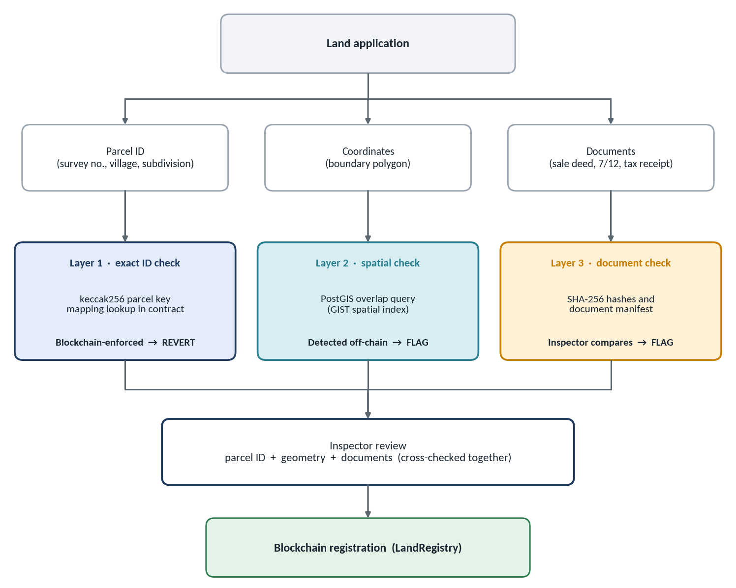
Figure 3. Three-layer duplicate protection.

7.1 Layer 1 — exact parcel ID (blockchain-enforced)
The parcel identity fields are normalized into one canonical string and hashed into a parcelKey. The contract refuses to register a key that already exists. This check must happen on-chain so the database cannot bypass it.
Canonical identifier:
State + District + Taluka + Village + Survey No + Subdivision
-> "MH|PUNE|HAV|VILLAGE-X|1234|2"

parcelKey = keccak256(canonicalIdentifier)

mapping(bytes32 => bool) parcelExists;

registerLand(...):
if parcelExists[parcelKey] -> REVERT
else -> register

The backend runs the same check before an application is even created, so invalid applications are stopped early. The contract remains the final enforcer.

7.2 Layer 2 — spatial overlap (PostGIS-detected)
Each property boundary is stored as a polygon, and a spatial query asks whether a new polygon overlaps an existing one. This is deliberately not done on the blockchain: complex spatial computation is far too expensive and inappropriate for a smart contract. The chain stores only a compact proof of the geometry (see section 8.4).

7.3 Layer 3 — document and cross-check (inspector-verified)
The inspector checks that documents, geometry and parcel identifier tell a consistent story. Changed or inconsistent document hashes are flagged. This is much stronger than checking the parcel number alone.

8. Geospatial boundaries and maps

8.1 A boundary needs a polygon, not a point
A single latitude/longitude pair is only a point. A land boundary is a polygon: a closed ring of points P1 → P2 → P3 → P4 → P1. For example:
[
{"lat": 18.5201, "lng": 73.8567},
{"lat": 18.5210, "lng": 73.8580},
{"lat": 18.5198, "lng": 73.8591},
{"lat": 18.5189, "lng": 73.8574}
]

8.2 What the map does — and does not — prove
The Google Maps JavaScript API can draw polygons from latitude/longitude paths, and Google also provides geometry utilities for polygon and coordinate operations. The project uses the Google Maps JavaScript API for the web interface.
- Google Maps is the visualization layer. It is not the authority that proves ownership.
- Satellite imagery must not be treated as the source of legal boundaries. The authoritative source is the official survey or cadastral boundary.
- Google Maps Platform has API-key, attribution and usage-policy requirements that must be followed.
- Google Earth Engine is a separate cloud platform with its own project and access requirements; it is not needed just to draw land parcels.
CURRENT API NOTE
The Google Maps Drawing Library was deprecated in August 2025 and is no longer available since May 2026. Do not build the polygon editor on it. Use an editable google.maps.Polygon or a maintained drawing library such as Terra Draw (the alternative Google itself names).

8.3 Boundary pipeline
Official survey / cadastral boundary
|
v
GeoJSON
|
v
PostGIS --> area calculation, overlap detection
|
v
Google Maps --> display of the approved boundary

8.4 Geometry off-chain, proof on-chain
A 50-point polygon is never stored on the blockchain; that would be wasteful. The polygon lives in PostGIS, and only its fingerprint goes on-chain:
- Take the GeoJSON polygon.
- Convert it to a canonical JSON form (fixed coordinate precision, normalized ring order and key order).
- Compute SHA-256 to obtain geometryHash.
- Store geometryHash on-chain; keep the real geometry in PostGIS.
Table 16. Geometry separation
Item | Where
Actual geometry | PostGIS database
Proof of geometry (geometryHash) | Blockchain

8.5 End-to-end map flow
Landowner enters parcel information → selects or uploads a boundary → GeoJSON polygon → PostGIS → area calculation → overlap detection → inspector review → approved boundary → displayed on Google Maps.

9. Document management and integrity

9.1 Architecture
Land documents are heavy and private, so they never go on the blockchain. The flow is: React → FastAPI → private object storage → SHA-256 hash → document metadata → blockchain document hash (Figure 4 shows the full picture).

9.2 Storage and metadata
Development uses MinIO; deployment uses AWS S3, Azure Blob or an equivalent private object store. The application talks to storage through one interface, so the switch needs no code redesign. The database keeps the metadata:
documents
-------------------------------------
document_id
land_id
file_name
mime_type
size
storage_key
sha256
uploaded_by
version
created_at

9.3 Demonstrating tamper detection
Suppose SaleDeed.pdf is uploaded. The backend calculates its SHA-256, say a3f9c2…91ab. The database stores it as DOC-100, and the blockchain stores the same hash. Later someone modifies the PDF; the new hash is 7b33d1…54ac. Comparing the on-chain hash with the current hash shows a mismatch, and the system reports document integrity check failed. This is a very clear, demonstrable feature.

9.4 Document manifest
A property usually has several documents: sale deed, 7/12 document, tax receipt, identity proof and survey map. Putting five hashes in the contract would be untidy. Instead the backend builds a document manifest listing each document and its hash, hashes the manifest to obtain manifestHash, and stores only that one value on-chain.
Figure 4 summarizes both directions: anchoring a document set when it is uploaded, and verifying it later.
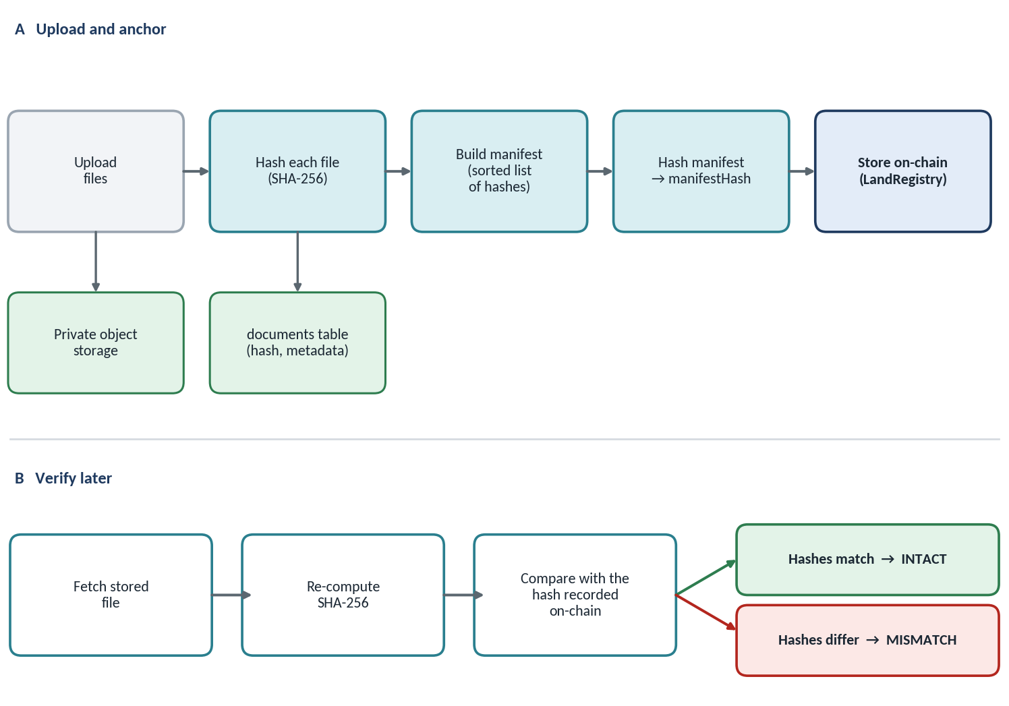
Figure 4. Document anchoring and later verification.

Part IV — Escrow-Based Ownership Transfer

10. Escrow design

10.1 From direct payment to an intermediate payment layer
The prototype's transfer is direct: the buyer calls completeTransfer() and the seller is paid immediately. The final design inserts an escrow contract between them:
Table 17. Payment flow before and after
Version | Money and ownership flow
Current | Buyer → completeTransfer() → Seller
Final | Buyer → Escrow → inspector approval → ownership transfer → escrow releases funds → Seller

Payment logic is kept separate from the land registry: LandRegistry raises the transfer request, TransferEscrow holds buyer funds, and settlement pays the seller and updates the owner together.

10.2 TransferEscrow responsibilities
- Deposit and lock funds
- Release to the seller on approved settlement
- Refund the buyer on rejection, expiry or cancellation
- Cancel and expire requests
Only financial logic lives here. This separation makes the code far easier to test and to explain.

10.3 Escrow lifecycle
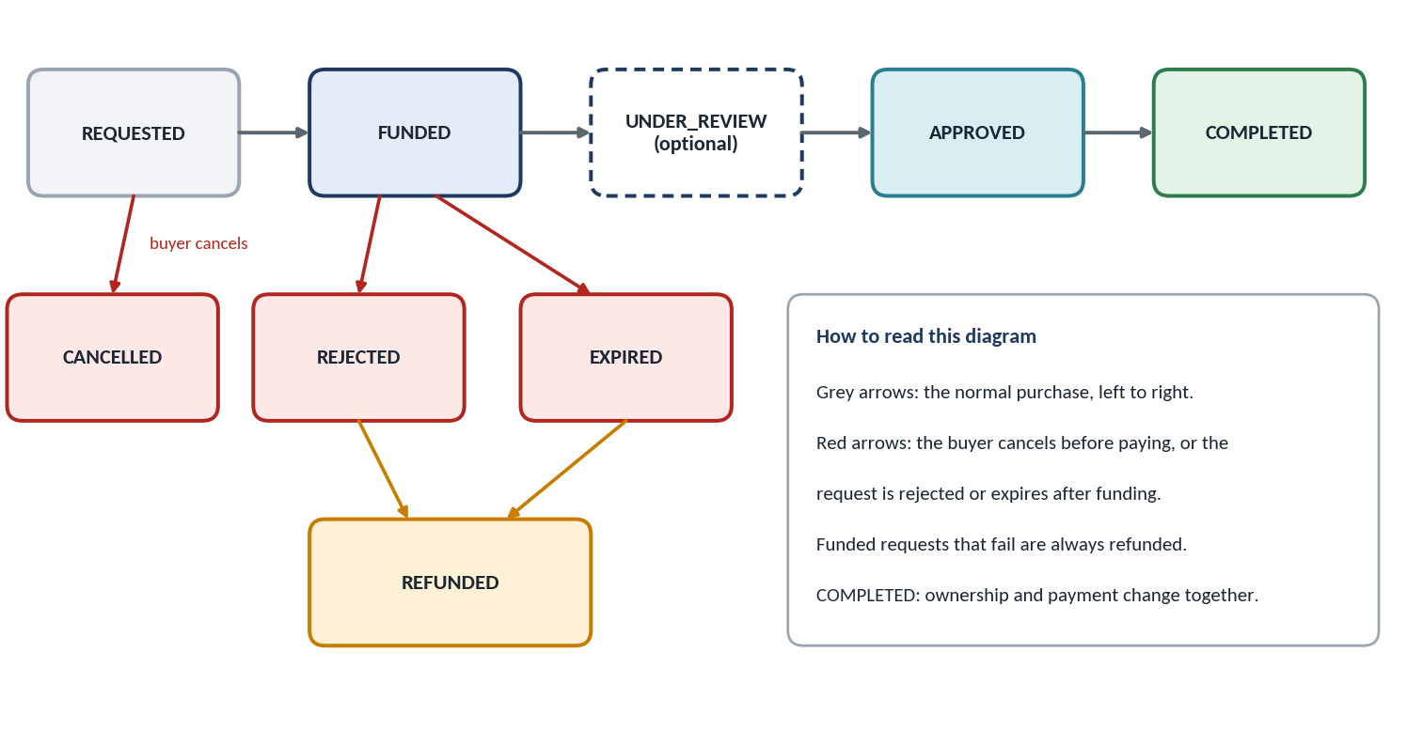
Figure 5. Escrow state machine, including failure paths.
Table 18. Escrow states
State | Meaning | Possible next states
REQUESTED | Buyer has created a transfer request; no money locked yet. | FUNDED, CANCELLED
FUNDED | Buyer funds are locked in escrow. | UNDER_REVIEW, APPROVED, REJECTED, EXPIRED
UNDER_REVIEW | Inspectors are reviewing (may be merged into FUNDED if a smaller state machine is preferred — decide at architecture freeze). | APPROVED, REJECTED, EXPIRED
APPROVED | Required inspector approvals are in place. | COMPLETED
COMPLETED | Ownership changed and the seller was paid. | Final
CANCELLED | Buyer withdrew before funding. | Final
REJECTED | Inspectors refused the transfer. | REFUNDED
EXPIRED | The deadline passed before completion. | REFUNDED
REFUNDED | Locked funds returned to the buyer. | Final

This lifecycle fixes one of the weaknesses identified in the original report: multiple competing transfer requests with no cancellation path.

10.4 A purchase, step by step
Table 19. Purchase walk-through
Step | Action | Result
1 | Buyer calls requestTransfer() | A request is created.
2 | Buyer sends payment to the escrow | The money is locked.
3 | Inspector calls approveTransfer() | Approval recorded (a Senior Inspector as well, if required).
4 | Settlement | Ownership changes and the escrow releases funds to the seller.
5 | Events emitted | TransferApproved, OwnershipTransferred, EscrowReleased — the backend picks these up.

10.5 Exact-payment protection
If the agreed price is 10 ETH, the buyer must not be able to fund with 5 or 15 unless the contract explicitly defines what happens. The contract requires exact funding:
require(msg.value == agreedPrice);

underpayment -> revert
overpayment -> revert
exact payment -> success

The existing project already validates exact payment in completeTransfer; the escrow design extends that rule instead of discarding it.

Part V — Synchronization, Contracts and Performance

11. Event-driven database synchronization

11.1 The database is a read model, not the source of truth
The database must stay in sync with the blockchain so that manual changes cannot corrupt the system. The key concept is:
DESIGN RULE
The database is a read model derived from blockchain events. It is never the source of truth.

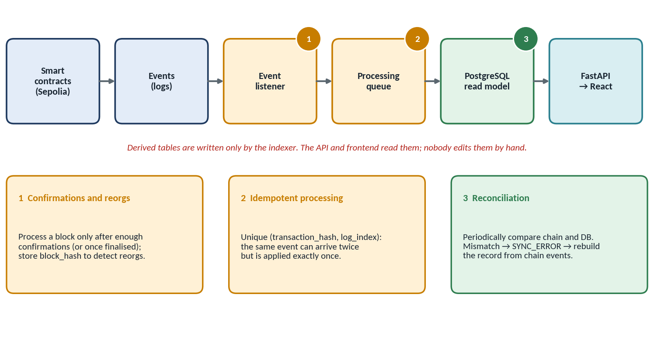
Figure 6. Event-driven synchronization pipeline.

11.2 Blockchain-derived records are read-only
If PostgreSQL says the owner is Alice, nobody should be able to run UPDATE land SET owner = 'Bob' and have the system accept it. Ownership changes only through the path blockchain event → indexer → database update. The application treats these fields as read-only derived state.

11.3 The event table
blockchain_events
---------------------------------
id
chain_id
contract_address
block_number
block_hash
transaction_hash
log_index
event_name
payload
processed_at

UNIQUE (transaction_hash, log_index) -- prevents double processing

11.4 Idempotent processing
Suppose OwnershipTransferred appears on-chain at block 1002398, transaction 0xabc, log index 3. The indexer asks: *have I processed tx 0xabc + log index 3?*
- No → update the land owner, update the transfer, save the event.
- Yes → ignore it as a duplicate.
Processing the same event twice must have the same effect as processing it once. This property is called idempotent event processing, and it is what makes restarts and retries safe.

11.5 Reconciliation
On a schedule, important records are compared between blockchain and PostgreSQL. If the chain owner differs from the database owner, the system creates a SYNC_ERROR and rebuilds the affected record from chain events. Normal synchronization plus periodic reconciliation is much stronger than synchronization alone.

11.6 Database security
Table 20. Database roles
Database user | Permissions
app_user | Controlled reads and writes on application (non-derived) tables; read-only on blockchain-derived tables.
readonly_user | Read-only access for reporting and the frontend-facing queries.
indexer_user | The only user allowed to write blockchain-derived tables.
admin_user | Exceptional maintenance only; every action is audited.

Every manual administrative action must itself be written to the audit log.

12. Smart-contract architecture

12.1 Four focused contracts
The blockchain layer is split into four contracts, not one giant LandRegistry.sol. Each depends on the one before it: IdentityRegistry → InspectorRegistry → LandRegistry → TransferEscrow.
Table 21. Contract responsibilities
Contract | Owns | Does not own
IdentityRegistry | Verified wallets, identity binding, wallet revocation, user status. Functions: verifyIdentity, activateWallet, revokeWallet, isVerified. | KYC documents or personal data.
InspectorRegistry | Roles, hierarchy, jurisdictions, activation, revocation, approval requirements. Functions: addInspector, removeInspector, changeInspectorLevel, assignJurisdiction, revokeInspector, isAuthorizedInspector. | Land records.
LandRegistry | Land application commitments and records, parcel uniqueness, verification, ownership, history. | KYC, PDF storage, PostGIS, the database.
TransferEscrow | Deposit, lock, release, refund, cancel, expire. | Land logic; inspector rules.

12.2 Refactor, do not rewrite
The current LandRegistry.sol is refactored rather than discarded. Its existing security logic — AccessControl, the seller re-check, the exact-payment rule and ReentrancyGuard — is still valuable and is carried forward.
Table 22. Where existing responsibilities move
Current LandRegistry holds | In the final design it lives in
Land records, parcel data | LandRegistry
Single inspector | InspectorRegistry (hierarchy, jurisdiction, expiry)
Transfer requests | LandRegistry / a thin TransferManager layer
Payment | TransferEscrow
History | Events, indexed off-chain

NOTE
Whether the transfer-coordination logic is a separate TransferManager contract or part of LandRegistry is an open design point to settle during architecture freeze (Phase 0).

12.3 Events the contracts emit
These events drive the indexer. Every one of them is stored in the blockchain_events table.
Table 23. Contract events
Event | Meaning
LandApplicationCreated | An application was committed (optional on-chain; may be an off-chain audit event only, per the Phase 0 decision).
LandRegistered | The registry accepted a land record on-chain.
LandVerified | Required inspector approvals completed.
LandRejected | An application or land record was rejected.
InspectorAdded / InspectorRevoked | Inspector appointment changes.
TransferRequested | A buyer opened a transfer request.
EscrowFunded | Buyer funds were locked.
TransferApproved | Required inspector approvals for the transfer are in place.
OwnershipTransferred | The land owner changed.
EscrowReleased | Funds were paid to the seller.
RefundIssued | Funds were returned to the buyer.

13. Performance optimization
Do not optimize randomly. Optimize where the cost actually exists.

13.1 Blockchain
- Minimal storage. Store parcelKey, owner, status, jurisdiction, geometryHash and documentManifestHash; never full PDFs, full polygons, long descriptions or photos.
- Use events for history instead of repeatedly storing and querying large arrays.
- Efficient types. Use uint32, uint64 or uint128 where values do not need uint256 — but do not pack storage aggressively until correctness is finished.
- Mappings instead of array scans, for example parcelKey → landId.

13.2 Frontend
The prototype dashboard performs several sequential blockchain reads per land record, which does not scale. The final path is React → FastAPI → PostgreSQL, using pagination, search, filtering, debouncing and cached queries instead of loading, say, 10,000 properties every time.

13.3 Backend and database
- Indexes on parcel_key, owner, jurisdiction_id, status, application_date and transaction_hash.
- A PostGIS spatial index, GIST(geometry), essential for overlapping-parcel search.
- Connection pooling, async endpoints and bulk event processing.

14. User workflows

14.1 Buyer workflow
- Buyer logs in and searches for land (served from PostgreSQL).
- Reviews results, map, property details and ownership history.
- Requests a purchase and deposits funds into escrow.
- Inspector approval (plus senior approval where required).
- Settlement: ownership transfers and escrow releases funds to the seller.

Part VI — Evaluation and Research

15. Research framing

15.1 The central question
The project has moved from "we have a blockchain land registry" to a more complete engineering problem:
How do we build an auditable land registry where verified identities, hierarchical inspectors, land uniqueness, geographic boundaries, documents, payment escrow, blockchain state and off-chain search all remain consistent?

That question is the centre of the final-year project and the research paper. The strongest version of the project is not the biggest one: it is the one where every component has a defined purpose, every security rule is tested, and every major architectural claim has measured evidence.

15.2 What the paper should claim
The paper should not claim to have invented the blockchain land registry. Its contribution is the integrated protocol and its measured engineering properties. A fitting title:
A Hierarchical, Identity-Bound and Escrow-Secured Blockchain Architecture for Auditable Land Registration with Geospatial Validation and Event-Driven Synchronization

The research angle is a multi-layer integrity and authorization architecture for blockchain-based land registration, not "blockchain plus AI". What makes it publishable is the evaluation: the paper should not say "we implemented PostgreSQL" but measure direct blockchain querying against an event-indexed PostgreSQL.

15.3 Research questions
Table 24. Research questions
ID | Topic | Question
RQ1 | Inspector governance | How does hierarchical, jurisdiction-based authorization behave under valid and unauthorized actions?
RQ2 | Duplicate land protection | Can exact parcel-key validation plus spatial overlap checking detect duplicate and overlapping registrations?
RQ3 | Escrow security | Can escrow prevent payment/ownership mismatches, double release and unauthorized release?
RQ4 | Off-chain synchronization | Can an event-driven database maintain a consistent, queryable view of on-chain state?
RQ5 | Document integrity | Can document hashing reliably detect modification?
RQ6 | Read scalability | How does indexed querying compare with direct per-record blockchain reads?

These are actual experiments, not feature descriptions.

15.4 What makes each component research-worthy
Table 25. Component evaluation matrix
Component | Why it is added | How it is evaluated
Hierarchical inspectors | Remove single-inspector dependency | Authorization and jurisdiction tests
Identity binding | One verified identity → one active wallet | Identity and permission tests
Escrow | Prevent payment/ownership mismatch | Attack and failure tests
Parcel uniqueness | Prevent exact duplicates | Duplicate-injection tests
PostGIS | Detect spatial overlap | Geometry benchmark
Google Maps | Visualize verified geometry | Map workflow review
Document hashing | Detect document modification | Tampering tests
Event indexer | Keep the database derived from the chain | Sync and recovery benchmark
PostgreSQL | Fast querying | Latency and load tests
Ethereum Sepolia | Realistic testnet deployment | End-to-end transactions
No ML | Reduce unnecessary complexity | Focus on deterministic security

16. Experiment design

16.1 Read scalability (RQ6)
Compare direct blockchain querying with event-indexed PostgreSQL at 10, 50, 100, 500, 1,000 and 5,000 records. Measure latency, number of RPC calls, database query time and total dashboard load time. The original report already proposed dashboard-load and RPC-call analysis.

16.2 Escrow experiments (RQ3)
Table 26. Escrow test cases
ID | Scenario | Expected outcome
TC01 | Correct deposit | Success
TC02 | Underpayment | Revert
TC03 | Overpayment | Revert
TC04 | Unauthorized refund | Revert
TC05 | Unauthorized release | Revert
TC06 | Double release | Revert
TC07 | Cancelled request refund | Funds returned
TC08 | Expired request refund | Funds returned
TC09 | Seller changed before settlement | Settlement blocked
TC10 | Settlement failure | State and funds remain consistent

For every case, report Pass/Fail, gas used and the revert reason.

16.3 Inspector experiments (RQ1)
Test six actor types: normal inspector, senior inspector, wrong-region inspector, revoked inspector, expired inspector, and a non-inspector. Examples:
Table 27. Inspector authorization tests
Scenario | Expected | Why
Pune inspector → Pune land | Allowed | Jurisdiction matches
Pune inspector → Nashik land | Rejected | Wrong jurisdiction
Revoked inspector → any land | Rejected | Not active
Expired inspector → any land | Rejected | Appointment expired
Non-inspector → any land | Rejected | No role

16.4 Duplicate-land experiments (RQ2)
Create Dataset A with 1,000 unique parcels. Then inject 100 exact duplicates, 50 overlapping polygons and 25 near-overlapping polygons. Test on-chain parcel uniqueness together with PostGIS spatial detection, and measure detection count, false positives, false negatives and processing time.

16.5 Document-integrity experiments (RQ5)
Create 100 documents and compute their hashes. Then modify each in four ways — one character, one page, metadata only, and the whole document — and check whether the stored hash differs from the new hash in every case. Report the detection results.

16.6 Synchronization experiments (RQ4)
Generate 1,000 blockchain events and process them. Measure event-processing latency, throughput, database synchronization delay, duplicate-event handling and recovery after an indexer restart. Then deliberately modify a derived database row and run reconciliation.
EXPECTED RESULT
Expected result: DB mismatch detected → record reconstructed → blockchain state restored. This is a very good systems-engineering experiment.

16.7 Testnet deployment experiment
The test environment is layered: Hardhat for unit tests, then the Ethereum Sepolia testnet for integration testing with real wallet signatures, real testnet transactions and explorer verification. For reproducibility, document:
- Contract addresses and deployment transaction hashes
- Compiler version, OpenZeppelin version, Node version and Hardhat version
- Chain ID (11155111) and RPC provider
NOTE
Testnet gas is free, so report gas in gas units, not currency. Sepolia gas prices and block conditions are not representative of mainnet cost; gas units per operation are the comparable measure.

16.8 Paper structure
- Introduction
- Problem Definition
- Related Work
- Threat Model
- Proposed Architecture
- Identity and Inspector Governance
- Land Registration and Duplicate Detection
- Document Integrity Architecture
- Escrow-Based Transfer Protocol
- Event-Driven Synchronization
- Implementation on Ethereum Sepolia
- Experimental Methodology
- Results
- Security Analysis
- Limitations
- Conclusion
The paper is written only after all experiments are complete.

Part VII — Development Workflow for the Implementing Engineer
Parts I to VI explain what the system is and why. This final part explains how to build it. It is written for the engineer who will do the work. It splits the project into twelve long phases (Phase 0 to Phase 11), each with objectives, concrete work packages, testing, a Sepolia deployment activity, deliverables and exit criteria.

17. How to use this workflow

17.1 Build order principle
BUILD ORDER
Do not start with Google Maps or document uploads. Freeze the architecture, then build identity, inspectors, the land state machine, duplicate rules and escrow, then write tests — and only then build backend, indexer, documents, maps and UI. Otherwise UI features end up resting on a contract architecture that later has to be redesigned.

The full sequence is: freeze architecture → identity and wallet model → inspector hierarchy → land state machine → duplicate rules → escrow design → refactor Solidity → write tests → backend with PostgreSQL and PostGIS → event indexer → documents and hashing → maps → frontend integration → testnet release candidate → security testing → performance experiments → research paper.

17.2 Conventions used in every phase
- Contracts first, tested locally, then deployed to Sepolia. Every contract phase ends with a deployment to the Sepolia testnet and verification on the block explorer.
- Each phase has a Definition of Done. A phase is finished only when its exit criteria are met, its tests pass in CI, and its documents are updated.
- Specifications are the contract between phases. If implementation needs to deviate from the frozen specification, update the specification in the same pull request.
- Small pull requests, short-lived branches, mandatory review. Contract changes always need a second reviewer.
- Configuration, not code, selects the network. Chain ID, RPC URL, contract addresses and storage endpoints come from environment configuration.
- Secrets never enter the repository. Commit .env.example only.

17.3 Planning assumptions
The durations shown are indicative planning figures, not commitments. They assume a team of two engineers working on parallel tracks (one on contracts, one on backend and data, joining for integration), for a total of roughly 27 calendar weeks. A single engineer working sequentially should expect roughly 44 weeks (the sum of all phase durations). Re-estimate at the end of Phase 1 once real velocity is known.

18. Environment strategy
Work moves up a ladder of environments. Never promote to the next level until the previous one is green.
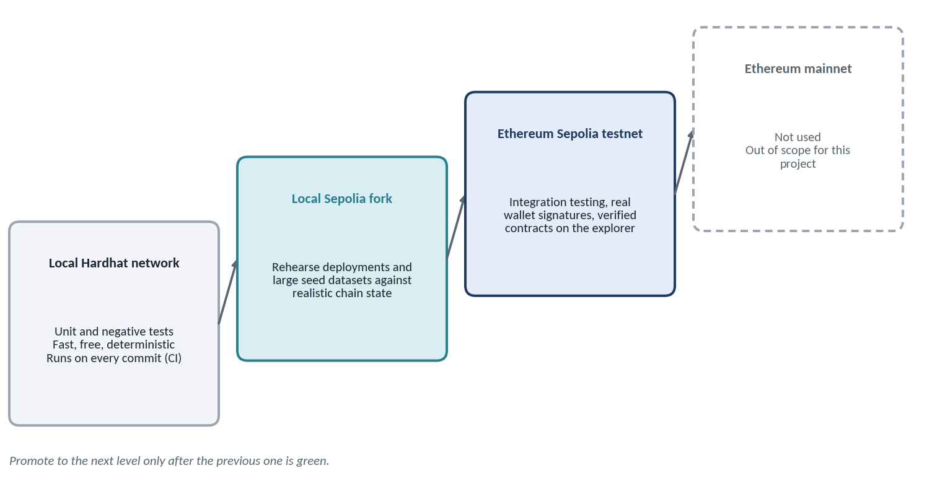
Figure 7. Environment ladder.
Table 28. What runs where
Layer | Local development | Sepolia integration | Notes
Smart contracts | Hardhat in-process network | Ethereum Sepolia (chain ID 11155111) | Deploy with scripted, repeatable deployment modules.
Database | Docker: PostgreSQL + PostGIS | Managed PostgreSQL + PostGIS (staging) | Migrations through Alembic.
File storage | Docker: MinIO | S3-compatible bucket (staging) | Same storage interface in both.
Event indexer | Reads local Hardhat node | Reads Sepolia through an RPC provider | Confirmation-aware; see Phase 5.
Frontend | Vite dev server + MetaMask on local chain | Static hosting + MetaMask on Sepolia | Network guard in the UI.
Wallets | Hardhat test accounts | Dedicated testnet-only wallets | Never reuse keys from any other network.

18.1 Sepolia reference
Table 29. Sepolia network reference
Item | Value
Network | Ethereum Sepolia testnet (application-development testnet)
Chain ID | 11155111 (hex 0xaa36a7)
Currency | Sepolia test ETH — no monetary value; obtained from faucets
Block explorer | https://sepolia.etherscan.io
RPC endpoint | From an RPC provider account (for example Alchemy, Infura or QuickNode); the URL contains an API key, so it lives in an environment variable and is never committed
Faucets | Provider faucets typically need a free account and enforce daily limits, so request funds early and spend them carefully (use small prices such as 0.01 ETH in test transactions)
Block time | About 12 seconds per block; confirmations take real time
Finality | Read final state using the finalized block tag (or a fixed confirmation depth) rather than the latest block

CHECK BEFORE THE DEMO
Public testnets are periodically retired or replaced. Before the final demonstration, confirm that Sepolia is still active. Because the network is configuration-only, moving to another Ethereum testnet requires changing configuration and redeploying, not redesigning.

18.2 Environment rules
- Use a dedicated deployer wallet and test role wallets (administrator, registrar, senior inspector, inspector, two landowners, buyer) that exist only for this project.
- Record every deployment in deployments/sepolia.json: contract addresses, deployment transaction hashes, block number, compiler settings and library versions.
- Verify every deployed contract on the explorer so the source code is publicly readable and matches the deployed bytecode.
- Use a local fork of Sepolia to rehearse deployments and to seed large datasets without spending faucet funds.
- Pin versions of Node, Solidity, Hardhat, OpenZeppelin, Python and every major dependency, and record them for reproducibility.

19. Large-file storage strategy
Land records involve many documents, from small scanned PDFs to very large survey and imagery bundles. None of this belongs on-chain. The storage design has one rule: files live in storage, fingerprints live on-chain, metadata lives in PostgreSQL.

19.1 Options compared
Table 30. Storage options
Option | Strengths and limits | Role in this project
Private S3-compatible object storage (MinIO in development; AWS S3, Azure Blob or equivalent in deployment) | Private by default; access through short-lived signed URLs; versioning and encryption at rest; multipart uploads for very large files; simple operations; deletion and correction are possible. | Primary store for all documents.
IPFS with pinning (self-hosted node or pinning service) | Content-addressed: the identifier (CID) is derived from the content, so tampering is detectable and data can be replicated. But IPFS is public by default, availability depends on someone pinning the data, and data cannot be reliably deleted once spread. | Optional secondary copy — encrypted payloads only.
Permanent storage networks (Filecoin, Arweave) | Designed for permanence, which conflicts with privacy, legal correction and deletion requirements for land and identity documents. | Not used.
Database BLOB columns | Bloat the database and perform poorly for large files. | Not used for files; metadata only.
On-chain storage | Extremely expensive and permanently public. | Never.

19.2 File classes and handling
The sizes below are planning assumptions to be tuned during Phase 6.
Table 31. File classes
Class | Examples | Typical size | Handling
Scanned documents | Sale deed, 7/12 extract, tax receipt, identity proof | 0.2–25 MB | Single or multipart upload; SHA-256; store.
Maps and images | Survey map, site photographs | 5–100 MB | Multipart upload; SHA-256; optional derived preview.
Large survey packages | Drone orthophotos, GIS bundles (GeoPackage, shapefile sets) | 100 MB to several GB | Resumable multipart upload with per-part checksums; background hashing; never rendered in the browser.
Generated artifacts | Document manifest JSON, GeoJSON snapshots | Under 1 MB | Stored with the application; hashed; referenced by the manifest.

19.3 Upload and verification pipeline
- The client asks the backend to start an upload, declaring file name, type, size and the application it belongs to. The backend authenticates the user and checks role, application ownership and policy limits.
- The backend creates a documents row with status PENDING and returns presigned multipart-upload URLs.
- The client uploads the parts directly to storage, bypassing the API server. Failed parts can be retried, so interrupted uploads can resume.
- The client signals completion; the backend finalizes the multipart upload.
- The backend streams the stored object to compute its SHA-256 in constant memory, so a multi-gigabyte file never has to be loaded into RAM.
- Content checks run: real file type from magic bytes (not the extension), size limits, and a malware scan.
- The row becomes AVAILABLE with its hash, size and version. Files are never overwritten: a new version creates a new object and a new row.
- The manifest is rebuilt from the current document hashes; its manifestHash is what the on-chain registration records.
- Downloads use short-lived signed URLs after an access check. Verification re-hashes the object and compares it with the database and on-chain values.

19.4 Optional encrypted IPFS copy
If the team adds IPFS for redundancy, the flow is: encrypt the file first with a per-document key (for example AES-256-GCM, with the key protected by a master key held in a secrets manager); add the ciphertext to a self-hosted IPFS node (a Docker container in development); pin it with a pinning service or the team's own node; store the resulting CID in documents.storage_pointer. The manifest records both the SHA-256 of the plaintext and the CID of the ciphertext, and verification fetches the CID, decrypts and re-hashes.
PRIVACY RULE
Never upload unencrypted personal or land documents to IPFS. Anything added to a public network should be assumed readable and permanent.

20. Roadmap overview
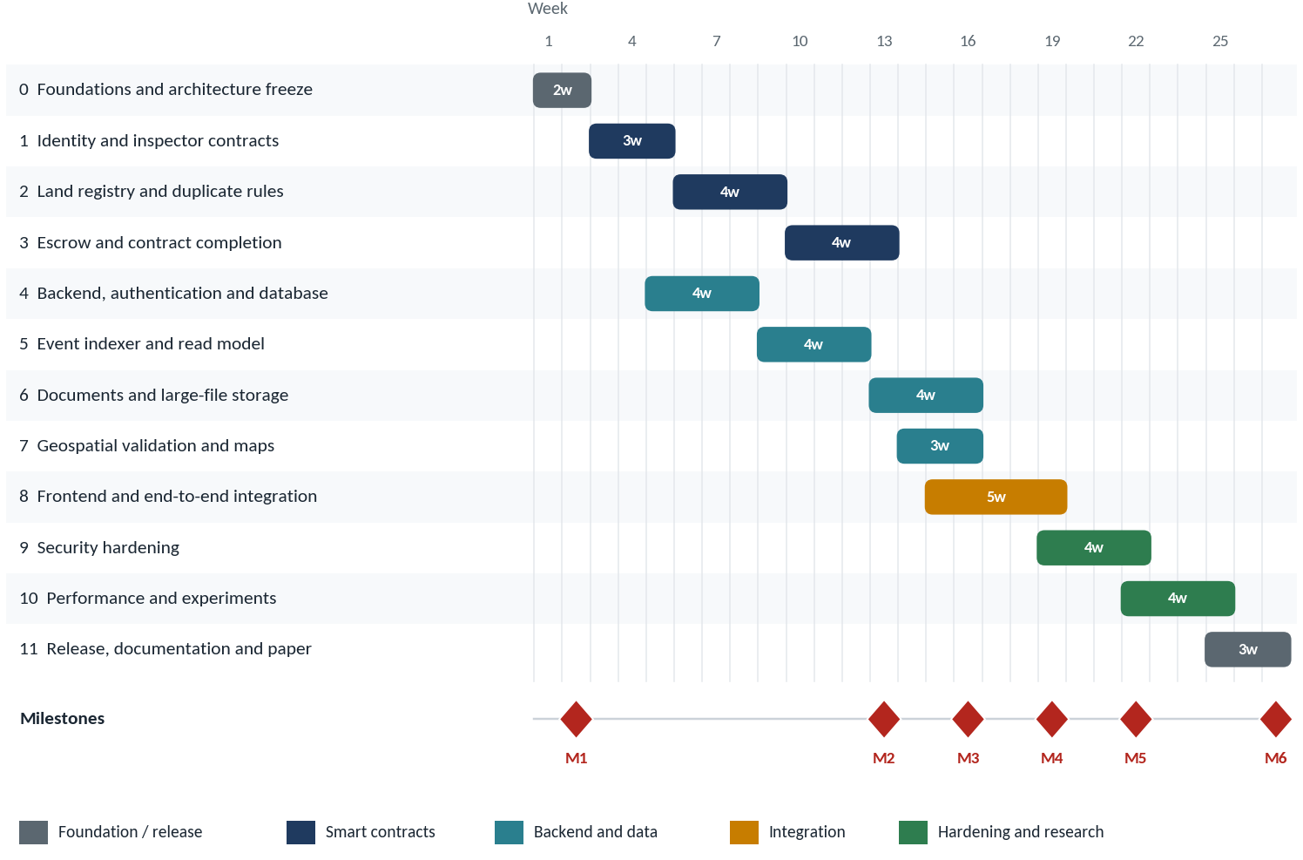
Figure 8. Indicative development schedule for two engineers (27 weeks). Phases 4–7 run in parallel with contract work.
Table 32. Phase summary (sum of durations: 44 effort-weeks; about 27 calendar weeks with parallel tracks)
Phase | Title | Duration | Milestone
0 | Foundations and architecture freeze | 2 weeks | M1 — full toolchain proven end-to-end on Sepolia
1 | Identity and inspector governance contracts | 3 weeks
2 | Land registry core and duplicate prevention | 4 weeks
3 | Escrow, transfers and contract completion | 4 weeks | M2 — complete contract suite verified on Sepolia
4 | Backend foundation: API, database, authentication | 4 weeks
5 | Event indexer and read model | 4 weeks
6 | Documents and large-file storage | 4 weeks | M3 — documents and geospatial layers working
7 | Geospatial validation and maps | 3 weeks
8 | Frontend and end-to-end integration | 5 weeks | M4 — integrated application running against Sepolia
9 | Security hardening and verification | 4 weeks | M5 — hardened release candidate on Sepolia
10 | Performance measurement and research experiments | 4 weeks
11 | Release, documentation and paper | 3 weeks | M6 — release and paper draft

20.1 How the original roadmap maps onto these phases
The earlier 17-step roadmap (steps 0 to 16) is preserved. Its acceptance criteria are carried into the exit criteria of the phases below.
Table 33. Original roadmap mapped to development phases
Step | Focus and key outputs | Acceptance criteria | Built in
0 | Architecture freeze: architecture.md, api-spec.md, contract-spec.md, database-schema.md, security-model.md, test-plan.md; freeze roles, states, contracts, database, event names, API boundaries | One master architecture diagram | Phase 0
1 | Identity system: IdentityRegistry; users, wallet_bindings, kyc_records; nonce-signing authentication; wallet revocation; KYC adapter | One verified identity → one active wallet; a revoked wallet cannot transact as that user | Phases 1, 4
2 | Inspector governance: add, remove, change level, assign jurisdiction, revoke, expiry; inspector and admin dashboards | Wrong inspector, wrong jurisdiction, revoked inspector → rejected | Phases 1, 8
3 | Land application and geospatial system: land_applications, land_boundaries; PostGIS geometry and GIST index; map, polygon creation and display | User can select a location, draw or upload a polygon, see the area and submit an application | Phases 4, 7
4 | Duplicate prevention: on-chain parcelKey uniqueness; backend exact and spatial checks; inspector duplicate warning | Same parcelKey → blockchain revert; overlapping boundary → application flagged | Phases 2, 7
5 | Document management: private storage, SHA-256, manifest, versioning; manifest hash on-chain | Modified document → hash mismatch | Phase 6
6 | LandRegistry refactor: jurisdiction, parcelKey, geometryHash, documentManifestHash, multi-inspector authorization, land lifecycle | Clean contract responsibilities | Phase 2
7 | Escrow: request, fund, approve, settle, cancel, expire, refund | No double payment, double refund, unauthorized release, stale transfer or wrong-buyer settlement | Phase 3
8 | Event-driven backend: listeners for all contract events; store every event | Every event stored exactly once | Phase 5
9 | PostgreSQL read model: users, inspectors, land_applications, lands, land_boundaries, documents, transfers, escrows, blockchain_events, audit_logs, sync_state | Database acts as derived read model plus private store, never as blockchain authority | Phases 4, 5
10 | Search and dashboard: search, filters, pagination, jurisdiction, status, owner, parcel number, map, history, documents, transfer status | No per-record blockchain loops for normal dashboard use | Phase 8
11 | Admin and inspector workflows: create inspector, assign region and level, revoke; pending applications, documents, map, duplicate warnings, verify, reject, transfer approvals; senior second-level approvals and appeals | Workflows operable end to end | Phase 8
12 | Security hardening: Hardhat tests, Slither, fuzz, negative, access-control, escrow and reentrancy tests | Every revert condition tested | Phases 3, 9
13 | Testnet deployment: deploy and verify the four contracts; configure RPC, chain ID and addresses | Contracts verified on the Sepolia explorer | Phases 0–3, 9
14 | Performance measurement: gas per operation, API latency, event latency, database query time, dashboard load, search latency, overlap detection time, upload and hashing time | All measured and recorded | Phase 10
15 | Research experiments: eight controlled experiments (section 16) | Results reproducible | Phase 10
16 | Paper | Written only after everything above | Phase 11

Phase-by-phase development plan
Each phase below follows the same layout so the engineer always knows where to look. Phases 4 to 7 can overlap with contract work (see the schedule in section 20).

Phase 0 — Foundations and architecture freeze
PHASE  0 | Foundations and architecture freeze | Indicative duration  2 weeks  Weeks 1–2

Objective
Make every decision that is expensive to change later, and prepare the repository, tooling, infrastructure and testnet accounts so that all later phases can start immediately.

Work packages
- Create the repository as a monorepo with these top-level folders: contracts/, backend/, indexer/, frontend/, infra/, docs/, scripts/, deployments/.
- Write and freeze the six specifications: architecture.md, api-spec.md, contract-spec.md, database-schema.md, security-model.md, test-plan.md. Freeze roles, states, contracts, database tables, event names and API boundaries. Produce one master architecture diagram.
- Settle the open design points and record each decision in architecture.md: whether UNDER_REVIEW is its own escrow state; whether a separate TransferManager contract exists; which transfers need senior approval (for example above a price threshold); whether applications emit an on-chain event or stay fully off-chain until approved; the exact on-chain land states; the canonical parcel-key format; the jurisdiction ID scheme.
- Build local infrastructure with Docker Compose: PostgreSQL with PostGIS, MinIO, and (optional) an IPFS node. One command, docker compose up, must start everything.
- Pin the toolchain: Node LTS, Hardhat, a fixed Solidity compiler version, OpenZeppelin, Python, FastAPI, SQLAlchemy and Alembic. Add linters and formatters (Solhint, Prettier, Ruff) and pre-commit hooks.
- Create the CI skeleton (for example GitHub Actions): compile and test contracts, run Slither, run backend tests against service containers, run linters.
- Prepare Sepolia access: create an RPC provider account and API key; create a dedicated deployer wallet and the role test wallets; request faucet funds early because faucets are rate-limited; create an explorer API key for contract verification; add a sepolia network to the Hardhat configuration that reads the RPC URL and the deployer key from environment variables; commit only .env.example.
- Create the reproducibility log template: a file recording tool versions, chain ID, RPC provider, contract addresses and deployment hashes, to be filled in from this phase onward.

Testing
- CI runs green on the empty skeleton (compile, lint, empty test suite).
- A smoke test starts the Docker Compose stack and checks that PostgreSQL (with the PostGIS extension) and MinIO answer.

Sepolia and deployment activity
- Deploy a trivial "hello" contract to the local Hardhat network, then to Sepolia, and verify it on the explorer. This proves that keys, RPC access, faucet funds, the deployment script and explorer verification all work before real contracts depend on them.

Deliverables
- Repository with CI and Docker Compose environment.
- Six frozen specification documents, tagged v0.1-architecture, and the master architecture diagram.
- .env.example, Sepolia network configuration, reproducibility log.
- Verified smoke-test contract on Sepolia.
EXIT CRITERIA
Specifications reviewed, frozen and tagged.
docker compose up brings up the database and storage; CI is green.
The smoke-test contract is deployed and verified on Sepolia (milestone M1).

Phase 1 — Identity and inspector governance contracts
PHASE  1 | Identity and inspector governance contracts | Indicative duration  3 weeks  Weeks 3–5

Objective
Build the permission foundation on-chain: who is a verified user, who is an inspector, at which level and in which jurisdiction — fully tested before any land logic depends on it.

Starts from
- Frozen specifications from Phase 0, including roles, levels and jurisdiction scheme.

Work packages
- IdentityRegistry.sol: store verified wallets and the binding between an opaque, platform-generated identity identifier and one active wallet. Implement verifyIdentity(), activateWallet(), revokeWallet() and isVerified(). The identity identifier must be random or platform-issued and must never be derived from any government ID number.
- Enforce the binding rule: one identity maps to at most one active wallet, and a wallet maps to one identity. Activating a new wallet for an identity requires the old one to be revoked (the recovery path).
- InspectorRegistry.sol: implement the Inspector record (wallet, level, jurisdictionId, active, validUntil) and addInspector(), removeInspector(), changeInspectorLevel(), assignJurisdiction(), revokeInspector() and isAuthorizedInspector(wallet, jurisdictionId, minLevel).
- Appointment hierarchy: the administrator appoints registrars; a registrar may appoint inspectors only within their own jurisdiction; nobody can appoint at or above their own level.
- Approval requirements: configurable rules for how many approvals, and at which levels, each kind of action needs (for example, one inspector for verification; an inspector plus a senior inspector for high-value transfers).
- Administrative safety: use OpenZeppelin access control, a two-step transfer of the administrator role, and emit an event for every change.
- Deployment modules and seed scripts: repeatable local deployment and a script that creates the test administrator, registrars, senior inspectors and inspectors.

Testing
- Unit tests for every function and every revert path: non-admin calls, duplicate wallets, activating a second wallet without revoking, revoked and expired inspectors.
- Authorization matrix tests: normal inspector, senior inspector, wrong-region inspector, revoked inspector, expired inspector, non-inspector.
- Event tests (correct names and parameters) and a gas report for each function.

Sepolia and deployment activity
- Deploy both registries to Sepolia, verify them on the explorer and record addresses in deployments/sepolia.json.
- Run the seed script, then perform real MetaMask transactions on Sepolia: add an inspector, change a level, revoke an inspector.

Deliverables
- IdentityRegistry and InspectorRegistry with full test suites and gas report.
- Deployment modules, seed scripts, verified Sepolia deployment and updated contract-spec.md.
EXIT CRITERIA
One verified identity can have only one active wallet; a revoked wallet is rejected.
Wrong inspector, wrong jurisdiction and revoked or expired inspector are all rejected in tests.
Both contracts verified on Sepolia.

Phase 2 — Land registry core and duplicate prevention
PHASE  2 | Land registry core and duplicate prevention | Indicative duration  4 weeks  Weeks 6–9

Objective
Implement the land lifecycle with on-chain parcel uniqueness, multi-inspector authorization and the commitments (geometry hash and document-manifest hash) that tie the chain to off-chain data. This is the refactor of the existing LandRegistry.

Starts from
- Deployed and tested registries from Phase 1.
- Frozen land states, parcel-key format and approval rules.

Work packages
- Refactor `LandRegistry.sol` to hold only land logic: land record, parcel uniqueness, verification, ownership and history. Remove KYC, document storage, geometry and database concerns.
- Land record fields: parcelKey, owner, status, jurisdictionId, geometryHash, documentManifestHash. Keep the record minimal; history comes from events, not arrays.
- Land state machine exactly as frozen in Phase 0, with explicit allowed transitions and a revert for every disallowed one.
- Parcel uniqueness: mapping(bytes32 => bool) parcelExists plus parcelKey → landId. Registration reverts if the key already exists.
- Shared test vectors for parcel keys: the canonical-identifier normalization happens off-chain, so create a file of input strings and expected parcelKey values that both the contract tests and the future backend tests use. A single character of difference must never produce two keys for the same parcel.
- Jurisdiction check: an inspector may act only on land in their own jurisdiction (queried from InspectorRegistry).
- Multi-inspector authorization: record approvals per land and per inspector, count distinct approvers by level, and enforce the configured threshold before registration or verification takes effect.
- Preserve existing security logic: access control, the seller re-check and reentrancy protection carry over from the prototype.
- Events for every state change: LandRegistered, LandVerified, LandRejected (and LandApplicationCreated if the Phase 0 decision calls for it).

Testing
- Duplicate registration reverts; two near-identical canonical inputs resolve to the expected keys.
- Jurisdiction mismatch reverts; threshold not met reverts; the same inspector approving twice does not count twice.
- Illegal state transitions revert; events carry the right data; gas measured for registration and verification.
- Fuzz tests on the parcel-key uniqueness and approval-counting logic.

Sepolia and deployment activity
- Deploy LandRegistry wired to the two registries; verify it; update the deployment record.
- Scripted scenario on Sepolia: register five test parcels with the correct approvals, then attempt a duplicate and confirm the contract rejects it.

Deliverables
- Refactored LandRegistry with tests, shared parcel-key test vectors and updated specification.
- Verified Sepolia deployment and the scripted registration scenario.
EXIT CRITERIA
Same parcelKey → blockchain revert.
Multi-inspector rules and jurisdiction rules enforced and tested.
Contract verified on Sepolia and responsibilities cleanly separated.

Phase 3 — Escrow, transfers and contract completion
PHASE  3 | Escrow, transfers and contract completion | Indicative duration  4 weeks  Weeks 10–13

Objective
Implement the escrow-secured transfer protocol, finish and harden all four contracts, and deploy the complete suite to Sepolia.

Starts from
- LandRegistry from Phase 2.
- Frozen escrow state machine and the decision on the TransferManager layer.

Work packages
- TransferEscrow.sol following the frozen lifecycle: request, fund, approve, settle, cancel, expire, refund.
- Exact funding: require(msg.value == agreedPrice); underpayment and overpayment both revert.
- Safe money movement: apply checks-effects-interactions, reentrancy protection and a pull-payment pattern for refunds and seller proceeds, so that a recipient that rejects funds cannot lock the escrow.
- Deadlines: a request expires after a configured time; after expiry anyone may trigger the refund path.
- Settlement rules: before settling, re-check that the seller still owns the land, that the buyer is the buyer on the request, and that all required approvals exist; update ownership and release funds in the same transaction.
- Authority boundary: only the escrow's settlement path may change land ownership; direct owner changes are impossible.
- Transfer coordination between LandRegistry and TransferEscrow, as a separate TransferManager or inside LandRegistry (per the Phase 0 decision). Only one active transfer request per land, with cancellation to free it.
- Events: TransferRequested, EscrowFunded, TransferApproved, OwnershipTransferred, EscrowReleased, RefundIssued.
- Full test suites for all four contracts, including the ten escrow cases TC01–TC10 (section 16.2), invariant tests and static analysis with Slither.
- Deployment modules for the whole suite, including wiring and permission granting (for example giving the escrow the right to trigger ownership change).

Testing
- All escrow cases TC01–TC10 with pass/fail, gas and revert reason recorded.
- Invariant: the escrow's balance always equals the sum of funded, unsettled requests. Fuzz the sequence of actions (request, fund, approve, cancel, expire, settle) and assert the invariant holds.
- Reentrancy tests using a deliberately malicious receiver contract.
- Coverage target agreed in Phase 0 (for example at least 95% line and branch coverage on contracts); every revert condition exercised; Slither findings triaged and fixed or documented.

Sepolia and deployment activity
- Deploy the complete four-contract suite to Sepolia, wire the contracts together, verify all of them and update the deployment record.
- Run a scripted end-to-end purchase on Sepolia: request, fund (a small test price), inspector approvals, settlement. Also run one cancelled and one expired request, and check the refund. Record gas per operation.

Deliverables
- Four finished contracts, full test suite, coverage and Slither reports.
- Verified Sepolia deployment of the whole suite, with gas table.
- Final contract-spec.md and event list that the indexer will implement.
EXIT CRITERIA
No double payment, no double refund, no unauthorized release, no stale transfer, no wrong-buyer settlement.
All contracts verified on Sepolia and an end-to-end purchase succeeded there (milestone M2).
The event list is frozen.

Phase 4 — Backend foundation: API, database and authentication
PHASE  4 | Backend foundation: API, database and authentication | Indicative duration  4 weeks  Weeks 5–8 (parallel with Phases 1–2)

Objective
Build the FastAPI backend, the PostgreSQL schema, wallet authentication and the off-chain application workflow, with the identity and KYC layers in place.

Starts from
- Frozen API, database and security specifications.
- Registry ABIs from Phase 1 for cross-checks.

Work packages
- Project structure: FastAPI application, SQLAlchemy models, Pydantic schemas, Alembic migrations, configuration loaded from the environment.
- Database schema: users, wallet_bindings, kyc_records, inspectors, land_applications, lands, land_boundaries, documents, transfers, escrows, blockchain_events, audit_logs, sync_state. Enable the PostGIS extension.
- Database roles: create app_user, readonly_user, indexer_user and admin_user with the grants from section 11.6. Blockchain-derived tables must be read-only for everyone except the indexer.
- Wallet authentication (nonce signing, ideally the Sign-In with Ethereum standard, EIP-4361): a nonce endpoint; signature verification; single-use nonces with short expiry; binding of the message to the domain and chain ID; then a session or token. Replayed or expired nonces must be rejected.
- Authorization layer: resolve wallet → identity → KYC status → role → permission, and enforce jurisdiction on every inspector endpoint.
- KYC adapter with a stable interface and a mock provider (a placeholder for a future official provider). Wallet binding, revocation and recovery endpoints.
- Application workflow API: create a draft application, submit it, list applications for an inspector filtered by jurisdiction, approve, reject. These steps are off-chain; only approved land is registered on-chain.
- Contract client module (web3.py or equivalent) for reads and for building transaction data. The backend never holds users' or inspectors' private keys; state-changing transactions are signed in the user's wallet.
- Audit logging for every sensitive action, including administrative database actions.
- OpenAPI documentation generated from the code and checked against api-spec.md.

Testing
- Unit and API tests (for example pytest with an HTTP test client) for every endpoint, including permission failures.
- Authentication tests: replayed nonce, expired nonce, wrong chain, signature from a different wallet.
- Database tests: migrations apply cleanly from empty; attempting UPDATE on a derived table as app_user is denied.

Sepolia and deployment activity
- Configure the backend with the Sepolia chain ID and refuse requests that claim another chain.
- Add a cross-check that reads inspector and identity status from the deployed Sepolia registries and compares it with the database.

Deliverables
- Running backend with documented API, migrations and role-based database access.
- Mock KYC provider and wallet authentication with tests.
EXIT CRITERIA
A user can authenticate with a wallet signature, be bound to an identity and obtain a role.
Inspector endpoints are jurisdiction-filtered; derived tables cannot be modified by the application user.
All endpoints documented and tested.

Phase 5 — Event indexer and read model
PHASE  5 | Event indexer and read model | Indicative duration  4 weeks  Weeks 9–12

Objective
Build the service that turns blockchain events into the PostgreSQL read model, safely and repeatably, and the reconciliation that detects and repairs divergence.

Starts from
- Frozen event list and finished contracts (at least Phase 2 events; Phase 3 events as they land).
- Schema and database roles from Phase 4.

Work packages
- Indexer service as its own process, using the same language as the backend for simplicity. It reads logs for the four contracts, tracks progress in sync_state, and writes only as indexer_user.
- Log retrieval: fetch logs in block ranges (respecting the provider's range limits), with retry and exponential back-off for rate limits.
- Confirmation and reorg handling: process a block only when it is confirmed (a fixed depth, or the finalized tag). Store each event's block_hash; if the stored hash differs from the chain's, roll back affected rows and reprocess.
- Idempotency: insert into blockchain_events with the unique key (transaction_hash, log_index). In one database transaction, insert the event and apply its effect to the derived tables, so a crash can never leave half an update.
- Event handlers for every event in section 12.3, each updating the right derived tables (lands, transfers, escrows, inspectors).
- Processing queue: start with a database-backed queue; move to Redis or a task queue only if measured throughput requires it.
- Backfill command: rebuild everything from the deployment block, so the entire read model can be recreated from the chain alone.
- Reconciliation job: on a schedule, compare owner, status and escrow state in the database with direct contract reads; on mismatch, raise SYNC_ERROR, log it, and rebuild that record from events.
- Observability: structured logs, a lag metric (chain head minus last processed block) and an admin endpoint showing sync status.

Testing
- Replay the same event batch twice: the database ends in the same state with no duplicates.
- Kill the indexer mid-batch and restart: it resumes with no gap and no duplicate.
- Simulate a reorg on a local chain (snapshot and revert) and verify rollback and reprocessing.
- Tamper with a derived row by hand and run reconciliation: the mismatch is detected and the record is restored from chain events.
- Bulk test with 1,000 events (feeds the experiment in section 16.6).

Sepolia and deployment activity
- Run the indexer against the live Sepolia contracts from their deployment block and confirm that the database mirrors the explorer for every registered land and transfer.
- Expect about 12 seconds per block and provider rate limits; tune range sizes, back-off and confirmation depth accordingly.

Deliverables
- Indexer service, backfill and reconciliation tools, lag metrics.
- Test results for idempotency, restart recovery, reorg and tamper repair.
EXIT CRITERIA
Every event is stored exactly once and applied exactly once.
The read model can be rebuilt from the chain from scratch.
A manually altered derived row is detected and repaired by reconciliation.

Phase 6 — Documents and large-file storage
PHASE  6 | Documents and large-file storage | Indicative duration  4 weeks  Weeks 13–16

Objective
Implement private, versioned, tamper-evident document handling for files of any size, and anchor the document manifest on-chain.

Starts from
- Storage design from section 19.
- LandRegistry accepts a documentManifestHash (Phase 2).

Work packages
- Storage abstraction with put, get, stat, signed URL, logical delete and exists. Implement it first for MinIO through the S3 API, keeping it compatible with AWS S3 and Azure Blob.
- Bucket policy: private by default, versioning on, server-side encryption, no public access, lifecycle rules.
- Upload pipeline as in section 19.3: policy checks, PENDING rows, presigned multipart uploads direct to storage, completion, streaming SHA-256, magic-byte type verification and a malware scan.
- Large-file hardening: set sensible per-class size limits, use resumable multipart uploads with per-part checksums, raise reverse-proxy body limits only where needed, and ensure hashing runs in constant memory in the background for very large files.
- Versioning: a new upload never overwrites; it creates a new version with its own hash. Old versions remain retrievable and are referenced by past manifests.
- Manifest builder: canonical JSON (sorted keys, UTF-8, no insignificant whitespace) listing each document id, version and SHA-256; hash it to produce manifestHash; store the manifest itself alongside the application.
- Verification endpoint: re-hash the stored object and compare with the database hash and the on-chain documentManifestHash; return INTACT or MISMATCH with the failing document identified.
- Secure download: short-lived signed URLs only after role and ownership checks; log every access in audit_logs.
- Optional encrypted IPFS copy (section 19.4): encryption with per-document keys, pinning, and CID recorded in the manifest. Implement only after the primary path is complete.

Testing
- Determinism: the same file always gives the same hash; changing one byte changes it.
- Large file: upload a file in the hundreds of megabytes (and one in the gigabyte range if infrastructure allows) while memory use stays flat; interrupt an upload and resume it.
- Wrong file types, oversized files and unauthorized downloads are rejected.
- Manifest order independence (sorted) and version history preserved.
- The four modification types of the integrity experiment (one character, one page, metadata, whole file) are all detected.

Sepolia and deployment activity
- Register test parcels on Sepolia with a real documentManifestHash.
- Demonstrate tamper detection: alter a stored test file in staging storage and show that verification fails against the on-chain value.

Deliverables
- Document service, storage abstraction, manifest builder and verification endpoint.
- Large-file test report and the updated documents schema documentation.
EXIT CRITERIA
A modified document produces a hash mismatch against the on-chain manifest.
Large uploads are resumable and do not load whole files into memory.
Documents are private, versioned and access-logged.

Phase 7 — Geospatial validation and maps
PHASE  7 | Geospatial validation and maps | Indicative duration  3 weeks  Weeks 14–16

Objective
Store boundaries as real geometries, detect overlaps reliably, hash the geometry deterministically, and display approved boundaries on a map.

Starts from
- PostGIS enabled and land_boundaries table (Phase 4).
- geometryHash field in LandRegistry (Phase 2).

Work packages
- Geometry storage: land_boundaries.geometry as a polygon in the WGS 84 coordinate system, with a GIST spatial index.
- Input validation for GeoJSON: closed ring, at least four points, coordinate ranges, no self-intersection (ST_IsValid), a reasonable area.
- Area calculation using geography-based or properly projected calculation, not planar degrees.
- Overlap detection: test intersection and measure the area of the intersection relative to both parcels. Define thresholds in the specification for *exact overlap*, *partial overlap* and *near-overlap* (within a few metres). Shared boundaries are not overlap.
- Result model: overlaps flag the application with the conflicting parcels listed; the inspector decides. Nothing is auto-rejected on geometry alone.
- Canonical geometry hash: fix coordinate precision, ring orientation and start vertex, sort keys, serialize to canonical JSON, and compute SHA-256. The same polygon must always yield the same geometryHash, regardless of how it was entered.
- Map interface: Google Maps JavaScript API for display and polygon editing. Do not use the discontinued Drawing Library; use an editable google.maps.Polygon or a maintained drawing library such as Terra Draw. Restrict the API key by HTTP referrer and respect attribution rules.
- Inspector map view showing the applicant's polygon and any overlapping registered parcels highlighted.
- Synthetic dataset generator for the duplicate experiment: 1,000 unique parcels plus injected exact duplicates, overlaps and near-overlaps (section 16.4).

Testing
- Fixture-based tests: identical polygons, partial overlap, near-overlap, touching edges, disjoint polygons, invalid polygons.
- Hash stability: re-serializing or re-ordering vertices does not change the hash; any real change does.
- Benchmark overlap queries with 10,000 parcels to prove the spatial index is effective.

Sepolia and deployment activity
- Register parcels on Sepolia with the real geometryHash.
- Add an integrity check: recompute the hash from the stored geometry and compare it with the on-chain value.

Deliverables
- Geospatial service, overlap-detection rules, canonical hashing library and map components.
- Synthetic dataset generator and benchmark results.
EXIT CRITERIA
A user can select a location, draw or upload a polygon, see its area and submit.
An overlapping boundary is flagged to the inspector.
Geometry hash recomputed from the database matches the value on Sepolia.

Phase 8 — Frontend and end-to-end integration
PHASE  8 | Frontend and end-to-end integration | Indicative duration  5 weeks  Weeks 15–19

Objective
Deliver the complete user experience for landowners, buyers, inspectors, senior inspectors and administrators, running against the backend and the Sepolia contracts.

Starts from
- Backend APIs (Phase 4), indexer data (Phase 5), documents (Phase 6), maps (Phase 7), contracts on Sepolia (Phase 3).

Work packages
- Application shell: React with Vite, ethers.js and Material UI; routing; a typed API client generated from the OpenAPI document.
- Wallet and network handling: connect MetaMask; verify the connected chain is Sepolia (11155111) and offer to switch or add the network; handle account change and disconnect.
- Sign-in and onboarding exactly as in section 5.4, including the KYC step.
- Landowner screens: create application, enter parcel data, draw the boundary, upload documents (with progress and resume), track status, view registered land.
- Buyer screens: search and filter land, map view, property details, ownership history, request purchase, fund escrow, track transfer status, cancel.
- Inspector screens: jurisdiction-filtered queue, application detail with map, documents, duplicate warnings and KYC information, approve and reject, transfer approvals.
- Senior inspector screens: second-level approvals and appeals.
- Administrator screens: create inspector, assign region and level, revoke, view sync status and audit log.
- Search and dashboards served from PostgreSQL through the API: pagination, filters (jurisdiction, status, owner, parcel number), debounced search and cached queries. No dashboard loops over blockchain reads.
- Transaction experience: clear pending, confirmed and failed states with links to the Sepolia explorer; readable messages for rejected signatures, wrong network and insufficient test ETH; a visible indicator of indexer lag.
- Staging deployment: static hosting for the frontend, a container platform for the backend and indexer, managed PostgreSQL with PostGIS, and an S3-compatible bucket, all pointing at the Sepolia contracts.

Testing
- End-to-end browser tests (for example with Playwright) using a scripted test wallet in CI, and manual runs with real MetaMask on Sepolia for demonstrations.
- Role-based UI tests: each role sees only the actions it may perform; forbidden actions are also rejected by the API and contracts.
- Accessibility and responsive checks on the main screens.

Sepolia and deployment activity
- Run complete flows on Sepolia with real wallets: register land with inspector and senior approvals; purchase with escrow; cancel and expire a request; show a tamper-detection result.
- Prepare a scripted three-scenario demonstration: register land, transfer with escrow, detect a modified document.

Deliverables
- Complete web application and staging environment.
- End-to-end test suite and a written demonstration script.
EXIT CRITERIA
All user journeys work end to end against Sepolia (milestone M4).
No normal screen performs per-record blockchain reads.
The three demonstration scenarios run reliably.

Phase 9 — Security hardening and verification
PHASE  9 | Security hardening and verification | Indicative duration  4 weeks  Weeks 19–22

Objective
Systematically attack and review every layer, fix what is found, and produce a hardened release candidate deployed on Sepolia.

Starts from
- Feature-complete system from Phase 8.

Work packages
- Threat model refresh: update security-model.md using a structured method (for example STRIDE) across contracts, backend, indexer, storage, database and frontend.
- Contract review: run Slither on the final code; manually review each finding; extend fuzz and invariant tests; build an access-control matrix test (role × function × state); review for unbounded loops and denial-of-service risks; document the upgrade policy (for this prototype, contracts are immutable and redeployed on change).
- Negative testing: confirm that every revert condition in every contract has a test.
- Backend review: check the API against the OWASP API Security Top 10; add rate limiting; verify input validation and ORM use against injection; test file-upload abuse (oversized files, wrong types, malicious archives); review session expiry and CORS.
- Database and storage review: attempt manual writes to derived tables as every non-indexer role and confirm denial; verify that administrative actions are audited, buckets are not public, signed URLs expire and encryption at rest is on.
- Privacy, secrets and dependencies: confirm that no Aadhaar number, image or XML (or any hash of one) is stored anywhere and that logs are scrubbed; scan for secrets; audit dependencies; rotate the testnet keys used during development.
- Fix, retest, document: every finding gets an issue, a fix, a regression test and an entry in the security report.

Testing
- Re-run the whole suite (contracts, backend, indexer, end-to-end) after every fix.
- Run attack scenarios from section 16 again against the release candidate, including escrow cases TC01–TC10.

Sepolia and deployment activity
- Redeploy the audited contract suite to Sepolia as the release candidate, verify it, freeze the addresses in deployments/sepolia.json, and point staging at it.
- Run the full end-to-end scenarios once more against the frozen deployment.

Deliverables
- Security report (threat model, findings, fixes, residual risks), coverage and Slither reports.
- Frozen release-candidate deployment on Sepolia.
EXIT CRITERIA
No open high or medium findings; every revert condition tested.
Derived tables cannot be altered outside the indexer; no sensitive identity data stored.
Release-candidate contracts frozen and verified on Sepolia (milestone M5).

Phase 10 — Performance measurement and research experiments
PHASE  10 | Performance measurement and research experiments | Indicative duration  4 weeks  Weeks 22–25

Objective
Produce the measured evidence that answers the research questions, reproducibly, on the frozen release candidate.

Starts from
- Frozen release candidate (Phase 9).
- Synthetic dataset generator (Phase 7) and test plan (Phase 0).

Work packages
- Experiment harness: scripts that set up data, run each experiment, collect raw results as CSV and generate plots. Everything is committed so a reviewer can re-run it.
- Gas analysis: gas units per operation (register, verify, approve, escrow fund, settlement, refund, inspector management).
- Backend measurements: API latency under load (for example with k6 or Locust), event-processing latency, database query time.
- Read-scaling experiment (RQ6): direct blockchain reads versus indexed PostgreSQL at 10, 50, 100, 500, 1,000 and 5,000 records, measuring latency, RPC calls, query time and total dashboard load time.
- Authorization experiment (RQ1), escrow experiment (RQ3), duplicate and overlap experiment (RQ2), document-integrity experiment (RQ5) and synchronization experiment (RQ4), each as designed in section 16.
- Statistical practice: repeat timing measurements many times (for example 30 or more), report medians and 95th percentiles, describe the hardware and software used, and keep warm-up runs separate.
- Reproducibility record: fill in contract addresses, deployment hashes, compiler, OpenZeppelin, Node, Hardhat and Python versions, chain ID and RPC provider.
PRACTICAL NOTE
Seeding thousands of records on Sepolia would need thousands of transactions, a lot of faucet funds and a lot of time. Run the large-scale scaling experiments (for example the 5,000-record case) on a local fork of Sepolia or a local Hardhat node, and run a smaller sample (for example 50 to 100 records) on live Sepolia to confirm the results are consistent.
Sepolia gas prices and congestion are not representative of mainnet, so report gas units, not currency.

Testing
- Each experiment has a pass/fail or measured outcome defined in advance in test-plan.md.
- Re-run each experiment at least once to confirm results are stable.

Sepolia and deployment activity
- Run the live validation sample on Sepolia, including real transactions for gas measurement, and record transaction hashes so results can be checked on the explorer.

Deliverables
- Raw data, plots and a results document for every research question.
- Completed reproducibility record.
EXIT CRITERIA
All eight experiment groups completed and reproducible from committed scripts.
Results are documented against the research questions RQ1–RQ6 (milestone M5 evidence).

Phase 11 — Release, documentation and paper
PHASE  11 | Release, documentation and paper | Indicative duration  3 weeks  Weeks 25–27

Objective
Package the project so someone else can run, understand and evaluate it, and write the paper from the completed evidence.

Starts from
- All previous phases complete.

Work packages
- Release candidate to release: tag the repository, freeze dependency versions, and archive the final deployment record.
- Reproducible setup guide: a README that takes a new engineer from a clean machine to a running local stack, then to a Sepolia deployment, using only documented commands.
- Documentation set: final architecture, API, contract, database and security documents; a user manual for each role; an administrator manual.
- Final test report: unit, integration, end-to-end, security and performance results in one place.
- Demonstration: the three-scenario demonstration script and, if useful, a recorded walkthrough.
- Paper: write following the sixteen-section structure in section 16.8, drawing every claim from measured results; include the threat model, limitations and the reproducibility record.
- Limitations and future work: real KYC through an authorized provider, legal and regulatory review, governance of the administrator key, privacy beyond pseudonymous identifiers, and what moving beyond a testnet would require (independent audit, operations, legal framework). Mainnet deployment is explicitly out of scope.
- Project retrospective: what went well, what changed from the plan, and the backlog.

Testing
- A fresh-machine run-through of the setup guide by someone who did not write it.
- A final regression run of the full suite against the tagged release.

Sepolia and deployment activity
- Confirm that the Sepolia network and every verified contract link in the documentation still work, and that the demonstration runs against the frozen deployment.

Deliverables
- Tagged release, setup guide, manuals and final test report.
- Paper draft, demonstration script and retrospective.
EXIT CRITERIA
An independent person can reproduce the setup and the headline results from the documentation.
The paper's claims each point to a measured result (milestone M6).

21. Cross-cutting practices

21.1 Testing strategy
Table 34. Test levels
Test level | Tools | Runs where | When
Contract unit and negative tests | Hardhat tests | Local network | Every commit
Contract fuzz and invariant tests | Hardhat property tests; Echidna or Foundry fuzzing if adopted | Local network | Every pull request
Static analysis | Slither | CI | Every pull request
Backend unit and API tests | pytest with an HTTP test client | CI with service containers | Every commit
Database migration and permission tests | Alembic, SQL tests | CI | Every pull request
Indexer replay, restart and reorg tests | Local chain snapshots | CI / local | Every pull request touching the indexer
Integration tests | Docker Compose with local chain | CI / local | Daily and before merge to main
Sepolia smoke tests | Scripted scenarios | Sepolia | After each contract deployment and nightly during integration
End-to-end UI tests | Playwright with scripted wallet | Staging | Before each milestone
Performance and experiments | Harness scripts, k6 or Locust | Local fork and Sepolia | Phase 10

21.2 Continuous integration and delivery
- On every pull request: lint, compile, run contract tests, run Slither, run backend tests, build the frontend.
- On merge to the main branch: run integration tests with the Docker Compose stack and publish build artifacts.
- On a release tag: deploy to staging, run Sepolia smoke tests, and produce the deployment record.
- Contract deployments to Sepolia are always manual, reviewed steps run from a script, never an automatic side effect of a merge.

21.3 Working agreements
- Trunk-based development with short-lived branches; every change reviewed; contract changes need a second reviewer.
- Every bug fix includes a regression test.
- Every change to behaviour updates the matching specification document in the same pull request.
- Keep a decision log of design choices and the reasoning behind them.

22. Risk register
Table 35. Risks and mitigations
Risk | Effect | Mitigation
Faucet limits or low testnet funds | Deployments and experiments stall. | Request funds early from several faucets; use small prices in tests; run heavy workloads on a local fork.
RPC provider rate limits or outages | Indexer falls behind; scripts fail. | Back-off and retry; range-limited log queries; a second provider configured as a fallback.
Testnet reorganizations or retirement | Derived data becomes wrong, or the network disappears. | Confirmation depth or finalized tag; hash-checked events; network is configuration-only.
Contract size or gas limits | A contract cannot be deployed. | Keep contracts focused (four-contract split); enable the optimizer; measure size in CI.
Inconsistent parcel-key normalization | The same parcel yields different keys, defeating uniqueness. | Shared test vectors used by contracts and backend; a single normalization library.
Geometry hash instability | Integrity checks fail spuriously. | Canonical serialization with fixed precision; property tests.
Large uploads fail or exhaust memory | Poor user experience; server crashes. | Direct-to-storage multipart uploads; streaming hashing; per-class limits; resume support.
Key or secret leakage | Compromised deployer or provider account. | Environment-only secrets, secret scanning, testnet-only keys, rotation.
Misuse of identity data | Privacy harm and legal exposure. | Mock KYC for the prototype; never store identity numbers, images or hashes of them; privacy review in Phase 9.
Scope creep | Schedule slips; architecture blurs. | Specification freeze; every new idea must name its single responsibility and its test.
Third-party API changes | A feature stops working (for example a deprecated map feature). | Check vendor deprecation pages before building; isolate third-party code behind small modules.

23. Final definition of done
The project is complete when all of the following are true:
- All four contracts are implemented, fully tested, statically analysed and verified on the Ethereum Sepolia explorer.
- Identity binding, hierarchical inspector governance, escrow, duplicate prevention, document integrity and event synchronization each have passing tests that match the original acceptance criteria.
- The database can be rebuilt from blockchain events, and manual edits to derived data are detected and repaired.
- Documents of any supported size can be uploaded, versioned, verified and downloaded privately.
- The web application supports every role end to end against Sepolia.
- No sensitive identity data is stored on-chain or hashed on-chain; the KYC adapter is the only identity boundary.
- All experiments for RQ1–RQ6 have been run, are reproducible and are documented.
- A new engineer can set up and run the system from the documentation alone.
- The paper has been written from the measured results.
THE MAIN IDEA
A system in which every component has a defined purpose, every security rule is tested, and every major architectural claim has measured evidence is stronger than a bigger system built for its own sake.

Appendix — Glossary
Table 36. Glossary
Term | Meaning
Blockchain / chain | A shared, append-only ledger. Here: the Ethereum Sepolia test network.
Smart contract | Program stored on the chain that enforces rules automatically.
Wallet | A key pair that signs transactions. MetaMask is the wallet used by the project.
Testnet | A public network with valueless coins for testing. Sepolia is the project's testnet.
Faucet | A service that gives free test coins to developers.
Chain ID | A number identifying a network; Sepolia's is 11155111.
RPC provider | A service giving applications access to a blockchain node.
Gas | The unit of computation cost on Ethereum networks.
Escrow | A neutral holder of funds, released only when conditions are met.
Inspector registry | Contract recording inspectors, their levels and jurisdictions.
Jurisdiction | The region within which an inspector may act.
KYC | Know Your Customer: verifying who a user is.
Parcel key | A hash of the canonical parcel identifier, used to enforce uniqueness on-chain.
PostGIS | A PostgreSQL extension for geographic data and spatial queries.
GeoJSON | A standard text format for geographic shapes such as polygons.
GIST index | A database index structure that makes spatial queries fast.
SHA-256 | A hash function producing a fixed fingerprint of any file.
Manifest | A list of documents and their hashes, itself hashed to one value.
Event | A log entry emitted by a contract when something happens.
Indexer | A service that reads events and updates the database.
Read model | A database view of data derived from another source of truth.
Idempotent | Safe to apply more than once with the same result.
Reorg | A change in the recent chain history that can invalidate recent blocks.
Finalized block | A block that can no longer be reverted under normal conditions.
Reconciliation | Comparing two data sources and repairing differences.
Pinning | Keeping content available on the IPFS network.
CID | Content identifier on IPFS, derived from the content itself.
Presigned URL | A temporary link that grants limited access to a stored object.

