CEN 593 – Computer Networks Laboratory File

BTech Computer Engineering
Vth Semester

Submitted by:
M Bakhtiyar Ali (20BCS040)

Submitted to:
Professor M Amjad
Mr. Hannan Mansoor

Department of Computer Engineering,
Faculty of Engineering & Technology,
Jamia Millia Islamia, New Delhi
2022

Index

Sr No | Name of Program | Page No
1. | Baconian Cypher | 3
2. | Substitution Cypher | 4
3. | Transposition Cypher | 5
4. | RailFence Cypher | 6
5. | Vigenère Cipher | 7
6. | Playfair Cypher | 8
7. | Server-Client with Substitution Cipher | 9
8. | Server-Client with Rail-Fencing Cipher | 10
9. | Server-Client with Vigenère Cipher | 11
10. | Client-Server-Multiple Client Broadcasting | 12
11. | Check the Datatype of Input from the Client on Server | 14

1. Baconian Cypher

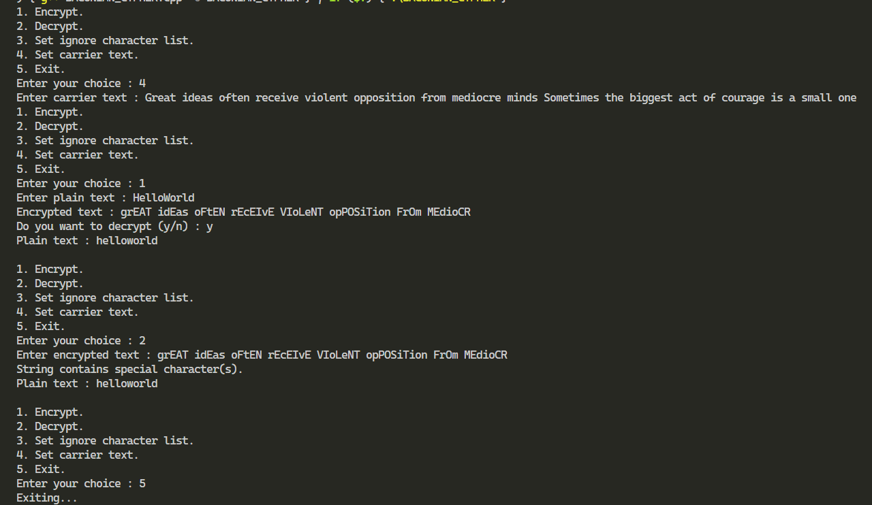

2. Substitution Cypher
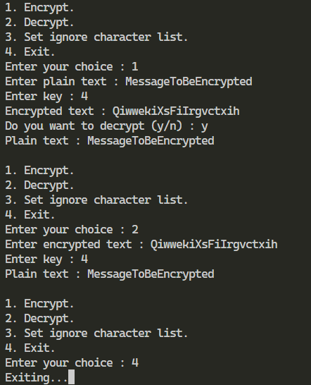
3. Transposition Cypher

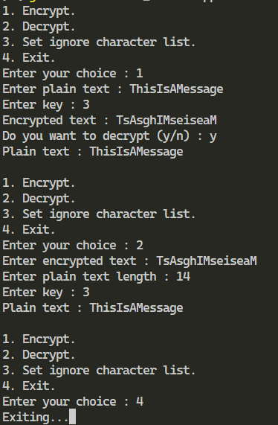
4. RailFence Cypher
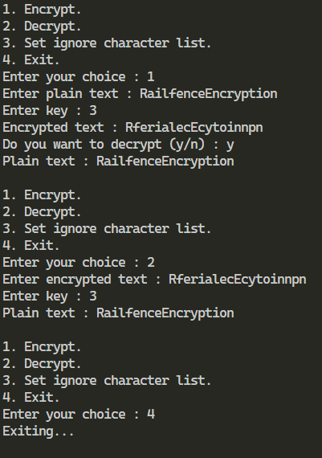
5. Vigenère Cipher
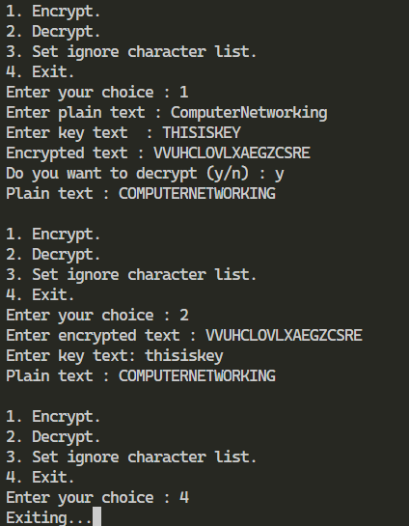
6. Playfair Cypher

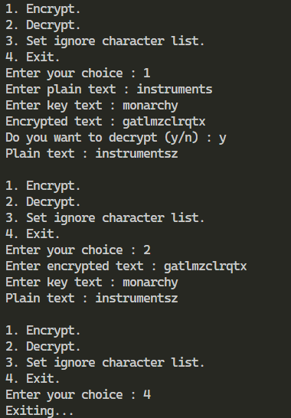
7. Server-Client with Substitution Cipher

server:
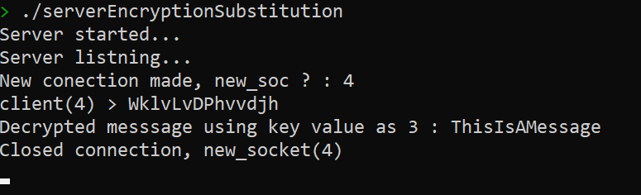

client:
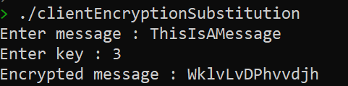
8. Server-Client with Rail-Fencing Cipher

server:

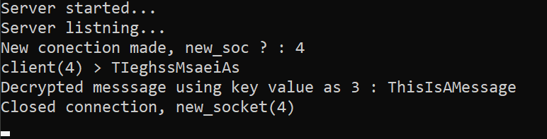

client:

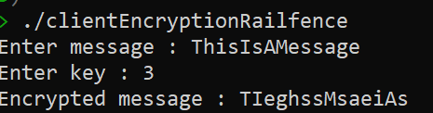
9. Server-Client with Vigenère Cipher

server:

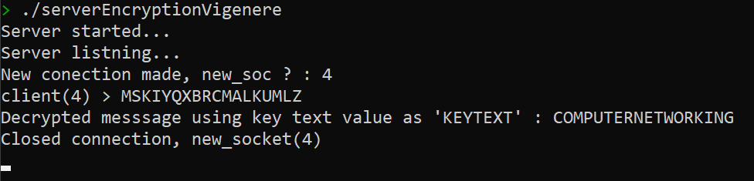

client:

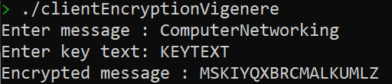
10. Client-Server-Multiple Client Broadcasting

server:

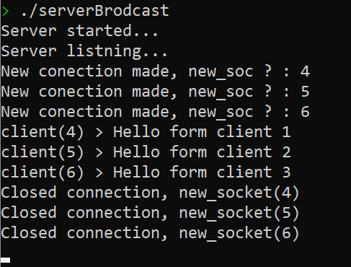

client:

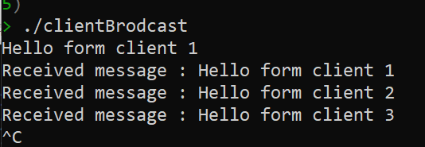

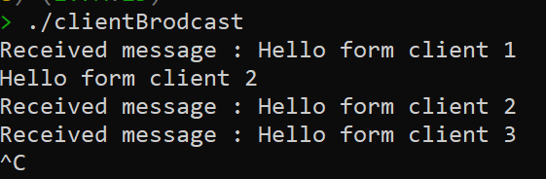

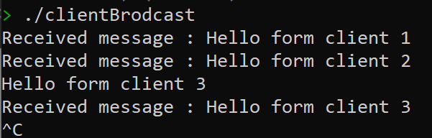

11. Check the Datatype of Input from the Client on Server
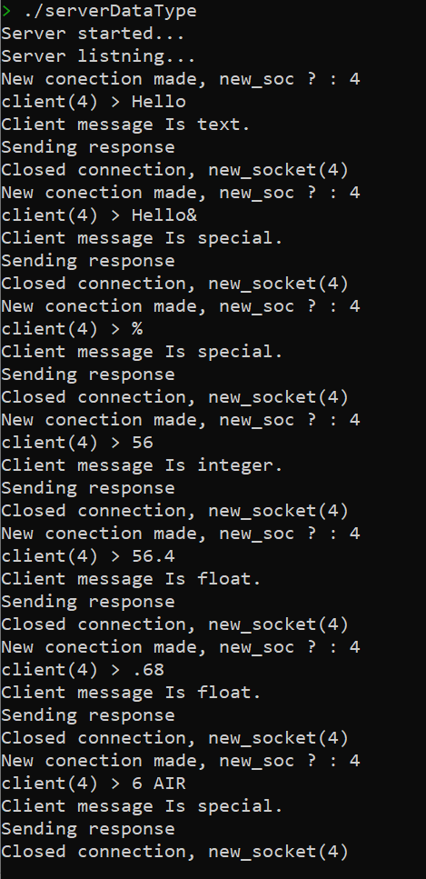
server:

client:

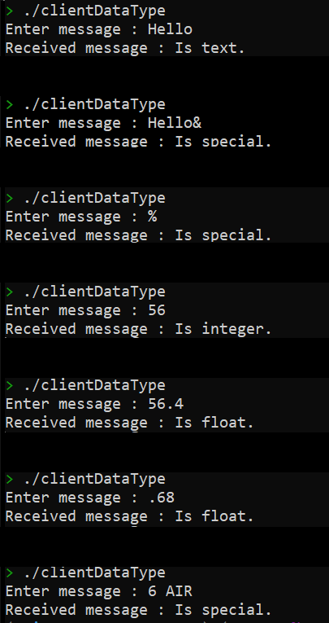


https://github.com/ZennoZenith/Computer-Networks/tree/master/PracticalFile

