Program 4:

WAP to implement the conversion of a NFA to a corresponding DFA. The NFA must be given through a separate file.

#include <stdio.h>
#include <string.h>

#define MAX_TRANSISTION 100
#define MAX_VARIABLES 100
#define MAX_FINAL_STATES MAX_VARIABLES

int isInStateArr(int arr[], int len, int state)
{
for (int i = 0; i < len; ++i)
if (arr[i] == state)
return 1;
return 0;
}

int Read(char *str)
{
int i = 0;
while (1)
{
str[i] = getchar();
if (str[i] == '\n' || str[i] == '\r')
{
str[i] = '\0';
return i;
}
i++;
}
}

int swap(int *x, int *y)
{
int temp = *x;
*x = *y;
*y = temp;
}

void sortArray(int arr[], int len)
{
int flag = 0;
for (int i = 0; i < len; ++i)
{
flag = 0;
for (int j = 0; j < len - i - 1; ++j)
if (arr[j] > arr[j + 1])
{
swap(&arr[j], &arr[j + 1]);
flag = 1;
}
if (flag == 0)
break;
}
}

// removes duplicates from sorted array
void removeDuplicates(int arr[], int *len)
{
for (int i = 0; i < *len - 1; ++i)
{
if (arr[i] == arr[i + 1])
{
for (int j = i + 1; j < (*len) - 1; ++j)
arr[j] = arr[j + 1];
(*len)--;
}
}
}

int compareArray(int arr1[], int arr2[], int len1, int len2)
{
if (len1 != len2)
return 0;
len1--;
while (len1 > -1)
{
if (arr1[len1] != arr2[len1])
return 0;
len1--;
}
return 1;
}

void copyArray(int arr1[], int arr2[], int len)
{
for (int i = 0; i < len; ++i)
arr1[i] = arr2[i];
}
int appendArray(int arr1[], int arr2[], int len1, int len2)
{
for (int i = len1; i < len1 + len2; ++i)
arr1[i] = arr2[i - len1];
return len1 + len2;
}

void printArray(int *arr, int len)
{
for (int i = 0; i < len; ++i)
printf("%d ", arr[i]);
printf("\n");
}

int createSignatue(int *arr, int *len)
{
sortArray(arr, *len);
removeDuplicates(arr, len);
}

struct Transistion_Cell
{
int statesToTransistion[10];
int sTTLen;
};

struct State
{
int stateSignature[10];
int sSlen;
};

int isPresentInStates(struct State *states, int sLen, int *stateSignature, int ssLen)
{
for (int i = 0; i < sLen; i++)
if (compareArray(states[i].stateSignature, stateSignature, states[i].sSlen, ssLen))
return i;
return -1;
}

void printStates(struct State *states, int sLen)
{
for (int i = 0; i < sLen; i++)
{
int t = states[i].sSlen;
printf("state index : %2d, ", i);
printf("state signature : ");
for (int j = 0; j < t; j++)
printf("%d, ", states[i].stateSignature[j]);
printf("\n");
}
}

void printTransistionTable(struct Transistion_Cell TM[][100], int numberOfStates, int numberOfInputs, int *initialStates, int initialStatesLen, int *finalStates, int finalStatesLen)
{
int tempInputs = 4;
printf("\nTransistion Table\n");
printf("| State |");
for (int j = 0; j < numberOfInputs; j++)
printf(" Input(%d) |", j);
printf("\n");

for (int i = 0; i < numberOfStates; ++i)
{
printf("| ");

char str[4] = " ";
if (isInStateArr(initialStates, initialStatesLen, i))
str[0] = '-', str[1] = '>';
if (isInStateArr(finalStates, finalStatesLen, i))
str[2] = '*';
printf("%s%3d | ", str, i);
for (int j = 0; j < numberOfInputs; j++)
{
int t = tempInputs;
if (TM[i][j].sTTLen == 0)
{
printf("%2d | ", -1);
continue;
}

for (int k = 0; k < TM[i][j].sTTLen - 1; k++)
{
printf("%2d,", TM[i][j].statesToTransistion[k]);
t--;
}
printf("%2d ", TM[i][j].statesToTransistion[TM[i][j].sTTLen - 1]);
t--;
while (t > 0)
printf(" "), t--;

printf(" | ");
}
printf("\n");
}
}

void printDFATransistionTable(struct State *states, int sLen, struct Transistion_Cell TM[][100], int numberOfStates, int numberOfInputs, int *initialStates, int initialStatesLen, int *finalStates, int finalStatesLen)
{
printf("\nDFA Transistion Table\n");
printf("| State |");
for (int j = 0; j < numberOfInputs; j++)
printf(" Input(%d) |", j);
printf("\n");

for (int i = 0; i < numberOfStates; ++i)
{
printf("| ");

char str[4] = " ";
if (isInStateArr(initialStates, initialStatesLen, i))
str[0] = '-', str[1] = '>';
if (isInStateArr(finalStates, finalStatesLen, i))
str[2] = '*';
printf("%s%3d | ", str, i);

for (int j = 0; j < numberOfInputs; j++)
{
if (TM[i][j].sTTLen == 0)
{
printf(" %3d | ", -1);
continue;
}
printf(" %3d | ", isPresentInStates(states, sLen, TM[i][j].statesToTransistion, TM[i][j].sTTLen));
}
printf("\n");
}
}

int main()
{
int i = 0, j = 0, k = 0;
int tempInt1, tempInt2;
char ch1, ch2;

FILE *filePointer = NULL;
filePointer = fopen("NFAtoDFA.txt", "r");

int finalStates[MAX_FINAL_STATES] = {0};
int initialStates[MAX_FINAL_STATES] = {0};
int reachableStates[MAX_FINAL_STATES] = {0};
unsigned int finalStatesLen = 0;
unsigned int initialStatesLen = 0;
unsigned int reachableStatesLen = 0;

struct Transistion_Cell TM[MAX_VARIABLES][MAX_VARIABLES];
for (i = 0; i < MAX_TRANSISTION; ++i)
for (j = 0; j < MAX_VARIABLES; ++j)
TM[i][j].sTTLen = 0;

if (filePointer == NULL)
{
printf("Unable to open NFAtoDFA.txt\n");
return 1;
}

int initialState = -1;
int currentState = -1;
int numberOfStates = 0;
int numberOfInputs = 0;
struct State states[MAX_FINAL_STATES];

fscanf(filePointer, "%d%c", &initialState, &ch1);
initialStates[initialStatesLen] = initialState;
initialStatesLen++;
printf("Initial state (->) : %d\n", initialState);

printf("Final states (*) : ");
do
{
fscanf(filePointer, "%d%c", &tempInt1, &ch1);
finalStates[finalStatesLen] = tempInt1;
finalStatesLen++;
printf("%d ", tempInt1);
} while (ch1 != '\n');
printf("\n");

i = j = 0;
while (fscanf(filePointer, "%d%c", &tempInt1, &ch1) != EOF)
{
if (tempInt1 < 0)
TM[i][j].sTTLen = 0;
else
{
TM[i][j].statesToTransistion[TM[i][j].sTTLen] = tempInt1;
TM[i][j].sTTLen++;
}

if (ch1 == ',')
continue;

sortArray(TM[i][j].statesToTransistion, TM[i][j].sTTLen);
removeDuplicates(TM[i][j].statesToTransistion, &TM[i][j].sTTLen);

j++;
if (ch1 == '\n')
{
numberOfInputs = j, j = 0;

states[numberOfStates].stateSignature[0] = i;
states[numberOfStates].sSlen = 1;
numberOfStates++;

i++;
}
}
fclose(filePointer);

printTransistionTable(TM, numberOfStates, numberOfInputs, initialStates, initialStatesLen, finalStates, finalStatesLen);
printStates(states, numberOfStates);

for (i = 0; i < numberOfStates; ++i)
{
for (j = 0; j < numberOfInputs; j++)
{
if (TM[i][j].sTTLen < 2)
continue;

if (isPresentInStates(states, numberOfStates, TM[i][j].statesToTransistion, TM[i][j].sTTLen) != -1)
continue;

copyArray(states[numberOfStates].stateSignature, TM[i][j].statesToTransistion, TM[i][j].sTTLen);
states[numberOfStates].sSlen = TM[i][j].sTTLen;
createSignatue(states[numberOfStates].stateSignature, &states[numberOfStates].sSlen);

for (k = 0; k < numberOfInputs; k++)
{
TM[numberOfStates][k].sTTLen = 0;
for (int l = 0; l < states[numberOfStates].sSlen; l++)
{
// TM[numberOfStates][k].sTTLen += TM[states[numberOfStates].stateSignature[l]][k].sTTLen;

if (k == 0 && isInStateArr(initialStates, initialStatesLen, states[numberOfStates].stateSignature[l]))
{
initialStates[initialStatesLen] = numberOfStates;
initialStatesLen++;
}
if (k == 0 && isInStateArr(finalStates, finalStatesLen, states[numberOfStates].stateSignature[l]))
{
finalStates[finalStatesLen] = numberOfStates;
finalStatesLen++;
}

struct Transistion_Cell *tempPtr = &TM[states[numberOfStates].stateSignature[l]][k];
TM[numberOfStates][k].sTTLen =
appendArray(TM[numberOfStates][k].statesToTransistion,
tempPtr->statesToTransistion, TM[numberOfStates][k].sTTLen, tempPtr->sTTLen);
}
sortArray(TM[numberOfStates][k].statesToTransistion, TM[numberOfStates][k].sTTLen);
removeDuplicates(TM[numberOfStates][k].statesToTransistion, &TM[numberOfStates][k].sTTLen);
}

numberOfStates++;
}
}
removeDuplicates(initialStates, &initialStatesLen);
removeDuplicates(finalStates, &finalStatesLen);

printTransistionTable(TM, numberOfStates, numberOfInputs, initialStates, initialStatesLen, finalStates, finalStatesLen);
printStates(states, numberOfStates);

printf("\n\nInitial States (->) : ");
printArray(initialStates, initialStatesLen);
printf("Final States (*) : ");
printArray(finalStates, finalStatesLen);
printDFATransistionTable(states, numberOfStates, TM, numberOfStates, numberOfInputs, initialStates, initialStatesLen, finalStates, finalStatesLen);

printf("\nExiting...\n");

return 0;
}

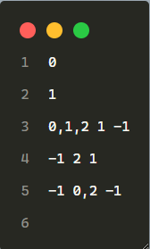
NFAtoDFA.txt

NFA:
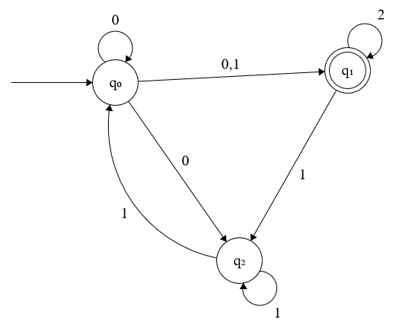

DFA:
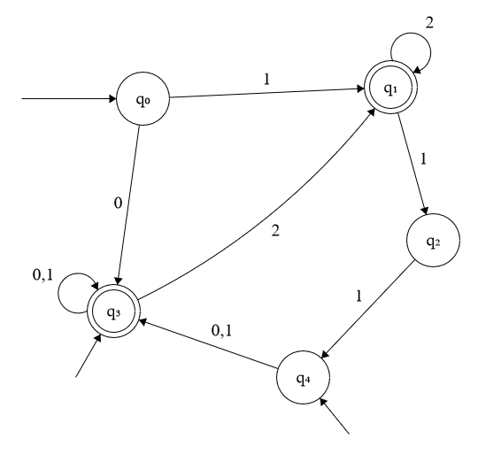

Output:

