Program 1:

WAP to implement a program that takes an input string from the console and verifies it against a Deterministic
Finite Automaton which is given through a separate file.
#include <stdio.h>
#include <string.h>

#define MAX_TRANSISTION 100
#define MAX_VARIABLES 100
#define MAX_FINAL_STATES MAX_VARIABLES

int isInFinalState(int arr[], int len, int state)
{
for (int i = 0; i < len; ++i)
if (arr[i] == state)
return 1;
return 0;
}

int Read(char *str)
{
int i = 0;
while (1)
{
str[i] = getchar();
if (str[i] == '\n' || str[i] == '\r')
{
str[i] = '\0';
return i;
}
i++;
}
}

int main()
{

int i = 0, j = 0;
int tempInt1, tempInt2;
char ch1, ch2;

FILE *filePointer = NULL;
filePointer = fopen("DFA.txt", "r");

int finalStates[MAX_FINAL_STATES] = {0};
unsigned int finalStatesLen = 0;
int DFA_Table[MAX_TRANSISTION][MAX_VARIABLES];

for (i = 0; i < MAX_TRANSISTION; ++i)
for (j = 0; j < MAX_VARIABLES; ++j)
DFA_Table[i][j] = -1;

if (filePointer == NULL)
{
printf("Unable to open DFA.txt\n");
return 1;
}

int initialState = -1;
int currentState = -1;
int numberOfStates = 0;
int numberOfInputs = 0;

fscanf(filePointer, "%d%c", &initialState, &ch1);
printf("Initial state : %d\n", initialState);

printf("Final states : ");

do
{
fscanf(filePointer, "%d%c", &tempInt1, &ch1);
finalStates[finalStatesLen] = tempInt1;
finalStatesLen++;
printf("%d, ", tempInt1);
} while (ch1 != '\n');
printf("\n");

i = j = 0;
while (fscanf(filePointer, "%d%c", &tempInt1, &ch1) != EOF)
{
DFA_Table[i][j] = tempInt1;
j++;
if (ch1 == '\n')
numberOfInputs = j, j = 0, i++;
}
numberOfStates = i;
fclose(filePointer);

printf("Transistion Table\n");
printf("| State | Input(0) | Input(1) |\n");
for (i = 0; i < numberOfStates; ++i)
{
printf("| %3d | ", i);
for (j = 0; j < numberOfInputs; j++)
{
printf(" %3d | ", DFA_Table[i][j]);
}
printf("\n");
}

int flag = 0;
char inputString[100] = {0};
int inputStringLen = 0;

while (1)
{
printf("\n------------------------\nEnter input string ('#' to exit) : ");
inputStringLen = Read(inputString);

if (inputString[0] == '#')
break;

printf("Input string : %s, Input string len : %d\n\n", inputString, inputStringLen);

currentState = initialState;
flag = 0;
for (i = 0; i < inputStringLen; ++i)
{
tempInt1 = inputString[i] - '0';

printf("string and state transition : %d , q%d -> ", tempInt1, currentState);
currentState = DFA_Table[currentState][tempInt1];

if (currentState == -1)
{
printf("NO TRANSISTION\n");
flag = 1;
break;
}
printf("q%d\n", currentState);
}

if (flag == 1 || !isInFinalState(finalStates, finalStatesLen, currentState))
printf("\nString %s is NOT accepted by the DFA!\n", inputString);
else
printf("\nString %s is accepted by the DFA!\n", inputString);
}

printf("\nExiting...\n");

return 0;
}

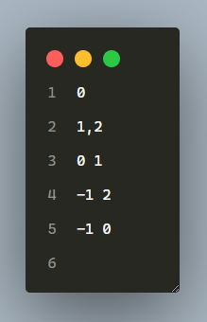
DFA.txt

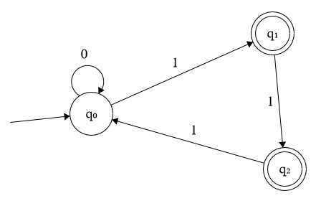
Output:

