Program 2:

WAP to implement a MEALY MACHINE, where the program generates an output corresponding to an input string given through the console.

#include <stdio.h>
#include <stdlib.h>
#include <string.h>

#define MAX_TRANSISTION 100
#define MAX_VARIABLES 100

struct Transistion
{
int stateToTransistion;
char output[5];
};

int Read(char *str)
{
int i = 0;
while (1)
{
str[i] = getchar();
if (str[i] == '\n' || str[i] == '\r')
{
str[i] = '\0';
return i;
}
i++;
}
}

int main()
{

int tempInt1, tempInt2;
char ch1, ch2, ch;
int i = 0, j = 0, k = 0;
char str1[10] = {0};
char str2[10] = {0};

FILE *filePointer = NULL;
filePointer = fopen("MEALY2.txt", "r");

if (filePointer == NULL)
{
printf("Unable to open MEALY.txt\n");
return 1;
}

struct Transistion Transistion_Table[MAX_TRANSISTION][MAX_VARIABLES];

for (i = 0; i < MAX_TRANSISTION; ++i)
for (j = 0; j < MAX_VARIABLES; ++j)
{
Transistion_Table[i][j].output[0] = '\0';
Transistion_Table[i][j].stateToTransistion = -1;
}

int initialState = -1;
int currentState = -1;
int numberOfStates = 0;
int numberOfInputs = 0;

fscanf(filePointer, "%d%c", &initialState, &ch1);
printf("Initial state : %d\n", initialState);
fscanf(filePointer, "%d%c", &numberOfInputs, &ch1);
printf("Number of inputs : %d\n", numberOfInputs);

i = j = 0;
while (1)
{
if (fscanf(filePointer, "%s%s", str1, str2) == EOF)
break;
tempInt1 = atoi(str1);
if (tempInt1 > -1)
{
Transistion_Table[i][j].stateToTransistion = tempInt1;
strcpy(Transistion_Table[i][j].output, str2);
}
else
{
Transistion_Table[i][j].stateToTransistion = -1;
strcpy(Transistion_Table[i][j].output, "-1");
}
j++;
if (j == numberOfInputs)
j = 0, i++;
}
numberOfStates = i;
fclose(filePointer);

printf("Number of states : %d\n", numberOfStates);

printf("Transistion Table\n");
printf("| State | Input(0) Output | Input(1) Output |\n");
for (i = 0; i < numberOfStates; ++i)
{
printf("| %3d | ", i);
for (j = 0; j < numberOfInputs; j++)
{
printf(" %3d %6s | ", Transistion_Table[i][j].stateToTransistion, Transistion_Table[i][j].output);
}
printf("\n");
}

int flag = 0;
char inputString[100] = {0};
char outputString[100] = {0};
int inputStringLen = 0;
int outputStringLen = 0;

while (1)
{
outputString[0] = '\0';

printf("\n------------------------\nEnter input string ('#' to exit) : ");
inputStringLen = Read(inputString);

if (inputString[0] == '#')
break;

printf("Input string : %s, Input string len : %d\n\n", inputString, inputStringLen);

currentState = initialState;
flag = 0;
for (i = 0; i < inputStringLen; ++i)
{
tempInt1 = inputString[i] - '0';

printf("input string and state transition : %d , q%d -> ", tempInt1, currentState);
int oldState = currentState;
currentState = Transistion_Table[currentState][tempInt1].stateToTransistion;

if (currentState == -1)
{
printf("NO TRANSISTION\n");
flag = 1;
break;
}
strcat(outputString, Transistion_Table[oldState][tempInt1].output);
printf("q%d / %s\n", currentState, Transistion_Table[oldState][tempInt1].output);
}

printf("\nOutput of Mealy Machine : %s\n", outputString);
}

printf("\nExiting...\n");

return 0;
}

MEALY.txt

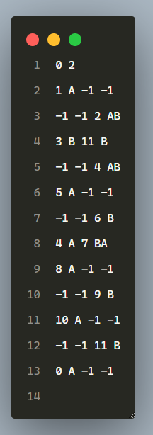
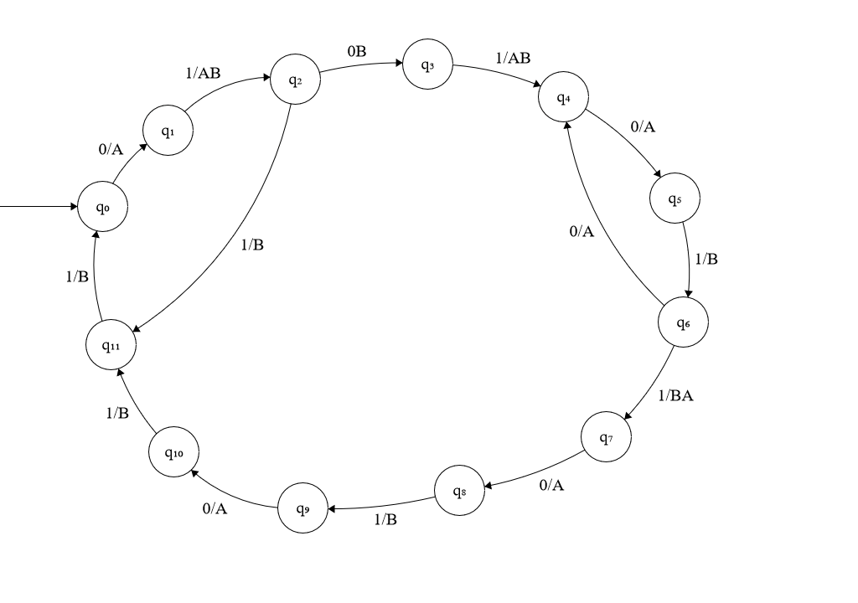
Output:
