Program 3:

WAP to implement a MOORE MACHINE, where the program generates an output corresponding to an input string given through the console.

#include <stdio.h>
#include <stdlib.h>
#include <string.h>

#define MAX_TRANSISTION 100
#define MAX_VARIABLES 100

int Read(char *str)
{
int i = 0;
while (1)
{
str[i] = getchar();
if (str[i] == '\n' || str[i] == '\r')
{
str[i] = '\0';
return i;
}
i++;
}
}

int main()
{

int tempInt1, tempInt2;
char ch1, ch2, ch;
int i = 0, j = 0, k = 0;
char str1[10] = {0};
char str2[10] = {0};

FILE *filePointer = NULL;
filePointer = fopen("MOORE2.txt", "r");

if (filePointer == NULL)
{
printf("Unable to open MOORE.txt\n");
return 1;
}

int Transistion_Table[MAX_TRANSISTION][MAX_VARIABLES];
char OutputTable[MAX_TRANSISTION][10];

for (i = 0; i < MAX_TRANSISTION; ++i)
{
for (j = 0; j < MAX_VARIABLES; ++j)
Transistion_Table[i][j] = 0;
OutputTable[i][0] = '\0';
}

int initialState = -1;
int currentState = -1;
int numberOfStates = 0;
int numberOfInputs = 0;

fscanf(filePointer, "%d%c", &initialState, &ch1);
printf("Initial state : %d\n", initialState);
fscanf(filePointer, "%d%c", &numberOfInputs, &ch1);
printf("Number of inputs : %d\n", numberOfInputs);

i = j = 0;

while (1)
{
if (fscanf(filePointer, "%s", str1) == EOF)
break;
tempInt1 = atoi(str1);
Transistion_Table[i][j] = tempInt1;
j++;
if (j == numberOfInputs)
{
fscanf(filePointer, "%s", str1);
strcpy(OutputTable[i], str1);
j = 0, i++;
}
}
numberOfStates = i;
fclose(filePointer);

printf("Number of states : %d\n", numberOfStates);

printf("Transistion Table\n");
printf("| State | Input(0) | Input(1) | Output |\n");
for (i = 0; i < numberOfStates; ++i)
{
printf("| %3d | ", i);
for (j = 0; j < numberOfInputs; j++)
{
printf(" %3d | ", Transistion_Table[i][j]);
}
printf("%6s | \n", OutputTable[i]);
}

int flag = 0;
char inputString[100] = {0};
char outputString[100] = {0};
int inputStringLen = 0;
int outputStringLen = 0;

while (1)
{
outputString[0] = '\0';

printf("\n------------------------\nEnter input string ('#' to exit) : ");
inputStringLen = Read(inputString);

if (inputString[0] == '#')
break;

printf("Input string : %s, Input string len : %d\n\n", inputString, inputStringLen);

currentState = initialState;
flag = 0;
for (i = 0; i < inputStringLen; ++i)
{
tempInt1 = inputString[i] - '0';

printf("input string and state transition : %d , q%d / %s -> ", tempInt1, currentState, OutputTable[currentState]);
int oldState = currentState;
currentState = Transistion_Table[currentState][tempInt1];
strcat(outputString, OutputTable[currentState]);

if (currentState == -1)
{
printf("NO TRANSISTION\n");
flag = 1;
break;
}
printf("q%d / %c\n", currentState, outputString[i]);
}
outputString[i] = '\0';

printf("\nOutput of Moore Machine : %s\n", outputString);
}

printf("\nExiting...\n");

return 0;
}

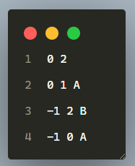
MOORE.txt

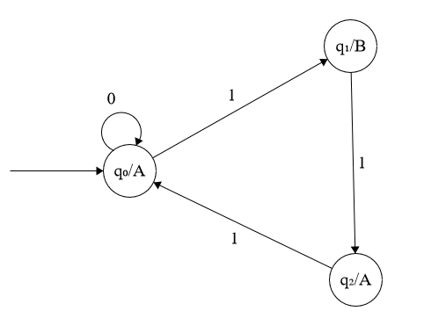
Output:

