3.1.i & 3.1.ii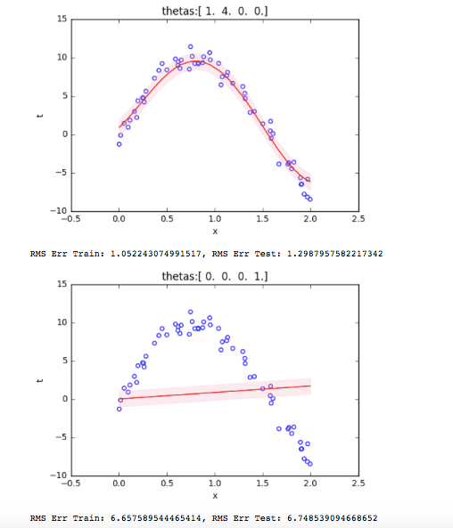

3.1.iii

1. theta0 and theta1 play an important part for regression to fit real data. That's why theta_list [0,0,0,1]'s error is larger than others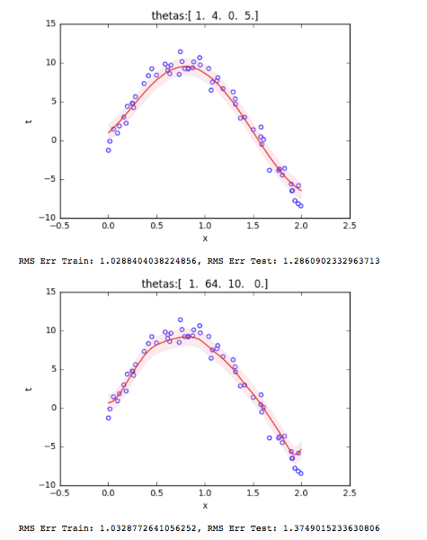.

2. theta2's and theta3's impacts are smaller.

3. When theta1 becomes larger, the error becomes larger, it is a little bit overfittting.

Theta [1,4,0,5] is the best result.

3.2.i

3.2.ii & 3.2.iii

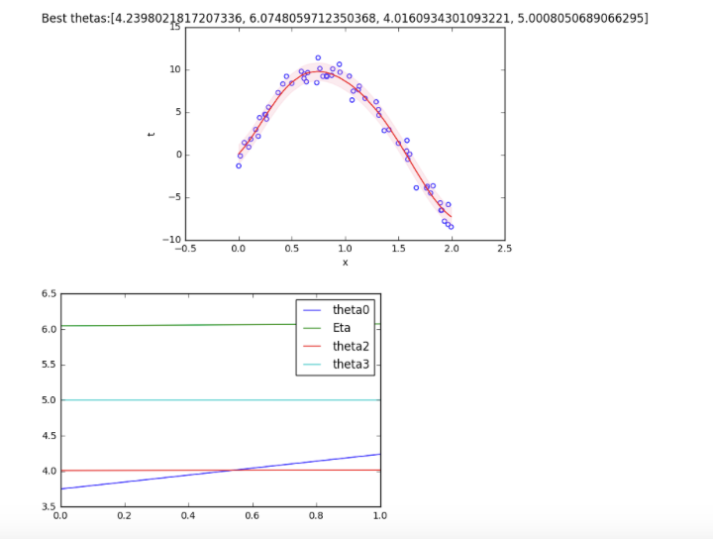

3.2.iv

RMS Err Train: 0.8276395997022568, RMS Err Test: 1.1186281577797195

3.2.v

Baysian Linear Regression

