1.

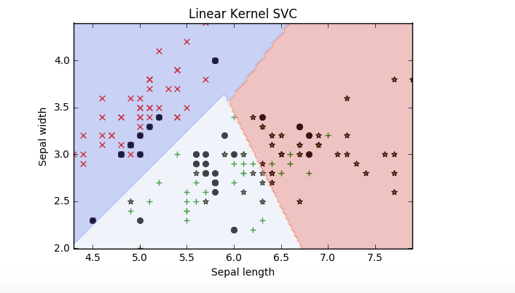

2.

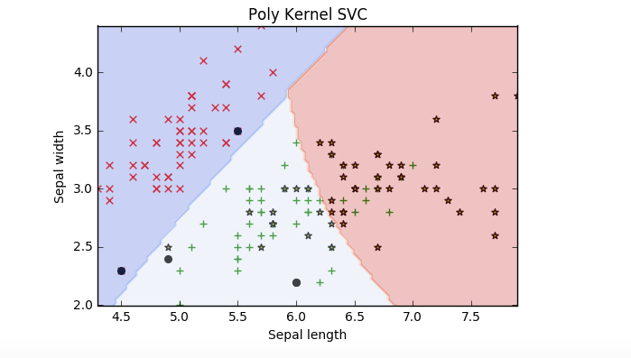

3.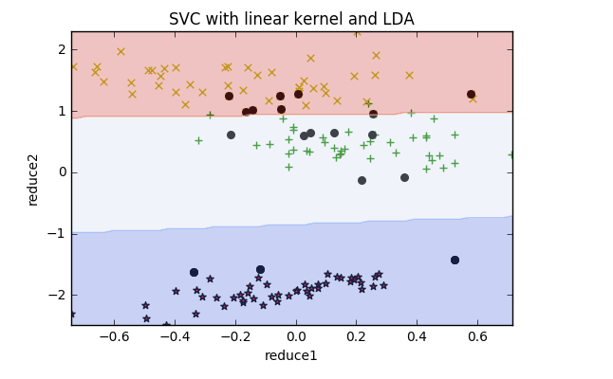

4.

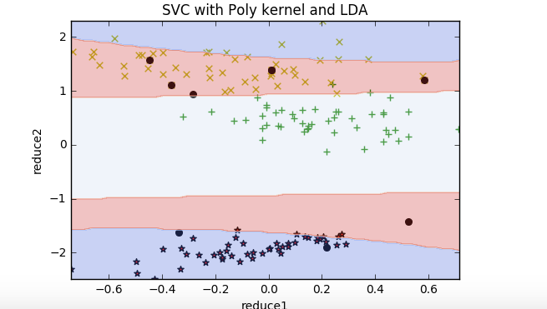

5.

(1)influence of dimension reduction and the difference:

Comapare to (1) and (3) SVM train better and faster when we use LDA. because LDA can make same features more closer and make speartion better. Also, it is diffcult for machine to learn so many features to classify at the same time, when we reduce features efficiently, it can make machine eaiser to classify.

(2) As we split every features to train SVM, and the best accuracy of every classification(0&1, 0&2, 1&2) is feature4.