Petalinux OS image:
Found at: https://xilinx-wiki.atlassian.net/wiki/spaces/A/pages/3281321985/2025.1+Release#Downloads
On C drive: C:\Users\zenop\OneDrive\Documents\ZenoRobotics\FPGA\Xilinx Kria KR260
-------------------------------------------------------------------
Yes. Here is the practical step-by-step path I would use for your project.
Goal
PL UART parser
→ AXI Stream
→ AXI DMA S2MM
→ DDR DMA buffer
→ Linux userspace app
→ UDP/Ethernet
→ Jetson
The clean development approach is:
u-dma-buf = shared DMA-safe memory buffer
UIO/devmem = userspace access to AXI DMA registers
userspace C/Python = start DMA, wait complete, send UDP
u-dma-buf is specifically intended to allocate contiguous DMA buffers and expose them to userspace, often with UIO-based userspace drivers. (GitHub)

7. Userspace C app first
I would do this in C first, not Python.
Reason: register mmap, volatile register access, and cache sync are easier and safer in C.
Once C works, Python can be added later.
Your C app will:
- mmap /dev/udmabuf0
- read physical address from /sys/class/u-dma-buf/udmabuf0/phys_addr
- mmap AXI DMA registers
- create UDP socket
- loop forever:
  - arm DMA
  - wait complete
  - send 28 bytes to Jetson

Step-by-step plan
1. Confirm Vivado hardware
Your PL design should contain:
uart_packet_parser
→ AXI DMA S_AXIS_S2MM
→ Zynq MPSoC HP/HPC/ACP DDR path
For now, you only need AXI DMA S2MM.
Also confirm the AXI DMA AXI-Lite control interface has a known base address, for example:
AXI DMA base = 0xA0000000
You will need the real value from Vivado Address Editor.

2. Export XSA with bitstream
From Vivado:
File → Export → Export Hardware
Include bitstream = checked
For Linux overlay/PetaLinux work, include the bitstream.

3. Build or configure Linux image
Use PetaLinux or KR260 Ubuntu overlay flow.
You need Linux to know about:
- AXI DMA register region
- UIO access, or no kernel driver claiming that address
- u-dma-buf buffer
AMD/Xilinx notes that there is not really a simple generic “do everything” userspace AXI DMA solution; full control usually means either a kernel driver or careful userspace control. (AMD Customer Community)

4. Add u-dma-buf
Install/build u-dma-buf.
How? I looked up the steps needed:
If you get an error: insmod: ERROR: could not load module udmabuf.ko: No such file or directory … Here is a quick fix (Ubuntu):
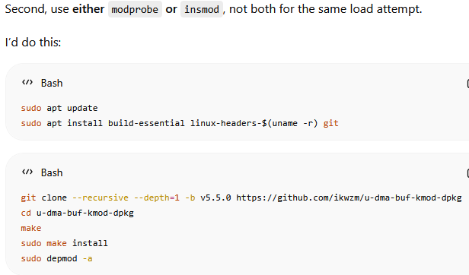
For copy and paste:
sudo apt update
sudo apt install build-essential linux-headers-$(uname -r) git
git clone --recursive --depth=1 -b v5.5.0 https://github.com/ikwzm/u-dma-buf-kmod-dpkg
cd u-dma-buf-kmod-dpkg
make
sudo make install
sudo depmod -a

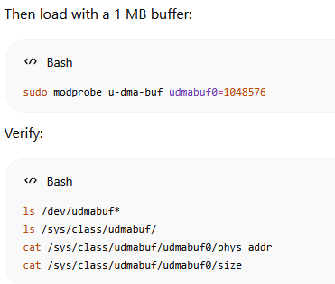
For copy and paste:
sudo modprobe u-dma-buf udmabuf0=1048576
ls /dev/udmabuf*
ls /sys/class/udmabuf/
cat /sys/class/udmabuf/udmabuf0/phys_addr
cat /sys/class/udmabuf/udmabuf0/size

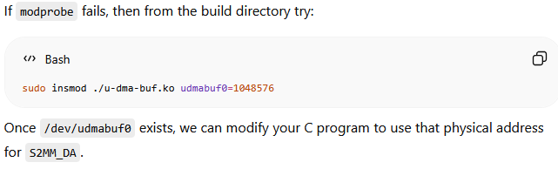
Verification
lsmod | grep u_dma_buf
ls /dev/udmabuf0
FYI: The error insmod: ERROR: could not insert module u-dma-buf.ko: File exists typically means the u-dma-buf module (or a conflicting module) is already loaded in the Linux kernel.

Conceptually:
sudo insmod udmabuf.ko udmabuf0=1048576
Then check:
ls /dev/udmabuf0
ls /sys/class/u-dma-buf/udmabuf0/
Important files:
cat /sys/class/u-dma-buf/udmabuf0/phys_addr
cat /sys/class/u-dma-buf/udmabuf0/size
The DMA engine needs the physical address, not the Linux virtual address. This is a key point for userspace DMA. (EngineerZone)

5. Map AXI DMA registers
For initial testing, you can use devmem/devmem2 to verify the DMA registers respond.
AXI DMA S2MM registers are typically:
S2MM_DMACR = base + 0x30
S2MM_DMASR = base + 0x34
S2MM_DA = base + 0x48
S2MM_LENGTH = base + 0x58
Your userspace app will later mmap() the AXI DMA register region through UIO or /dev/mem.

6. Basic S2MM transfer sequence
For each 28-byte packet:
1. Reset/check DMA
2. Write destination physical address
3. Start S2MM channel
4. Write transfer length = 28
5. Wait until complete
6. Read 28 bytes from mapped udmabuf
7. Send UDP packet
8. Repeat
Pseudo-register flow:
write32(S2MM_DMACR, 0x4); // reset
wait reset clears

write32(S2MM_DA, dma_phys_addr); // destination buffer physical addr
write32(S2MM_DMACR, 0x1); // run
write32(S2MM_LENGTH, 28); // start transfer

while (!(read32(S2MM_DMASR) & IOC_IRQ_BIT)) {
// wait complete
}

packet = udmabuf_mapped_ptr;
sendto(sock, packet, 28, 0, ...);

7. Userspace C app first
I would do this in C first, not Python.
Reason: register mmap, volatile register access, and cache sync are easier and safer in C.
Once C works, Python can be added later.
Your C app will:
- mmap /dev/udmabuf0
- read physical address from /sys/class/u-dma-buf/udmabuf0/phys_addr
- mmap AXI DMA registers
- create UDP socket
- loop forever:
  - arm DMA
  - wait complete
  - send 28 bytes to Jetson

8. Jetson receiver stays the same
Your Jetson decoder should continue using:
header, length, seq, timestamp_us, qw, qx, qy, qz, calib, reserved, checksum = \
struct.unpack("<HHIIhhhhHHI", data)
No need to change that if the PL-DMA path sends the same 28-byte packet.

Recommended milestone order
Milestone 1:
Load PL design under Linux.

Milestone 2:
Use devmem to read AXI DMA status register.

Milestone 3:
Load u-dma-buf and confirm physical buffer address.

Milestone 4:
C app performs one 28-byte S2MM transfer.

Milestone 5:
C app prints packet words.

Milestone 6:
C app sends packet over UDP.

Milestone 7:
Jetson decodes quaternion exactly like the USB-UART path.
That last comparison is your proof:
USB UART path quaternion == PL-DMA-UDP path quaternion

My recommendation
Do not jump straight to continuous streaming.
First make this work:
one DMA packet → print in Linux
Then:
one DMA packet → UDP to Jetson
Then:
continuous loop
Your next concrete item is to identify the AXI DMA base address from Vivado and verify from Linux that the register region is visible.

2) Simplest Method for Ubuntu
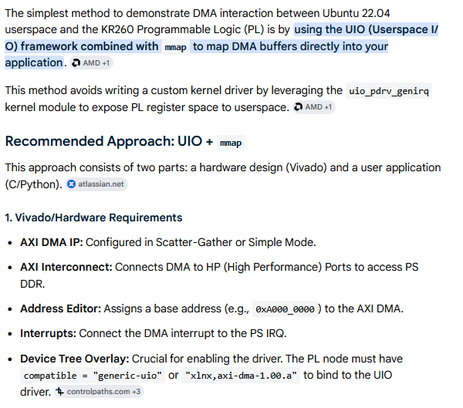
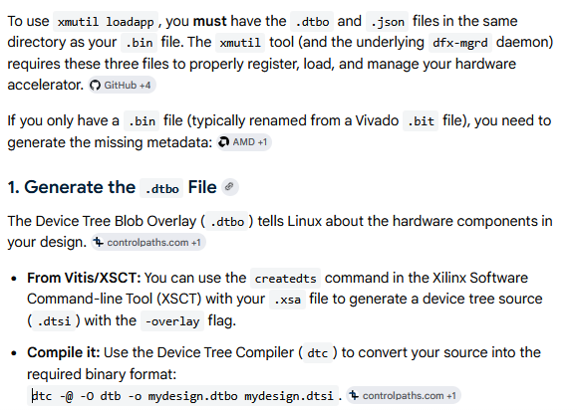
2. Create the shell.json File
This is a simple text file that describes the design type. For most standard "flat" designs on Kria, a basic version looks like this:
json
{
"shell_type": "PL_FLAT",
"num_pl_slots": 1
}
3. Folder Setup and Loading
- Organize Files: Create a directory at /lib/firmware/xilinx/mydesign/.
- Rename/Move: Ensure your files follow a consistent naming convention (e.g., mydesign.bin, mydesign.dtbo,).
- Refresh and Load:
  - sudo xmutil listapps (This rescans the directory; your app should now appear).
  - sudo xmutil unloadapp (Unload any currently active app).
  - sudo xmutil loadapp mydesign.

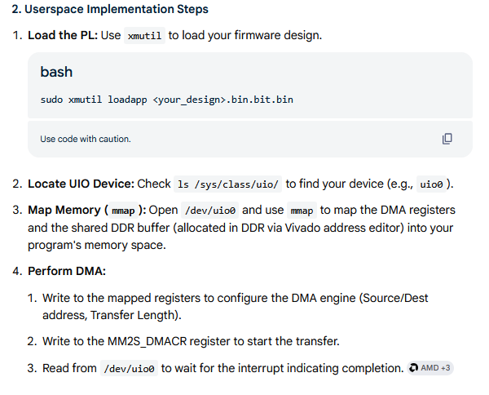
Related Details Left Out of Instructions Above
Opening /dev/uio0 is done in C by using the standard open() system call, typically with O_RDWR and O_SYNC flags to allow reading/writing and synchronized I/O for mapping registers. Once opened, use mmap() to map the device memory into user space and read() to wait for interrupts.
Steps to Open and Access /dev/uio0
C Code
#include <fcntl.h>
#include <sys/mman.h>
#include <unistd.h>
#include <stdio.h>
#include <stdlib.h>

int main() {
// 1. Open the UIO device
int fd = open("/dev/uio0", O_RDWR | O_SYNC);
if (fd < 0) {
perror("Failed to open /dev/uio0");
return -1;
}

// 2. Map the device memory (example: mapping 4KB of map 0)
// Map0 typically starts at offset 0
size_t size = 4096;
void *map_addr = mmap(NULL, size, PROT_READ | PROT_WRITE, MAP_SHARED, fd, 0);
if (map_addr == MAP_FAILED) {
perror("mmap failed");
close(fd);
return -1;
}

printf("UIO device mapped at %p\n", map_addr);

// 3. Access memory
// *(volatile uint32_t *)map_addr = 0x1; // Example write

// 4. Close
munmap(map_addr, size);
close(fd);
return 0;
}
-------------------------------------------------
Key Considerations
- Permissions: You may need root privileges (sudo) to open /dev/uio0.
- Memory Mapping: Use mmap() to map the device's memory regions into your application's address space.
- Interrupts: The read() function on /dev/uioX is used to wait for interrupts. The read will block until an interrupt occurs, returning a 32-bit integer count of interrupts.
- Platform Device Setup: Ensure the UIO driver is properly loaded (e.g., uio_pdrv_genirq) and the device is active in /sys/class/uio/uio0.
- For more information, see the Userspace I/O HOWTO

Alternative "Simpler" Method (Faster Development)
For even faster demonstration without handling UIO interrupts, use the axidma library as demonstrated in the 1.1.3 Kria KR260 DMA Debugging Repository. This library abstracts the mmap and UIO interaction
// Example: Using a hypothetical DMA library
int fd = open("/dev/axidma", O_RDWR);
// Configure DMA...
ioctl(fd, AXIDMA_START_TRANSFER, &transfer_params);
// Data is moved in background
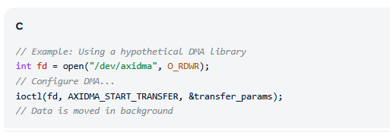
Copy Version:
// Example: Using a hypothetical DMA library
int fd = open("/dev/axidma", O_RDWR);
// Configure DMA... ioctl(fd, AXIDMA_START_TRANSFER, &transfer_params);
// Data is moved in background
------------------------------------------------
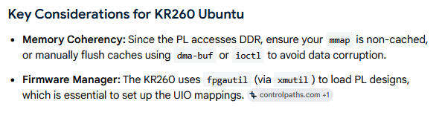

Yet Another Simple Method
Source internet: https://www.controlpaths.com/2025/08/31/ubuntu-overlays-kria/#connecting-to-the-kr260-via-ssh

Source: ChatGPT
Yes — your snapshot verifies:
AXI DMA control:
0xA000_0000 - 0xA000_FFFF

AXI version register:
0xA001_0000 - 0xA001_FFFF
So your overlay could expose both as separate UIO devices:
DTS File:
/dts-v1/;
/plugin/;

/ {
fragment@0 {
target-path = "/amba_pl";

__overlay__ {
#address-cells = <2>;
#size-cells = <2>;

axi_dma_uio: dma-uio@a0000000 {
compatible = "generic-uio";
reg = <0x0 0xa0000000 0x0 0x00010000>;
status = "okay";
};

axi_version_uio: version-uio@a0010000 {
compatible = "generic-uio";
reg = <0x0 0xa0010000 0x0 0x00010000>;
status = "okay";
};
};
};
};

Compile:
dtc -@ -I dts -O dtb -o top_kr260_uio.dtbo top_kr260_uio.dts

Load:
sudo fpgautil -o kria_dma_uio.dtbo
sudo fpgautil -b ./top_kr260_wrapper.bin -f Full

Expected UIO maps:
/dev/uio0 → one of the two blocks
/dev/uio1 → the other block

Check which is which with:
cat /sys/class/uio/uio*/name
--------
If it doesn’t work (give new, address from dts to dtbo):
After the compile .../map0/addr = ubuntu@kria:~/kria_overlay_plus$ cat /sys/class/uio/uio*/maps/map0/addr
0x00000000ffa00000
0x00000000fd0b0000
0x00000000fd490000
0x00000000ffa10000

That means the overlay nodes for 0xA0000000 and 0xA0010000 are not currently present in the live device tree.
So the .dtbo likely compiled, but it has not been applied/loaded.
Next check:
ls /sys/kernel/config/device-tree/overlays
If that directory does not exist:
sudo modprobe configfs
sudo mount -t configfs configfs /sys/kernel/config
ls /sys/kernel/config/device-tree/overlays

To load the overlay manually:
sudo mkdir /sys/kernel/config/device-tree/overlays/top_kr260_uio
sudo cp top_kr260_uio.dtbo /sys/kernel/config/device-tree/overlays/top_kr260_uio/dtbo

Then check again:
find /proc/device-tree -iname "*a0000000*" -o -iname "*a0010000*"
And:
for u in /sys/class/uio/uio*; do
echo "$u"
cat $u/name
cat $u/maps/map0/addr
cat $u/maps/map0/size
echo
done
You want to see:
0x00000000a0000000
0x00000000a0010000

-----------------------------
Load .bin file
sudo fpgautil -b ./top_kr260_wrapper.bin -f Full

Also, you can Load bitstream + DTBO together
Use fpgautil:
sudo fpgautil -b kria_dma_v2.bit.bin -o kria_dma_v2.dtbo

That loads the FPGA bitstream and applies the device-tree overlay together.

If you only want to load the DTBO:
sudo fpgautil -o kria_dma_v2.dtbo

If you only want to load the bitstream:
sudo fpgautil -b kria_dma_v2.bit.bin

Don’t reload .dtbo file:
1) Why overwriting .dtbo failed
That happens because the DTBO is already applied in the live device tree. Easiest workaround: do not overwrite the same filename. Give each build a new name.
Example:
kria_dma_v2.bit.bin
kria_dma_v2.dtbo
Then load that new pair.
Rebooting is also acceptable if ‘sudo xmutil unloadapp’ does not cleanly remove it.

