Train as Experts, Deploy as Dense: Sequence-Level Mixture-of-LoRA Adaptation of a 4-bit Vision-Language Model for Edge Devices
Harsh Raj¹, Instrumentation & Control Engineering Department, Netaji Subhas University of Technology, New Delhi, India-110078, harsh.raj.ug23@nsut.ac.in, ORCID 0009-0000-3091-1946
Saurav Kumar², Instrumentation & Control Engineering Department, Netaji Subhas University of Technology, New Delhi, India-110078, saurav.kumar_ug23@nsut.ac.in, ORCID 0009-0003-2525-1316
Rumeshi Mittal³, Instrumentation & Control Engineering Department, Netaji Subhas University of Technology, New Delhi, India-110078, rumeshi.mittal.ug23@nsut.ac.in, ORCID 0009-0001-0925-6542
Vicky Suri⁴, Instrumentation & Control Engineering Department, Netaji Subhas University of Technology, New Delhi, India-110078, vickysuri@nsut.ac.in
Abstract
Vision-language models (VLMs) can read documents and charts and reason about scenes, but they are large, and serving several tasks on one small device usually means storing several models. We adapt Qwen2-VL-2B, quantised to 4 bits, to document VQA, chart QA and visual spatial reasoning with a mixture of LoRA experts (MoE-LoRA) whose router reads the question once and picks one expert for the whole answer. Training runs on a single 16 GB T4 GPU, with the full-precision model as a distillation teacher. On held-out test data this sequence-level MoE-LoRA is as accurate as a dense LoRA of the same rank (−0.7 points, 95% CI [−1.7, +0.4], three seeds), yet its experts line up with the tasks without ever seeing a task label, carrying about ten times more task information than token-level experts. Since every request uses a single expert, the experts fold into ordinary per-task checkpoints with no loss: on a 4 GB GTX 1650 laptop GPU the folded model costs exactly what the 4-bit base costs (2.0 GB peak, 18.8 tokens/s), while keeping the router adds 11% memory and slows decoding by 24%. With HQQ 4-bit quantisation, MoE-LoRA reaches 79.6 points, 2.8 above the original full-precision model (95% CI [+0.4, +5.2]), while peak GPU memory drops from 4.2 GB to 1.9 GB; the full-precision model does not even fit on the 4 GB GPU. We also tried MoPEQ-style per-layer bit allocation. It helps the untuned model a little at every memory budget (+1.2 to +2.2 points, not significant on its own), stops helping once the adapters are trained, and goes badly wrong when sensitivity comes from a cheap Hessian-trace estimate.
Index Terms— vision-language models, mixture of experts, LoRA, quantization, edge deployment, knowledge distillation

I. Introduction
Compact VLMs such as Qwen2-VL-2B [1] can read documents and charts and reason about scenes, so they are natural candidates for offline use on laptops, embedded boards and field equipment. Two things get in the way. The full-precision weights alone take about 4.1 GB, and many edge GPUs have 4 GB or less. And a single device is often asked to do several different jobs: one shared model tends to lose accuracy, while one model per job multiplies storage.
Low-rank adapters (LoRA) [2] trained on top of a 4-bit base (QLoRA) [3] make training cheap enough for one small GPU. Mixtures of LoRA experts [4], [5] tackle the multi-task problem by giving the model several adapters and a router, much like sparse mixture-of-experts layers [6], [7]. The catch is deployment: a live router and extra experts cost memory and latency, which an edge device can least afford, and token-level routers rarely end up with experts that match recognisable tasks.
We ask whether MoE-LoRA can be trained with multi-task capacity and then shipped at the cost of the base model. Concretely, we contribute:
- A MoE-LoRA layer for the MLP blocks of a 4-bit VLM whose router decides once per request, from the question text, which expert to use, trained with top-$k$ distillation from the full-precision model on one T4 GPU.
- A three-seed comparison on held-out test data against dense LoRA (same rank and same parameter count) and token-level routing, with paired bootstrap tests.
- Evidence that the per-request router finds the tasks by itself (0.48 vs 0.05 bits of task–expert mutual information) and that its experts fold into plain per-task checkpoints, which run on a 4 GB laptop GPU with no overhead over the base model.
- A memory–accuracy study against the unquantised model, covering per-component and MoPEQ-style per-layer mixed precision: with an HQQ base the adapted model is significantly more accurate than fp16 ($+2.8$ points, $p=0.01$) with peak GPU memory cut from 4.2 GB to 1.9 GB.

II. Related Work
Parameter-efficient adaptation. LoRA [2] learns low-rank updates to frozen weights; QLoRA [3] trains them on top of a 4-bit NF4 base, which we adopt. MoPEQ [8] assigns mixed bit widths to the experts of large pretrained MoE VLMs by sensitivity; our small experts are folded away (Section 6), so we keep them in full precision and study mixed precision of the base. Mixture of experts. Sparsely gated MoE layers [6] and Switch Transformers [7] route tokens to experts with load-balancing losses; router $z$-losses [9] stabilise training. Mixtures of LoRA experts apply the idea to adapters [4], [5]. These works route at token level and keep the router at inference. We route at sequence level and fold experts away for deployment. We distil [10] from the unquantised model into the 4-bit student.

III. Method
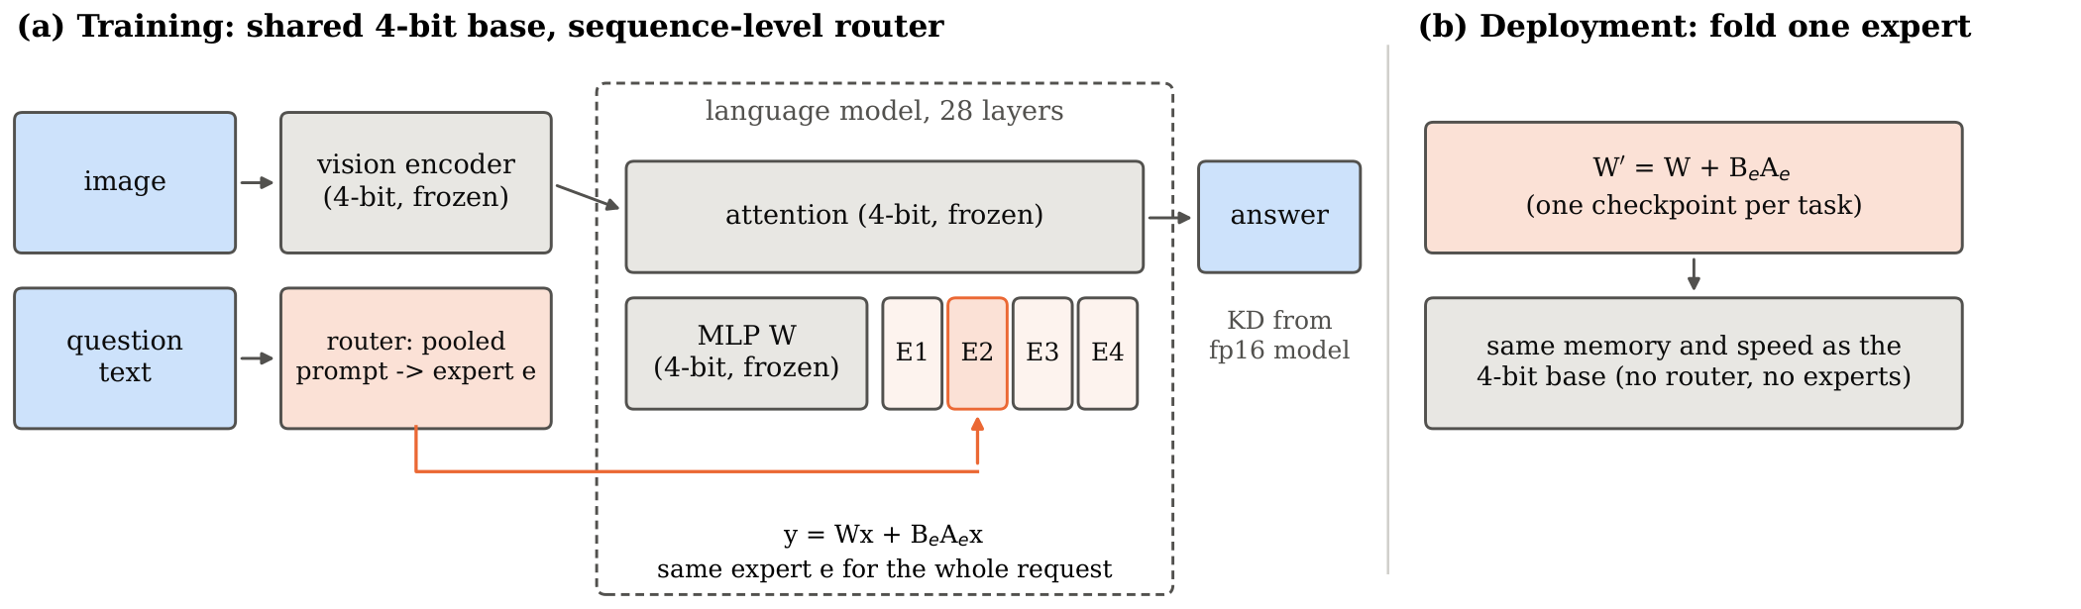
Fig. 1. (a) Training: the 4-bit base is frozen and shared; each language-model MLP carries four LoRA experts, and a sequence-level router picks one expert per request from the pooled prompt. (b) Deployment: the chosen expert is folded into the weights, giving a standard checkpoint per task with the cost of the base model.

A. Shared-base MoE-LoRA layer
Fig. 1 summarises the approach. Each MLP block of the language model, $y=W_{d} (σ(W_{g}x)⊙W_{u}x)$, keeps its frozen 4-bit weights and receives $E$ LoRA experts on each of the three projections:
$$W_{p}^{′}x=W_{p}x+\sum_{e=1}^{E}{g_{e}}(x) s B_{p,e}A_{p,e} x, p∈\{g,u,d\},$$
with rank $r$, scale $s=α/r$ and gate vector $g(x)$. Because the frozen projection is computed once and left unscaled, setting every $B$ to zero gives back the base model exactly. The $E$ adapters of a projection are stored stacked, and the gate is applied as a block mask on the rank dimension, so the cost equals one LoRA of rank $Er$ without a loop over experts. For the selected top-$k$ experts the gate is $g_{e}=(E/k) p_{e}$, where $p$ is the router’s softmax output; a dense LoRA baseline is the special case $E=1$.

B. Token-level vs sequence-level routing
A token-level router, as in standard MoE, looks at every token’s hidden state and may pick a different expert for each. Our sequence-level router decides once per request. It averages the layer input over the text tokens of the prompt, ignoring image tokens, runs the router on that average, and keeps the chosen expert for the whole sequence. The choice is made during prefill and reused while decoding, so the generated answer has no say in it. Because a single decision per sample makes per-batch load statistics meaningless at batch size 1, the load-balancing loss Ee​uepe uses an exponential moving average $\overset{‾}{u}$ of expert usage (decay 0.99); a router $z$-loss [9] is added.

C. Training objective
The loss is $L=L_{CE}+λ_{KD}L_{KD}+λ_{lb}L_{lb}+λ_{z}L_{z}$, computed on answer tokens only. The teacher is the same model in fp16 without quantisation. We cache its top-50 probabilities at temperature $T=2$ for every answer token. At $T=2$ the top-50 tokens cover only 44% of the probability mass on average, so renormalising them would distort the teacher. We instead lump the remaining mass into one “tail” bucket and take $L_{KD}$ as the exact KL divergence between teacher and student over these $k+1$ buckets, scaled by $T^{2}$.

D. Folding experts for deployment
In fixed mode the gate is a constant vector $\overset{‾}{g}$ and each projection’s update is the dense matrix e​gesBeAe, which is added to the unquantised base weights and saved as a standard Qwen2-VL checkpoint. A task profile uses, for each layer, the expert that the router chose most often for that task on the development set, with its mean gate value; a full merge uses the expected gate over all development samples. With sequence-level routing a request uses exactly one expert per layer, so a task profile reproduces the routed computation whenever the router’s choice agrees with the profile.

IV. Experimental Setup
Data. 400/50/200 training/development/test samples per task from DocVQA [11] (document_ocr), ChartQA [12] (chart_qa) and VSR [13] (spatial_reasoning), 1200/150/600 in total. Metrics: ANLS [14] for documents, relaxed accuracy for charts and accuracy on True/False for VSR; we report their macro average. The development set (50 samples per task, where a few points on one task are a handful of questions) is used only for epoch selection; all comparisons use the four times larger test set.
Model and training. Qwen2-VL-2B-Instruct with the language model in 4-bit NF4 (double quantisation, fp16 compute). Images are resized by the processor to at most 401,408 pixels (“512 px”), chosen by a resolution sweep on the base model (dev macro 70.5/75.9/76.5 at 256/512/768 px). Variants: dense16 (LoRA rank 16, 14.1M parameters), dense64 (rank 64, 56.4M, parameter-matched to the MoE), moe (4 experts of rank 16, top-1, token-level routing, 56.6M) and moe_seq (the same with sequence-level routing). AdamW, learning rate $2×{10}^{−4}$ (${10}^{−3}$ for routers), cosine schedule with 5% warm-up, batch 1 with 8-step accumulation, 2 epochs, gradient checkpointing; $λ_{KD}=1$, $λ_{lb}=0.01$, $λ_{z}={10}^{−3}$. One run takes 64–69 minutes on one T4. We ran seeds 0–2 for dense16 and moe_seq, 0–1 for moe and seed 0 for dense64; reruns reproduce scores to the last digit. Significance: paired bootstrap over test samples (stratified by task, 10,000 resamples, per-sample scores averaged over seeds).
Hardware. Training and evaluation: NVIDIA T4 (16 GB); edge: HP Victus laptop, GTX 1650 (4 GB, no tensor cores), Intel i5-12450H, 8 GB RAM. Greedy decoding, batch 1.

V. Results

A. Accuracy
TABLE I. Held-out test accuracy (%). Number of seeds in parentheses; macro is mean $±$ s.d. over seeds. $Δ$: difference to dense16 with 95% paired bootstrap CI.
Model | Chart | Doc | Spatial | Macro | $Δ$ [95% CI]
Base (4-bit) | 72.0 | 82.2 | 60.5 | 71.6 | $−6.8$ [$−9.7,−4.1$]
dense16 (3) | 73.5 | 83.5 | 78.2 | 78.4$±$0.7 | –
dense64 (1) | 76.5 | 83.0 | 75.0 | 78.2 | $−0.2$ [$−2.4,+2.0$]
moe, token (2) | 74.5 | 83.3 | 73.2 | 77.0$±$0.9 | $−1.4$ [$−2.7,0.0$]
moe_seq (3) | 73.0 | 84.4 | 75.8 | 77.7$±$0.9 | $−0.7$ [$−1.7,+0.4$]
Every adapter improves the 4-bit base model by 6–7 points (Table 1). The sequence-level MoE is statistically indistinguishable from dense LoRA, while token-level routing is measurably worse ($−1.4$, CI upper bound 0.0). A four times larger dense adapter (dense64) brings no gain, so adapter capacity does not limit accuracy in this setting. moe_seq led on the development set (84.8 vs 84.6) but not on test, so we do not claim that MoE improves accuracy.
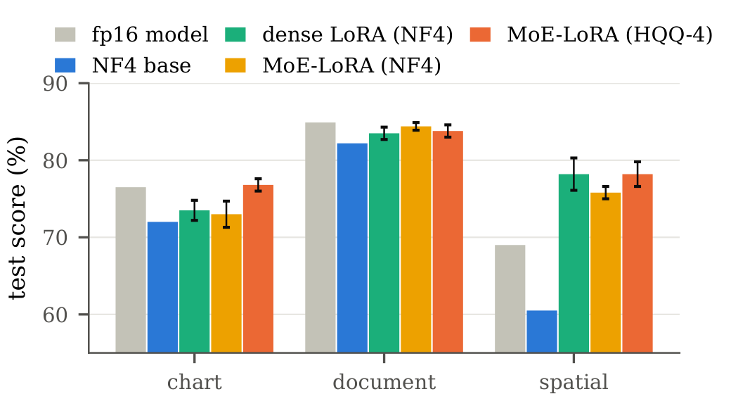
Fig. 2. Test score per task (adapted models: mean and s.d. over three seeds). Adapters recover most of the 4-bit loss on spatial reasoning; the HQQ-based MoE-LoRA (Section 5.7) is the only variant that also exceeds the full-precision model on charts.
Fig. 2 breaks the scores down by task. Quantisation hurts spatial reasoning most (69.0 to 60.5), and every adapter more than recovers it.

B. Expert specialisation
TABLE II. Task–expert mutual information (bits; max. $\log_{2}3=1.585$), development set, mean over 28 layers.
Routing | Seed 0 | Seed 1 | Seed 2
Token-level (moe) | 0.051 | 0.046 | –
Sequence-level (moe_seq) | 0.526 | 0.469 | 0.436
Table 2 measures how much the router’s choice reveals about the task: token-level routing spreads every task over all experts, while sequence-level routing carries about ten times more task information in every seed without ever seeing a task label. In the most specialised layer of seed 0, charts, documents and spatial questions go to three different experts in 100%, 84% and 94% of cases. Charts and documents often share an expert in other layers, consistent with both requiring text reading. Which layers specialise varies between seeds; some collapse to one expert and act as a dense LoRA. Fig. 3 shows the per-layer picture over all seeds.
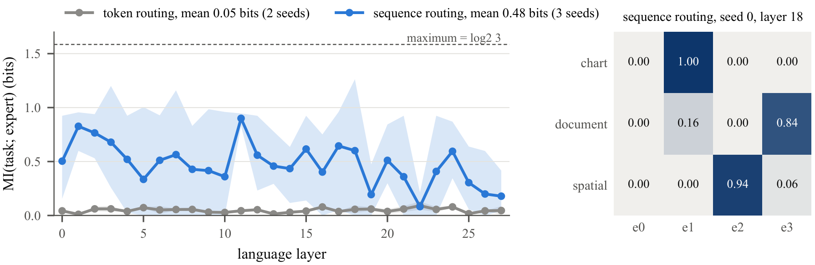
Fig. 3. Left: mutual information between task and chosen expert in each of the 28 language layers (development set; line = mean over seeds, band = range across seeds). Right: share of each task’s prompts sent to each expert in the most task-specific layer of sequence-level routing (layer 18).

C. Folding experts into standard checkpoints
For moe_seq, per-task profile checkpoints score 76.9, 78.2 and 77.5 on test for seeds 0–2, against 76.9, 78.7 and 77.6 for the routed models (mean $−0.2$). A single full merge without task information loses 0.7 points on dev (83.9 vs 84.6). Each profile is a standard Qwen2-VL checkpoint.

D. Edge deployment
TABLE III. GTX 1650 (4 GB) laptop GPU, 4-bit weights, fp32 compute, batch 1. Folded models have the adapters merged into the base weights, so they are identical in size to the base model.
Model | Peak VRAM | Latency | Decode
Base | 2054 MiB | 3.09 s | 18.8 tok/s
moe_seq, routed | 2278 MiB | 3.25 s | 14.2 tok/s
moe_seq, folded | 2054 MiB | 3.08 s | 18.8 tok/s
dense16, folded | 2054 MiB | 3.08 s | 18.7 tok/s
A folded checkpoint has exactly the memory and speed of the base model (Table 3), while keeping the router costs 11% more memory and 24% slower decoding. About 2.9 s of the 3.1 s latency is the prefill pass, dominated by the vision encoder, so the number of image tokens is the main lever for latency. The fp16 model’s 4.1 GB of weights do not fit this GPU’s 4 GB. Without tensor cores, fp16 matrix multiplication here is about five times slower than fp32, so fp32 compute with 4-bit weights cuts time to first token from 12.8 to 3.0 s at equal accuracy for 0.5 GB more memory.

E. Accuracy versus memory and resolution
Table 4 compares our models with the unquantised model (fp16 weights and compute, 512 px) on the test set; Fig. 4 places every evaluated configuration on the accuracy–memory plane. A 512 px image gives 440.6 visual tokens, a 256 px one 241.7 ($−45\%$). For 256 px we rebuilt the teacher cache and trained moe_seq and dense16 with the same recipe (three seeds; 42 and 36 minutes per run instead of about 65).
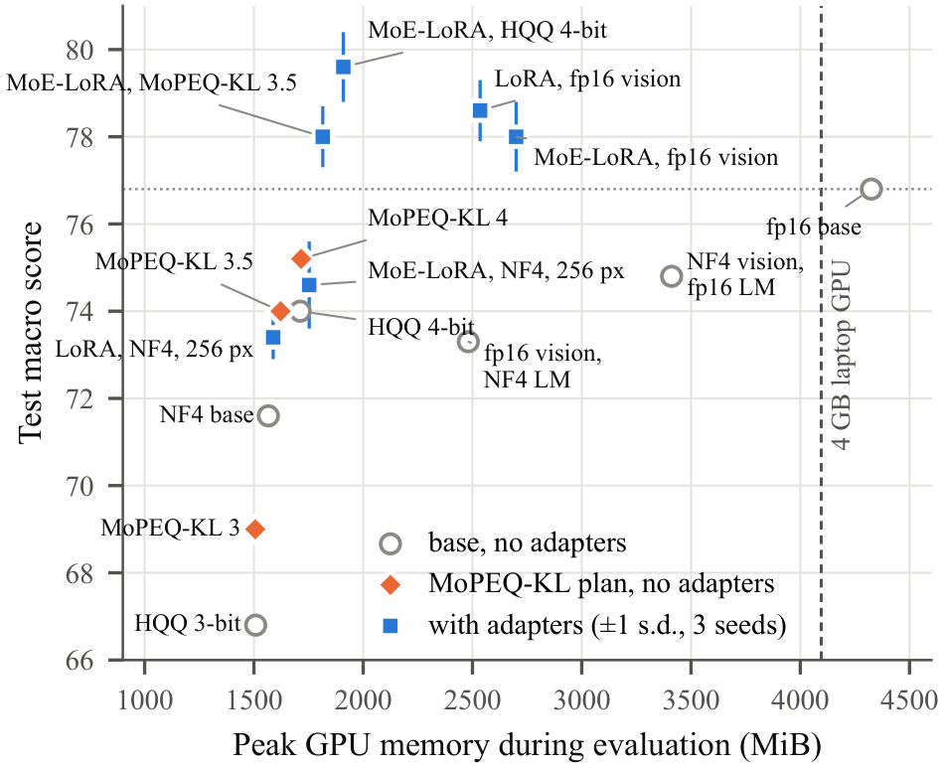
Fig. 4. Test macro score versus peak GPU memory during evaluation for all configurations (base models without adapters, MoPEQ-style KL plans without adapters, and adapted models with $±1$ s.d. over three seeds). The dotted line marks the unquantised fp16 model, the dashed line the 4 GB of the GTX 1650.
TABLE IV. Test accuracy (%) and T4 GPU memory against the unquantised model. $Δ$: difference to fp16 at 512 px with 95% paired bootstrap CI. 512 px adapter rows are from Table 1.
Model | px | Chart | Doc | Spatial | Macro | Peak
fp16 (original) | 512 | 76.5 | 84.9 | 69.0 | 76.8 | 4325 MiB
4-bit base | 512 | 72.0 | 82.2 | 60.5 | 71.6 | 1566 MiB
4-bit base | 256 | 70.5 | 72.8 | 58.5 | 67.3 | –
dense16 | 512 | 73.5 | 83.5 | 78.2 | 78.4 | $≈$1.6 GB
moe_seq | 512 | 73.0 | 84.4 | 75.8 | 77.7 | $≈$1.75 GB
dense16 | 256 | 70.0 | 74.7 | 75.7 | 73.4 | 1588 MiB
moe_seq | 256 | 71.7 | 75.0 | 77.0 | 74.6 | 1753 MiB
$Δ$ vs fp16: 4-bit base 512 $−5.2$ [$−7.8,−2.7$]; dense16@256 $−3.3$ [$−6.3,−0.4$]; moe_seq@256 $−2.2$ [$−5.1,+0.7$].
Quantising to 4-bit cuts weight memory from 4213 MiB to 1390 MiB but costs 5.2 points. The adapters recover this loss: at 512 px dense16 (78.4) and moe_seq (77.7) score on par with or above the unquantised model (76.8; $+1.6$ and $+0.9$, 95% CIs $[−0.8,+4.0]$ and $[−1.4,+3.2]$, so not significant) while using about $2.6×$ less weight and peak memory. The gain comes mostly from spatial reasoning (+7 to +9 points), where fine-tuning teaches the yes/no answer format; document OCR stays slightly below the unquantised model.
Halving the image budget is harder. At 256 px document OCR falls by about 10 points for every model, since small text becomes unreadable, while spatial reasoning is unaffected. Sequence-level MoE-LoRA stays within noise of the unquantised model ($−2.2$, CI includes zero) and 1.2 points ahead of dense16 (higher on all three tasks), which is significantly below it; task experts seem to help most on compressed input, though three seeds are too few to call the 1.2-point gap significant.
On the T4, 4-bit inference is no faster than fp16 (0.49–0.56 vs 0.50 s per answer); the gain is memory, which decides whether a model fits the 4 GB GTX 1650.

F. Where the 4-bit loss comes from
Table 5 keeps one component of the base in fp16 and quantises the rest to NF4 (test, 512 px). Both components contribute: an fp16 vision encoder recovers 1.7 of the 5.2 points lost to 4-bit quantisation for 949 MiB, an fp16 language model 3.2 points for 1875 MiB, about the same gain per megabyte. The vision encoder matters most for document and chart reading, the language model for spatial reasoning. After fine-tuning, however, the difference almost vanishes: with an fp16 vision encoder dense16 reaches 78.6 (vs 78.4 with a 4-bit encoder) and moe_seq 78.0 (vs 77.7), for about 1 GB more memory. Trained on the quantised encoder with distillation from the fp16 model, the adapters absorb the quantisation error, so a uniform 4-bit base is the better edge trade-off.
TABLE V. Mixed precision by component (test, %). $Δ$: difference to the fp16 model, 95% paired bootstrap CI. Trained rows: mean of three seeds.
Base precision | Macro | $Δ$ vs fp16 | Weights
fp16 | 76.8 | – | 4213 MiB
NF4 (all) | 71.6 | $−5.2$ [$−7.8,−2.7$] | 1390 MiB
NF4, vision fp16 | 73.3 | $−3.5$ [$−5.7,−1.3$] | 2339 MiB
NF4, language fp16 | 74.8 | $−2.0$ [$−3.8,−0.3$] | 3265 MiB
dense16, NF4 | 78.4 | $+1.6$ [$−0.8,+4.0$] | 1444 MiB
dense16, vision fp16 | 78.6 | $+1.8$ [$−0.6,+4.1$] | 2393 MiB
moe_seq, NF4 | 77.7 | $+0.9$ [$−1.4,+3.2$] | 1606 MiB
moe_seq, vision fp16 | 78.0 | $+1.2$ [$−0.9,+3.4$] | 2555 MiB

G. Sensitivity-guided mixed precision
Following MoPEQ [8], we split the frozen base into 89 units (32 vision blocks, the vision–language merger, and the attention and MLP of each of the 28 language layers; 1.97B parameters) and choose 2, 3, 4 or 8 bits per unit with HQQ [15] (group size 64). Sensitivity is measured in two ways on 32 training samples: directly, as the KL divergence between the fp16 model and the model with only that unit quantised, and with the HAWQ/MoPEQ proxy [16], the Hessian trace per parameter (Hutchinson estimate with finite-difference Hessian-vector products, 16 samples at 256 px, the most a T4 allows) times the quantisation error. An exact knapsack then minimises the summed sensitivity at the memory of uniform 3, 3.5 or 4 bits.
TABLE VI. Mixed precision of the base (test, %). Quantised-part memory in MiB; trained rows: moe_seq, mean of three seeds. $Δ$ vs fp16 with 95% paired bootstrap CI.
Base | Quant. MiB | Macro | $Δ$ vs fp16
fp16 | – | 76.8 | –
NF4 (bitsandbytes) | – | 71.6 | $−5.2$
HQQ uniform 4-bit | 1059 | 74.0 | $−2.8$
HQQ uniform 3-bit | 823 | 66.8 | $−10.0$
KL-guided, 4 bit avg | 1055 | 75.2 | $−1.6$
KL-guided, 3.5 bit avg | 938 | 74.0 | $−2.8$
KL-guided, 3 bit avg | 821 | 69.0 | $−7.8$
Hessian-guided, 4 bit avg | 1055 | 58.6 | $−18.2$
Hessian-guided, 3 bit avg | 821 | 33.4 | $−43.4$
moe_seq, NF4 | – | 77.7 | $+0.9$
moe_seq, HQQ 4-bit | 1059 | 79.6 | $+2.8$ [$+0.4,+5.2$]
moe_seq, KL 3.5 bit | 938 | 78.0 | $+1.2$ [$−1.4,+3.8$]
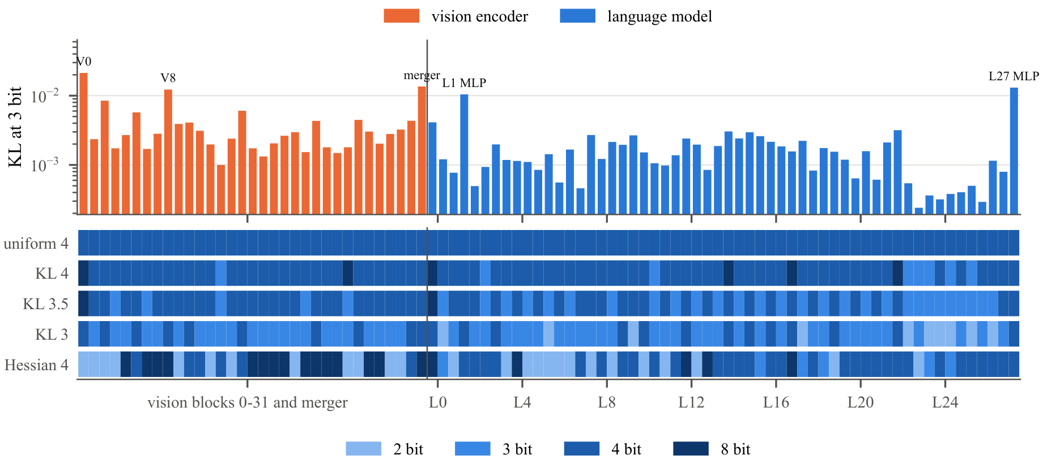
Fig. 5. Top: measured KL sensitivity of each of the 89 quantisation units at 3 bits (log scale; vision blocks, the vision–language merger, then attention and MLP of each language layer). Bottom: bits per unit chosen by the exact knapsack at the memory of uniform 4, 3.5 and 3 bits, and by the Hessian proxy at 4 bits.
Before fine-tuning (Table 6), KL-guided allocation beats uniform quantisation at every budget (+1.2 points at 4 bits, +2.2 at 3; $p=0.13$ and $0.09$, so not individually significant on 600 samples) and matches uniform 4-bit with 11% less quantised memory at 3.5 bits. The allocator protects the vision–language merger, the first and last language MLPs and the first vision block, and spends more bits on the vision encoder than on the language model; spatial reasoning gains most (+6 points at the 4-bit budget).
The Hessian proxy fails: its plans lose 15–40 points against uniform quantisation, because it rates several units as nearly insensitive and sends them to 2 bits, where the true damage (by KL) is 10–50 times that at 3 bits. Its ranking correlates weakly with the measured KL (Spearman $ρ=0.17$–$0.27$), and 26 of the 89 trace estimates are not even positive (Fig. 6); clamped to zero, these units look free to quantise. Fig. 5 shows the resulting plans side by side.
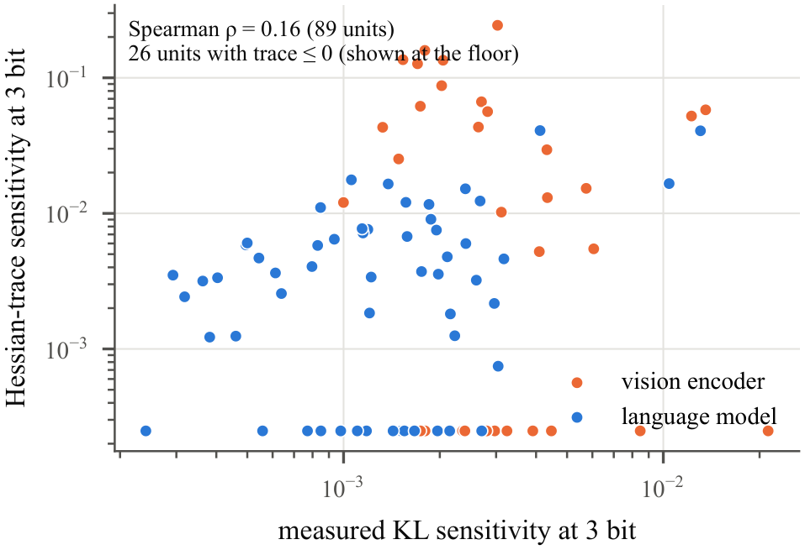
Fig. 6. Hessian-trace versus measured KL sensitivity of the 89 units at 3 bits. Units whose trace estimate is $≤0$ are drawn at the floor of the plot.
We blame the noisy, low-budget estimate and the second-order approximation at 2–3 bits, not Hessian-aware allocation itself; on edge-scale compute a 20-minute direct KL probe is more reliable.
After fine-tuning, moe_seq on uniform HQQ 4-bit reaches 79.6 $±$ 0.8, significantly above the full-precision model ($p=0.01$) with 2.4$×$ less weight memory (1724 vs 4213 MiB; peak 1909 vs 4325 MiB), and 1.9 points above the same recipe on NF4 (95% CI $[+0.0,+3.8]$, $p=0.02$). On the KL-guided 3.5-bit base it reaches 78.0, saving 94 MiB but losing 1.6 points: as with the fp16 vision encoder above, the adapters absorb most of the quantisation error, so a better uniform quantiser helps more than a cleverer allocation. HQQ dequantisation in PyTorch is about twice as slow as NF4 on the T4 (1.0 vs 0.56 s per answer), so NF4 remains our latency reference.

VI. Conclusion
Our sequence-level MoE-LoRA, trained on one T4 GPU, achieves on held-out test data:
- Better than full precision at less than half the memory: on an HQQ 4-bit base, MoE-LoRA scores 79.6 vs 76.8 for the original fp16 model ($+2.8$, $p=0.01$), with peak GPU memory cut from 4.2 GB to 1.9 GB; HQQ itself adds 1.9 points over NF4 ($p=0.02$). Only ours fits a 4 GB GPU.
- Quantisation loss recovered: adapters lift the 4-bit base from 71.6 to 77.7–79.6, and spatial reasoning from 60.5 to 75.8–78.2.
- Experts that find the tasks on their own: sequence-level routing carries 0.48 bits of task information against 0.05 for token-level routing, with no task labels, at the accuracy of dense LoRA.
- Zero deployment overhead: folded checkpoints lose 0.2 points and run on the GTX 1650 at exactly the base model’s cost (2054 MiB, 18.8 tokens/s); keeping the router would cost 11% more memory and 24% slower decoding. fp32 compute cuts its time to first token from 12.8 to 3.0 s.
- Fewer image tokens: at 256 px (45% fewer tokens, about 35% shorter training) MoE-LoRA stays within noise of the fp16 model and 1.2 points ahead of dense LoRA.
- Where precision matters: the language model causes 3.2 and the vision encoder 1.7 of the 5.2 points lost to 4-bit; KL-guided per-layer bits help the untuned model by 1.2–2.2 points, a cheap Hessian estimate fails, and after fine-tuning a good uniform quantiser is the best choice.
Limitations: three tasks of 400 training samples, one 2B backbone, task profiles that assume the task is known, and HQQ being slower than NF4 in PyTorch. Expert-level mixed precision as in MoPEQ gives little here, because our experts are 2.3% of the parameters and are folded away. We expect it to matter when experts are a large share of the weights: pretrained MoE VLMs, larger experts that must stay unfolded, or 10B-scale backbones where a few gigabytes decide whether a model fits on an edge device.

References
[1] P. Wang, S. Bai, S. Tan, et al., “Qwen2-VL: Enhancing vision-language model’s perception of the world at any resolution,” arXiv preprint arXiv:2409.12191, 2024.
[2] E. J. Hu et al., “LoRA: Low-rank adaptation of large language models,” in International conference on learning representations (ICLR), 2022.
[3] T. Dettmers, A. Pagnoni, A. Holtzman, and L. Zettlemoyer, “QLoRA: Efficient finetuning of quantized LLMs,” in Advances in neural information processing systems (NeurIPS), 2023.
[4] T. Zadouri, A. Üstün, A. Ahmadian, B. Ermiş, A. Locatelli, and S. Hooker, “Pushing mixture of experts to the limit: Extremely parameter efficient MoE for instruction tuning,” in International conference on learning representations (ICLR), 2024.
[5] S. Dou, E. Zhou, Y. Liu, et al., “LoRAMoE: Alleviating world knowledge forgetting in large language models via MoE-style plugin,” in Proceedings of the 62nd annual meeting of the association for computational linguistics (ACL), 2024, pp. 1932–1945.
[6] N. Shazeer et al., “Outrageously large neural networks: The sparsely-gated mixture-of-experts layer,” in International conference on learning representations (ICLR), 2017.
[7] W. Fedus, B. Zoph, and N. Shazeer, “Switch transformers: Scaling to trillion parameter models with simple and efficient sparsity,” Journal of Machine Learning Research, vol. 23, no. 120, pp. 1–39, 2022.
[8] K. T. Chitty-Venkata, J. Ye, and M. Emani, “MoPEQ: Mixture of mixed precision quantized experts,” in Proc. IEEE/CVF int. Conf. Computer vision workshops (ICCVW), 2025, pp. 4082–4091.
[9] B. Zoph, I. Bello, S. Kumar, et al., “ST-MoE: Designing stable and transferable sparse expert models,” arXiv preprint arXiv:2202.08906, 2022.
[10] G. Hinton, O. Vinyals, and J. Dean, “Distilling the knowledge in a neural network,” arXiv preprint arXiv:1503.02531, 2015.
[11] M. Mathew, D. Karatzas, and C. V. Jawahar, “DocVQA: A dataset for VQA on document images,” in IEEE/CVF winter conference on applications of computer vision (WACV), 2021.
[12] A. Masry, D. X. Long, J. Q. Tan, S. Joty, and E. Hoque, “ChartQA: A benchmark for question answering about charts with visual and logical reasoning,” in Findings of the association for computational linguistics (ACL), 2022.
[13] F. Liu, G. Emerson, and N. Collier, “Visual spatial reasoning,” Transactions of the Association for Computational Linguistics, vol. 11, pp. 635–651, 2023.
[14] A. F. Biten, R. Tito, A. Mafla, et al., “Scene text visual question answering,” in IEEE/CVF international conference on computer vision (ICCV), 2019.
[15] H. Badri and A. Shaji, “Half-quadratic quantization of large machine learning models.” https://dropbox.tech/machine-learning/halfquadratic-quantization-of-large-machine-learning-models, 2023.
[16] Z. Dong, Z. Yao, A. Gholami, M. W. Mahoney, and K. Keutzer, “HAWQ: Hessian aware quantization of neural networks with mixed-precision,” in Proc. IEEE/CVF int. Conf. Computer vision (ICCV), 2019.

