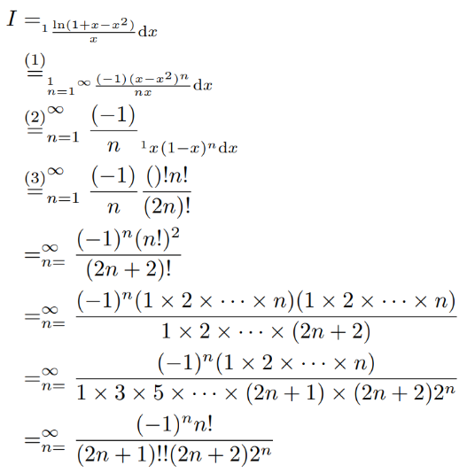

__Explanation__

(1) Using the Maclaurin series of , where .

(2) It is legal to change the position of and .

(3) Integrate by parts times.

[Notice that](https://math.stackexchange.com/questions/534736/evaluate-this-power-series) ,

integrate both sides from , we have .

Letting leads to

.

Combining with , we have

or where denotes the golden ratio.